Supplementary Information

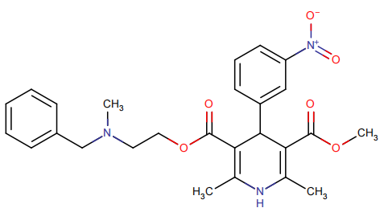

Fig. S1 Chemical structure of the drug Nicardipine.
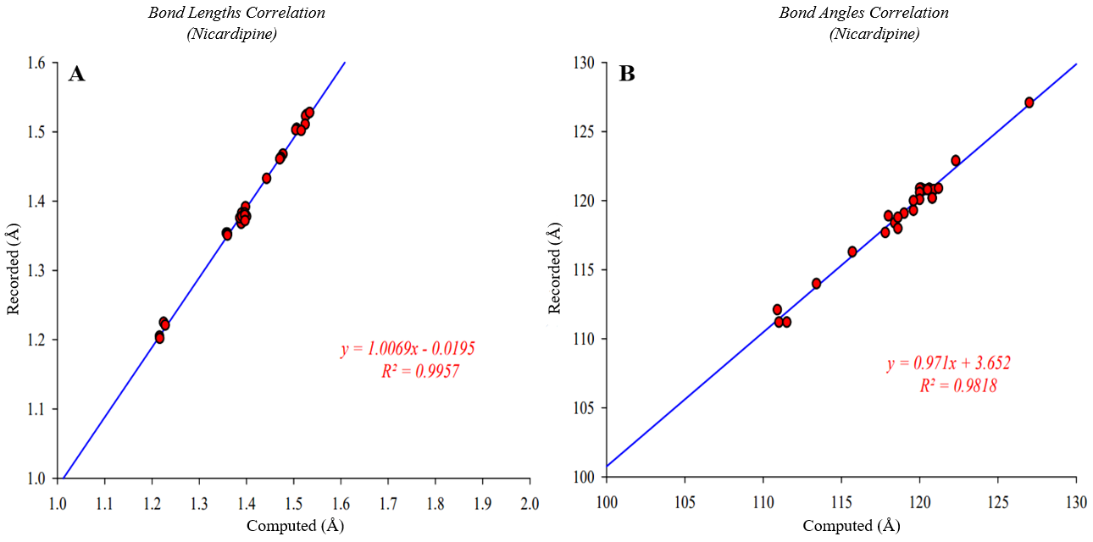
Fig. S2 Correlation Plots of Nicardipine for Bond lengths (A) and Bond angles (B)

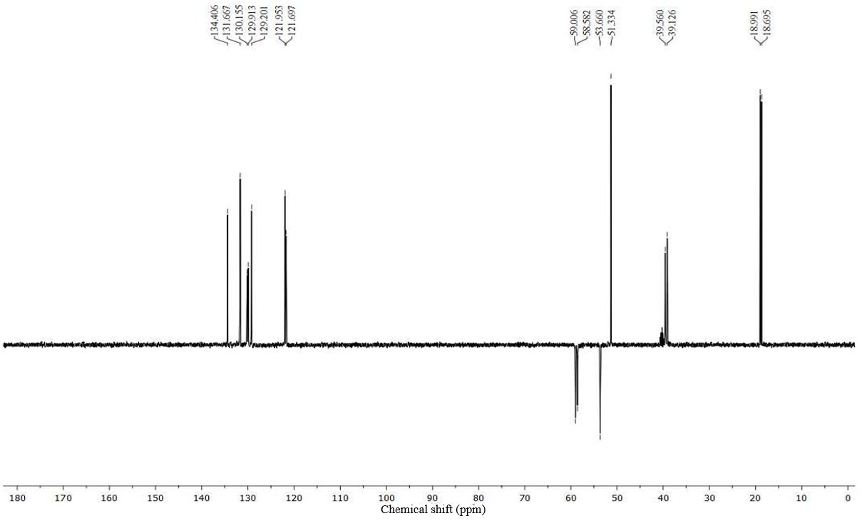
Fig. S3 Experimentally Recorded DEPT NMR Spectrum of Nicardipine Hydrochloride
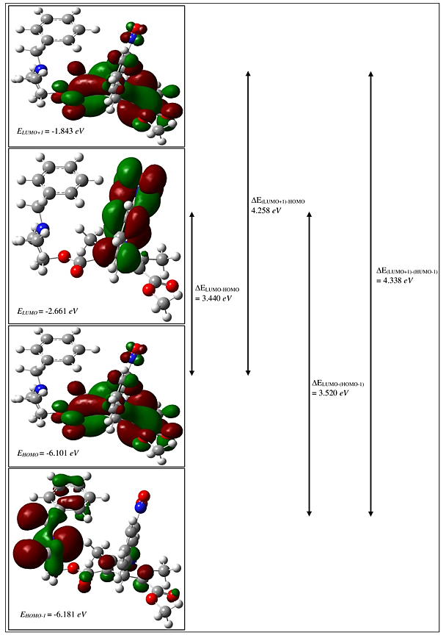
Fig. S4a Patterns of the Principal Frontier Molecular Orbitals of Nicardipine (in Gas Phase)
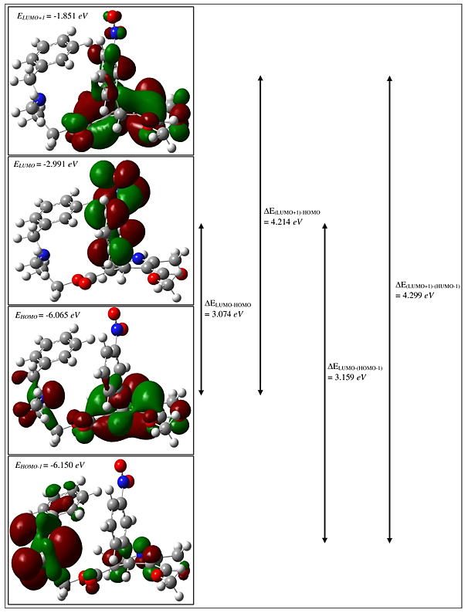
Fig. S4b Patterns of the Principal Frontier Molecular Orbitals of Nicardipine (in Ethanol)

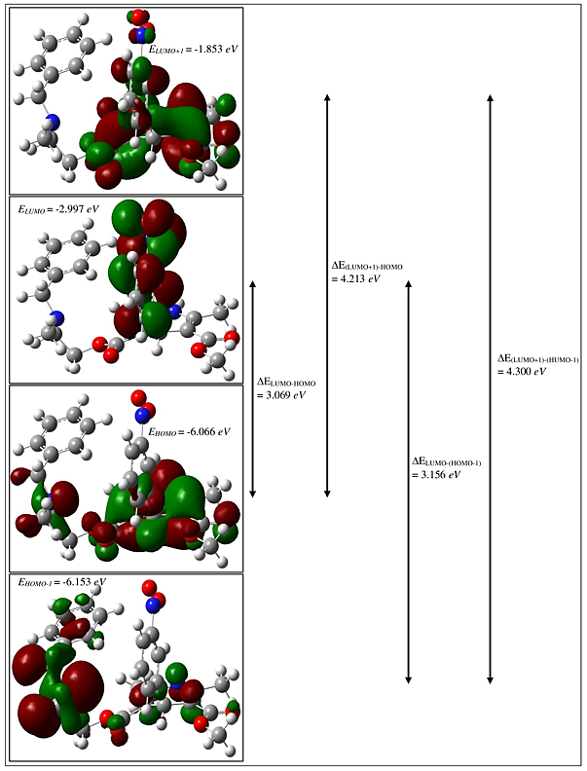
Fig. S4c Patterns of the Principal Frontier Molecular Orbitals of Nicardipine (in Methanol)
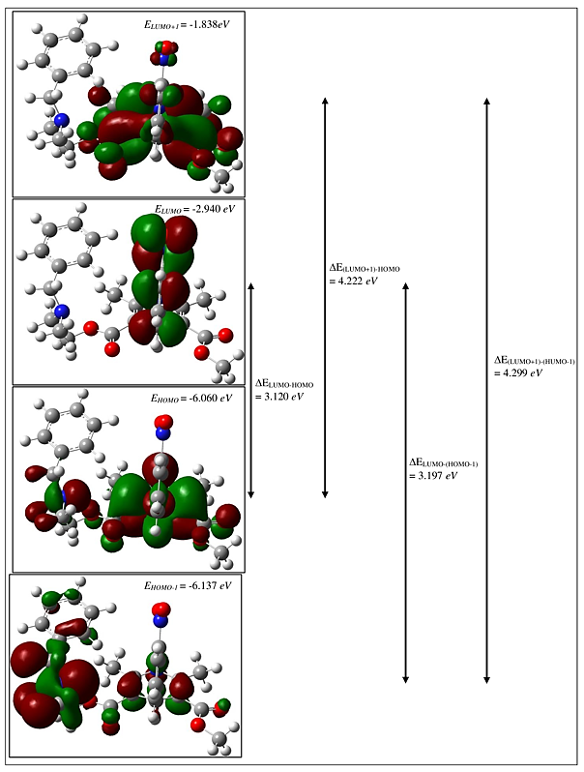
Fig. S4d Patterns of the Principal Frontier Molecular Orbitals of Nicardipine (in THF)
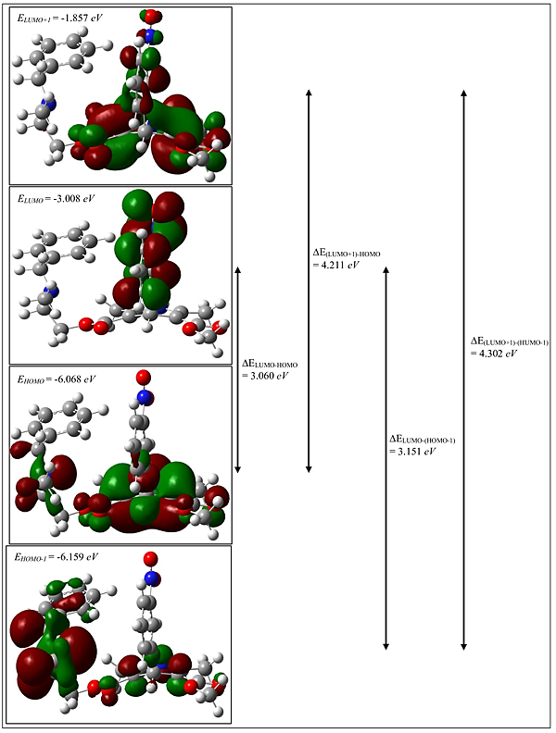
Fig. S4e Patterns of the Principal Frontier Molecular Orbitals of Nicardipine (in Water)

Table S1. Recorded and calculated vibrational spectral data for Nicardipine (Hydrochloride)
Experimental |  | B3LYP / 6-311++G(d.p)
FT-IR | Raman | No | Unscaled  Freq. | Scaled  Freq. | Reduced  Mass | Force  Constant | IR  Intensity | Raman  Activity | Raman  Intensity
 |  | 1 | 14 | 14 | 5.64 | 0.00 | 0.74 | 2.72 | 0.20
 |  | 2 | 15 | 15 | 6.15 | 0.00 | 1.30 | 2.71 | 0.18
 |  | 3 | 18 | 18 | 7.39 | 0.00 | 0.50 | 1.03 | 0.06
 |  | 4 | 23 | 23 | 5.56 | 0.00 | 0.30 | 1.23 | 0.05
 |  | 5 | 33 | 32 | 4.61 | 0.00 | 0.52 | 2.55 | 0.08
 |  | 6 | 40 | 39 | 6.45 | 0.01 | 0.14 | 3.72 | 0.09
 |  | 7 | 42 | 41 | 3.94 | 0.00 | 0.12 | 4.44 | 0.10
 |  | 8 | 47 | 46 | 4.48 | 0.01 | 0.94 | 1.84 | 0.04
 |  | 9 | 52 | 51 | 6.09 | 0.01 | 1.98 | 1.94 | 0.04
 |  | 10 | 57 | 56 | 6.06 | 0.01 | 0.51 | 2.20 | 0.04
 |  | 11 | 63 | 62 | 5.03 | 0.01 | 4.31 | 1.33 | 0.02
 |  | 12 | 72 | 71 | 3.24 | 0.01 | 0.04 | 1.06 | 0.01
 |  | 13 | 89 | 87 | 4.17 | 0.02 | 1.42 | 0.45 | 0.01
 |  | 14 | 93 | 91 | 3.99 | 0.02 | 0.41 | 0.57 | 0.01
 |  | 15 | 107 | 106 | 1.67 | 0.01 | 0.87 | 0.64 | 0.01
 |  | 16 | 119 | 117 | 2.04 | 0.02 | 1.37 | 1.02 | 0.01
 |  | 17 | 128 | 125 | 1.47 | 0.01 | 1.54 | 0.32 | 0.00
 |  | 18 | 136 | 133 | 1.55 | 0.02 | 0.20 | 0.95 | 0.01
 | 140.7 | 19 | 142 | 140 | 2.10 | 0.03 | 0.56 | 0.97 | 0.01
 |  | 20 | 154 | 151 | 3.46 | 0.05 | 0.67 | 1.37 | 0.01
 |  | 21 | 156 | 154 | 3.39 | 0.05 | 1.09 | 0.40 | 0.00
 | 161.9 | 22 | 171 | 168 | 3.93 | 0.07 | 0.72 | 0.97 | 0.01
 |  | 23 | 179 | 176 | 3.82 | 0.07 | 1.33 | 0.78 | 0.00
 |  | 24 | 212 | 209 | 4.54 | 0.12 | 6.14 | 1.61 | 0.01
 |  | 25 | 219 | 216 | 1.95 | 0.06 | 0.29 | 2.38 | 0.01
 |  | 26 | 224 | 220 | 3.41 | 0.10 | 0.98 | 1.29 | 0.01
 |  | 27 | 233 | 230 | 2.49 | 0.08 | 0.14 | 0.85 | 0.00
 |  | 28 | 255 | 251 | 3.48 | 0.13 | 3.61 | 4.84 | 0.02
 |  | 29 | 277 | 272 | 3.24 | 0.15 | 1.02 | 1.50 | 0.01
 |  | 30 | 301 | 296 | 5.21 | 0.28 | 0.02 | 1.19 | 0.24
 |  | 31 | 311 | 306 | 3.69 | 0.21 | 1.70 | 1.36 | 0.26
 |  | 32 | 329 | 323 | 4.50 | 0.29 | 3.10 | 0.70 | 0.12
 | 327.8 | 33 | 336 | 330 | 3.03 | 0.20 | 0.64 | 2.83 | 0.46
 |  | 34 | 337 | 331 | 3.23 | 0.22 | 6.79 | 1.14 | 0.18
 |  | 35 | 347 | 341 | 5.13 | 0.36 | 1.23 | 1.08 | 0.16
 |  | 36 | 351 | 345 | 4.13 | 0.30 | 3.63 | 3.63 | 0.53
 |  | 37 | 361 | 355 | 2.16 | 0.17 | 1.16 | 0.87 | 0.12
 | 360.6 | 38 | 365 | 359 | 4.81 | 0.38 | 7.60 | 0.55 | 0.08
 |  | 39 | 381 | 374 | 3.79 | 0.32 | 16.34 | 1.23 | 0.15
 |  | 40 | 396 | 389 | 8.96 | 0.83 | 1.07 | 2.18 | 0.25
 |  | 41 | 403 | 396 | 4.36 | 0.42 | 4.54 | 0.99 | 0.11
 |  | 42 | 416 | 409 | 2.88 | 0.29 | 0.14 | 0.04 | 0.00
 | 430.0 | 43 | 429 | 422 | 2.28 | 0.25 | 0.87 | 1.10 | 0.10
 |  | 44 | 430 | 422 | 3.25 | 0.35 | 0.02 | 0.11 | 0.01
 | 455.0 | 45 | 462 | 455 | 5.86 | 0.74 | 11.21 | 7.00 | 0.57
 |  | 46 | 494 | 486 | 3.09 | 0.45 | 17.45 | 0.76 | 0.05
480.2 |  | 47 | 500 | 491 | 1.24 | 0.18 | 36.40 | 8.13 | 0.55
 |  | 48 | 520 | 511 | 5.35 | 0.85 | 2.04 | 1.32 | 0.08
 |  | 49 | 540 | 531 | 6.51 | 1.12 | 1.72 | 1.56 | 0.09
541.9 |  | 50 | 556 | 546 | 2.89 | 0.53 | 1.90 | 1.00 | 0.05
 |  | 51 | 581 | 572 | 3.80 | 0.76 | 3.51 | 1.80 | 0.09
 |  | 52 | 593 | 583 | 4.70 | 0.97 | 1.80 | 0.74 | 0.03
590.1 | 590.0 | 53 | 606 | 595 | 4.81 | 1.04 | 6.48 | 2.21 | 0.10
607.5 |  | 54 | 616 | 605 | 4.52 | 1.01 | 1.05 | 1.30 | 0.06
 |  | 55 | 625 | 614 | 4.45 | 1.02 | 0.83 | 1.28 | 0.05
 | 620.0 | 56 | 635 | 624 | 6.26 | 1.49 | 0.04 | 3.29 | 0.13
640.3 | 640.2 | 57 | 659 | 648 | 4.52 | 1.16 | 3.60 | 8.12 | 0.30
 |  | 58 | 676 | 665 | 3.80 | 1.03 | 0.12 | 0.81 | 0.03
678.8 |  | 59 | 698 | 686 | 6.41 | 1.84 | 1.76 | 5.05 | 0.16
698.1 |  | 60 | 709 | 697 | 2.42 | 0.72 | 50.01 | 1.43 | 0.04
709.7 |  | 61 | 714 | 702 | 2.03 | 0.61 | 26.98 | 0.24 | 0.01
 |  | 62 | 748 | 736 | 2.36 | 0.78 | 19.79 | 2.28 | 0.06
 |  | 63 | 750 | 738 | 3.68 | 1.22 | 30.19 | 3.25 | 0.09
742.5 |  | 64 | 758 | 745 | 5.84 | 1.98 | 20.90 | 2.27 | 0.06
 |  | 65 | 785 | 772 | 5.94 | 2.16 | 8.71 | 2.91 | 0.07
788.7 |  | 66 | 794 | 781 | 5.91 | 2.19 | 24.04 | 0.29 | 0.01
 |  | 67 | 796 | 782 | 3.57 | 1.33 | 19.34 | 4.51 | 0.11
 |  | 68 | 814 | 800 | 2.27 | 0.89 | 6.99 | 5.75 | 0.13
808.0 | 806.0 | 69 | 820 | 806 | 3.24 | 1.28 | 16.37 | 5.09 | 0.11
 |  | 70 | 836 | 822 | 3.62 | 1.49 | 3.40 | 9.49 | 0.20
827.3 | 827.0 | 71 | 842 | 828 | 3.86 | 1.61 | 4.15 | 6.06 | 0.13
 |  | 72 | 846 | 831 | 7.50 | 3.16 | 3.60 | 13.32 | 0.27
 |  | 73 | 863 | 848 | 1.25 | 0.55 | 0.03 | 1.17 | 0.02
 |  | 74 | 880 | 865 | 2.64 | 1.21 | 1.28 | 6.43 | 0.12
906.4 |  | 75 | 927 | 912 | 1.39 | 0.71 | 4.04 | 0.33 | 0.01
 |  | 76 | 932 | 917 | 1.70 | 0.87 | 10.20 | 0.31 | 0.01
919.9 |  | 77 | 938 | 922 | 5.07 | 2.63 | 17.04 | 0.76 | 0.01
 |  | 78 | 951 | 934 | 1.40 | 0.75 | 2.95 | 0.21 | 0.00
943.0 |  | 79 | 967 | 951 | 5.75 | 3.17 | 13.84 | 18.48 | 0.27
750.7 | 956.5 | 80 | 970 | 953 | 2.41 | 1.33 | 38.08 | 2.34 | 0.03
 |  | 81 | 989 | 972 | 1.36 | 0.78 | 0.04 | 0.17 | 0.00
 |  | 82 | 991 | 974 | 2.13 | 1.23 | 11.63 | 7.27 | 0.10
 |  | 83 | 994 | 977 | 1.58 | 0.92 | 20.52 | 8.71 | 0.12
 |  | 84 | 1003 | 986 | 1.34 | 0.80 | 0.41 | 0.23 | 0.00
 |  | 85 | 1010 | 993 | 1.35 | 0.81 | 1.02 | 0.41 | 0.01
 |  | 86 | 1014 | 997 | 2.92 | 1.77 | 16.38 | 3.45 | 0.05
 |  | 87 | 1018 | 1000 | 5.40 | 3.29 | 2.87 | 66.87 | 0.87
 | 1002.8 | 88 | 1019 | 1001 | 5.39 | 3.30 | 1.77 | 11.18 | 0.15
1014.4 |  | 89 | 1033 | 1015 | 1.97 | 1.24 | 16.67 | 1.72 | 0.02
 |  | 90 | 1046 | 1028 | 2.36 | 1.52 | 25.40 | 13.92 | 0.17
 | 1033.6 | 91 | 1048 | 1030 | 1.54 | 0.99 | 7.05 | 1.21 | 0.02
 |  | 92 | 1055 | 1037 | 1.66 | 1.09 | 5.94 | 1.64 | 0.02
 |  | 93 | 1056 | 1038 | 2.11 | 1.39 | 21.55 | 4.72 | 0.06
1052.9 |  | 94 | 1067 | 1049 | 2.39 | 1.60 | 65.85 | 1.42 | 0.02
 |  | 95 | 1088 | 1069 | 2.49 | 1.74 | 33.52 | 4.60 | 0.05
 |  | 96 | 1098 | 1080 | 1.69 | 1.20 | 34.42 | 1.32 | 0.01
 |  | 97 | 1103 | 1084 | 1.56 | 1.12 | 6.04 | 0.34 | 0.00
 |  | 98 | 1113 | 1094 | 2.42 | 1.76 | 66.00 | 7.90 | 0.08
1097.3 |  | 99 | 1115 | 1096 | 3.64 | 2.67 | 56.46 | 12.07 | 0.13
1116.6 | 1114.6 | 100 | 1130 | 1111 | 3.92 | 2.95 | 21.10 | 6.68 | 0.07
 |  | 101 | 1147 | 1127 | 1.43 | 1.11 | 5.68 | 4.33 | 0.04
1141.7 |  | 102 | 1158 | 1139 | 3.50 | 2.76 | 49.39 | 11.09 | 0.11
 |  | 103 | 1171 | 1151 | 1.28 | 1.04 | 0.64 | 2.20 | 0.02
 |  | 104 | 1181 | 1161 | 1.14 | 0.94 | 0.95 | 2.59 | 0.02
 |  | 105 | 1184 | 1164 | 2.03 | 1.67 | 9.61 | 5.28 | 0.05
 |  | 106 | 1188 | 1168 | 1.38 | 1.15 | 6.34 | 13.07 | 0.12
 |  | 107 | 1200 | 1180 | 1.14 | 0.97 | 0.62 | 10.48 | 0.09
 |  | 108 | 1207 | 1186 | 1.66 | 1.42 | 29.70 | 17.75 | 0.15
 | 1195.6 | 109 | 1212 | 1191 | 2.41 | 2.09 | 3.34 | 24.49 | 0.21
1197.6 |  | 110 | 1224 | 1203 | 2.70 | 2.38 | 4.23 | 15.45 | 0.13
 |  | 111 | 1235 | 1214 | 2.09 | 1.88 | 97.18 | 18.95 | 0.15
 |  | 112 | 1240 | 1219 | 1.95 | 1.77 | 78.24 | 15.24 | 0.12
 |  | 113 | 1262 | 1240 | 4.28 | 4.02 | 44.28 | 10.32 | 0.08
 | 1251.5 | 114 | 1274 | 1253 | 1.61 | 1.54 | 12.89 | 9.51 | 0.07
1270.9 | 1268.9 | 115 | 1285 | 1264 | 1.65 | 1.61 | 12.86 | 2.29 | 0.02
 |  | 116 | 1309 | 1287 | 2.46 | 2.48 | 51.51 | 2.50 | 0.02
 |  | 117 | 1312 | 1290 | 1.35 | 1.37 | 19.14 | 4.61 | 0.03
 |  | 118 | 1322 | 1299 | 1.37 | 1.41 | 22.78 | 7.48 | 0.05
1303.6 | 1303.6 | 119 | 1330 | 1308 | 2.79 | 2.91 | 75.83 | 14.23 | 0.09
1315.2 |  | 120 | 1344 | 1321 | 2.57 | 2.74 | 39.22 | 5.94 | 0.04
 |  | 121 | 1344 | 1321 | 3.22 | 3.42 | 6.34 | 2.45 | 0.02
 |  | 122 | 1352 | 1329 | 2.25 | 2.42 | 26.09 | 12.08 | 0.08
 |  | 123 | 1358 | 1335 | 1.32 | 1.43 | 4.13 | 0.73 | 0.01
1353.8 | 1353.7 | 124 | 1366 | 1343 | 12.75 | 14.02 | 76.69 | 161.93 | 1.00
 |  | 125 | 1380 | 1356 | 2.16 | 2.42 | 14.70 | 2.17 | 0.01
1373.0 | 1376.0 | 126 | 1395 | 1372 | 1.46 | 1.67 | 36.27 | 8.34 | 0.05
 |  | 127 | 1407 | 1383 | 1.41 | 1.64 | 13.07 | 3.21 | 0.02
 |  | 128 | 1421 | 1396 | 1.23 | 1.46 | 42.33 | 15.00 | 0.08
 |  | 129 | 1424 | 1400 | 1.22 | 1.46 | 4.18 | 8.08 | 0.05
1415.5 |  | 130 | 1425 | 1401 | 1.36 | 1.63 | 4.96 | 2.10 | 0.01
1434.8 |  | 131 | 1458 | 1433 | 1.18 | 1.48 | 3.02 | 2.52 | 0.01
 |  | 132 | 1464 | 1439 | 1.07 | 1.35 | 38.62 | 10.91 | 0.06
 |  | 133 | 1469 | 1444 | 1.20 | 1.52 | 31.15 | 3.23 | 0.02
 |  | 134 | 1471 | 1446 | 1.05 | 1.34 | 16.31 | 10.42 | 0.05
 |  | 135 | 1473 | 1448 | 2.38 | 3.05 | 5.64 | 1.20 | 0.01
1556.0 |  | 136 | 1481 | 1455 | 1.72 | 2.22 | 8.49 | 2.40 | 0.01
 |  | 137 | 1482 | 1457 | 1.05 | 1.35 | 8.55 | 11.08 | 0.06
 |  | 138 | 1484 | 1458 | 1.17 | 1.52 | 11.00 | 11.66 | 0.06
 |  | 139 | 1489 | 1463 | 1.14 | 1.48 | 37.45 | 10.63 | 0.05
 |  | 140 | 1490 | 1464 | 1.15 | 1.50 | 2.92 | 7.41 | 0.04
 |  | 141 | 1494 | 1468 | 1.17 | 1.53 | 96.68 | 12.67 | 0.06
 |  | 142 | 1496 | 1471 | 1.15 | 1.52 | 28.07 | 16.64 | 0.08
 |  | 143 | 1498 | 1473 | 1.13 | 1.49 | 53.38 | 20.35 | 0.10
 |  | 144 | 1501 | 1475 | 1.43 | 1.90 | 20.18 | 34.87 | 0.17
 |  | 145 | 1505 | 1479 | 1.10 | 1.46 | 33.48 | 18.78 | 0.09
 |  | 146 | 1507 | 1482 | 2.42 | 3.24 | 4.30 | 0.70 | 0.00
1488.8 | 1492.6 | 147 | 1508 | 1483 | 1.06 | 1.42 | 10.39 | 2.36 | 0.01
 |  | 148 | 1527 | 1501 | 2.17 | 2.98 | 5.66 | 0.70 | 0.00
1533.0 | 1527.0 | 149 | 1575 | 1548 | 9.96 | 14.55 | 64.46 | 20.27 | 0.09
 | 1583.0 | 150 | 1619 | 1591 | 5.90 | 9.11 | 4.40 | 47.95 | 0.19
 |  | 151 | 1623 | 1596 | 5.55 | 8.62 | 0.53 | 8.65 | 0.03
 |  | 152 | 1642 | 1615 | 5.58 | 8.87 | 1.18 | 25.58 | 0.10
1620.0 |  | 153 | 1648 | 1620 | 3.90 | 6.25 | 93.81 | 86.64 | 0.32
 |  | 154 | 1651 | 1623 | 7.09 | 11.39 | 10.07 | 10.25 | 0.04
 |  | 155 | 1672 | 1644 | 8.12 | 13.38 | 94.90 | 274.80 | 0.98
1645.0 | 1643.0 | 156 | 1725 | 1653 | 11.31 | 19.84 | 74.61 | 120.47 | 0.39
1703.0 | 1706.0 | 157 | 1740 | 1667 | 9.88 | 17.63 | 27.65 | 27.02 | 0.09
 |  | 158 | 2880 | 2759 | 1.07 | 5.25 | 78.36 | 142.92 | 0.09
 |  | 159 | 2905 | 2783 | 1.07 | 5.30 | 40.45 | 65.63 | 0.04
 |  | 160 | 2915 | 2793 | 1.07 | 5.35 | 26.42 | 350.91 | 0.21
 |  | 161 | 3038 | 2910 | 1.04 | 5.66 | 19.68 | 196.26 | 0.10
 |  | 162 | 3043 | 2915 | 1.04 | 5.68 | 23.32 | 192.81 | 0.10
 |  | 163 | 3048 | 2920 | 1.09 | 5.94 | 11.01 | 53.54 | 0.03
 |  | 164 | 3048 | 2920 | 1.03 | 5.64 | 46.32 | 205.70 | 0.10
 | 2937.0 | 165 | 3068 | 2939 | 1.06 | 5.90 | 61.22 | 133.24 | 0.07
 |  | 166 | 3073 | 2944 | 1.08 | 6.00 | 17.92 | 50.31 | 0.03
2948.6 | 2950.5 | 167 | 3074 | 2945 | 1.08 | 6.01 | 2.11 | 110.51 | 0.05
 | 2962.0 | 168 | 3097 | 2966 | 1.10 | 6.22 | 10.75 | 80.95 | 0.04
 |  | 169 | 3104 | 2974 | 1.10 | 6.24 | 9.55 | 66.65 | 0.03
 |  | 170 | 3106 | 2976 | 1.08 | 6.16 | 0.90 | 29.99 | 0.01
 |  | 171 | 3117 | 2986 | 1.10 | 6.31 | 13.65 | 30.21 | 0.01
 | 2993.0 | 172 | 3119 | 2988 | 1.11 | 6.34 | 18.74 | 66.50 | 0.03
 |  | 173 | 3134 | 3003 | 1.10 | 6.37 | 7.90 | 37.45 | 0.02
 |  | 174 | 3139 | 3008 | 1.10 | 6.37 | 2.26 | 46.53 | 0.02
 |  | 175 | 3140 | 3008 | 1.10 | 6.38 | 1.84 | 69.02 | 0.03
 |  | 176 | 3150 | 3018 | 1.11 | 6.47 | 12.63 | 54.48 | 0.02
 |  | 177 | 3152 | 3019 | 1.09 | 6.36 | 5.27 | 42.18 | 0.02
 | 3027.7 | 178 | 3161 | 3028 | 1.09 | 6.40 | 3.12 | 74.57 | 0.03
 |  | 179 | 3170 | 3037 | 1.09 | 6.46 | 8.52 | 95.98 | 0.04
 |  | 180 | 3178 | 3044 | 1.09 | 6.47 | 7.09 | 82.46 | 0.04
 | 3049.0 | 181 | 3178 | 3045 | 1.09 | 6.51 | 23.99 | 26.29 | 0.01
 |  | 182 | 3186 | 3053 | 1.10 | 6.57 | 9.17 | 327.79 | 0.14
3072.0 | 3066.0 | 183 | 3196 | 3061 | 1.09 | 6.58 | 5.01 | 104.47 | 0.04
 |  | 184 | 3222 | 3086 | 1.09 | 6.67 | 1.00 | 14.75 | 0.01
3180.0 |  | 185 | 3223 | 3088 | 1.09 | 6.69 | 1.92 | 99.58 | 0.04
3255.3 |  | 186 | 3634 | 3481 | 1.08 | 8.38 | 53.61 | 126.52 | 0.03
Recorded by Thermo Scientific Nicolet 6700 FT-IR spectrometer

Table S2. Energy values and energy differences of molecular orbitals involved in electronic transitions of nicardipine molecule calculated by B3LYP method in 6-311++G(d,p) basis set.
 | Gas |  | Ethanol |  | Methanol |  | THF |  | Water
 | Hartree | eV | Hartree | eV | Hartree | eV | Hartree | eV | Hartree | eV
E_{HOMO} | -0,22422 | -6,101 | -0,22290 | -6,065 | -0,22294 | -6,066 | -0,22271 | -6,060 | -0,22303 | -6,068
E_{HOMO-1} | -0,22716 | -6,181 | -0,22604 | -6,150 | -0,22613 | -6,153 | -0,22556 | -6,137 | -0,22634 | -6,159
E_{LUMO} | -0,09780 | -2,661 | -0,10995 | -2,991 | -0,11016 | -2,997 | -0,10808 | -2,940 | -0,11057 | -3,008
E_{LUMO+1} | -0,06773 | -1,843 | -0,06804 | -1,851 | -0,06811 | -1,853 | -0,06758 | -1,838 | -0,06826 | -1,857
∆E_{(LUMO+1)-HOMO} | 0,15647 | 4,258 | 0,15486 | 4,214 | 0,15482 | 4,213 | 0,15515 | 4,222 | 0,15475 | 4,211
∆E_{(LUMO+1)-(HUMO-1)} | 0,15941 | 4,338 | 0,15798 | 4,299 | 0,15802 | 4,300 | 0,15798 | 4,299 | 0,15809 | 4,302
∆E_{LUMO-HOMO} | 0,12641 | 3,440 | 0,11296 | 3,074 | 0,11278 | 3,069 | 0,11465 | 3,120 | 0,11245 | 3,060
∆E_{LUMO-(HOMO-1)} | 0,12935 | 3,520 | 0,11609 | 3,159 | 0,11598 | 3,156 | 0,11748 | 3,197 | 0,11579 | 3,151

Table S3. The atomic charges obtained by Mulliken Analysis for Nicardipine
Atom | Gas | Ethanol | Methanol | THF | Water | Atom | Gas | Ethanol | Methanol | THF | Water
O(1) | 0.092 | 0.088 | 0.088 | 0.088 | 0.088 | C(33) | -0.340 | -0.370 | -0.371 | -0.365 | -0.372
O(2) | -0.039 | -0.058 | -0.058 | -0.054 | -0.059 | C(34) | -0.446 | -0.469 | -0.469 | -0.465 | -0.470
O(3) | -0.189 | -0.248 | -0.249 | -0.238 | -0.251 | C(35) | -0.514 | -0.536 | -0.537 | -0.534 | -0.537
O(4) | -0.264 | -0.325 | -0.326 | -0.315 | -0.328 | H(36) | 0.333 | 0.325 | 0.325 | 0.327 | 0.325
O(5) | 0.056 | 0.005 | 0.004 | 0.012 | 0.002 | H(37) | 0.328 | 0.370 | 0.370 | 0.363 | 0.372
O(6) | 0.025 | -0.022 | -0.022 | -0.015 | -0.024 | H(38) | 0.271 | 0.274 | 0.274 | 0.273 | 0.274
N(7) | 0.019 | 0.020 | 0.020 | 0.018 | 0.021 | H(39) | 0.211 | 0.224 | 0.224 | 0.222 | 0.225
N(8) | 0.354 | 0.320 | 0.319 | 0.330 | 0.316 | H(40) | 0.204 | 0.190 | 0.189 | 0.193 | 0.189
N(9) | -0.308 | -0.254 | -0.253 | -0.262 | -0.251 | H(41) | 0.229 | 0.234 | 0.234 | 0.233 | 0.235
C(10) | -0.476 | -0.392 | -0.389 | -0.409 | -0.385 | H(42) | 0.089 | 0.126 | 0.126 | 0.119 | 0.128
C(11) | 0.154 | 0.117 | 0.116 | 0.124 | 0.114 | H(43) | 0.091 | 0.123 | 0.124 | 0.118 | 0.125
C(12) | -0.511 | -0.534 | -0.535 | -0.530 | -0.536 | H(44) | 0.214 | 0.204 | 0.203 | 0.206 | 0.203
C(13) | 0.655 | 0.604 | 0.602 | 0.620 | 0.598 | H(45) | 0.227 | 0.228 | 0.228 | 0.228 | 0.228
C(14) | -0.161 | -0.136 | -0.136 | -0.140 | -0.136 | H(46) | 0.123 | 0.140 | 0.141 | 0.136 | 0.142
C(15) | 0.315 | 0.361 | 0.362 | 0.352 | 0.363 | H(47) | 0.161 | 0.165 | 0.165 | 0.164 | 0.166
C(16) | -0.419 | -0.418 | -0.419 | -0.413 | -0.421 | H(48) | 0.180 | 0.177 | 0.177 | 0.178 | 0.177
C(17) | -0.164 | -0.161 | -0.161 | -0.162 | -0.160 | H(49) | 0.165 | 0.188 | 0.189 | 0.184 | 0.190
C(18) | -0.211 | -0.207 | -0.207 | -0.208 | -0.206 | H(50) | 0.195 | 0.226 | 0.226 | 0.221 | 0.227
C(19) | -0.682 | -0.706 | -0.706 | -0.703 | -0.706 | H(51) | 0.126 | 0.142 | 0.143 | 0.138 | 0.144
C(20) | 0.154 | 0.190 | 0.190 | 0.183 | 0.192 | H(52) | 0.167 | 0.178 | 0.179 | 0.177 | 0.179
C(21) | -0.815 | -0.837 | -0.838 | -0.834 | -0.838 | H(53) | 0.240 | 0.251 | 0.251 | 0.249 | 0.252
C(22) | -0.511 | -0.504 | -0.504 | -0.504 | -0.504 | H(54) | 0.128 | 0.125 | 0.125 | 0.125 | 0.125
C(23) | -0.068 | -0.075 | -0.075 | -0.075 | -0.074 | H(55) | 0.131 | 0.142 | 0.142 | 0.139 | 0.143
C(24) | 0.220 | 0.245 | 0.246 | 0.239 | 0.247 | H(56) | 0.142 | 0.153 | 0.153 | 0.151 | 0.153
C(25) | -0.616 | -0.655 | -0.656 | -0.649 | -0.657 | H(57) | 0.147 | 0.174 | 0.175 | 0.169 | 0.176
C(26) | -0.753 | -0.717 | -0.716 | -0.727 | -0.713 | H(58) | 0.102 | 0.114 | 0.114 | 0.114 | 0.113
C(27) | -0.056 | -0.074 | -0.074 | -0.070 | -0.075 | H(59) | 0.144 | 0.160 | 0.160 | 0.157 | 0.160
C(28) | 0.563 | 0.533 | 0.532 | 0.537 | 0.532 | H(60) | 0.185 | 0.187 | 0.187 | 0.187 | 0.187
C(29) | -0.344 | -0.365 | -0.365 | -0.361 | -0.366 | H(61) | 0.177 | 0.180 | 0.180 | 0.180 | 0.180
C(30) | -0.200 | -0.219 | -0.219 | -0.216 | -0.220 | H(62) | 0.177 | 0.202 | 0.202 | 0.198 | 0.203
C(31) | 0.453 | 0.446 | 0.445 | 0.450 | 0.443 | H(63) | 0.196 | 0.198 | 0.198 | 0.196 | 0.198
C(32) | -0.222 | -0.234 | -0.234 | -0.232 | -0.234 | H(64) | 0.165 | 0.187 | 0.188 | 0.184 | 0.189

Table S4. The HOMO&LUMO energies and computed other parameters of Nicardipine
Parameters | Formula | Results
LUMO energy (eV) | $$E_{LUMO}$$ | -2.66
HOMO energy (eV) | $$E_{HOMO}$$ | -6.10
Energy band gap | $$∆E=E_{LUMO}-E_{HOMO}$$ | 3.44
Ionization potential | $${I=-E}_{HOMO}$$ | 6.10
Electron affinity | $${A=-E}_{LUMO}$$ | 2.66
Chemical hardness | $$η={\left(I-A\right)}/2$$ | 1.72
Chemical softness | $$ξ=1/{2η}$$ | 0.29
Electronegativity | $$χ={\left(I+A\right)}/2$$ | 4.38
Chemical potential | $$μ=-{\left(I+A\right)}/2$$ | -4.38
Electrophilicity index | $$ψ={μ^{2}}/{2η}$$ | 5.58

