Cannabis Smoke Extract Disrupts Trophoblast Differentiation and Causes Mitochondrial Dysfunction Beyond the Effects Of Δ9-THC Alone
Cristina Monaco¹, Mahek Minhas^{1,2}, Tina Podinic¹, Joshua P Nederveen^{1,2}, Amica-Mariae Lucas³, Thane Tomy³, Gregg T Tomy³, Alison C Holloway⁴, Sandeep Raha¹*

¹ Department of Pediatrics, McMaster University, Faculty of Health Sciences, 1280 Main St. W. Hamilton, ON L8S 4K1, Canada
² Department of Kinesiology, McMaster University, 1280 Main St. W., Hamilton, ON L8S 4K1, Canada
³ Department of Chemistry, Centre for Oil and Gas Research and Development (COGRAD), University of Manitoba, 586 Parker Building, 144 Dysart Rd., Winnipeg, MB R3T 2N2, Canada
⁴ Department of Obstetrics and Gynecology, McMaster University, Hamilton, ON L8S 4K1, Canada

*Corresponding author
Email: rahas@mcmaster.ca

Supplementary Information

Supplementary Tables and Figures.

Table S1. Primer sequences of human genes analyzed by real-time qPCR
Gene | Forward (5′→3′) | Reverse (5′→3′)
CYP1A1 | CAAGGGGCGTTGTGTCTTTG | GTCGATAGCACCATCAGGGG
AhR | TAACCCAGACCAGATTCCTC | GCAAACAAAGCCAACTGAG
AhRR | CGCCTCAGTGTCAGTTACC | ACTCACGACCAGAGCAAAG
CGA | GCAGGATTGCCCAGAATGC | TCTTGGACCTTAGTGGAGTGG
CGB | ACCCCTTGACCTGTGAT | CTTTATTGTGGGAGGATCGG
Ki67 | CGTCCCAGTGGAAGAGTTGT | CGACCCCGCTCCTTTTGATA
ERVW-1 | GTTAATGACATCAAAGGCACCC | CCCCATCTCAACAGGAAAACC
HSP60 | GAAGGCATGAAGTTTGATCG | TTCAAGAGCAGGTACAATGG
HSP70 | GGAGTTCAAGAGAAAACACAAG | AAGTCGATGCCCTCAAAC
SOD1 | AAAGATGGTGTGGCCGATGT | CAAGCCAAACGACTTCCAGC
SOD2 | GCTCCGGTTTTGGGGTATCT | GATCTGCGCGTTGATGTGAG
MFN-1 | TTGGAGCGGAGACTTAGCAT | GCCTTCTTAGCCAGCACAAAG
MFN-2 | CACAAGGTGAGTGAGCGTCT | ACCAGGAAGCTGGTACAACG
OPA-1 | GCTCTGCATACATCTGAAGAACA | AGAGGCTGGACAAAAGACGTT
DRP-1 | AAACTTCGGAGCTATGCGGT | AGGTTCGCCCAAAAGTCTCA
DAGL | TGCTCTTCGGCCTGGTCTAT | CGCATGCTCAGCCAGATGAT
MAGL | CAAGGCCCTCATCTTTGTGT | ACGTGGAAGTCAGACACTAC
NAPE-PLD | AGATGGCTGATAATGGAGAA | TTCTCCTCCCACCAGTC
PPARγ | AGTGGGGATGTCTCATAATGCC | AGCTCAGCGGACTCTGGATTC
FAAH | AAGGTGATTTCGTGGACCCC | AATGTTCCATCTGGGCCTCG
TRPV-1 | AGCACCTCACAGACAACGAG | ATGGTGGTGTTCTGTCCGTC
18S | CACGCCACAAGATCCCA | AAGTGACGCAGCCCTCTATG
B-actin | TTACAGGAAGTCCCTTGCCATC | GCAATGCTATCACCTCCCCTG

Fig. S1. CaSE significantly reduces cellular viability at concentrations above 10% CaSE. BeWo b30 cells were treated with vehicle, and varying concentrations of CaSE (0.1%, 0.5%, 1.0%, 2.5%, 5.0%, 10.0%, 15.0%, 25.0%, 50%, 75%) during differentiation and monitored at 48 hours for cellular viability using an Alamar Blue assay. Significant differences were determined by a one-way ANOVA and corrected by a post-hoc Tukey test. Each value is presented as mean ± SEM (n=6). Different letters denote significant differences of p < 0.05.
Figure S2. CaSE disrupts mitochondrial bioenergetic parameters at concentrations above 5.0% CaSE. BeWo b30 cells were treated with vehicle (0.1% methanol), 1 μM THC, 10 μM THC, 1%, 2.5%, 5.0% and 10% CaSE for 48 hours during differentiation, and subjected to the mitochondrial stress test. Basal OCR tracings were obtained using the Seahorse XFe24 Analyzer using the sequential addition of oligomycin, FCCP and antimycin A/rotenone; values were normalized to total protein content via the BCA assay (μg/mL). The detection of OCR was performed with four technical replicates per experiment, for each treatment condition, and repeated three more times (n=3 biological replicates). Group mean and SEM are displayed below (a-c). Arrows indicate the sequential addition of the respective compounds. Significant differences were determined by a one-way ANOVA and corrected by a post-hoc Tukey test. Different letters denote significant differences of p < 0.05. (a) Proton leak, (b) Maximal respiration, (c) Non-mitochondrial respiration.
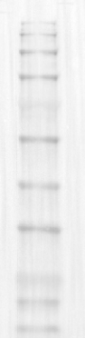
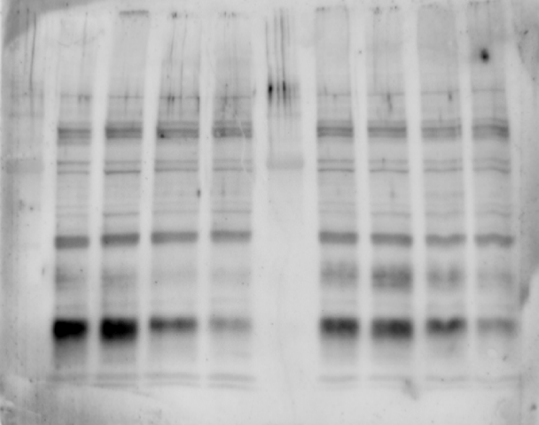
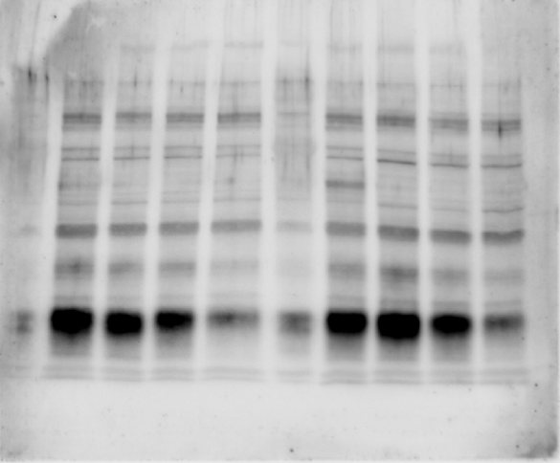
(a) (b)
70 kDa
55 kDa
40 kDa
8 kDa
Pristine™ Pre-Stained Protein Ladder
20 kDa
28 kDa
20 kDa
13 kDa
20 kDa

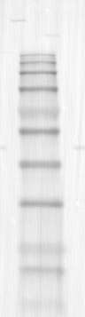
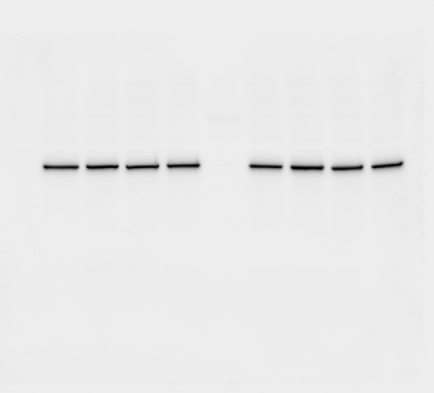
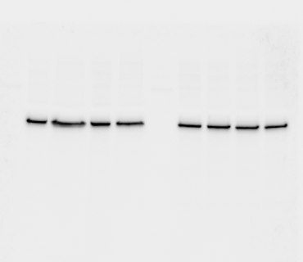
(c) (d)
70 kDa
28 kDa
40 kDa
55 kDa
20 kDa
39 kDa
39 kDa
Pristine™ Pre-Stained Protein Ladder

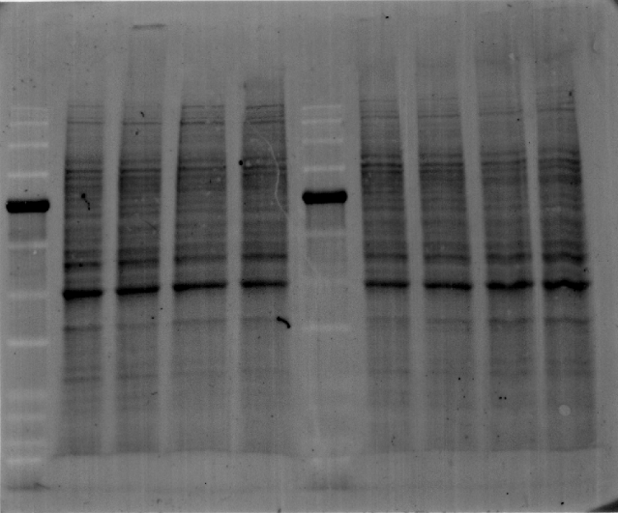
(e) (f)
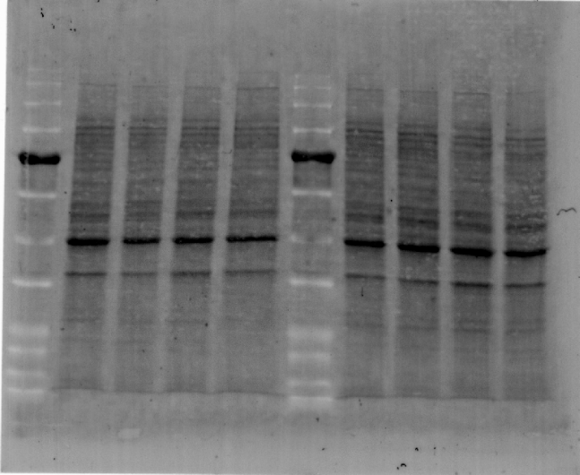

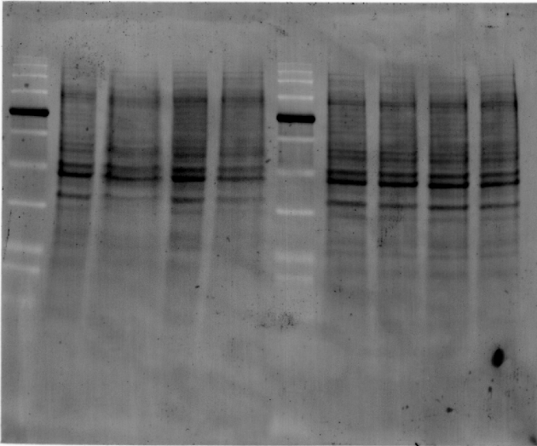
(g) (h)
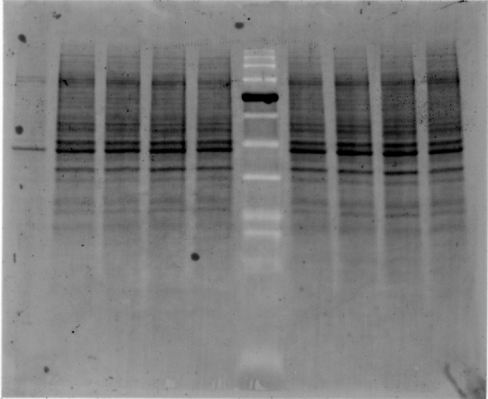

Figure S3. Representation of composite Western blot images and stain-free gel images. Uncropped Western blot images representing figures displayed in the manuscript. (a) hCG (n1-n2); (b) hCG (n3-n4); (c) CB1R (n1-n2); (d) CB1R (n3-n4) Total protein visualized using Stain-Free gels used for the Western blot normalization in panels (e) hCG (n1-n2); (f) hCG (n3-n4) (g) CB1R (n1-n2), (h) CB1R (n3-n4).

