Supplemental Materials: Bilinear magnetoresistance in HgTe topological insulator: opposite signs at opposite surfaces demonstrated by gate control
Yu Fu,^{1,*} Jing Li,^{3,4,*} Jules Papin,^{2,3,*} Paul Noël,¹ Maxen Cosset-Chéneau,¹ Cécile Grèzes,¹ Thomas Guillet,¹ Candice Thomas,³ Yann-Michel Niquet,⁴ Philippe Ballet,³ Tristan Meunier,² Jean-Philippe Attané,^{1,ⴕ} Albert Fert⁵ and Laurent Vila^{1,‡}
1 Univ. Grenoble Alpes, CEA, CNRS, SPINTEC, F-38054, Grenoble, France
2 Univ. Grenoble Alpes, CNRS, Institut NEEL, F-38042, Grenoble, France
3 Univ. Grenoble Alpes, CEA, Leti, F-38000, Grenoble, France
4 Univ. Grenoble Alpes, CEA, IRIG-MEM-L_Sim, F-38000, Grenoble, France
5 Unité Mixte de Physique, CNRS, Thales, Université Paris-Saclay, 91767 Palaiseau, France

- Development of two surface models for BMR and calculations:
  - BMR of single surface
The definition of the amplitude of BMR (A. Dyrdal PRL 124, 046802, 2020) is:
$$A_{BMR}=\frac{ΔR}{R_{0}}=-\frac{Δσ}{σ}≈-\frac{Δσ}{σ_{0}}∝\frac{IB}{{\left|E_{f}\right|}^{3}},$$
where $R_{0}$ and $σ_{0}$ are conductance and resistance at zero magnetic field. The above formula is for a single surface, the amplitude of BMR is proportional to${1/\left|E_{f}\right|}^{3}$, where $E_{f}$ is Fermi-level measured respect to the Dirac point of the surface bands.

  - BMR with two surfaces
Two surfaces are in parallel, their total conductance is the sum of their individual conductance:
$$σ=σ_{t}+σ_{b}$$
Therefore, the amplitude of BMR for two surfaces is:
$$A_{BMR}=-\frac{Δσ}{σ}=-\frac{Δσ_{t}+Δσ_{b}}{σ_{t}+σ_{b}}∝\frac{σ_{t}}{σ_{t}+σ_{b}}\frac{I_{t}B}{{\left|E_{f,t}\right|}^{3}}-\frac{σ_{b}}{σ_{t}+σ_{b}}\frac{I_{b}B}{{\left|E_{f,b}\right|}^{3}},$$
where $I_{t}$ and $I_{b}$ are the current on top and bottom surface, and $E_{f,t}$ and $E_{f,b}$ are the Fermi-level measured respect to the Dirac-cone of the corresponding surface, namely $E_{f,t}=E_{f}-E_{DP,t}$. The total current on surface states is the sum of each surface, $I_{ss}=I_{t}+I_{b}$. We have $I_{t}=\frac{σ_{t}}{σ_{t}+σ_{b}}I_{ss}$ and $I_{b}=\frac{σ_{b}}{σ_{t}+σ_{b}}I_{ss}$, for the current distribution.
$$A_{BMR}∝{\left(\frac{σ_{t}}{σ_{t}+σ_{b}}\right)}^{2}\frac{I_{ss}B}{{\left|E_{f,t}\right|}^{3}}-{\left(\frac{σ_{b}}{σ_{t}+σ_{b}}\right)}^{2}\frac{I_{ss}B}{{\left|E_{f,b}\right|}^{3}}$$
Assuming the conductance $σ$ is proportional to the carrier density, $n\left(E\right)=\frac{E^{2}}{2{πv}^{2}ℏ^{2}}$, which gives the relation ${σ∝E}^{2}$. Hence, the amplitude of BMR for two surfaces is
$$A_{BMR}=\frac{ΔR}{R_{0}}=-\frac{Δσ}{σ}∝\left(\left|E_{f,t}\right|-\left|E_{f,b}\right|\right)\frac{I_{ss}B}{{{(E}_{f,t}^{2}+E_{f,b}^{2})}^{2} }$$
Taking into account that $R_{0}=\frac{1}{σ_{t}+σ_{b}}∝\frac{1}{E_{f,t}^{2}+E_{f,b}^{2}}$, we have the expression for $ΔR$:
$$ΔR∝\left(\left|E_{f,t}\right|-\left|E_{f,b}\right|\right)\frac{I_{ss}B}{E_{f,t}^{2}+E_{f,b}^{2} }$$
In the manuscript, we plotted$α_{BMR}=\frac{ΔR}{B}$, which follows:
$$α_{BMR}∝\left(\left|E_{f,t}\right|-\left|E_{f,b}\right|\right)\frac{I_{ss}}{E_{f,t}^{2}+E_{f,b}^{2} }$$
  - Extraction of the Fermi level
We could extract the Fermi level from the two points where the BMR is crossing zero. First point at $V_{g}^{*}=1.0V$ , the BMR is zero which implies$E_{f,t}=E_{f,b}$. The electron carrier density on the two surfaces is about $n_{2D}≈5.1×{10}^{10}cm^{-2}$. Taking the group velocity$v=5×{10}^{5}m⋅s^{-1}$, and solve that $n_{2D}=\frac{E^{2}}{2{πv}^{2}ℏ^{2}}$, we have $E_{f,t}=E_{f,b}=18.6 meV$ at $V_{g}^{*}=1.0 V$.
At $V_{g}^{*}=-1.05 V$, BMR is about zero because ${-E}_{f,t}=E_{f,b}$. Holes are on the top surface and electrons on the bottom surface. The electron and hole carrier densities are equal, $n_{e}=n_{h}=\frac{E_{f }^{2}}{{4πv}^{2}ℏ^{2}}≈2.5×{10}^{10}cm^{-2}$. So we have $E_{f,t}=-18.45 meV$ and $E_{f,b}=18.45 meV$ at $V_{g}^{*}=-1.05 V$.
We may assume, the fermi levels, $E_{f,t}$ and $E_{f,b}$ vary linearly with $V_{g}^{*}$. So we could the plot $α_{BMR}$ as shown by figure 3.e in the main text,
$$α_{BMR}∝\left(\left|E_{f,t}\right|-\left|E_{f,b}\right|\right)\frac{I_{ss}}{E_{f,t}^{2}+E_{f,b}^{2} },$$
with $I_{ss}$ extracted from experiment, $I_{ss}=\frac{σ_{t}+σ_{b}}{σ_{t}+σ_{b}+σ_{bulk}}I$ , as shown in figure 3.d in the main text.

- Exclusion of Nernst effect
In order to rule out the possibility of magnetothermal effect under electrical current injection due to a vertical thermal gradient along z, angular scans have been perform as seen in fig S1. The magnetothermal effect with similar symmetries to the one of the UMR/USMR/BMR is the Nernst effect [14,15]. The Nernst effect can be seen in the xy angular dependence as the Nernst effect should appear in the Hall channel with a 90° angle shift difference from the longitudinal case and with an amplitude proportional to the difference of aspect ratio of the Rxx and Rxy resistances. Here the length and the width are 10 µm and 3 µm respectively. As can be seen in Fig S1 there is no noticeable effect in the Rxy signals while the change of aspect ratio is of the order of 3. So we can safely exclude thermal effect as the dominant source of our observed BMR. Moreover, the gate dependence with multiple sign change is also unlikely coming from thermal effects.
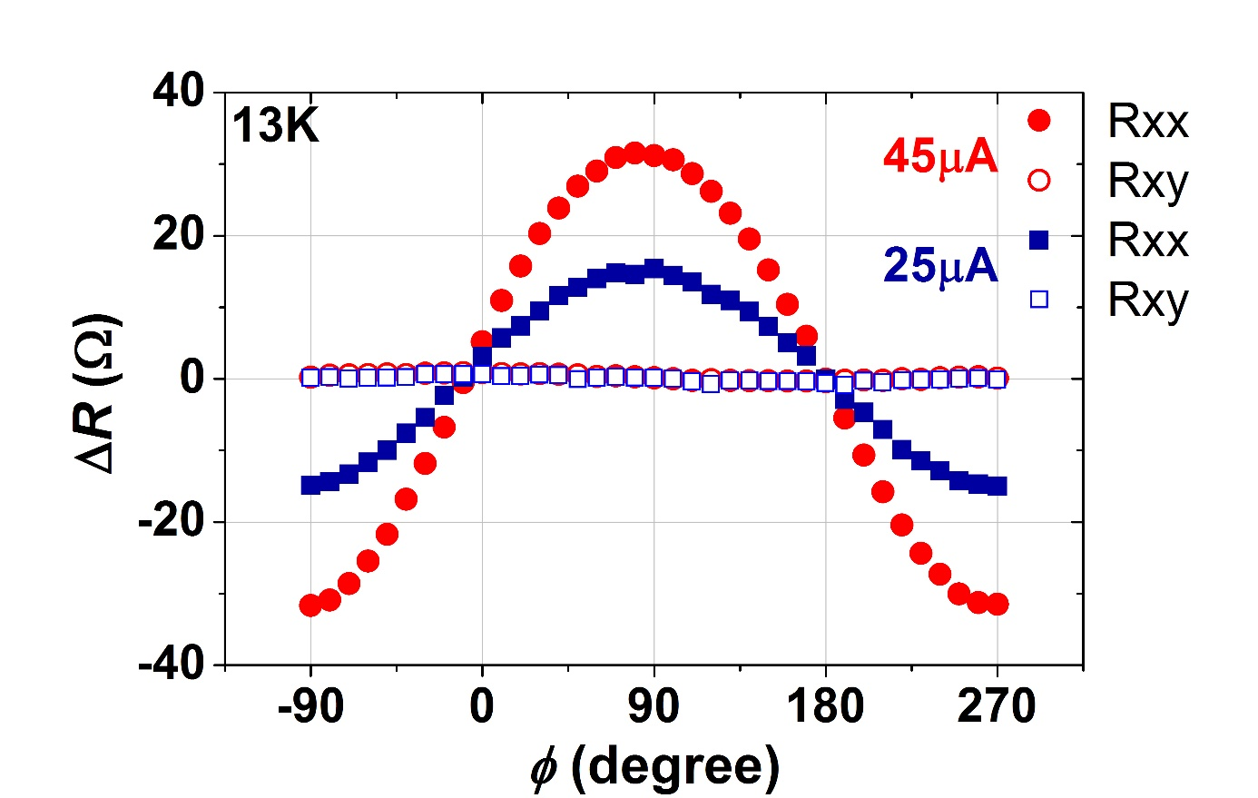Figure S1 : Azimuthal angular dependence of the resistance of the slab (R_{xx}) and of the Hall resistance (R_{xy}) measured within the xy plan, at 25 and 45 µA. φ stands for the magnetic field applied along x.

