Supplemental Figures

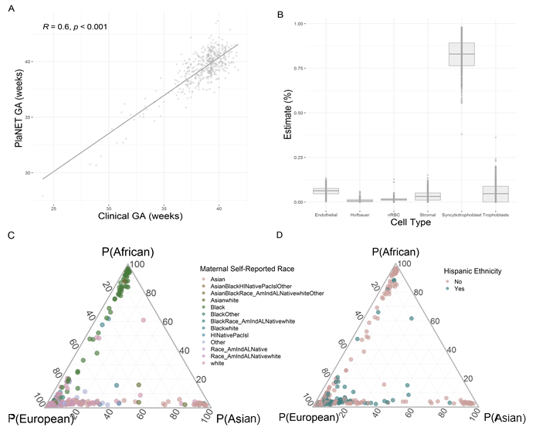
Fig. S1. Relationships between PlaNET‑estimated gestational age, clinical gestational age, cell type, and self‑reported ethnicity. (A) PlaNET‑estimated gestational age (GA) using the refined‑robust placental clock (RRPC), compared to clinical gestational age. (B) The mean estimated proportion (%) of each PlaNET predicted cell type for the whole cohort. (C) Ternary plot of PlaNET ancestry probabilities (P(European), P(Asian) and P(African)), colored by self‑reported maternal race (American Indian or Alaskan Native, Asian, Black, Hawaiian Native or Pacific Islander, white, Other Race, or combinations of the afore mentioned). (D) Ternary plot of PlaNET ancestry probabilities (P(European), P(Asian) and P(African)), colored by maternal self-reported Hispanic ethnicity. The axis labels give 0 to 100 percent probabilities for samples belonging to each of the three PlaNET predicted ancestry groups.

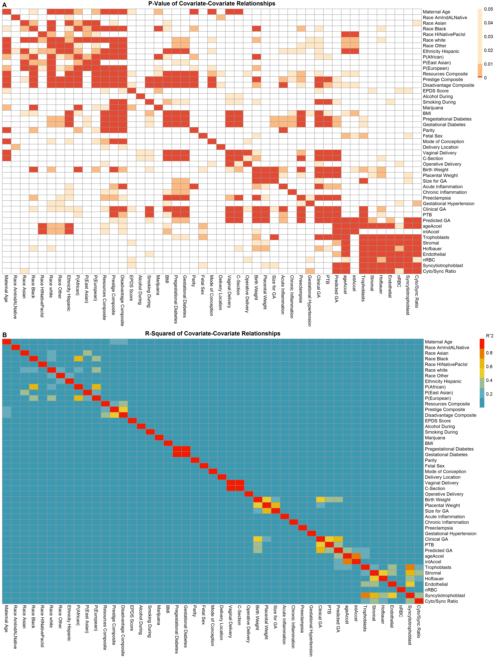
Fig. S2. Heatmap of the strength of association between pairs of covariates. (A) P values of linear models run on Covariate~Covariate demographic variables. (B) R2 values of linear models run on Covariate~Covariate demographic variables. “Trophoblasts” refers to predicted levels of cytotrophoblast, “P(African/Asian/European)” refers to the continuous calculated PlaNET ancestry probabilities, “nRBC” refers to predicted levels of nucleated red blood cells, “PTB” refers to preterm birth (<37 weeks gestational age at birth), and ageAccel and intAccel refer to extrinsic and intrinsic epigenetic age acceleration scores respectively.

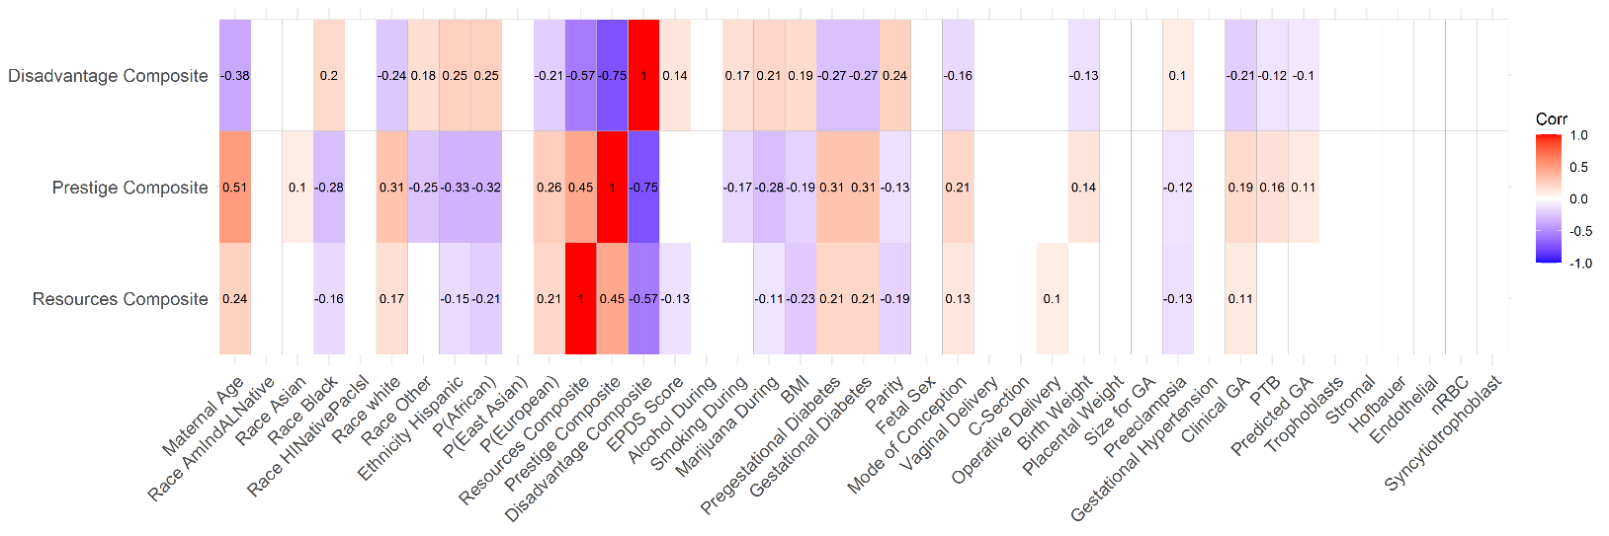
Fig. S3. Heatmap of the correlation of the SES variables with other variables of interest in the SPAH cohort. The rounded Pearson correlation value is displayed on the graph for significant (p value<0.05) relationships only, non-significant relationships are indicated by blank white tiles. “Trophoblasts” refers to predicted levels of cytotrophoblast, “P(African/Asian/European)” refers to the continuous calculated PlaNET ancestry probabilities, “nRBC” refers to predicted levels of nucleated red blood cells, “PTB” refers to preterm birth (<37 weeks gestational age at birth),, and ageAccel and intAccel refer to extrinsic and intrinsic epigenetic age acceleration scores respectively.

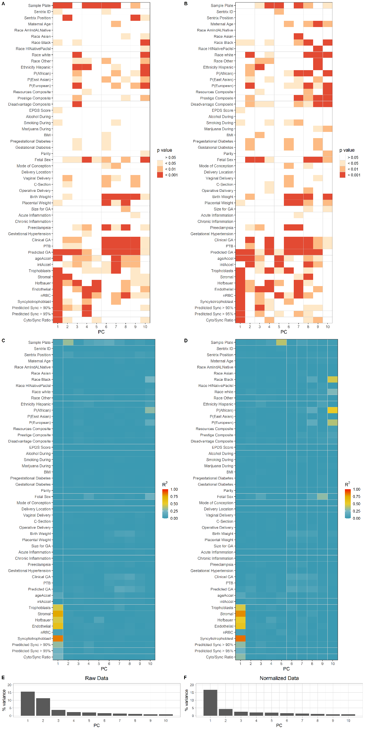
Fig. S4. Principal Component Analysis of DNAme variation before and after normalization. (A-D) Heat maps show the p-value and R² values of association from linear models run independently for each metadata variable (i.e., PC ~Variable) for the raw (A,C), and dasen + noob normalized (B,D) data. (E-F) Scree plots show the proportion of variance explained by each principal component (PC) on raw (E) and dasen + noob normalized (F) data. “Trophoblasts” refers to predicted levels of cytotrophoblast, “P(African/Asian/European)” refers to the continuous calculated PlaNET ancestry probabilities, “nRBC” refers to predicted levels of nucleated red blood cells, “PTB” refers to preterm birth (<37 weeks gestational age at birth), and ageAccel and intAccel refer to extrinsic and intrinsic epigenetic age acceleration scores respectively.

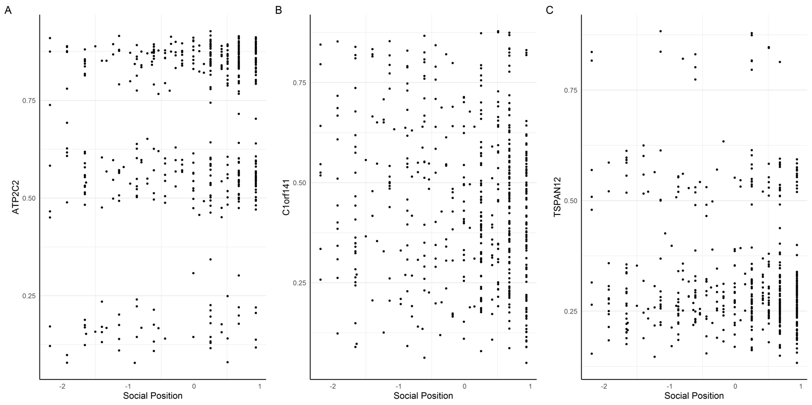
Fig. S5. Methylation values for the the (A,B) 2 CpGs that passed differential methylation threshold (FDR < 0.05, |∆β| > 0.05) with the Social Position SES whole cohort mode and the (C) 1 CpG with the sex stratified autosome model. The β methylation value is depicted on the y axis (labelled by the gene associated with the CpG) and Social Position score is shown on the x axis.

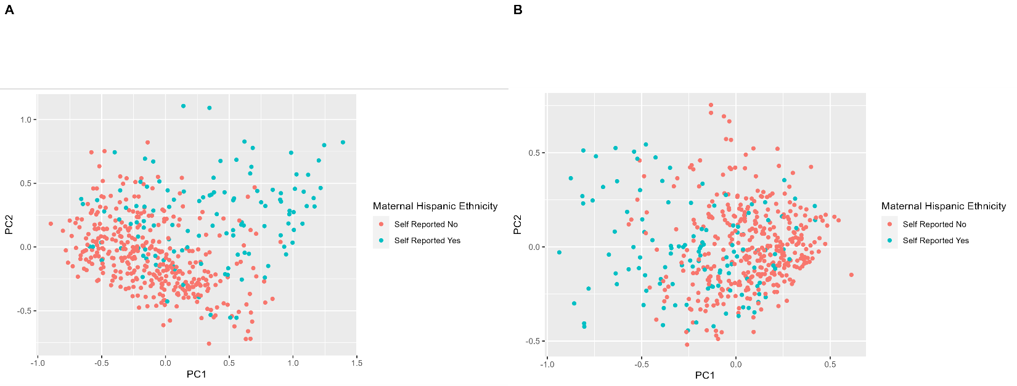
Fig. S6. Scatter plots of the first two Principal Components for 77 hits with Social Position (A) and 22 hits with Disadvantage (B) composite scores from the linear model of DNAme ~ SES + Ancestry + Gestational Age (Model D) coloured by maternal self-reported Hispanic ethnicity.

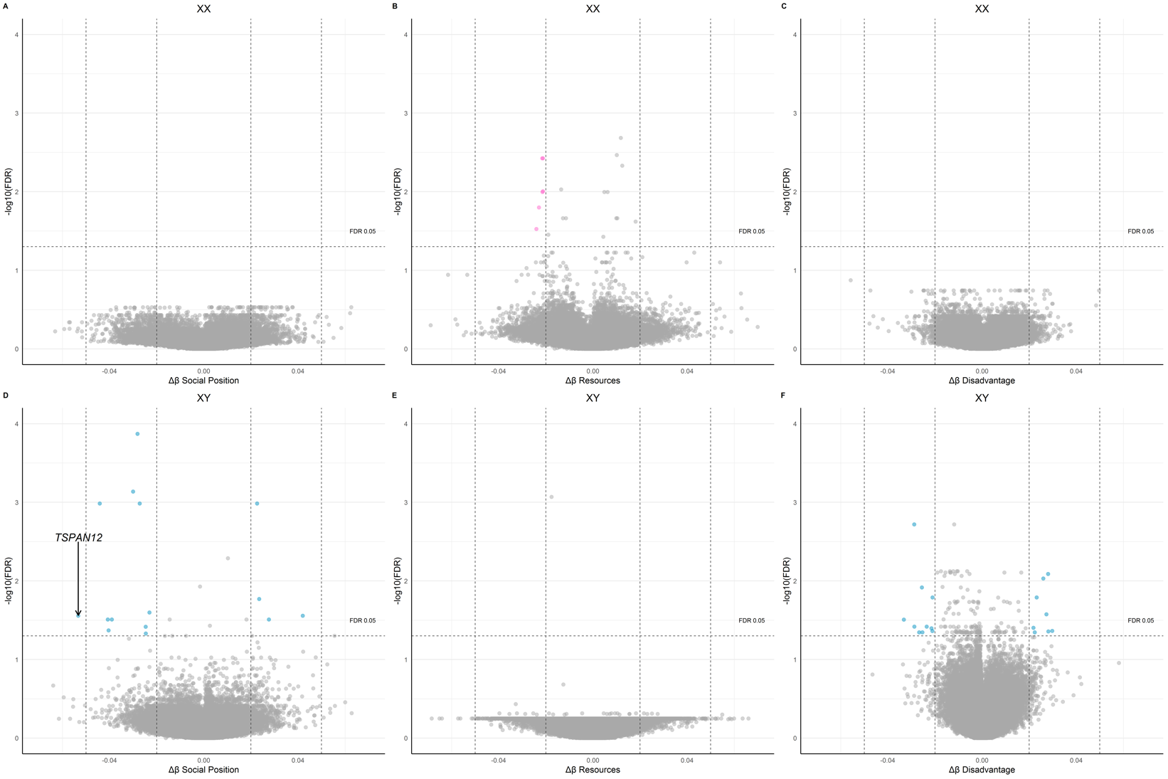
Fig. S7. Volcano plots for differential autosomal DNAme in association with SES exposure in linear models corrected for gestational age and PlaNET estimated ancestry (Model B) in sex stratified analyses. False discovery rate (FDR) is depicted along the Y axis. More significant (lower FDR) values are shown at the top of the plot. Vertical dashed lines outlines |Δβ| = 0.02 (inner) and 0.05 (outer), and horizontal dashed line indicates FDR = 0.05. Gene names label the CpGs that pass FDR < 0.05, |∆β| > 0.05 cutoff. (A-C) Volcano plots for Model B run with Social Position (A), Resources (B), and Disadvantage (C) composite score as the SES exposure variable in XX samples only. (D-F) Volcano plots for Model B run with Social Position (D), Resources (E), and Disadvantage (F) composite score as the SES exposure variable in XY samples only.

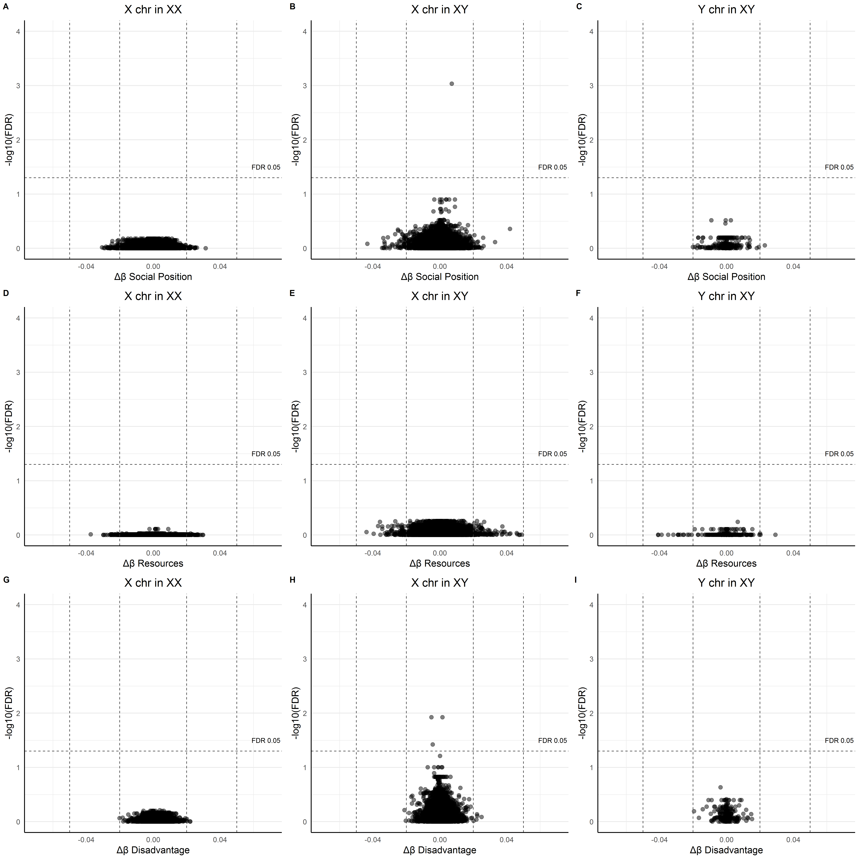
Fig. S8. Volcano plots for differential sex chromosome DNAme in association with SES exposure in linear models corrected for gestational age and PlaNET estimated ancestry (Model B) in sex stratified (X chromosome in XX samples, X chromosome in XY samples, Y chromosome in XY samples) analyses. False discovery rate (FDR) is depicted along the Y axis. More significant (lower FDR) values are shown at the top of the plot. Vertical dashed lines outlines |Δβ| = 0.02 (inner) and 0.05 (outer), and horizontal dashed line indicates FDR = 0.05. Gene names label the CpGs that pass FDR < 0.05, |∆β| > 0.05. (A-C) Volcano plots for Model B run with Social Position composite score as the SES exposure variable on the X chromosome of XX samples (A), the X chromosome of Y samples (B), and the Y chromosome of XY (C) respectively. (D-F) Volcano plots for Model B run with Resources composite score as the SES exposure variable on the X chromosome of XX samples (D), the X chromosome of Y samples (E), and the Y chromosome of XY (F) respectively. (G-I) Volcano plots for Model B run with Disadvantage composite score as the SES exposure variable on the X chromosome of XX samples (G), the X chromosome of Y samples (H), and the Y chromosome of XY (I) respectively.

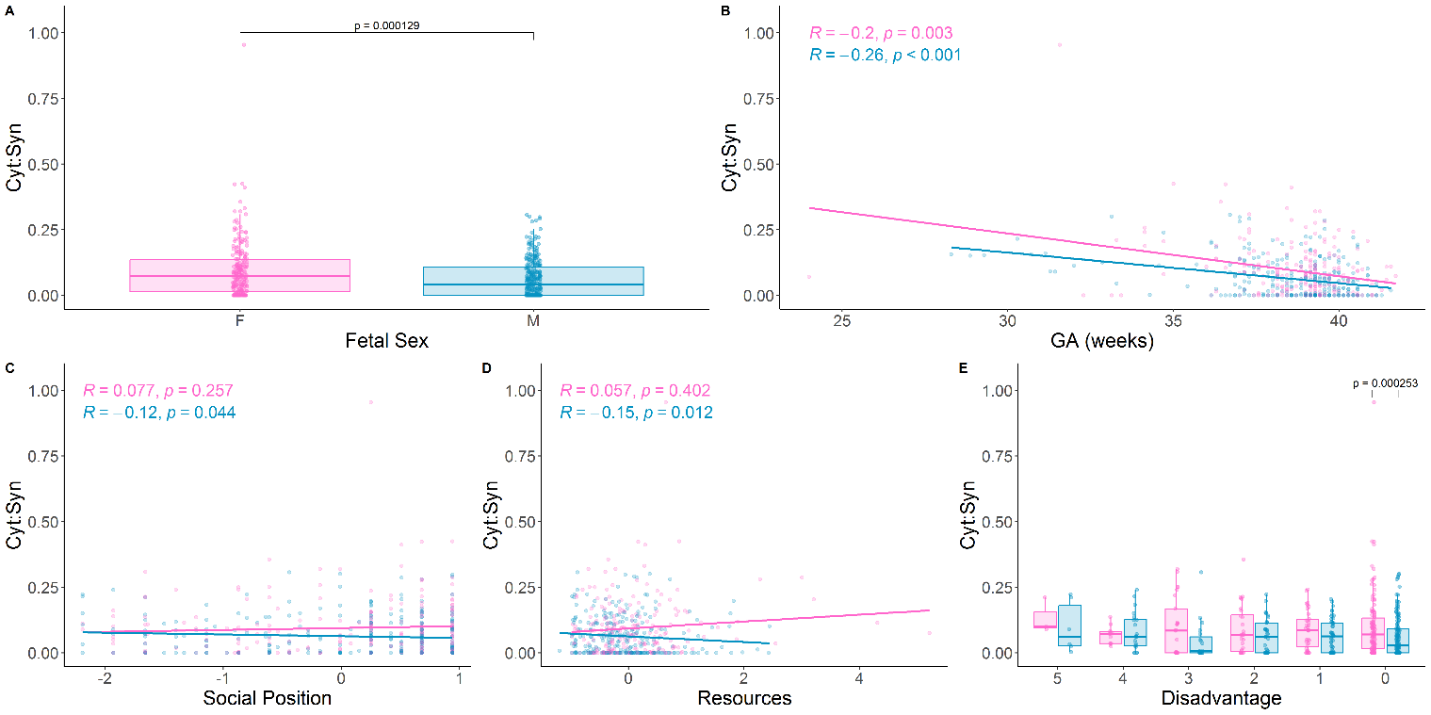
Fig. S9. Association of predicted cytotrophoblast to syncytiotrophoblast (cyt:syn) ratio with (A) fetal sex, (B) gestational age at delivery, (C) Social Position Score, (D) Resources Score, and (E) Disadvantage Score. For all plots, points are coloured by fetal sex (pink = XX , blue = XY). Spearman’s correlation and significance values (B-D) and statistically significant comparisons (Wilcoxon Rank Sum Test p<0.05) (A, E) are indicated if present.

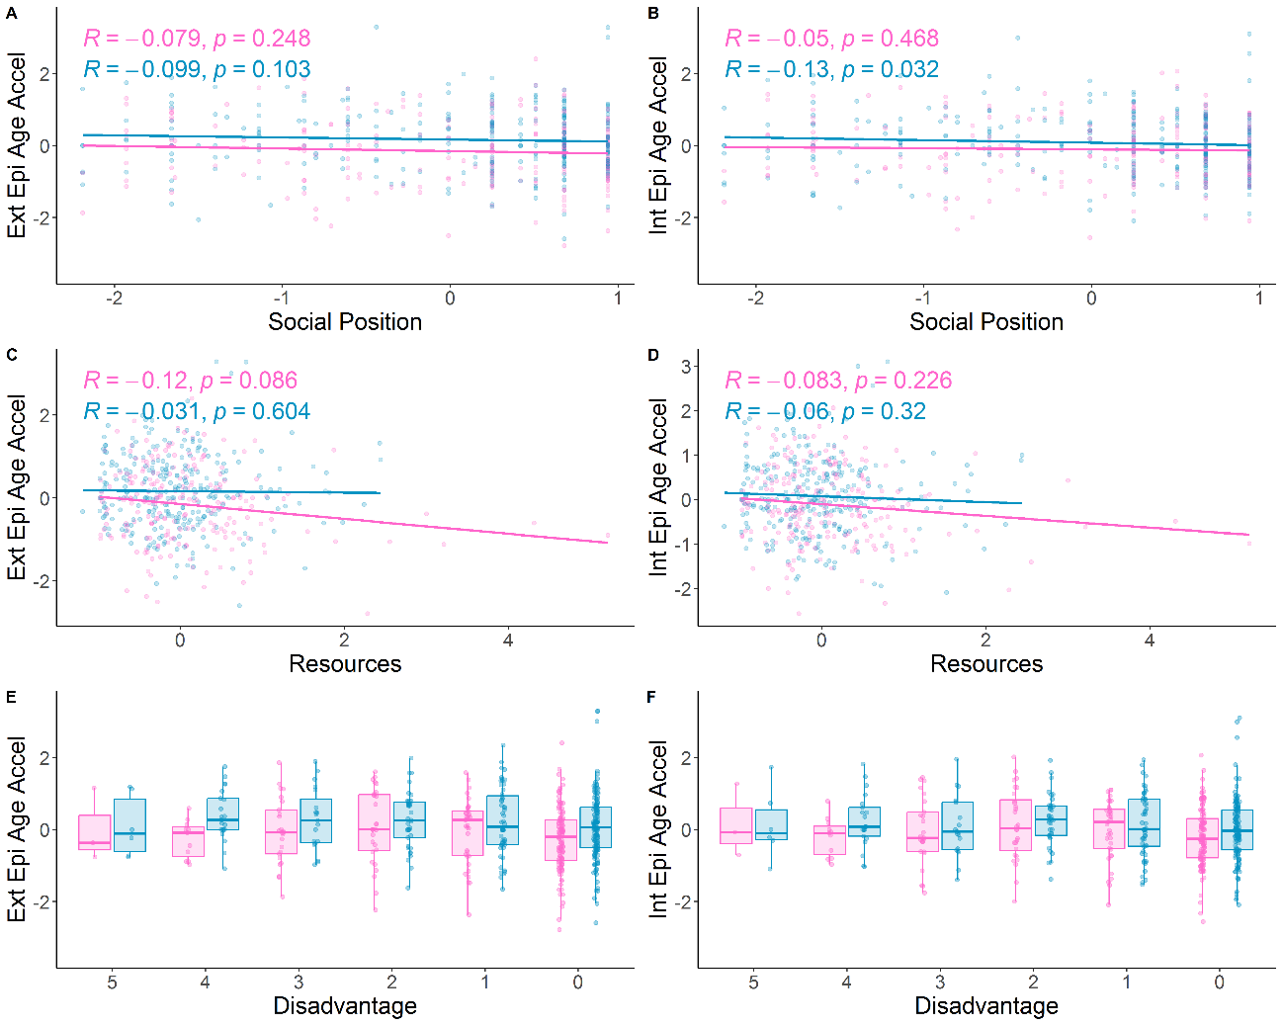
Fig. S10. Relationships between PlaNET-estimated extrinsic (A,C,E) and intrinsic (B,D,F) epigenetic age acceleration and Social Position (A,B), Resources (C,D), and Disadvantage (E,F) composite scores with fetal sex. For all plots, points are coloured by fetal sex (pink = XX , blue = XY). Spearman’s correlation and significance values (A-D) and Wilcoxon Rank Sum Test (p<0.05) significance values if present (E-F) are shown above respective plots.

