Appendix
For reference GT Drive layouts for Series and Parallel hybrid are shown below.
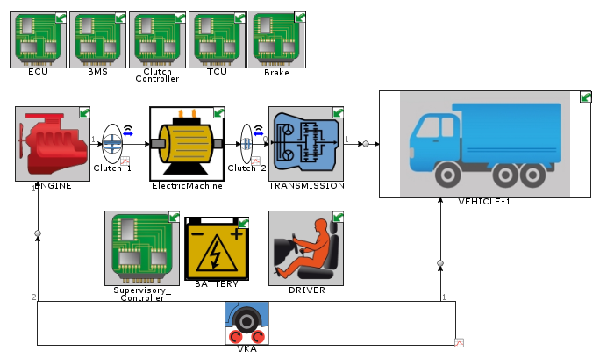
Figure 15: GT-Drive model for the Parallel hybrid layout
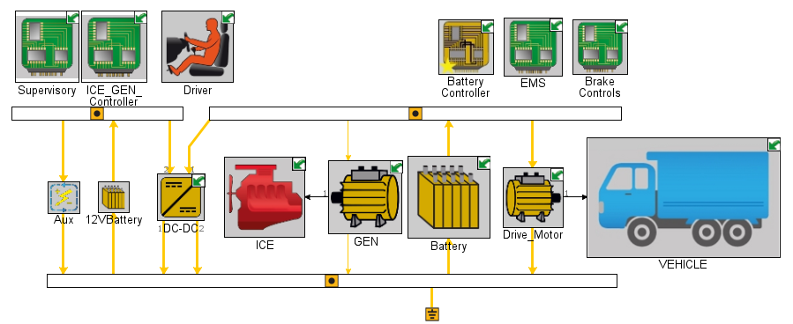
Figure 16: GT-Drive model for the Series hybrid layout
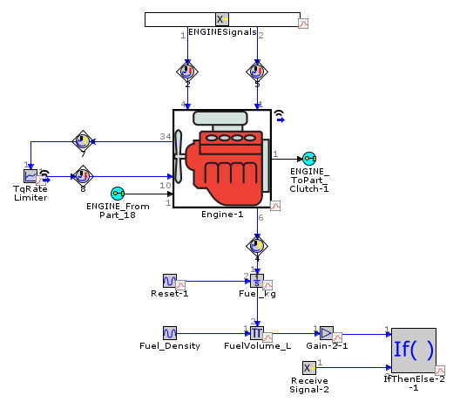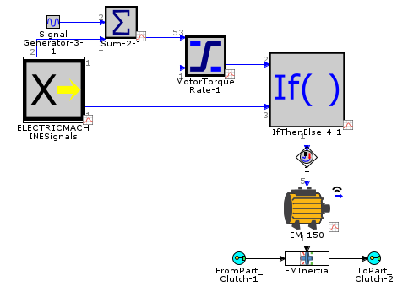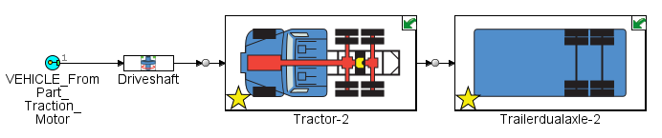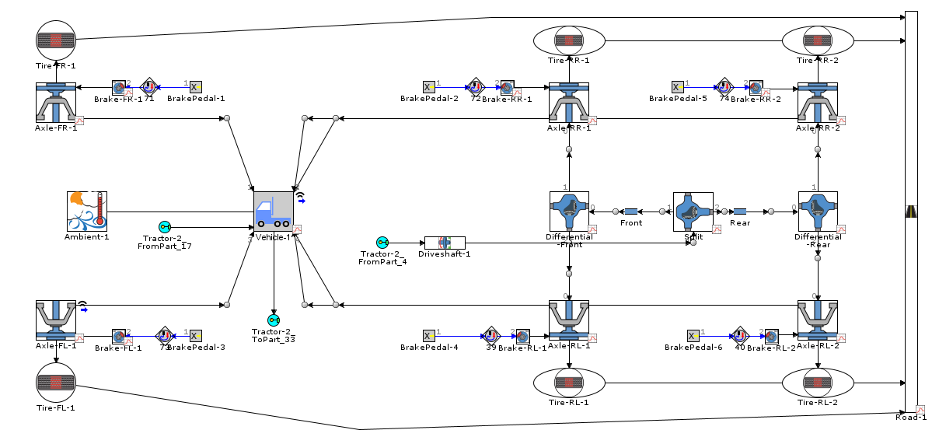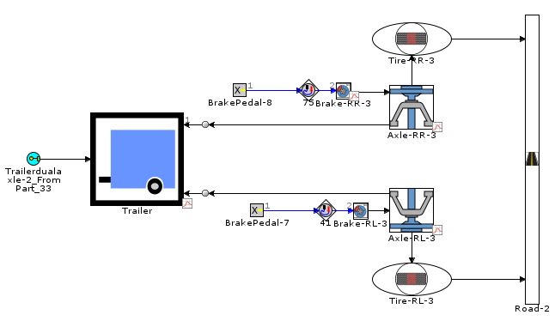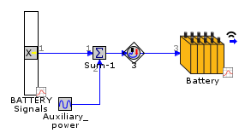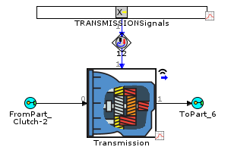
(a)
(b)
(c)
(c1)
(c2)
(d)
(e)
Figure 17: Aggregate and sub-modal details. (a) Engine (b) Electric motor (c) Vehicle;(c1) Tractor (c2) Trailer (d) Battery (e) Transmission

