EZ-AR: An accessible AR application for multi-model visualization and real-time tracking in healthcare settings

Supplementary Document -
Alicia Pose-Díez-de-la-Lastra^{1,2,}*, Gemma Arce-Alonso^{1,2}, José-Antonio Calvo-Haro^{2,3,4}, Rubén Pérez-Mañanes^{2,3,4}, Javier Pascau^{1,2}
¹ Departamento de Bioingeniería, Universidad Carlos III de Madrid, 28911 Leganés, Spain.
² Instituto de Investigación Sanitaria Gregorio Marañón, 28007 Madrid, Spain.
³ Servicio de Cirugía Ortopédica y Traumatología, Hospital General Universitario Gregorio Marañón, 28007 Madrid, Spain
⁴ Departamento de Cirugía, Facultad de Medicina, Universidad Complutense de Madrid, 28040 Madrid, Spain
* Corresponding author: apose@ing.uc3m.es

Introduction
This document supplements the article EZ-AR: An Accessible AR Application for Multi-Model Visualization and Real-Time Tracking in Healthcare Settings, which presents a novel framework designed to bring augmented reality closer to non-expert users by enabling them to deploy their own virtual 3D models in Microsoft HoloLens 2 without the need for programming. It is designed for users without prior experience in AR development, aiming to support the creation of customized AR applications through an intuitive, code-free workflow. Practical recommendations are also provided regarding model optimization, file size limitations, and Google Drive accessibility requirements.
The following sections provide detailed guidance on the use of the EZ-AR setup module, developed for 3D Slicer, as well as the AR application designed for Microsoft HoloLens 2 (EZ-AR).

EZ-AR setup: The 3D Slicer module
This section describes each of the four main components of the 3D Slicer module: Initialization, Positioning, Save Models, and Customize Model Info; and explains how to properly prepare the necessary files for successful deployment and visualization of the 3D virtual models within the Microsoft HoloLens 2 environment.

Initialization
This block is divided into two subsections: AR Marker and 3D Models. Figure 1 shows an screenshot of this section in 3D Slicer.
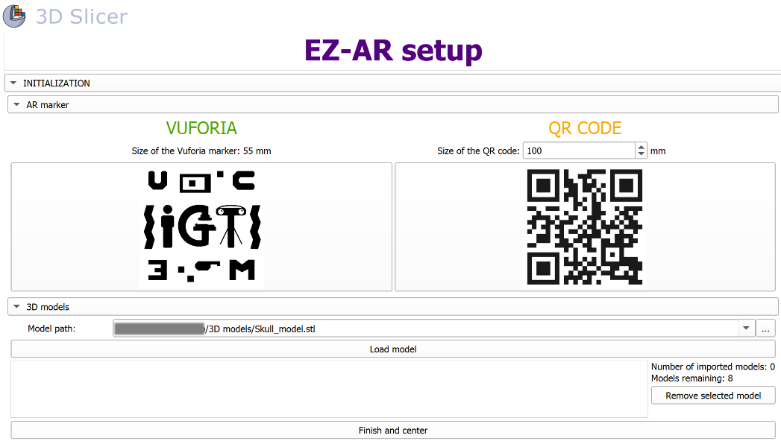
Figure 1. “Initialization” section of EZ-AR setup module in 3D Slicer.
- AR marker: One of the main objectives of this study is to propose and compare two alternative tracking methods for Microsoft HoloLens 2. In this subsection, users are asked to choose which tracking method they prefer to use: Vuforia or QR tracking. The application supports both options, and the decision is entirely up to the user, based on personal preferences or available resources. To assist in selecting the most suitable option, the main manuscript includes a series of experiments designed to evaluate and compare the AR projection accuracy achieved with each tracking method.
- 3D models: Once the reference marker has been defined, the next step allows users to select the virtual models to be visualized in the AR application from the local storage of their PC. The system supports the import of up to eight models. To optimize performance on the headset, it is recommended to decimate the models as much as possible (without compromising surface resolution). A maximum file size of 10 MB per model is recommended.

Positioning
After selecting the models of interest, this section provides a set of sliders that allow users to translate and rotate all models along the three main axes with respect to the AR reference marker, treating them as a single group (Figure 2). An additional slider is also provided to scale all models uniformly, offering maximum flexibility in adjusting their appearance relative to the selected AR reference marker.
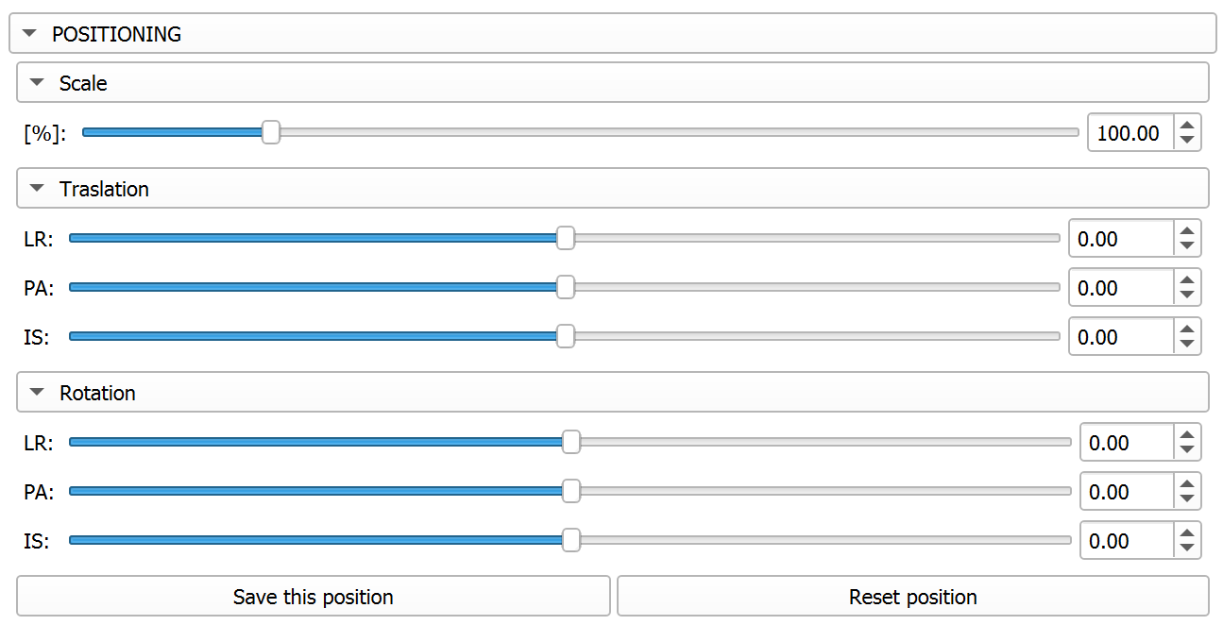
Figure 2. “Positioning” section of EZ-AR setup module in 3D Slicer.

Save models
This section (Figure 3) allows the user to define a local directory on their computer where the current 3D Slicer scene can be saved in .mrb format for future reference. It also stores the transformation applied to the models during the Positioning step as a file named fromModelToMarkerTransform.h5. Finally, all models are hardened and exported in .obj format—compatible with Microsoft HoloLens 2—using the suffix _registered. Following the module’s instructions, users must upload all these files to a Google Drive folder and set the sharing permission to “Anyone with the link” to make them accessible from the AR headset.
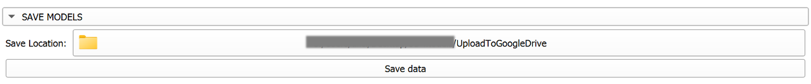
Figure 3. “Save models” section of EZ-AR setup module in 3D Slicer.

Customize models info
In this section, the user is required to provide a sharing link from Google Drive for each of the 3D virtual models saved in the previous step, as well as the desired display name and color for each model in the AR application (Figure 4). Based on this information, the module automatically generates a configuration file in JSON format that summarizes all user-defined settings, including the selected tracking method, direct download links to each 3D model, their display names, and the hexadecimal color codes to be used for visualization in the headset. This configuration file must also be uploaded to a Google Drive folder and its sharing settings set to “Anyone with the link” to ensure accessibility from the AR headset. An example of the configuration file is presented in Figure 5.
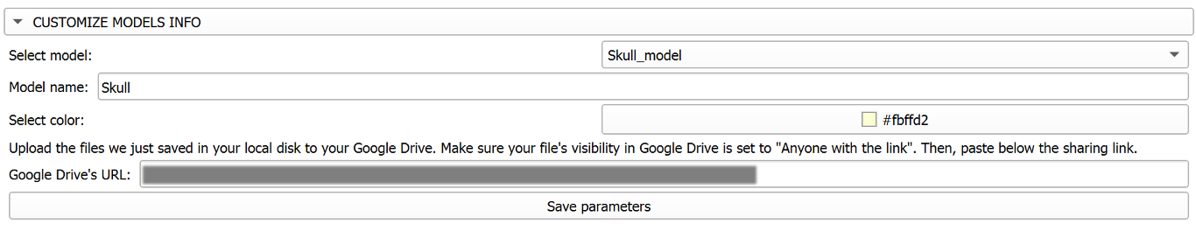
Figure 4. “Customize models info” section of EZ-AR setup module in 3D Slicer.

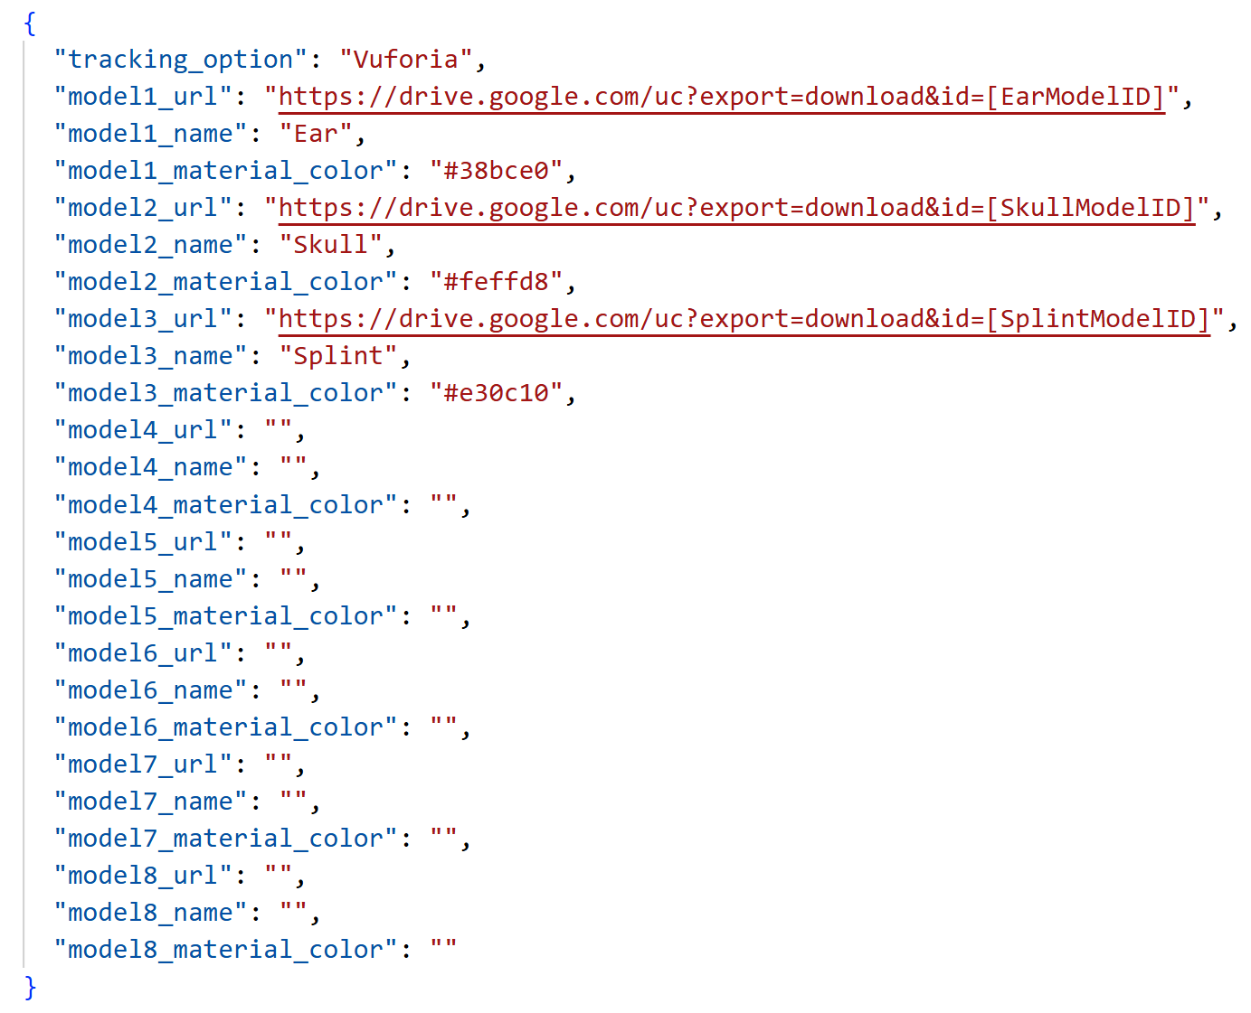
Figure 5. Example of configuration file ("config_file.json") generated by the 3D Slicer module with all necessary information for 3D virtual model download and display in Microsoft HoloLens 2.

EZ-AR: The AR application for Microsoft HoloLens 2
Upon launch, the application initiates a sequential validation process to ensure that all required components are correctly configured. The first step is to verify access to the configuration file generated in 3D Slicer. If the file cannot be located, a warning message prompts the user to paste the sharing link from Google Drive into the file named Configuration file url.txt. To do that, users must open the Windows Device Portal for Microsoft HoloLens 2 from a computer connected to the same Wi-Fi network. After logging in with the headset’s credentials, users should navigate to: System > File Explorer > Local App Data > EZ-AR > LocalState > Configuration file url.txt. Once the link is detected, the application verifies that it is correctly formatted and publicly accessible before initiating the download. If valid, the configuration file is retrieved and parsed to determine which tracking system should be used. The corresponding initialization routine is then executed based on the selected method. If Vuforia is chosen, an additional warning panel prompts the user to enter a valid Vuforia license key.

User interface
After initialization, a generic user interface is displayed half a meter in front of the user (Figure 6A). This interface can be repositioned within the environment. The UI includes eight toggle buttons, each corresponding to a distinct virtual 3D model.
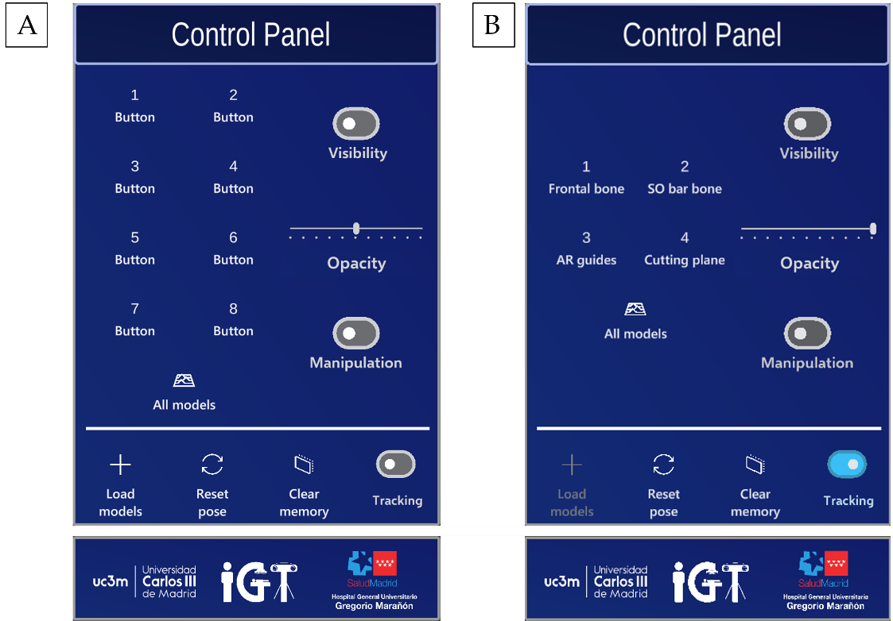
Figure 6. User interface of the EZ-AR application in Microsoft HoloLens 2. (A) Unconfigured control panel displayed before any 3D virtual models are loaded. (B) Control panel adjusted after loading four personalized 3D virtual models.
The Load Models button must always be pressed first, initializing the application according to the user-defined parameters. When clicked, it downloads the virtual 3D models from Google Drive using the direct download URLs provided in the configuration file. The downloaded models are stored in the headset's local storage, eliminating the need for an internet connection in future sessions. This means that connectivity is only required during the initial setup. Once the downloading process is complete, tracking of the desired AR reference marker begins. The 3D virtual models are automatically instantiated in their corresponding positions in the real space with their assigned colors. The model names specified in the configuration file are mapped, in order, to the corresponding toggle buttons. If fewer than eight models are defined, the unused buttons are removed, and the layout of the interface is adjusted to fill the designated space evenly (Figure 6B).
On the right side of the control panel, a set of interactive elements allows users to apply visualization adjustments to individual models by selecting the corresponding toggle button beforehand. The All Models button can be used to apply any of these settings to all models simultaneously. The options are:
- The Visibility toggle button lets users show or hide a selected model.
- The Opacity slider controls the transparency of the models.
- The Manipulation toggle switch converts the virtual 3D models into fully interactive objects that can be grabbed, translated, rotated, and scaled using hand gestures. When this option is turned off, the models remain anchored and move only with respect to the AR reference marker.
The Manipulation functionality may be particularly useful in surgical contexts. For example, to temporarily enlarge anatomical structures that are difficult to interpret. Models can be restored to their original pose relative to the AR reference marker at any time by pressing the Reset Pose button. The application also allows users to toggle the tracking capability of the headset, enabling or disabling the detection of the AR reference marker as needed. Finally, the Clear Memory button erases all downloaded content from the device’s local storage. This feature is intended to facilitate the loading of a new configuration file, for instance, when switching to data from a different patient.

