Soil microbiome dynamics of Cannabis sativa L. under biotic stress induced by Tetranychus urticae.
Pinto Alman L.¹*, De Urraza P. ³, Coppotelli B.², Colman D.², Bernardo V.⁴, Ruscitti M.⁴, Vaccarini C.¹, Bugvila C.¹, Sedán D.¹, Andrinolo D.¹

¹ Environmental Research Center (CIM), CONICET – National University of La Plata (UNLP), Buenos Aires, Argentina
² Research and Development Center for Industrial Fermentations (CINDEFI), CONICET, Buenos Aires, Argentina
³ General Microbiology, Department of Biological Sciences, Faculty of Exact Sciences, National University of La Plata (UNLP), Buenos Aires, Argentina
⁴ Plant Physiology Institute (INFIVE), CONICET – National University of La Plata (UNLP), Buenos Aires, Argentina
*Corresponding author: lucaspintoalman@gmail.com

Supplementary Material
Fig. 1 - Shannon index of microenvironments under Control and Stress treatments.
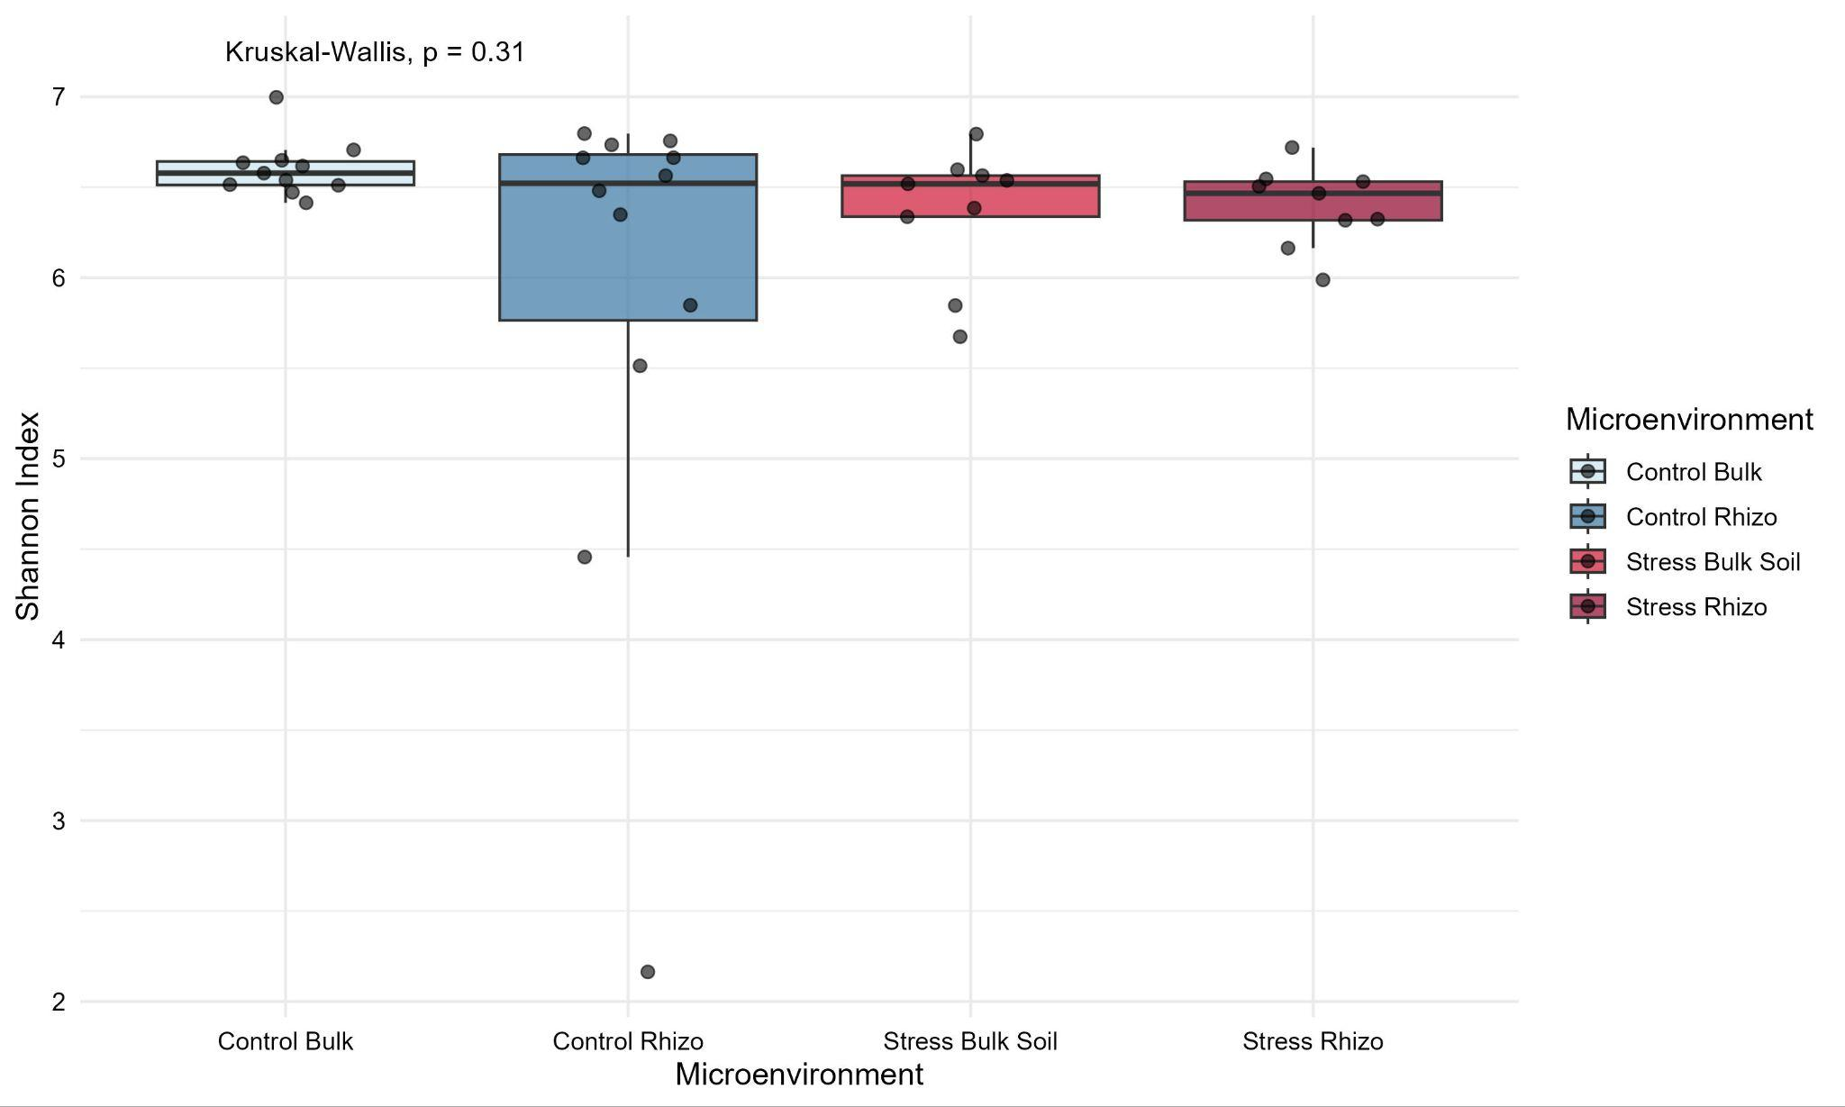

Fig. 2. Shannon index throughout the three life cycle stages
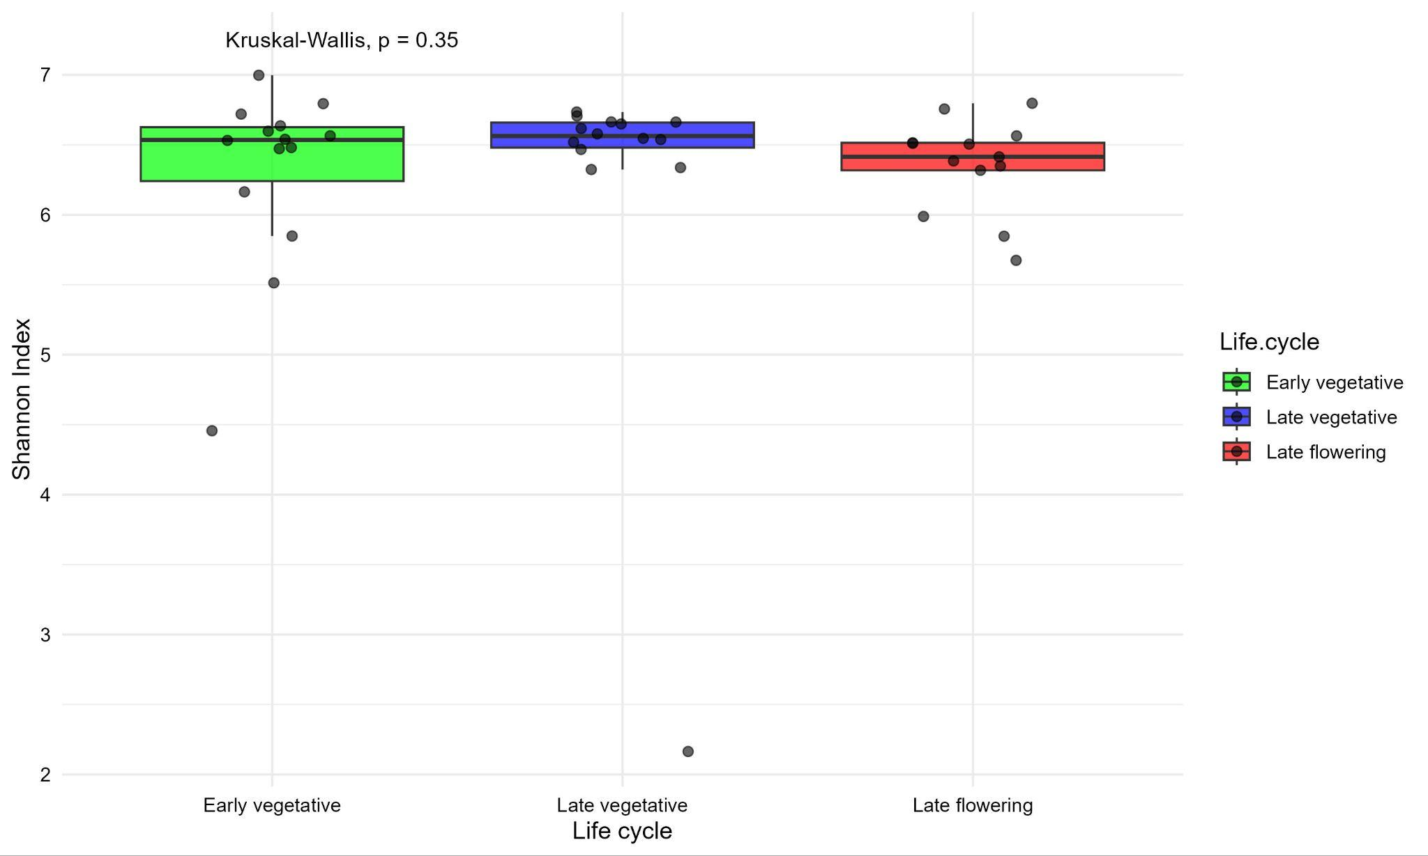

Table 1 – Genus-level LEfSe analysis differentiating control and stress treatments in distinct microenvironments. The top 15 taxa based on LDA score are presented.
Taxa | Enrich_group | ef_lda | pvalue | padj
Pseudomonas | Control Rhizo | 3,934 | 0,0228 | 0,0228
Gemmatimonadaceae_uncultured | Stress Rhizo | 3,915 | 0,0096 | 0,0096
BIrii41 | Control Bulk | 3,839 | 0,0376 | 0,0376
S0134_terrestrial_group | Control Bulk | 3,822 | 0,0167 | 0,0167
Lacunisphaera | Stress Bulk Soil | 3,772 | 0,0437 | 0,0437
Unknown | Control Bulk | 3,658 | 0,0025 | 0,0025
Rhodothermaceae_uncultured | Control Bulk | 3,582 | 0,0074 | 0,0074
MND1 | Control Bulk | 3,549 | 0,0234 | 0,0234
Delftia | Control Rhizo | 3,542 | 0,0084 | 0,0084
TRA3-20 | Control Bulk | 3,406 | 0,0023 | 0,0023
IS-44 | Control Bulk | 3,346 | 0,0240 | 0,0240
Flavobacteriaceae_Unknown | Control Bulk | 3,342 | 0,0407 | 0,0407
Rhizobiaceae_Unknown | Control Rhizo | 3,337 | 0,0229 | 0,0229
BD2-11_terrestrial_group | Control Bulk | 3,331 | 0,0123 | 0,0123
PAUC26f | Control Bulk | 3,327 | 0,0021 | 0,0021

Table 2 – Genus-level LEfSe analysis across developmental stages. The top 15 taxa based on LDA score are presented.
Taxa | Enrich_group | ef_lda | pvalue | padj
Rhodanobacter | early vegetative | 4.559 | 0.0001 | 0.0001
Sandaracinaceae_uncultured | late flowering | 4.237 | 6.5E-05 | 6.5E-05
Vicinamibacterales_uncultured_uncultured | late vegetative | 4.079 | 0.0021 | 0.0021
Iamia | late flowering | 3.956 | 3.3E-06 | 3.3E-06
Microscillaceae_uncultured | late flowering | 3.934 | 0.0086 | 0.0086
Gemmatimonadaceae_uncultured | late flowering | 3.837 | 0.0251 | 0.0251
Hirschia | late flowering | 3.781 | 1.5E-05 | 1.5E-05
Unknown_Unknown_Unknown_Unknown_Unknown | early vegetative | 3.772 | 0.0082 | 0.0082
Steroidobacter | late flowering | 3.656 | 1.7E-05 | 1.7E-05
Vicinamibacteraceae | late vegetative | 3.606 | 0.0163 | 0.0163
Pedosphaeraceae_uncultured | early vegetative | 3.593 | 0.0014 | 0.0014
Lacunisphaera | late flowering | 3.572 | 0.0283 | 0.0283
Granulicella | early vegetative | 3.561 | 0.0009 | 0.0009
Anaerolineaceae_uncultured | late flowering | 3.532 | 0.0021 | 0.0021
Rhodobacteraceae_Unknown | late flowering | 3.494 | 6.4883E-06 | 6.48E-06

Fig. 3 - Lefse analysis at family level evaluating control and stress treatments and microenvironments. The top 15 taxa based on LDA score are presented.
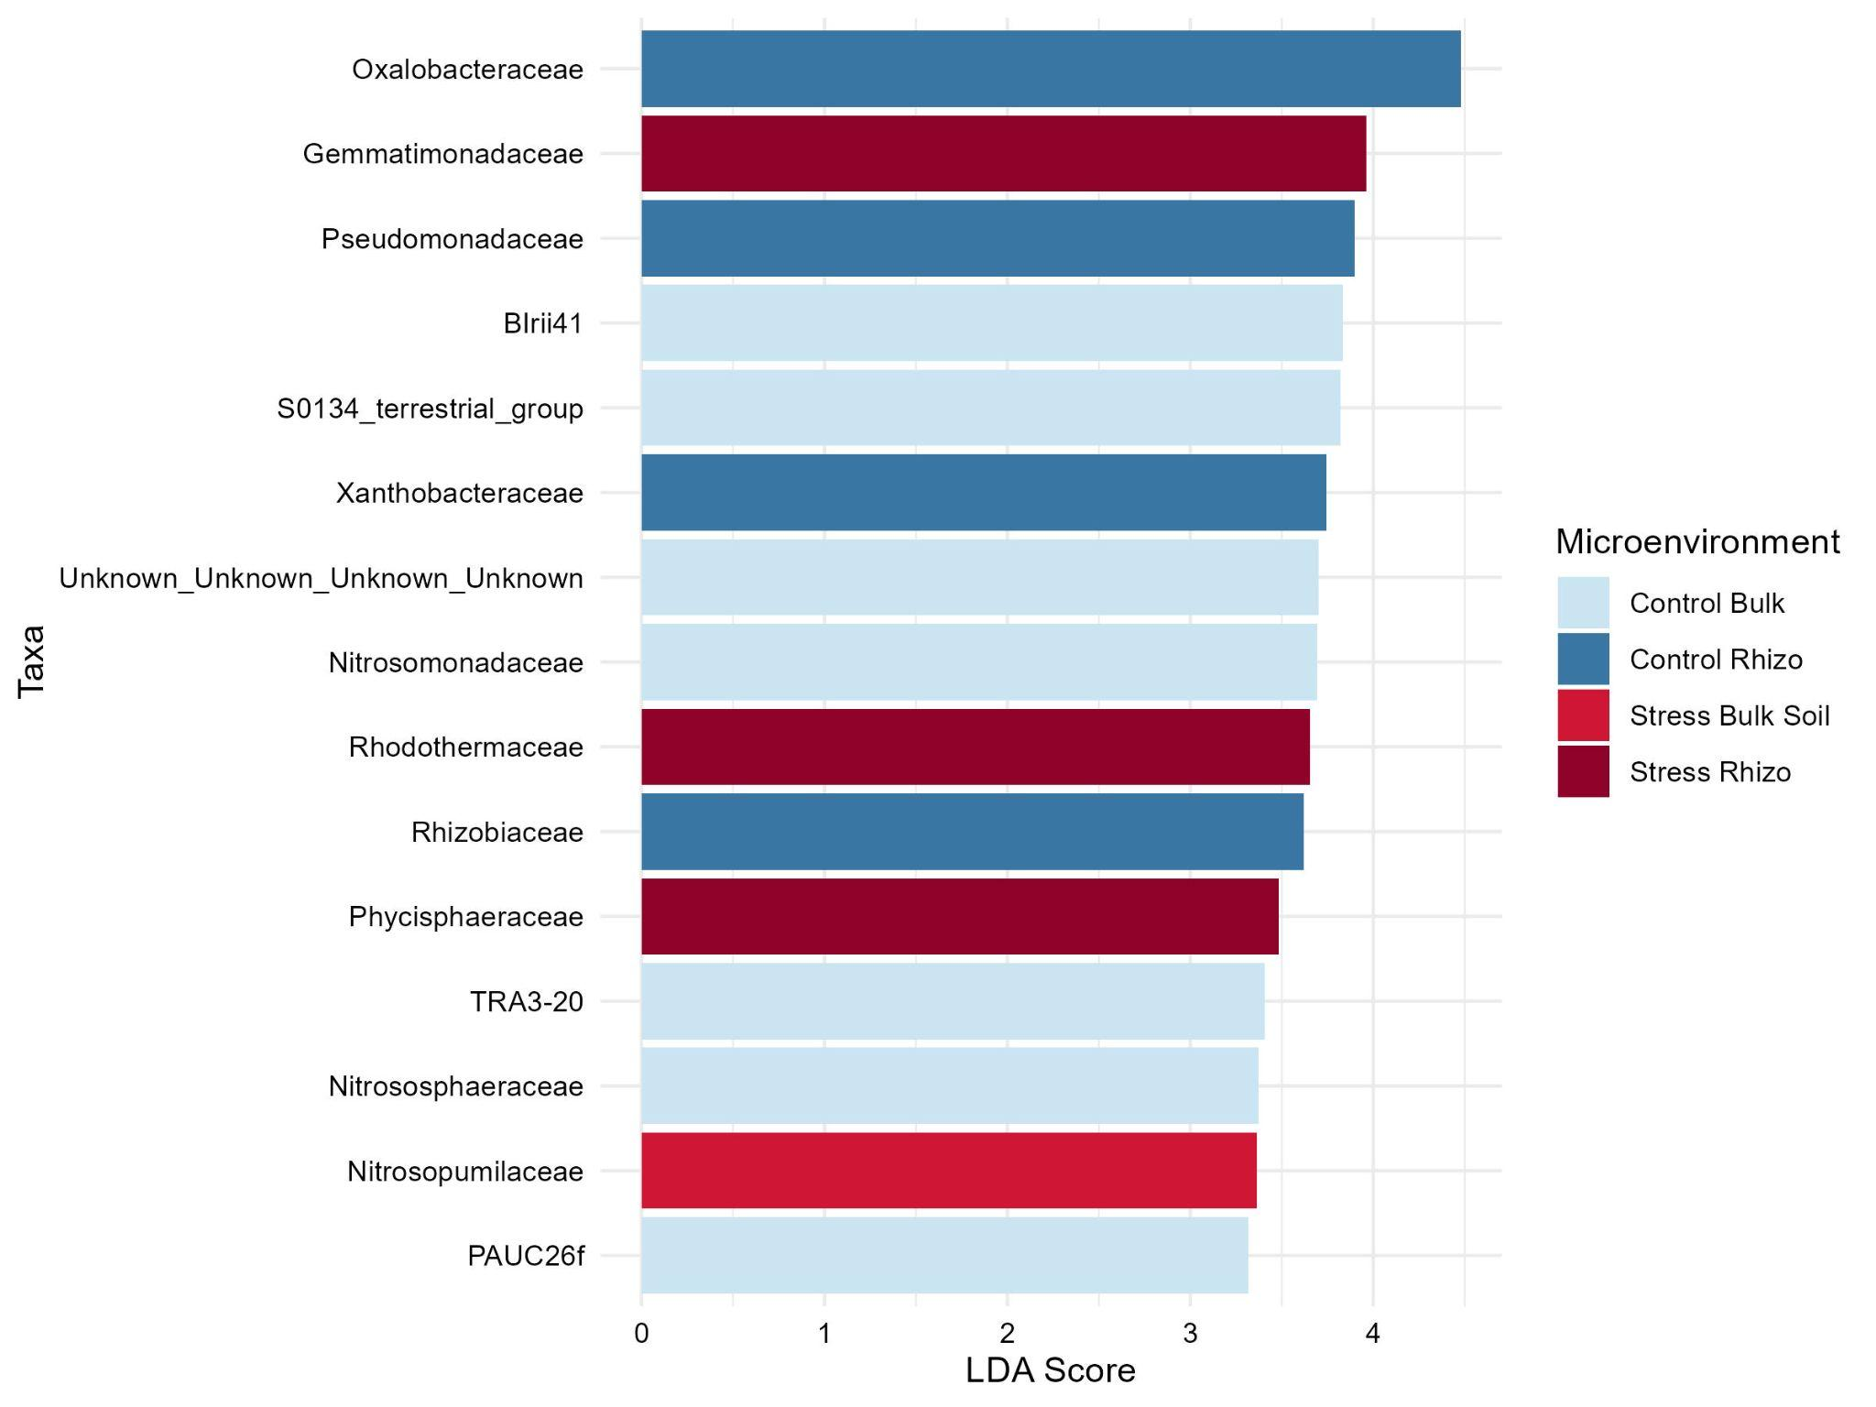

Table 3 – Family-level LEfSe analysis differentiating control and stress treatments in distinct microenvironments. The top 15 taxa based on LDA score are presented.
Taxa | Enrich_group | ef_lda | pvalue | padj
Oxalobacteraceae | Control Rhizo | 4.389 | 0.0423 | 0.0423
Gemmatimonadaceae | Stress Rhizo | 3.989 | 0.0116 | 0.0116
Pseudomonadaceae | Control Rhizo | 3.975 | 0.0228 | 0.0228
BIrii41 | Control Bulk | 3.860 | 0.037 | 0.037
S0134_terrestrial_group | Control Bulk | 3.846 | 0.0167 | 0.0167
Xanthobacteraceae | Control Rhizo | 3.801 | 0.0425 | 0.0425
Nitrosomonadaceae | Control Bulk | 3.740 | 0.0313 | 0.0313
Rhizobiaceae | Control Rhizo | 3.681 | 0.0190 | 0.0190
Rhodothermaceae | Stress Rhizo | 3.673 | 0.0087 | 0.0087
Unknown_Unknown_Unknown_Unknown | Control Bulk | 3.649 | 0.0025 | 0.0025
Phycisphaeraceae | Stress Rhizo | 3.483 | 0.0209 | 0.0209
TRA3-20 | Control Bulk | 3.428 | 0.0023 | 0.0023
Nitrosopumilaceae | Stress Bulk Soil | 3.377 | 0.048 | 0.048
Nitrososphaeraceae | Control Bulk | 3.361 | 0.0034 | 0.0034
PAUC26f | Control Bulk | 3.358 | 0.0021 | 0.0021

Fig. 4 – Lefse analysis at family level across lifecycle. The top 15 taxa based on LDA score are presented.
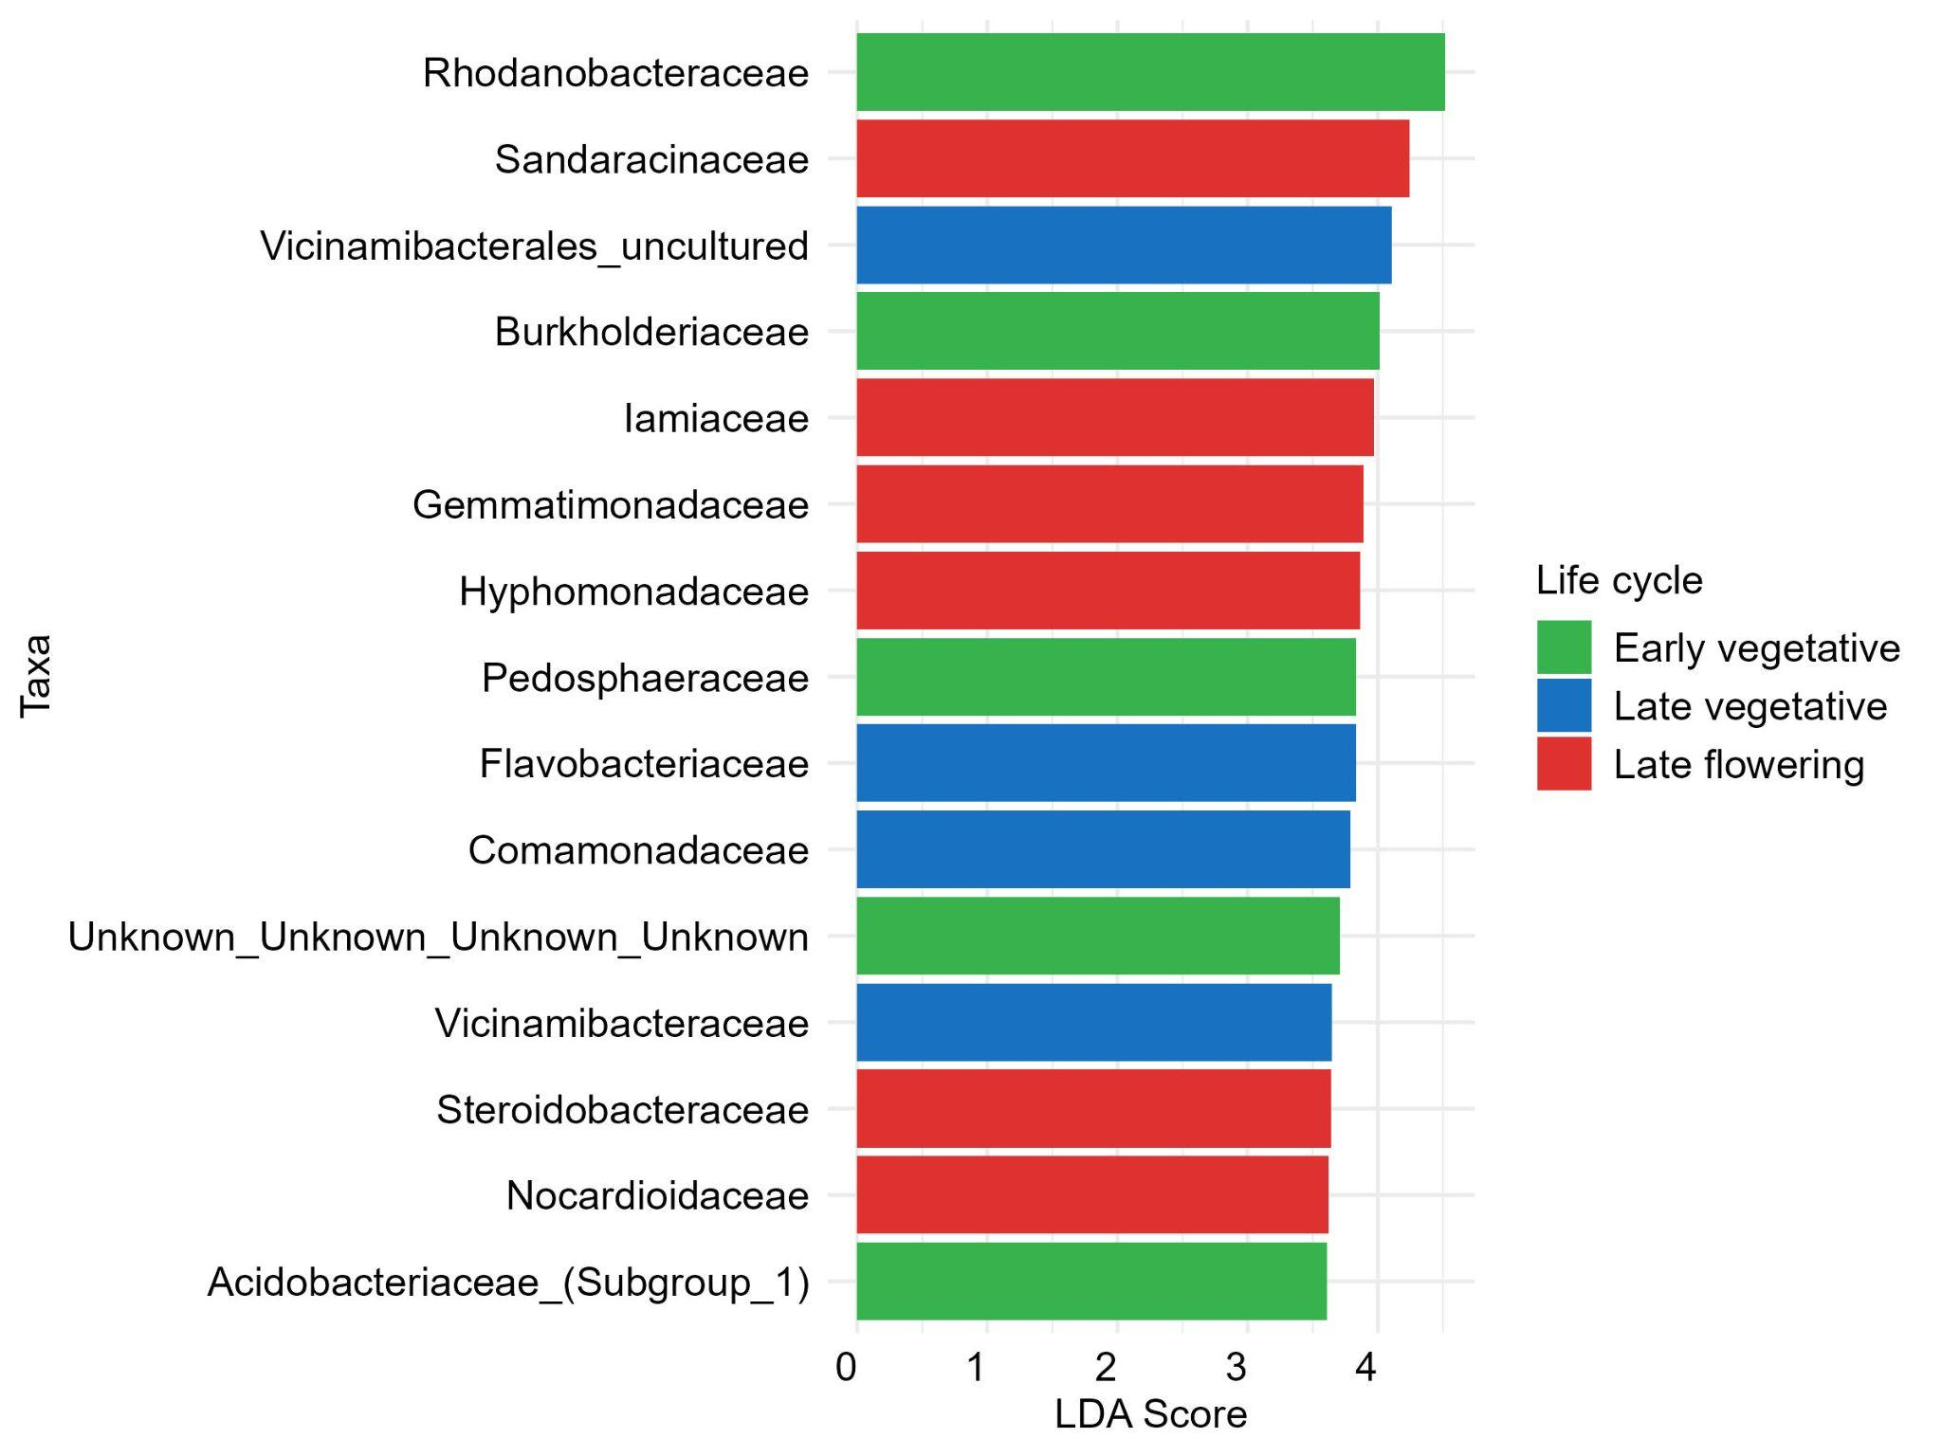

Table 4 - Lefse analysis at family level across life cycle. The top 15 taxa based on LDA score are presented.

Taxa | Enrich_group | ef_lda | pvalue | padj
Rhodanobacteraceae | early vegetative | 4.509 | 0.0007 | 0.0007
Sandaracinaceae | late flowering | 4.245 | 5.69E-05 | 5.69E-05
Vicinamibacterales_uncultured | late vegetative | 4.108 | 0.0021 | 0.0021
Iamiceae | late flowering | 3.988 | 3.33E-06 | 3.33E-06
Burkholderiaceae | early vegetative | 3.976 | 0.023 | 0.023
Gemmatimonadaceae | late flowering | 3.952 | 0.019 | 0.019
Hyphomondaceae | late flowering | 3.854 | 4.087Ee-05 | 4.087Ee-05
Pedosphaeraceae | early vegetative | 3.839 | 0.0002 | 0.0002
Comamonadaceae | late vegetative | 3.785 | 0.0016 | 0.0016
Nocardiiodaceae | late flowering | 3.768 | 0.0368 | 0.0368
Flavobacteriaceae | late vegetative | 3.750 | 0.0094 | 0.0094
Unknown | early vegetative | 3.747 | 0.0082 | 0.0082
Vicinamibacteraceae | late vegetative | 3.672 | 0.0144 | 0.0144
Acidobacteriaceae_(Subgroup_1) | early vegetative | 3.623 | 1.70E-05 | 1.70E-05

Fig. 5.Ternary plots comparing the Control group (top) and the Biotic Stress group (bottom) at genus level. Each point represents a genus with relative abundance >1% in at least one developmental stage. 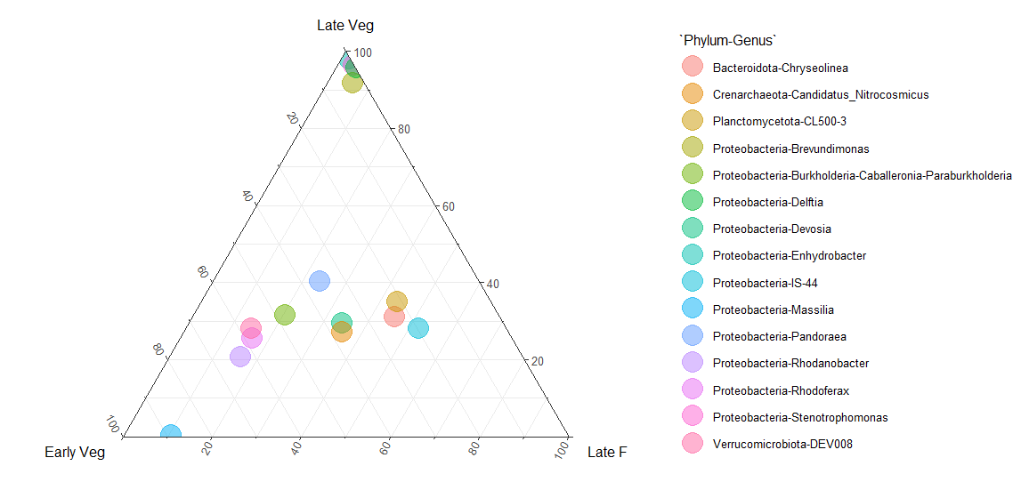 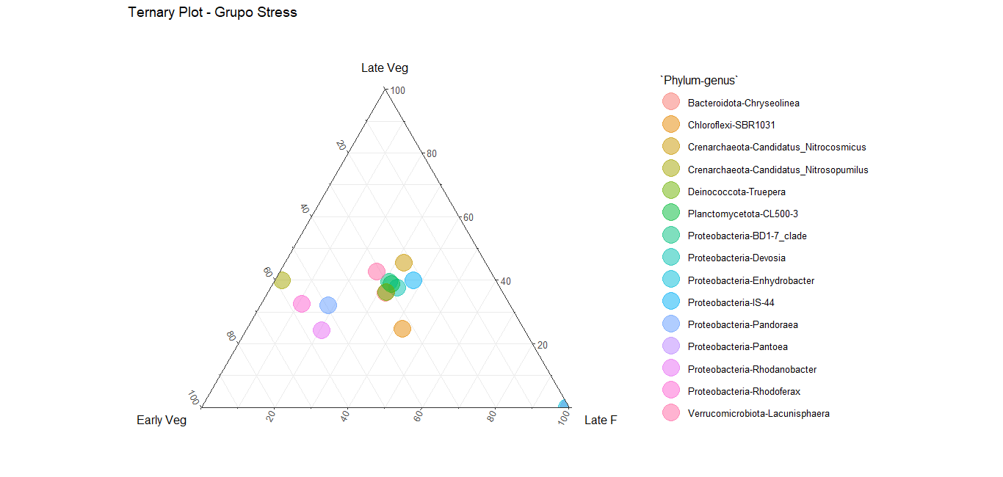

Fig. 6. Heatmap of Picrust analysis comparing differential KOs between control and stress in bulk soil and rhizosphere.
