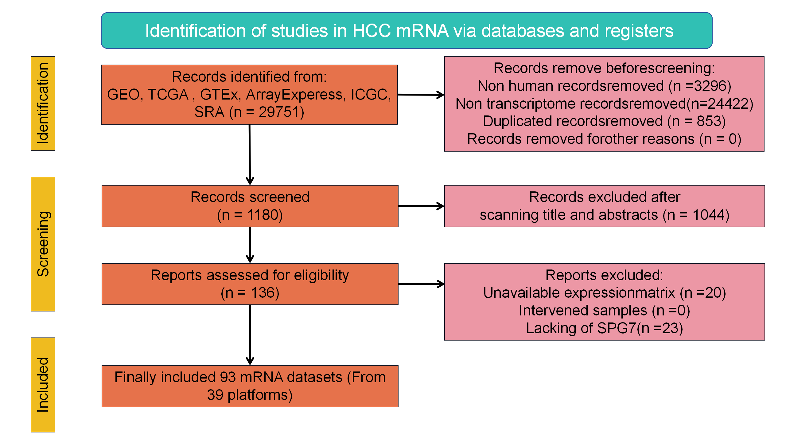
Supplementary Figure 1. Screening process of SPG7 mRNA-related datasets in bulk RNA
Supplementary Figure 2. Violin plot and ROC curve showing the SPG7 mRNA expression levels (yellow for non-HCC group, red for HCC group).
Supplementary Figure 3. Violin plot and ROC curve showing the SPG7 mRNA expression levels (yellow for non-HCC group, red for HCC group).
Supplementary Figure 4. Molecular functions of SPG7 in GeneMANIA.

Supplementary Figure 5. Potential regulatory mechanisms of SPG7 in bulk RNA. A. GO. B. KEGG.
Supplementary Figure 6. The regulatory mechanism of SPG7 in malignant hepatocytes from scRNA-seq data of HCC. A. GO. B. KEGG.
Supplementary Figure 7. SPG7 functional enrichment in scRNA-seq under TACE HCC. A. GO. B. KEGG.
Supplementary Figure 8. The relationship of SPG7 low-expression group in cell communication. A. Ligand-receptor signaling intensity of hepatocytes in SPG7 low-expression and high-expression groups. B. Heatmap of overall signal strength of output and input across different cell types.
Supplementary Figure 9. Overall output and input signals of SPG7. A. The number of output patterns. B. Sankey diagram of output patterns for each cell type, with line width representing the contribution of cell pathways to different cells. C. The number of input patterns. D. Sankey diagram of output patterns for each cell type.
Supplementary Figure 10. The relationship of the SPG7 high expression group in TACE HCC cell communication. A. Ligand-receptor signal strength in hepatocytes of the SPG7 high expression group, SPG7 low expression group, and primary untreated group. B. Heatmap of the overall signal strength of output and input for each cell type.
Supplementary Figure 11. Overall output and input signals of SPG7. A. The number of output patterns. B. Sankey diagram of output patterns for each cell type. C. The number of input patterns. D. Sankey diagram of output patterns for each cell type.
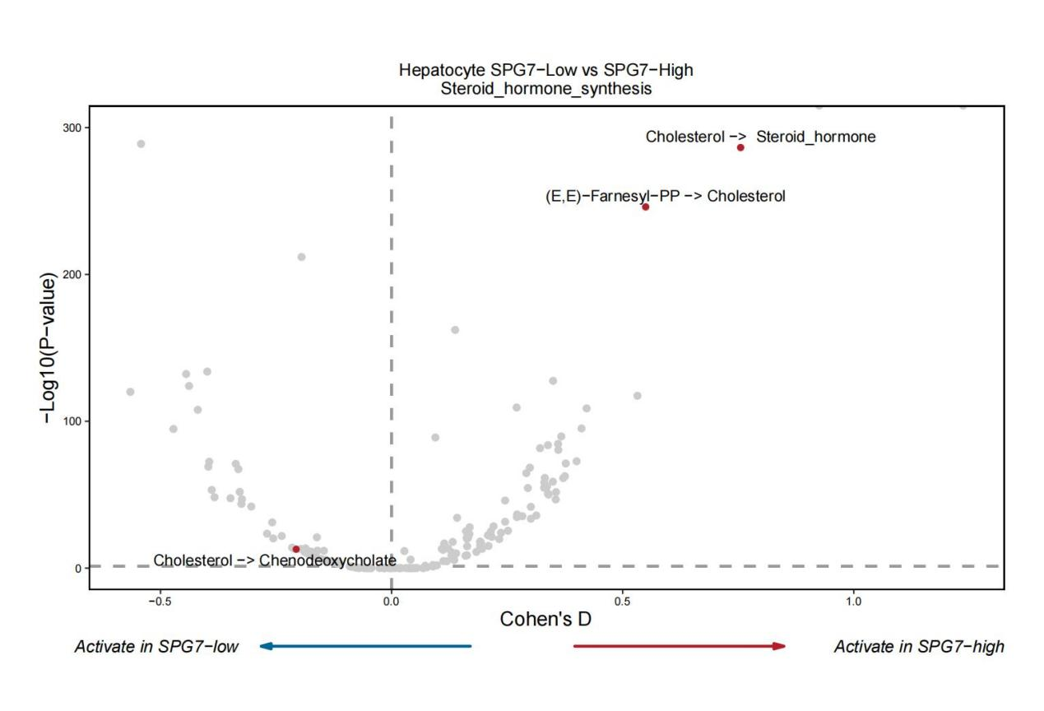
Supplementary Figure 12. Volcano plot of metabolite conversions related to steroid hormone synthesis.
Supplementary Figure 13. Relationship between SPG7 expression and drug sensitivity. A. 5-Fluoro deoxy uridine. B. Gemcitabine. C. PKI-587. D. Vinblastine.

