Additional Files

Additional File 1: EQ-5D-5L against clinician diagnosis and GAD-7 performance in anxiety screening ROC curves
S1a Figure: EQ-5D vs GAD-7 diagnostic performance against clinician diagnosis for anxiety screening ROC curves | S 1b Fig: SCID anxiety diagnosis and EQ-5D quantiles | S1c Fig: GAD-7 and EQ-5D quantiles

Additional File 2: EQ-5D-5L against clinician diagnosis and PHQ-9 performance in depression screening ROC curves
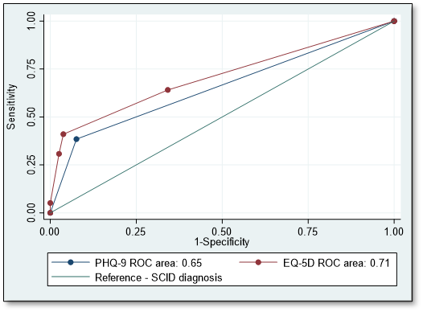  S2a Figure: EQ-5D vs GAD-7 diagnostic performance against clinician diagnosis for depression screening ROC curves | S 2b Fig: SCID depression diagnosis and EQ-5D quantiles | S2c Fig: PHQ-9 and EQ-5D quantiles

Additional File 3: EQ-5D-5L against clinician diagnosis and SSQ-14 performance in comorbid anxiety/depression screening ROC curves
S3a Figure: EQ-5D vs SSQ-14 diagnostic performance against clinician diagnosis for comorbid anxiety/depression ROC curves | S3b Figure: SCID comorbid anxiety/depression diagnosis & EQ-5D quantiles | S3c Figure: SSQ-14 & EQ-5D quantiles

