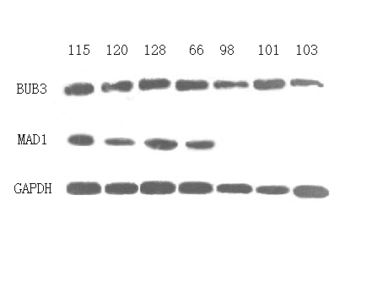
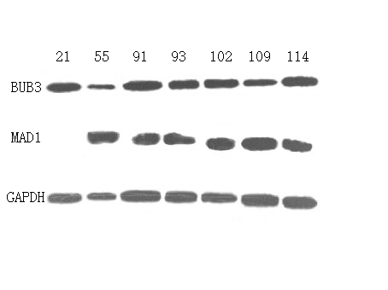
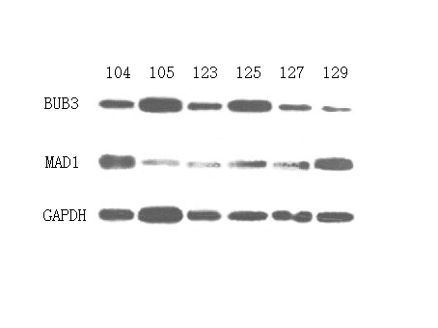
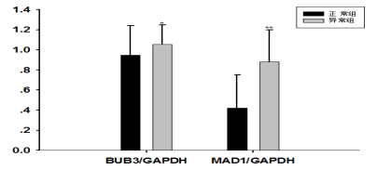
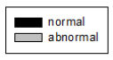

Figure S2:BUB3 protein in abnormal group was slightly up-regulated,while the relative expression of MAD1 protein in abnormal group was significantlys up-regulated.while the relative expression of MAD1 protein in abnormal group was significantly up-regulated (P<0.05).
WB glue map of MAD1 and BUB3;Use related indexes of Table S2 , plotted by Sigmaplot software .

