Supplementary material
Figure. Growth curve obtained from fungal biomass cultured at 28°C and 140 rpm for 15 days for the fungi: (a) Bjerkandera sp. CCMIBA_R111 in malt extract broth, potato dextrose broth, and malt extract broth enriched with peptone and yeast extract; (b) Clonostachys rosea CCMIBA_R014 in malt extract broth and Sabouraud dextrose broth; and (c) Purpureocillium lilacinum CCMIBA_R018 in malt extract broth and Sabouraud dextrose broth.
a)
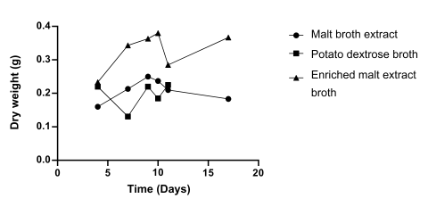
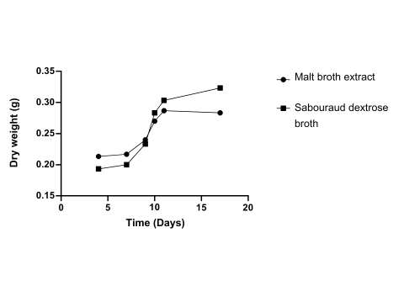
b)
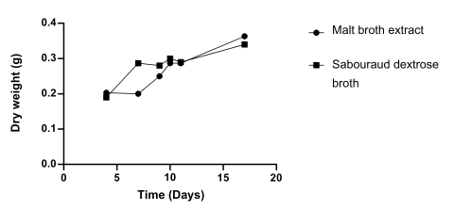

c)

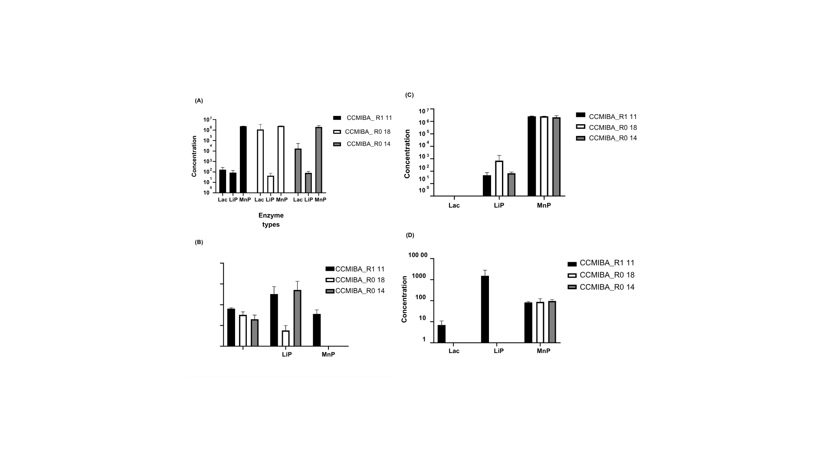
Figure. Analysis of Enzyme Production (Lac, LiP, and MnP): (a) simple pre-inoculum assays without the addition of biochar ; (b) Condition C1: inoculated on biochar without the addition of a moisturizing agent; (c) Condition C2: inoculated on biochar with 1% buffered peptone water (pH 7.0) added only at the beginning of the treatment; (d) Condition C3: inoculated on biochar with 1% peptone water added every four days; (e) Condition C4: inoculated on biochar with 1% buffered peptone water (pH 7.0) added every four days.

Table. Physicochemical analyses of soil samples taken from microcosms ME1, ME1C, ME2, and ME2C after 24 days of incubation. The microcosms were contaminated with 10 mg/L of commercial ATZ, with soil conditions varying between being previously sterilized in an autoclave (referred to as ME1) and not sterilized (referred to as ME2). Controls for the microcosms (ME1C and ME2C) were maintained under identical conditions with the absence of the fungal consortium.

Physicochemical analyses | ME1 |  | ME1c |  | ME2 | ME2c
pH (CaCl2) (Un.) | 5,6 | 5,4 |  | 5,6 |  | 5,3
Ca (cmolc/dm³) | 5,7 | 5,6 |  | 6,1 |  | 6,6
Mg (cmolc/dm³) | 1,6 | 1,3 |  | 1 |  | 1
Ca+Mg (cmolc/dm³) * | 7,3 | 6,9 |  | 7,1 |  | 7,6
Al (cmolc/dm³) | 0 | 0 |  | 0 |  | 0
H+Al (cmolc/dm³) * | 1,9 | 2,8 |  | 2,1 |  | 2,5
CTC (cmolc/dm³) * | 9,73 | 10,24 |  | 9,73 |  | 10,63
P (Mehlich I) (mg/dm³) * | 7 | 2 |  | 6 |  | 1,4
K (cmolc/dm³) | 0,53 | 0,537 |  | 0,53 |  | 0,527
K (mg/dm³) | 206 | 210 |  | 206 |  | 206
Na (mg/dm³) | 1 | 1 |  | 1 |  | 1
S (mg/dm³) * | 6 | 5 |  | 5 |  | 4
B (mg/dm³) | 0,26 | 0,28 |  | 0,25 |  | 0,26
Cu (mg/dm³) | 4,3 | 4,5 |  | 4,4 |  | 4,5
Fe (mg/dm³) * | 60 | 45 |  | 46 |  | 48
Mn (mg/dm³) | 95 | 98 |  | 88 |  | 83
Zn (mg/dm³) | 4,6 | 4,5 |  | 4,6 |  | 4,2
pH (H2O) (.) | 6 | 5,9 |  | 6,1 |  | 5,8
Mat. Org. (%) | 0,7 | 1 |  | 1 |  | 1,2
Mat. Org. (g/kg) * | 7 | 10 |  | 10 |  | 12
Sat. Al (M%) (%) | 0 | 0 |  | 0 |  | 0
Sat. Base (V%) (%) * | 81 | 73 |  | 79 |  | 77
Ca/Mg (.) * | 3,6 | 4,3 |  | 6,1 |  | 6,6
Ca/CTC (%) * | 58,8 | 54,9 |  | 62,9 |  | 62,3
Mg/CTC (%) | 16,5 | 12,7 |  | 10,3 |  | 9,4
(H+Al)/CTC (%) * | 19,6 | 27,5 |  | 21,6 |  | 23,6
K/CTC (%) | 5,4 | 5,3 |  | 5,4 |  | 5
N (%) | 0 | 0,1 |  | 0,1 |  | 0,1
Cd (mg/kg) | 0,1 | 0,2 |  | 0,1 |  | 0,1
Cr (mg/kg) | 0,1 | 0,1 |  | 0,1 |  | 0,1
Ni (mg/kg) | 0,3 | 0,1 |  | 0,1 |  | 0,1
Pb (mg/kg) | 0,3 | 0,3 |  | 0,2 |  | 0,4
Se* (mg/Kg) | 0 | n.d |  | 0 |  | n.d
C. Org. Tot. (%) * | 0,41 | 0,58 |  | 0,58 |  | 0,7
Hg (mg/Kg) | 0 | n.d |  | 0 |  | n.d
As (mg/Kg) | 0 | n.d |  | 0 |  | n.d
* p-valor <0,05

