Tailored piezoelectric chitosan thin film for ultrasound-controlled drug delivery
Gaia de Marzo^{a,b}, Valentina Antonaciª, Virgilio Brunettiª, Laura Blasi^{a,c}, Luca Fachechiª, Sergio Marras^{d}, Antonio Qualtieriª, Francesco Rizziª, Roberto Fiammengo^{e}, Massimo De Vittorio^{a,b}
ªIstituto Italiano di Tecnologia—Center for Biomolecular Nanotechnologies, Lecce 73010, Italy
^{b}Center IDUN, Department of Health Technology, Technical University of Denmark, Kongens Lyngby 2800, Denmark
^{c}CNR-IMM Istituto per la Microelettronica ed i Microsistemi - UOS di Lecce c/o Campus Universitario Ecotekne, Lecce 73100, Italy.
^{d} Materials Characterization Facility, Istituto Italiano di Tecnologia (IIT), Via Morego 30, 16163, Genova, Italy
^{e}Department of Biotechnology, University of Verona, Strada Le Grazie 15, Verona 37134, Italy.

Supplementary figure S1:
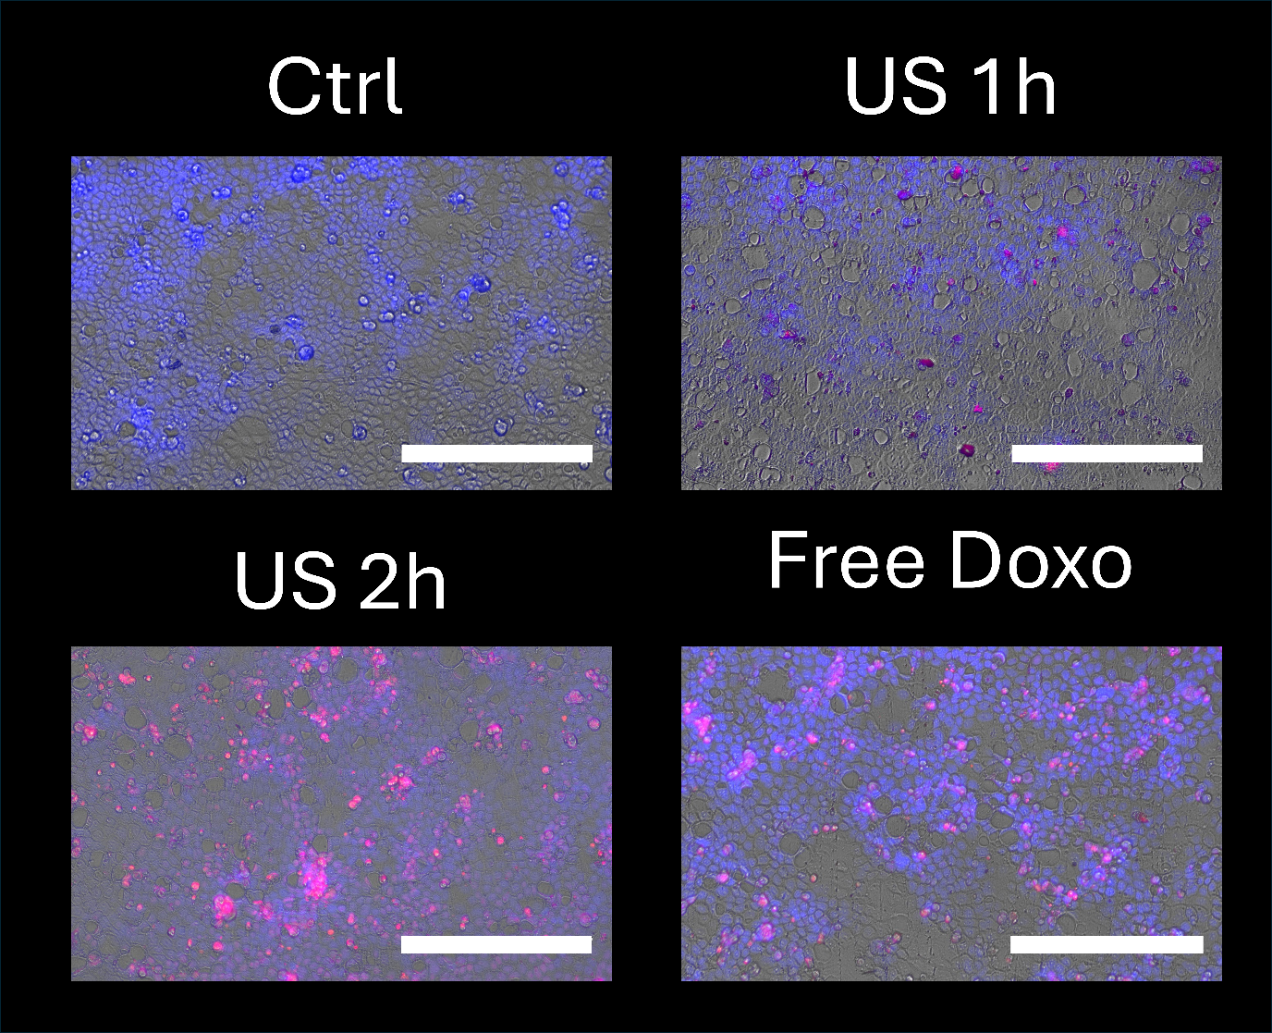
Figure S1: Merged images of the Hoechst 33258 distribution, Doxorubicin distribution and transmission image of Caco-2 cells after 48 h of treatment.

