Genomic and Proteolytic Profiling of Lacticaseibacillus sp. PRA205: Insights into PepX-Mediated Bioactive Peptide Metabolism
Marianna Cristofolini¹, Alice Cattivelli², Alessandra Barbieri¹, Giulia Zaccarini¹, Loris Bertoldi³, Lisa Solieri^{1*}, Davide Tagliazucchi²

¹ Lactic acid bacteria and Yeast Biotechnology Lab (LYB), Department of Life Science, University of Modena and Reggio Emilia, 42122 Reggio Emilia, Italy
² Nutritional Biochemistry Lab, Department of Life Science, University of Modena and Reggio Emilia, 42122 Reggio Emilia, Italy
³ BMR Genomics Srl, 35131, Padua, Italy
*Corresponding author: Lisa Solieri, Department of Life Science, University of Modena and Reggio Emilia, Via Amendola 2, Besta Building, 42122 Reggio Emilia, Italy. Email: lisa.solieri@unimore.it; Phone: +39 0522 522026.
Supplementary Figures

Supplementary Fig. S1. Functional distribution of core, dispensable, and singleton genes in COG categories. The dataset included Lacticaseibacillus sp. strain PRA205, L. zeae subsp. zeae DSM 20178^{T}, L. zeae subp. silagei DSM 116376T, L. parahuelsenbergensis DSM 116105^{T}, L. huelsenbergensis DSM 115425^{T}, and L. styriensis DSM 116297^{T}.
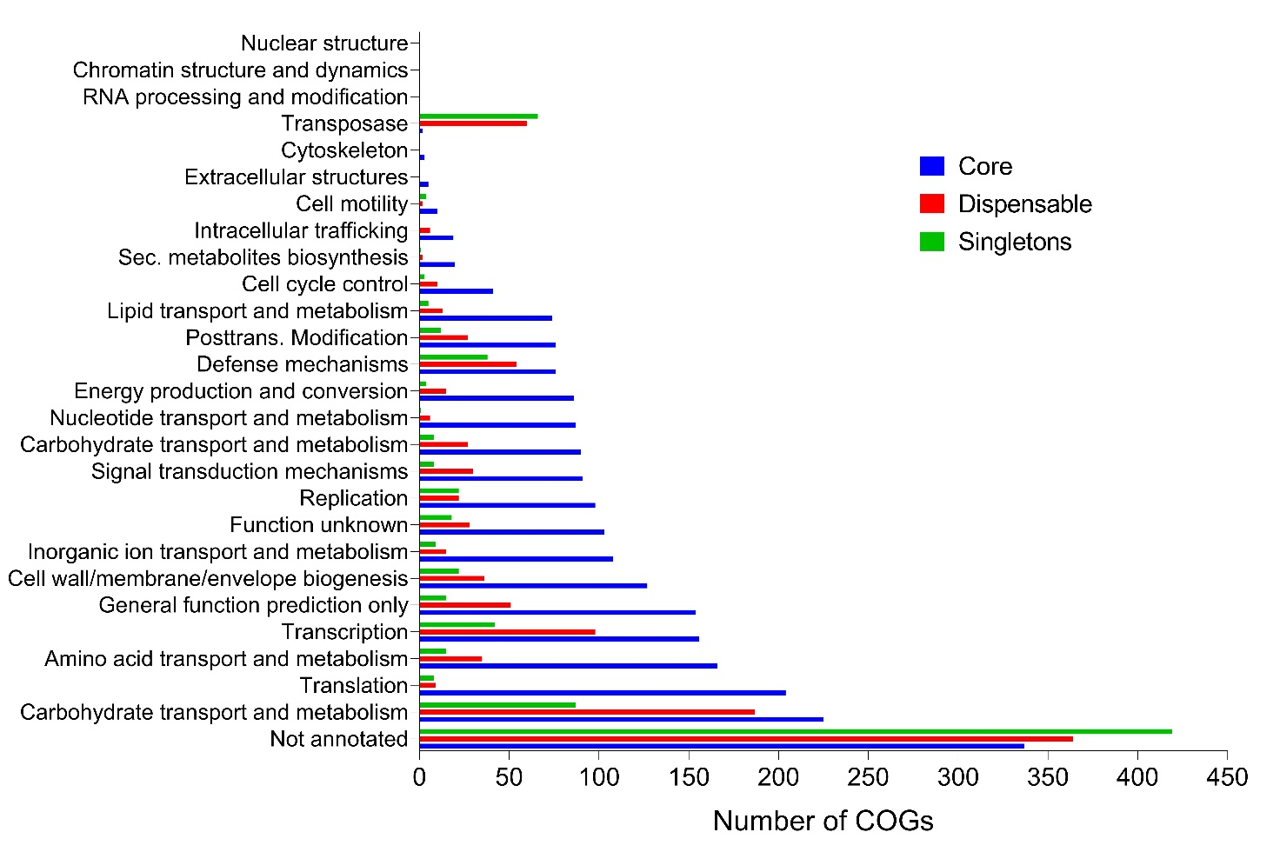

Supplementary Fig. S2. Partial purification of PepX from the cytoplasmic extract of PRA205 by size-exclusion chromatography (Sephadex G-100). Protein content was monitored by determining the absorbance values at 280 nm, whereas PepX activity was calculated by using Gly-Pro-pNA as substrate and measuring the absorbance at 410 nm.
