Supplementary Materials for
Wearable, Broadband Auscultation Patch with Cantilever Pressure Transducer for Remote Healthcare Monitoring
Tran Bach Dang,ª Chi Cong Nguyen,*ª Seung Yun Heo,^{b} Thanh Vinh Nguyen,^{c} Nicholas Tong,ª Michael G. Ruppert,^{d} Thanh An Truong,^{e,f} Michael Listyawan,ª James Davies,^{g} Sinuo Zhao,ª Quang Anh Nguyen, ª Nhat Minh Doan,ª Anthony Sunjaya,^{h,i} Tracie Barber,ª Nigel H. Lovell,^{g,j} Thanh Nho Do,^{g,j} Hoang-Phuong Phan*^{a,j}
* Corresponding author. E-mail: hp.phan@unsw.edu.au, cong.c.nguyen@unsw.edu.au
- School of Mechanical & Manufacturing Engineering, UNSW Sydney, Kensington, NSW 2052, Australia
- Hemorhythmics Inc., Evanston, IL 60201, USA
- Formfactor Inc., Livermore, CA 94551, USA
- Centre for Audio, Acoustics and Vibration, University of Technology Sydney, Ultimo, NSW 2007, Australia
- School of Engineering and Built Environment, Griffith University, Gold Coast Campus, Queensland 4222, Australia
- Queensland Quantum and Advanced Technologies Research Institute (QUATRI), Griffith University, Nathan, Queensland 4111, Australia.
- Graduate School of Biomedical Engineering, UNSW Sydney, Kensington Campus, Sydney, NSW 2052, Australia
- School of Population Health, Faculty of Medicine, UNSW Sydney, NSW 2052, Australia
- The George Institute for Global Health, UNSW Sydney, NSW 2052, Australia
Tyree Foundation Institute of Health Engineering, UNSW Sydney, Kensington Campus, Sydney, NSW 2052, Australia

The supplementary materials include:
Supporting Notes S1 – S10
Supporting Figures S1 – S45
Supporting Table S1 – S2
References cited in this document.
Other Supplementary Information for this manuscript includes the following:
Supplementary Movies S1 to S6
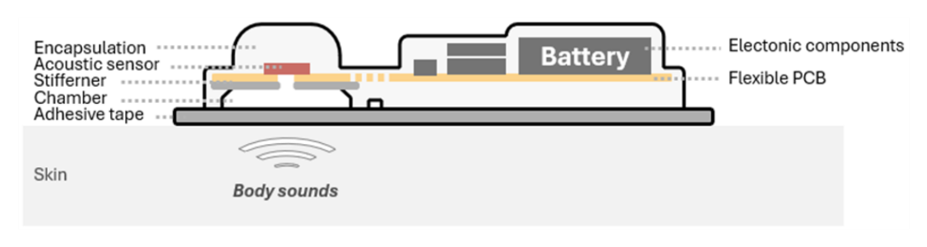
Supplementary Fig. 1 2D-layer diagram of the AusculPatch.

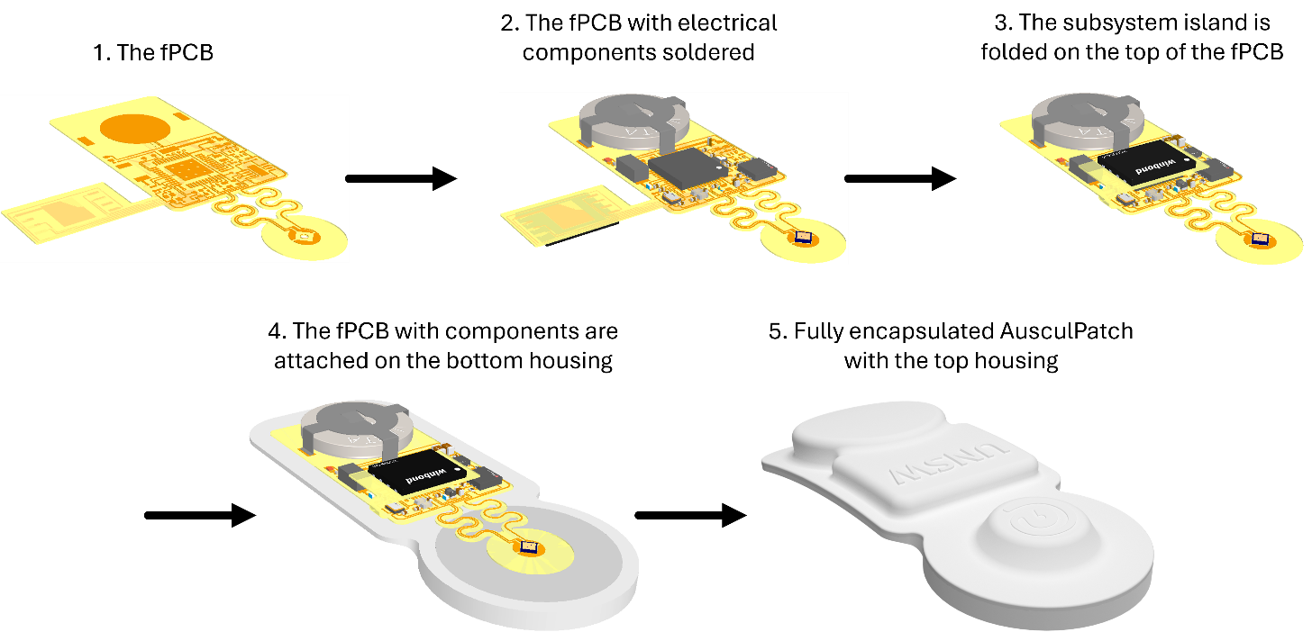
Supplementary Fig. 2 Integration and fabrication steps of AusculPatch.

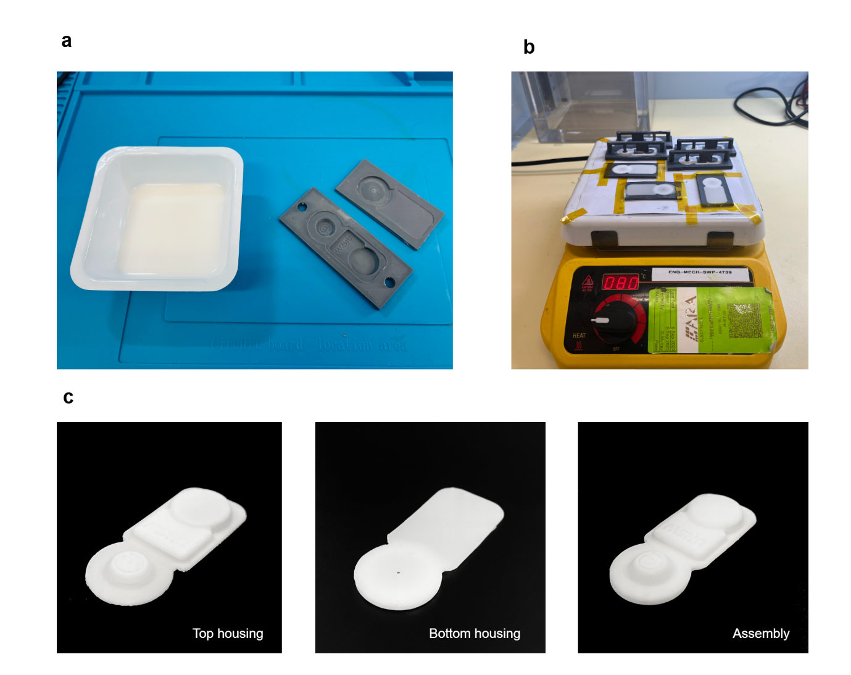
Supplementary Fig. 3 Fabrication steps of device housings. (a) Photos of soft silicone elastomer composition (PDMS, SylgardTM 184 Silicon Elastomer Kit) with a mixing ratio of 10:1 and 3D printed moulds for the top and bottom housings. (b) The PDMS liquid was cured on a hot plate at 80 °C for 2 hours. (c) From left to right, the fabricated top housing, the bottom housing, and the assembly of AusculPatch.

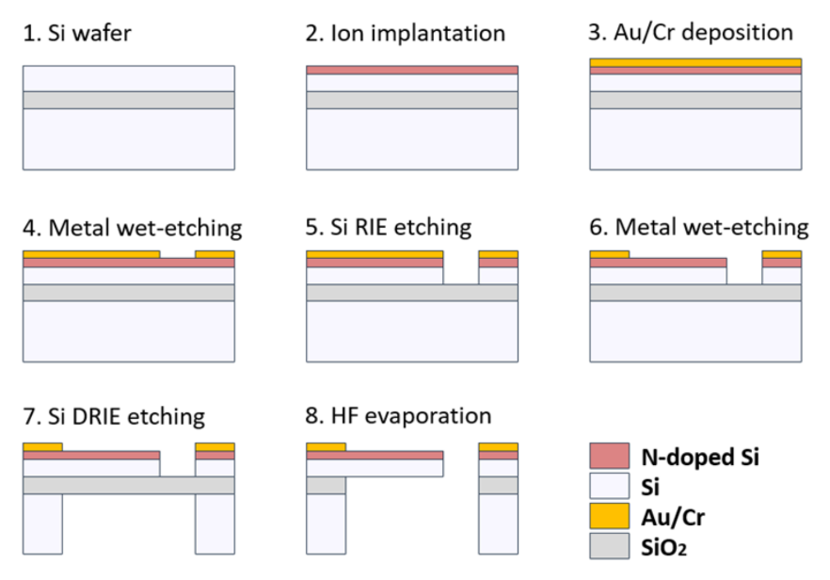
Supplementary Fig. 4 The fabrication steps of the CPT.

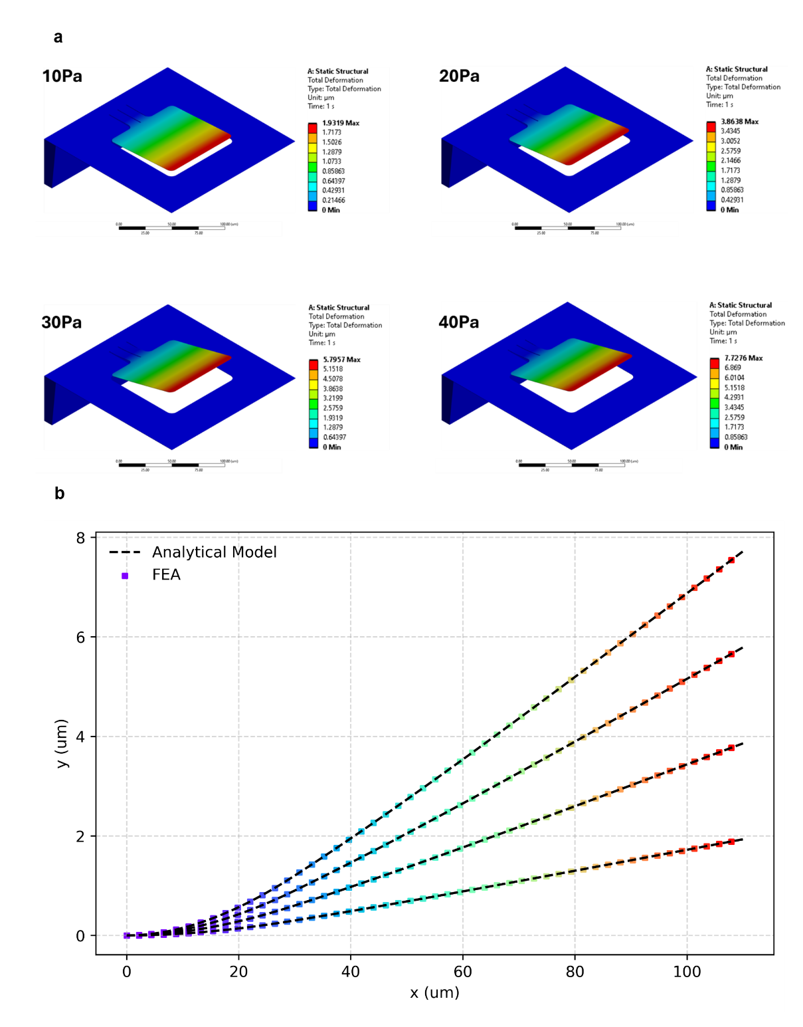
Supplementary Fig. 5 Analytical results and the FEA results of the cantilever deflection at different pressure values 10Pa, 20Pa, 30Pa, and 40Pa. (a) The FEA results. (b) The plot figure shows strong agreement between FEA results and the analytical model.

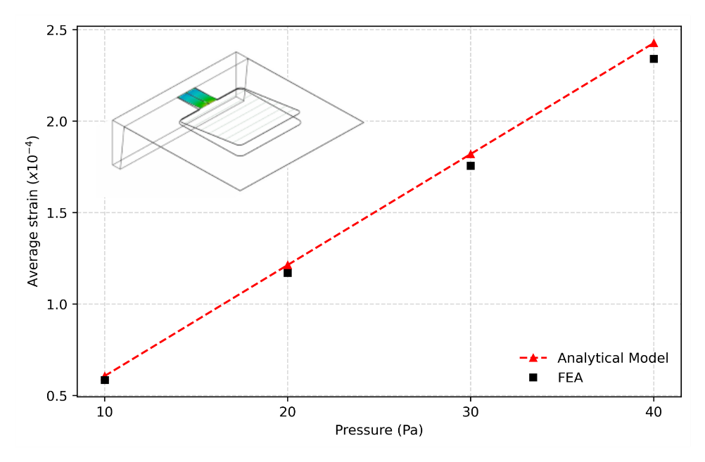
Supplementary Fig. 6 Average strain on the piezoresistive region of the CPT according to applied pressure

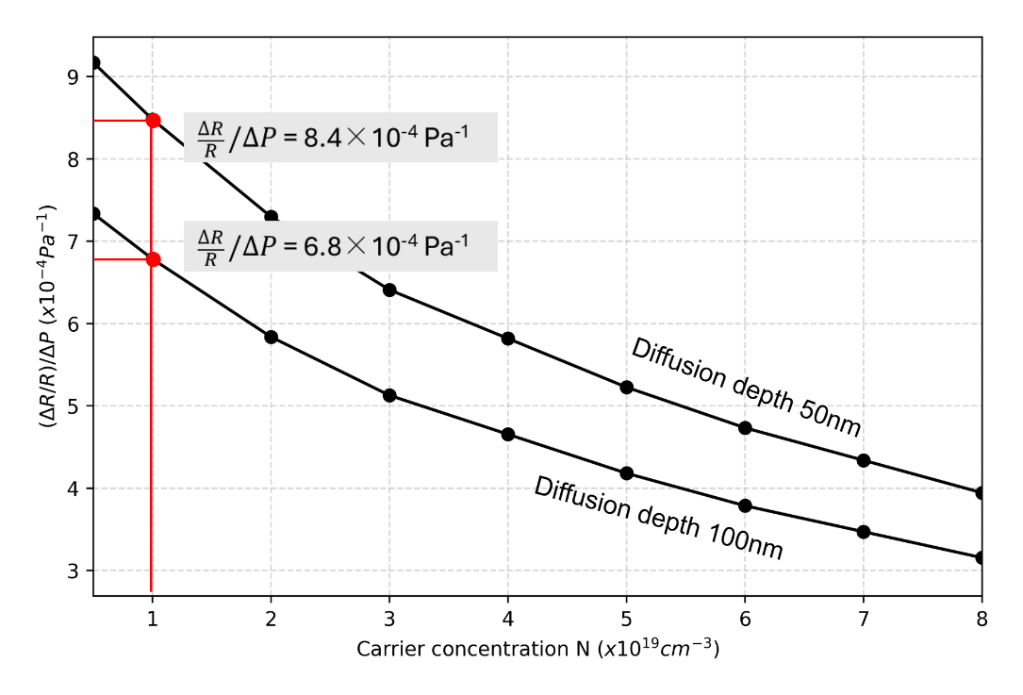
Supplementary Fig. 7 Expected sensitivity of the CPT according to diffusion depth

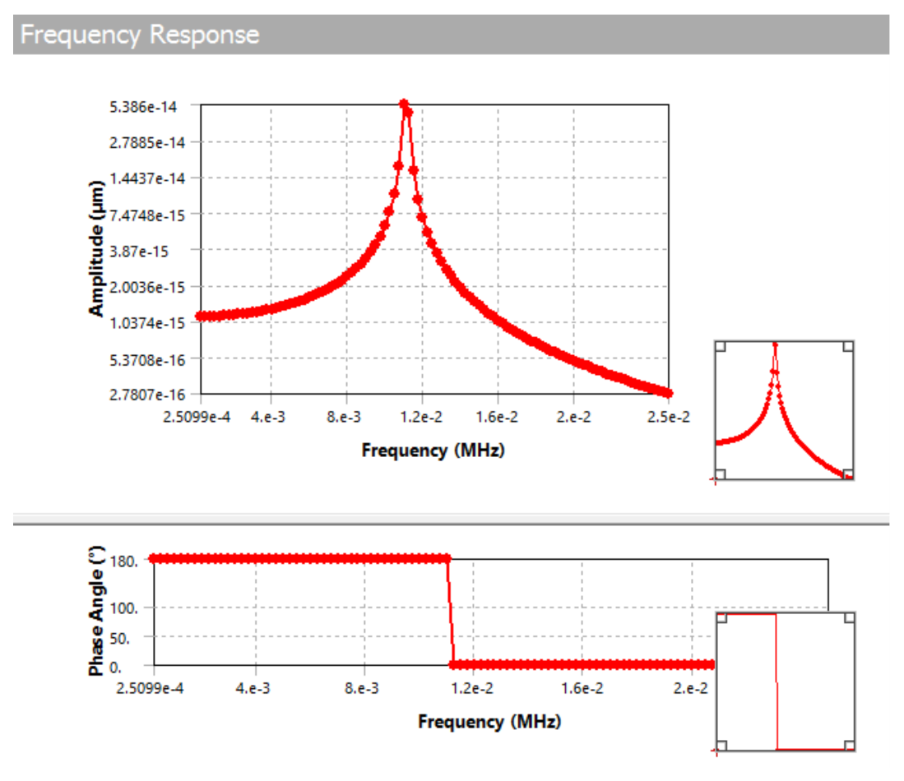
Supplementary Fig. 8 Frequency response of the CPT simulated using FEA. The commercial software ANSYS was used to perform FEA to evaluate the mechanical properties of CPT. The elastic modulus (E) and the Poisson’s ratio (v) of the <100> n-type Silicone cantilever are $E_{Si}$=130 GPa and $ν_{Si}$=0.3

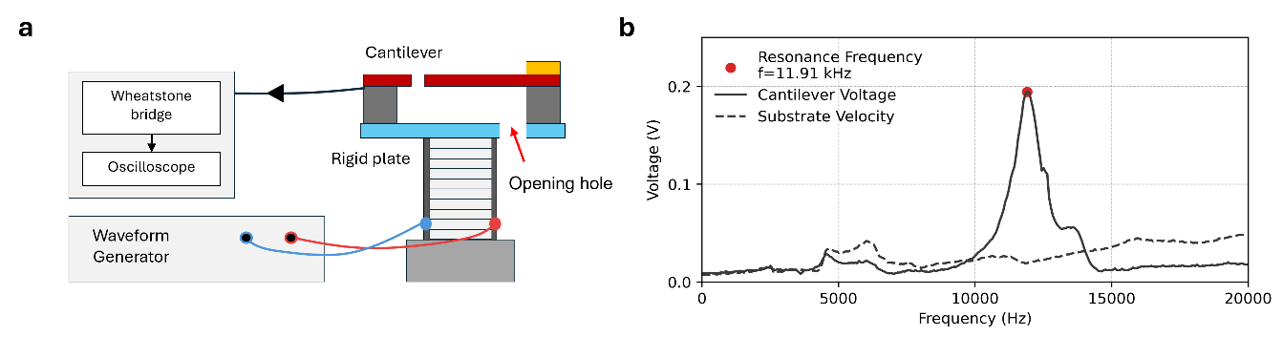
Supplementary Fig. 9 Resonance frequency characterization of the CPT. (a) Experimental setup: The CPT is mounted on a piezoelectric actuator with an open-back cavity to minimize damping. (b) Frequency response spectrum obtained from a 0–20 kHz sine sweep, showing a sharp fundamental resonance peak at 11.91 kHz, confirming the theoretical predictions.

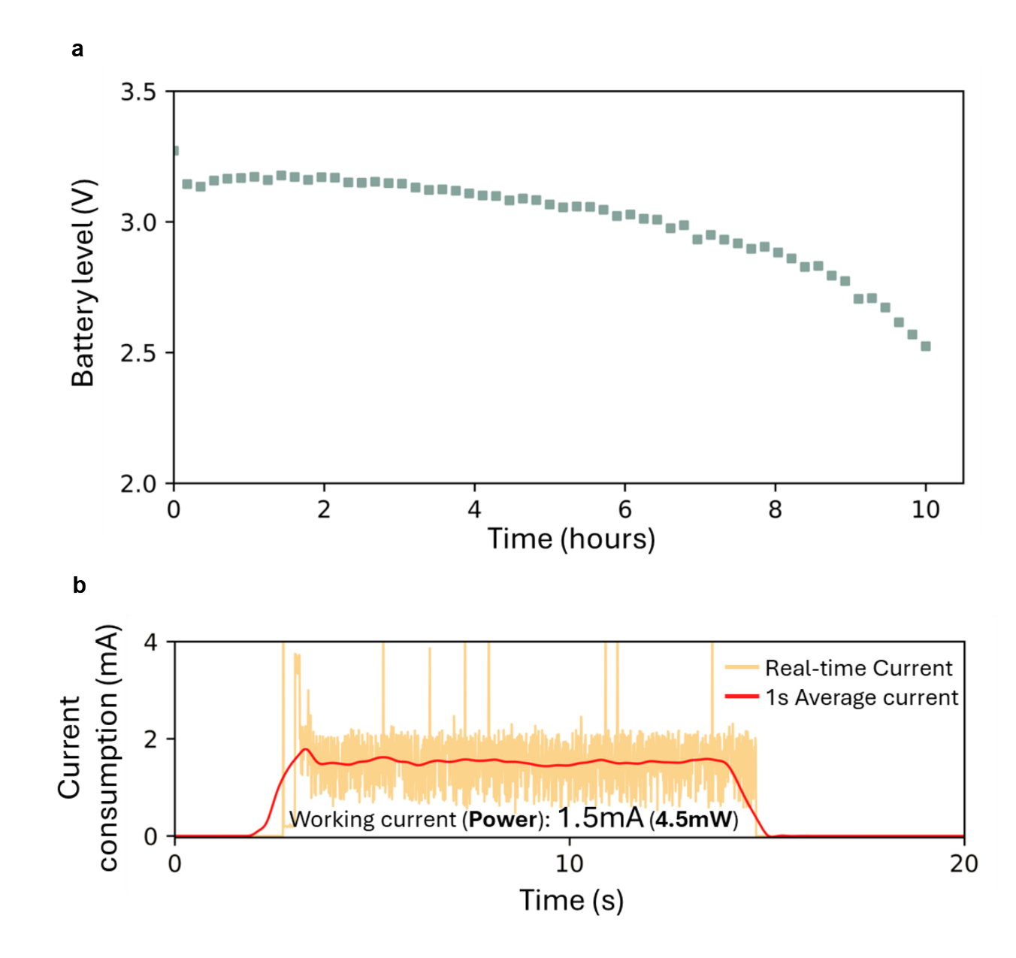
Supplementary Fig. 10 Power consumption of the AusculPatch. (a) Battery level during a 10-hour continuous measurement, using a CR1216 coin battery (3V, 30 mAh). (b) Current consumption of the AusculPatch.

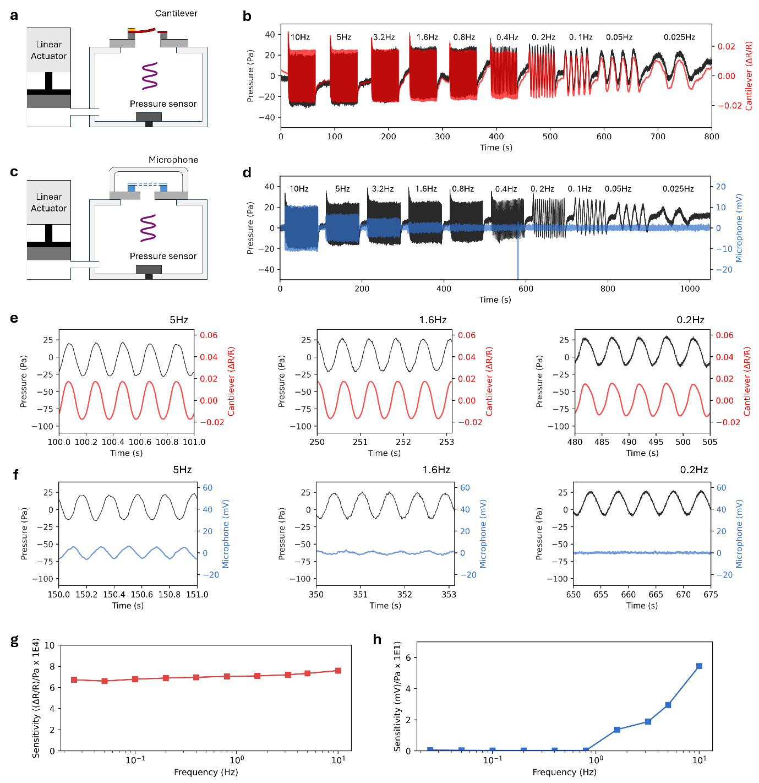
Supplementary Fig. 11 Validation of sub-Hz frequency response. (a–b) Experimental setup and sensor response of CPT, compared against a reference pressure sensor. (c–d) Experimental setup and response of a conventional microphone under identical conditions. (e–f) Zoomed-in views of the time-domain signal response at discrete low frequencies (5 Hz, 1.6 Hz, and 0.2 Hz) for CPT (e) and the conventional microphone (f). (g–h) Measured frequency response sensitivity across the sweep range (0.025 Hz–10 Hz) for CPT (g) and the conventional microphone (h), demonstrating the superior low-frequency sensitivity of the CPT.
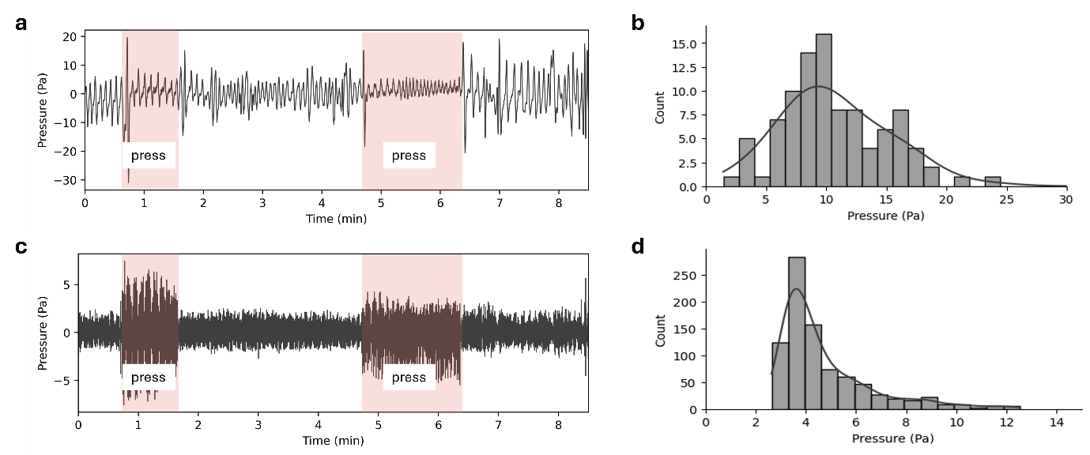
Supplementary Fig. 12 Respiration and Cardiac signal amplitude validation. (a-b) Time-domain recording of respiration signals using the AusculPatch (a) and Histogram of signal amplitudes (b). (c-d) Time-domain recording of cardiac signals using the AusculPatch (c) and Histogram of signal amplitudes (d).
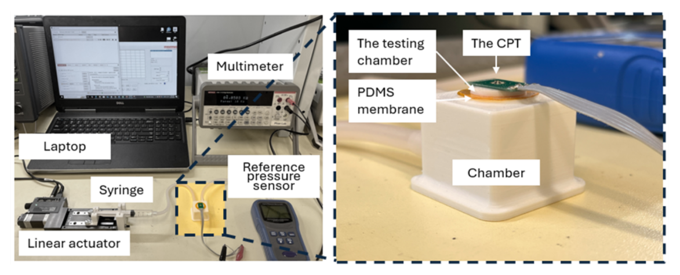
Supplementary Fig. 13 Experimental setup for the chamber volume characterization. A multimeter was used to read out the sensor resistance in real-time. A linear actuator was used to apply consistent cyclic pressure changes to the chamber through a syringe, causing the deflection of the PDMS membrane and resulting in the change of the testing chamber volume. A laptop was used to control the linear actuator and record the multimeter data via USB ports. A commercial reference pressure sensor was used to measure the chamber pressure.

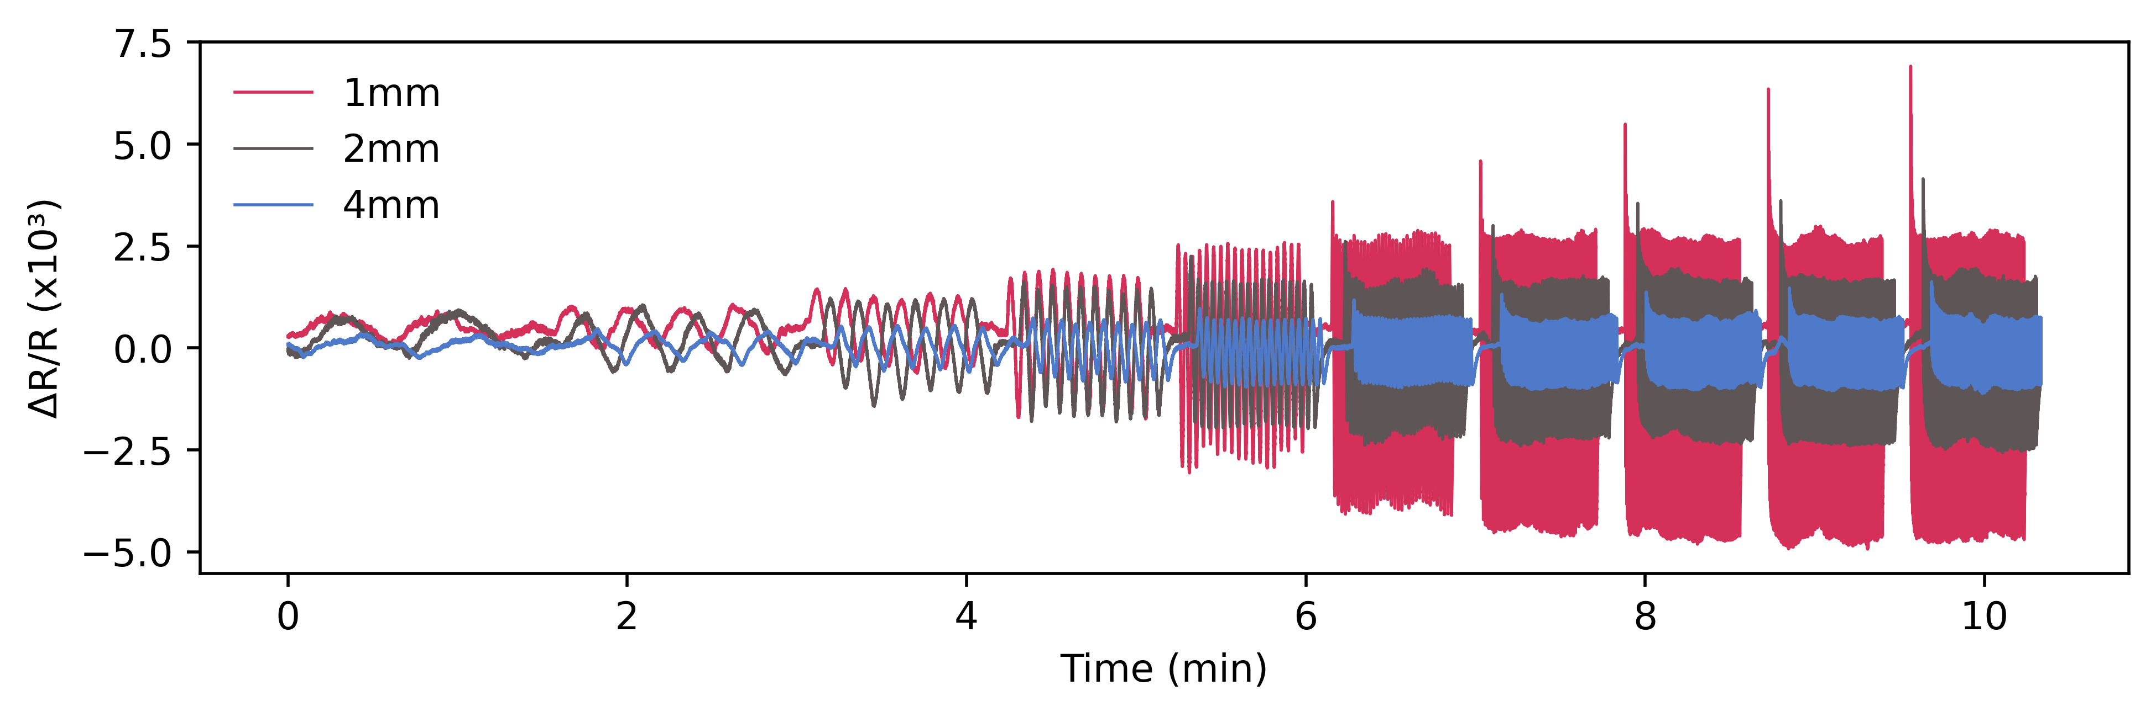
Supplementary Fig. 14 Response of CPT corresponding to different chamber height 1mm, 2mm, and 4mm plotted in time domain

Supplementary Fig. 15 Experimental setup for the membrane diameter characterization. A waveform generator was used to drive a speaker to generate sound waves at different frequencies: 40Hz, 60Hz, 80Hz, and 100Hz. A phantom skin was fabricated by pouring PDMS (mixing ratio 20:1, thickness 2mm, Young’s modulus ~1MPa(6)) and Ecoflex (00-30, thickness 6mm, Young’s modulus 100-125kPa(7)) on a 3D printed substrate, mimicking the chest wall epidermal layer of humans. The generated sound waves from the speaker passed through the phantom skin, elastic membrane, and device chamber, focused and vibrated the CPT cantilever, resulting in resistance changes. The resistance variation was then converted to voltage signals by a customized Wheatstone bridge, amplified, before being read out by an oscilloscope.

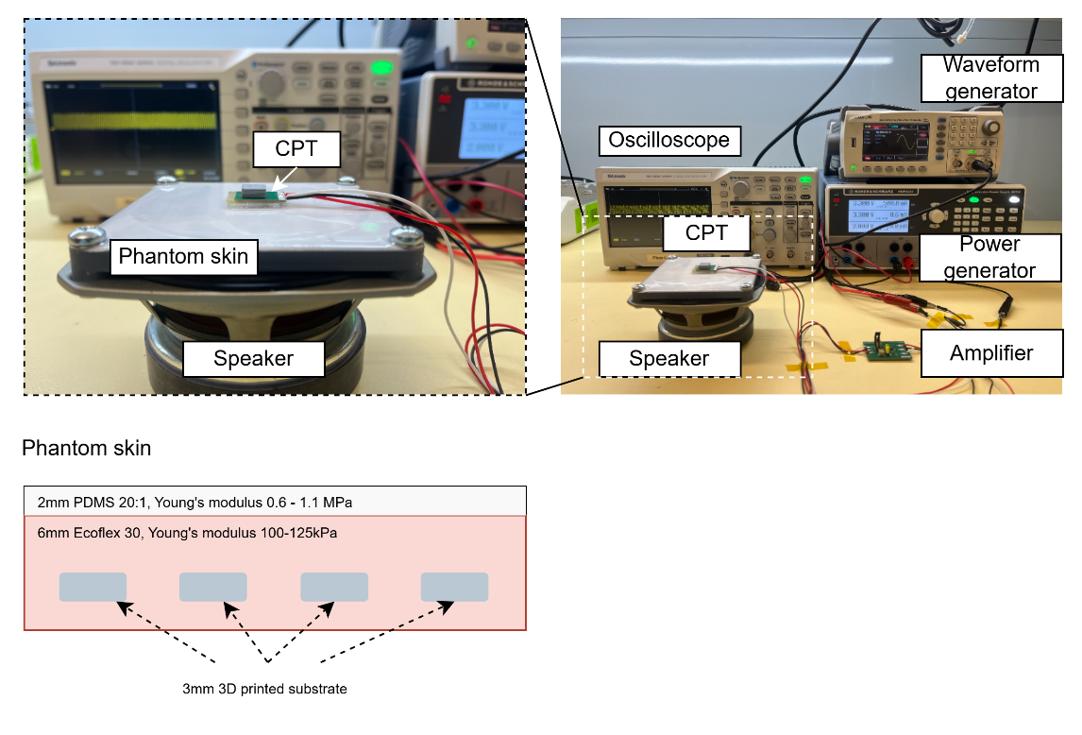
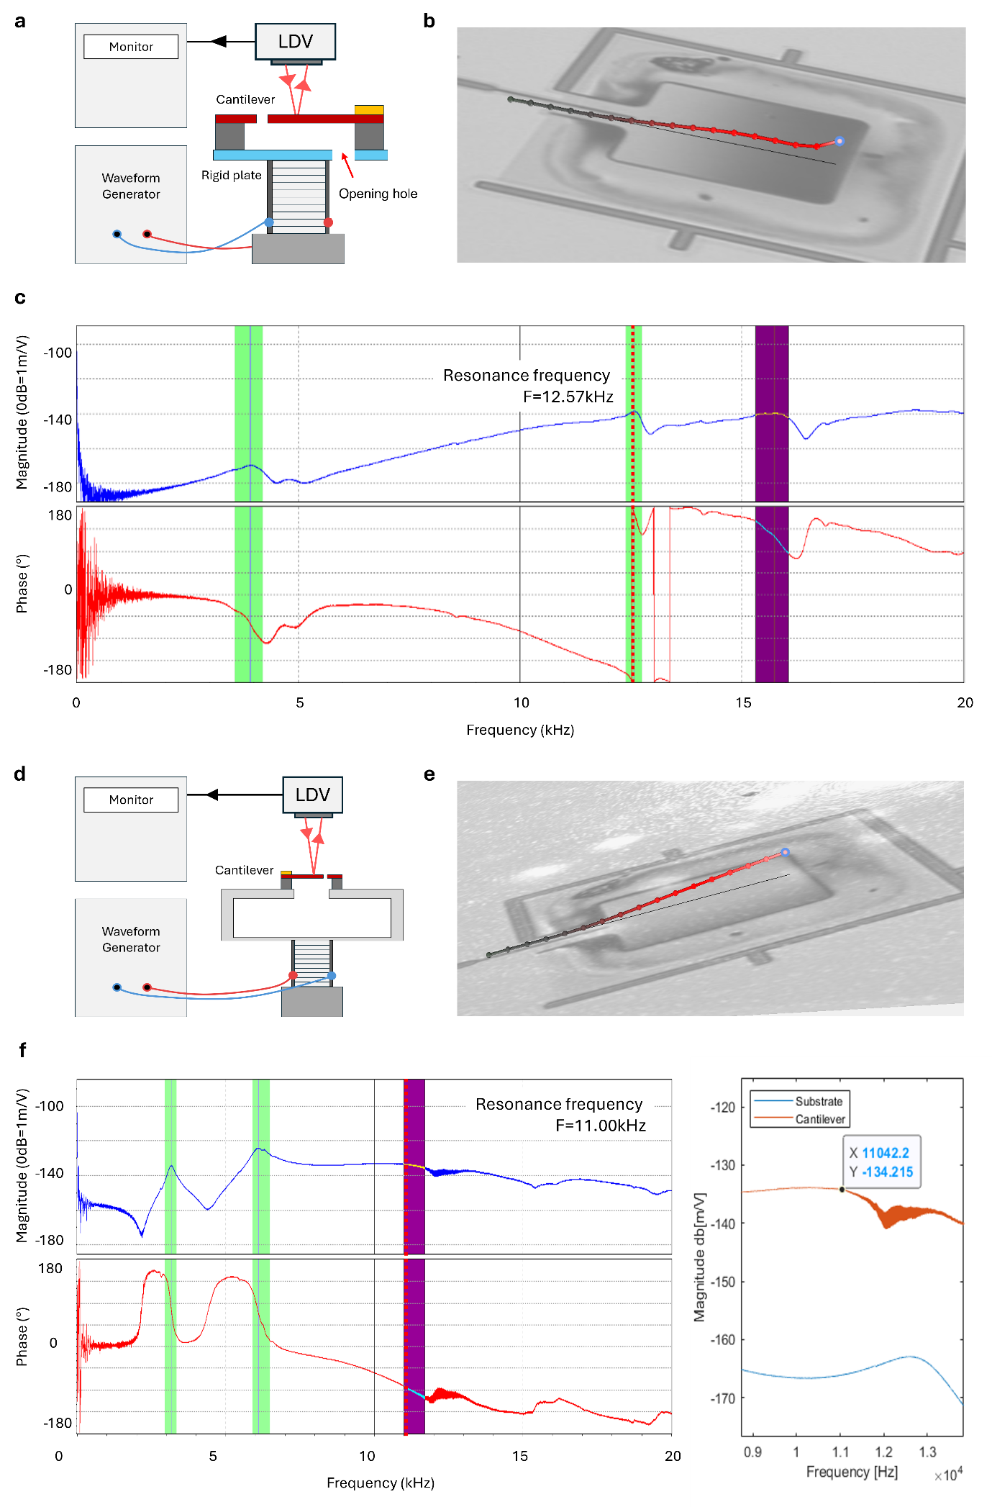
Supplementary Fig. 16 Damping effect validation of CPT. (a-c) Experimental setup and result of CPT 1st mode frequency without the chamber. (a) Experimental setup. (b) Image of the cantilever. (c) Magnitude and Phase response of the experiment, showing a 1st mode frequency at 12.57kHz. (d-f) Experimental setup and result of CPT 1st mode frequency with the chamber. (d) Experimental setup. (e) Image of the cantilever. (f) Magnitude and Phase response of experiment, showing a 1st mode frequency at 11.00 kHz.

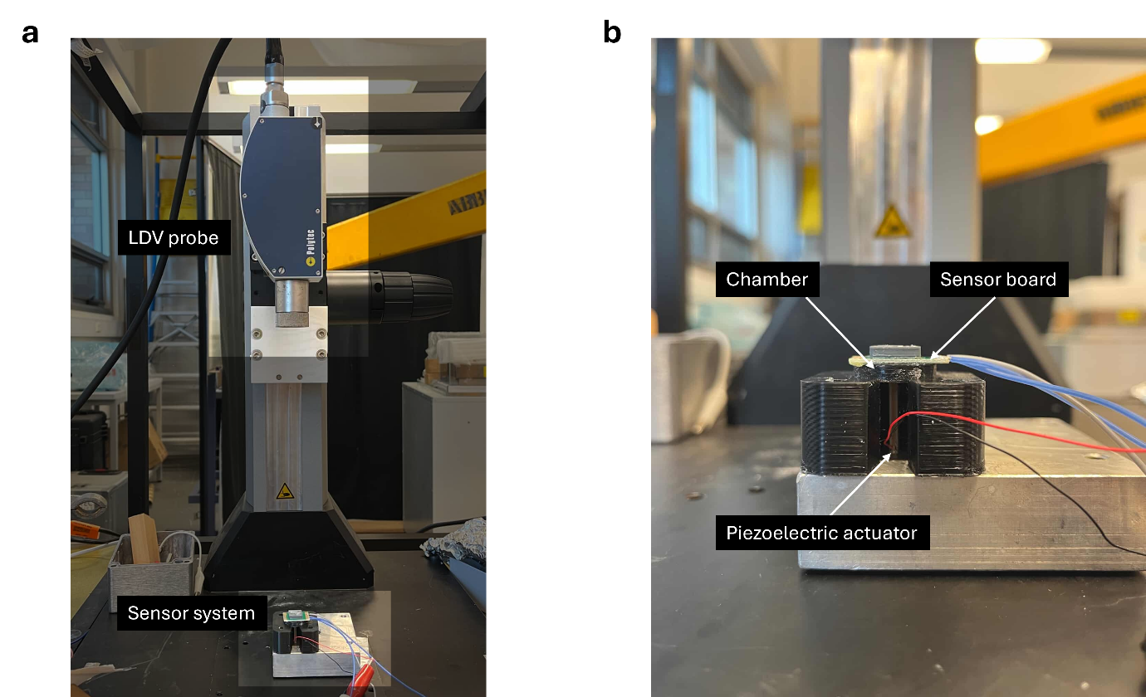

Supplementary Fig. 17 Experimental setup of high-frequency response validation. (a) A photograph of the LDV machine and the CPT-chamber system. (b) A zoomed-in photograph of the CPT-chamber system, showing a piezoelectric actuator underneath the device’s chamber to vibrate the device membrane.

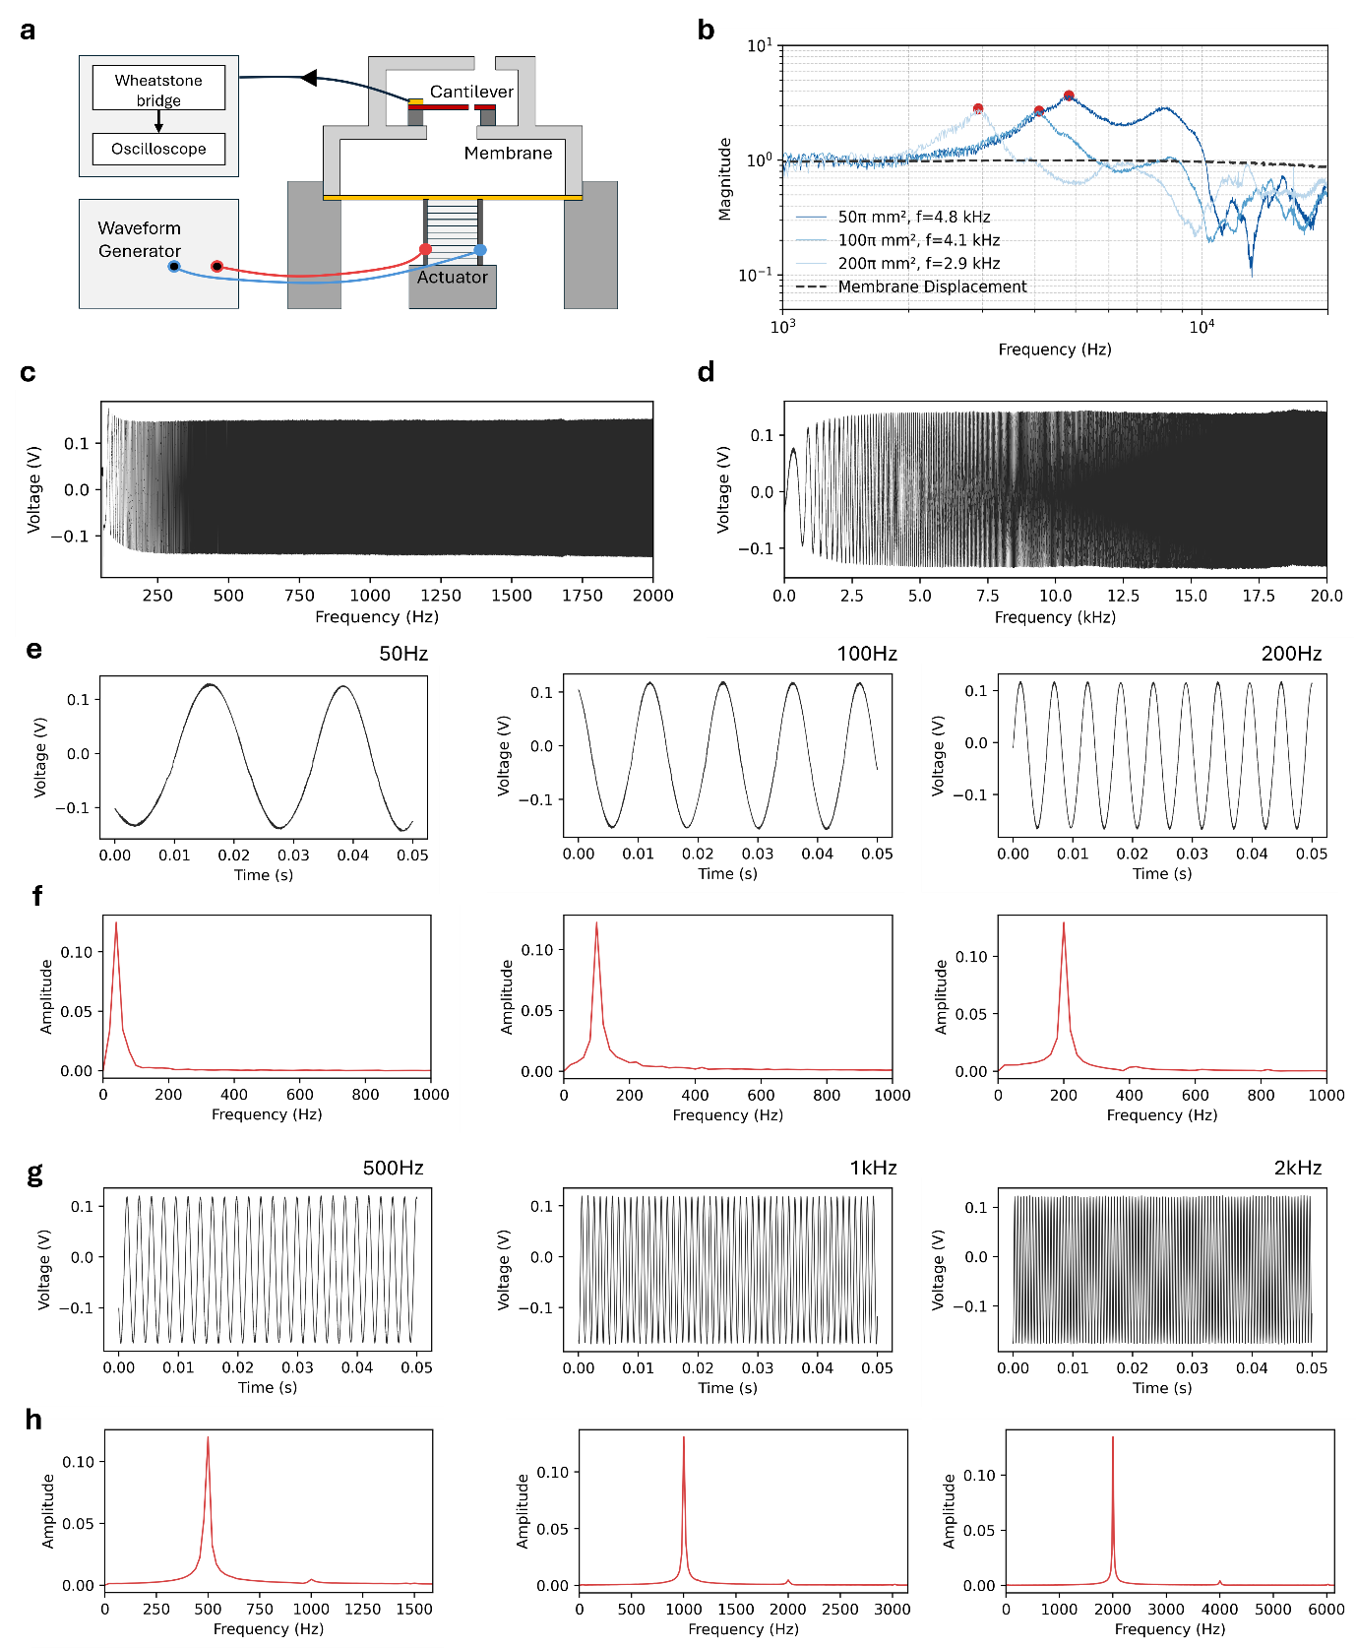
Supplementary Fig. 18 Validation of high-frequency response. (a) Experimental setup utilizing a piezoelectric stack actuator to characterize the frequency response. (b) Frequency response of CPT integrated with different chamber volumes (50π, 100π, and 200 π ${mm}^{3}$ across the 0–20 kHz range. (c–d) Swept-sine response data for the optimized chamber 50 π ${mm}^{3}$ in the high-frequency range (0–2000 Hz) (c) and low-frequency range (0–20 Hz) (d). (e–f) Time-domain signals responding to excitation frequencies of 50 Hz, 100 Hz, and 200 Hz (e) and corresponding FFT analysis (f). (g–h) Time-domain signals responding to excitation frequencies at 500 Hz, 1 kHz, and 2 kHz (g) and corresponding FFT analysis (h).
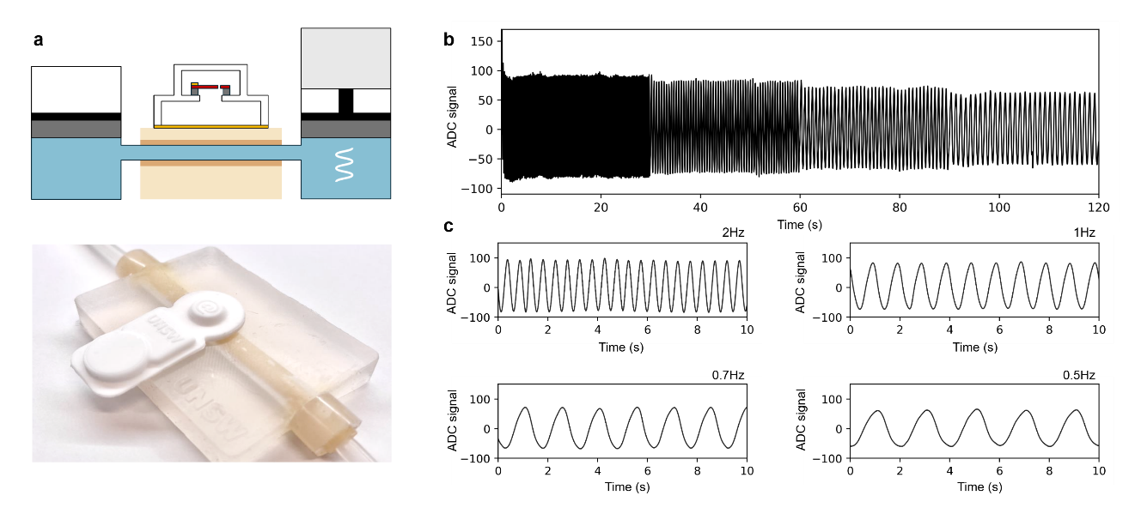
Supplementary Fig. 19 Experimental setup for the validation of AusculPatch in detecting pulsatile flow(a) Experimental setup with sine wave fluid flow pumping through an artificial vessel. (b) ADC change response to different applied frequencies 2Hz, 1Hz, 0.7Hz, and 0.5Hz (1mm displacement) with (c) 10s zoomed in on each frequency.

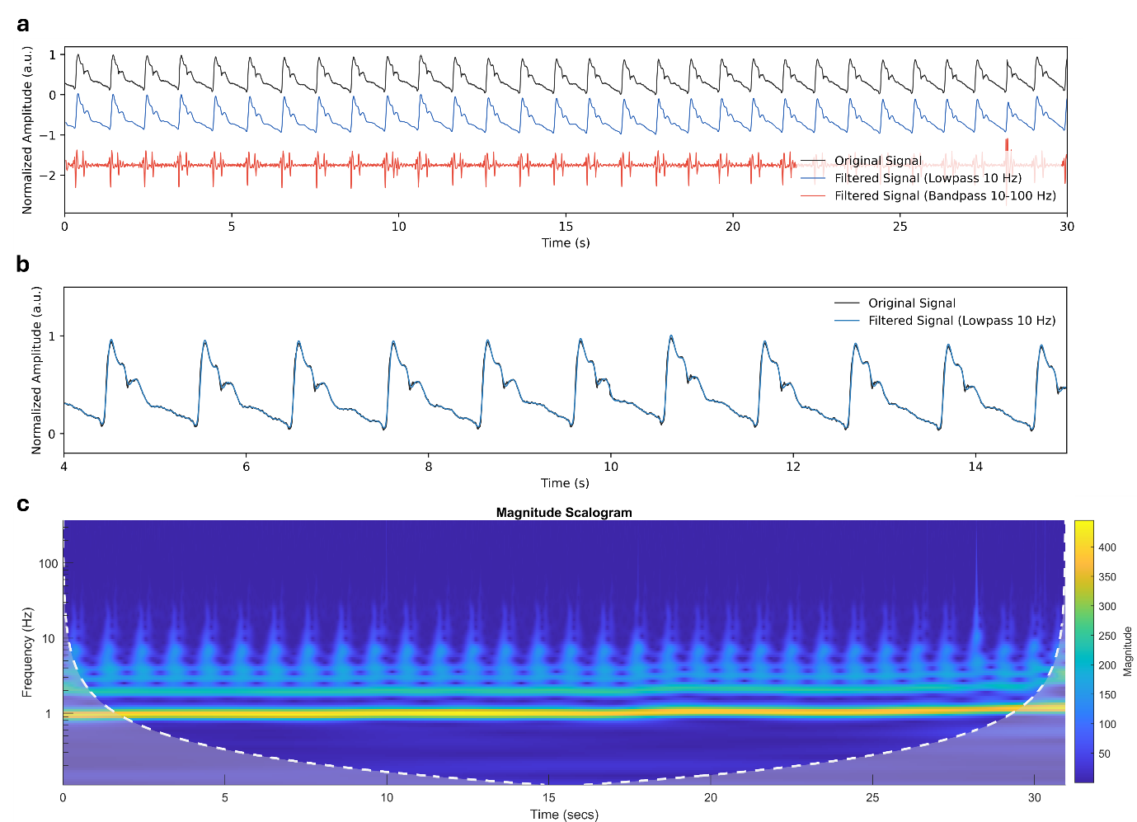
Supplementary Fig. 20 Carotid pulse wave measurement recorded from the side of the neck. (a) Raw signal collected from the side of the neck and the extracted pulse wave (<10Hz) and higher frequency component (>10Hz). (b) Overlapped signal comparing the extracted pulse wave and the raw signal, proving that CPT can capture high fidelity low frequency pulse wave form with minimal effect of other high-frequency components. (c) Wavelet spectrogram of the raw data.
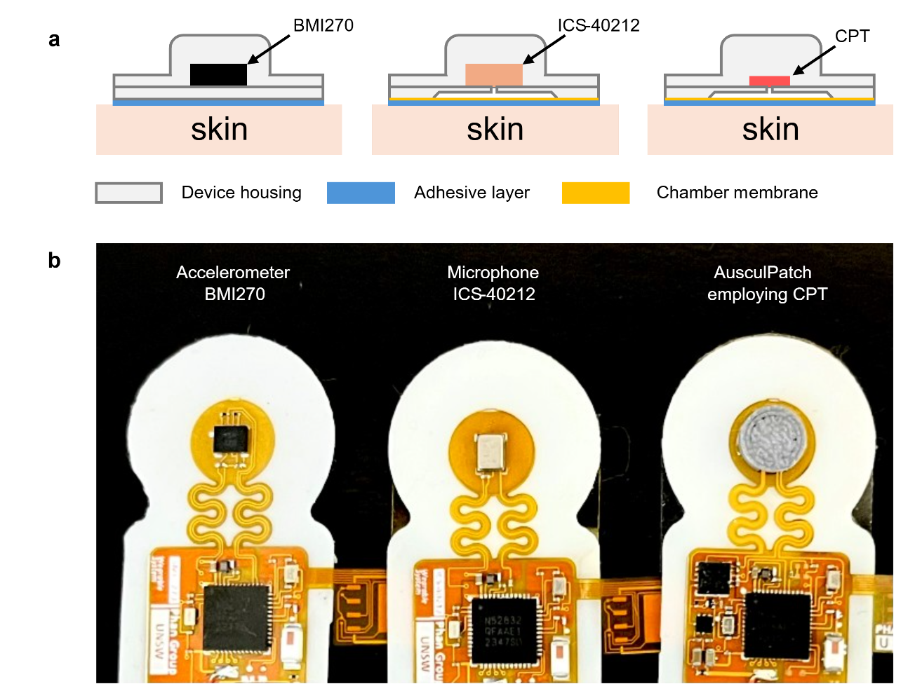

Supplementary Fig. 21 Three wearable designs employing (left to right) commercial IMU (BMI270), commercial microphone (ICS-40212), and CPT for comparison. (a) Cross-sectional images of the devices. (b) The fabricated devices without the top housing.

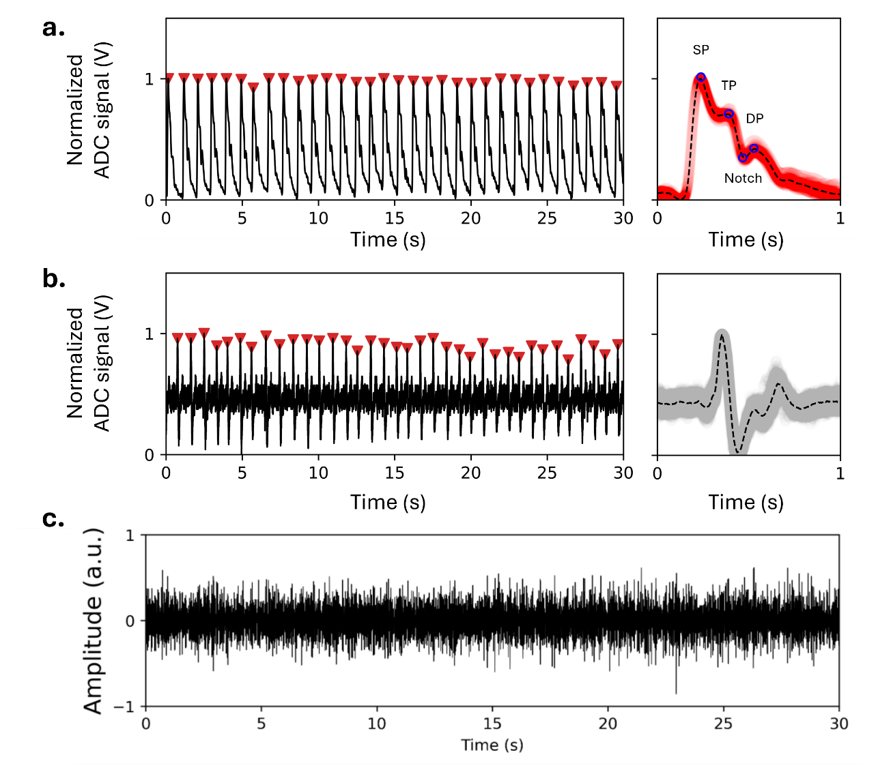
Supplementary Fig. 22 Pulse wave measurement using the AusculPatch and other commercial acoustic sensors. (a) Pulse wave measurement using the AusculPatch with the peaks and notch is well detected, and an overlaid plot showing a cycle of the detected pulse wave. The dashed line shows the mean ADC values of the data. (b) Pulse wave measurement using a commercial MEMS microphone ICS-40212 and an overlaid plot showing a cycle of the detected pulse wave. The dashed line shows the mean ADC values of the data. The microphone can detect pulse events, but failed to accurately capture the waveform. (c) MEMS accelerometer BMI-270 failed to detect pulse events.

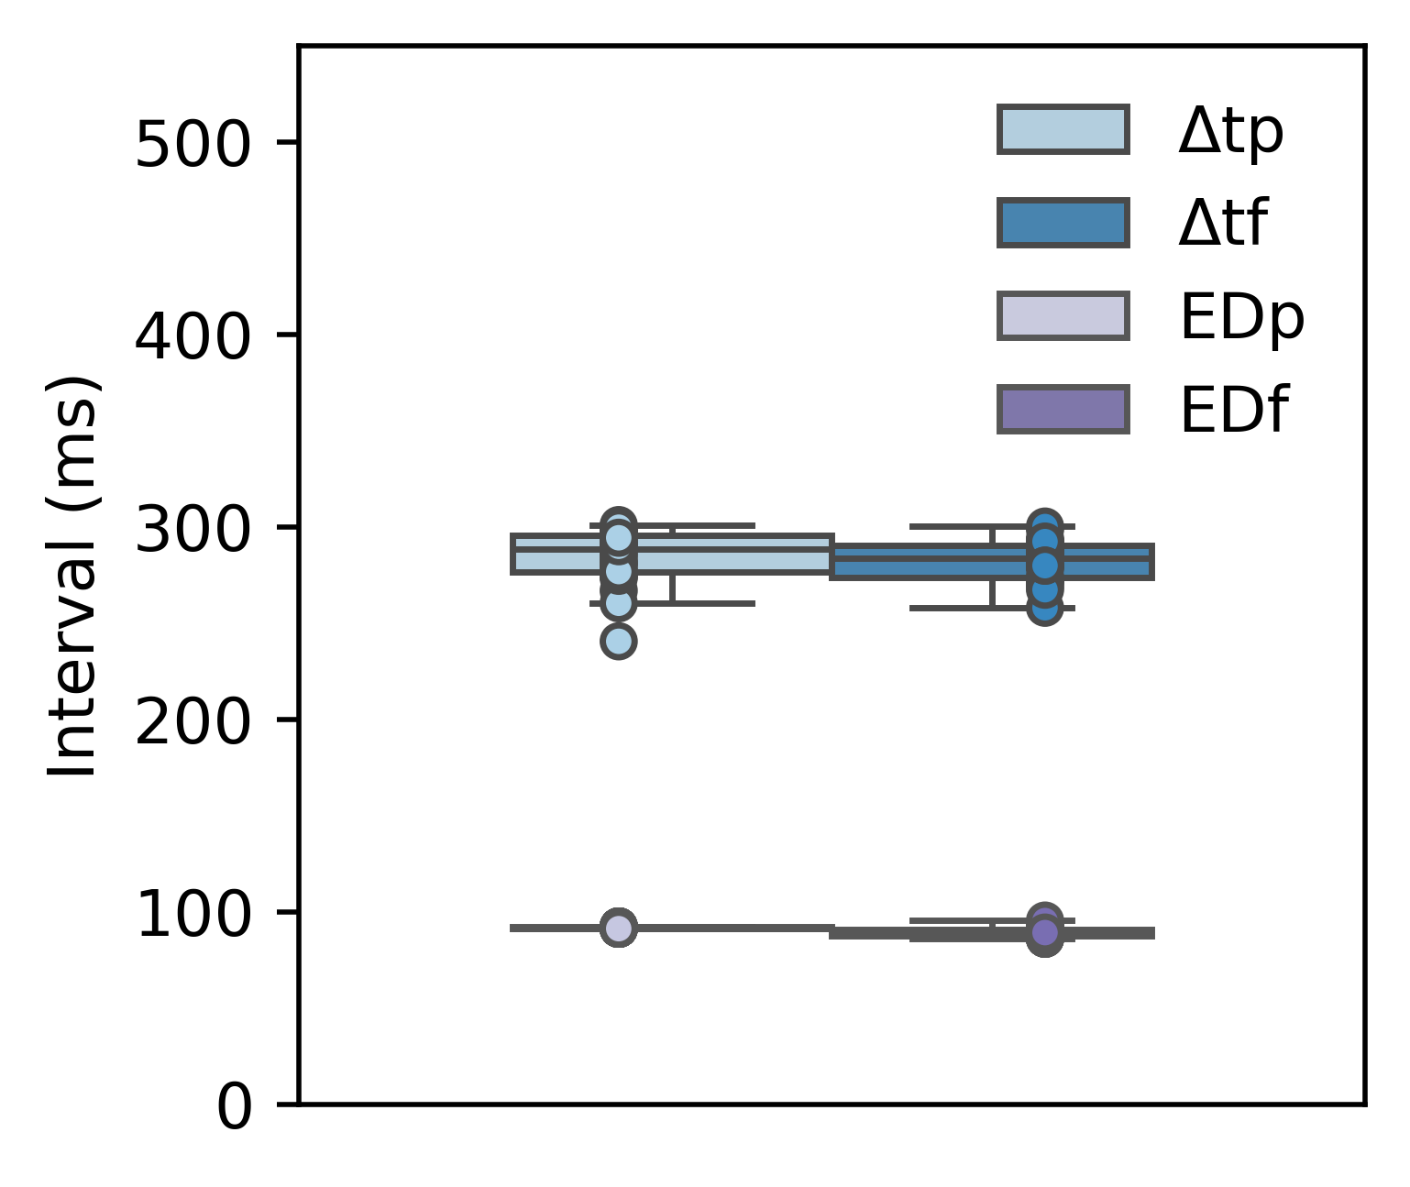
Supplementary Fig. 23 Temporal association of $Δtp$ and $Δtf$, and $EDp$ and $EDf$ between pulse waves recorded from AusculPatch and blood flow velocity waves scanned using an Ultrasound probe (measurement based on 30 pulse waves, n = 25). Boxes show range between the 25th and 75th percentiles, whiskers show range between the 5th and 95th percentiles and midline indicates the median of each dataset..

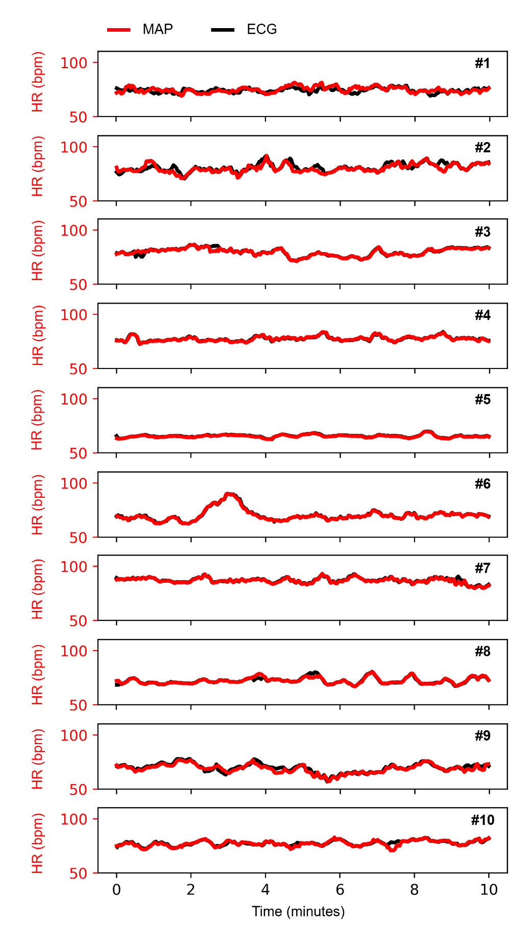
Supplementary Fig. 24 HR measurement recorded from AusculPatch within 10 minutes from 10 subjects, in comparison with ECG

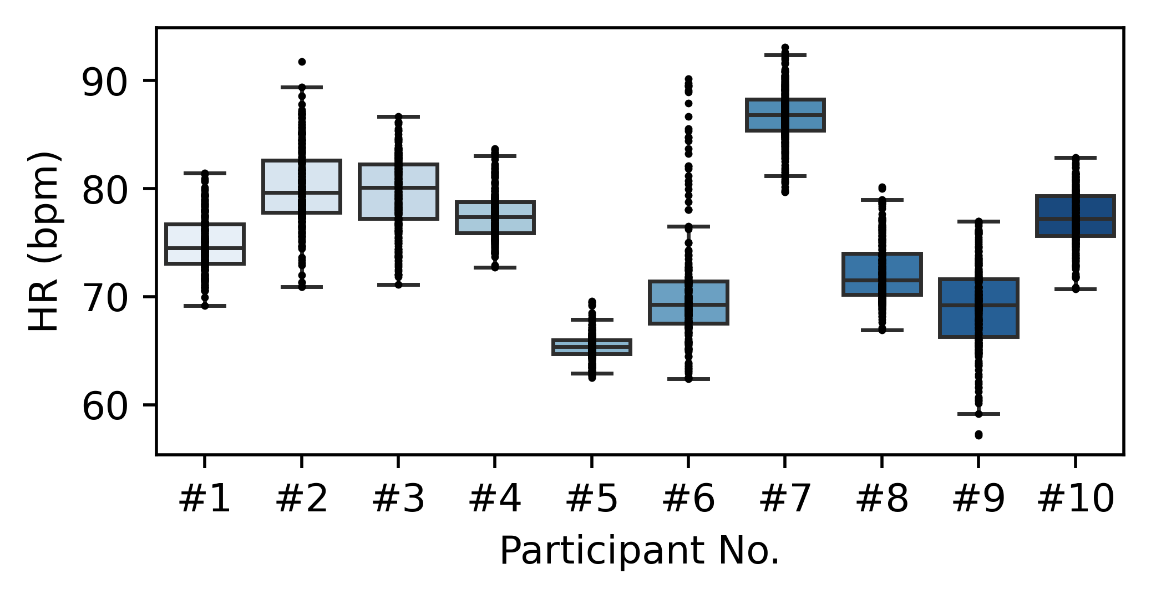Supplementary Fig. 25 Box plots showing HR distributions recorded from 10 participants within 10 minutes using AusculPatch (n = 249, 267, 265, 258, 218, 234, 290, 241, 230, 258, corresponding to subjects #1 to #10, respectively). Boxes show range between the 25th and 75th percentiles, whiskers show range between the 5th and 95th percentiles and midline indicates the median of each dataset.

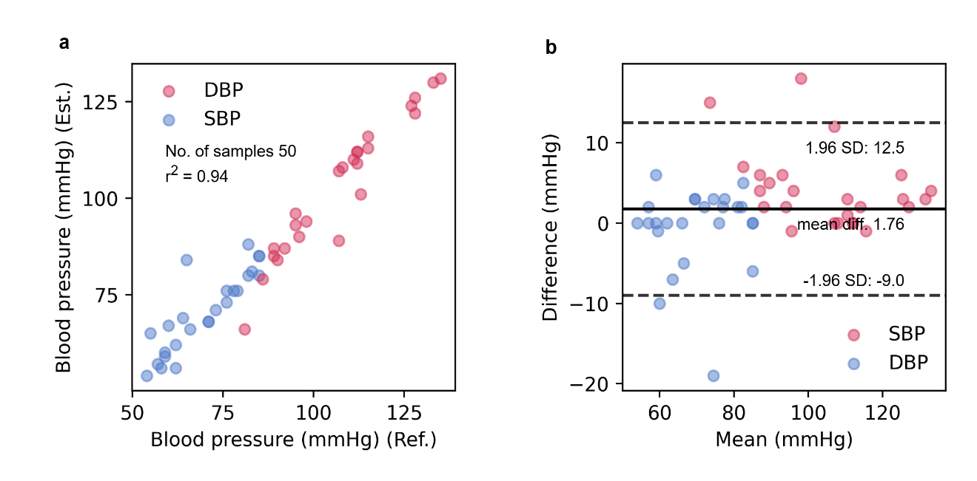
Supplementary Fig. 26 Benchmarking BP measured using AusculPatch with the Omron device. (a) Correlation plot of HR measurement between AusculPatch and reference ECG illustrating linear curve fit with r² = 0.94. (b) Bland-Altman plot with 1.76 bpm difference and a standard deviation of 5.48 mmHg.

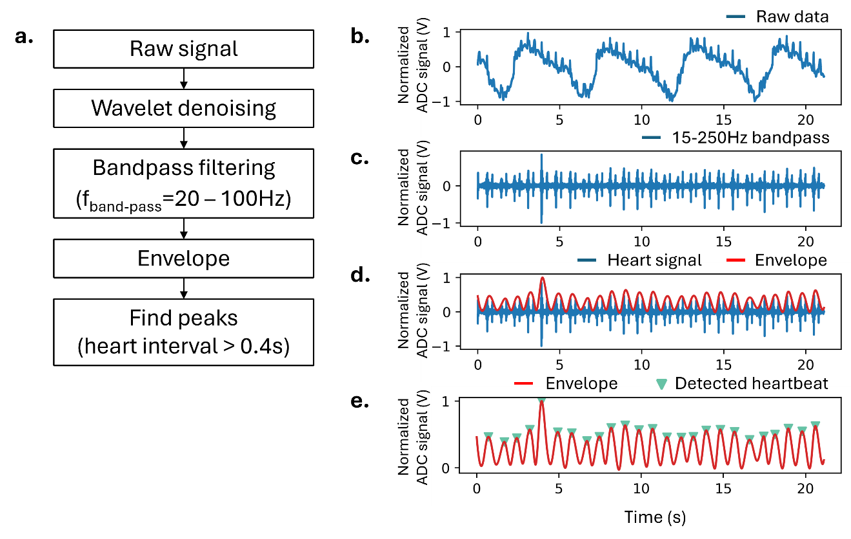
Supplementary Fig. 27 Algorithm for determining the heartbeats from the cardiorespiratory signal. (a) Block diagram of signal processing flow for heartbeat detection. (b) Raw ADC signal recorded from a human. (c) Bandpass filtered signal from 30 to 250Hz. (d) Detected envelope of the filtered signal. (e) Detected heartbeat using the find-peaks algorithm.

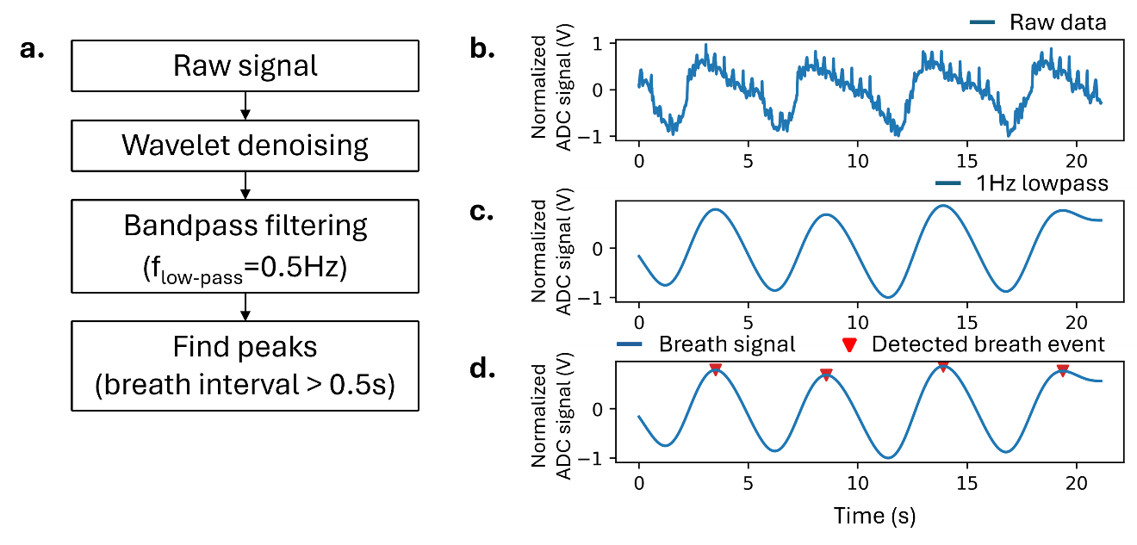
Supplementary Fig. 28 Algorithm for determining the breath events from the cardiorespiratory signal. (a) Block diagram of signal processing flow for breath event detection. (b) Raw ADC signal recorded from a human. (c) Lowpass filtered signal at 1Hz. (d) Detected breath events using the find-peaks algorithm.

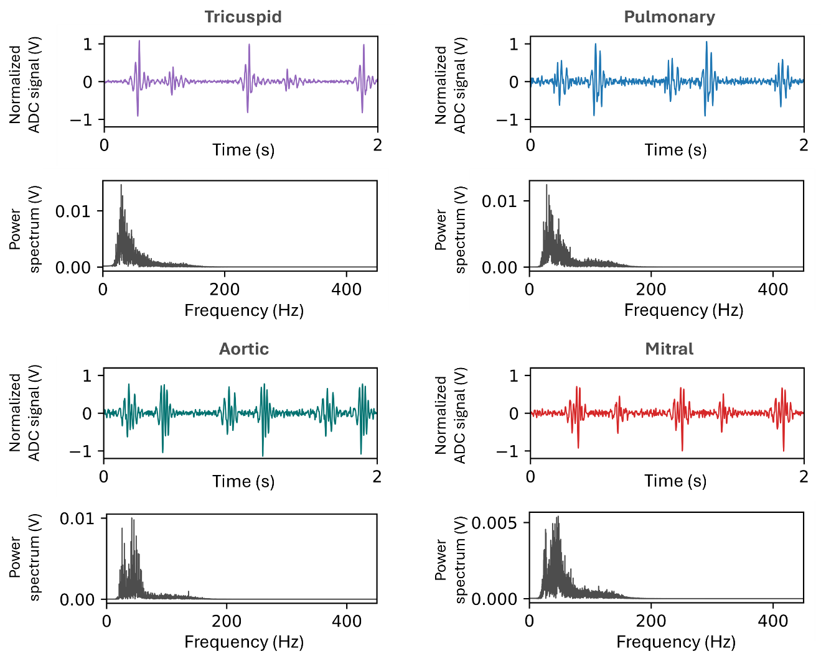
Supplementary Fig. 29 Time-domain plot and frequency-domain plot of heart sounds captured using the AusculPatch, measured at different positions on the chest wall.

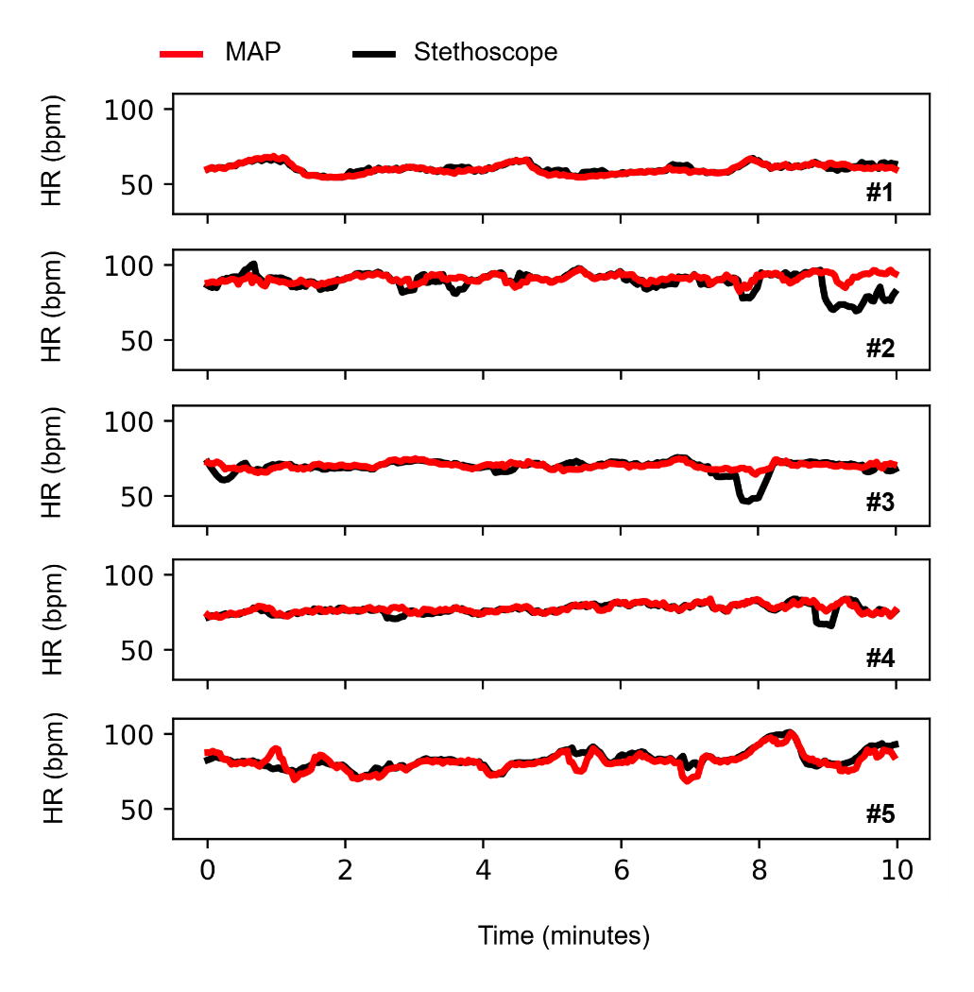
Supplementary Fig. 30 HR measurement recorded from AusculPatch within 6 minutes from 4 subjects, in comparison with the Littmann stethoscope.

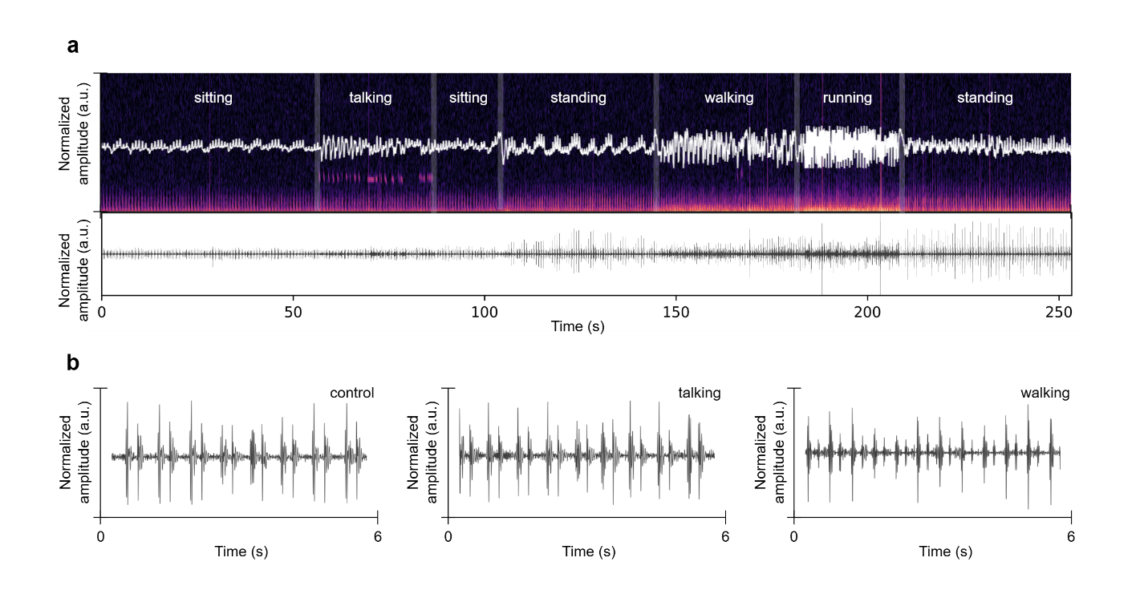
Supplementary Fig. 31 Heart sounds measured by AusculPatch during different activities (control (sitting and standing), talking, walking, and running). (a) The time-domain and frequency-domain of the raw signal, and the corresponding extracted heart sounds from measured data. (b) Zoomed-in data showing clear heart sounds measured in control, talking, and walking activities.
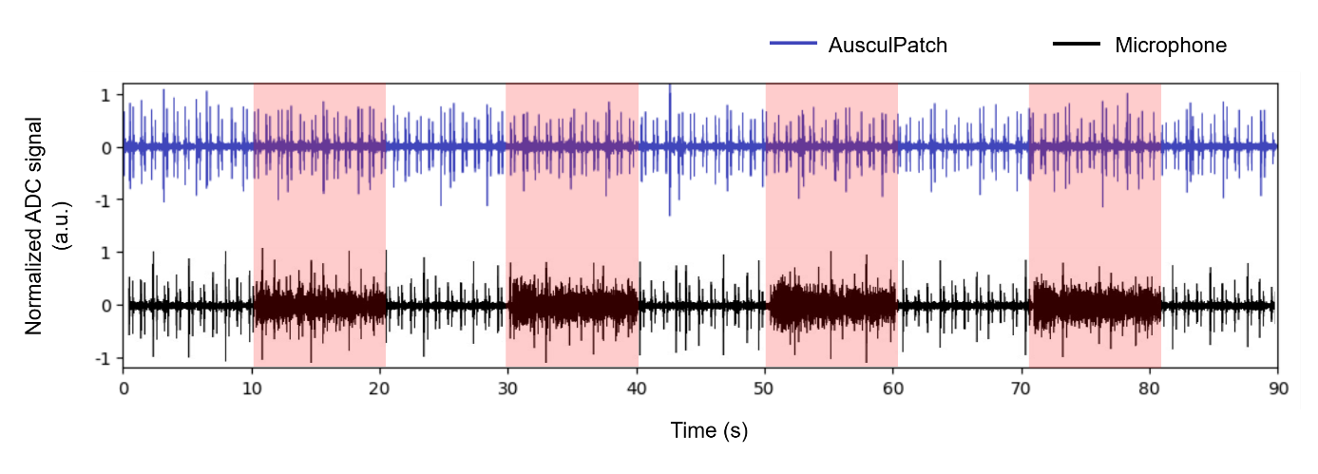
Supplementary Fig. 32 Heart sounds auscultation in a noisy environment using AusculPatch and a device employed commercial microphone ICS-40212. White noise was played every 10 seconds, lasting 10 seconds. The figure shows that the AusculPatch signal quality remained unaffected by the ambient noise, whereas the microphone signal became noisy whenever the white noise was triggered.
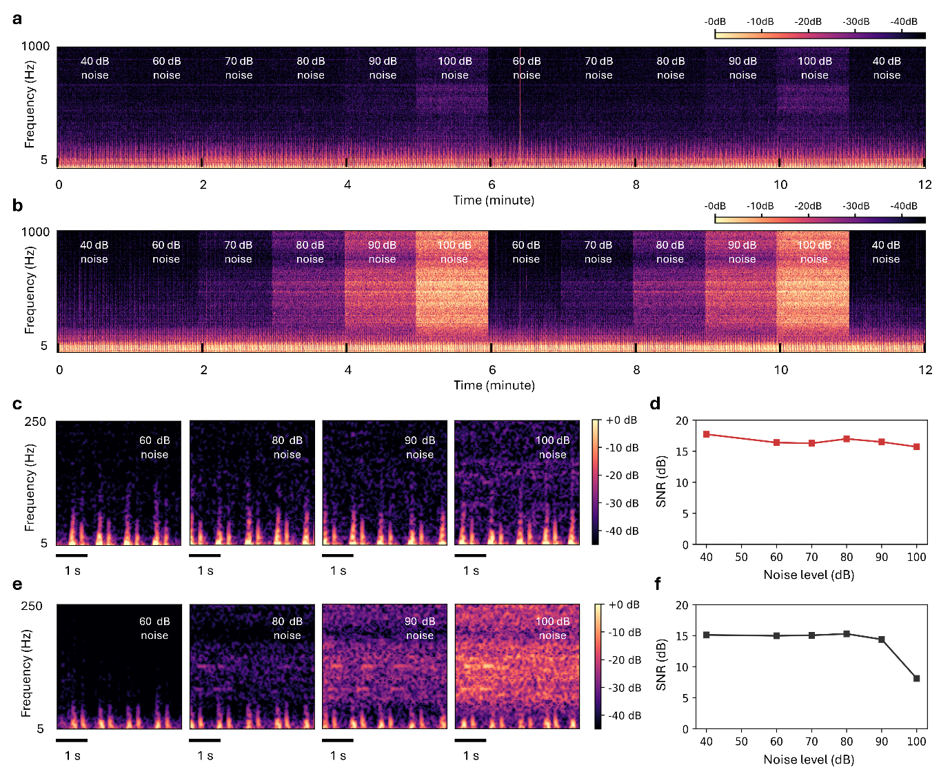
Supplementary Fig. 33 Cardiac signals recorded using the AusculPatch under white-noise conditions. (a, b) Mel-spectrograms of heart sounds with different white noise levels captured by the AusculPatch (a) and the microphone (b). (c–f) Magnified views of signals in the 5–250 Hz frequency range and the corresponding signal-to-noise ratios of cardiac signals measured at different white-noise levels from the AusculPatch (c, d) and the microphone (e, f), respectively. The error bars refer to the 2 standard deviations on the basis of 100-cycle measurements from the same sound frequency and membrane size (n = 100).

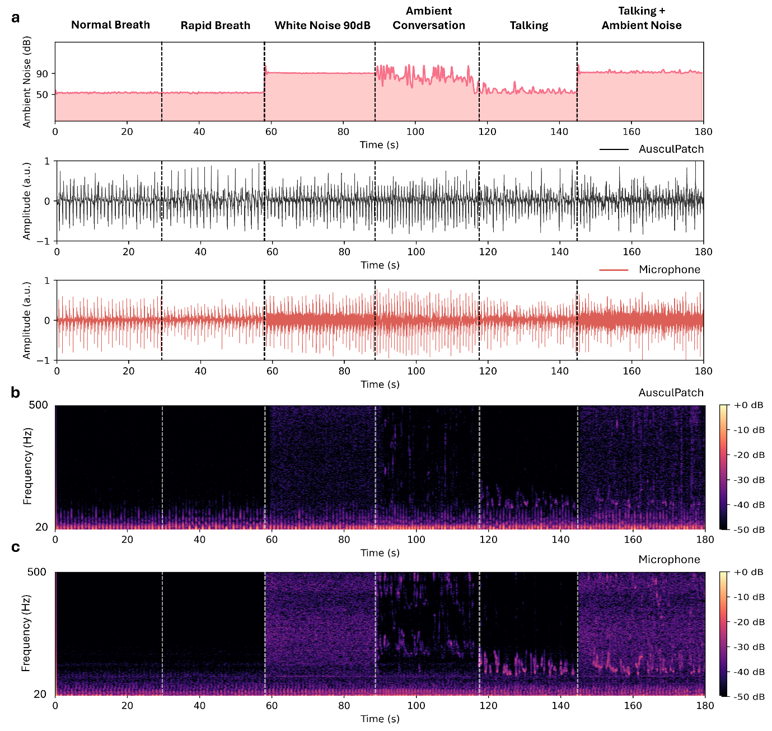
Supplementary Fig. 34 Recorded data in different ambient noise. (a) Comparative time-domain recordings: (Top) Measured ambient noise levels, (Middle) AusculPatch signal, and (Bottom) Reference microphone signal across five conditions: Normal, Rapid Breath, White Noise (90 dB), Conversation, and Mixed Noise. (b) Mel-spectrogram of the AusculPatch data. (c) Mel-spectrogram of the Microphone data, showing significant contamination by broadband environmental noise.

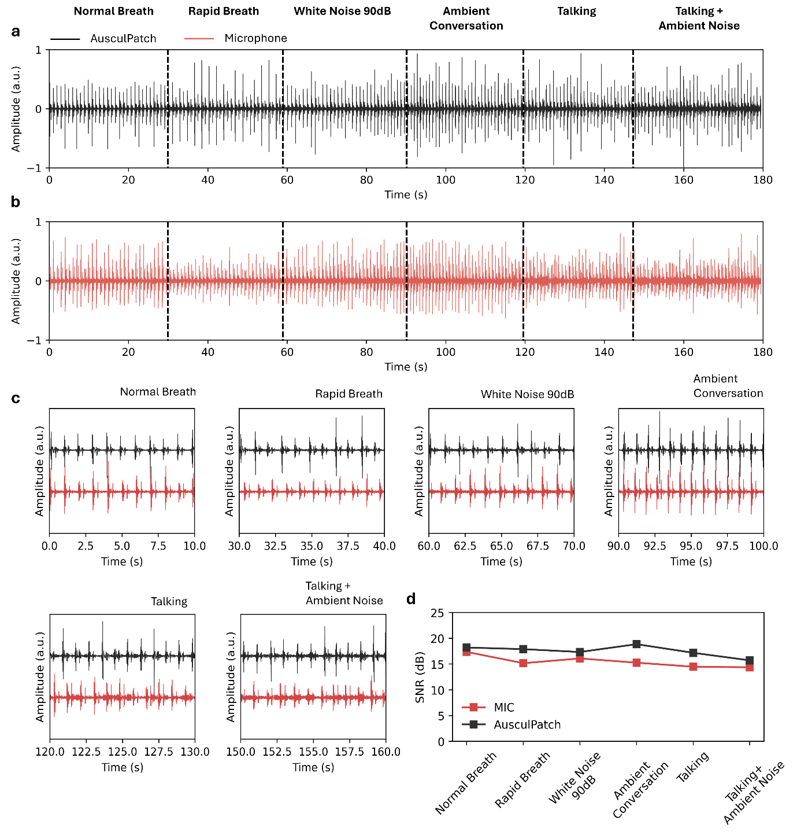
Supplementary Fig. 35 Extraction of cardiac signals under noise. (a–b) Cardiac signal recordings from the AusculPatch (a) and Microphone (b) under varying noise conditions. (c) Zoomed-in waveform comparison. The AusculPatch consistently resolves individual heartbeats with high fidelity, whereas the microphone signal is obscured by ambient interference in noisy scenarios. (d) Cardiac SNR quantitative of AusculPatch and Microphone under varying noise conditions.

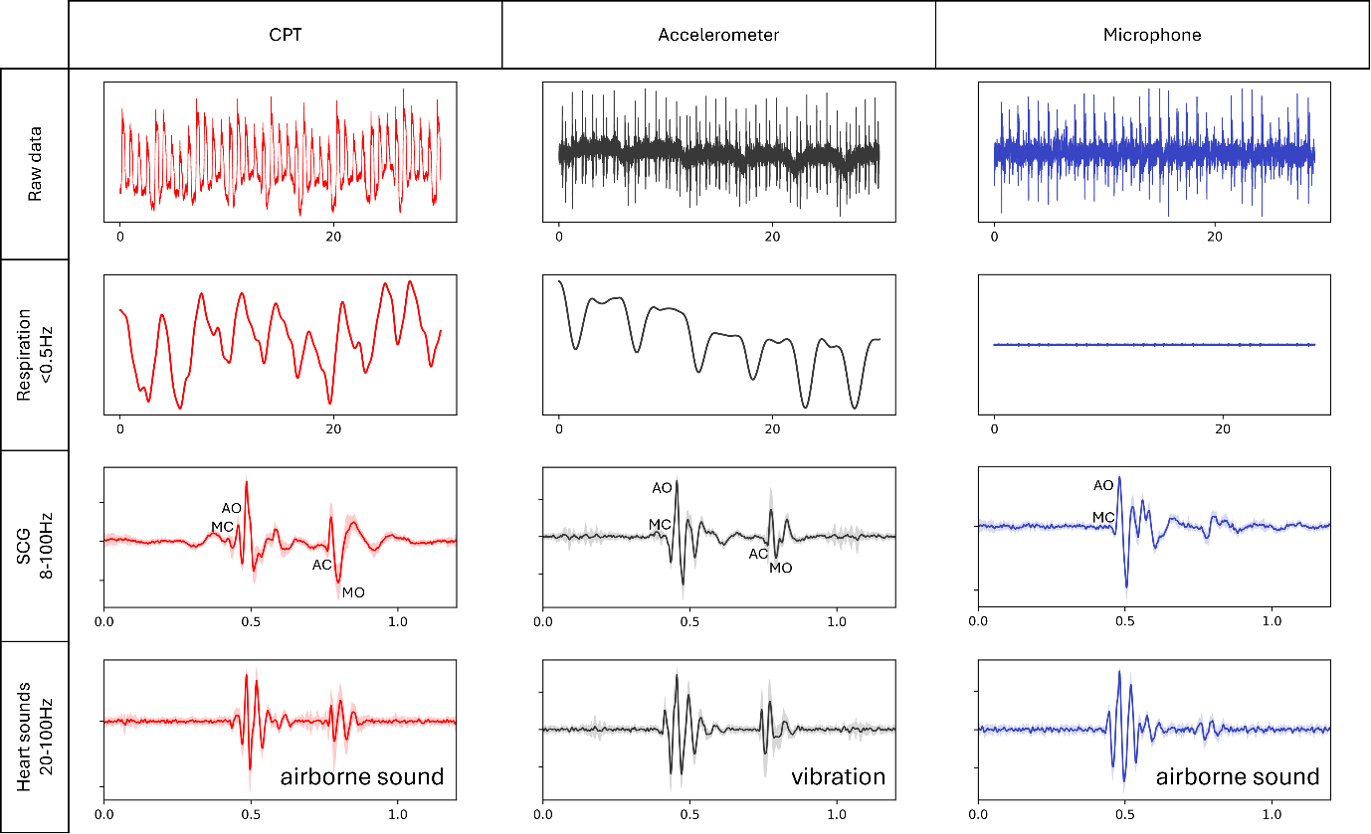
Supplementary Fig. 36 Cardiorespiratory measurement using AusculPatch, Accelerometer (BMI270), and Microphone (ICS-40212) attached to the chest wall. The microphone failed to detect the low-frequency respiration signal and the high-fidelity cardiac mechanical events, such as the opening of the aortic valve (AO) and the closing of the mitral valve (MC).

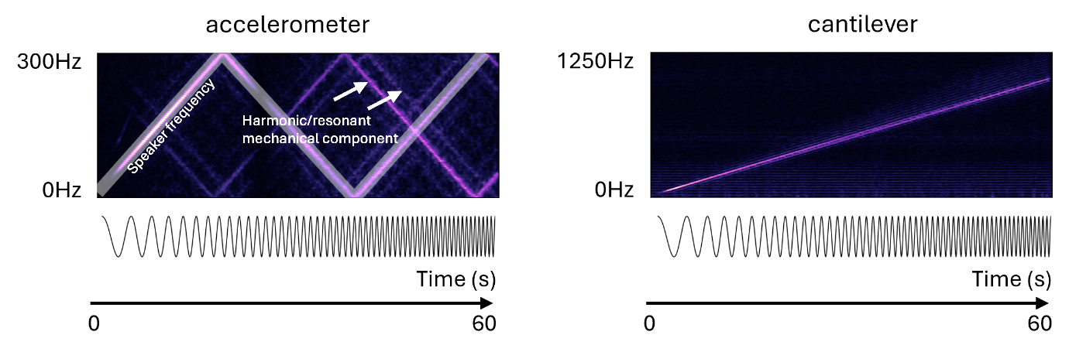
Supplementary Fig. 37 Sound sweep signal (10Hz – 1000Hz) capturing using AusculPatch and Accelerometer (BMI270). The figure reveals that conventional accelerometers are susceptible to high-order harmonic or resonant mechanical components, leading to the distortion of the acoustic signal, while the cantilever sensor captured sweep sounds with high fidelity. Furthermore, the limited sampling rate of digital accelerometers restricts the ability to capture high-frequency sounds.

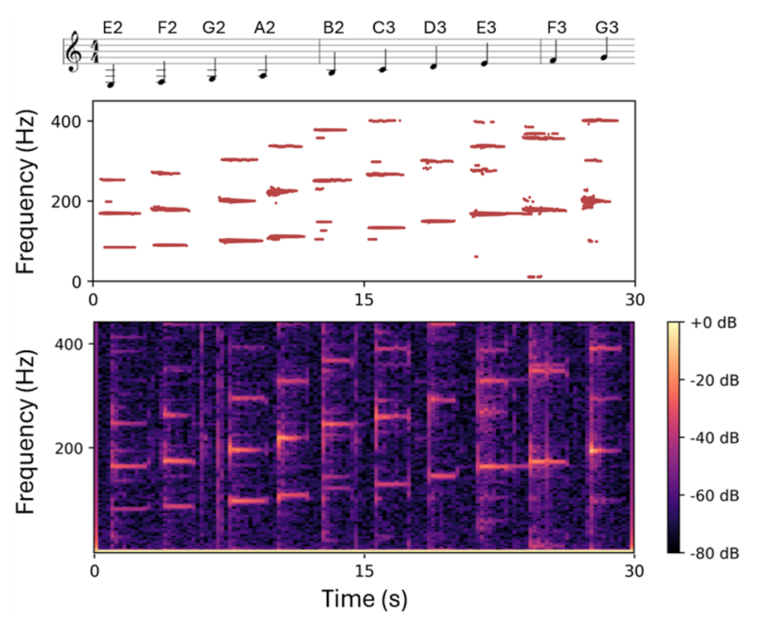
Supplementary Fig. 38 Record a piece of music from a Guitar with AusculPatch.
(E2: 82.4Hz F2: 87.3Hz G2: 98.0Hz A2: 110.0Hz B2: 123.5Hz
C3: 130.8Hz D3: 146.8Hz E3: 164.8Hz F3: 174.6Hz G3: 196.0Hz)

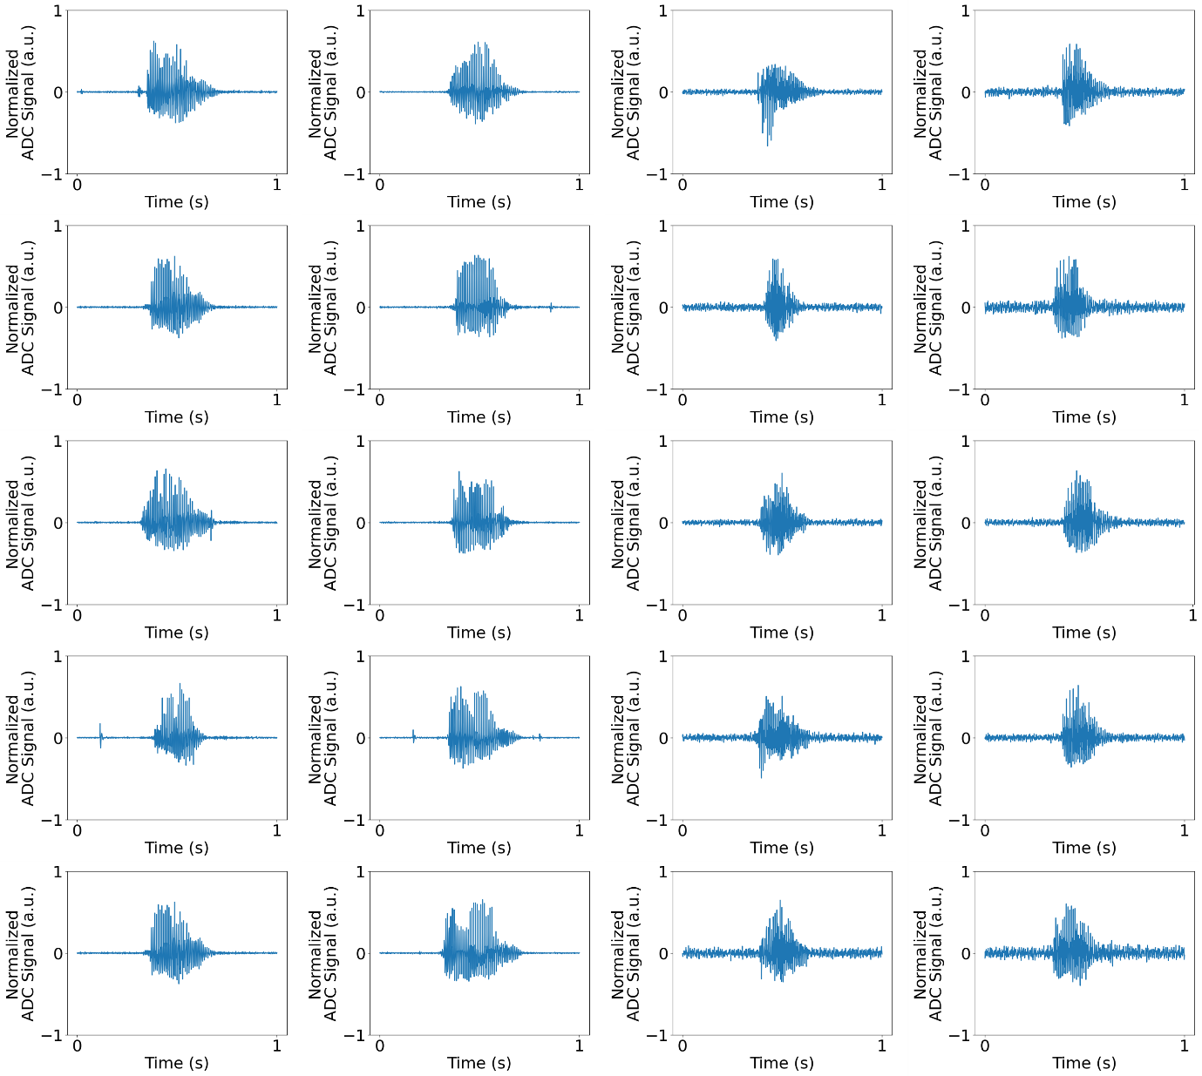
Supplementary Fig. 39 Time domains signal showing (a) vocal cord vibrations recorded from AusculPatch attached to the throat and (b) airborne sounds recorded from CPT located in front of the participant’s mouth, when speaking “one” and “no”. Both signals were frequency filtered with a high-pass filter (cut-off low frequency 80Hz). The vocal cord vibration recordings showed a higher SNR compared to the airborne sound recordings, thanks to the presence of the cone-shaped chamber, which focused sound energy passing through the elastic membrane to the CPT.
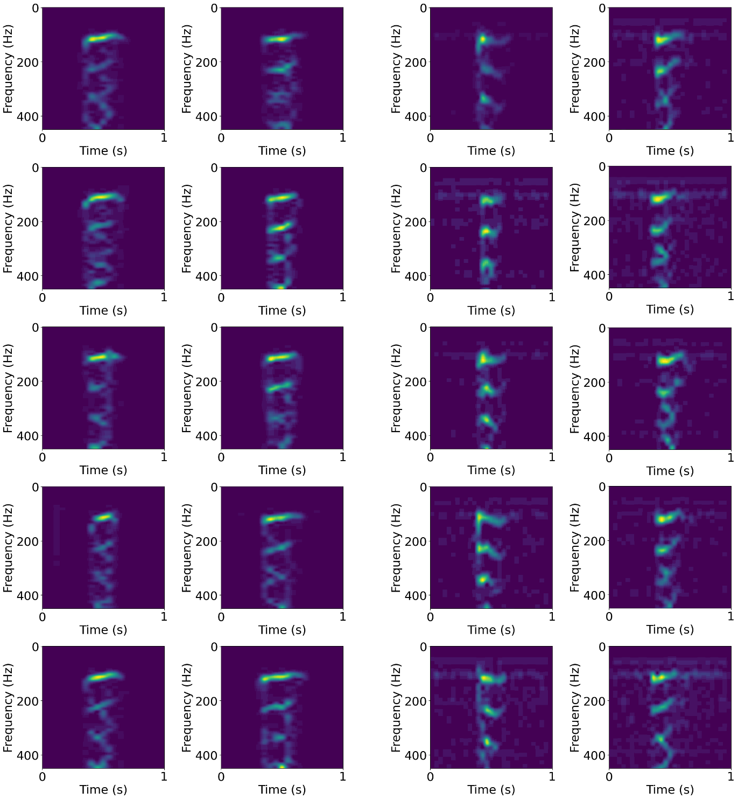
Supplementary Fig. 40 Spectrogram image showing frequency domain of (a) vocal cord vibrations recorded from AusculPatch attached to the throat and (b) airborne sounds recorded from CPT located in front of the participant’s mouth, when speaking “one”, and “no”. Although the vocal cord vibration recordings showed a higher SNR, the airborne sound recordings presented brighter patterns in high-frequency (above 200Hz), showing clearer differences in the spectrogram of “one” and “no”. This implies that, when the sound passed through the throat skin, high-frequency components of sound were attenuated, resulting in a similar perception between some words, such as “one” and “no”, as illustrated above.

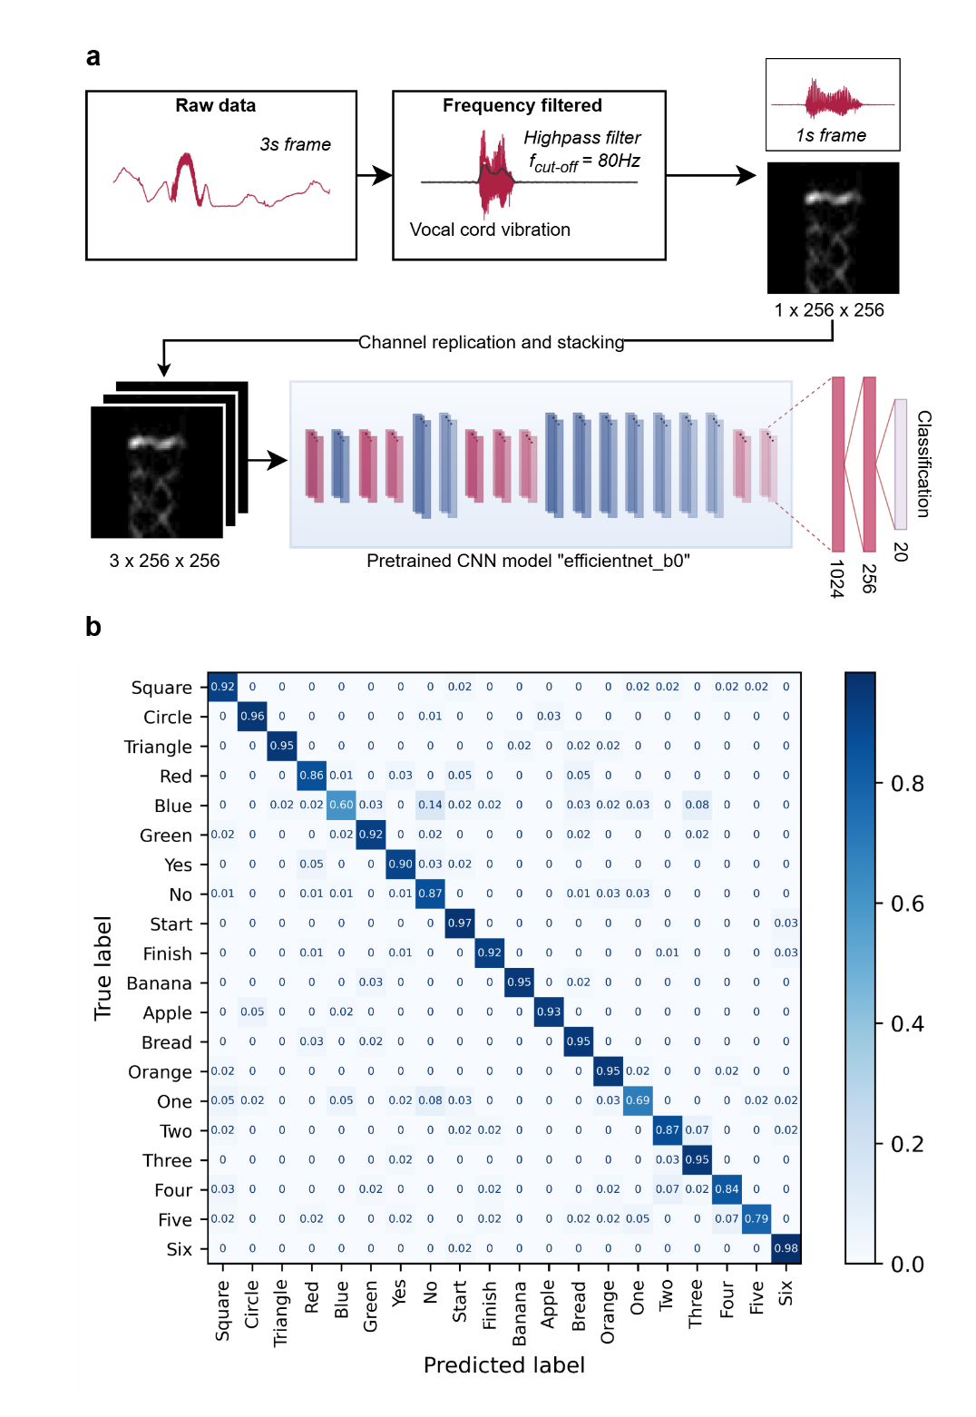
Supplementary Fig. 41 Machine Learning model trained with only the high-frequency vocal cord vibration signal. (a) The block diagram illustrates the model's architecture. (b) The confusion matrix figure presents the training result of the model, with low accuracy in classifying the words “one”/”no” and “blue”/”no”.

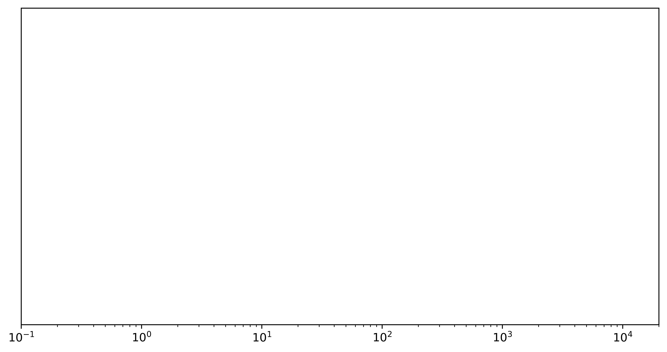
Supplementary Fig. 42 Frequency distribution of human cardiorespiratory signals (top) and a comparison between AusculPatch’s bandwidth and other studies (bottom).
HR (4)

~0Hz

10kHz

1Hz

100Hz

10Hz

1kHz

This work

Commercial MIC

Commercial IMU

ACM (2)

Wearable Piezoelectret Patches (3)
Triboelectric stethoscope (1)

BMS (5)

Human audible range

Heart sounds

SCG cardiac

Pulse waves

Respiration

Korotkoff sounds

Cardiorespiratory signals

Wearable devices

Frequency

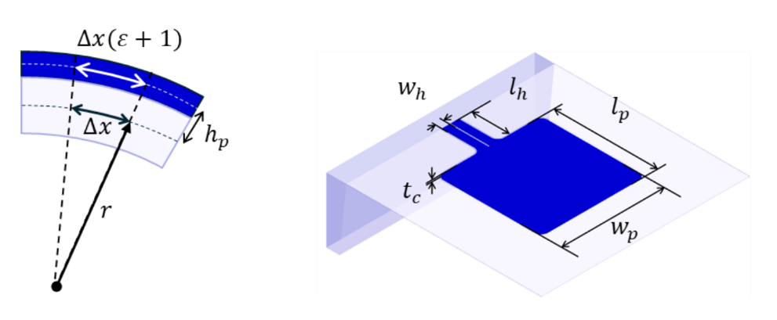

Supplementary Fig. 43 Definition of the CPT’s design parameters

Supplementary Note S1 Analytical Model of the Cantilever Element
When the differential pressure reaches the cantilever membrane, it causes the cantilever to deform. The longitudinal deformation of an element $∆x$ can be expressed as follows (with design parameters defined in Supplementary Fig. 43):
$$ε=\frac{h_{p}}{r}$$ | (1)
Where $h_{p}$ is the distance between the piezoresistive layer and the neutral axis, $r$ is the bending curvature radius of the element $∆x$ under applied pressure. Given that the deflection of the cantilever is small, the stress of the cantilever surface along the longitudinal direction can be expressed using Young’s modulus $E$:
$$σ=E×ε$$ | (2)
The differential equation of a cantilever for a small deflection is given by:
$$r=\frac{d^{2}y(x)}{dx^{2}}=\frac{E.I}{M}$$ | (3)
Where $M$is the bending moment, $E$ is Young's modulus, and $y(x)$ is the deflection along the cantilever beam. $I$ is the moment of inertia of the cross-section with respect to the neutral axis of the cantilever.
From Supplementary Equations (1-3), the stress along the longitudinal direction can be expressed through the bending moment as follows:
$$σ=\frac{Mh_{p}}{I}$$ | (4)
Given $π_{l}$ is a constant showing the relationship between the change in resistance and the stress caused in the longitudinal direction, then, the fractional resistance changes of the cantilever beam $ΔR/R$ is
$$\frac{∆R}{R}=\frac{π_{l}}{l_{h}}\int_{0}^{l_{h}}{σdx}=\frac{π_{l}}{l_{h}}\int_{0}^{l_{h}}{\frac{Mh_{p}}{I}dx}$$ | (5)
The moment of inertia I is given by:
$$I=\left\{\begin{aligned}\frac{w_{h}{t_{c}}^{3}}{6}, &0≤x≤l_{h} \\ \frac{w_{p}{t_{c}}^{3}}{12}, &l_{h}<x≤l_{h}+l_{p}\end{aligned}\right.$$ | (6)
When a differential pressure $∆P$ is applied equally across the cantilever surface, the bending moment $M$ is calculated using the following equation:
$$M=\left\{\begin{aligned}\frac{∆Pw_{p}\left[2l_{p}\left(l_{h}-x\right)+{l_{p}}^{2}\right]}{2}+2×\frac{∆Pw_{h}{\left(l_{h}-x\right)}^{2}}{2}, &0≤x≤l_{h} \\ \frac{∆Pw_{p}(l_{h}+{l_{p}-x)}^{2}}{2}, &l_{h}<x≤l_{h}+l_{p}\end{aligned}\right.$$ | (7)
Finally, integrating Supplementary Equations (5-7), the sensitivity can be expressed:
$$\frac{∆R}{R}=∆P×\frac{2×π_{l}×h_{p}}{{t_{c}}^{3}}×\left[{l_{h}}^{2}+\frac{3\frac{w_{p}}{w_{h}}×l_{p}(l_{h}+l_{p})}{2}\right]$$ | (8)

Supplementary Note S2 Resonance validation
Theoretical analysis
We employed the Rayleigh-Ritz method to approximate the fundamental natural frequency of the cantilever system. According to the Rayleigh-Ritz formulation, the angular velocity of the first mode of vibration is given by:
$${w_{CPT}}^{2}=\frac{\int_{0}^{L}{EI(x){\left[y^{''}(x)\right]}^{2}dx}}{\int_{0}^{L}{ρA(x){\left[y(x)\right]}^{2}dx}}$$ | (9)

where $EI(x)$is the flexural rigidity of the cantilever; $ρA(x)$ is the mass per unit length; and $y(x)$is the assumed mode shape function satisfying the boundary conditions.
The differential equation of a cantilever for a small deflection is given by:
$$\frac{d^{2}y(x)}{dx^{2}}=\frac{E.I}{M}$$ | (10)
Where $M$ is the bending moment, $E$ is Young’s modulus, and $y(x)$ is the deflection along the cantilever beam. $I$ is the moment of inertia of the cross-section with respect to the neutral axis of the cantilever.
$${w_{CPT}}^{2}=\frac{\int_{0}^{l_{h}}{\frac{{M_{1}}^{2}}{EI_{1}}dx}+\int_{0}^{l_{h}+l_{p}}{\frac{{M_{2}}^{2}}{EI_{2}}dx}}{\int_{0}^{l_{h}}{ρt_{c}(2w_{h})}{y_{1}}^{2}dx+\int_{l_{h}}^{l_{h}+l_{p}}{ρt_{c}w_{p}}{y_{2}}^{2}dx}$$
Solving the fundamental frequency with parameters presented in Supplementary Table 1, the Rayleigh-Ritz method yields a theoretical first mode at 11.9 kHz. This value shows solid agreement with the Finite Element Analysis (FEA) simulation data presented in Supplementary Fig. 8.
Experimental Validation
To validate the theoretical analysis, we conducted a frequency sweep experiment on the bare CPT sensor. As shown in Supplementary Fig. 9a, the CPT sensor was mounted directly onto a piezoelectric stack actuator (SA030305, PiezoDrive) with the bottom cavity left open to minimize air damping on the intrinsic resonance of the cantilever. The piezoelectric stack was driven by a waveform generator, producing a swept-sine excitation from 1 Hz to 20 kHz at a constant amplitude of 10V. The piezoresistive response of the Si cantilever was transduced into a voltage signal via a Wheatstone bridge circuit.
Supplementary Fig. 9b presents the frequency response spectrum, revealing a distinct resonance peak at approx. 12 kHz, which closely matches the theoretical Rayleigh-Ritz calculation and FEA simulation above.
Supplementary Note S3 Validation of sub-Hz frequency response
The gap surrounding the cantilever element allows air in the cavity to leak through the gap and attenuates slow deformation. To overcome this problem, we reduced the size of the gap to 1um (the fabrication tolerance of our lithography system) to reduce air leakage, thereby improving the device performance at low frequency. This approach shifted the corner frequency of our mechanical high-pass filter to the sub-Hertz range (~0.2 Hz).
Regarding the classification of the sensing mechanism, CPT acts predominantly as a broadband pressure sensor. It is capable of capturing dynamic sound pressure in the audible range (20 Hz–10 kHz) while maintaining sufficient sensitivity to sense pressure-driven physiological signals (e.g., respiration, neck movement, and pulse waves) in the infrasonic range (~0.2–20 Hz). To demonstrate the ability of CPT in capturing sub-Hz frequency, we conducted a comparative frequency sweep surveying the range of 0.025 Hz to 10 Hz against a commercial microphone (ICS-40212). The experimental results are plotted in Supplementary Fig. 11. As shown in Supplementary Fig. 11a,b, CPT was attached to a sealed chamber connected to a programmable syringe pump. The syringe was modulated sinusoidally to generate cyclic pressure variations inside the chamber at specific frequencies and a constant displacement of 0.05 mm. A reference pressure sensor was employed to monitor the pressure inside the chamber (C33, TDK Electronics).
Supplementary Fig. 11e,f compares the response of CPT and the commercial microphone at 0.2 Hz, 1.6 Hz, and 5 Hz. While the chamber pressure exhibits a slight decrease due to the inherent high-pass effect mentioned in Manuscript-Section 2.3 – (Fundamental characteristics of AusculPatch), CPT maintains significant sensitivity of approximately 0.0007 Pa⁻¹ at low frequencies (Supplementary Fig. 11g), consistent with the calibrated data in Manuscript-Section 2.3.
In contrast, the conventional microphone fails to track the sub-Hz signals. As illustrated in Supplementary Fig. 11h, the sensitivity of the microphone exhibits a slope plot in the range of 10 Hz down to 1 Hz. This sharp decline confirms its AC-coupled nature, where the acoustic vents equalize the pressure too rapidly to capture slow physiological waveforms. This observation is attributed to its standard architecture, where (1) MEMS microphone typically utilizes the piezoelectric mechanism due to its lower power consumption and larger working range; however, piezoelectric materials are limited in low-frequency response, (2) membrane-based microphone typically employs hole patterns on membrane surface designed to minimize residual stress post-fabrication and broaden the working load, thereby allowing air to escape from the pattern and reduce its sensitivity at low frequency.

Supplementary Note S4 Durability test of CPT
Preliminary pilot data (Supplementary Fig. 12) indicate that physiological pressures exerted on the CPT remain below 50 Pa. Typically, respiratory activity dominates the signal amplitude due to significant skin surface deformation at below 30Pa, while cardiac signals typically remain below 5Pa. To rigorously evaluate durability, we conducted a cyclic pressure loading test at a frequency of 10 Hz and an amplitude of 100 Pa. This experiment mimics the respiratory cycle at twice the typical physiological amplitude and approximately 20 times the standard frequency as a means to accelerate the long-term stability test. As illustrated in Manuscript Fig. 3e, the device underwent 94,000 cycles over 2.5 hours, which is functionally equivalent to 50 hours of continuous monitoring at a standard respiratory rate of 0.5 Hz.
The sensor responses at the 100th cycle and 80000th cycle demonstrate that the resistance variation of the CPT remained highly consistent. No significant baseline drift or signal degradation was observed throughout the duration of the test, confirming the mechanical robustness and sensing reliability of the AusculPatch under supra-physiological conditions.

Supplementary Note S5 Theoretical analysis of high-pass cut-off frequency
Based on the ideal gas law, the differential pressure $∆P$ between the two sides of the cantilever can be expressed as follows, assuming that the temperature inside each chamber is equal to the ambient temperature:
$$\left\{\begin{aligned}P_{1}V_{1}=n_{1}RT \\ P_{2}V_{2}=n_{2}RT \\ ∆P=P_{2}-P_{1}\end{aligned}\right.$$ | (11)
where R and T are the gas constant and temperature inside the chamber, respectively. $P_{1}$, $V_{1}, { n}_{1}$, and $P_{2}$, $V_{2}, { n}_{2}$ are the chamber pressure, volume, and amount of air within chambers 1 and 2, respectively. The resulting pressure difference $∆P$ drives air leakage through the narrow gap at a volumetric flow rate $q$:
$$\left\{\begin{aligned}\frac{dn_{1}}{dt}=q\frac{n_{1}}{V_{1}} \\ \frac{dn_{2}}{dt}=q\frac{n_{2}}{V_{2}}\end{aligned}\right.$$ | (12)
Here, we assume that, with a low differential pressure $∆P$, the flow rate $q$ obey the linear relation: $q=k∆P$, where $k$ is the proportionality coefficient depends on the air gap geometries. Considering the mechanical model as a single-input ($∆V_{2}$), single-output ($∆P$) system, the relationship between the pressure variation $∆P$ of chamber 2 and its volume change $∆V_{2}$ can be described by a transfer function $G_{1}(s)$ using the Laplace operator (8):
$$G_{1}\left(s\right)=\frac{∆P}{∆V_{2}}=\frac{P_{atm}}{V_{2}}×\frac{s}{s-k×P_{atm}\left(\frac{1}{V_{1}}+\frac{1}{V_{2}}\right)}$$ | (13)
The cutoff frequency of the system is given by $f_{c}​$ is given by:
$$f_{c}=kP_{atm}\left(\frac{1}{V_{1}}+\frac{1}{V_{2}}\right)$$ | (14)

Supplementary Note S6 Leakage characterization
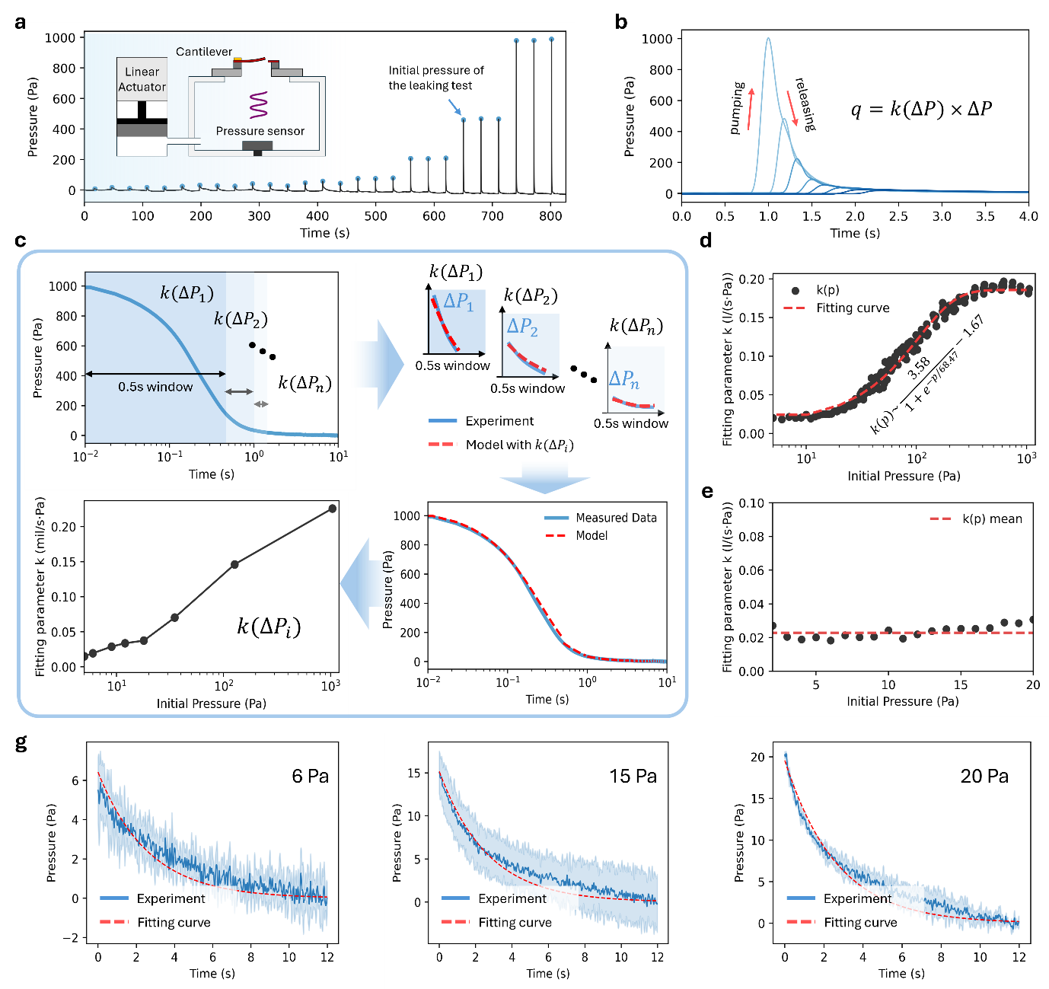
Supplementary Fig. 44 Leakage characterization. (a) Experimental setup and pressure response: The chamber is pressurized by a linear actuator, then air is allowed to leak through the cantilever gap. (b) Overlapped pressure decay profiles from multiple initial pressures, showing consistent leakage behaviour. (c) The windowing algorithm used to calculate the leakage coefficient from the decay data. (d, e) The derived leakage coefficient k plotted against different initial pressures in the range 0-1000Pa (d) and the zoomed-in plot in 20Pa pressure range. (g) Pressure decay profile at, from left to right, 6Pa, 15Pa, and 20Pa, and the fitted curve with the determined leakage coefficient k. Solid lines represent the mean pressure across 3-cycle measurements from each frequency and chamber volume (n = 3), shaded areas represent 2 standard deviations in pressure.

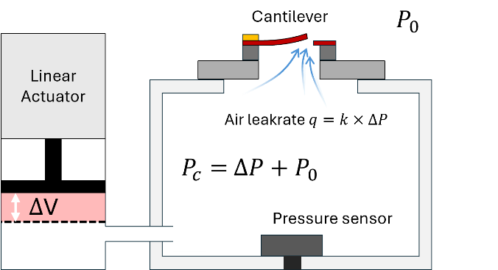
Supplementary Fig. 45 Illustration of air leakage through the cantilever
The experiment for leakage characterization has been summarized and included in Supplementary Fig. 44. A linear actuator is programmed to pressurize the chamber to a prescribed setpoint, and then hold its position, allowing air to escape freely through the cantilever gap (approx. 1 µm) until equilibrium with atmospheric pressure is reached (Supplementary Fig. 45). We recorded the pressure decay profiles from various initial pressures, using a reference pressure sensor integrated inside the chamber (C33, TDK Electronics). The resulting decay curves (Supplementary Fig. 44b) exhibit a highly consistent and repeatable profile, confirming that the leakage rate is deterministic and can be well approximated as a state function of the pressure difference ($q(∆P)$) between the chamber and the ambient environment. We assume that the leakage rate can be approximated as the product of a function $k(∆P)$ and pressure difference $∆P$:
$$q(∆P)=k(∆P)×∆P$$ | (15)
To find the relationship between $k(∆P)$ and $∆P$, we investigate the discrete value of $k(∆P)$ at a specific pressure difference $∆P$. We divide the leaking decay profile into multiple segments of 0.5s time windows and determine the value of$k(∆P)$ for each segment, where $∆P$ correspond to the initial pressure difference of the decay segment (Supplementary Fig. 44c). Within each short-duration window, the leakage coefficient is assumed to be constant, $k_{i}=k(∆P_{0i})$.
Interpretation of $k(∆P)$:
We derive the leakage model based on the Ideal Gas Law. Let $P_{c}, V_{c}, n_{c}$ denote the pressure, volume, and amount of gas inside the chamber, respectively.
$$P_{c}V_{c}=n_{c}RT$$ | (16)
$$∆P=P_{c}-P_{0}$$ | (17)
where $P_{0}$ is the atmospheric pressure.
Assuming that the air inside the chamber is distributed uniformly, the derivation of the amount of gas inside the chamber ($n_{c}$) can be expressed through the air volume leak rate $q$:
$$\frac{dn_{c}}{dt}=q\frac{n_{c}}{V_{c}}$$ | (18)
Deriving (1) and replacing the derivation of the amount of air with the air leak rate, we have:
$$\frac{dP_{c}}{dt}V_{c}+\frac{dV_{c}}{dt}P_{c}=\frac{dn_{c}}{dt}RT=q\frac{n_{c}}{V_{c}}RT$$ | (19)
Furthermore, using the assumption that $q=k×∆P$, Equation (19) becomes:
$$\frac{dP_{c}}{dt}V_{c}+\frac{dV_{c}}{dt}P_{c}=k×\frac{∆Pn_{c}RT}{V_{c}}$$ | (20)

As the chamber volume does not change during air leakage through the cantilever gap (i.e., $\frac{dV_{c}}{dt}=0$), and from the relationship established in Equation (17): $\frac{dP_{c}}{dt}=\frac{d∆P}{dt}$, Equation (20) can be rewritten as follows:
$$\frac{dP_{c}}{dt}V_{c}=k×\frac{∆Pn_{c}RT}{V_{c}}$$ | (21)
$$\frac{1}{∆P}d∆P=k×\frac{n_{c}RT}{{V_{c}}^{2}}dt$$ | (22)

Over a short duration and at low pressure, $n_{c}(t)$ is approximated by the initial amount of air $n_{c0}$. Integrating Supplementary Equation (8) and applying the boundary condition, $∆P\left(0\right)=∆P_{0}$ at $t=0$, where $∆P_{0}$ is the initial chamber pressure difference, yield the following expression for $∆P$:
$$∆P\left(t\right)=e^{k\frac{n_{c0}RT}{{V_{c}}^{2}}t}×∆P_{0}$$ | (23)
Hence, the leakage coefficient $k_{i}$ in a short 0.5s time window can be expressed through $∆P$:
$$k_{i}=k(∆P_{0i})=\frac{ln⁡(\frac{∆P_{0.5}}{∆P_{0}})}{\frac{n_{c0}RT}{{V_{c}}^{2}}×0.5}$$ | (24)
where $∆P_{0.5}$ is the chamber different pressure at t=0.5s.
Based on this algorithm, we evaluate $k\left(∆P\right)$across different value of $∆P$, and generate an overlaid plot of $k$, which exhibits a sigmoid-like function when plotted on a logarithmic X-axis. This behavior is subsequently fitted with a function: $k\left(p\right)\sim \frac{3.58}{1+e^{-p/68.47}}-1.67$ (Supplementary Fig. 44d).
Given that the most prevalent range of respiration amplitudes is 5-20Pa (see Supplementary Fig. 12), the leakage coefficient within this pressure range can be approximated as a constant: $k\sim 0.023 l/s×{Pa}^{-1}$ (Supplementary Fig. 44e).

Supplementary Note S7 Damping effect validation
The integration of the CPT sensor into an acoustic chamber introduces air damping and mass-loading effects, which can lower the resonance frequency. To quantify these effects, we characterized the resonance frequency of the CPT in two configurations: as a bare cantilever and when mounted onto the AusculPatch air chamber. The experiment was summarized and included in Supplementary Fig. 16. We utilized a Laser Doppler Vibrometer (MSA-100-3D, Polytec) to capture the vibration spectrum of CPT (Supplementary Fig. 16a, d). The vibration profile was mapped by scanning multiple points along the cantilever beam to visualize the first mode shape.
As shown in the magnitude and phase response (Supplementary Fig. 16c), the bare sensor exhibits a fundamental resonance frequency of 12.57 kHz. Upon integration into the chamber, the resonance frequency shifts to 11kHz (Supplementary Fig. 16f). Modelling the sensor as a damped harmonic oscillator, the relationship between the undamped natural frequency $f_{CPT}$ and the damped natural frequency $f_{C}$ is expressed as:
$$f_{C}=\sqrt{1-ξ^{2}}f_{CPT}$$ | (25)
Substituting the experimental values:
$$ξ=\sqrt{1-{(\frac{11}{12.57})}^{2}}=0.48$$ | (26)
The acoustic packaging introduces a damping ratio of approximately 0.48. While this damping shifts the resonance frequency downward, the resulting resonant peak (11.00 kHz) remains significantly higher than the system resonance frequency at 4.8 kHz (see Supplementary Fig. 18). Therefore, the damping effect does not compromise the ability of AusculPatch in detecting physiological signals within the target frequency range.

Supplementary Note S8 Validation of high-frequency response
Although the bare CPT sensor (i.e., without the air chamber) exhibits a high natural resonance (approx. 12 kHz, Supplementary Fig. 9), the overall frequency response might be influenced by device packaging, specifically the integration of the air chamber underneath.
We characterized the acoustic bandwidth of the optimized system from 1Hz to 20 kHz through a sweep test with the setup and results being presented in Supplementary Fig. 17 and Supplementary Fig. 18. A piezoelectric stack actuator (AE0203D18H18DF, KEMET) was used to apply a consistent, frequency-varied displacement to the chamber membrane (Supplementary Fig. 18a). It is worth noting that in this experiment, only the elastic membrane was vibrated while other resting parts of the system (i.e., chamber frame) were fixed; meanwhile, in the experiment discussed in Supplementary Fig. 16, the membrane was made by rigid substrates (i.e., metal plate), and the whole system was mounted on and vibrated using a piezoelectric stack. This actuator is driven by a waveform generator (UTG2122X, UNI-T), producing a nearly flat displacement profile across frequencies up to 20kHz, allowing for systematic evaluation of the acoustic response of CPT. The chamber membrane displacement was validated using a Laser Doppler Vibrometer (MSA-050, Polytec). The CPT output is converted to a voltage signal using a Wheatstone bridge circuit and recorded with a portable oscilloscope (Analog Discovery 3, Diligent).
We further investigated the effect of chamber volume on the resonance frequency using three configurations: the optimized AusculPatch chamber (50$π{mm}^{3}$volume, 16 mm diameter) and two larger test chambers (100$π{mm}^{3}$ and 200$π{mm}^{3}$). As shown in Supplementary Fig. 18b, the optimized AusculPatch chamber exhibits a resonance frequency at ~4.8 kHz. In contrast, the 100$π{mm}^{3}$ and 200$π{mm}^{3}$ chambers show lower resonance frequencies of 4.1 kHz and 2.9 kHz, respectively. This inverse relationship is consistent with classical spring-mass system theory, in which a larger chamber volume raises the acoustic compliance (i.e., reduces the stiffness of the enclosed air spring), thereby inherently lowering the resonance frequency.
The zoomed-in spectra in Supplementary Fig. 18c confirm a nearly flat frequency response across the critical 0–2 kHz range, while Supplementary Fig. 18d demonstrates a stable performance at low frequencies (0-20Hz) with a minimal low-frequency cutoff. Fig. Supplementary Fig. 18e–h presents representative time-domain signals and their corresponding Fast Fourier Transforms (FFT) at discrete excitation frequencies (50 Hz, 100 Hz, 200 Hz, 500 Hz, 1 kHz, and 2 kHz). These results confirm the reliable operation of AusculPatch and its ability to capture high-fidelity body signals without significant attenuation across the clinically relevant bandwidth.
Supplementary Note S9 Influence of Valsalva maneuver on heart rate behavior
At the initial phase of the Valsalva maneuver, the participant first performed a deep inhalation followed by breath-holding. At the beginning, the contraction of the rib cage elevated intrathoracic pressure, thereby exerting an external compressive force on the heart. Thoracic blood vessels compress the vessels and cardiac chambers by decreasing the transmural pressure across their walls(9). This reduction in venous return, combined with the compression of the cardiac chambers, reduces ventricular filling and preload, leading to a decrease in heart rate (HR).
When the person breathes normally again, the release of intrathoracic pressure causes a transient fall in aortic pressure, as the external compression on the aorta is removed. This leads to a brief reflexive increase in heart rate (HR). As expected, the HR recorded by AusculPatch (Manuscript Fig. 4h) displayed a reduction phase followed by a recovery phase during the Valsalva maneuver process, with consistent results in comparison with the ECG measurement.

Supplementary Note S10 Machine learning model for speech recognition
To classify spoken words from recorded acoustic signals, we employed a machine learning model based on a pretrained Convolutional Neural Network (CNN), EfficientNet-B0. The model was developed in an open-source machine learning framework PyTorch, built on the Torch library in Python. For optimization, we utilized the Adam optimizer in conjunction with a OneCycleLR scheduler to adaptively adjust the learning rate along with the training step. The cycle percentage was set to 0.3, such that the learning rate increased during the first 30% of training steps and decreased thereafter. CrossEntropyLoss was utilized as the training loss function, and a softmax activation function was used to produce class-probability distributions.
Model validation was performed using the 5-fold cross-validation technique. The dataset collected from two volunteer participants was randomly partitioned into five equally sized, non-overlapping groups using the StratifiedKFold utility. In each iteration, the model was trained on four folds and evaluated on the remaining fold. The model-trained parameters were renewed prior to each training cycle to ensure the learned features at the last iteration do not affect the following iteration. Ground-truth labels and predicted outputs of the test sets were stored from each iteration. Finally, all the prediction values were combined to make a prediction of the entire dataset, and a confusion matrix was used to visualize classification performance.
The model input and output details:
Input: 3000 x 1 vector
Output: an integer number in [0, 19], corresponding to 20 classes of daily used words
- The manual feature extraction layer:
  - Input: 3000 x 1 vector
  - Output: 3 x 256 x 256 image
- The automatic feature extraction layer:
  - Input: 3 x 256 x 256 image
  - Output: 1x1000 vector
- The classification layer:
  - Input: 1x1000 vector
  - Output: an integer number in [0, 19]
The optimal hyperparameters are:
- optimizer=𝐴𝑑𝑎𝑚
- learning_rate=1𝑒 – 4
- weight_decays=1e-4
- batch_size=20
- dropout=0.5
- number of epochs=60.

Supplementary Table 1 Design parameters of the cantilever.
Design parameters | $$t_{c}$$ | $$w_{p}$$ | $$l_{p}$$ | $$w_{h}$$ | $$l_{h}$$
Value (um) | 0.30 | 80 | 80 | 10 | 30

Supplementary Table 2 Human studies.
Heart sounds |  | Pulse waves |  |  | Korotkoff sounds & BP |  | Voice recognition
ID | Gender |  | ID | Gender | ID | Gender | ID | Gender
#H1 | Male |  | #P1 | Female | #K1 | Male | #V1 | Male
#H2 | Male |  | #P2 | Male | #K2 | Male | #V2 | Male
#H3 | Male |  | #P3 | Male | #K3 | Male
#H4 | Male |  | #P4 | Male | #K4 | Male
#H5 | Male |  | #P5 | Male | #K5 | Male
 |  |  | #P6 | Male
 |  |  | #P7 | Male
 |  |  | #P8 | Male
 |  |  | #P9 | Male
 |  |  | #P10 | Male

REFERENCES

1. X. Hui, L. Tang, D. Zhang, S. Yan, D. Li, J. Chen, F. Wu, Z. L. Wang, H. Guo, Acoustically Enhanced Triboelectric Stethoscope for Ultrasensitive Cardiac Sounds Sensing and Disease Diagnosis. Adv Mater 36, e2401508 (2024).
2. P. Gupta, M. J. Moghimi, Y. Jeong, D. Gupta, O. T. Inan, F. Ayazi, Precision wearable accelerometer contact microphones for longitudinal monitoring of mechano-acoustic cardiopulmonary signals. Npj Digit Med 3, (2020).
3. L. Y. Han, W. J. Liang, Q. S. Xie, J. J. Zhao, Y. Dong, X. H. Wang, L. W. Lin, Health Monitoring via Heart, Breath, and Korotkoff Sounds by Wearable Piezoelectret Patches. Adv Sci 10, (2023).
4. S. Gong, X. Zhang, X. A. Nguyen, Q. Q. Shi, F. E. Lin, S. Chauhan, Z. Y. Ge, W. L. Cheng, Hierarchically resistive skins as specific and multimetric on-throat wearable biosensors. Nat Nanotechnol 18, 889-+ (2023).
5. J. Yang, J. Chen, Y. J. Su, Q. S. Jing, Z. L. Li, F. Yi, X. N. Wen, Z. N. Wang, Z. L. Wang, Eardrum-Inspired Active Sensors for Self-Powered Cardiovascular System Characterization and Throat-Attached Anti-Interference Voice Recognition. Adv Mater 27, 1316-+ (2015).
6. I. Sotiri, A. Tajik, Y. Lai, C. T. Zhang, Y. Kovalenko, C. R. Nemr, H. Ledoux, J. Alvarenga, E. Johnson, H. S. Patanwala, J. V. I. Timonen, Y. H. Hu, J. Aizenberg, C. Howell, Tunability of liquid-infused silicone materials for biointerfaces. Biointerphases 13, (2018).
7. S. L. Thomson, Synthetic, self-oscillating vocal fold models for voice production research. J Acoust Soc Am 156, 1283-1308 (2024).
8. T. Nabeshima, T. V. Nguyen, H. Takahashi, Frequency Characteristics of Pulse Wave Sensor Using MEMS Piezoresistive Cantilever Element. Micromachines-Basel 13, (2022).
9. M. J. Kern, S. Puri, T. J. Donohue, R. G. Bach, Hemodynamic rounds series II: Hemodynamics of dual-chamber pacing and valsalva maneuver in a patient with hypertrophic obstructive cardiomyopathy. Catheter Cardio Diag 44, 438-442 (1998).

