Supplementary materials

Supplementary Figure 1. Normality Assessment: ASC Scales. Distribution plots (top) and Q-Q plots (bottom) for all altered states of consciousness scales. Red lines show normal distribution fits. While some scales show deviations from normality, parametric analyses were used with non-parametric verification
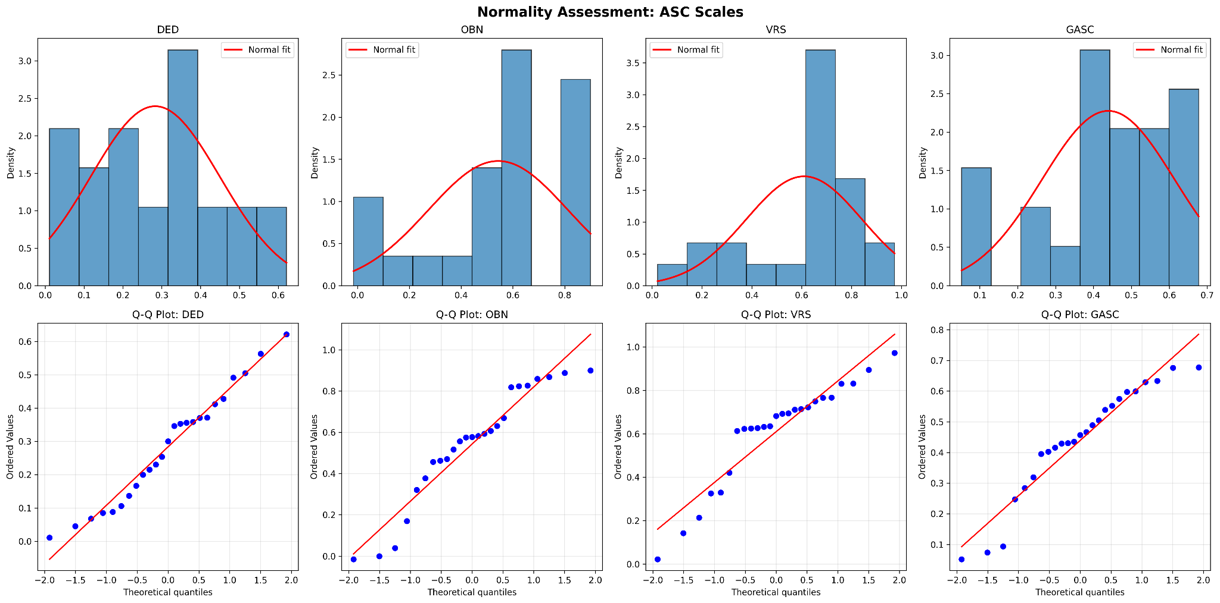

Supplementary Figure 2. Normality Assessment: Brain Regions. Distribution plots (top) and Q-Q plots (bottom) for cingulate cortex thickness measures across all regions. Red lines show normal distribution fits.
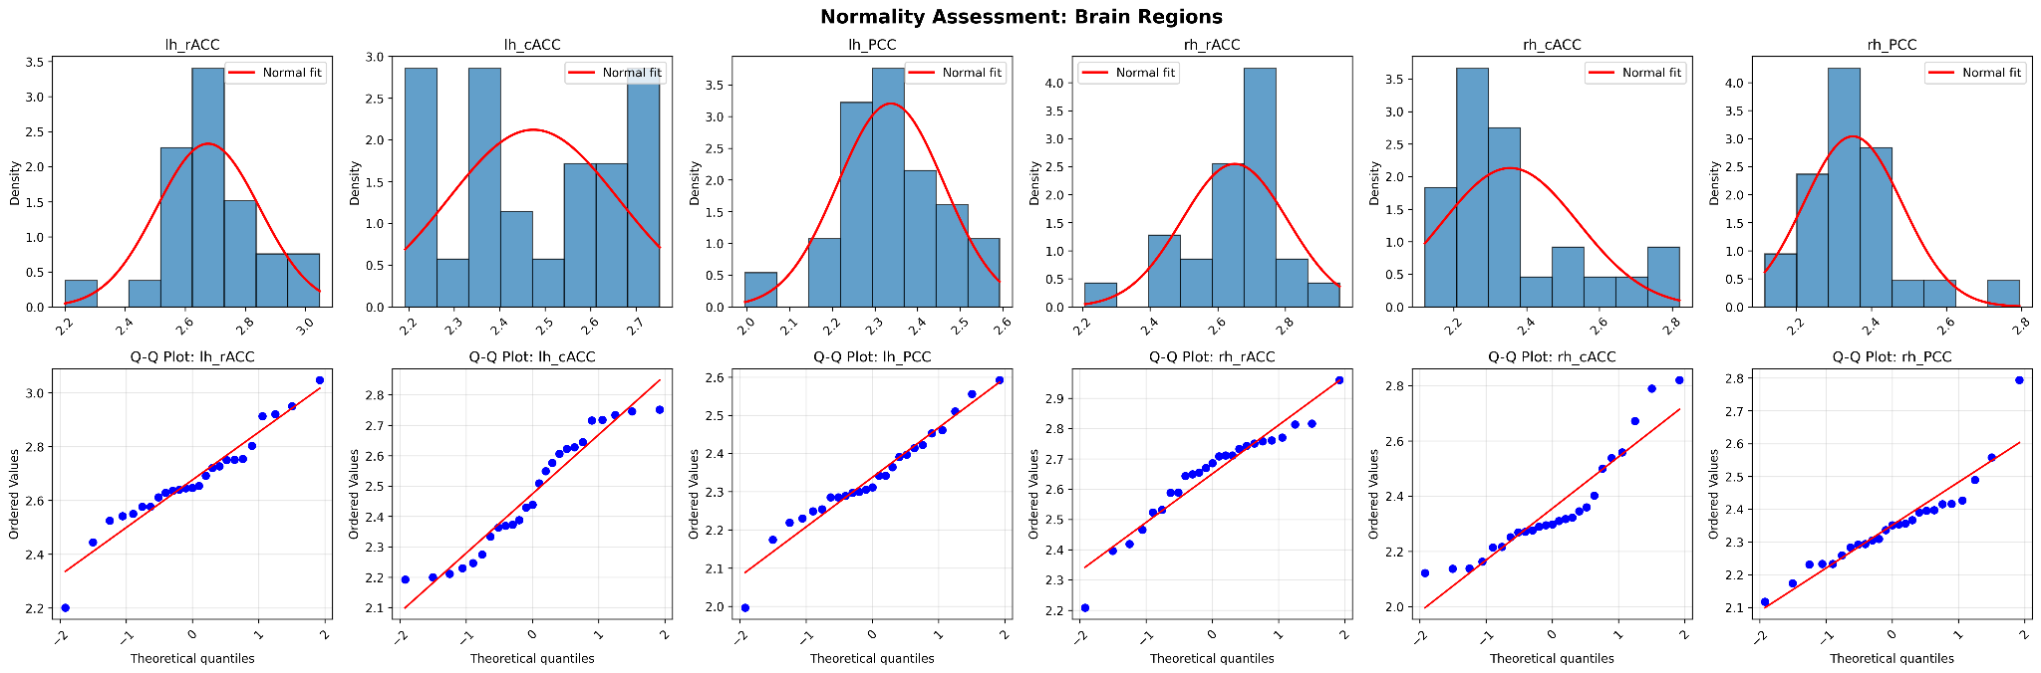

Supplementary Table 1. Complete results of multivariate linear regression analysis examining associations between cingulate cortex thickness and altered states of consciousness subscales. Models controlled for age, sex, and postcentral gyrus thickness. FDR correction applied both within each hemisphere (12 tests: 3 regions × 4 ASC scores) following Lewis et al.'s approach, and across the whole brain (24 tests total) for more conservative control. Standardized beta coefficients, raw p-values, and FDR-corrected p-values are presented for all tested associations.
Hemisphere | Region | ASC scale | Coefficient | p value | Hemisphere FDR p | Whole Brain FDR p | Sig. Hemisphere FDR | Sig. Whole Brain FDR
Left | PCC | VRS | -0.928 | 0.003 | 0.031 | 0.059 | TRUE | FALSE
Right | PCC | GASC | -0.881 | 0.006 | 0.059 | 0.059 | FALSE | FALSE
Left | rACC | VRS | 0.559 | 0.008 | 0.050 | 0.059 | FALSE | FALSE
Right | PCC | VRS | -1.064 | 0.010 | 0.059 | 0.059 | FALSE | FALSE
Right | PCC | DED | -0.731 | 0.026 | 0.105 | 0.105 | FALSE | FALSE
Left | cACC | VRS | -0.428 | 0.030 | 0.091 | 0.105 | FALSE | FALSE
Left | rACC | DED | 0.498 | 0.035 | 0.091 | 0.105 | FALSE | FALSE
Left | cACC | OBN | -0.684 | 0.038 | 0.091 | 0.105 | FALSE | FALSE
Right | PCC | OBN | -1.083 | 0.039 | 0.118 | 0.105 | FALSE | FALSE
Right | rACC | GASC | 0.537 | 0.071 | 0.170 | 0.167 | FALSE | FALSE
Left | cACC | GASC | -0.354 | 0.076 | 0.153 | 0.167 | FALSE | FALSE
Right | rACC | DED | 0.532 | 0.095 | 0.189 | 0.180 | FALSE | FALSE
Left | rACC | GASC | 0.342 | 0.098 | 0.161 | 0.180 | FALSE | FALSE
Left | PCC | GASC | -0.467 | 0.107 | 0.161 | 0.184 | FALSE | FALSE
Right | rACC | VRS | 0.571 | 0.138 | 0.236 | 0.220 | FALSE | FALSE
Left | PCC | OBN | -0.664 | 0.155 | 0.207 | 0.233 | FALSE | FALSE
Right | rACC | OBN | 0.523 | 0.297 | 0.445 | 0.419 | FALSE | FALSE
Right | cACC | VRS | -0.252 | 0.455 | 0.586 | 0.607 | FALSE | FALSE
Right | cACC | OBN | -0.310 | 0.488 | 0.586 | 0.616 | FALSE | FALSE
Right | cACC | GASC | -0.143 | 0.578 | 0.630 | 0.660 | FALSE | FALSE
Left | PCC | DED | -0.164 | 0.602 | 0.660 | 0.660 | FALSE | FALSE
Left | cACC | DED | -0.111 | 0.605 | 0.660 | 0.660 | FALSE | FALSE
Left | rACC | OBN | 0.130 | 0.687 | 0.687 | 0.716 | FALSE | FALSE
Right | cACC | DED | 0.050 | 0.856 | 0.856 | 0.856 | FALSE | FALSE

Supplementary Table 2. Complete Spearman Correlation Results: Cingulate Cortex Thickness vs ASC scales. Non-parametric Spearman correlation analysis examining associations between cingulate cortex thickness and altered states of consciousness scales. FDR correction was applied across all 24 brain-experience associations (3 regions × 4 outcomes × 2 hemispheres). Correlation coefficients (ρ), raw p-values, and FDR-corrected p-values are presented for all tested associations. Three correlations survived FDR correction (highlighted in green): left cACC-OBN, left cACC-VRS, and right PCC-GASC, all showing negative associations between cortical thickness and psychedelic experience intensity.
Hemisphere | Region | ASC scale | Coefficient | p value | Whole Brain FDR p | Sig. Whole Brain FDR
Left | cACC | OBN | -0.545 | 0.005 | 0.041 | TRUE
Left | cACC | VRS | -0.542 | 0.005 | 0.041 | TRUE
Right | PCC | GASC | -0.542 | 0.005 | 0.041 | TRUE
Right | PCC | OBN | -0.491 | 0.013 | 0.067 | FALSE
Left | PCC | VRS | -0.486 | 0.014 | 0.067 | FALSE
Left | cACC | GASC | -0.469 | 0.018 | 0.072 | FALSE
Left | rACC | DED | 0.440 | 0.028 | 0.095 | FALSE
Right | PCC | DED | -0.426 | 0.034 | 0.101 | FALSE
Right | PCC | VRS | -0.417 | 0.038 | 0.102 | FALSE
Right | cACC | OBN | -0.320 | 0.119 | 0.285 | FALSE
Right | cACC | VRS | -0.268 | 0.196 | 0.427 | FALSE
Left | PCC | GASC | -0.250 | 0.227 | 0.429 | FALSE
Left | cACC | DED | -0.239 | 0.249 | 0.429 | FALSE
Left | PCC | OBN | -0.239 | 0.250 | 0.429 | FALSE
Left | rACC | VRS | 0.224 | 0.281 | 0.446 | FALSE
Right | cACC | GASC | -0.217 | 0.298 | 0.446 | FALSE
Right | rACC | VRS | -0.195 | 0.351 | 0.482 | FALSE
Left | PCC | DED | -0.185 | 0.376 | 0.482 | FALSE
Left | rACC | GASC | 0.183 | 0.382 | 0.482 | FALSE
Right | rACC | DED | 0.173 | 0.408 | 0.490 | FALSE
Right | rACC | OBN | -0.110 | 0.601 | 0.686 | FALSE
Right | rACC | GASC | -0.048 | 0.818 | 0.892 | FALSE
Left | rACC | OBN | -0.035 | 0.869 | 0.907 | FALSE
Right | cACC | DED | 0.017 | 0.936 | 0.936 | FALSE

Supplementary Material S1. Inclusion and Exclusion Criteria:

Inclusion criteria required participants to be healthy volunteers between 28-65 years old, with no personal history of mental disorders according to the ICD-10 and no family history of psychosis up to second-degree relatives.

Exclusion criteria included pregnant women, intracranial hypertension, severe arterial or pulmonary hypertension, history of stroke, congestive heart failure, presence of a pacemaker or metal clip in the head/face area, celiac disease, left-handedness, regular medication use (except hormonal contraception), and being in a dependent relationship with study staff.

Supplementary Table 3. Comparison between placebo and psilocybin conditions. Note: ASC = Altered State of Consciousness; DED = Dread of Ego Dissolution; OBN = Oceanic Boundlessness; VRS = Visionary Restructuralization; GASC = Global Altered States of Consciousness Score. Scores range from 0 to 100, where 100 represents maximum intensity. Paired t-tests were used to compare placebo and psilocybin conditions.
ASC scale | Placebo (Mean ± SD) | Psilocybin (Mean ± SD) | t-value | p-value
DED | 1.56 ± 3.27 | 29.89 ± 16.13 | 8.329 | <0.001
OBN | 2.79 ± 4.23 | 57.12 ± 26.95 | 9.867 | <0.001
VRS | 1.59 ± 2.91 | 62.57 ± 22.91 | 12.857 | <0.001
GASC | 1.85 ± 3.10 | 45.76 ± 17.05 | 12.271 | <0.001

