Water-based, large-scale transfer of 2D materials grown on sapphire substrates
Nico Rademacher ^{1,2,‡}, Lukas Völkel ^{2,‡}, Eros Reato ², Martin Otto ¹, Simonas Krotkus ³, Jan Mischke ³, Emre Yengel ³, Christof Mauder ³, Alex Henning ³, Michael Heuken ³, Ke Ran ^{1,4}, Joachim Mayer ⁴, Max C. Lemme ^{1,2,*}
1 AMO GmbH, Advanced Microelectronic Center Aachen, Otto-Blumenthal-Str. 25, 52074 Aachen, Germany.
2 Chair of Electronic Devices, RWTH Aachen University, Otto-Blumenthal-Str. 25, 52074 Aachen, Germany.
3 AIXTRON SE, Dornkaulstr. 2, 52134 Herzogenrath, Germany.
4 Central Facility for Electron Microscopy GFE, RWTH Aachen University, Ahornstr. 55, 52074 Aachen, Germany.
‡ These authors contributed equally to this work
*email: max.lemme@eld.rwth-aachen.de

Section S1: Discussion on measurement errors in Raman spectra
We calculated the difference between the measurement points in the Raman spectra in cm⁻¹, to estimate the measurement errors on our data points. Half of the difference gives the error of each measurement point, assuming that the real value is uniformly distributed around its measurement point. We found, the larger the wavenumber, the smaller the difference between the measurement points. We get different measurement errors because we measure different spectral ranges for the two materials. The biggest and the smallest measurement error for each material are summarized in Table TS1.
Material | Biggest measurement error [cm⁻¹] | Smallest measurement error [cm⁻¹]
h-BN | 0.28 | 0.25
MoS₂ | 0.32 | 0.29
Table TS1: Summary of the biggest and smallest measurement error for each material.
The FWHM of a Raman peak is the distance between the two points on the Lorentz function that are at 50% of the peak height. Thus, it corresponds to a subtraction of two measurement points of the Raman spectrum. Error propagation leads to an error on the calculation of the FWHM of a peak according to
$σ_{FWHM}=\sqrt{σ_{1}^{2}+σ_{2}^{2}}$,
where $σ_{FWHM}$ is the error of the FWHM, and $σ_{1,2}$ are the errors of the two points corresponding to 50 % of the height of the peak fit. Table TS2 summarizes the biggest and smallest error for the FWHM calculation for each material.
Material | Biggest FWHM error [cm⁻¹] | Smallest FWHM error [cm⁻¹]
h-BN | 0.40 | 0.36
MoS₂ | 0.46 | 0.41
Table TS2: Summary of the biggest and smallest error on the FWHM calculation for each material.

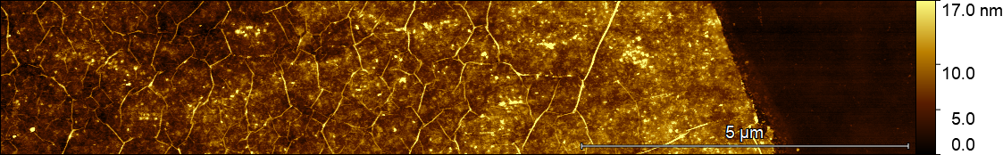
Figure S1: AFM scan of the SiO2/ h-BN edge of a transferred h-BN film to measure the h-BN film thickness.

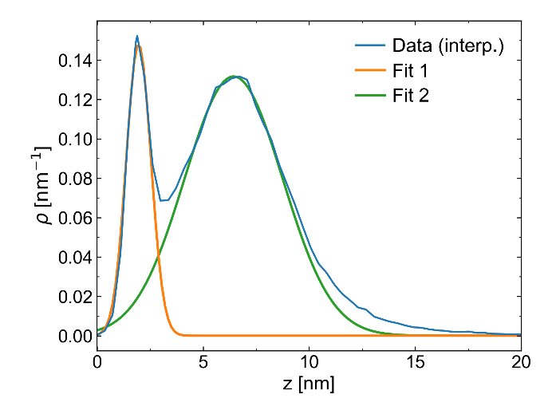
Figure S2: Height distribution from the AFM scan in Figure S1. The left peak corresponds to the SiO₂ surface height and the right peak to the h-BN surface height. Fit one and two are gaussian fits to the corresponding peaks. The film thickness is calculated by the difference of the peak positions of the gaussian fits. The error of the film thickness is calculated by error propagation of the peak widths of the gaussian fits. The extracted film thickness is 4.5 ± 2.4 nm. The big error is attributed to edge effects: The h-BN appears thicker at the edge compared to the center of the film, which is visible in the color-grading of the h-BN surface in Fig. S1. This broadens the right height distribution peak and leads to a large error.

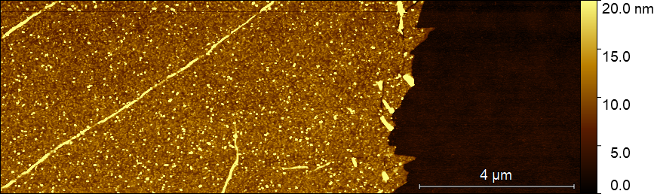
Figure S3: AFM scan of the SiO2/ MoS₂ edge of a transferred MoS₂ film to measure the MoS₂ film height.

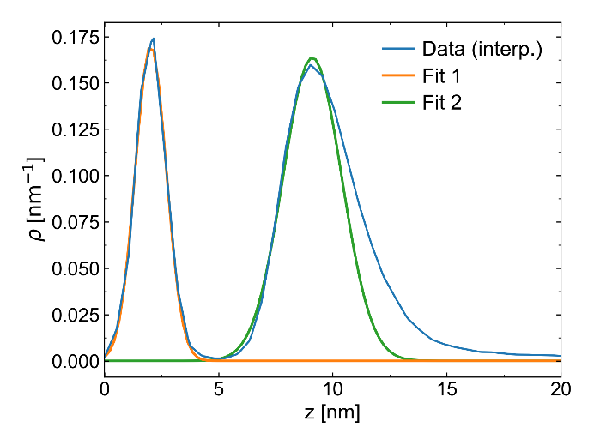
Figure S4: Height distribution from the AFM scan in Figure S3. The left peak corresponds to the SiO₂ surface height and the right peak to the MoS₂ surface height. Fit one and two are gaussian fits to the corresponding peaks. The film thickness is calculated by the difference of the peak positions of the gaussian fits. The error of the film thickness is calculated by error propagation of the peak widths of the gaussian fits. The extracted film thickness is 7.1 ± 1.4 nm.

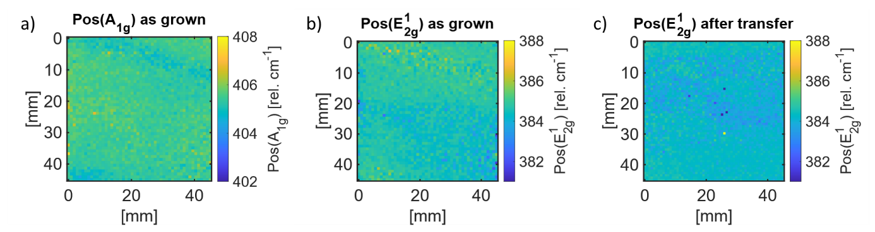
Figure S5: Raman maps of the A_{1g} and E¹_{2g} Peak positions of the large-area transfer. a) Map of the A_{1g} peak position of the as-grown material. b) Map of the E¹_{2g} peak position of the as-grown material. c) Map of the E¹_{2g} peak position of the material after the transfer.

