Metacognitive antecedents to states of mental ill-health: Drops in confidence precede symptoms of OCD
Supplementary Materials
A.A. Marzuki^{1,2}, L.A. Kosina¹, L. Dome^{1,2}, S.R.C. Hewitt^{3,4}, T.U.Hauser^{1,2,3}
1. Department of Psychiatry and Psychotherapy, Faculty of Medicine, Tübingen University, Tübingen, Germany
2. German Center for Mental Health (DZPG), Tübingen, Germany
3. Max Planck UCL Centre for Computational Psychiatry and Ageing Research, University College London, UK
4. Functional Imaging Laboratory, Department of Imaging Neuroscience, University College London, London WC1N 3AR, United Kingdom

Contents
Participant Recruitment Flowchart and Symptom Log Distribution 2
Demographic Details 3
State survey items 3
Trait-State Relationships 4
Partial Correlations between State and Trait Variables 5
Time-of-day and day-of-week analysis methods 6
Daily activities and contexts associated with OCD symptom logs, severity ratings, and self-confidence 6
Time-of-day and day-of-week effects on OCD severity ratings and self-confidence 8
Day-to-day OCD severity ratings are predicted by current and past self-confidence 10
Robustness tests for regression models 11
Testing symptom log effects in shorter time windows 13
Assessing reliability of task metacognitive bias 13

Participant Recruitment Flowchart and Symptom Log Distribution
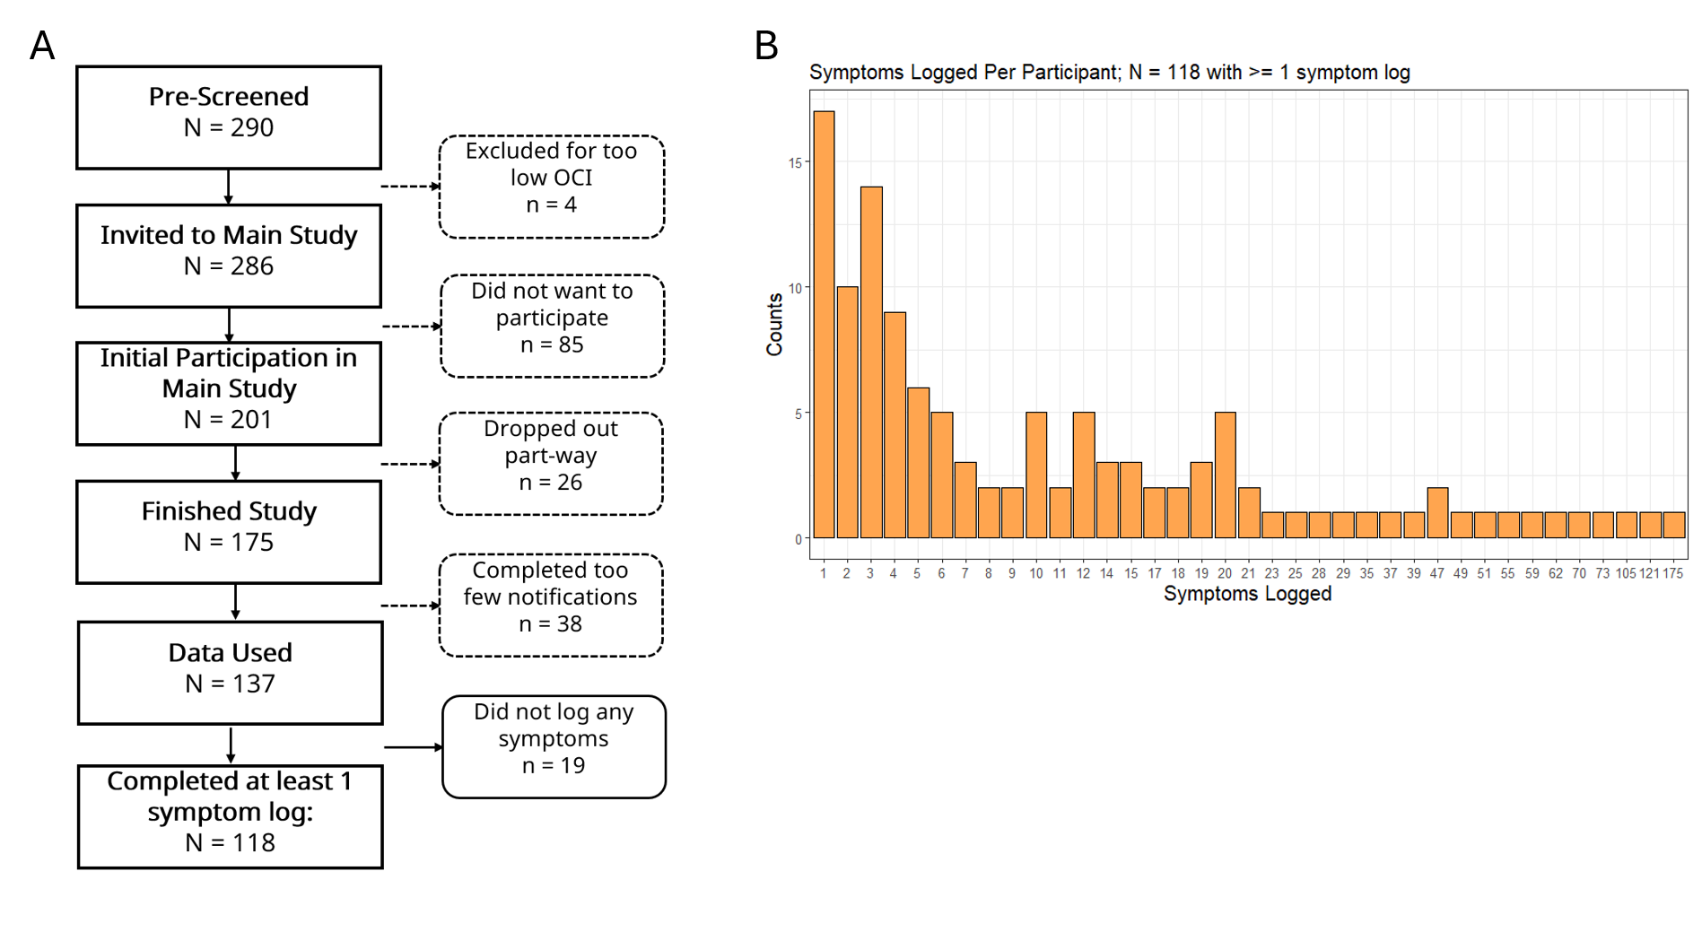
Figure S1: A. Flowchart of participant recruitment. B. Histogram of number of symptoms logged per participant throughout EMCT period.

Demographic Details
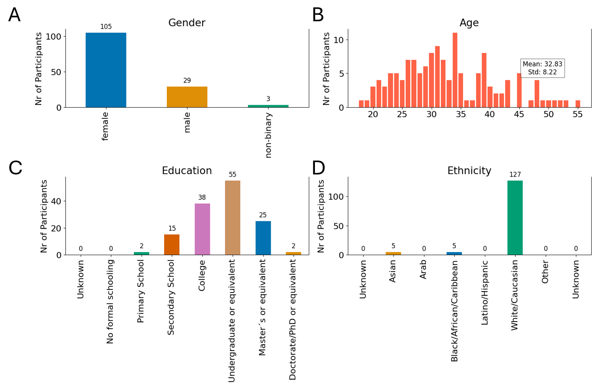
Figure S2: Plots of participant demographics, for gender (A), age (B), education level (C), and ethnicity (D).

State survey items
Table S1: Daily survey items used in EMCT study
Item | Question
Obsessive-compulsive severity | How intense are your symptoms of OCD right now?
Self-confidence | How confident do you feel right now?
Anxiety | How anxious do you feel right now?
Happiness | How happy do you feel right now?
Brain Fog | Do you have difficulty thinking clearly right now?
Sleep Quality | How well did you sleep last night?
Current Activity/Context | What are you doing right now?
Social Context | Who are you with right now?

Trait-State Relationships
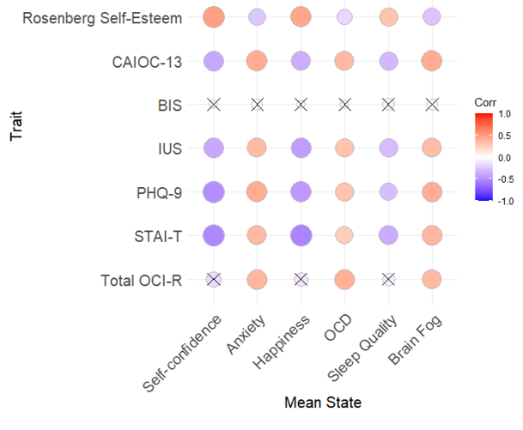
Figure S3: Correlation matrix showing overall Spearman correlations between all state measures (averaged across 14 days) and trait measures CAIOC-13: Cognitive Assessment Instrument of Obsessions and Compulsions, BIS: Barratt Impulsivity Scale, IUS: Intolerance of Uncertainty Scale, PHQ-9: Patient Health Questionnaire-9 for depression severity, STAI-T: trait anxiety scale, OCI-R: obsessive compulsive inventory-revised. ‘X’ indicates correlation is not statistically significant. There was no significant correlation between trait measures and averaged inter-symptom intervals.

Partial correlations between state and trait variables
In the main manuscript, we investigated whether the self-confidence state measure was associated with well-established trait measures. Here we report whether the relationships reported maintained statistical significance even when conducting partial Spearman correlations to control for other averaged state variables (Tables S2 – S3). All significant associations were maintained.
Table S2: Partial Spearman correlations for association between state averaged confidence and trait self-esteem (Rosenberg Self-Esteem Scale)
Variable being controlled for | Statistic
State averaged anxiety | rho = 0.45, p <.001
State averaged OCD severity | rho = 0.47, p <.001
State averaged sleep quality | rho = 0.42, p <.001
State averaged brain fog | rho = 0.46, p <.001
State averaged happiness | rho = 0.22, p = .009

Table S3: Partial Spearman correlations for association between state averaged confidence and perceived cognitive impairment related to OCD (Cognitive Assessment Instrument of Obsessions and Compulsions-13)
Variable being controlled for | Statistic
State averaged anxiety | rho = -0.27, p = .002
State averaged OCD severity | rho = -0.33, p < .001
State averaged sleep quality | rho = -0.29, p < .001
State averaged brain fog | rho = -0.26, p = .002
State averaged happiness | rho = -0.17, p = .045

We also ascertained that averaged OCD severity ratings during notification periods were significantly correlated with trait obsessive-compulsive scores (measured using OCI-R, rho = 0.41, p-FDR < .001). This was the case even when partially controlling for other state variables (Table S4).
Table S4: Partial Spearman correlations for association between state averaged OCD severity and trait obsessive-compulsive severity (Obsessive-compulsive Inventory-Revised)
Variable being controlled for | Statistic
State averaged anxiety | rho = 0.2, p = .01
State averaged confidence | rho = 0.40, p < .001
State averaged sleep quality | rho = 0.41, p < .001
State averaged brain fog | rho = 0.24, p = .004
State averaged happiness | rho = 0.40, p < .001

Time-of-day and day-of-week analysis methods
When assessing day-of-week effects on moment-to-moment state variables, we dummy coded the days in which notifications were completed (e.g., for the variable ‘Monday’ it would be either Monday [1] or not Monday [0]). The separate days were then inserted as predictors within the same linear mixed effects model predicting self-confidence and OCD severity.
In our time-of-day analyses, we divided notification completion times into discrete periods: morning (06:00 – 11:59), afternoon (12:00 – 16:00), evening (16:00 – 20:00), night (20:00 - 23:59), and late-night (00:00 – 05:59). ‘Late-night’ rows were removed from this analysis due to low number of data points (only making up 1.5% of data). The times were dummy coded (e.g., the morning variable would contain either ‘Morning’ [1] or not [0]) and all were initially inserted into the same linear mixed-effects model. However, due to too high collinearity, we opted to insert them each into a separate model predicting self-confidence and OCD severity.
We tested time-of-day and day-of-week effects on symptom logs by summing the number of symptom logs per subject per day and per time. Two repeated measures ANOVAs (for time-of-day and day-of-week) were then conducted followed by post-hoc pairwise t-tests with Bonferroni adjustment. Neither the ANOVAs nor the paired t-tests yielded significant time or day effects on the number of symptoms logged.

Daily activities and contexts associated with OCD symptom logs, severity ratings, and self-confidence
To evaluate the ecological validity OCD symptom logs and ratings of OCD severity and self-confidence, we investigated whether they were meaningfully capturing external events. We examined how OCD symptom logging varied based on current activities and social contexts (such as whether participants were spending time with others or alone) – Figure S4A. All context variables were added simultaneously to regression models predicting either OCD symptom logs (logistic mixed-effects model) or self-confidence/OCD symptom severity (linear mixed-effects models). We found people were less inclined to log symptoms during periods of rest (Odds ratio = 0.59 =, β = -0.54, p < .001). Additionally, partaking in leisure (Odds ratio = 0.70, β = -0.36, p = .003), and self-care activities (Odds ratio = 0.69, β = -0.37, p = .008) predicted a lower likelihood of symptom logs, suggesting that, intuitively, engaging in relaxing or enjoyable activities is associated with reduced OCD symptoms.
As a validation step, we confirmed that OCD severity ratings, which were recorded alongside “current context” during notified periods and were thus more frequent, showed similar associations with activities and social context (Figure S4B). Congruent with symptom log findings, OCD severity ratings were lower when participants were resting (β = -0.10, 95% CI [-0.18 -0.03], p = .006). OCD severity ratings were also elevated when participants were involved in daily routines like running errands (β = 0.26, 95% CI [0.17 0.34], p < .001), travelling/commuting (β = 0.18, 95% CI [0.05 0.31], p =.007), and working/studying (β = 0.13, 95% CI [0.03 0.22], p =.006). Whilst we cannot determine the causality of this effect, it aligns with previous reports of OCD symptoms making it difficult to complete daily tasks and driving occupational impairment^{22,23}, while our symptom log findings in the main text suggest that periods of rest and relaxation are important for symptom alleviation.
OCD severity ratings during notifications were also significantly linked to participating in sports or exercising (β = -0.17, 95% CI [-0.34 -0.005], p = .04), and when around other people (β = -0.07, 95% CI [-0.12 -0.02], p = .004). Inversely, OCD ratings were elevated when people reported running errands (β = 0.26, 95% CI [0.17 0.34], p < .001), travelling/commuting (β = 0.18, 95% CI [0.05 0.31], p =.007), and working/studying (β = 0.13, 95% CI [0.03 0.22], p =.006).
Self-confidence also showed fluctuations with external contexts (Figure S4C): people reported greater self-confidence during sports or exercising (β = 0.50, 95% CI [0.34 0.67], p < .001), and when with other people (β = 0.15, 95% CI [0.10 0.19], p < .001). In addition, self-confidence was elevated when partaking in leisure (e.g., watching television, reading; β = 0.11, 95% CI [0.03 0.19], p =.0042) and self-care (e.g., eating, drinking; β = 0.19, 95% CI [0.10 0.28], p < .001) activities. This suggests that, intuitively, greater self-confidence is associated with pleasurable contexts.

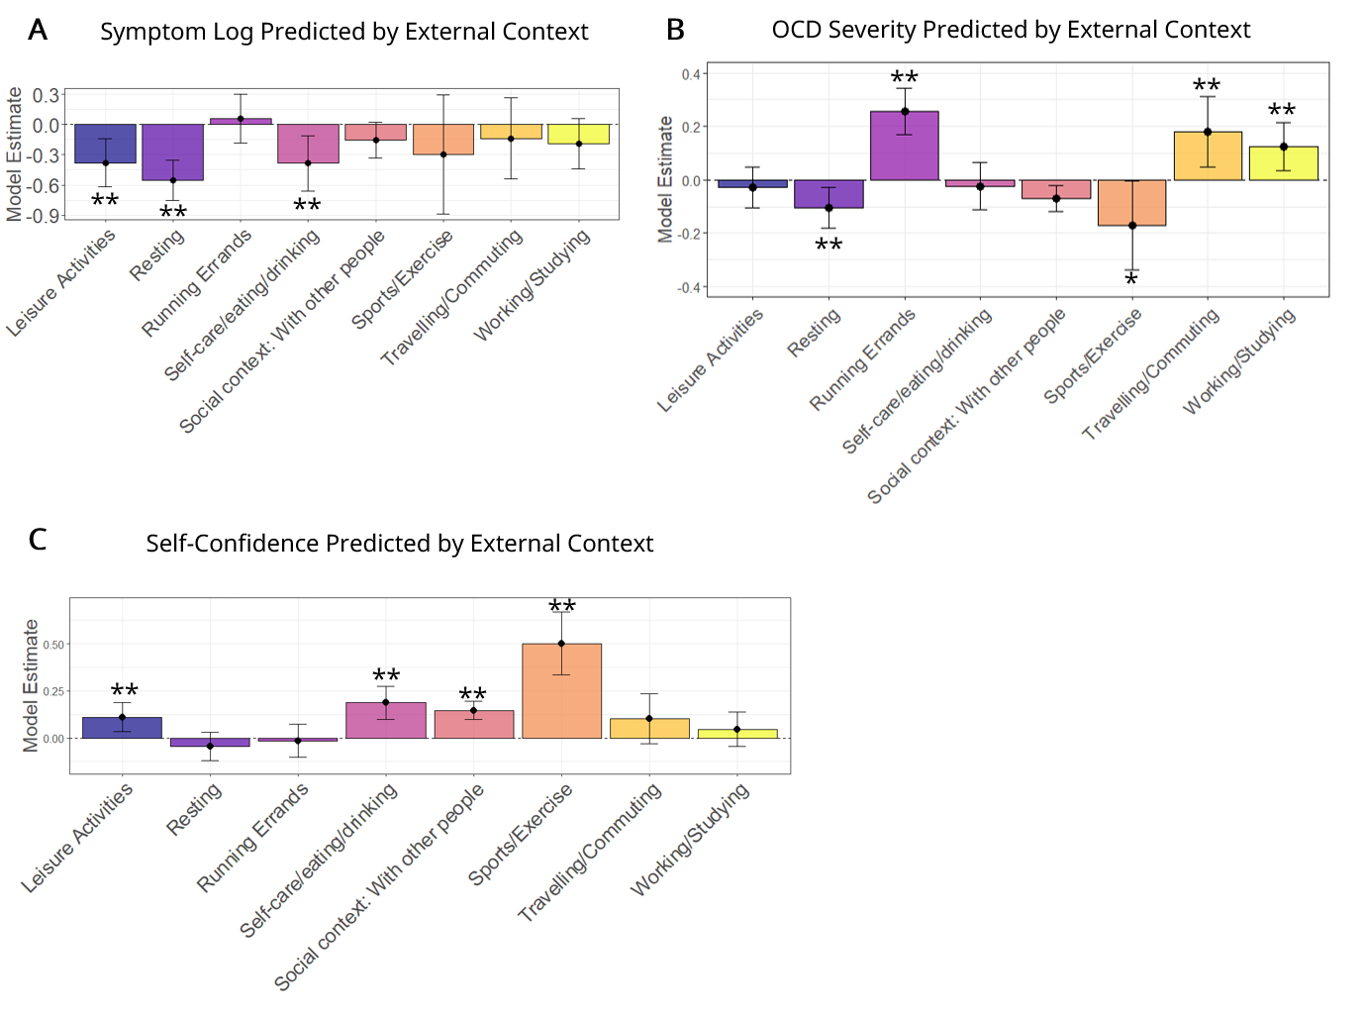
Figure S4: Bar plots depicting the estimated model coefficients obtained from linear mixed-effect models with current activity and social context (whether with other people or not) associated with A. Symptom Logs, B. OCD severity, and C. Self-confidence. Activities and social context were entered as predictors together within the same models. Key: *p < .05; ** p < .001

Time-of-day and day-of-week effects on OCD severity ratings and self-confidence
We also assessed time-of-day and day-of-week effects on the state measures. These contexts were not significantly linked to OCD symptom logging (all associations showed p > .05). However, we did find fluctuations in state notified OCD severity ratings and self-confidence – likely because these variables were measured more regularly (i.e., multiple times daily) across the study period.
OCD severity ratings showed a characteristic periodic structure where people experienced greater severity in the middle of the week compared to other days (Wednesdays: β = 0.14, 95% CI [0.05 0.23], p <.001) and lower severity during weekends (i.e., on Saturdays: β = -0.098, 95% CI [-0.19 -0.007], p =.034; Figure S5A). Self-confidence showed similar day-to-day variation, with lower self-confidence reported mid-week (Wednesdays: β = -0.092, 95% CI [-0.18 -0.001], p =.047; Figure S5B). These weekday-related effects remained significant even when we controlled for whether participants were currently at work/in employment (which may be driving weekday effects).
When looking at fluctuations within a single day, OCD severity ratings (Figure S5C) and self-confidence (Figure S5D) showed dissociable daytime-effects. The latter was significantly lower in the mornings (β = -0.10, 95% CI [-0.16 -0.045], p < .001) while OCD severity was lower at night (β = -0.074, 95% CI [-0.016 -0.0037], p =.039). This is consistent with previous self-monitoring findings demonstrating that OCD peaks in midday before waning in the evening and night¹⁵.

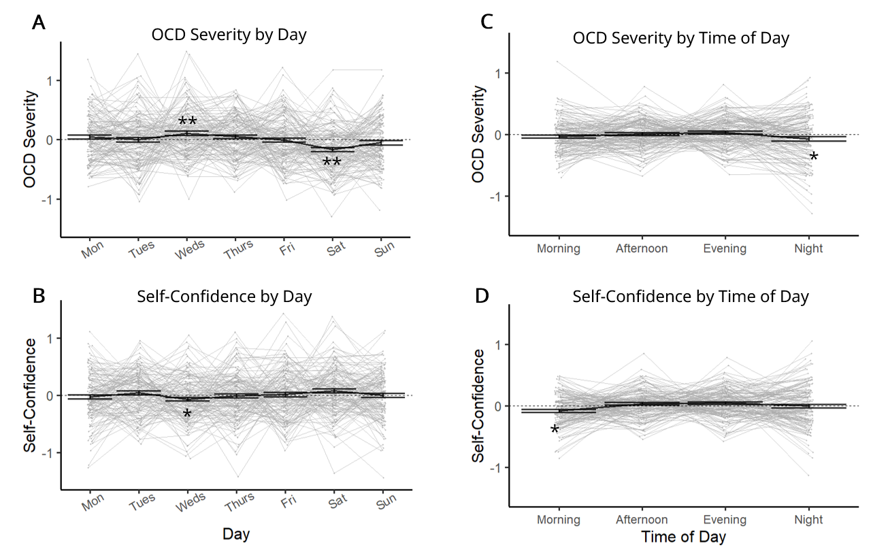
Figure S5: A. Mean (normalized within-person) state OCD severity (grey) and group mean ± standard error of mean (black) across days (x- axis). Each grey line is an individual participant. Linear mixed-effect models revealed OCD severity was significantly worse mid-week (Wednesdays) and significantly improved on Saturdays. B. Mean state self-confidence variability across days. Self-confidence was significantly reduced on Wednesdays. C. Mean state OCD severity per subject and group mean by time of day. OCD severity was significantly lower at night. D. Mean state self-confidence by time of day. Self-confidence was significantly lower during the mornings. Error bars represent 95% confidence intervals. Key: *p < .05; ** p < .001.

Day-to-day OCD severity ratings are predicted by current and past self-confidence
To corroborate our results showing reduced self-confidence is associated with future symptom logs, we assessed whether we see similar relationships when considering OCD severity ratings during timed notifications.
Linear mixed effects models showed that having low self-confidence at a given time point was significantly linked with higher OCD severity (β = -0.04, 95% CI [-0.06 -0.02], p <.001; Figure S6A). Alongside self-confidence, current OCD severity showed expected relationships with other state measures: it was associated positively with anxiety (β = 0.41, 95% CI [0.38 0.43], p < .001) and brain fog (β = 0.18, 95% CI [0.16 0.21], p < .001 ) and negatively with happiness (β = -0.09, 95% CI [-0.11 -0.06], p < .001) and sleep quality (entered in a separate model to prevent data loss; β = -0.19, 95% CI [-0.23 -0.14], p < .001) – Figure S4A.
Next, we were interested in the directionality of these effects, i.e. whether, like our symptom log findings, drops in self-confidence preceded increased OCD severity ratings. Self-confidence at a given moment was significantly (inversely) related to future (β = -0.03, 95% CI [-0.05 -0.009], p = .008), and present OCD severity (β = -0.34, 95% CI [-0.37 -0.32], p < .001), but not with past OCD (β = -0.009, p = .49) – Figure S6B. This suggests that reduced self-confidence drives future OCD ratings and not vice versa.
However, metacognitive bias was not significantly associated with OCD severity ratings (β = 0.040, p = .21).
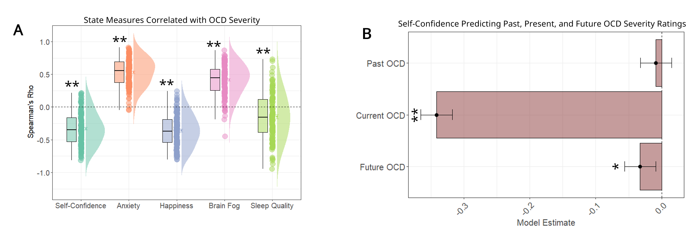
Figure S6: A. Raincloud plots (for visualisation purposes) showing within-subject correlations between OCD severity (a) and other state measures. Each circle represents one participant’s Spearman’s Rho value depicting the correlation strength between the state measure on the x-axis with their own OCD severity and self-confidence. Group mean standard error bars and boxplots are displayed. Significance stars indicate the variable was significantly predictive in a linear model (all predictors inserted at the same time) B. Bar plot depicting model coefficient estimates from linear model with past, current, and future OCD severity as predictors of self-confidence. Error bars represent 95% confidence intervals directional effects of self-confidence over OCD severity. Here, self-confidence predicted current and future OCD severity at a given moment, but past OCD did not impact current self-confidence.

Robustness tests for regression models
First, we found compliance was inversely correlated with metacognitive bias (rho = -0.23, p = .007) – likely due to staircasing procedure causing accuracy to converge to ~70% the more the task is played. Hence, we repeated our logistic mixed effect model with metacognitive bias predicting a symptom log, but this time controlling for compliance (number of notifications answered throughout assessment period). Metacognitive bias remained a significant predictor of a future symptom log (Odds ratio = 0.76, β = -0.28, p = .023).
For regression analyses of interest, we assessed robustness by 1) accounting for different slopes per subject, 2) controlling for age and gender. Given that the probability of occurrence of OCD symptom logs varied by current activities, we also reran models controlling for these variables. Moreover, as state OCD severity was affected by time-of-day, day-of-the-week, and current activities, we also controlled for these variables when assessing the impact of state variables (self-confidence and OCD severity ratings) on the occurrence of symptom logs.
Table S5 outlines these results. The table also indicates whenever models controlling for different subject slopes failed to converge.
Table S5: Results from robustness checks for models reported in paper
Significant Model | Relevant Figure in Main Paper | Robustness Check | Result of interest
Current OCD Severity_{,i} ~ Future Symptom Log_{i} + Past Future Log_{i} | 2e | Different slopes per subject | Future Symptom Log: β = 0.26, p < .001;  Past Symptom Log: β = 0.17, p = .001
Current OCD Severity_{,i} ~ Future Symptom Log_{i} + Past Future Log_{i} | 2e | Control for age and gender | Future Symptom Log: β = 0.24, p < .001;  Past Symptom Log: β = 0.15, p < .001
Current OCD Severity_{,i} ~ Future Symptom Log_{i} + Past Future Log_{i} | 2e | Control for time of day and day-of-week | Future Symptom Log: β = 0.23, p < .001;  Past Symptom Log: β = 0.14, p < .001
Current OCD Severity_{,i} ~ Future Symptom Log_{i} + Past Future Log_{i} | 2e | Control for current activities and social context | Future Symptom Log: β = 0.21, p < .001;  Past Symptom Log: β = 0.14, p < .001
Future Symptom Log_{i,t} ∈{0,1} ~ Current Activities | 3a | Different slopes per subject | Convergence failure
Future Symptom Log_{i,t} ∈{0,1} ~ Current Activities | 3a | Control for age and gender | Resting: β = -0.53, p < .001; Leisure: β = -0.37, p = .002; Self-care/eating/drinking: β = -0.38, p = .007
Self-confidence_{t,i} ~ Current Activities | 3b | Different slopes per subject | Convergence failure
Self-confidence_{t,i} ~ Current Activities | 3b | Control for age and gender | Leisure: β = 0.12, p = .002; Sports: β = 0.54, p < .001; Self-care/eating/drinking: β = 0.12, p < .001; With other people (vs alone): β = 0.15, p < .001
Future Symptom Log_{i,t} ∈{0,1} ~ State Variables_{t,i} | 4a | Different slopes per subject | Convergence failure
Future Symptom Log_{i,t} ∈{0,1} ~ State Variables_{t,i} | 4a | Control for age and gender | OCD severity: β = 0.30, p = .007; Self-Confidence: β = -0.34, p = .005
Future Symptom Log_{i,t} ∈{0,1} ~ State Variables_{t,i} | 4a | Control for time of day and day-of-week | OCD severity: β = 0.03, p = .009; Self-Confidence: β = -0.03, p = .005
Future Symptom Log_{i,t} ∈{0,1} ~ State Variables_{t,i} | 4a | Control for current activities and social context | OCD severity: β = 0.27, p = .02; Self-Confidence: β = -0.34, p =.005
Current Self-Confidence_{t,i} ~ Future Symptom Log_{i} + Past Future Log_{i} | 4b | Different slopes per subject | Convergence failure
Current Self-Confidence _{t,i} ~ Future Symptom Log_{i} + Past Future Log_{i} | 4b | Control for age and gender | Future Symptom Log: β = -0.19, p < .001
Current Self-Confidence _{t,i} ~ Future Symptom Log_{i} + Past Future Log_{i} | 4b | Control for time of day and day-of-week | Future Symptom Log: β = -0.17, p < .001
Current Self-Confidence _{t,i} ~ Future Symptom Log_{i} + Past Future Log_{i} | 4b | Control for current activities and social context | Future Symptom Log: β = -0.18, p < .001
Task metacognitive bias_{t,i} ~ Current Self-Confidence _{t,i} | 4c | Different slopes per subject | β = 0.12, p = .002
Task metacognitive bias_{t,i} ~ Current Self-Confidence _{t,i} | 4c | Control for age and gender | β = 0.11, p < .001
Task metacognitive bias_{t,i} ~ Current Self-Confidence _{t,i} | 4c | Control for time of day and day-of-week | β = 0.12, p < .001
Task metacognitive bias_{t,i} ~ Current Self-Confidence _{t,i} | 4c | Control for current activities and social context | β = 0.11, p < .001
Future Symptom Log_{i,t} ∈{0,1} ~ Task Metacognitive Bias_{t,i} | 4d | Different slopes per subject | β = -0.23, p = .038
Future Symptom Log_{i,t} ∈{0,1} ~ Task Metacognitive Bias_{t,i} | 4d | Control for age and gender | β = -0.21, p = .035
Task Metacognitive Bias_{t,i} ~ Future Symptom Log_{i} + Past Future Log_{i} | 4e | Different slopes per subject | Future Symptom Log: β = -0.21, p = .034
Task Metacognitive Bias_{t,i} ~ Future Symptom Log_{i} + Past Future Log_{i} | 4e | Control for age and gender | Future Symptom Log: β = -0.21, p = .035

Testing symptom log effects in shorter time windows
All symptom log results reported in the main paper define a ‘symptom log occurrence’ as a log conducted within a 4-hour time window from the completion of a state or task notification. Hence, we also confirmed that the results hold in shorter time windows (Table S6).

Table S6: Results from testing symptom log effects in shorter time windows
Model | Time Window | Result
Symptom Log_{i,t} ∈{0,1} ~ Self-confidence_{t,i} | 3 hours | β = -0.23, p < .001
Symptom Log_{i,t} ∈{0,1} ~ Self-confidence_{t,i} | 2 hours | β = -0.22, p < .001
Symptom Log_{i,t} ∈{0,1} ~ Self-confidence_{t,i} | 1 hour | β = -0.29, p < .001
Symptom Log_{i,t} ∈{0,1} ~ Task Metacognitive Bias _{t,i} | 3 hours | β = -0.26, p = .046
Symptom Log_{i,t} ∈{0,1} ~ Task Metacognitive Bias _{t,i} | 2 hours | β = -0.36, p = .011
Symptom Log_{i,t} ∈{0,1} ~ Task Metacognitive Bias _{t,i} | 1 hour | β = -0.31, p = .048

Assessing reliability of task metacognitive bias
As metacognitive bias emerged as the strongest task predictor of symptom logs, we checked the reliability of this measure by calculating the intraclass correlation coefficient between each pair of games (e.g., 1 and 2, 2 and 8 etc) and computed the average per pair across all subjects (Figure S7). Average reliability for metacognitive bias was high (M = 0.83, standard error mean = 0.01, 95% CI [0.81, 0.85]).

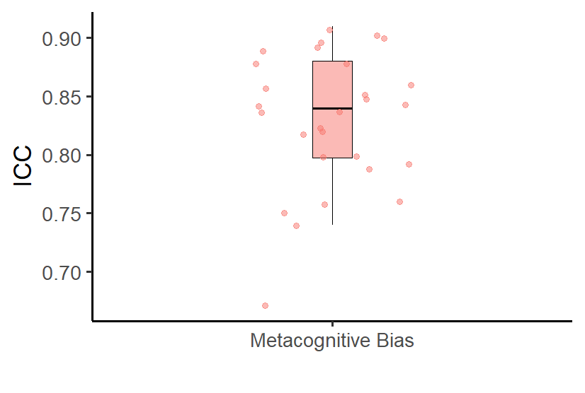
Figure S7: Average intraclass correlation coefficient for metacognitive bias. Each point is a pair of games (e.g., 1 and 2, 2 and 8 etc)

