Appendix

Table S1. EAPDs (%) between Cases with and without Short-Term Endpoints Incorporated in Scenarios without Delayed Effects.
$$HR_{tot}$$ | $P_{med}$% | 𝜑%
$$HR_{tot}$$ | $P_{med}$% | 10 | 20 | 30 | 40 | 50
0.8 | 100 | 0.5 | 1.2 | 1.8 | 2.2 | 2.8
0.8 | 90 | 0.3 | 0.6 | 1.2 | 1.8 | 1.8
0.8 | 80 | 0.3 | 0.6 | 0.8 | 1.4 | 1.8
0.8 | 70 | 0.1 | 0.4 | 0.7 | 0.7 | 0.9
0.8 | 60 | 0.1 | 0.2 | 0.5 | 0.5 | 0.9
0.8 | 50 | 0.1 | 0.2 | 0.5 | 0.4 | 0.6
0.8 | 0 | -0.1 | -0.1 | -0.1 | -0.1 | -0.2
0.7 | 100 | 1.5 | 2.7 | 3.8 | 4.6 | 5.1
0.7 | 90 | 0.9 | 2.2 | 2.8 | 4.0 | 4.5
0.7 | 80 | 0.6 | 1.2 | 2.0 | 2.7 | 3.6
0.7 | 70 | 0.3 | 0.9 | 1.4 | 1.7 | 2.1
0.7 | 60 | 0.2 | 0.4 | 1.1 | 1.3 | 1.5
0.7 | 50 | 0.0 | 0.3 | 0.5 | 0.8 | 0.7
0.7 | 0 | -0.1 | 0.0 | -0.1 | -0.2 | -0.1
0.6 | 100 | 2.4 | 4.7 | 7.2 | 9.5 | 11.4
0.6 | 90 | 1.8 | 3.5 | 5.2 | 6.6 | 8.2
0.6 | 80 | 1.0 | 2.3 | 3.6 | 4.8 | 6.0
0.6 | 70 | 0.6 | 1.1 | 2.1 | 3.2 | 4.0
0.6 | 60 | 0.2 | 0.8 | 1.5 | 2.2 | 2.9
0.6 | 50 | 0.2 | 0.3 | 0.6 | 1.1 | 1.5
0.6 | 0 | -0.3 | -0.2 | -0.2 | 0.1 | -0.2

Table S2. Time and Sample Size Savings after Introducing Futility Analysis in Scenarios without Delayed Effects.
$$HR_{tot}$$ | $P_{med}$% | Considering short-term endpoint | Most Time-Saving Design |  |  | Most Sample Size-Saving Design
$$HR_{tot}$$ | $P_{med}$% | Considering short-term endpoint | $f$%, $φ$% | $T_{save}$% | $N_{save}$% | $f$%, $φ$% | $N_{save}$% | $T_{save}$%
0.8 | 100 | Y | 30, 20 | 36.4 | 17.7 | 25, 15 | 18.7 | 33.0
0.8 | 100 | N | 40, 20 | 34.8 | 10.6 | 10, 10 | 16.6 | 21.0
0.8 | 80 | Y | 40, 20 | 34.8 | 10.6 | 25, 15 | 18.7 | 33.0
0.8 | 80 | N | 45, 20 | 34.1 | 6.8 | 25, 15 | 18.6 | 32.8
0.8 | 60 | Y | 35, 20 | 35.8 | 14.3 | 20, 15 | 20.2 | 31.4
0.8 | 60 | N | 40, 20 | 34.8 | 10.6 | 20, 15 | 20.3 | 31.5
0.8 | 0 | Y | 35, 20 | 35.8 | 14.3 | 20, 15 | 20.2 | 31.4
0.8 | 0 | N | 35, 20 | 36.0 | 14.4 | 20, 15 | 20.3 | 31.5
0.7 | 100 | Y | 40, 25 | 36.9 | 11.1 | 20, 15 | 21.0 | 32.7
0.7 | 100 | N | 40, 15 | 32.6 | 9.9 | 15, 10 | 17.0 | 23.7
0.7 | 80 | Y | 35, 20 | 35.3 | 14.0 | 20, 15 | 21.0 | 32.7
0.7 | 80 | N | 45, 20 | 34.0 | 6.7 | 25, 15 | 18.5 | 32.6
0.7 | 60 | Y | 30, 20 | 36.5 | 17.6 | 20, 15 | 21.0 | 32.7
0.7 | 60 | N | 45, 20 | 34.0 | 6.7 | 25, 15 | 18.5 | 32.6
0.7 | 0 | Y | 30, 20 | 36.5 | 17.6 | 15, 15 | 21.4 | 29.9
0.7 | 0 | N | 35, 20 | 35.4 | 14.0 | 15, 15 | 21.5 | 30.1
0.6 | 100 | Y | 35, 25 | 38.8 | 15.8 | 20, 20 | 23.0 | 35.8
0.6 | 100 | N | 50, 15 | 30.8 | 3.2 | 15, 10 | 16.9 | 23.6
0.6 | 80 | Y | 35, 20 | 36.1 | 14.7 | 20, 15 | 20.4 | 31.8
0.6 | 80 | N | 45, 20 | 33.7 | 6.9 | 15, 10 | 16.9 | 23.6
0.6 | 60 | Y | 30, 20 | 36.6 | 18.1 | 20, 15 | 20.4 | 31.8
0.6 | 60 | N | 40, 20 | 35.5 | 10.9 | 20, 15 | 20.3 | 31.6
0.6 | 0 | Y | 40, 25 | 37.3 | 11.5 | 25, 15 | 18.9 | 32.8
0.6 | 0 | N | 35, 20 | 36.0 | 14.6 | 20, 15 | 20.3 | 31.6

Table S3. EAPDs (%) between Cases with and without Short-Term Endpoints Incorporated in Scenarios with Delayed Effects.
Scenario | $τ$ months | Considering delayed effect in analysis | $φ$%
Scenario | $τ$ months | Considering delayed effect in analysis | 10 | 20 | 30 | 40 | 50
4 | 3 | Y | -0.4 | -0.4 | -0.4 | -0.2 | 0.1
4 | 3 | N | -0.1 | -0.2 | 0.2 | 0.0 | 0.2
5 | 3 | Y | 2.0 | 4.3 | 6.1 | 8.2 | 10.4
5 | 3 | N | 0.8 | 1.1 | 1.3 | 1.5 | 1.8
6 | 3 | Y | 0.9 | 1.7 | 2.5 | 4.0 | 5.0
6 | 3 | N | 0.0 | 0.1 | 0.3 | 0.6 | 0.5

Table S4. Time and Sample Size Savings after Introducing Futility Analysis in Scenarios with Delayed Effects.
Scenario | $τ$ months | Considering delayed effect | Considering short-term endpoint | Most Time-Saving Design |  |  | Most Sample Size-Saving Design
 |  |  |  | $f$%, $φ$% | $T_{save}$% | $N_{save}$% | $f$%, $φ$% | $N_{save}$% | $T_{save}$%
4 | 3 | Y | Y | 45, 20 | 32.0 | 6.5 | 25, 10 | 12.7 | 22.1
4 | 3 | Y | N | 55, 30 | 32.1 | 1.1 | 25, 10 | 12.2 | 21.1
4 | 3 | N | Y | 65, 10 | 25.3 | 0.0 | 60, 5 | 0.2 | 24.3
4 | 3 | N | N | 65, 10 | 25.2 | 0.0 | 50, 5 | 2.6 | 24.7
5 | 3 | Y | Y | 40, 25 | 35.4 | 10.9 | 20, 15 | 17.2 | 26.7
5 | 3 | Y | N | 55, 15 | 28.3 | 0.9 | 30, 10 | 11.5 | 23.2
5 | 3 | N | Y | 65, 5 | 23.2 | 0.0 | 65, 5 | 0.0 | 23.2
5 | 3 | N | N | 65, 5 | 23.2 | 0.0 | 65, 5 | 0.0 | 23.2
6 | 3 | Y | Y | 45, 25 | 34.0 | 6.9 | 25, 15 | 15.8 | 27.3
6 | 3 | Y | N | 50, 20 | 30.9 | 3.1 | 25, 10 | 12.2 | 21.1
6 | 3 | N | Y | 65, 5 | 23.2 | 0.0 | 65, 5 | 0.0 | 23.2
6 | 3 | N | N | 65, 5 | 23.2 | 0.0 | 65, 5 | 0.0 | 23.2

Table S5. Simulation Scenarios with Reversed Direct and Indirect Effects.
Scenario | $$HR_{tot}$$ | $RD$% | $$ρ$$ | $$h$$
1 | 0.6 | 40 | 0.18 | 1.1
2 | 0.7 | 40 | 0.24 | 1.2
3 | 0.8 | 40 | 0.35 | 1.2
Based on the total treatment effect $HR_{tot}$, direct effect $h$, and the response rate difference $RD$ between the treatment groups, the indirect effect hazard ratio $ρ$ is derived through 2000 simulations to achieve a trial power of 85% in the absence of futility analysis.

Table S6. Simulation Scenarios with Different Enrollment Durations.
$$HR_{tot}$$ | $P_{med}$% | $RD$% | $$ρ$$ | $$h$$ | Enrollment duration in months
0.6 | 100 | 30 | 0.11 | 1.00 | 6, 12, 18
 | 80 | 30 | 0.18 | 0.90 | 6, 12, 18
 | 60 | 30 | 0.30 | 0.82 | 6, 12, 18
Based on the total treatment effect $HR_{tot}$ and the proportion of indirect effects $P_{med}\%$, the direct effect $h$ can be calculated. Given $HR_{tot}$, $h$, and the response rate difference $RD$ between the treatment groups, the indirect effect hazard ratio $ρ$ is derived through 2000 simulations to achieve a trial power of 85% in the absence of futility analysis.

Table S7. Different Effect Delay Times Specified in Analysis.
Scenario | $$RD$$ | $$ρ_{1}$$ | $$ρ_{2}$$ | $$h_{1}$$ | $$h_{2}$$ | $τ$ months | $τ_{0}$ months
1 | 0.4 | 1 | 1 | 1 | 0.46 | 3 | 0, 1, 2, 3, 4, 5
2 | 0.4 | 1 | 0.07 | 1 | 1 | 3 | 0, 1, 2, 3, 4, 5
3 | 0.4 | 1 | 0.19 | 1 | 0.8 | 3 | 0, 1, 2, 3, 4, 5
Given the total treatment effect $HR_{tot}=0.6$, $τ_{0}=τ=3$, the response rate difference $RD$ between the treatment groups, and the partially specified values of the parameters $ρ_{1}$, $ρ_{2}$, $h_{1}$, and $h_{2}$, the values of the remaining parameters are derived through 2000 simulations to achieve a trial power of 85% in the absence of futility analysis.

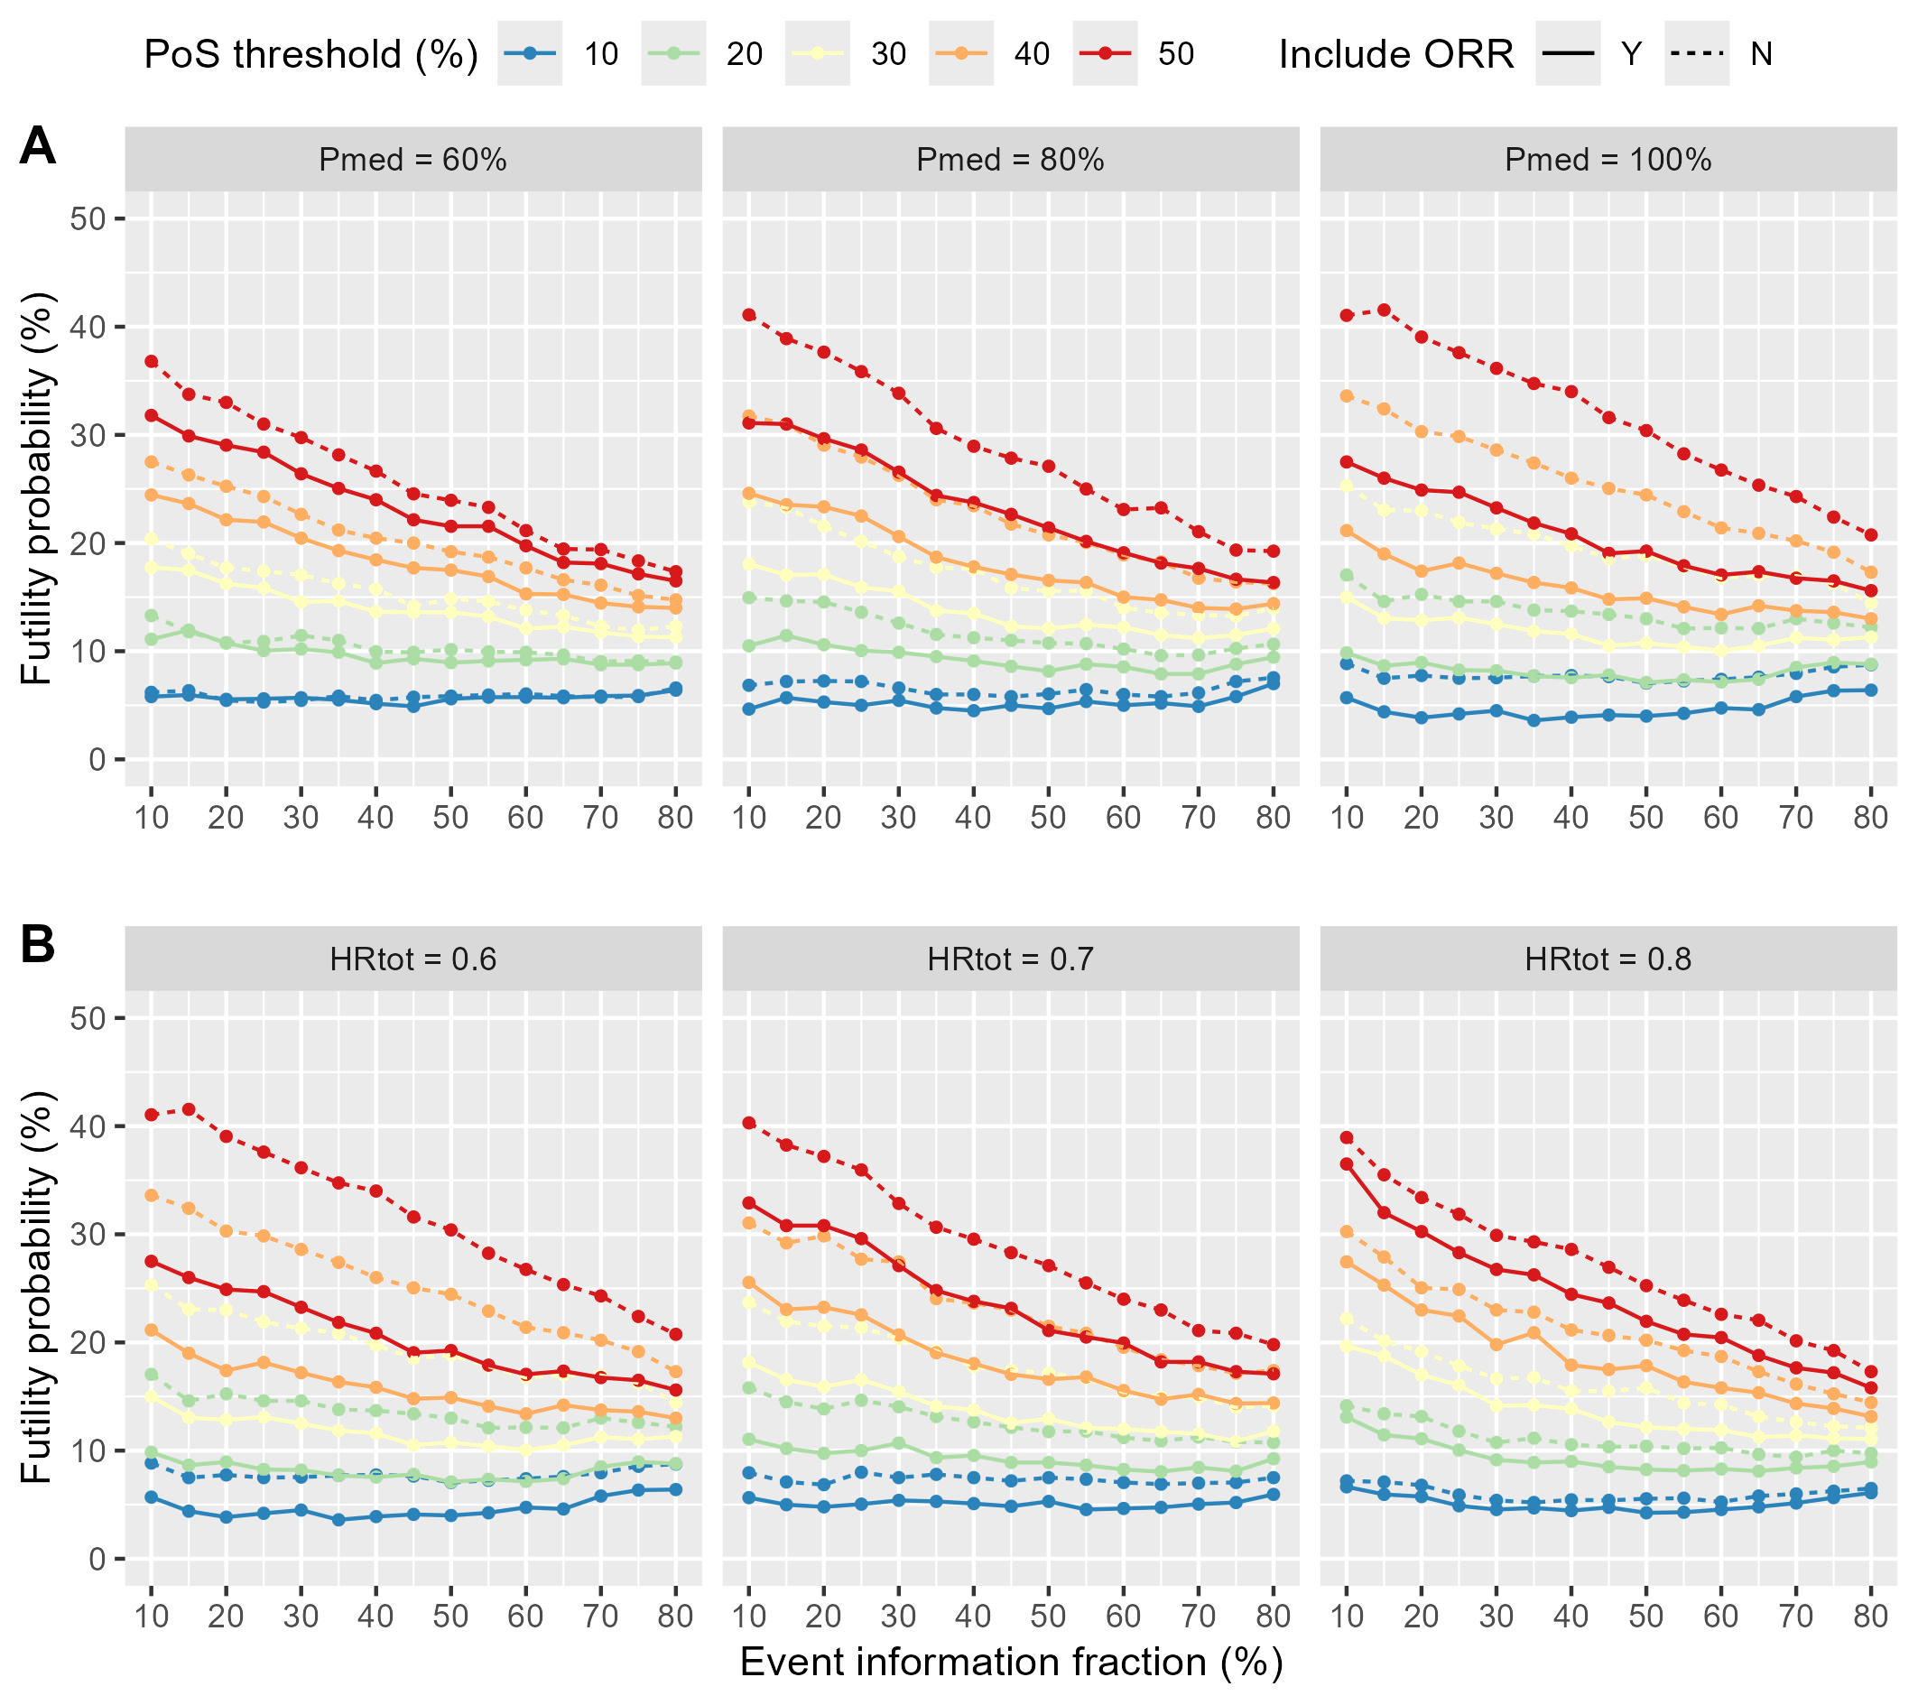

Figure S1. Probability of Futility Stopping under $H_{1}$ Hypothesis in Scenarios without Delayed Effects.
In Subfigure A, the total treatment effect $HR_{tot}=$0.6, with indirect effect proportions $P_{med}$ of 60%, 80%, and 100%, respectively; in Subfigure B, $P_{med}=$100%, and $HR_{tot}$ values are 0.6, 0.7, and 0.8, respectively.

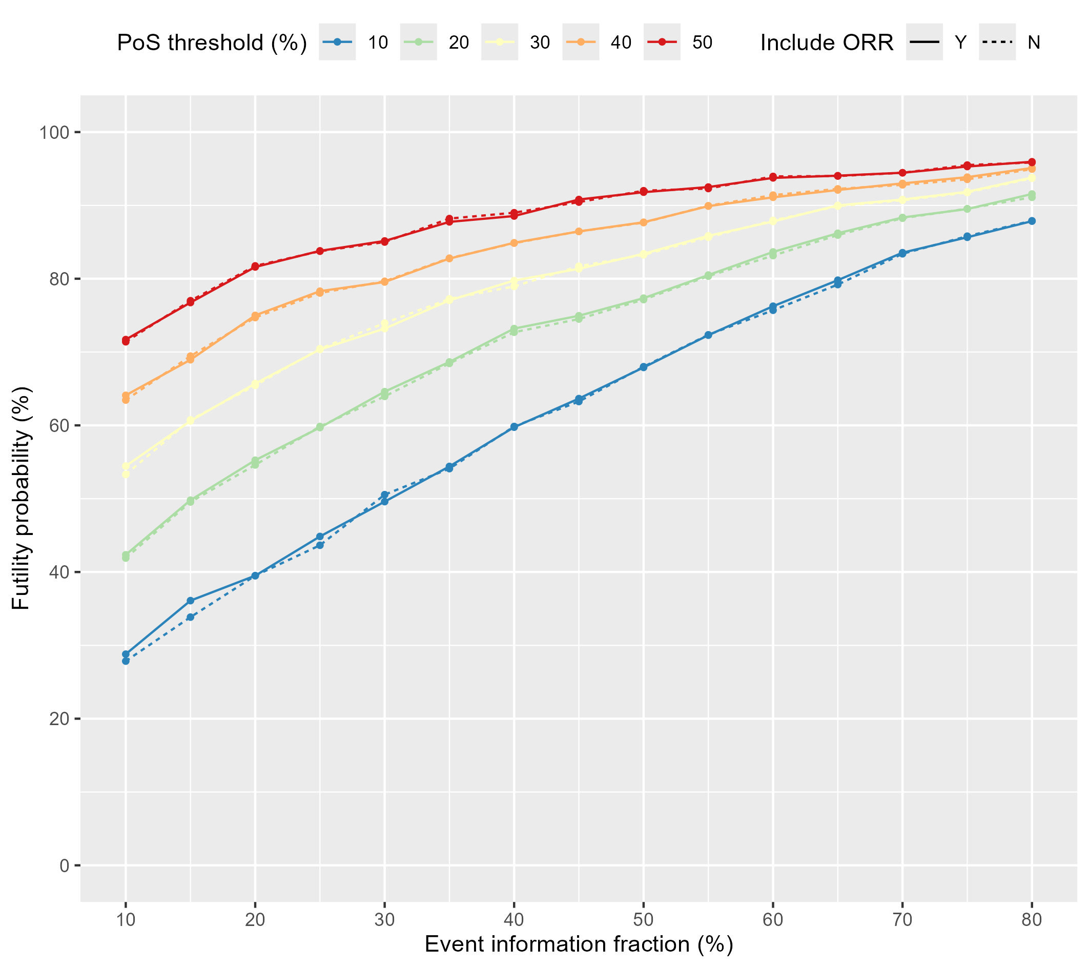

Figure S2. Probability of Futility Stopping under $H_{0}$ Hypothesis in Scenarios without Delayed Effects.

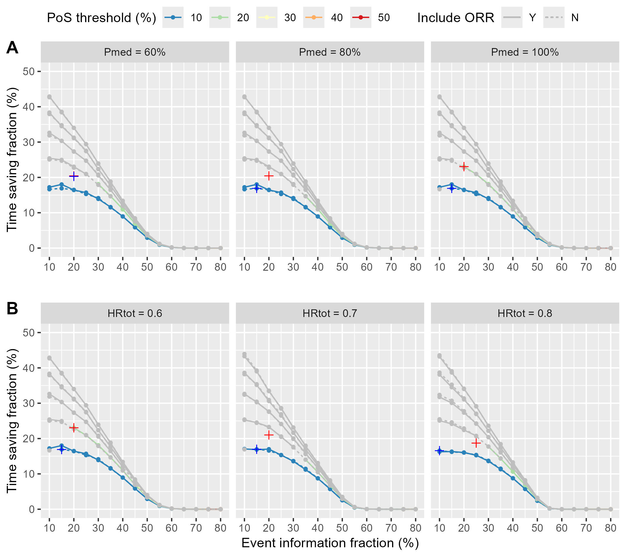

Figure S3. Sample Size Savings after Introducing Futility Analysis in Scenarios without Delayed Effects.
In Subfigure A, the total treatment effect $HR_{tot}$ is 0.6, with indirect effect proportions $P_{med}$ of 60%, 80%, and 100%, respectively; in Subfigure B, $P_{med}=$100%, and $HR_{tot}$ values are 0.6, 0.7, and 0.8, respectively. The gray lines and dots indicate a reduction in power ＞5% due to the introduction of futility analysis under the $H_{1}$ hypothesis, while the colored lines and dots indicate a reduction in power ≤5%. + and + represent the maximum sample size saved by incorporating and not incorporating short-term endpoints after introducing futility analysis, respectively. Note that the $PoS$ thresholds used in the simulation are 10%, 15%, 20%, ..., and 50%; however, only the thresholds of 10%, 20%, 30%, ..., and 50% are displayed in the figure.

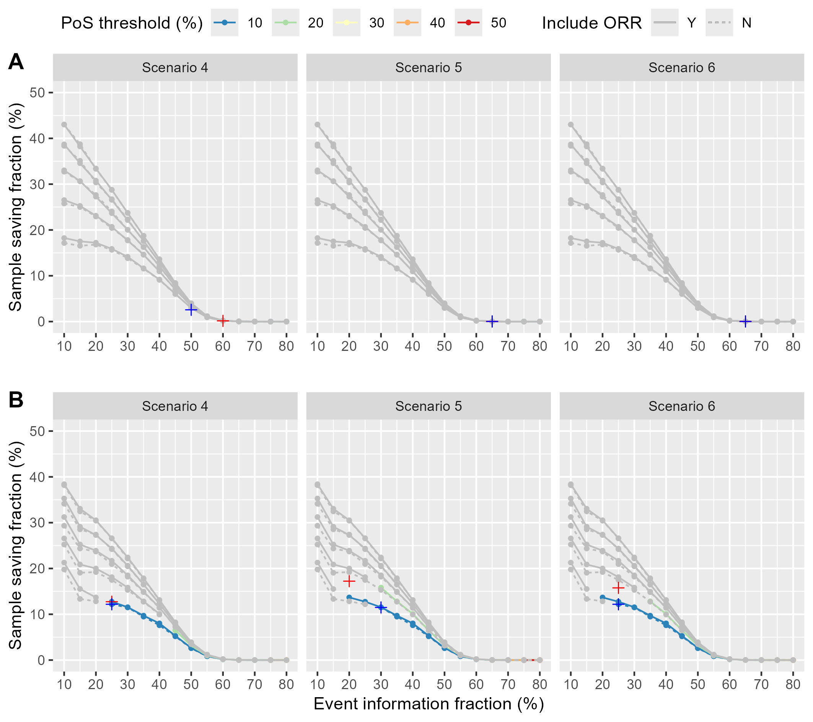

Figure S4. Sample Size Savings after Introducing Futility Analysis in Scenarios with Delayed Effects.
In Subfigure A, the delayed effects are not considered in the analysis; while in Subfigure B, they are considered. The gray lines and dots indicate a reduction in power ＞5% due to the introduction of futility analysis under the $H_{1}$ hypothesis, while the colored lines and dots indicate a reduction in power ≤5%. + and + represent the maximum sample size saved by incorporating and not incorporating short-term endpoints after introducing futility analysis, respectively. Note that the futility thresholds of $PoS$ used in the simulation are 10%, 15%, 20%, ..., and 50%; however, only the thresholds of 10%, 20%, 30%, ..., and 50% are displayed in the figure.

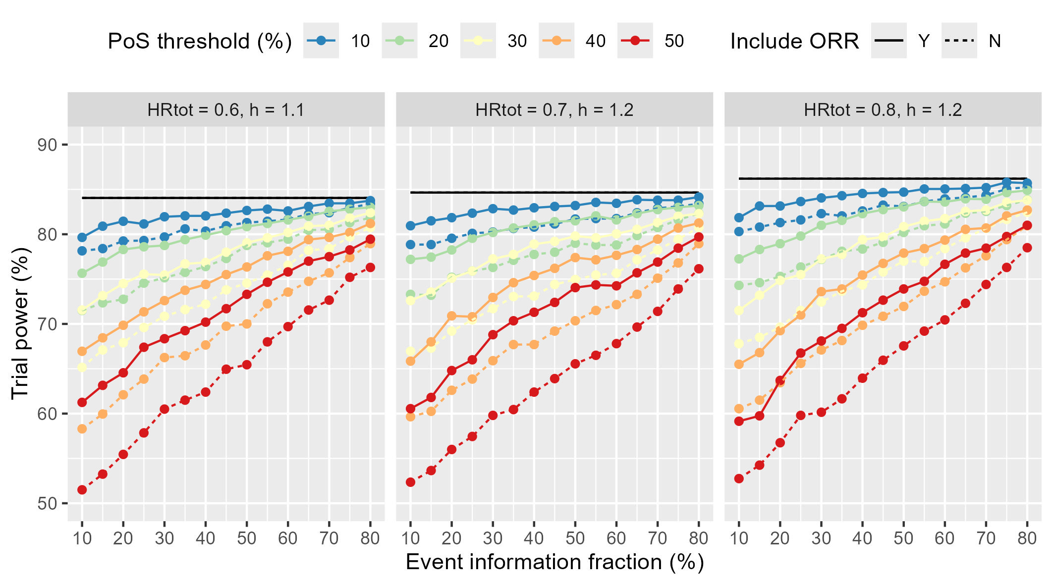

Figure S5. Trial Power with Reversed Direct and Indirect Effects.
The horizontal black line represents the trial power in the absence of futility analysis.

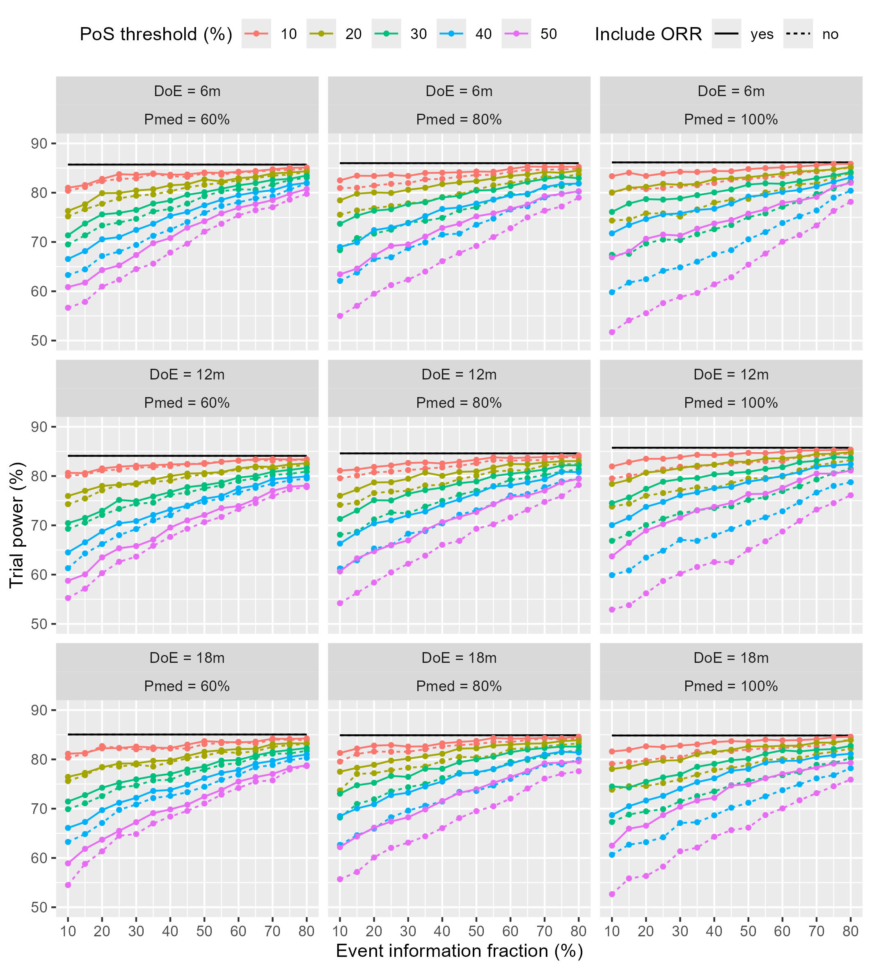

Figure S6. Trial Power with Different Enrollment Durations.
DoE means duration of enrollment in months. The horizontal black line represents the trial power in the absence of futility analysis.

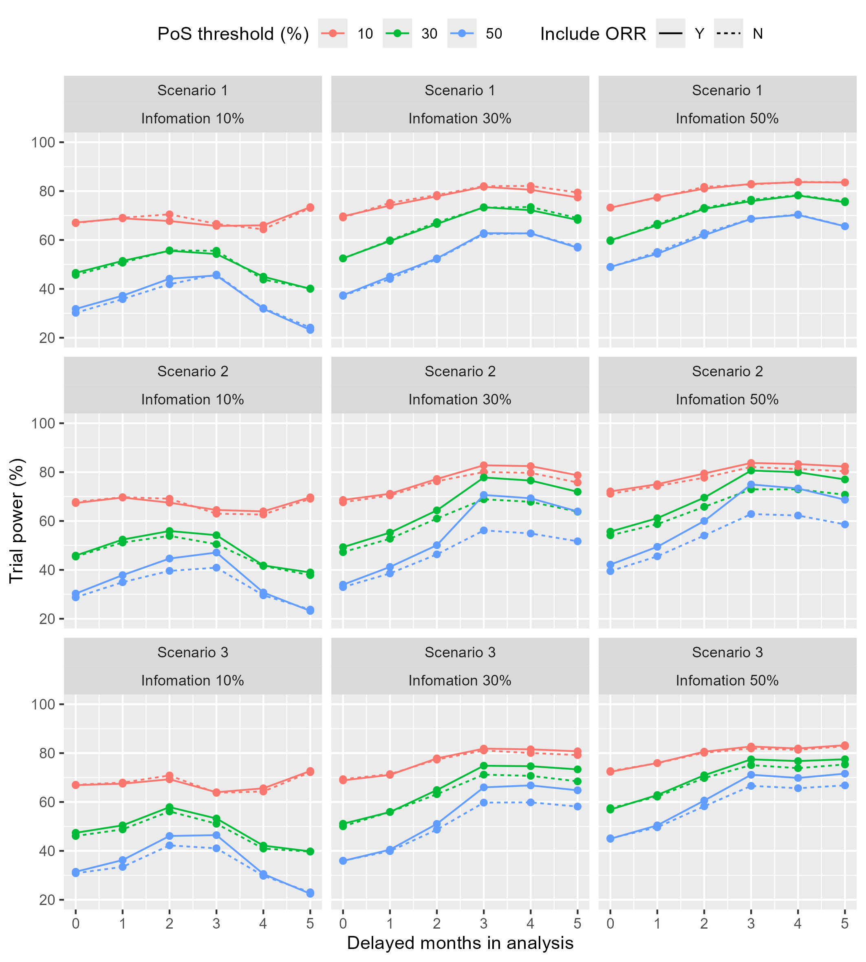

Figure S7. Trial Power with Different Effect Delay Times Specified in Analysis.
For Scenarios 1, 2, and 3, the actual effect delay times are all 3 months; the effect delay times specified in the analysis are 0, 1, 2, 3, 4, and 5 months, respectively. The figure shows the trial power when futility analysis is performed at 10%, 30%, and 50% event information, respectively.

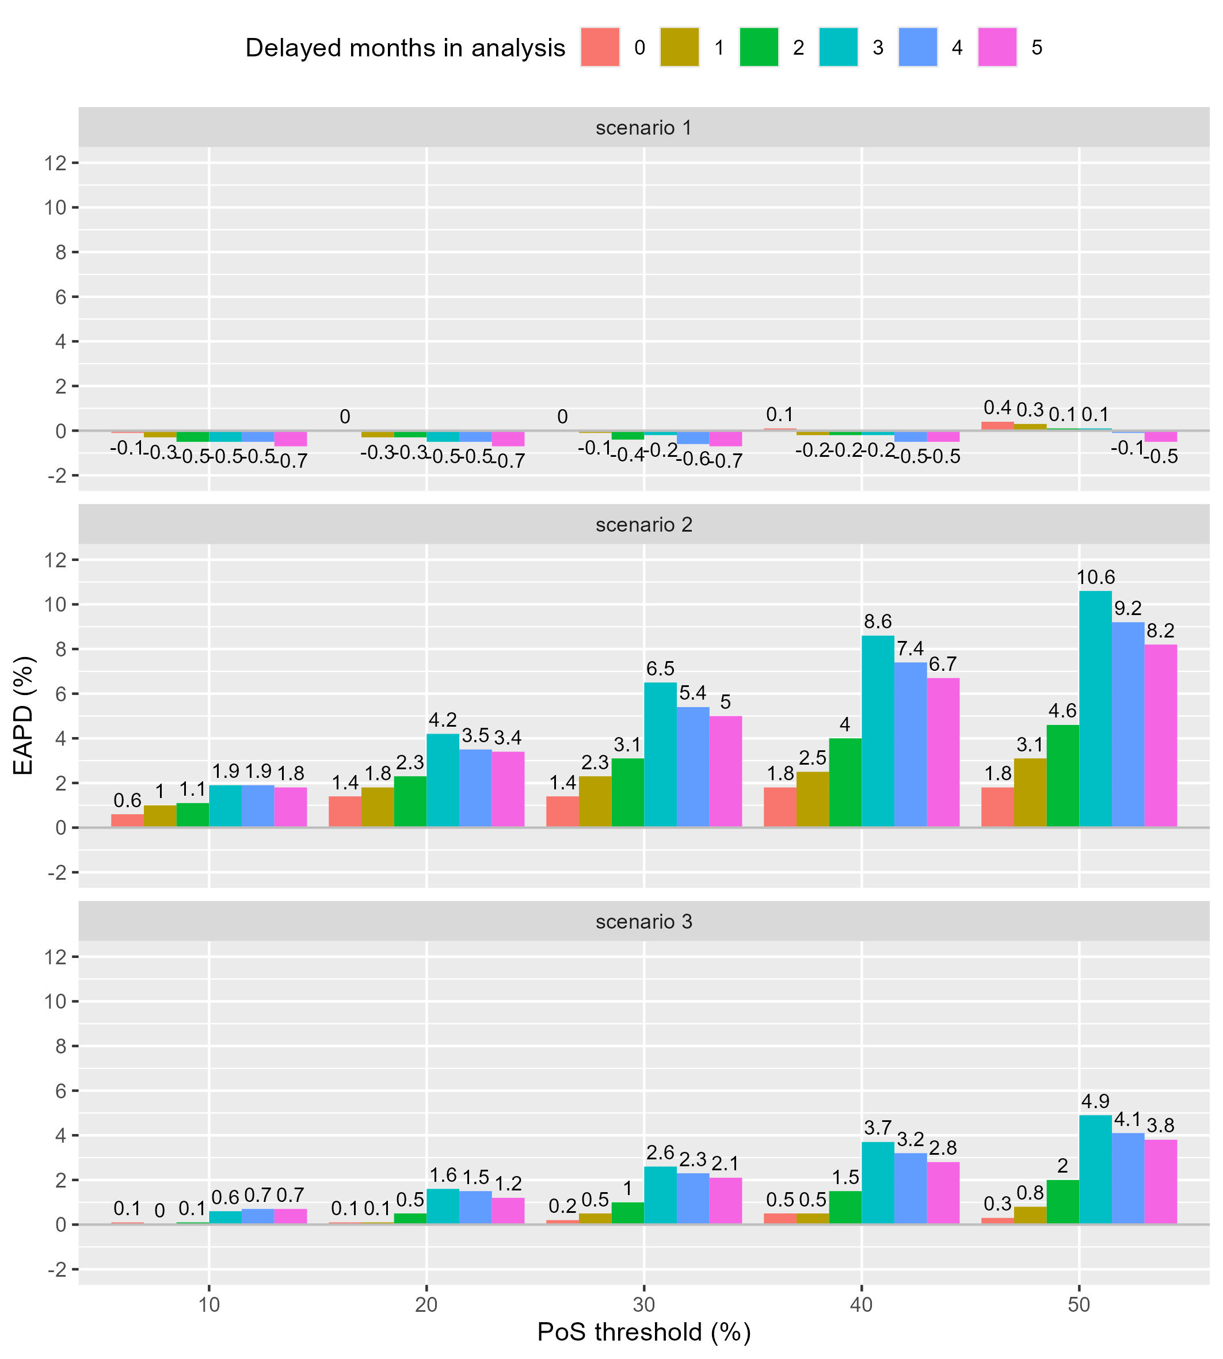

Figure S8. EAPDs (%) between Cases with and without Short-Term Endpoints Incorporated at Different Effect Delay Times.
For Scenarios 1, 2, and 3, the actual effect delay times are all 3 months; the effect delay times specified in the analysis are 0, 1, 2, 3, 4, and 5 months, respectively.

