Volatile organic compounds from Bacillus spp. reduce egg hatching, motility, infectivity and reproduction of Meloidogyne incognita
Journal of Plant Disease and Protection

Renata Silva Canuto de Pinho, Vicente Paulo Campos, Eduardo Souza Freire, Denilson Ferreira Oliveira, Ricardo Magela de Souza, Adrian Martin Polhit, Márcia de Oliveira Souza, Norberto Peporine Lopes, Jorge Teodoro de Souza*

*Corresponding author: jorge.souza@ufla.br
Departamento de Fitopatologia, Universidade Federal de Lavras, CP 3037, CEP 37200-000, Lavras, MG, Brazil.

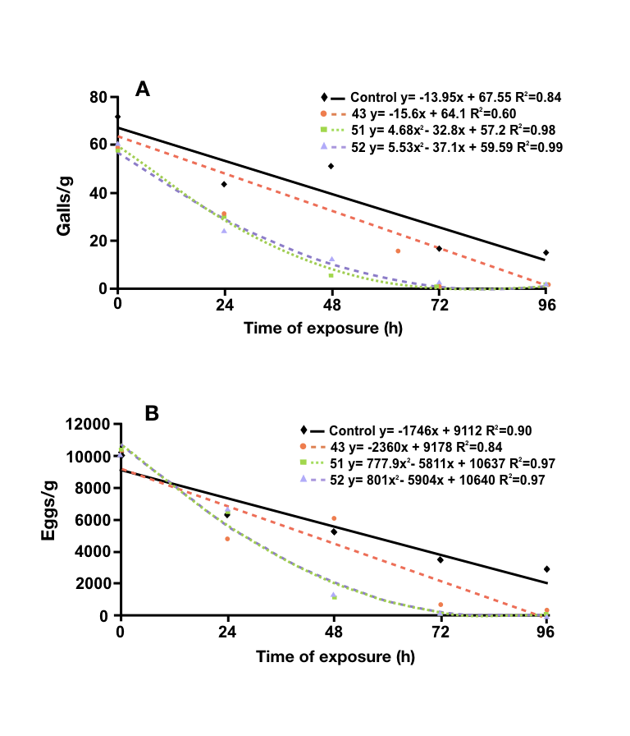

Fig. S1 Reproduction of Meloidogyne incognita after exposure to VOCs for different periods of time. (A) Regression analysis of the number of galls and (B) eggs on tomato roots induced by M. incognita that had the J2s exposed to bacterial VOCs produced by three Bacillus strains, Bacillus sphaericus strain 43 and B. pumilus strains 51 and 52, for 0, 24, 48, 72 and 96 h. Adjustment of regression models for each treatment with the R² are shown for each equation

