MOL ID | Structure | Name | OB（%） | DL
MOL001601 | 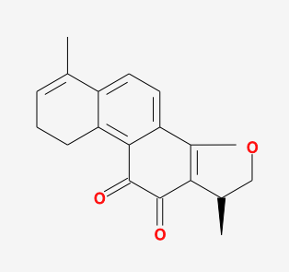 | 1,2,5,6-tetrahydrotanshinone | 38.75 | 0.36
MOL000085 |  | beta-daucosterol_qt | 36.91 | 0.75
MOL001659 | 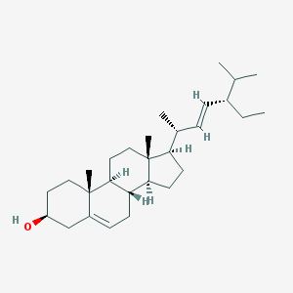 | Poriferasterol | 43.83 | 0.76
MOL001771 | 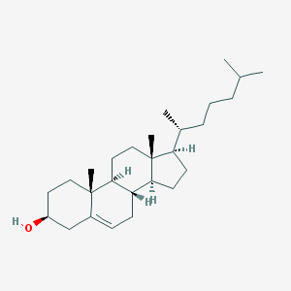 | poriferast-5-en-3beta-ol | 36.91 | 0.75
MOL001942 | 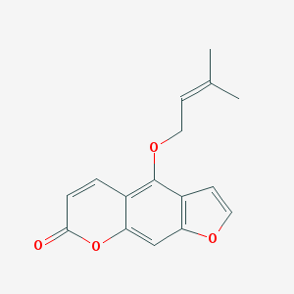 | isoimperatorin | 45.46 | 0.23
MOL002222 | 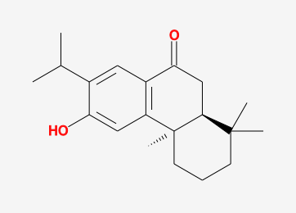 | sugiol | 36.11 | 0.28
MOL002651 | 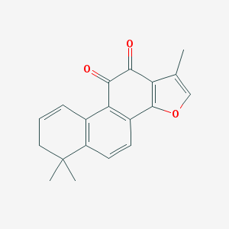 | Dehydrotanshinone II A | 43.76 | 0.40
MOL000569 | 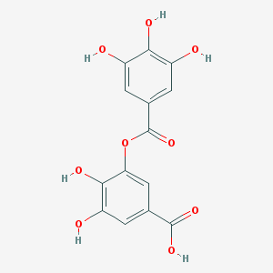 | digallate | 61.85 | 0.26
MOL000006 | 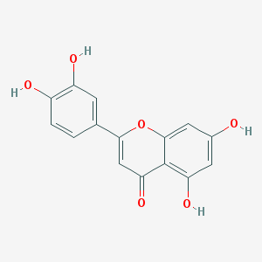 | luteolin | 36.16 | 0.25
MOL007036 | 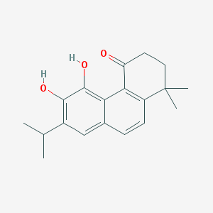 | 5,6-dihydroxy-7-isopropyl-1,1-dimethyl-2,3-dihydrophenanthren-4-one | 33.77 | 0.29
MOL007041 | 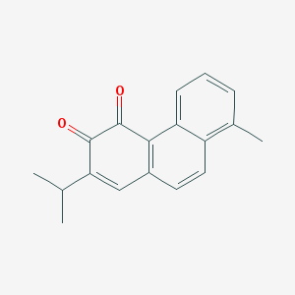 | 2-isopropyl-8-methylphenanthrene-3,4-dione | 40.86 | 0.23
MOL007045 | 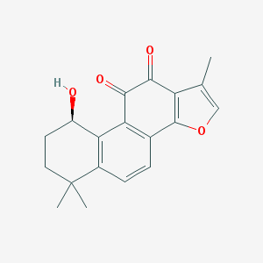 | 3α-hydroxytanshinoneⅡa | 44.93 | 0.44
MOL007048 | 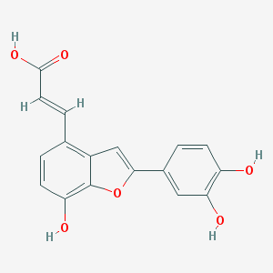 | (E)-3-[2-(3,4-dihydroxyphenyl)-7-hydroxy-benzofuran-4-yl]acrylic acid | 48.24 | 0.31
MOL007049 | 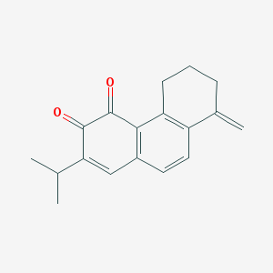 | 4-methylenemiltirone | 34.35 | 0.23
MOL007050 | 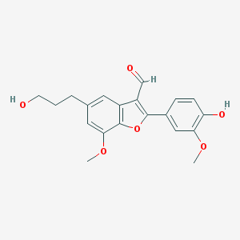 | 2-(4-hydroxy-3-methoxyphenyl)-5-(3-hydroxypropyl)-7-methoxy-3-benzofurancarboxaldehyde | 62.78 | 0.40
MOL007058 | 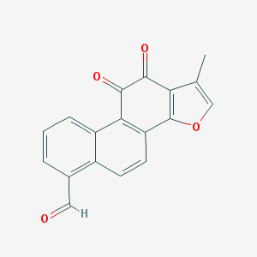 | formyltanshinone | 73.44 | 0.42
MOL007059 | 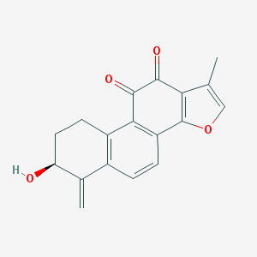 | 3-beta-Hydroxymethyllenetanshiquinone | 32.16 | 0.41
MOL007061 | 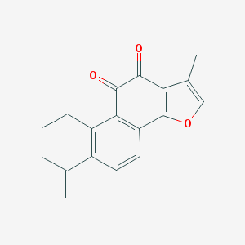 | Methylenetanshinquinone | 37.07 | 0.36
MOL007063 | 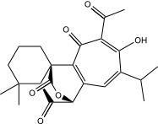 | przewalskin a | 37.11 | 0.65
MOL007064 | 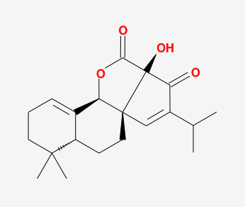 | przewalskin b | 110.32 | 0.44
MOL007068 | 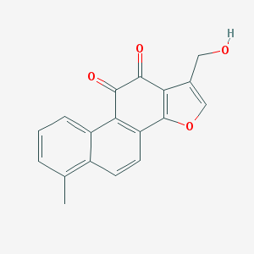 | Przewaquinone B | 62.24 | 0.41
MOL007069 | 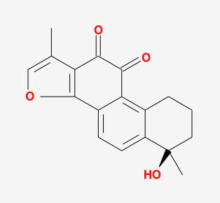 | przewaquinone c | 55.74 | 0.40
MOL007070 | 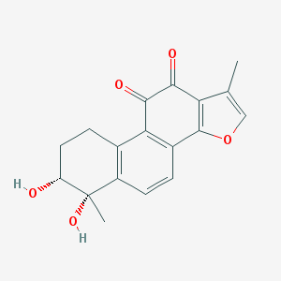 | (6S,7R)-6,7-dihydroxy-1,6-dimethyl-8,9-dihydro-7H-naphtho[8,7-g]benzofuran-10,11-dione | 41.31 | 0.45
MOL007071 | 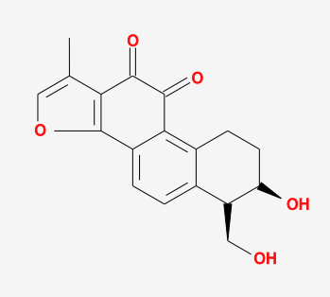 | przewaquinone f | 40.31 | 0.46
MOL007077 | 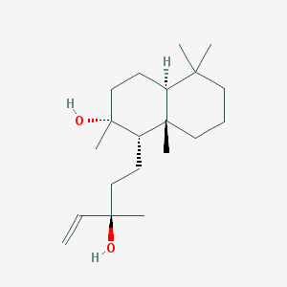 | sclareol | 43.67 | 0.21
MOL007079 | 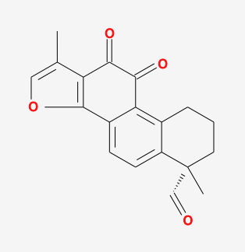 | tanshinaldehyde | 52.47 | 0.45
MOL007081 | 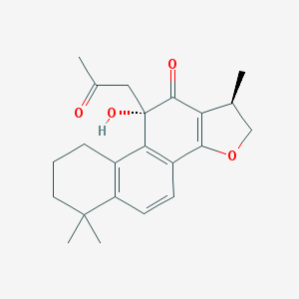 | Danshenol B | 57.95 | 0.56
MOL007082 | 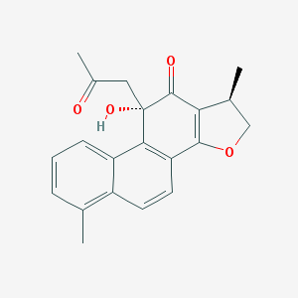 | Danshenol A | 56.97 | 0.52
MOL007085 | 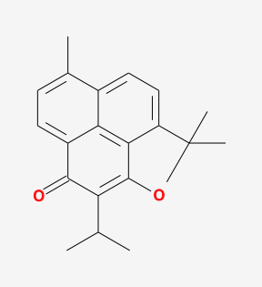 | Salvilenone | 30.38 | 0.38
MOL007088 | 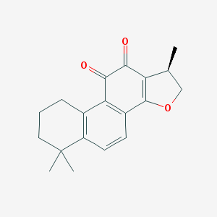 | cryptotanshinone | 52.34 | 0.40
MOL007093 | 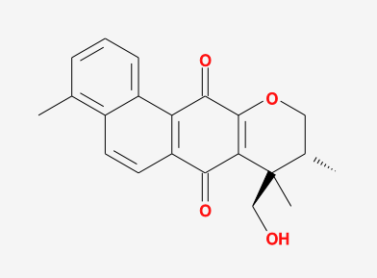 | dan-shexinkum d | 38.88 | 0.55
MOL007094 | 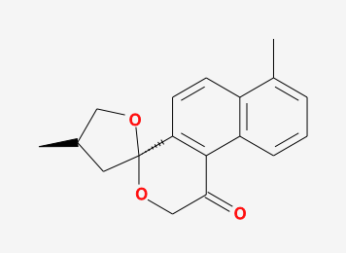 | danshenspiroketallactone | 50.43 | 0.31
MOL007098 | 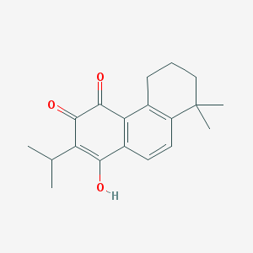 | deoxyneocryptotanshinone | 49.40 | 0.29
MOL007100 | 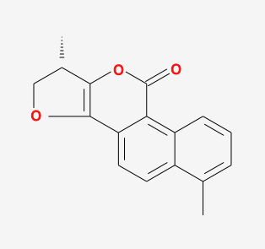 | dihydrotanshinlactone | 38.68 | 0.32
MOL007101 | 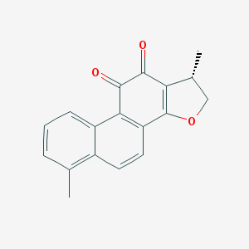 | dihydrotanshinoneⅠ | 45.04 | 0.36
MOL007105 | 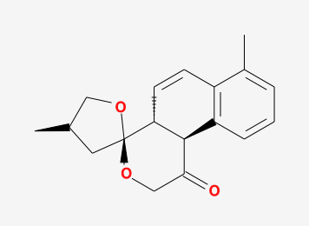 | epidanshenspiroketallactone | 68.27 | 0.31
MOL007107 | 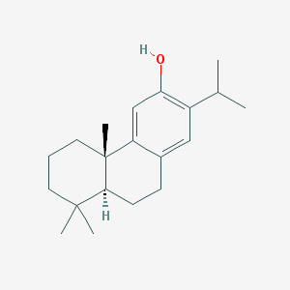 | C09092 | 36.07 | 0.25
MOL007108 | 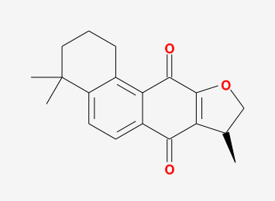 | isocryptotanshi-none | 54.98 | 0.39
MOL007111 | 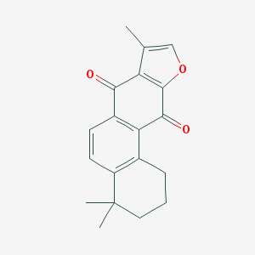 | Isotanshinone II | 49.92 | 0.40
MOL007119 | 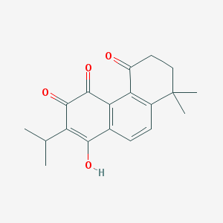 | miltionone Ⅰ | 49.68 | 0.32
MOL007120 | 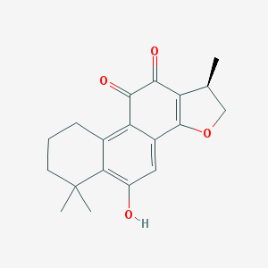 | miltionone Ⅱ | 71.03 | 0.44
MOL007121 | 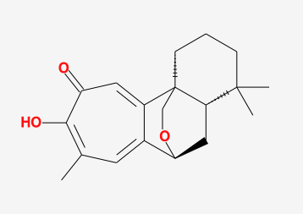 | miltipolone | 36.56 | 0.37
MOL007122 | 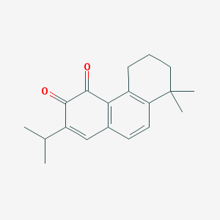 | Miltirone | 38.76 | 0.25
MOL007124 | 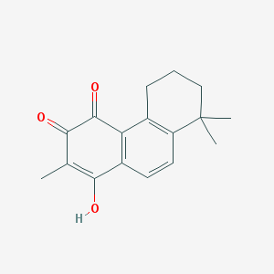 | neocryptotanshinone ii | 39.46 | 0.23
MOL007125 | 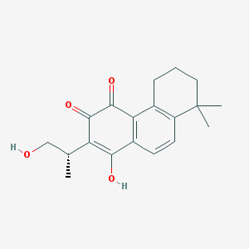 | neocryptotanshinone | 52.49 | 0.32
MOL007127 | 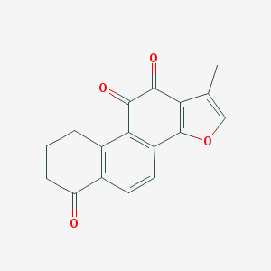 | 1-methyl-8,9-dihydro-7H-naphtho[5,6-g]benzofuran-6,10,11-trione | 34.72 | 0.37
MOL007130 | 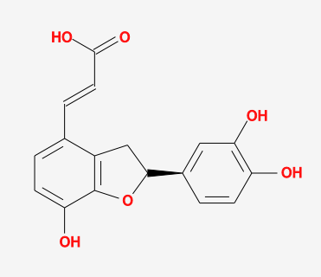 | prolithospermic acid | 64.37 | 0.31
MOL007132 | 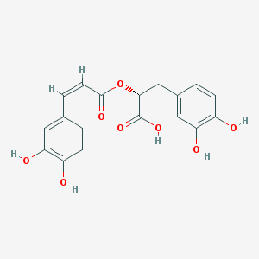 | (2R)-3-(3,4-dihydroxyphenyl)-2-[(Z)-3-(3,4-dihydroxyphenyl)acryloyl]oxy-propionic acid | 109.38 | 0.35
MOL007141 | 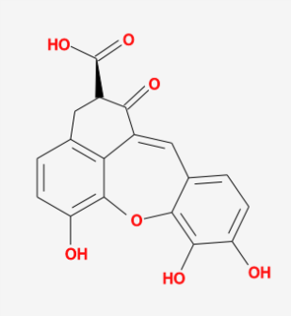 | salvianolic acid g | 45.56 | 0.61
MOL007142 | 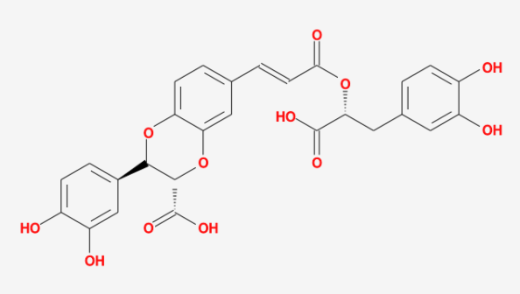 | salvianolic acid j | 43.38 | 0.72
MOL007143 | 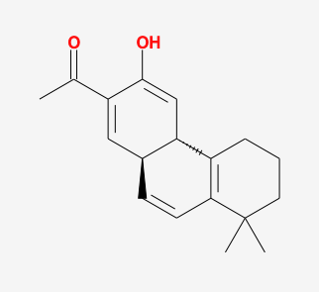 | salvilenone Ⅰ | 32.43 | 0.23
MOL007145 | 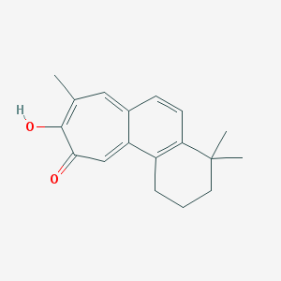 | salviolone | 31.72 | 0.24
MOL007150 | 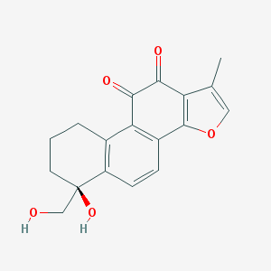 | (6S)-6-hydroxy-1-methyl-6-methylol-8,9-dihydro-7H-naphtho[8,7-g]benzofuran-10,11-quinone | 75.39 | 0.46
MOL007151 | 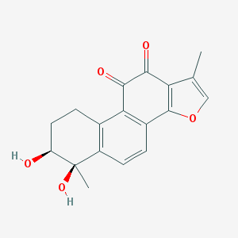 | Tanshindiol B | 42.67 | 0.45
MOL007152 | 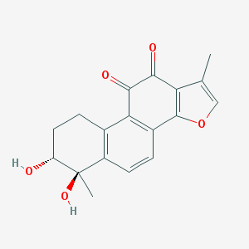 | Przewaquinone E | 42.85 | 0.45
MOL007154 | 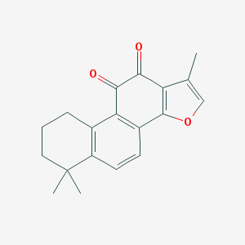 | tanshinone iia | 49.89 | 0.40
MOL007155 | 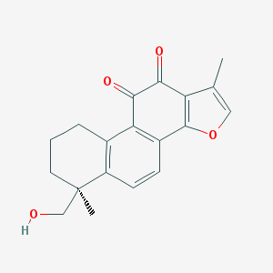 | (6S)-6-(hydroxymethyl)-1,6-dimethyl-8,9-dihydro-7H-naphtho[8,7-g]benzofuran-10,11-dione | 65.26 | 0.45
MOL007156 | 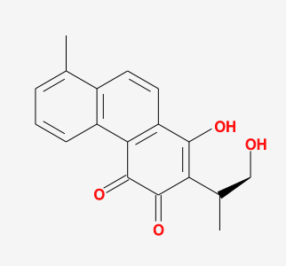 | tanshinone Ⅵ | 45.64 | 0.30
Supplementary Table 1: Active ingredients parameters of SMRR.
* Oral Bioavailability: OB; Drug-Likeness: DL

