Polar Particles: Atmospheric Microplastic Pollution in the Arctic Region – an examination of deposited and suspended microplastics in Ny-Ålesund, Svalbard
Supplementary Information
Anna MacDonald^{1*}; Nikolaos Evangeliou²; Sabine Eckhardt²; Deonie Castle³; Christopher J. White¹; Vernon R. Phoenix¹; Dušan Materić^{4*},
¹University of Strathclyde, Department of Civil and Environmental Engineering, Glasgow, UK
²Stiftelsen NILU (former Norwegian Institute for Air Research), Department of Atmospheric & Climate Research (ATMOS), Kjeller, Norway
³ University of Waikato, School of Science, Hamilton, New Zealand
⁴Helmholtz Centre for Environmental Research, UFZ, Department of Environmental Analytical Chemistry, Leipzig, Germany
*correspondence: dusan.materic@ufz.de and anna.macdonald@strath.ac.uk

Table X1. Deposition Particle Size Distribution Values (Sample name – D denoting deposition and number denoting number of sample)
Particle size (count) | Field Blank Values | D7 | D8 | D9 | D10 | D11 | D12 | D13 | D14 | D5 | D16 | D17 | D18 | D19 | D20 | D21 | D22 | D23 | D24 | D25 | D26 | D27 | D28 | SUM | %
1.6-5µm | 5.33 | 127 | 51 | 211 | 44 | 110 | 93 | 58 | 51 | 46 | 46 | 49 | 60 | 47 | 9 | 91 | 146 | 30 | 33 | 20 | 16 | 89 | 20 | 1447 | 22.05
5-10µm | 9.33 | 179 | 94 | 257 | 45 | 151 | 132 | 52 | 53 | 85 | 72 | 64 | 78 | 57 | 28 | 177 | 131 | 39 | 81 | 21 | 28 | 96 | 41 | 1961 | 29.89
10-20µm | 7 | 100 | 22 | 151 | 31 | 78 | 92 | 61 | 47 | 50 | 52 | 46 | 56 | 24 | 10 | 93 | 71 | 21 | 91 | 23 | 29 | 101 | 25 | 1274 | 19.42
20-30µm | 1.33 | 27 | 7 | 25 | 0 | 13 | 15 | 11 | 5 | 14 | 14 | 12 | 5 | 5 | 3 | 13 | 26 | 6 | 16 | 0 | 3 | 35 | 4 | 259 | 3.95
30-40µm | 0.33 | 9 | 3 | 2 | 1 | 11 | 6 | 3 | 2 | 4 | 4 | 4 | 2 | 2 | 0 | 4 | 8 | 3 | 4 | 2 | 1 | 3 | 1 | 79 | 1.20
40-50µm | 0.33 | 4 | 2 | 1 | 0 | 2 | 4 | 1 | 0 | 0 | 1 | 3 | 1 | 0 | 0 | 2 | 1 | 4 | 2 | 0 | 0 | 5 | 1 | 34 | 0.52
50-100µm | 0 | 1 | 2 | 2 | 0 | 2 | 2 | 1 | 3 | 1 | 6 | 5 | 5 | 4 | 1 | 2 | 3 | 1 | 4 | 2 | 2 | 4 | 0 | 53 | 0.81
100-150µm | 0 | 2 | 0 | 1 | 0 | 0 | 0 | 0 | 0 | 0 | 2 | 0 | 0 | 0 | 0 | 0 | 1 | 0 | 0 | 0 | 0 | 0 | 0 | 6 | 0.09
150-200µm | 0 | 1 | 0 | 0 | 0 | 0 | 0 | 0 | 0 | 0 | 0 | 0 | 0 | 0 | 0 | 0 | 0 | 0 | 0 | 0 | 0 | 0 | 0 | 1 | 0.02
200-250µm | 0 | 0 | 0 | 0 | 0 | 0 | 0 | 0 | 0 | 0 | 0 | 0 | 0 | 0 | 0 | 0 | 0 | 0 | 0 | 0 | 0 | 0 | 0 | 0 | 0.00
250-300µm | 0 | 0 | 0 | 0 | 0 | 0 | 0 | 0 | 0 | 0 | 0 | 0 | 0 | 0 | 0 | 0 | 0 | 0 | 0 | 0 | 0 | 0 | 0 | 0 | 0.00
300-350µm | 0 | 0 | 0 | 0 | 0 | 0 | 0 | 0 | 0 | 0 | 0 | 0 | 0 | 0 | 0 | 0 | 0 | 0 | 0 | 0 | 0 | 0 | 0 | 0 | 0.00
350-400µm | 0 | 0 | 0 | 0 | 0 | 0 | 0 | 0 | 0 | 0 | 0 | 0 | 0 | 0 | 0 | 0 | 0 | 0 | 0 | 0 | 0 | 0 | 0 | 0 | 0.00
400-450µm | 0 | 0 | 0 | 0 | 0 | 0 | 0 | 0 | 0 | 0 | 0 | 0 | 0 | 0 | 0 | 0 | 0 | 0 | 0 | 0 | 0 | 0 | 0 | 0 | 0.00
450-500µm | 0 | 0 | 0 | 0 | 0 | 0 | 0 | 0 | 0 | 0 | 0 | 0 | 0 | 0 | 0 | 0 | 0 | 0 | 0 | 0 | 0 | 0 | 0 | 0 | 0.00
500-550µm | 0 | 0 | 0 | 0 | 0 | 0 | 0 | 0 | 0 | 0 | 0 | 0 | 0 | 0 | 0 | 0 | 0 | 0 | 0 | 0 | 0 | 0 | 0 | 0 | 0.00
550-600µm | 0 | 0 | 0 | 0 | 0 | 0 | 0 | 0 | 0 | 0 | 0 | 0 | 0 | 0 | 0 | 0 | 0 | 0 | 0 | 0 | 0 | 0 | 0 | 0 | 0.00
600-650µm | 0 | 0 | 0 | 0 | 0 | 0 | 0 | 0 | 0 | 0 | 0 | 0 | 0 | 0 | 0 | 0 | 0 | 0 | 0 | 0 | 0 | 0 | 0 | 0 | 0.00
650-700µm | 0 | 0 | 0 | 0 | 0 | 0 | 0 | 0 | 0 | 0 | 0 | 0 | 0 | 0 | 0 | 0 | 0 | 0 | 0 | 0 | 0 | 0 | 0 | 0 | 0.00
700-750µm | 0 | 0 | 0 | 0 | 0 | 0 | 0 | 0 | 0 | 0 | 0 | 0 | 0 | 0 | 0 | 0 | 0 | 0 | 0 | 0 | 0 | 0 | 0 | 0 | 0.00
750-800µm | 0 | 0 | 0 | 0 | 0 | 0 | 0 | 0 | 0 | 0 | 0 | 0 | 0 | 0 | 0 | 0 | 0 | 0 | 0 | 0 | 0 | 0 | 0 | 0 | 0.00
800-850µm | 0 | 0 | 0 | 0 | 0 | 0 | 0 | 0 | 0 | 0 | 0 | 0 | 0 | 0 | 0 | 0 | 0 | 0 | 0 | 0 | 0 | 0 | 0 | 0 | 0.00
850-900µm | 0 | 0 | 0 | 0 | 0 | 0 | 0 | 0 | 0 | 0 | 0 | 0 | 0 | 0 | 0 | 0 | 0 | 0 | 0 | 0 | 0 | 0 | 0 | 0 | 0.00
900-950µm | 0 | 0 | 0 | 0 | 0 | 0 | 0 | 0 | 0 | 0 | 0 | 0 | 0 | 0 | 0 | 0 | 0 | 0 | 0 | 0 | 0 | 0 | 0 | 0 | 0.00
950-1000µm | 0 | 0 | 0 | 0 | 0 | 0 | 0 | 0 | 0 | 0 | 0 | 0 | 0 | 0 | 0 | 0 | 0 | 0 | 0 | 0 | 0 | 0 | 0 | 0 | 0.00
1000-2000µm | 0 | 0 | 0 | 0 | 0 | 0 | 0 | 0 | 0 | 0 | 0 | 0 | 0 | 0 | 0 | 0 | 0 | 0 | 0 | 0 | 0 | 0 | 0 | 0 | 0.00
2000-3000µm | 0 | 0 | 0 | 0 | 0 | 0 | 0 | 0 | 0 | 0 | 0 | 0 | 0 | 0 | 0 | 0 | 0 | 0 | 0 | 0 | 0 | 0 | 0 | 0 | 0.00
3000-4000µm | 0 | 0 | 0 | 0 | 0 | 0 | 0 | 0 | 0 | 0 | 0 | 0 | 0 | 0 | 0 | 0 | 0 | 0 | 0 | 0 | 0 | 0 | 0 | 0 | 0.00
4000-5000µm | 0 | 0 | 0 | 0 | 0 | 0 | 0 | 0 | 0 | 0 | 0 | 0 | 0 | 0 | 0 | 0 | 0 | 0 | 0 | 0 | 0 | 0 | 0 | 0 | 0.00

Table X2. Nanotank Particle Size Distribution Values (Sample name – D denoting nanotank and number denoting number of sample)
Particle size (count) | Nano  blank | N1 | N2 | N3 | N4 | N5 | N6 | N7 | N15 | N16 | N17 | N18 | N19 | N20 | N21 | N22 | N23 | N24 | N25 | N26 | N27 | N28 | SUM | %
1.6-5 µm | 13.33 | 17 | 17 | 3 | 19 | 20 | 11 | 25 | 11 | 45 | 70 | 4 | 5 | 4 | 9 | 31 | 12 | 5 | 31 | 29 | 21 | 7 | 396 | 17.28
5-10 µm | 35.33 | 37 | 30 | 14 | 35 | 68 | 21 | 23 | 37 | 77 | 96 | 19 | 17 | 19 | 25 | 65 | 38 | 19 | 16 | 85 | 50 | 41 | 832 | 36.30
10-20 µm | 19.33 | 12 | 16 | 15 | 24 | 15 | 8 | 17 | 17 | 62 | 51 | 6 | 16 | 14 | 24 | 50 | 32 | 6 | 14 | 62 | 38 | 27 | 526 | 22.95
20-30 µm | 2.67 | 0 | 4 | 6 | 2 | 1 | 1 | 1 | 5 | 3 | 4 | 2 | 3 | 0 | 2 | 13 | 4 | 6 | 3 | 8 | 5 | 6 | 79 | 3.45
30-40 µm | 1.33 | 1 | 0 | 3 | 0 | 0 | 1 | 0 | 4 | 2 | 5 | 1 | 1 | 0 | 2 | 2 | 0 | 1 | 1 | 3 | 1 | 1 | 29 | 1.27
40-50µm | 0.67 | 0 | 2 | 0 | 0 | 0 | 0 | 0 | 0 | 0 | 0 | 0 | 0 | 1 | 1 | 3 | 1 | 1 | 3 | 2 | 0 | 1 | 15 | 0.65
50-100µm | 0.00 | 1 | 0 | 0 | 0 | 1 | 0 | 1 | 1 | 0 | 3 | 0 | 0 | 0 | 1 | 1 | 0 | 2 | 1 | 0 | 2 | 0 | 14 | 0.61
100-150µm | 0.00 | 0 | 0 | 0 | 0 | 0 | 0 | 0 | 0 | 0 | 0 | 0 | 0 | 0 | 0 | 0 | 0 | 0 | 0 | 0 | 0 | 0 | 0 | 0.00
150-200µm | 0.00 | 0 | 0 | 0 | 0 | 0 | 0 | 0 | 0 | 0 | 0 | 0 | 0 | 1 | 0 | 0 | 1 | 0 | 0 | 0 | 0 | 0 | 2 | 0.09
200-250µm | 0.00 | 1 | 0 | 0 | 0 | 0 | 0 | 0 | 0 | 0 | 0 | 1 | 0 | 0 | 0 | 1 | 0 | 0 | 0 | 0 | 0 | 0 | 3 | 0.13
250-300µm | 0.00 | 0 | 0 | 0 | 0 | 0 | 0 | 0 | 0 | 0 | 0 | 0 | 0 | 0 | 0 | 0 | 0 | 0 | 0 | 0 | 0 | 0 | 0 | 0.00
300-350µm | 0.00 | 0 | 0 | 0 | 0 | 0 | 0 | 0 | 0 | 0 | 0 | 0 | 0 | 0 | 0 | 0 | 0 | 0 | 0 | 0 | 0 | 0 | 0 | 0.00
350-400µm | 0.00 | 0 | 0 | 0 | 0 | 0 | 0 | 0 | 0 | 0 | 0 | 0 | 0 | 0 | 0 | 0 | 0 | 0 | 0 | 0 | 0 | 0 | 0 | 0.00
400-450µm | 0.00 | 0 | 0 | 0 | 0 | 0 | 0 | 0 | 0 | 0 | 0 | 0 | 0 | 0 | 0 | 0 | 0 | 0 | 0 | 0 | 0 | 0 | 0 | 0.00
450-500µm | 0.00 | 0 | 0 | 0 | 0 | 0 | 0 | 0 | 0 | 0 | 0 | 0 | 0 | 0 | 0 | 0 | 0 | 0 | 0 | 0 | 0 | 0 | 0 | 0.00
500-550µm | 0.00 | 0 | 0 | 0 | 0 | 0 | 0 | 0 | 0 | 0 | 0 | 0 | 0 | 0 | 0 | 0 | 0 | 0 | 0 | 0 | 0 | 0 | 0 | 0.00
550-600µm | 0.00 | 0 | 0 | 0 | 0 | 0 | 0 | 0 | 0 | 0 | 0 | 0 | 0 | 0 | 0 | 0 | 0 | 0 | 0 | 0 | 0 | 0 | 0 | 0.00
600-650µm | 0.00 | 0 | 0 | 0 | 0 | 0 | 0 | 0 | 0 | 0 | 0 | 0 | 0 | 0 | 0 | 0 | 0 | 0 | 0 | 0 | 0 | 0 | 0 | 0.00
650-700µm | 0.00 | 0 | 0 | 0 | 0 | 0 | 0 | 0 | 0 | 0 | 0 | 0 | 0 | 0 | 0 | 0 | 0 | 0 | 0 | 0 | 0 | 0 | 0 | 0.00
700-750µm | 0.00 | 0 | 0 | 0 | 0 | 0 | 0 | 0 | 0 | 0 | 0 | 0 | 0 | 0 | 0 | 0 | 0 | 0 | 0 | 0 | 0 | 0 | 0 | 0.00
750-800µm | 0.00 | 0 | 0 | 0 | 0 | 0 | 0 | 0 | 0 | 0 | 0 | 0 | 0 | 0 | 0 | 0 | 0 | 0 | 0 | 0 | 0 | 0 | 0 | 0.00
800-850µm | 0.00 | 0 | 0 | 0 | 0 | 0 | 0 | 0 | 0 | 0 | 0 | 0 | 0 | 0 | 0 | 0 | 0 | 0 | 0 | 0 | 0 | 0 | 0 | 0.00
850-900µm | 0.00 | 0 | 0 | 0 | 0 | 0 | 0 | 0 | 0 | 0 | 0 | 0 | 0 | 0 | 0 | 0 | 0 | 0 | 0 | 0 | 0 | 0 | 0 | 0.00
900-950µm | 0.00 | 0 | 0 | 0 | 0 | 0 | 0 | 0 | 0 | 0 | 0 | 0 | 0 | 0 | 0 | 0 | 0 | 0 | 0 | 0 | 0 | 0 | 0 | 0.00
950-1000µm | 0.00 | 0 | 0 | 0 | 0 | 0 | 0 | 0 | 0 | 0 | 0 | 0 | 0 | 0 | 0 | 0 | 0 | 0 | 0 | 0 | 0 | 0 | 0 | 0.00
1000-2000µm | 0.00 | 0 | 0 | 0 | 0 | 0 | 0 | 0 | 0 | 0 | 0 | 0 | 0 | 0 | 0 | 0 | 0 | 0 | 0 | 0 | 0 | 0 | 0 | 0.00
2000-3000µm | 0.00 | 0 | 0 | 0 | 0 | 0 | 0 | 0 | 0 | 0 | 0 | 0 | 0 | 0 | 0 | 0 | 0 | 0 | 0 | 0 | 0 | 0 | 0 | 0.00
3000-4000µm | 0.00 | 0 | 0 | 0 | 0 | 0 | 0 | 0 | 0 | 0 | 0 | 0 | 0 | 0 | 0 | 0 | 0 | 0 | 0 | 0 | 0 | 0 | 0 | 0.00
4000-5000µm | 0.00 | 0 | 0 | 0 | 0 | 0 | 0 | 0 | 0 | 0 | 0 | 0 | 0 | 0 | 0 | 0 | 0 | 0 | 0 | 0 | 0 | 0 | 0 | 0.00

Table X3. Direct Air Filtration Particle Size Distribution Values (Sample name – AF denoting air filtration and number denoting number of sample)
Particle size (count) | Field Blank Values | AF2 | AF5 | AF6 | AF7 | AF8 | AF9 | SUM | %
<2µm | 4.67 | 6 | 48 | 42 | 4 | 4 | 5 | 113.67 | 4.23
2-5 µm | 6 | 8 | 393 | 155 | 71 | 62 | 49 | 744.00 | 27.69
1.6-5 µm | 10.67 | 14 | 441 | 197 | 75 | 66 | 54 | 857.67 | 31.92
5-10 µm | 9.33 | 19 | 384 | 113 | 93 | 114 | 82 | 814.33 | 30.31
10-20 µm | 7 | 11 | 59 | 3 | 25 | 13 | 16 | 134.00 | 4.99
20-30 µm | 1.33 | 1 | 2 | 0 | 2 | 3 | 2 | 11.33 | 0.42
30-40 µm | 0.33 | 0 | 0 | 0 | 1 | 2 | 1 | 4.33 | 0.16
40-50µm | 0.33 | 1 | 0 | 0 | 0 | 0 | 0 | 1.33 | 0.05
50-100µm | 0 | 0 | 1 | 0 | 0 | 0 | 3 | 4 | 0.15
100-150µm | 0 | 0 | 1 | 0 | 0 | 0 | 0 | 1 | 0.04
150-200µm | 0 | 0 | 0 | 0 | 1 | 0 | 0 | 1 | 0.04
200-250µm | 0 | 0 | 0 | 0 | 0 | 0 | 0 | 0 | 0.00
250-300µm | 0 | 0 | 0 | 0 | 0 | 0 | 0 | 0 | 0.00
300-350µm | 0 | 0 | 0 | 0 | 0 | 0 | 0 | 0 | 0.00
350-400µm | 0 | 0 | 0 | 0 | 0 | 0 | 0 | 0 | 0.00
400-450µm | 0 | 0 | 0 | 0 | 0 | 0 | 0 | 0 | 0.00
450-500µm | 0 | 0 | 0 | 0 | 0 | 0 | 0 | 0 | 0.00
500-550µm | 0 | 0 | 0 | 0 | 0 | 0 | 0 | 0 | 0.00
550-600µm | 0 | 0 | 0 | 0 | 0 | 0 | 0 | 0 | 0.00
600-650µm | 0 | 0 | 0 | 0 | 0 | 0 | 0 | 0 | 0.00
650-700µm | 0 | 0 | 0 | 0 | 0 | 0 | 0 | 0 | 0.00
700-750µm | 0 | 0 | 0 | 0 | 0 | 0 | 0 | 0 | 0.00
750-800µm | 0 | 0 | 0 | 0 | 0 | 0 | 0 | 0 | 0.00
800-850µm | 0 | 0 | 0 | 0 | 0 | 0 | 0 | 0 | 0.00
850-900µm | 0 | 0 | 0 | 0 | 0 | 0 | 0 | 0 | 0.00
900-950µm | 0 | 0 | 0 | 0 | 0 | 0 | 0 | 0 | 0.00
950-1000µm | 0 | 0 | 0 | 0 | 0 | 0 | 0 | 0 | 0.00
1000-2000µm | 0 | 0 | 0 | 0 | 0 | 0 | 0 | 0 | 0.00
2000-3000µm | 0 | 0 | 0 | 0 | 0 | 0 | 0 | 0 | 0.00
3000-4000µm | 0 | 0 | 0 | 0 | 0 | 0 | 0 | 0 | 0.00
4000-5000µm | 0 | 0 | 0 | 0 | 0 | 0 | 0 | 0 | 0.00

Table X5. Microplastic Concentrations expressed as MP/m³
Sample Name | MP/m³/day | Dates (2021) | Standard Deviation | Analysis Type
Direct Air Filter 1 | 0.29 | 17.05-20.05 | 0.21 | Raman
Direct Air Filter 2 | 2.26 | 20.05-23.05 | 17.97 | Nile Red
Direct Air Filter 3 | 0.24 | 23.05-26.05 | 0.16 | Raman
Direct Air Filter 4 | 0.58 | 26.05-29.05 | 0.18 | Raman
Direct Air Filter 5 | 49.06 | 29.05-1.06 | 17.97 | Nile Red
Direct Air Filter 6 | 12.32 | 1.05-4.06 | 17.97 | Nile Red
Direct Air Filter 7 | 6.80 | 4.06-7.06 | 17.97 | Nile Red
Direct Air Filter 8 | 4.67 | 07.06-10.06 | 17.97 | Nile Red
Direct Air Filter 9 | 3.45 | 10.06-13.06 | 17.97 | Nile Red
Deposition 1 | 5.29 | 18.05 | 3.74 | Raman
Deposition 2 | 5.29 | 19.05 | 2.16 | Raman
Deposition 3 | 7.06 | 20.05 | 1.25 | Raman
Deposition 4 | 4.41 | 21.05 | 1.25 | Raman
Deposition 5 | 45.88 | 22.05 | 1.25 | Raman
Deposition 6 | 4.41 | 23.05 | 1.25 | Raman
Deposition 7 | 87.24 | 24.05 | 29.57 | Nile Red
Deposition 8 | 33.81 | 25.05 | 29.57 | Nile Red
Deposition 9 | 127.45 | 26.05 | 29.57 | Nile Red
Deposition 10 | 22.11 | 27.05 | 29.57 | Nile Red
Deposition 11 | 71.03 | 28.05 | 29.57 | Nile Red
Deposition 12 | 66.43 | 29.05 | 29.57 | Nile Red
Deposition 13 | 35.01 | 30.05 | 29.57 | Nile Red
Deposition 14 | 29.81 | 31.05 | 29.57 | Nile Red
Deposition 15 | 37.62 | 1.06 | 29.57 | Nile Red
Deposition 16 | 36.61 | 2.06 | 29.57 | Nile Red
Deposition 17 | 34.21 | 3.06 | 29.57 | Nile Red
Deposition 18 | 39.02 | 4.06 | 29.57 | Nile Red
Deposition 19 | 25.41 | 5.06 | 29.57 | Nile Red
Deposition 20 | 8.20 | 6.06 | 29.57 | Nile Red
Deposition 21 | 74.03 | 7.06 | 29.57 | Nile Red
Deposition 22 | 74.83 | 8.06 | 29.57 | Nile Red
Deposition 23 | 18.41 | 9.06 | 29.57 | Nile Red
Deposition 24 | 43.82 | 10.06 | 29.57 | Nile Red
Deposition 25 | 11.20 | 11.06 | 29.57 | Nile Red
Deposition 26 | 13.41 | 12.06 | 29.57 | Nile Red
Deposition 27 | 64.23 | 13.06 | 29.57 | Nile Red
Deposition 28 | 18.41 | 14.06 | 29.57 | Nile Red
Nanotank 1 | 7.12 | 18.05 | 1.97 | Nile Red
Nanotank 2 | 3.74 | 19.05 | 1.97 | Nile Red
Nanotank 3 | 0.14 | 20.05 | 1.97 | Nile Red
Nanotank 4 | 0.65 | 21.05 | 1.97 | Nile Red
Nanotank 5 | 1.43 | 22.05 | 1.97 | Nile Red
Nanotank 6 | 0.00 | 23.05 | 0.00 | Nile Red
Nanotank 7 | 0.41 | 24.05 | 1.97 | Nile Red
Nanotank 8 | 0.90 | 25.05 | 0.48 | Raman
Nanotank 9 | 1.92 | 26.05 | 1.37 | Raman
Nanotank 10 | 0.77 | 27.05 | 0.63 | Raman
Nanotank 11 | 0.64 | 28.05 | 0.65 | Raman
Nanotank 12 | 1.73 | 29.05 | 0.31 | Raman
Nanotank 13 | 1.28 | 30.05 | 0.96 | Raman
Nanotank 14 | 1.1 | 31.05 | 0 | Raman
Nanotank 15 | 0.49 | 1.06 | 1.97 | Nile Red
Nanotank 16 | 3.64 | 2.06 | 1.97 | Nile Red
Nanotank 17 | 4.84 | 3.06 | 1.97 | Nile Red
Nanotank 18 | 0.03 | 4.06 | 1.97 | Nile Red
Nanotank 19 | 0.05 | 5.06 | 1.97 | Nile Red
Nanotank 20 | 0.03 | 6.06 | 1.97 | Nile Red
Nanotank 21 | 0.29 | 7.06 | 1.97 | Nile Red
Nanotank 22 | 2.93 | 8.06 | 1.97 | Nile Red
Nanotank 23 | 0.87 | 9.06 | 1.97 | Nile Red
Nanotank 24 | 0.17 | 10.06 | 1.97 | Nile Red
Nanotank 25 | 0.54 | 11.06 | 1.97 | Nile Red
Nanotank 26 | 3.69 | 12.06 | 1.97 | Nile Red
Nanotank 27 | 1.72 | 13.06 | 1.97 | Nile Red
Nanotank 28 | 0.83 | 14.06 | 1.97 | Nile Red

Table X5. Weather Data used for Correlation (Norwegian Climate Institute)
Sample | Date (2021) | Mean Cloud Cover (24hr) | Average air pressure, sea level (hPa; 24 h) | Average of mean wind speed (m/s; 24 h) | Precipitation  (mm) | Snow Cover (%) | Snow Depth (mm) | Wind Direction | Mean Dew Point Temperature (ºC; 24hr) | Maximum Relative Humidity (24 hr) | Mixing Ratio
Direct Air Filter 1 | 17.05-20.05 | 5.325 | 1022.3 | 2.275 | 0.25 | 4 | 45 | SE | -6.525 | 87.75 | 2.325
Direct Air Filter 2 | 20.05-23.05 | 4 | 1016.8 | 4 | 1.575 | 4 | 53 | SE | -8.1 | 81.75 | 2.075
Direct Air Filter 3 | 23.05-26.05 | 6.675 | 1019.075 | 3.925 | 0.05 | 4 | 52 | NW | -6.125 | 84.75 | 2.425
Direct Air Filter 4 | 26.05-29.05 | 6.75 | 1013.15 | 4.125 | 0.1 | 4 | 47.5 | NW | -4.25 | 87.5 | 2.8
Direct Air Filter 5 | 29.05-1.06 | 5.7 | 1012.8 | 2.5 | 0.05 | 4 | 42.25 | SE | -2.2 | 89.5 | 89.5
Direct Air Filter 6 | 1.05-4.06 | 8 | 1006.5 | 5.1 | 3.2 | 3 | 26.75 | NW | 0.475 | 96.25 | 3.95
Direct Air Filter 7 | 4.06-7.06 | 8 | 1011.3 | 2.3 | 1.125 | 3 | 15 | NW | -0.275 | 95.5 | 3.7
Direct Air Filter 8 | 07.06-10.06 | 8 | 1000.3 | 4.9 | 0.65 | 3 | 8.75 | NW | -1.05 | 92.5 | 3.525
Direct Air Filter 9 | 10.06-13.06 | 4.3 | 1005.5 | 5.6 | 0.2 | 3 | 10 | SE | -3.725 | -3.725 | 2.925
Deposition and Nanotank 1 | 18.05 | 5 | 1024.8 | 2.1 | 0 | 4 | 46 | SE | -6.3 | 85 | 2.1
Deposition and Nanotank 2 | 19.05 | 3.3 | 1022.8 | 1.2 | 0 | 4 | 46 | SE | -6.5 | 91 | 2.3
Deposition and Nanotank 3 | 20.05 | 8 | 1017.9 | 1.4 | 0 | 4 | 46 | SE | -5.2 | 86 | 2.3
Deposition and Nanotank 4 | 21.05 | 8 | 1016.3 | 3 | 1 | 4 | 56 | SE | -8.3 | 89 | 2.6
Deposition and Nanotank 5 | 22.05 | 7.3 | 1016.1 | 3.9 | 4.3 | 4 | 56 | NW | -10.7 | 81 | 2
Deposition and Nanotank 6 | 23.05 | 4 | 1016.8 | 4 | 1 | 4 | 54 | W | -8.2 | 75 | 1.7
Deposition and Nanotank 7 | 24.05 | 6.7 | 1020.7 | 5.2 | 0 | 4 | 52 | NW | -7.8 | 82 | 2
Deposition and Nanotank 8 | 25.05 | 8 | 1024.6 | 3.8 | 0 | 4 | 52 | W | -6.1 | 82 | 2.1
Deposition and Nanotank 9 | 26.05 | 8 | 1014.2 | 2.7 | 0 | 4 | 50 | NW | -2.4 | 86 | 2.4
Deposition and Nanotank 10 | 27.05 | 4.3 | 1007.9 | 7.8 | 0.2 | 4 | 48 | NW | -4.3 | 89 | 3.2
Deposition and Nanotank 11 | 28.05 | 7 | 1017.4 | 4.3 | 0.2 | 4 | 47 | SE | -6.7 | 93 | 2.8
Deposition and Nanotank 12 | 29.05 | 7.7 | 1013.1 | 1.7 | 0 | 4 | 45 | SW | -3.6 | 79 | 2.3
Deposition and Nanotank 13 | 30.05 | 5.7 | 1006.5 | 2.1 | 0 | 4 | 43 | SE | -3.1 | 89 | 2.9
Deposition and Nanotank 14 | 31.05 | 6 | 1012.1 | 4.4 | 0 | 4 | 42 | SE | -2.8 | 89 | 3
Deposition and Nanotank 15 | 1.06 | 5.7 | 1012.8 | 2.5 | 0 | 4 | 39 | SE | 0.7 | 85 | 3.1
Deposition and Nanotank 16 | 2.06 | 8 | 1004.6 | 5.7 | 0.2 | 3 | 30 | SW | 1.7 | 95 | 4
Deposition and Nanotank 17 | 3.06 | 5.7 | 1009.4 | 4.6 | 0 | 3 | 23 | SE | -0.8 | 100 | 4.3
Deposition and Nanotank 18 | 4.06 | 8 | 1006.5 | 5.1 | 10.5 | 3 | 15 | NW | 0.3 | 92 | 3.6
Deposition and Nanotank 19 | 5.06 | 8 | 1016.1 | 4.3 | 2.1 | 3 | 15 | NW | -1.1 | 98 | 3.9
Deposition and Nanotank 20 | 6.06 | 4.3 | 1020.7 | 2.2 | 0.8 | 3 | 15 | SE | -1.2 | 92 | 3.5
Deposition and Nanotank 21 | 7.06 | 8 | 1011.3 | 2.3 | 1.6 | 3 | 15 | NW | 0.9 | 92 | 3.4
Deposition 22 | 8.06 | 7.7 | 1008.5 | 2.2 | 0 | 3 | 12 | NW | -1.3 | 100 | 4
Deposition 23 | 9.06 | 4.7 | 1002.6 | 2.3 | 2.4 | 3 | 6 | NW | -1.8 | 92 | 3.5
Deposition 24 | 10.06 | 8 | 1000.3 | 4.9 | 0 | 3 | 2 | NW | -2 | 88 | 3.3
Deposition 25 | 11.06 | 5 | 1000.6 | 3.3 | 0.2 | 3 | 0 | NW | -2.8 | 90 | 3.3
Deposition 26 | 12.06 | 2.7 | 1002.9 | 2.3 | 0.6 | 3 | 0 | SE | -4.7 | 85 | 3.1
Deposition 27 | 13.06 | 4.3 | 1005.5 | 5.6 | 0 | 3 | 0 | SE | -5.4 | 70 | 2.7
Deposition 28 | 14.06 | 7 | 999.8 | 5.5 | 0 | 3 | 0 | NW | -5 | 62 | 2.6

SUPPLEMENTARY FIGURES
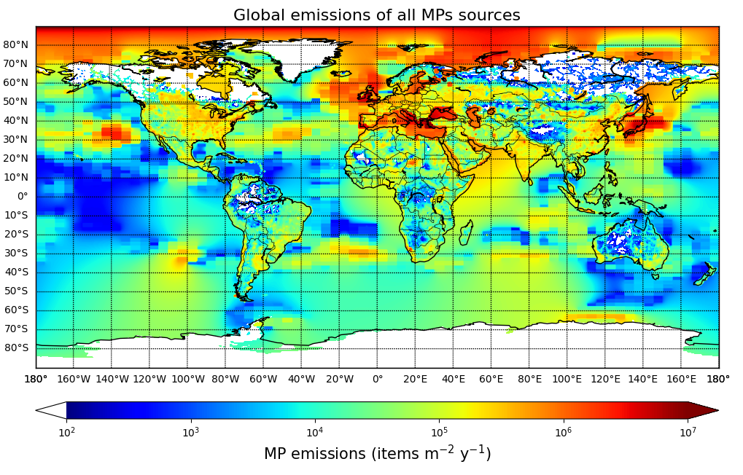
Fig. X1: Global emissions of MP (5-250 um) updated from Evangeliou et al. (2022). All sources are plotted, namely oceanic, agricultural, soil/mineral dust, road dust and clothing fibers.
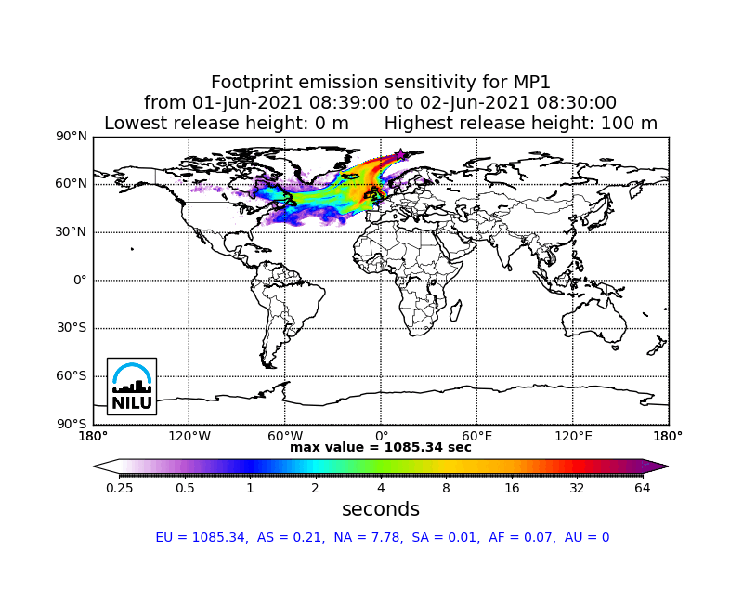
Fig. X2: Footprint emissions sensitivity of MP arriving at Svalbard on June 1st, 2021, when the largest surface concentrations were detected.

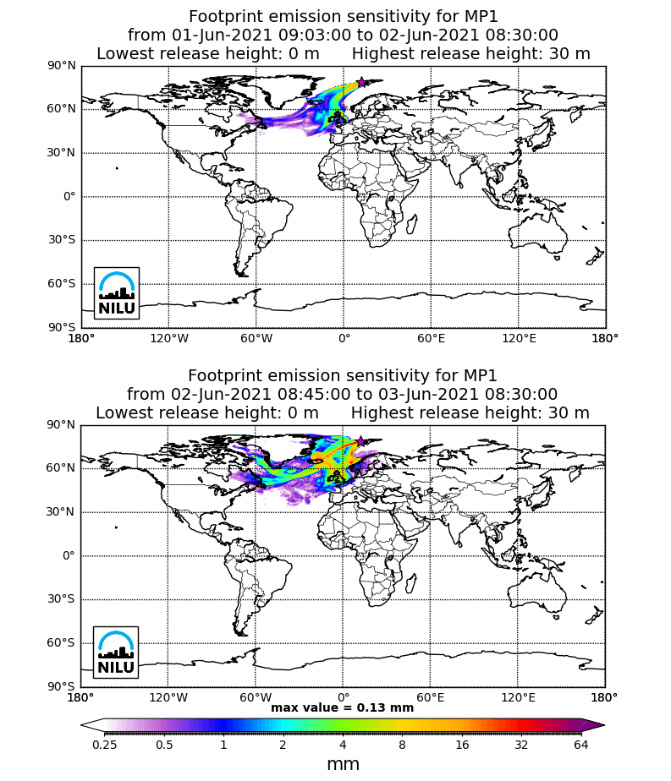
Fig. X3: Footprint emissions sensitivity of MP arriving and depositing at Svalbard due to dry deposition. Here, we have assumed that MP are slightly affected by wet deposition (in cloud and below cloud scavenging), as they are macromolecular polymers and therefore highly hydrophobic.

