Supplementary Information: Dietary shifts reshape land use and farm economics in Europe
- FABIO, FADN, and MRIO analysis
FABIO provides time-series, mass-balanced multi-regional input-output tables for agriculture and food in physical units (tonnes and heads of livestock). Coverage is 186 countries plus one Rest-of-World region, 123 commodities, and six final demand categories for 2010-2021. We use FABIO to represent baseline supply chains and propagate dietary changes through the full system. For the year 2020, we construct the technical coefficient matrix $A$ by column-normalizing intermediate flows with total output $x$. The Leontief inverse is $L= {(I-A)}^{-1}$. We retain bilaterial structure, so embodied impacts are traced by commodity and origin. Socio-economic and land use impacts of fish and seafood are excluded to align with FADN scope. The reporting geography is EU27 plus UK (EU+UK), but the MRIO retains non-EU countries as origins and destinations.
From FADN, we extract country-level micro-aggregates for 14 farm types in 2020. The variables used are:
- Farm employment in annual working units (AWU), which equals one person working full-time on farm over a year;
- CAP subsidies (Pillar I and Pilar II payments) received at farm type level;
- Farm net income as defined by FADN. We derive farm net profits excluding CAP (ex-CAP) by subtracting total CAP subsidies at farm type level from FADN farm net income. Negative values (i.e., losses ex-CAP) are retained.
FADN excludes very small holdings and fishery activities. The sample represents approximately 3.7 million farms in EU+UK in 2020 (~90% of all farming activities). Monetary values are kept in 2020 euro to match the baseline year used elsewhere in the analysis.
We construct a country-specific concordance that links each of the 14 farm types to one or more FABIO commodities. For each country and commodity s, we compute the share of total output of s in the sum over all mapped farm types. We then distribute each farm-type variable proportionally to commodities using these output shares. This yields country-commodity totals for farm employment ($e^{emp}$), CAP subsidies ($e^{sub}$), and profits ($e^{prof}$) that are fully consistent with the national FADN aggregates.
From the country-commodity allocations we derive satellite intensities as row vectors:
- Employment intensity $b^{emp}$ in AWU t⁻¹;
- Subsidy intensity $b^{sub}$ in € t⁻¹;
- Profit intensity $b^{prof}$ in € t⁻¹ (ex-CAP).
Each intensity is computed as the allocated variable divided by total output $x$ of the same country-commodity in FABIO. Intensities are applied at the farm gate. Upstream affects are captured by the MRIO through intermediate uses and feed flows.
For a given satellite b, embodied impacts associated with final demand Y are computed as $R$. We also decompose by supply-chain stage using contribution accounting. Reporting aggregates sum $R$ by origin, destination, and commodity group.

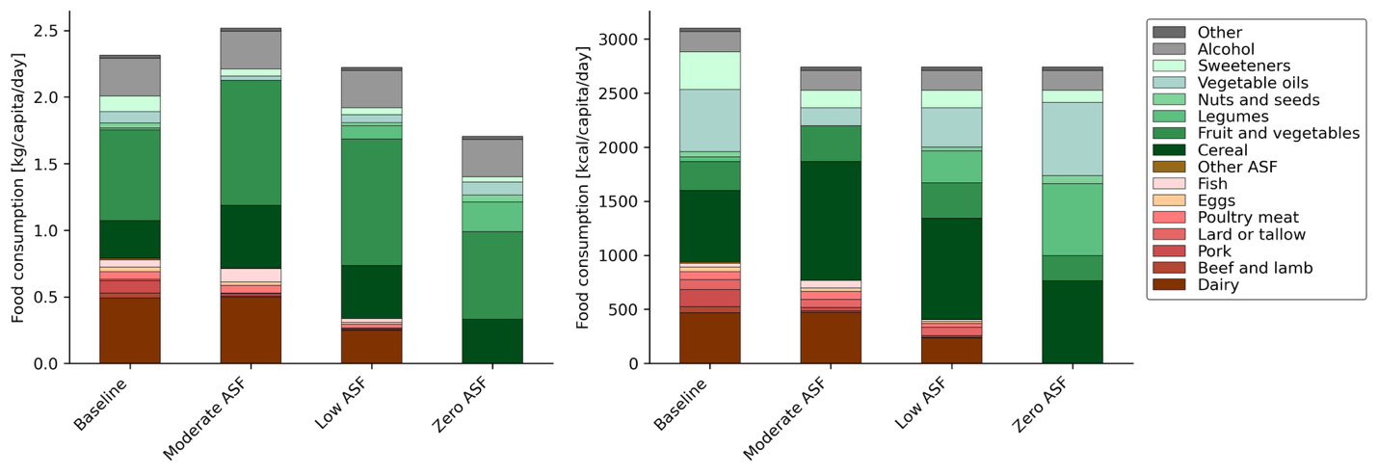
Fig. 1. EU27+UK food intake by mass (left) and energy content (right) under baseline and modelled dietary scenarios, excluding food waste.

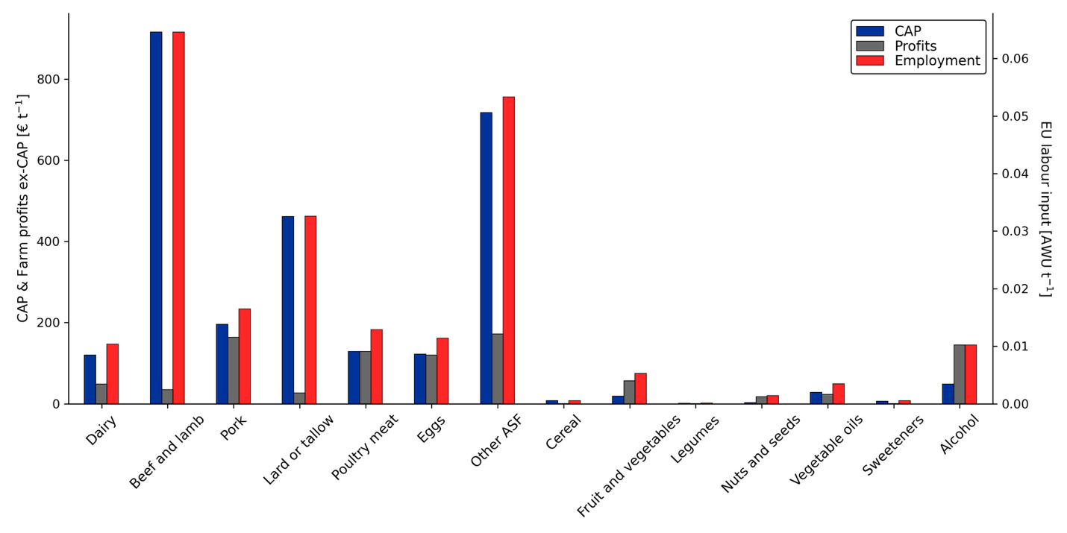
Fig. 2. CAP (Common Agricultural Policy) subsidies, Farm profits (left axis), and EU labour input (right axis) intensity in € or annual working unit (AWU) per tonne of EU+UK food produced.

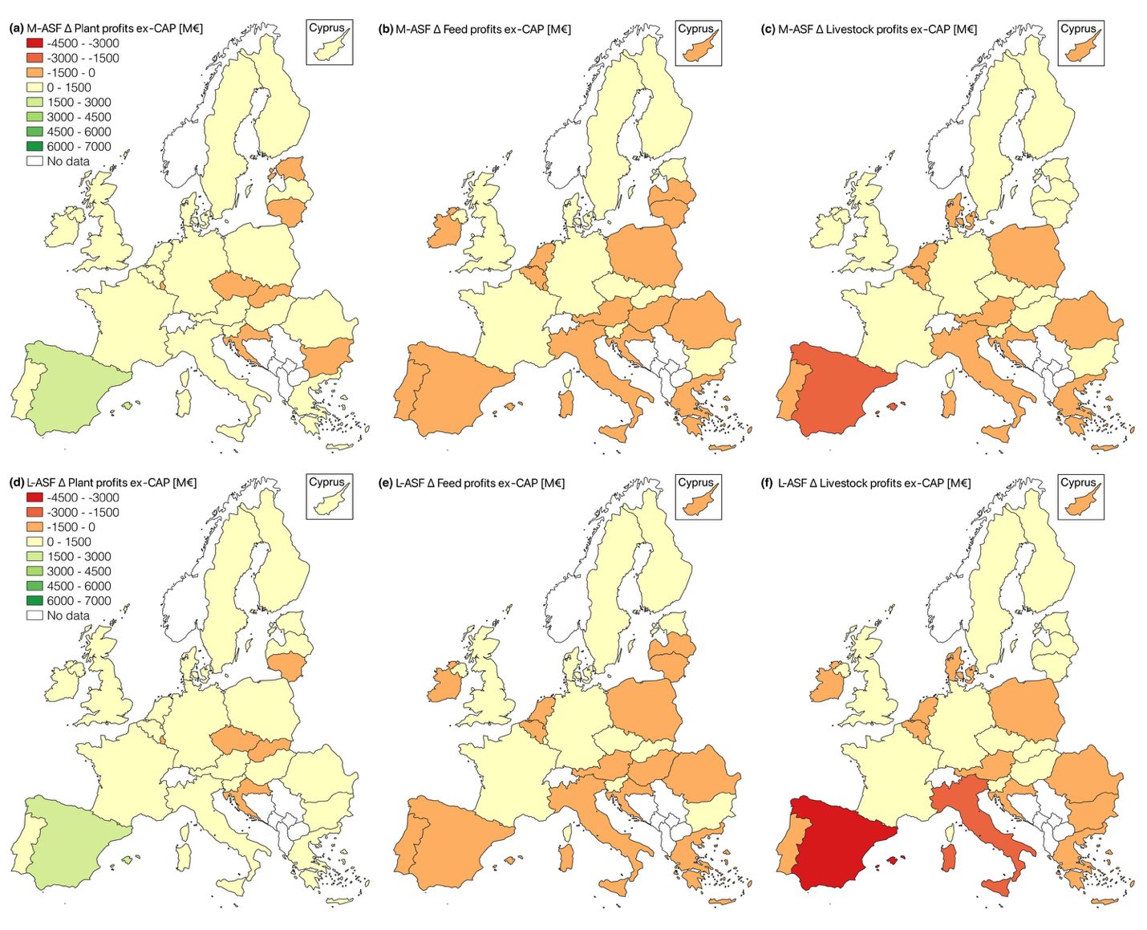
Fig. 3. Projected changes of profits under Moderate animal-sourced food (M-ASF) (panels a-c) and Low animal-sourced food (L-ASF) scenarios (panels (d-f).

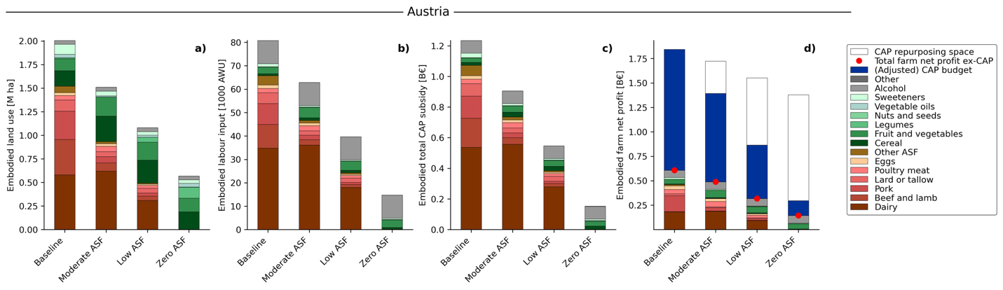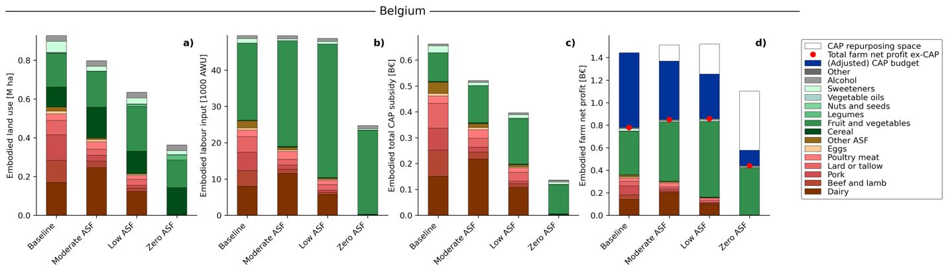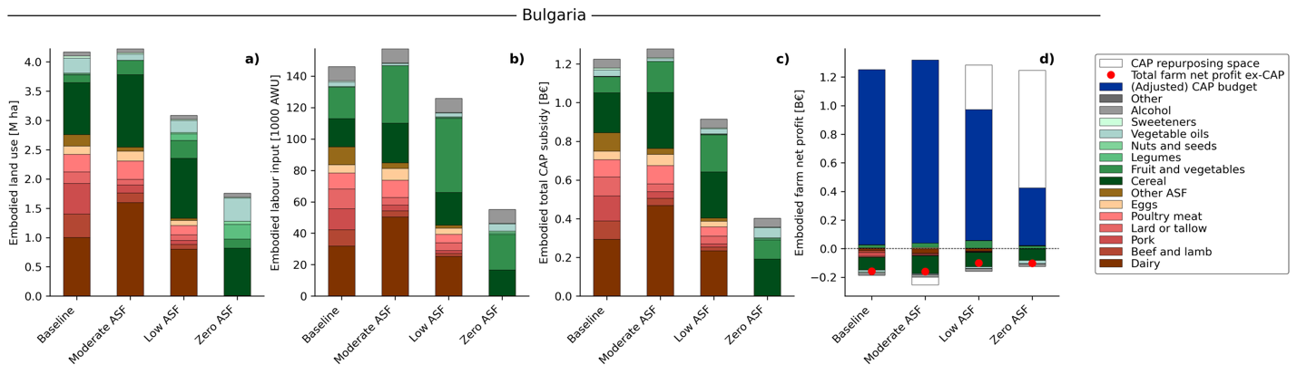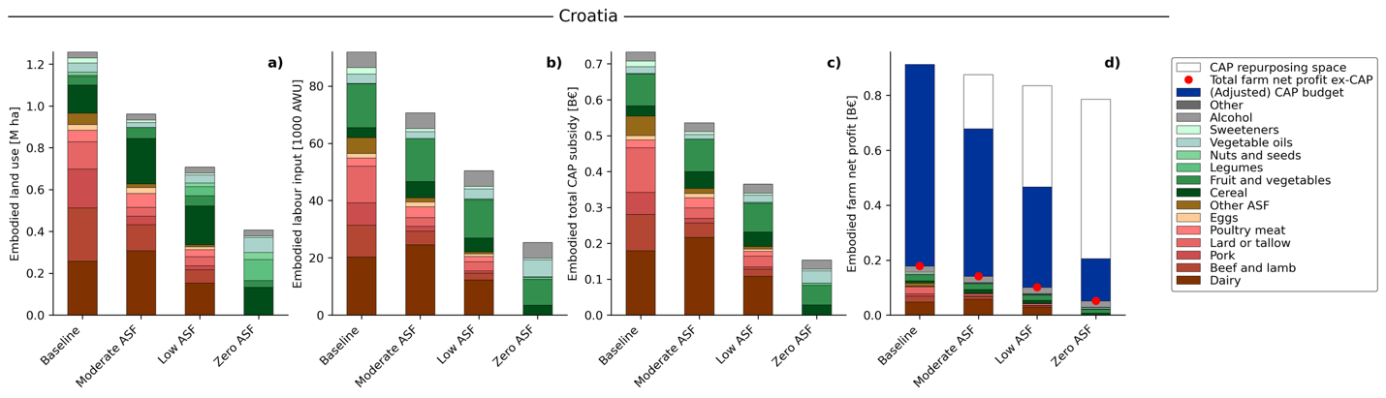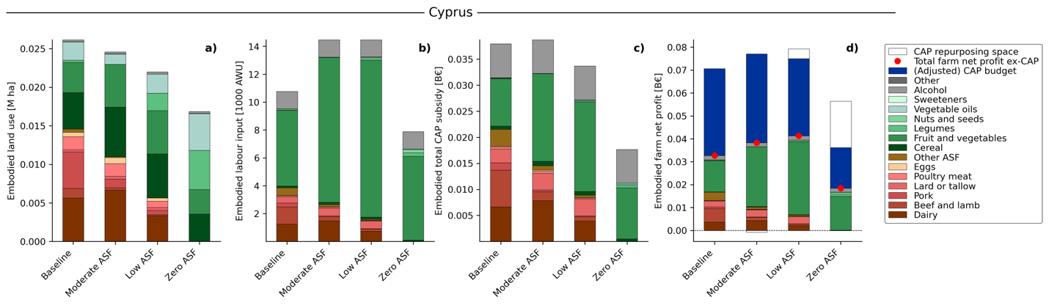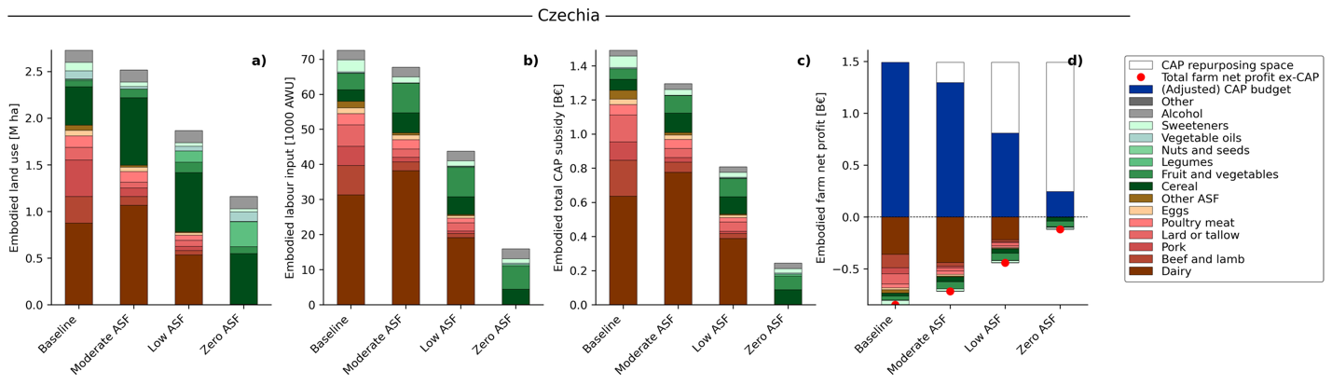

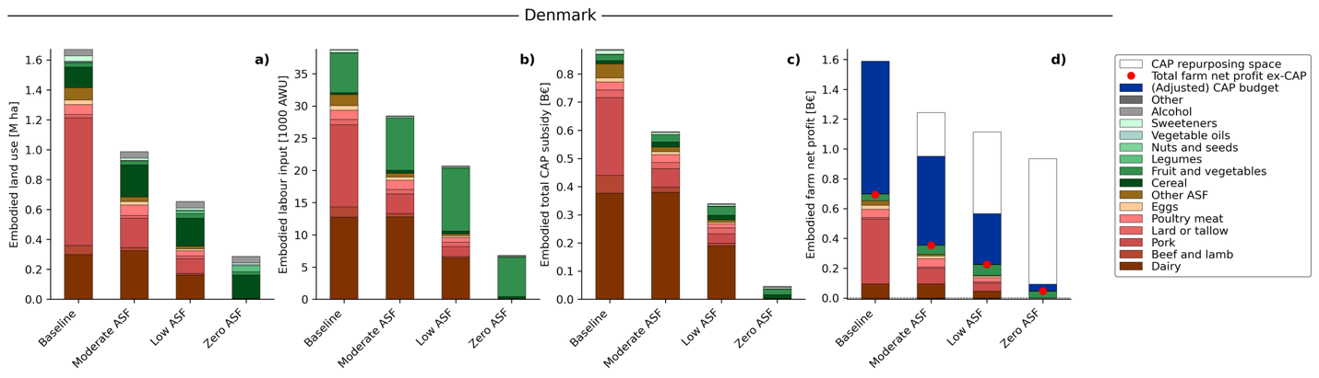
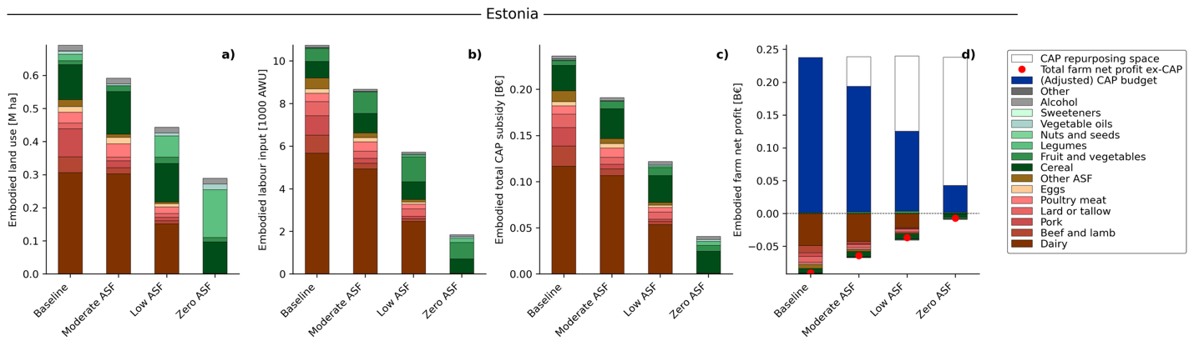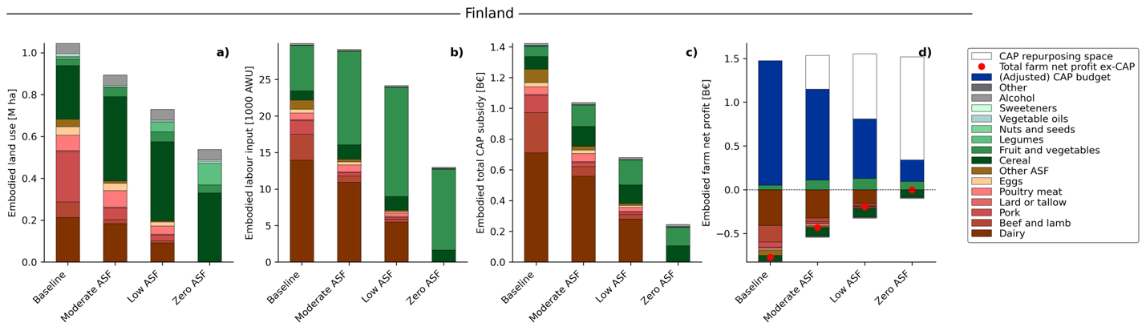
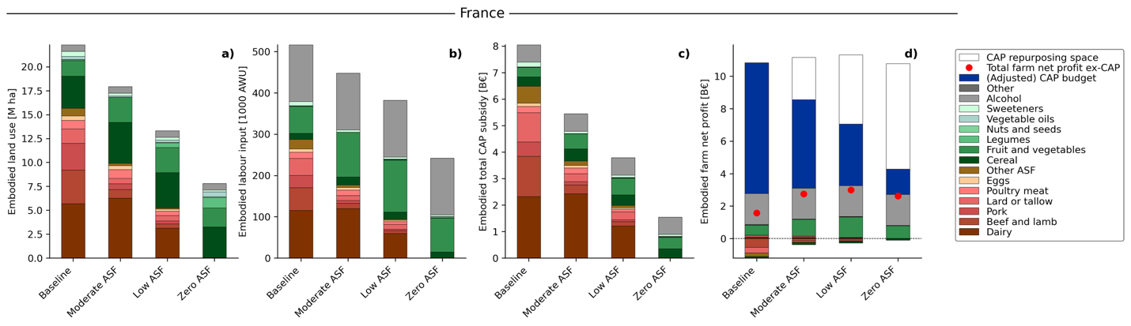
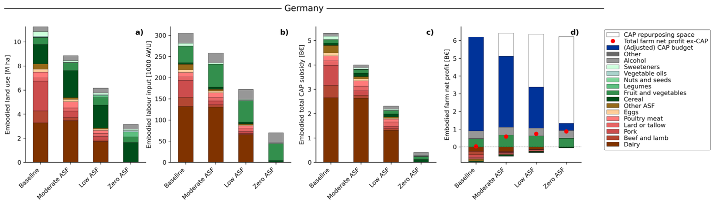
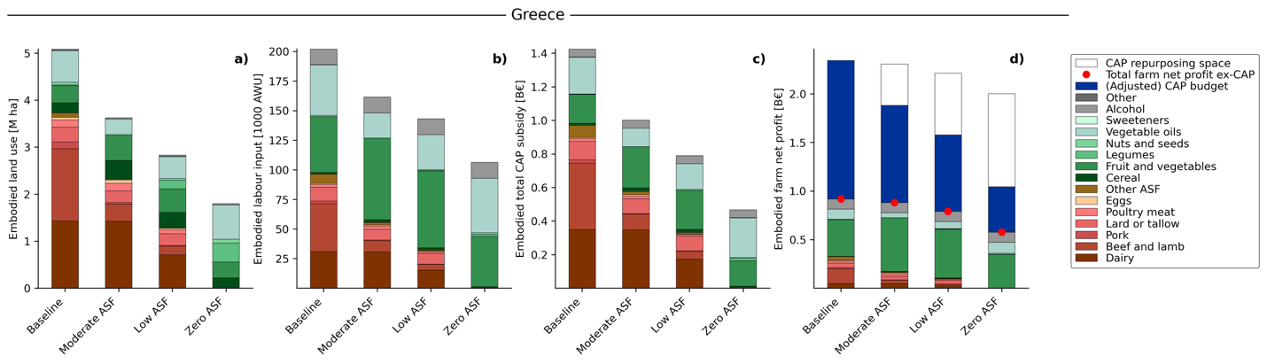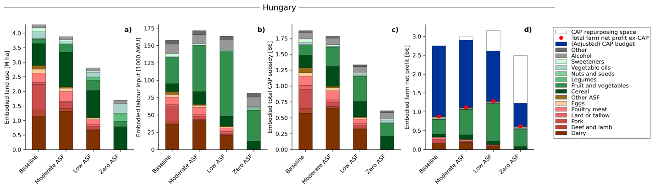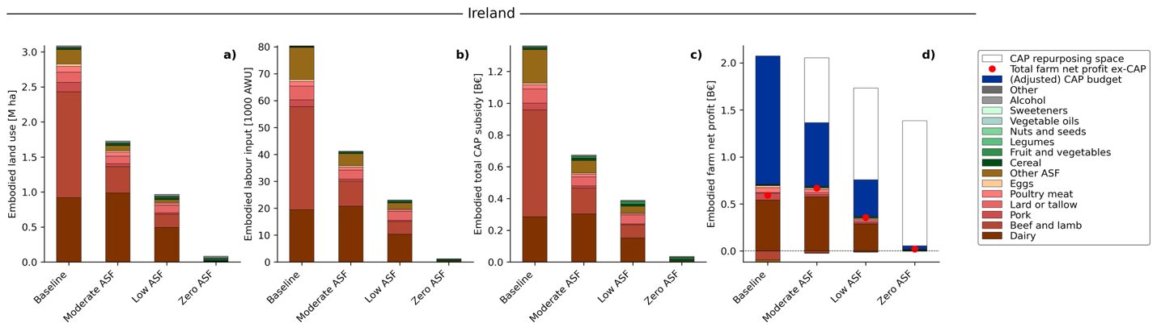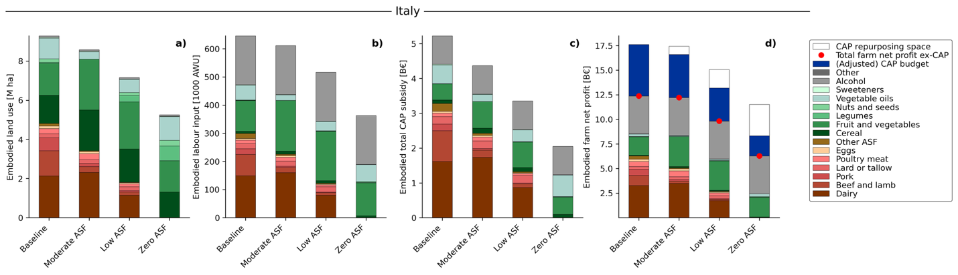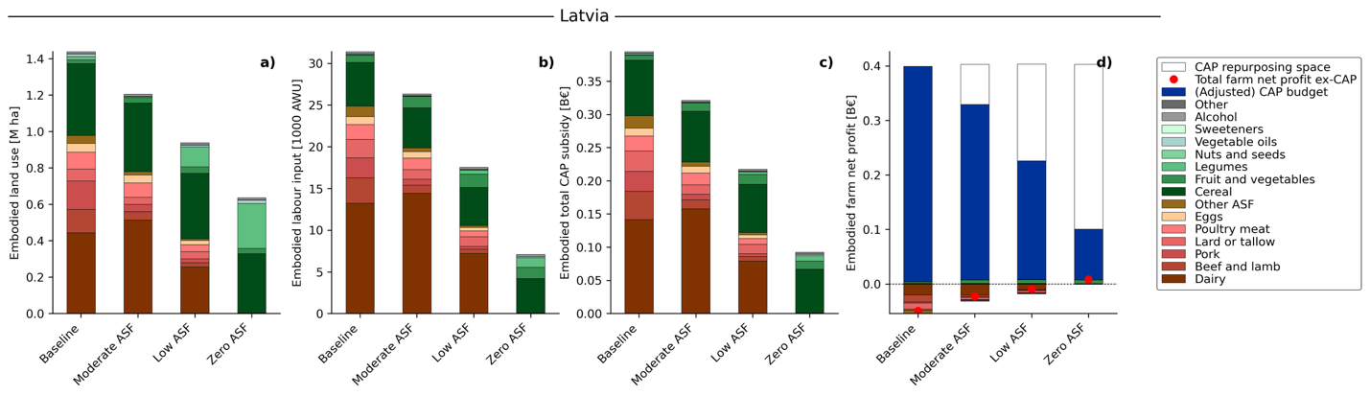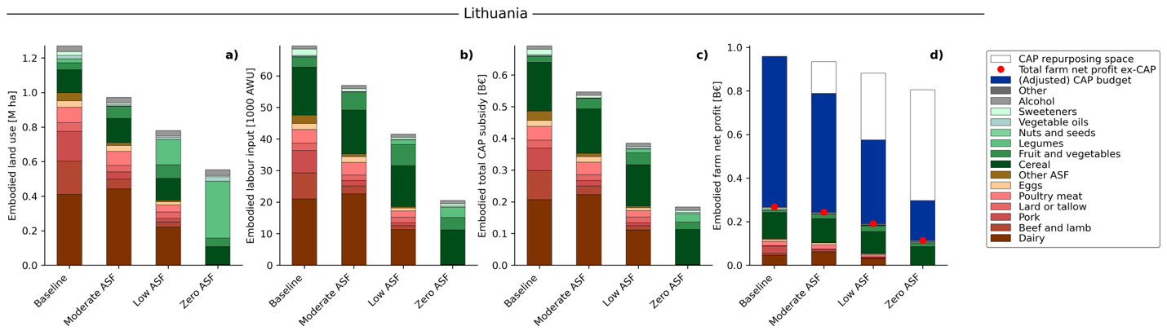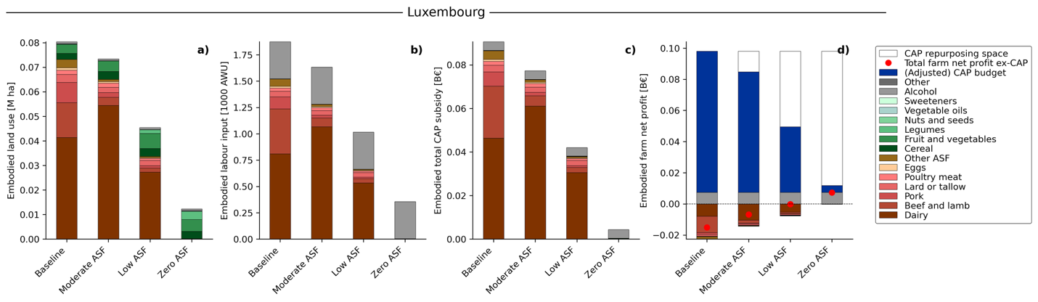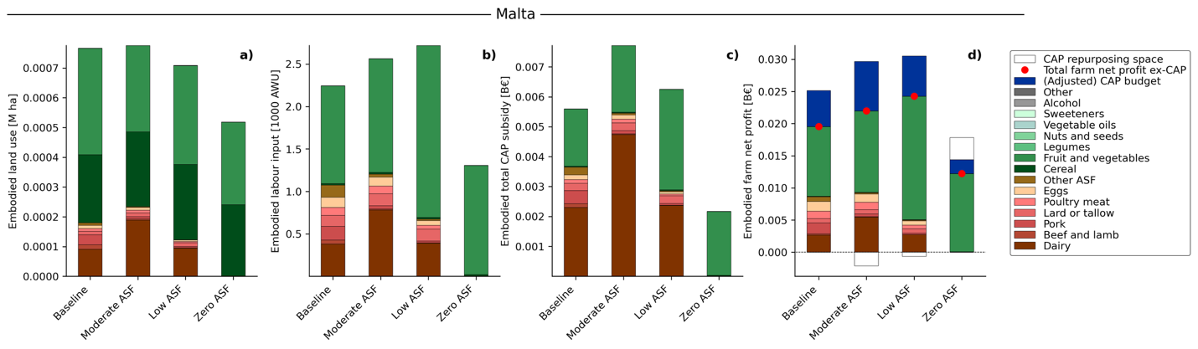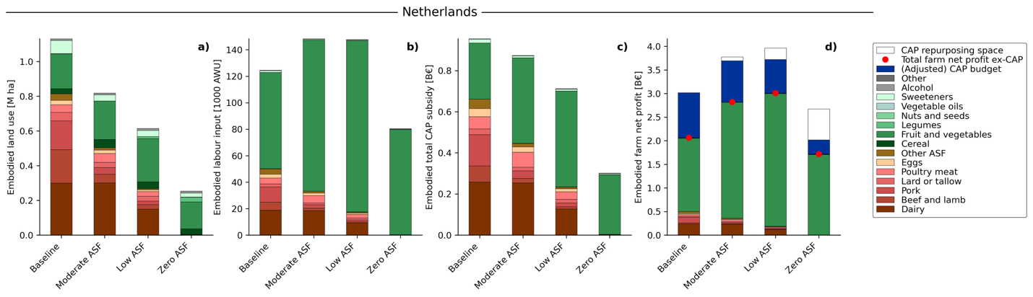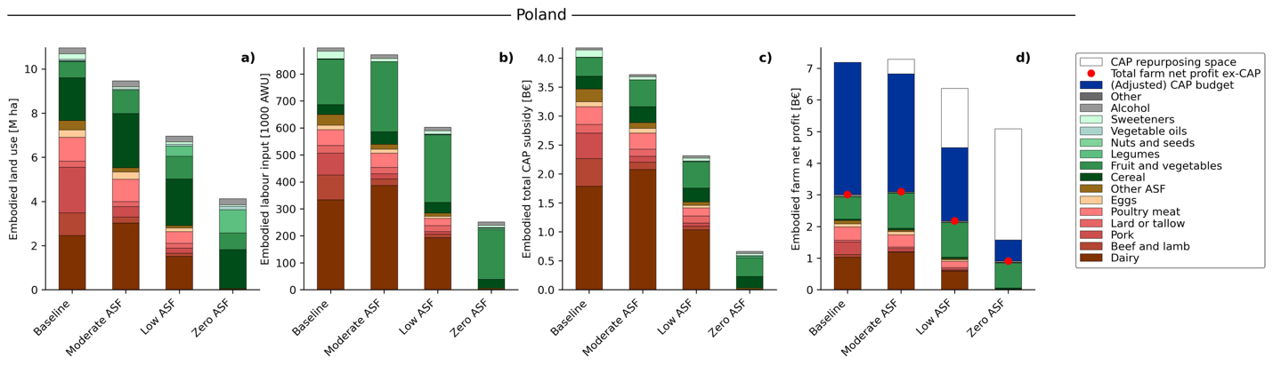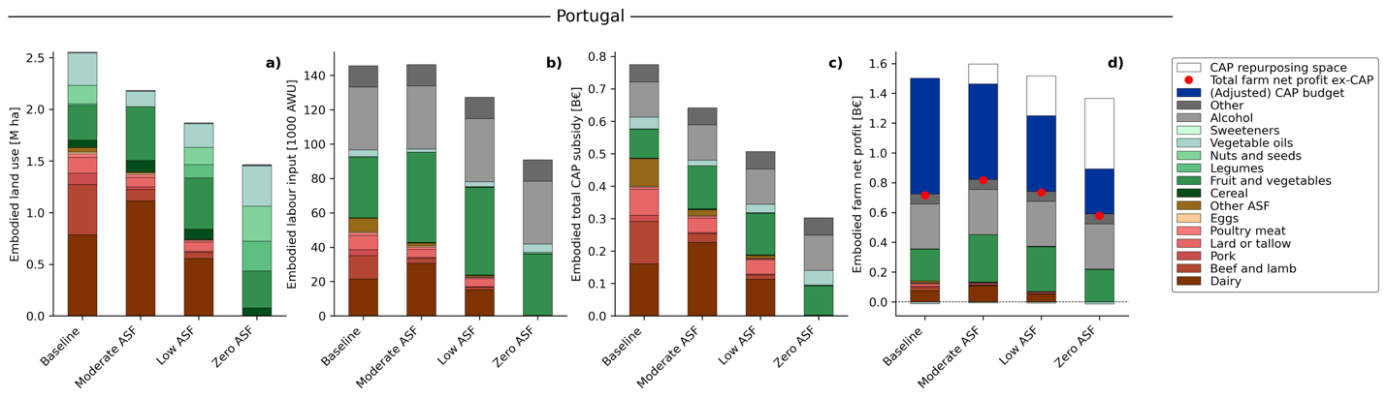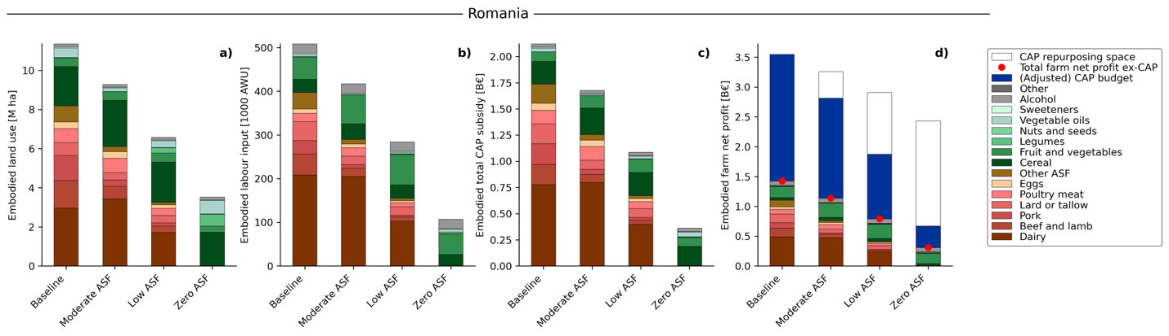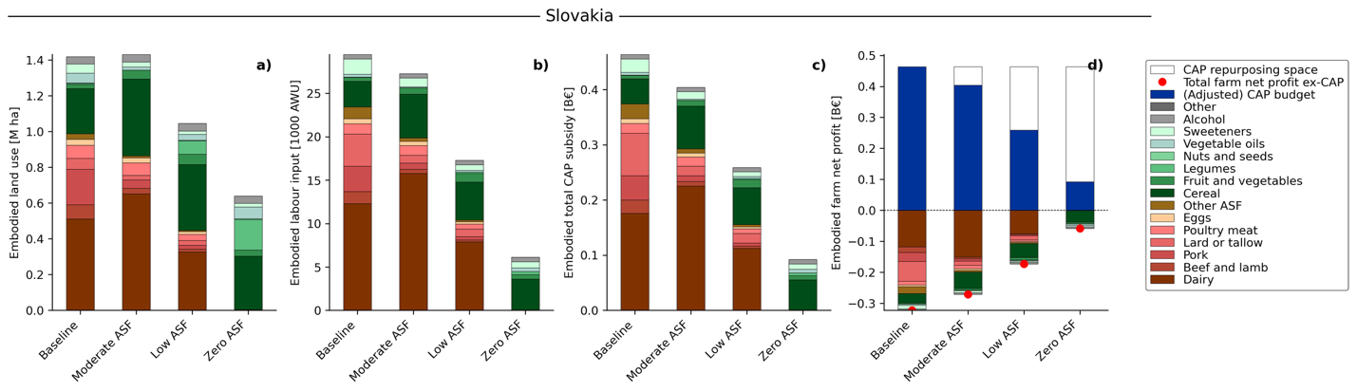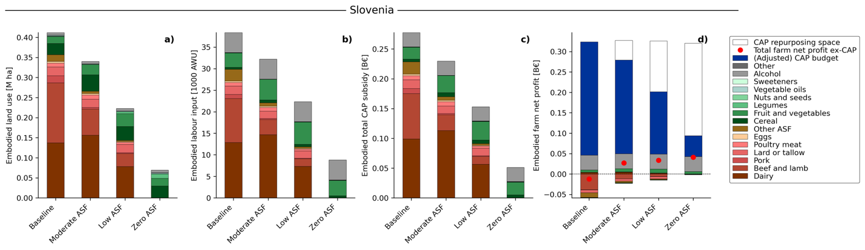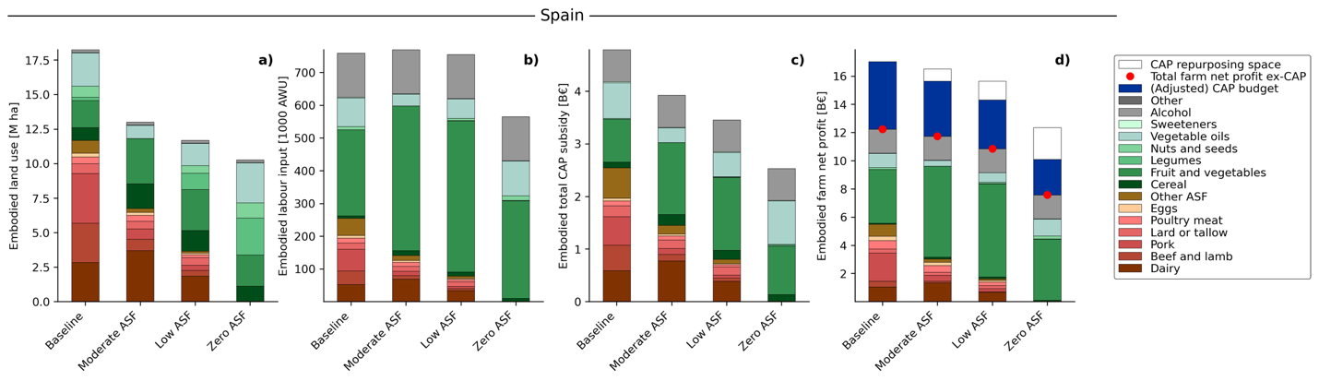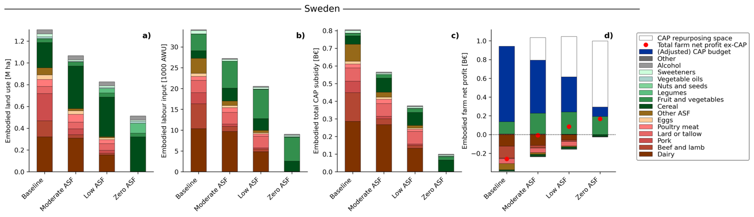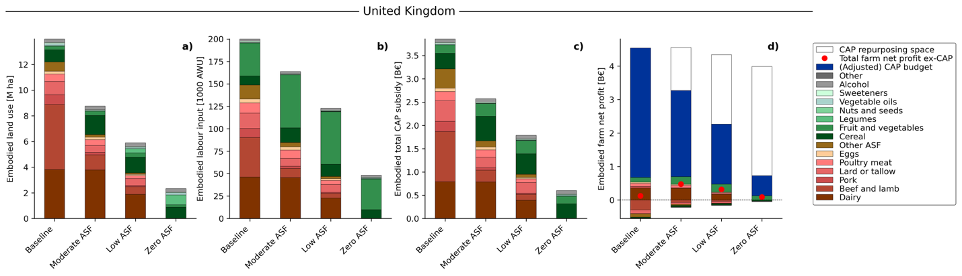
Fig. 4. Embodied land use (in million hectares), farm employment (in annual working units (AWU), CAP subsidies (in billion €), and farm net profits (in billion €) attributable to domestic production for each EU+UK country under four dietary scenarios: baseline, moderate ASF, low ASF, and zero ASF (aligned with the EAT-Lancet range). All indicators are calculated in embodied terms, capturing upstream inputs such as cropland used to grow livestock feed. Values denote each region’s own contribution through international supply chains and into final food products. Inputs generated outside a region’s border are excluded here and remain assigned to their region of origin. The embodied farm net profits ex-CAP (panel 4) include a red marker for the total farm net profits excluding CAP subsidies, a blue bar for the CAP budget which corresponds to the CAP budgets in panel c (current CAP budget for baselines and adjusted CAP budget for scenarios), and a transparent bar which refers to the CAP repurposing space for environmental and public health co-benefits.

