Support Information

A Reconfigurable Perovskite/Polymer Composite Film for Real-Time Detection of Agricultural Spraying

Haoran Zhang^{1,2}, Xubing Wu², Jiaying Du¹, Song Wang², Hui Fang³, Qi Zhang^{1,}*, Wen-Jun Wang², Shiping Zhu¹, Johan Hofkens^{2,4}, Pingwei Liu^{2,}*
^{1.} School of Science and Engineering, The Chinese University of Hong Kong, Shenzhen, Shenzhen 518172, P. R. China
^{2.} State Key Laboratory of Chemical Engineering, College of Chemical and Biological Engineering, Zhejiang University, Hangzhou 310027, P. R. China
^{3.} College of Biosystems Engineering and Food Science, Zhejiang University, Hangzhou 310029, P. R. China
^{4.} Department of Chemistry, KU Leuven, Leuven 3001, Belgium

e-mail: qizhang@cuhk.edu.cn; liupingwei@zju.edu.cn

Methods
1. Materials
Poly(dimethylsiloxane) (PDMS, Sylgard-184, Dow Corning) elastomer and curing agent were purchased from Dow Silicones Corporation, USA. Polyvinyl alcohol (PVA, Mowiol® 210, Mw ~ 67,000, and DH = 88%) and sodium benzoate (99.5%) were purchased from Shanghai Meryer Chemical Technology Co., Ltd. Perovskite precursors: cesium bromide (CsBr, 99.5%), lead(II) bromide (PbBr₂, 99.99%), silver bromide (AgBr, 99.9%), bismuth(III) bromide (BiBr₃, ≥98%) were purchased from Shanghai Macklin Biochemical Co., Ltd. Dimethyl sulfoxide (DMSO, Ar), anhydrous calcium chloride (CaCl₂, Ar) and allochroic silicagel were purchased from Sinopharm Chemical Reagent Co., Ltd. All chemicals and reagents were used as received from chemical companies without any further purification. Substrates including glass, polymethyl methacrylate (PMMA), and polyethylene terephthalate (PET) were cleaned ultrasonically in ethanol and deionized (DI) water, and dried in an oven.

2. Sample Preparation
2.1 Preparation of polymer layered matrix
Preparation process of the polymer multi-layer matrix is shown in Figure S1 (a-d). Firstly, liquid PDMS (base to curing agent ratio = 50:1, mixed evenly and degassed at low pressure) was coated on a pre-cleaned substrate (glass, PMMA or PET) by spin-coating (Smart Coater 100, Best Tools, spin speed = 500 rpm, spin time = 60 s, thickness ~ 0.5 mm), followed by thermal curing at 80 °C for 5 h in an oven. For stronger adhesion between PVA and PDMS, the cured PDMS was pre-treated by a O₂ plasma cleaner (Zepto Model 1, Diener electronic, power = 30 W, frequency = 13.56 MHz) prior to PVA coating for 45 s to enhance the surface hydrophilicity of PDMS. Then, PVA (containing 6 wt.% sodium benzoate as cross-linking agent) was coated on the plasma-treated PDMS by spin-coating its aqueous solution (spin speed = 1000 rpm, spin time = 60 s, concentration = 100–300 mg/mL, thickness ~ 0.7–11.6 μm) and dried in an oven at 60 °C for 2 h. After completely drying, the PVA film was cross-linked in a UV radiation chamber (SCIENTZ 03-II, Ningbo Scientz Biotechnology Co., Ltd., wavelength = 254 nm, intensity = 5 mw/cm²) for 2 h. During UV-cross-linking, desiccants of CaCl₂ and allochroic silicagel were also placed in the chamber to maintain low ambient humidity.

2.2 Incorporation of cesium lead halide perovskite fillers into polymer matrix
Incorporation of inorganic cesium lead bromide (Cs-Pb-Br) perovskite fillers into the as-prepared polymer matrix via a ligand-free “swelling-deswelling” process¹ is shown in Figure S1 (e-h). Perovskite precursors CsBr and PbBr₂ (1:1 molar ratio) were diluted in DMSO to give a different concentration of 0.02, 0.04, 0.06, 0.08, 0.10 mmol·mL⁻¹. The precursor solution was dropped onto the PVA/PDMS film, followed by spin-coating at 2000 rpm for 30 s to ensure complete infiltration into the cross-linked PVA network and removing of excess solution on surface. Under this process parameter, the swelling ratio of PVA film to DMSO solution is certain, which can be measured by weighing method. Thus, the addition amount of perovskite incorporated can be calculated according to different precursor concentration (Figure S4). Subsequently, the swollen film was baked in an oven at 150 °C for 30 min under vacuum. As DMSO evaporating, the perovskite precursors crystallized into CsPbBr₃ NPs that were well dispersed inside the deswelled PVA matrix, forming a light-yellow film as intermediate product. Then, the film was post-treated by moisture and dried on a hot plate (IKA, C-MAG HP7) at 80 °C to induce the phase change of perovskite NPs from CsPbBr₃ to CsPb₂Br₅ (Figure S12, Table S1 and Figure S13), thereby forming the final product of the composite film, which is colorless and transparent under natural light and emits bright green fluorescence under UV light (Figure 1c). The composite film sample was stored in a desiccator with desiccant CaCl₂ and allochroic silicagel until use.

2.3 Arraying process of the composite film
Arraying process of the composite film is shown in Figure S3. A stainless-steel UV-shielding stencil mask was placed atop the PVA layer (not yet cross-linked). The stencil mask (thickness ~ 0.15 μm) was patterned with a hexagonal-symmetry array of circular holes (diameter, D = 300 μm; distance between adjacent circles, d = 100 μm). Subsequently, the sample was exposed to UV radiation for cross-linking (wavelength = 254 nm, intensity = 5 mw/cm²) for 2 h, while mask-covered area remaining un-cross-linked during radiation, and then the film was immersed in deionized (DI) water to remove the non-cross-linked PVA. The above process is similar to “exposure” and “development” in lithography. The sample was then incorporated with perovskite NPs according to the same procedure in 2.2, and the perovskite NPs were also patterned into the same array, because the precursor solution permeated only the patterned PVA part, but not PDMS. Only the area with perovskite in PVA on PDMS can show reversibly-responsive fluorescence and wrinkles, while the bare PDMS area shows no fluorescence or wrinkles.

2.4 Preparation of composite film with lead-free perovskite (cesium silver-bismuth halide)
Incorporation of lead-free double perovskite (Cs₂AgBiBr₆) into the PVA/PDMS polymer matrix through the similar procedure in 2.2. DMSO solution of perovskite precursors containing CsBr, AgBr and BiBr₃ (2:1:1 molar ratio) was dropped onto the PVA/PDMS layered matrix. Then, the swollen film was baked in an oven at 150 °C for 30 min under vacuum. As DMSO evaporating, lead-free double perovskite NPs Cs₂AgBiBr₆ were crystallized in PVA matrix, forming the composite film with lead-free perovskite.

3. Water Spraying Test
Two kinds of portable facilities were used for water spraying in this work, as shown in Figure S9. One is an electric ultrasonic humidifier used to evenly moisturize the entire film. Its spray speed is about (28.4 ± 1.7) mg·s⁻¹, and its distance from the sample is kept about 4–8 cm in use. The other is a manual spray bottle used to simulate the actual spraying of pesticides. Its spray amount per time is about (160.6 ± 3.0 mg), and its distance from the sample is kept about 30–50 cm in use. The liquid used in all spray experiments was DI water.

4. Characterizations
Photoluminescence (PL) spectrum of the composite film was measured using an Ocean Optics spectrometer (QEpro) with a 450-nm-wavelength laser as excitation light (Lasever, LSR-PS-II), under conditions of room light off and sunlight blocked. Ultraviolet-visible (UV-Vis) spectrum of direct transmittance was measured a UV-visible spectrophotometer (Persee, TU-1901). To test the transmittance spectrum, the sample was encapsulated in a polystyrene petri dish and attached onto the sample holder inside the sample compartment. Optical microscopy images and videos were recorded on an optical microscope (Nikon, Eclipse E600W POL) under reflective mode. Fluorescence microscopy images and three-dimensional (3D) morphology images were obtained by using a microscope (Leica, DM6 M). For fluorescence microscopy, an external light source (Leica EL6000, with an Osram HXP120 mercury metal halide bulb) and a filter system (excitation filter: band-pass 355–425 nm, suppression filter: long-pass 470 nm) were used. For 3D imaging, the surface morphology was extracted based on the projection of z-stack planes. Scanning electron microscope (SEM) images and corresponding energy dispersive X-ray spectroscopy (EDS) results were collected with a field emission scanning electron microscope (Hitachi, SU-8010) with an accelerating voltage of 3 kV. Transmission electron microscope (TEM) images were obtained using a transmission electron microscope (Hitachi, HT-7700) with an accelerating voltage of 100 kV. For TEM imaging, sections of the sample were cut beforehand with an ultramicrotome (Leica, EMUC7) and transferred onto a copper grid with carbon film. X-ray diffraction (XRD) spectrum of the composite film was performed with an X-ray diffractometer (PANalytical X'Pert Pro, anode material Cu, K-Alpha1 and K-Alpha2 wavelengths are at 1.540598 Å and 1.544426 Å) using a scan step 0.0262606° and time per step 19.89 ms. X-ray photoelectron spectroscopy (XPS) was carried on an Escalab 250Xi unit (ThermoFisher) to record the element content with Mg Kα X-ray as excitation light source. The electrical conductivity of the samples was tested using a semiconductor parameter analyzer (Keithley, 4200A-SCS). The thickness of the PVA films was obtained with a profilometer (Dektak-XT, Bruker). Droplet impact experiment was performed using a 32G needle (droplet diameter = 1.5 mm, height of the needle above sample surface = 10 cm), and captured by a high-speed camera (NAC, Memrecam HX-5e-75K) at a frame rate of 15,000 fps.

5. Quantitative Measurement
5.1 Water absorption threshold
The quantitative measurement of the water absorption thresholds was performed on a 4 cm × 4 cm sample (area, S = 16 cm²) using an analytical balance (Mettler Toledo, XSE205 Dual Range). The original mass (M₀) of the film sample, the mass when the wrinkles are fully generated (M₁), and the mass when the fluorescence is completely quenched (M₂) were recorded, respectively. Thereby, the water absorption threshold (mass per unit area), for wrinkle (m_{w}) and for perovskite fluorescence (m_{p}) can be obtained as m_{w}=(M₁-M₀)/S and m_{p}=(M₂-M₀)/S, respectively.

5.2 Quantitative relationship
To determine the quantitative relationship between water absorption (mass per unit area) and surface scattering (average grayscale), we designed a measuring setup based on the analytical balance and a video camera, as shown in Figure S18 (a). The 4 cm × 4 cm sample was placed on the analytical balance, and its original mass at dry state without water absorption was measured firstly. Then, we took out the sample and sprayed water evenly on the surface to reach a saturated wrinkled state. Subsequently, we took the wet and wrinkled sample back onto the balance, and used the camera to simultaneously record the changes in the surface appearance and the mass of the sample, until the water was completely air-dried and the displayed mass unchanged. During the test, CaCl₂ desiccant was also placed in the chamber of analytical balance to maintain low ambient humidity. For an arbitrary moment, as shown in Figure S18 (b), we can obtain the average grayscale value of the surface and the mass of the absorbed water in the system according to real-time image analysis. Processing the entire video data, we can get time-varying curves of water absorption and average surface grayscale value, as shown in Figure 2e.

5.3 Normalization process
The grayscale value of the sample surface will be affected by the ambient light, so it is necessary to subtract the environmental impact. In our measurement, we utilized a glass slide with ground edge as a reference object for normalizing the data of grayscale value, as shown in Figure S18 (c). The grayscale value of the rough (A) and smooth part (B) of the glass slide were artificially defined as “1” and “0”, respectively, and thus the grayscale value of the sample (C) could be normalized as X=(C-B)/(A-B). Figure S19 shows the graphs before and after normalization of repeated tests as well as the tests under different environmental illuminance and camera angle. After normalization process, the consistency of the normalized curves is excellent with very small differences. The environment illuminance during the test was measured using a portable light intensity meter (Prokit’s Industries, MT-4617LED).

6. Bending Test
The bending test was performed on samples with PET as the substrate, by using a customized tensile stage, as shown in Figure S25 (a). The samples with and without array were bended at the same degree (curvature radius ~ 2.5 mm), as shown in Figure S25 (b). And then we observed the microscopic morphology of the sample under this bending degree with an optical microscope (Nikon, Eclipse E600W POL), including dry state and wet state by water spray (Figure 3d and Figure S24).

7. Practical Detection
7.1 Wearable sensor on a plant leaf
A composite film (~ 5 vol.% perovskite in 3.6 μm PVA on PDMS, size ~ 1×1 cm) was carefully peeled off from a glass substrate by using a blade and a tweezer. And then, the free-standing film was attached onto the Schefflera octophylla leaf, as shown in Figure 4b. In a nighttime environment, the on/off fluorescent switch of the film can be responsive to the water spray under UV irradiation (Figure 4c).

7.2 Box-type integrated monitoring device
The spray monitoring device was composed the film sample, a micro-camera, a Wi-Fi transmitter, batteries and a box. The box (size: ~ 12 cm × 12cm ×15 cm) was firstly designed by SolidWorks software, and then fabricated using 3D printing. For the water spraying test in the laboratory environment, we adjusted the light source obliquely irradiating on the film surface, but not directly into the camera. Before spraying, the film surface was completely black because no external light was captured by the camera. When spraying test began, the droplets triggered the local generation of wrinkles on the film which had a strong scattering effect on the light, showing as white bright spots in the images. After the spraying test was over, as the droplets evaporated and wrinkles disappeared gradually, the film surface returned to the original flat state. Therefore, without human handling, the sensor has a self-recovery function and applies to repeated tests for a long time. Then, for the outdoor test, we use natural ambient light without any artificial light sources. In spraying test, the camera automatically recorded and transmitted the real-time original images of film surface. After subsequent image processing, the background information was deducted from the original images, leaving the processed binary images with white spots on black background that were similar to the results of laboratory test. Through further image recognition (Figure S28), a database containing all the droplet information was established, from which a complete report of spraying test was obtained.

Supporting Figures and Tables
Figure S1. Schematic diagram of the fabrication process of the composite film. (a-d) Preparation of layered polymer matrix of PVA/PDMS on a substrate via stepwise spin-coating and UV-cross-linking. (e-h) Incorporation of inorganic Cs-Pb-Br perovskite NPs into the PVA layer via a swelling-deswelling process and post-treatment.

Figure S2. FTIR spectra of the PVA top layer before and after UV cross-linking. Before cross-linking, the peaks at 1598 cm⁻¹ and 1557 cm⁻¹ correspond to the C=C stretching vibration of the benzoate ring and the asymmetric carboxylate anion stretching of sodium benzoate. Their disappearance indicates the photo-decomposition of sodium benzoate during cross-linking process of PVA.

Figure S3. Schematic diagram of the fabrication process of the arrayed composite film.

Figure S4. Addition amount of perovskite in PVA layer (volume fraction, vol.%) with different concentration of precursor solution calculated by weighting method.

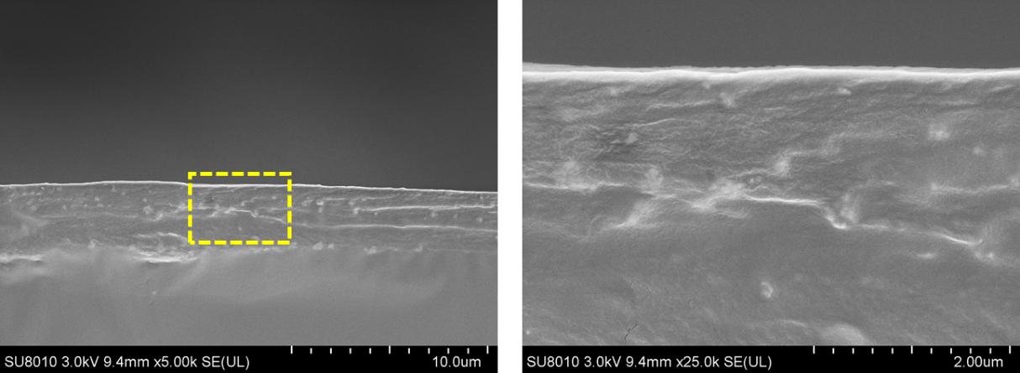
Figure S5. Cross-sectional SEM images of the composite film at different magnification.

Figure S6. Corresponding EDS analysis results of elements of Cs, Pb and Br.

Figure S7. Fluorescence micrograph of the composite film surface.

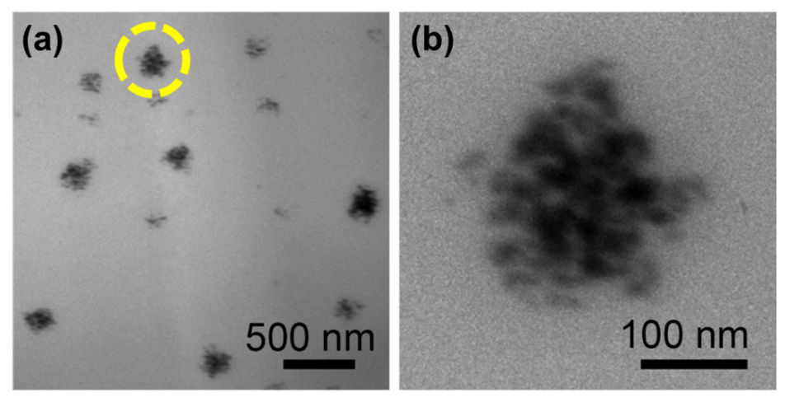
Figure S8. Cross-sectional TEM images of the embedded perovskite NPs in PVA layer.

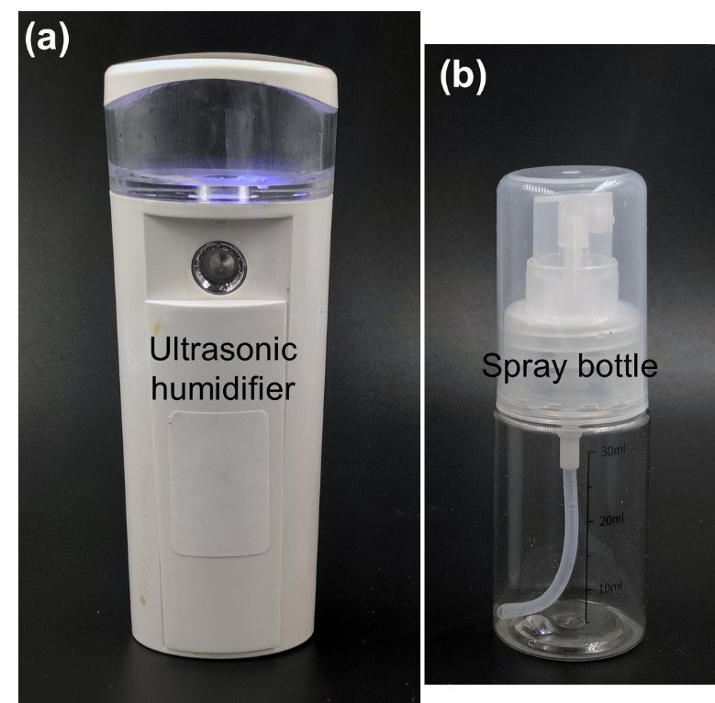
Figure S9. Two kinds of portable facilities used for water spraying, including an electric ultrasonic humidifier (a) and a manual spray bottle (b).

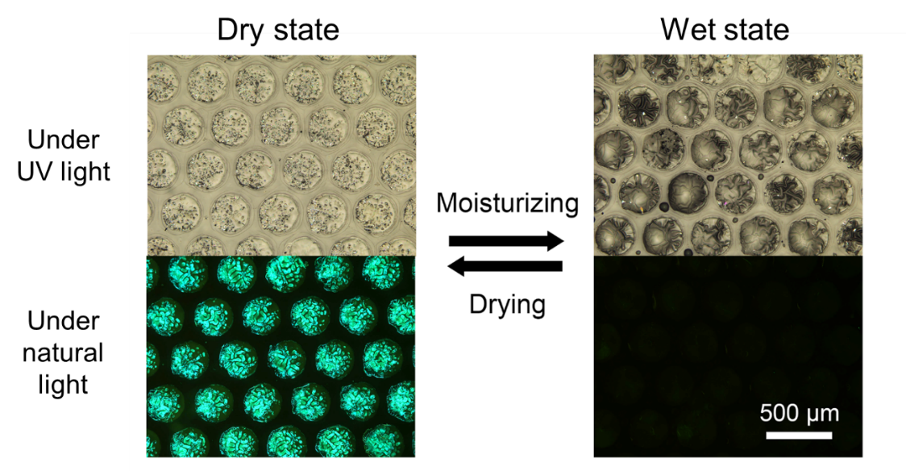
Figure S10. Optical microscopic results of the arrayed composite system with water spraying and recovery under UV and natural light.

Figure S11. Three-dimensional topography of the wrinkled surface of the composite film at wet state.

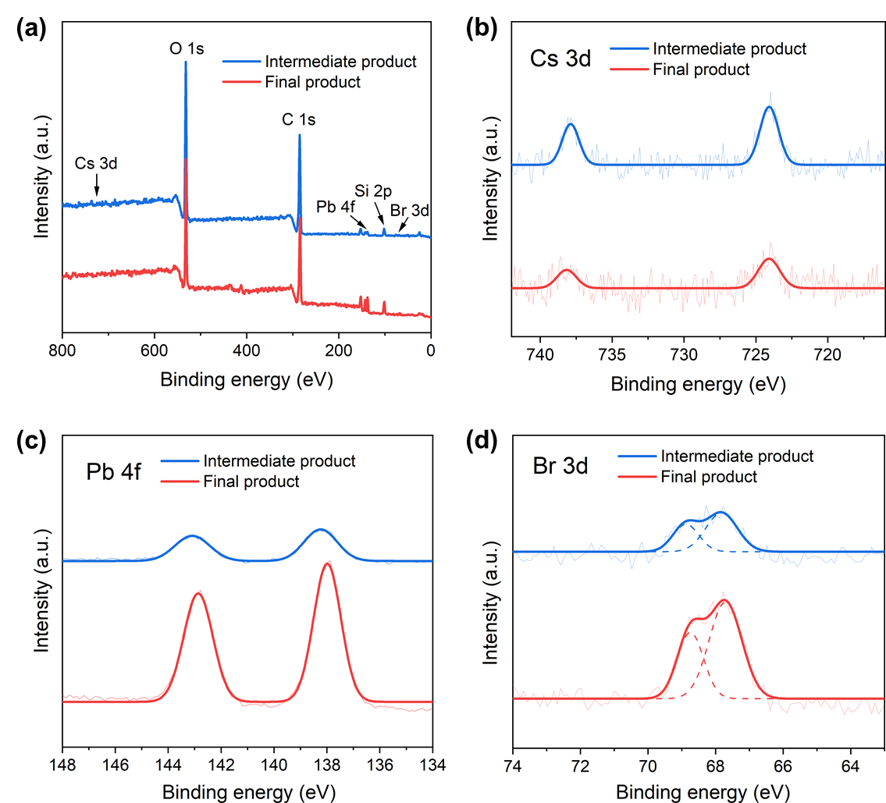
Figure S12. XPS results of the composite films, including (a) full spectrum and high-resolution spectra of the element (b) Cs 3d, (c) Pb af, and (d) Br 3d.

Table S1. Chemical composition of the composite film calculated from the XPS spectra.
Element | Intermediate product  (CsPbBr₃) | Final product  (CsPb₂Br₅)
Cs/Pb | 1/0.8 | 1/3.0
Cs/Br | 1/2.8 | 1/4.5
The atomic ratio of the elements Cs:Pb:Br in the intermediate product is about 1:0.8:2.8, approximately equal to the stoichiometric composition of CsPbBr₃. And the atomic ratio in the final product is about 1:3.0:4.5, approximately equal to the stoichiometric composition of CsPb₂Br₅. These results are consistent with the XRD results in Figure S13.

Figure S13. XRD results of the film samples. (a) Multi-layer polymer matrix. (b) Intermediate product after annealing before post-treatment. (c) Final product after post-treatment of the composite film.

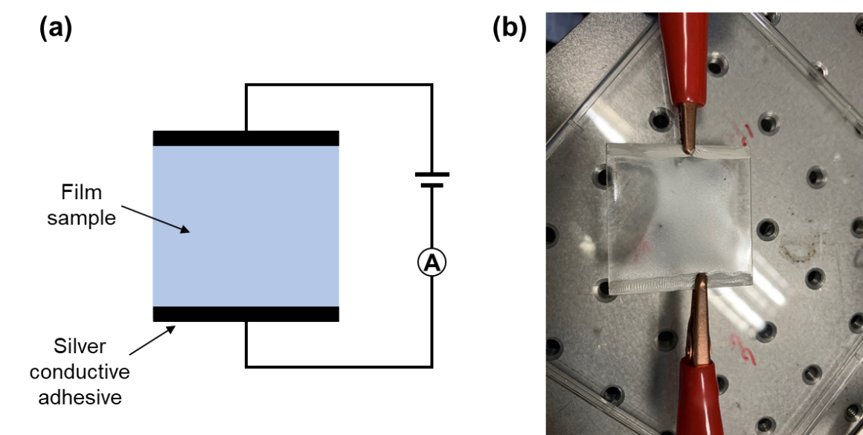
Figure S14. Conductivity measurement of the composite film. (a) Schematic diagram; (b) Experiment photograph.

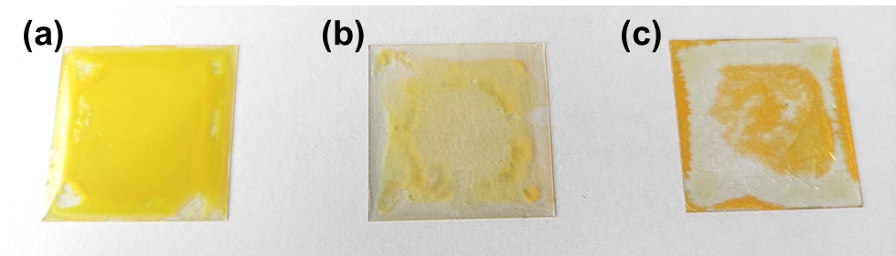
Figure S15. Photos of the film samples after annealing. (a) Glass/PDMS/cross-linked PVA; (b) Glass/PDMS/uncross-linked PVA; (c) Glass/cross-linked PVA.
If the PVA layer is un-cross-linked, DMSO can dissolve it during the preparation process, and the water will also dissolve it during post-treatment and in use. Therefore, if PVA is un-cross-linked, the composite film cannot be successfully prepared and normally used. If there is no soft PDMS as a middle buffer layer, when PVA is swollen by water or DMSO, the internal stress will cause delamination between the PVA and the glass substrate
Figure S16. XRD results of the composite film with lead-free perovskite, showing that the crystalline Cs₂AgBiBr₆ phase² in PVA network is recoverable.

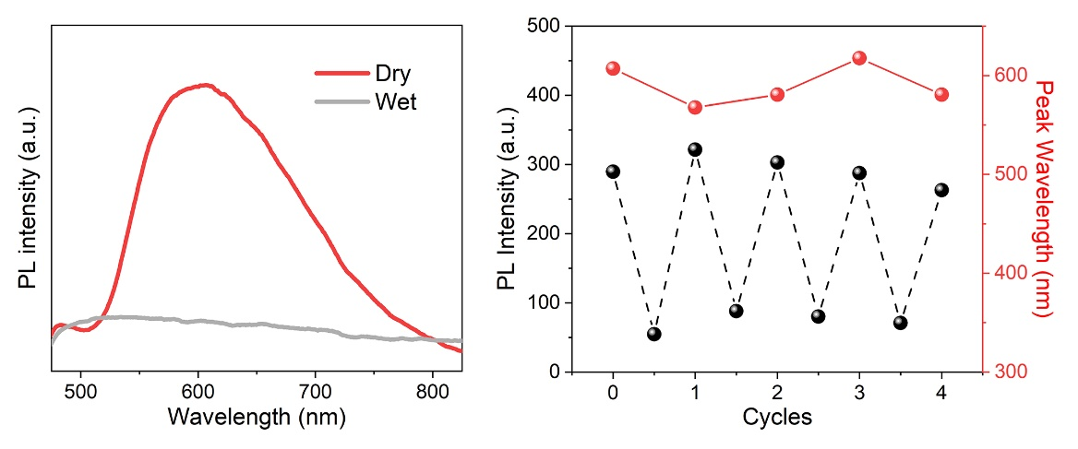
Figure S17. (a) PL spectra of the composite film with lead-free perovskite Cs₂AgBiBr₆ NPs in dry and wet states. (b) The change of PL intensity and peak position during 4 cycles.

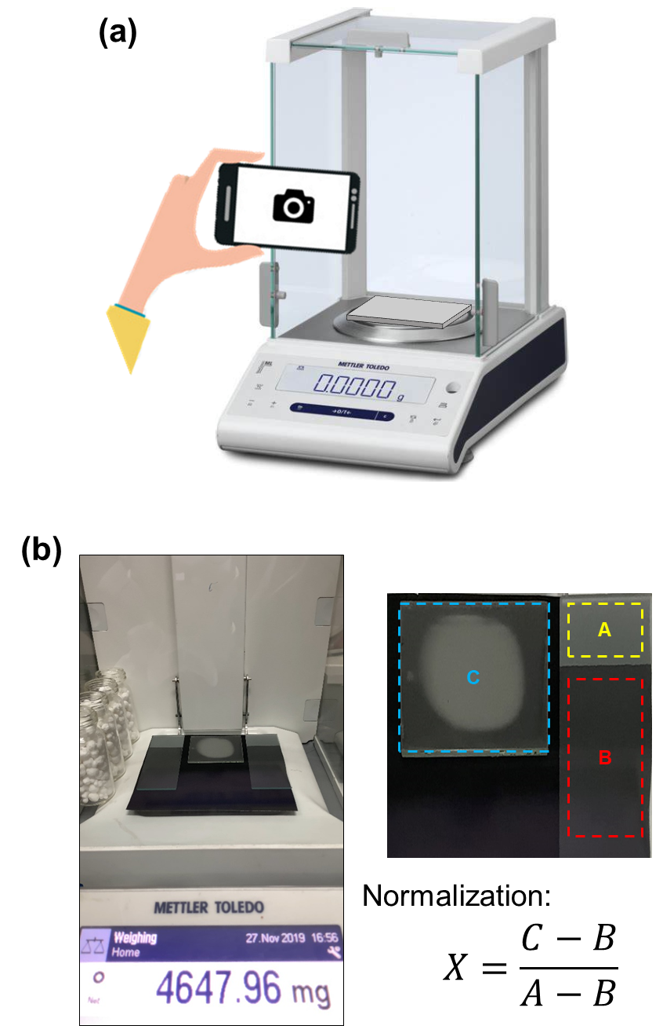
Figure S18. Establishment of quantitative relationship. (a) Schematic diagram of the setup that simultaneously measuring the mass of the composite film and recording its surface appearance. (b) Captured result at an arbitrary moment and the normalization process of the grayscale value data of the surface.

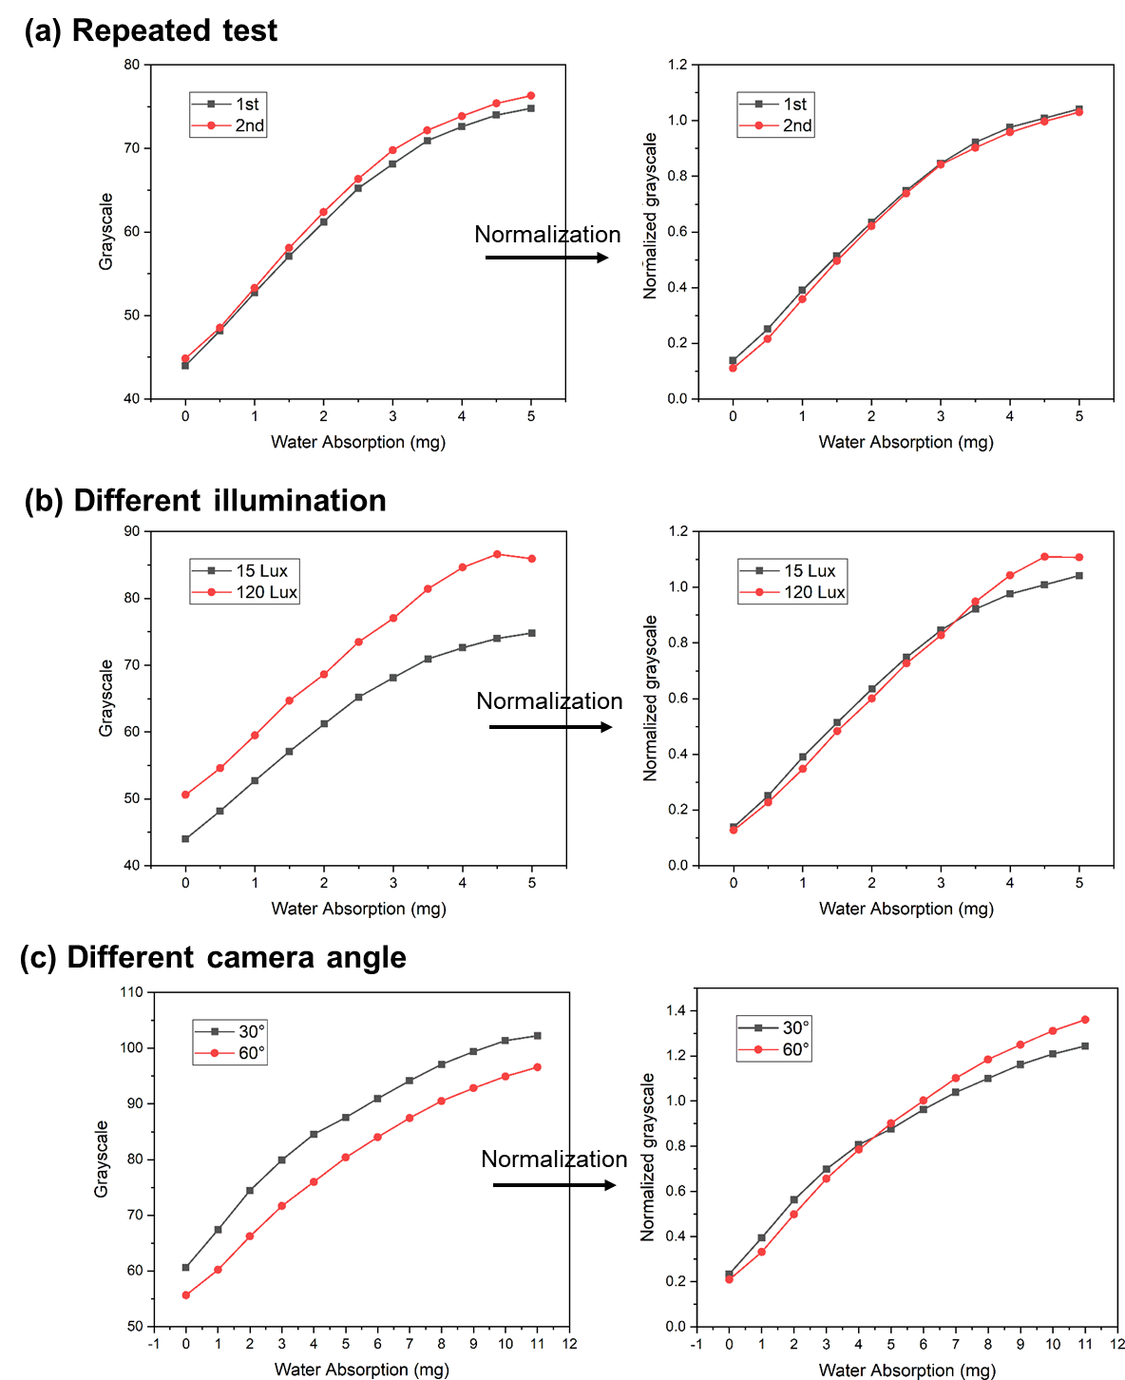
Figure S19. Normalization of the relation of surface grayscale versus water absorption. (a) Repeated test at the same conditions; (b) at different illumination; (c) at different camera angle.

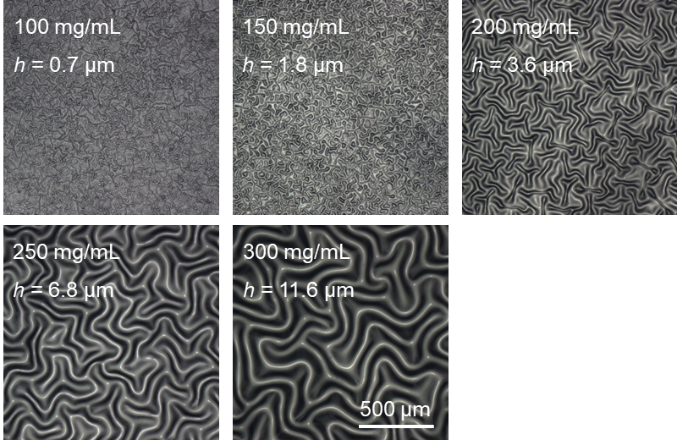
Figure S20. Morphologic evolution of the wrinkles on the multi-layer film as the increase of PVA thicknesses.

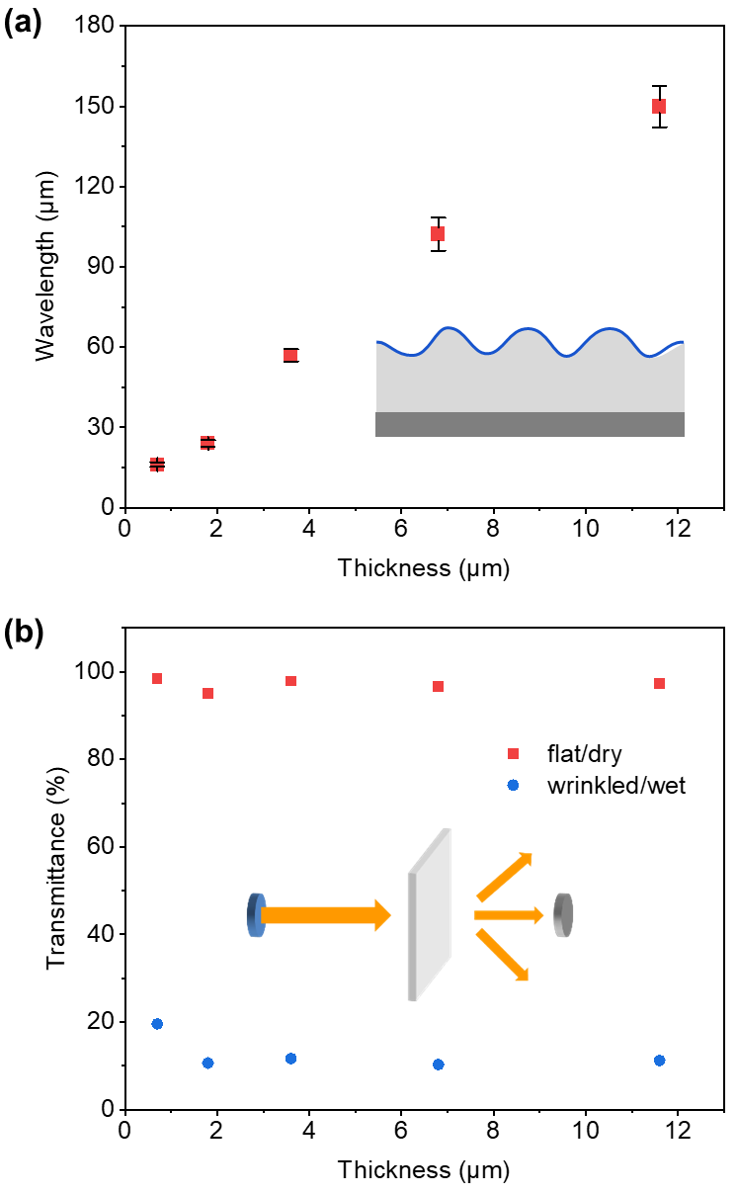
Figure S21. (a) Plot of the wrinkle wavelength at different PVA thickness. (b) Plots of average visible transmittance at dry and wet states at different PVA thickness.

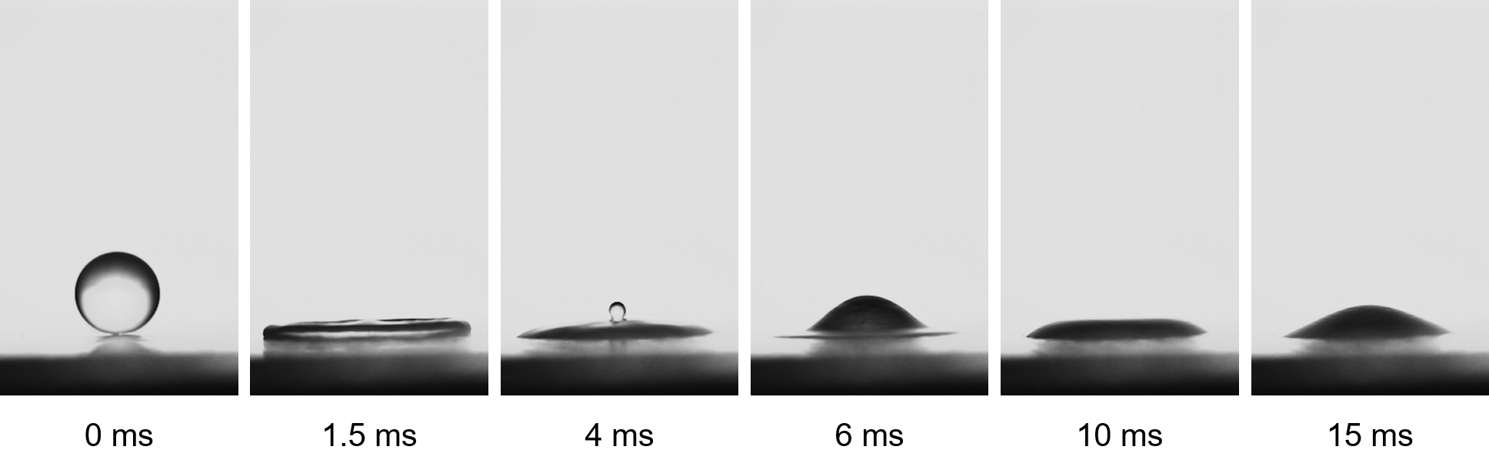
Figure S22. Representative snapshots of water droplet impact on the composite film showing the droplet deposition phenomenon without break-up, rebound, and splashing.

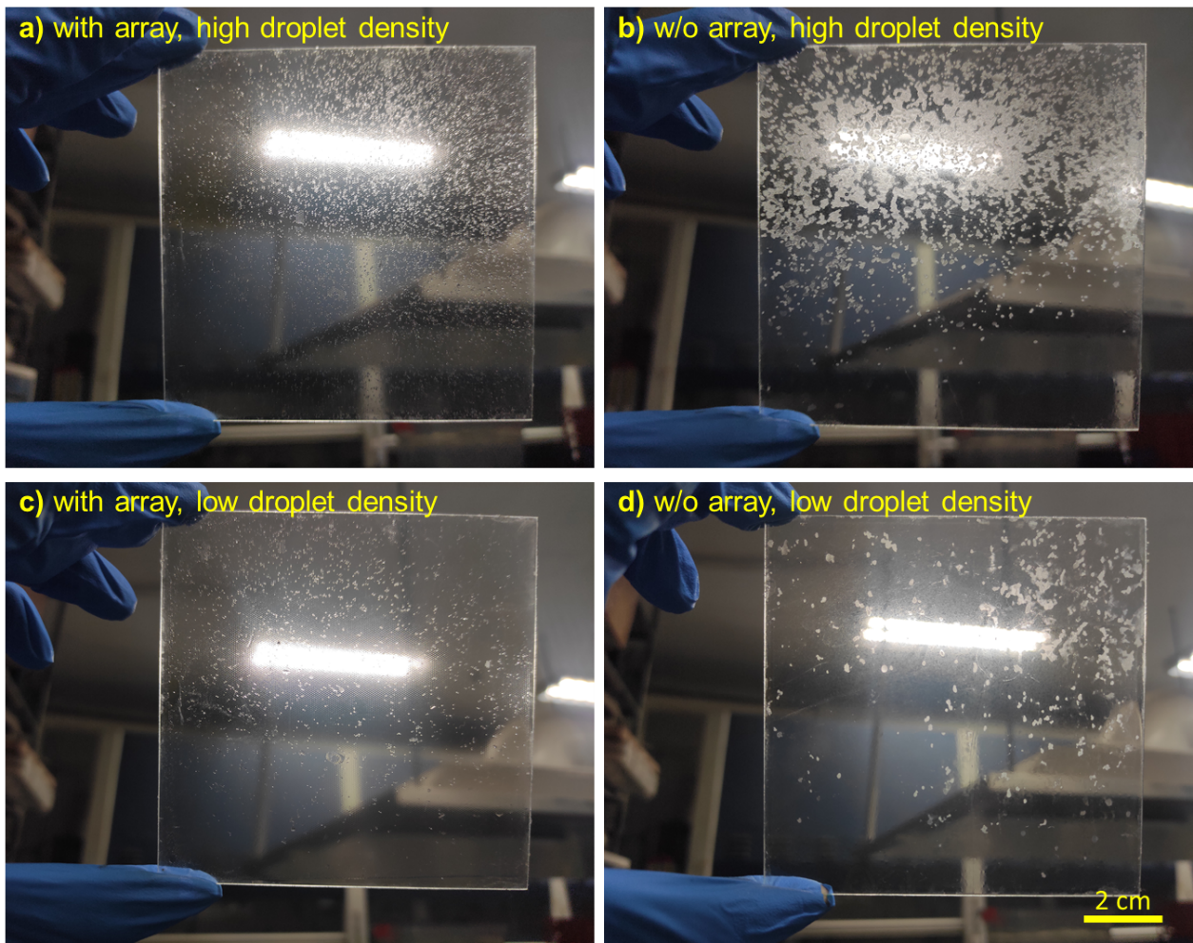
Figure S23. Experimental spraying results of the film with and without array at different droplet density.

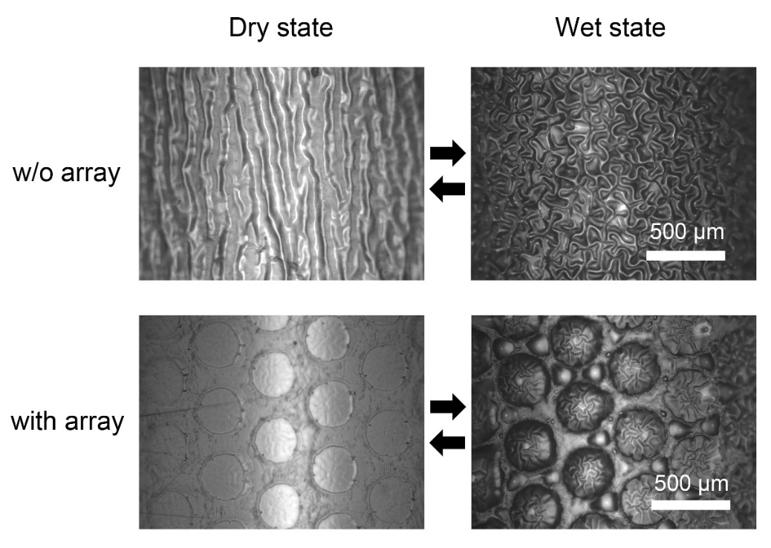
Figure S24. Surface morphology upon spraying test of the film with and without array.

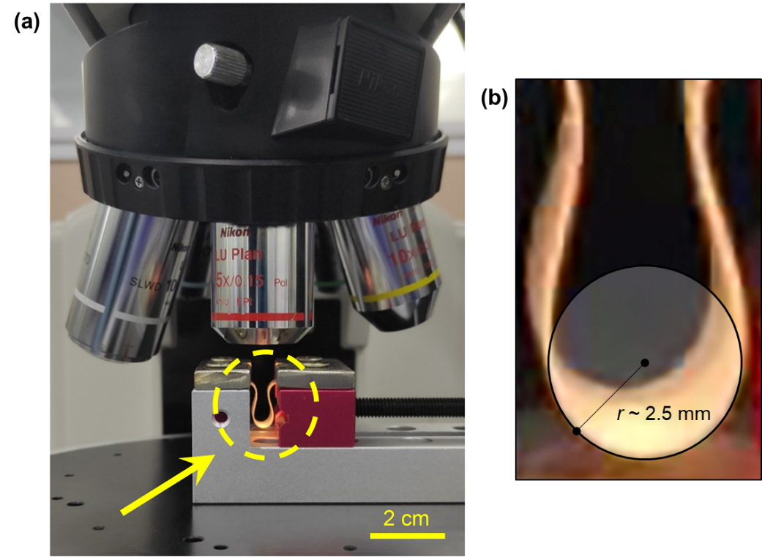
Figure S25. (a) Experimental photograph of the bending test. (b) The curvature radius of the bended film at the measured location is about 2.5 mm.

Figure S26. Experimental time-varying results of the spray test in the laboratory environment. The white spots in the images point the locations of wrinkles triggered by water droplets

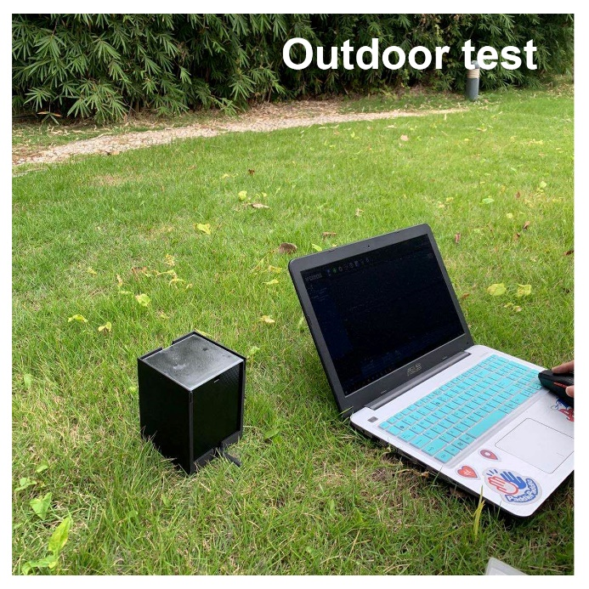
Figure S27. Outdoor test scenario of the box-type monitoring device.

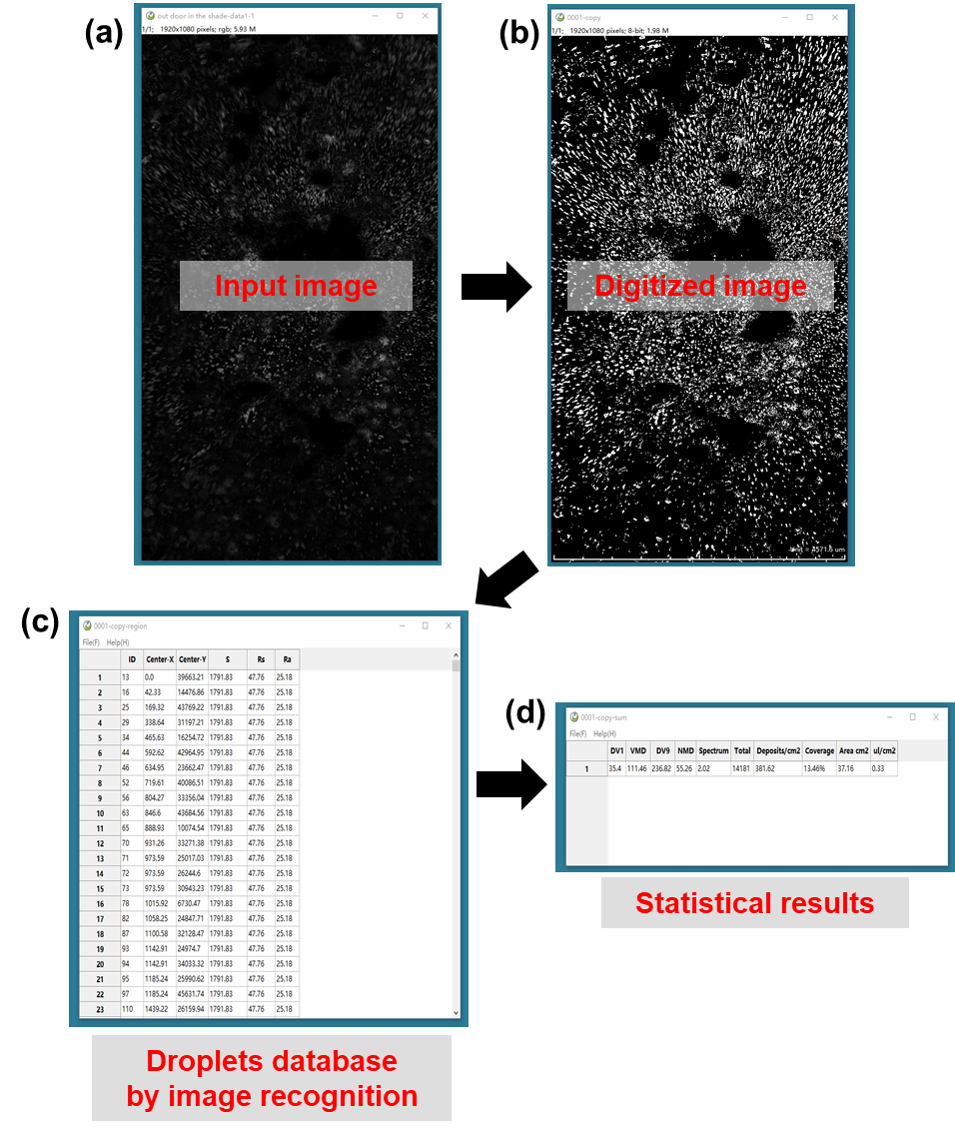
Figure S28. Image recognition process. An input image (a) was firstly transformed into recognizable digital image (b), and then each spot on it was identified and recorded into a database that concludes all droplets (c), and eventually an output data report of statistical results (d), such as the droplets number (N), average size (s), average spacing (d), total water volume (V) and coverage ratio (C) was obtained.

Supporting Videos
Video S1: Perovskite fluorescence quenching and recovery of the water-sensitive composite film.
Video S2: Wrinkle formation and disappearance of the water-sensitive composite film.
Video S3: Wrinkle formation and disappearance of the array-patterned water-sensitive composite film.

Reference
1 Wang, Y. et al. Ultrastable, Highly Luminescent Organic-Inorganic Perovskite-Polymer Composite Films. Adv Mater 28, 10710-10717, doi:10.1002/adma.201603964 (2016).
2 Fan, P. et al. Single-Source Vapor-Deposited Cs2AgBiBr6 Thin Films for Lead-Free Perovskite Solar Cells. Nanomaterials (Basel) 9, doi:10.3390/nano9121760 (2019).

