Additional file 3: Figure S1. Major phyla (each with a relative abundance >0.01 in all the samples) of prokaryotes detected in the rumen metagenome of cattle (C1-C8), dzo (D1-D6), and yak (Y1-Y10). Phyla with red, green, and blue asterisks are significantly more predominant in cattle, dzo, and yak, respectively, compared to the other two ruminant species. The difference among the three ruminant species was identified using the Kruskal-Wallis H test, with post hoc test done using the Tukey-Kramer test (n=6 per species). * P < 0.05, ** P < 0.01.

Additional file 4: Figure S2. Major bacterial genera (each with a relative abundance >0.1% in all the samples) that were identified in the rumen metagenome and significantly differed in relative abundance among the three ruminant species. The difference among the three ruminant species was identified using the Kruskal-Wallis H test, with post hoc test done using the Tukey-Kramer test. The error bars represent the standard error or mean (n=6 per species). * P < 0.05, ** P < 0.01.

Additional file 5: Figure S3. Bacterial genera identified in the rumen metagenome that possess the arcylate pathway for propionate production. Difference in relative abundance among the three ruminant species was tested using the Kruskal-Wallis H test, with post hoc test being done using Tukey-Kramer test. The error bars represent the standard error or mean (n=6 per species). * P < 0.05, ** P < 0.01

Additional file 6: Figure S4. Relative abundance of Ruminococcus albus, R. flavefaciens, and Fibrobacter succinogenes in the rumen microbiota of the three ruminant species. Difference in relative abundance was tested using the Kruskal-Wallis H test, with post hoc test done using the Tukey-Kramer test. The error bars represent the standard error or mean (n=6 per species). * P < 0.05, ** P < 0.01.

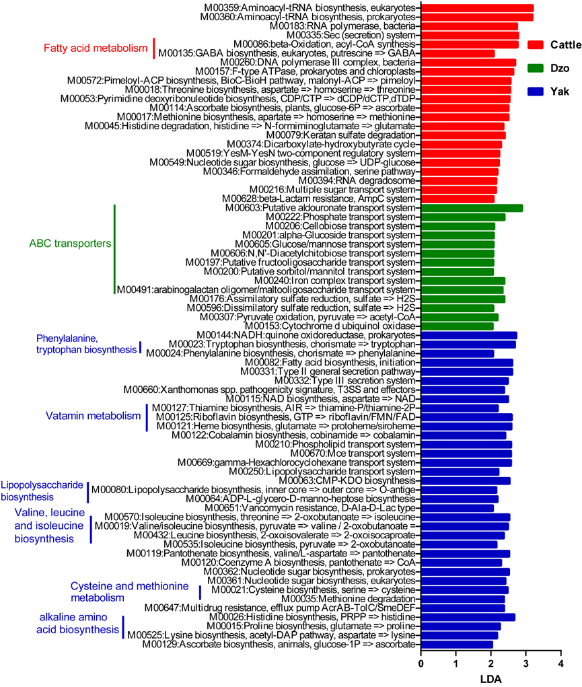
Additional file 10: Figure S5. Differential KEGG modules among the three ruminant species as determined using LEfSe. Only the pathways that differed significantly (P < 0.05) between two of the three ruminant species with an LDA >2 are shown.

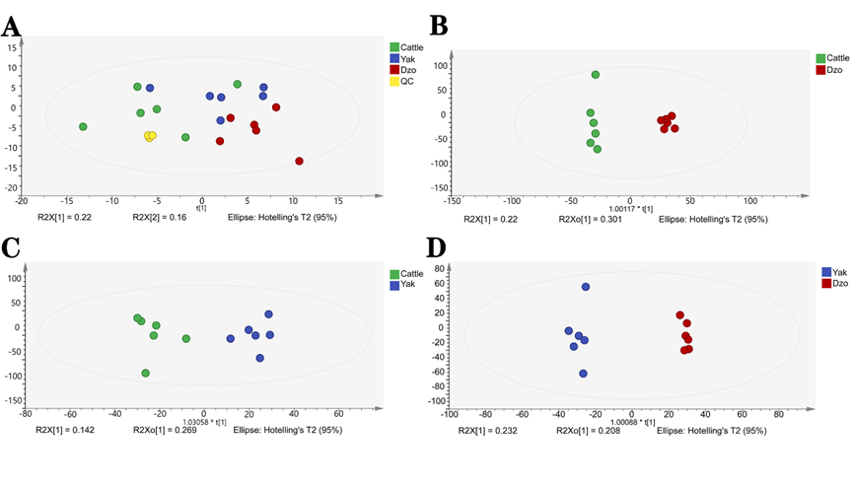
Additional file 11: Figure S6. Multivariate statistical analysis comparing the rumen metabolites among the three ruminant species. PCA analysis of all the samples and three QC samples (A). OPLS-DA plots of cattle vs. dzo (B), cattle vs. yak (C), dzo vs. yak (D).

Additional file 1: Table S1 Alpha diversity measurements of the rumen prokaryotic microbiota as determined by metataxonomics.
Item | Cattle | Dzo | Yak | SEM | P value
Chao1 | 1,599^{ab} | 1,626ª | 1,508^{b} | 21 | 0.049
ACE | 1,605ª | 1,621ª | 1,498^{b} | 21 | 0.025
Simpson diversity index | 0.01 | 0.01 | 0.01 | 0.00 | 0.144
Simpson evenness | 0.07^{b} | 0.08^{b} | 0.11ª | 0.01 | 0.009
P-values were calculated using ANOVA (n=9 per ruminant species).
Different superscripts in a row designate significant difference (P < 0.05).

Additional file 2: Table S2 Alpha diversity measurements of the fungal prokaryotic microbiota as determined by metataxonomics
Index | Cattle | Dzo | Yak | SEM | P value
Chao1 | 269^{b} | 613ª | 561ª | 33 | <0.001
ACE | 264^{b} | 631ª | 565ª | 35 | <0.001
Simpson diversity index | 0.09 | 0.06 | 0.12 | 0.02 | 0.352
Simpson evenness | 0.06ª | 0.04^{b} | 0.03^{b} | 0.00 | 0.004
P-values were calculated using ANOVA (n=9 per ruminant species).
Different superscripts in a row designate significant difference (P < 0.05).

Additional file 7: Table S3 Abundance (in TPM) of the top 15 polysaccharide lyase (PL) families that differed significantly among cattle, dzo and yak.
PL family | Cattle | Dzo | Yak | SEM | P value
PL1_2 | 153.85^{c} | 209.23ª | 184.06^{b} | 6.22 | <0.001
PL11 | 116.09^{b} | 156.22ª | 175.03ª | 7.73 | 0.001
PL1 | 79.33^{b} | 99.04ª | 99.01ª | 3.41 | 0.014
PL12 | 61.37^{b} | 91.58ª | 89.49ª | 5.51 | 0.032
PL9 | 49.38^{c} | 85.77^{b} | 110.43ª | 7.08 | <0.001
PL10 | 27.86^{b} | 35.18^{ab} | 39.79ª | 1.90 | 0.024
PL10_2 | 8.63^{b} | 17.35ª | 10.67^{b} | 1.13 | <0.001
PL9_1 | 7.47^{b} | 10.23^{b} | 19.17ª | 1.43 | <0.001
PL9_2 | 8.64ª | 4.84^{b} | 7.34^{ab} | 0.65 | 0.041
PL4_4 | 2.81^{b} | 6.29ª | 7.48ª | 0.58 | <0.001
PL18 | 6.08ª | 2.64^{b} | 3.65^{b} | 0.45 | 0.001
PL4 | 1.25^{b} | 3.35ª | 2.83ª | 0.28 | 0.001
PL5 | 0.93^{b} | 2.34ª | 2.89ª | 0.28 | 0.005
PL12_1 | 1.12^{ab} | 1.55ª | 0.28^{b} | 0.21 | 0.033
PL8_2 | 2.16ª | 0.13^{b} | 0.14^{b} | 0.27 | <0.001
P-values were calculated using ANOVA (n=6 per ruminant species).
Different superscripts in a row designate significant difference (P < 0.05).

Additional file 8: Table S4 Abundance (in TPM) of the top 15 glycosyl transferase (GT) families that differed significantly among cattle, dzo and yak.
GT family | Cattle | Dzo | Yak | SEM | P value
GT2 | 3,604.05^{b} | 3,909.17^{b} | 4,467.66ª | 102.84 | <0.001
GT4 | 2,097.92^{c} | 2,308.40^{b} | 2,640.78ª | 65.76 | <0.001
GT19 | 246.89^{ab} | 238.68^{b} | 264.93ª | 4.33 | 0.029
GT35 | 194.34^{ab} | 182.85^{b} | 199.35ª | 2.72 | 0.028
GT9 | 150.46^{c} | 183.93^{b} | 234.98ª | 9.67 | <0.001
GT8 | 162.76ª | 117.73^{b} | 156.58ª | 7.59 | 0.020
GT26 | 96.91^{c} | 127.34^{b} | 147.13ª | 5.94 | <0.001
GT10 | 11.56^{b} | 18.71^{b} | 30.95ª | 2.61 | 0.002
GT1 | 24.70ª | 12.19^{b} | 10.21^{b} | 1.77 | <0.001
GT32 | 138.73^{b} | 169.72^{ab} | 190.36ª | 8.53 | 0.035
GT30 | 131.43^{b} | 141.09^{b} | 162.17ª | 4.42 | 0.007
GT11 | 77.48^{b} | 89.19^{ab} | 107.21ª | 4.50 | 0.014
GT13 | 33.22^{b} | 43.62^{ab} | 49.85ª | 2.54 | 0.015
GT81 | 23.36^{b} | 29.73ª | 28.45ª | 1.10 | 0.031
GT23 | 17.21^{b} | 23.72^{ab} | 32.29ª | 2.24 | 0.012
P-values were calculated using ANOVA (n=6 per ruminant species).
Different superscripts in a row designate significant difference (P < 0.05).

Additional file 9: Table S5 Abundance (in TPM) of the top 15 Carbohydrate-Binding Module (CBM) families that differed significantly among cattle, dzo and yak.

CB family | Cattle | Dzo | Yak | SEM | P value
CBM48 | 329.60ª | 303.20ª | 247.77^{b} | 10.20 | <0.001
CBM67 | 245.82^{b} | 292.00ª | 287.41ª | 7.38 | 0.009
CBM61 | 241.50^{b} | 253.88^{b} | 305.24ª | 10.48 | 0.020
CBM4 | 216.86^{b} | 256.17ª | 228.29a^{b} | 6.79 | 0.040
CBM40 | 79.53^{b} | 95.74^{b} | 116.25ª | 4.85 | 0.002
CBM51 | 37.73^{b} | 35.37^{b} | 56.18ª | 2.75 | 0.000
CBM72 | 47.59ª | 34.35^{b} | 36.12^{b} | 2.31 | 0.028
CBM78 | 38.25ª | 36.23ª | 24.15^{b} | 2.18 | 0.007
CBM12 | 39.36ª | 26.02^{b} | 24.06^{b} | 2.59 | 0.021
CBM57 | 11.73^{b} | 18.87ª | 16.84ª | 0.93 | 0.001
CBM77 | 10.10^{b} | 16.23ª | 17.07ª | 0.98 | 0.001
CBM58 | 16.57ª | 11.09^{b} | 6.50^{c} | 1.29 | 0.001
CBM5 | 11.92ª | 6.26^{b} | 6.22^{b} | 0.98 | 0.012
CBM41 | 7.96ª | 9.47ª | 4.70^{b} | 0.59 | <0.001
CBM70 | 4.53^{b} | 6.21^{ab} | 11.24ª | 1.20 | 0.048
P-values were calculated using ANOVA (n=6 per ruminant species).
Different superscripts in a row designate significant difference (P < 0.05).

Additional file 12: Table S6 Abundance (in TPM) of GH13 and its subfamilies identified in the rumen metagenome of cattle, dzo and yak.
CAZymes family | Cattle | Dzo | Yak | SEM | P value
GH13 | 425.55 | 454.01 | 399.72 | 11.60 | 0.163
GH13_8 | 261.79ª | 229.84^{b} | 221.11^{b} | 5.17 | <0.001
GH13_9 | 93.41 | 103.12 | 103.86 | 3.80 | 0.484
GH13_13 | 62.29 | 74.27 | 67.75 | 2.47 | 0.138
GH13_11 | 49.48 | 51.33 | 58.99 | 2.59 | 0.299
GH13_14 | 23.00^{ab} | 26.31ª | 20.15^{b} | 0.91 | 0.012
GH13_10 | 2.06 | 3.35 | 3.24 | 0.40 | 0.363
GH13_12 | 0.48ª | 0.15^{b} | 0.01^{b} | 0.07 | 0.006
P-values were calculated using ANOVA (n=6 per ruminant species).
Different superscripts in a row designate significant difference (P < 0.05).

