Energy transition and social justice: Do renewable energy levies have an impact on income distribution and energy poverty?
Jan Priesmannª, Saskia Spiegelburgª, Reinhard Madlener^{a,b}, Aaron Praktiknjo^{a,}*
ª Institute for Future Energy Consumer Needs and Behavior (FCN), E.ON Energy Research Center/School of Business and Economics, RWTH Aachen University, Mathieustr. 10, 52074 Aachen, Germany
^{b} Department of Industrial Economics and Technology Management, Norwegian University of Science and Technology (NTNU), Sentralbygg I, Gløshaugen, 7491 Trondheim, Norway
* Corresponding author

Supplementary Information

Supplementary Table 1: Development of final electricity price and RES support levy for residential consumers from 2003 to 2018.
 | Total final electricity price |  | RES support levy |  | Final electricity price
 |  |  |  |  | (without RES support levy incl. VAT**)
 | Nominal value | In 2003  prices* | Nominal value | In 2003 prices* | Nominal  value | In 2003  prices*
 | [€-ct/kWh] | [€-ct/kWh] | [€-ct/kWh] | [€-ct/kWh] | [€-ct/kWh] | [€-ct/kWh]
2003 | 17.19 | 17.19 | 0.42 | 0.42 | 16.70 | 16.70
2018 | 29.47 | 23.72 | 6.79 | 5.47 | 21.39 | 17.21
Total change | 12.28 | 6.53 | 6.37 | 5.05 | 4.68 | 0.51
% change | 71.44% | 37.98% | 1517.14% | 1201.55% | 28.05% | 3.06%
* Based on relative change in consumer price index from 2018 to 2003: 24.25%
** VAT rate for 2003: 16%; VAT rate for 2018: 19%

Supplementary Table 2: Substitution, income, and total effect of the change in electricity consumption of private households from 2003 to 2018. Absolute values are given in kWh.
Income decile | Substitution effect  (with constant budget) |  | Income effect  (with constant budget) |  | Budget and household  composition effect |  | Total effect
Income decile | Absolute | Share of total effect | Absolute | Share of total effect | Absolute | Share of total effect | Absolute
1 | -201.04 | 55.66% | -25.41 | 7.03% | -134.77 | 37.31% | -361.22
2 | -283.22 | 77.13% | -21.81 | 5.94% | -62.17 | 16.93% | -367.20
3 | -380.23 | 94.00% | -18.96 | 4.69% | -5.29 | 1.31% | -404.48
4 | -350.76 | 99.18% | -16.68 | 4.72% | 13.78 | -3.90% | -353.66
5 | -389.04 | 101.72% | -16.88 | 4.41% | 23.44 | -6.13% | -382.48
6 | -450.31 | 102.07% | -18.06 | 4.09% | 27.21 | -6.17% | -441.17
7 | -522.91 | 110.67% | -21.08 | 4.46% | 71.51 | -15.14% | -472.48
8 | -539.50 | 105.23% | -17.79 | 3.47% | 44.62 | -8.70% | -512.67
9 | -585.46 | 110.84% | -18.59 | 3.52% | 75.84 | -14.36% | -528.22
10 | -656.74 | 97.30% | -23.50 | 3.48% | 5.25 | -0.78% | -674.99

Supplementary Table 3: Income classes of the different survey years.
 | ICS 2003 | ICS 2018
Income decile | Household net equivalent income  per year [€] | Household net equivalent income  per year [€]
1 | <= 12,016 | <= 13,785
2 | 12,016 – 15,197 | 13,785 – 18,308
3 | 15,197 – 17,726 | 18,308 – 22,020
4 | 17,726 – 20,069 | 22,020 – 25,336
5 | 20,069 – 22,560 | 25,336 – 28,680
6 | 22,560 – 25,392 | 28,680 – 32,376
7 | 25,392 – 28,952 | 32,376 – 36,896
8 | 28,952 – 33,829 | 36,896 – 42,533
9 | 33,829 – 42,256 | 42,533 – 52,181
10 | > 42,256 | > 52,181

Supplementary Table 4: Formulas for the 2018 income tax rate in Germany according to the German Income Tax Act in effect in 2018.
Taxable income (TI)
From | To | Income tax formula (results in €)
0 | 9,000 | $$Income tax = 0.0$$
9,001 | 13,996 | $$Income tax =\left(997.8*y+1,400\right)*y$$$with y=\frac{TI-9,000}{10,000}$
13,997 | 54,949 | $$Income tax =\left(220.13*z+2,397\right)*z+948.49 \\ with z=\frac{TI-13,996}{10,000}$$
54,950 | 260,532 | $$Income tax =0.42*TI-8,621.75$$
260,533 | unlimited | $$Income tax =0.45*TI-16,437.7$$

Supplementary Table 5: Difference in equivalent electricity consumption and electricity expenditure compared to the real RES support levy in 2018 for (1) the case that the RES support levy had been abolished, (2) the case of an income-progressive levy, and (3) the case of a (high) flat levy with an income-degressive compensation payment.
 | No levy |  | Income-progressive levy |  | Flat (high) levy with income-degressive compensation payment
Income decile | $∆$El. consumption  $$\left[\frac{kWh}{household∙a}\right]$$ | $∆$El. expenditure  $$\left[\frac{€}{household∙a}\right]$$ | $∆$El. consumption  $\left[\frac{kWh}{household∙a}\right]$ | $∆$El. expenditure  $$\left[\frac{€}{household∙a}\right]$$ | $∆$El. consumption  $\left[\frac{kWh}{household∙a}\right]$ | $∆$El. expenditure  $\left[\frac{€}{household∙a}\right]$
1 | 228.00 | -95.64 | 216.29 | -91.18 | -336.29 | 285.18
2 | 365.38 | -101.66 | 279.67 | -80.04 | -518.32 | 294.13
3 | 516.68 | -91.09 | 307.70 | -56.07 | -702.11 | 255.03
4 | 496.67 | -114.12 | 214.26 | -50.21 | -691.78 | 325.58
5 | 565.18 | -112.33 | 153.87 | -28.13 | -776.54 | 317.16
6 | 668.75 | -106.54 | 78.57 | -5.59 | -900.55 | 296.25
7 | 784.37 | -89.24 | -27.28 | 15.33 | -1026.87 | 242.91
8 | 790.62 | -95.98 | -173.40 | 44.35 | -1040.41 | 262.27
9 | 853.53 | -91.66 | -347.77 | 75.21 | -1112.43 | 248.67
10 | 900.19 | -94.48 | -690.51 | 167.07 | -1171.19 | 255.96
Average | 618.38 | -99.28 | 0.21 | -0.57 | -829.46 | 278.27

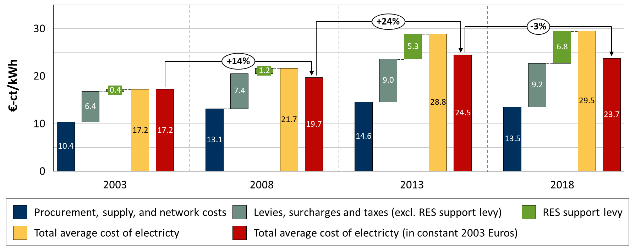
Supplementary Figure 1: Development of the private household average cost of electricity. Average costs are given in €-ct per kWh and stated separately for different price components. Average cost represents the annual electricity expenditure (including base and operating price) divided by the annual consumption. The data is shown for the annual consumption of 3500 kWh.

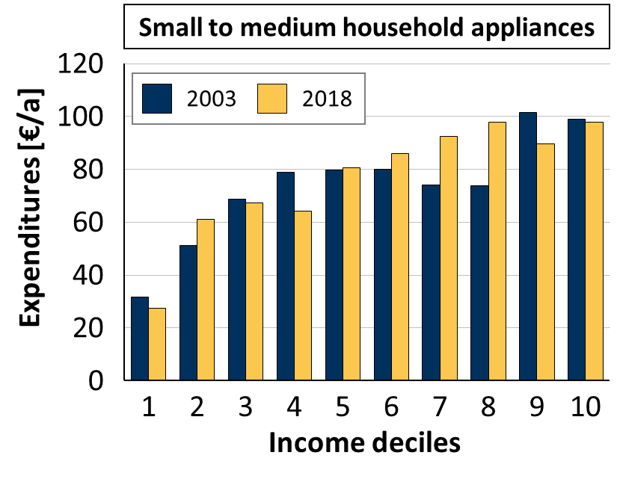 | 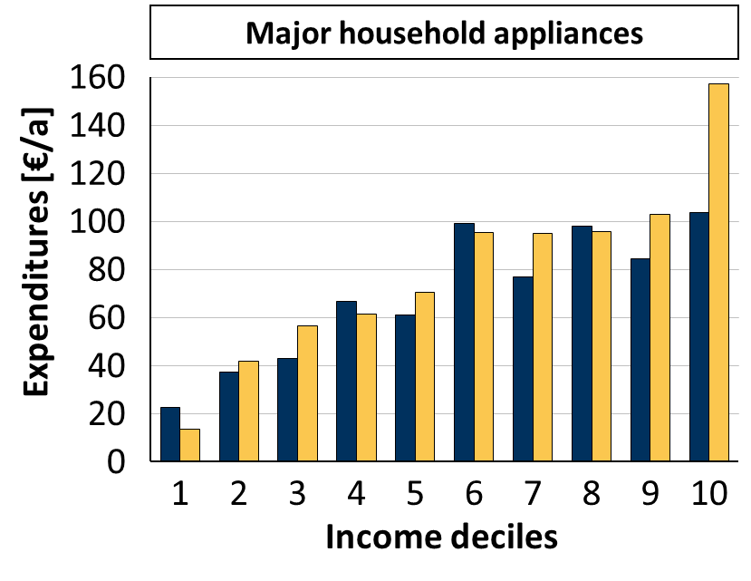
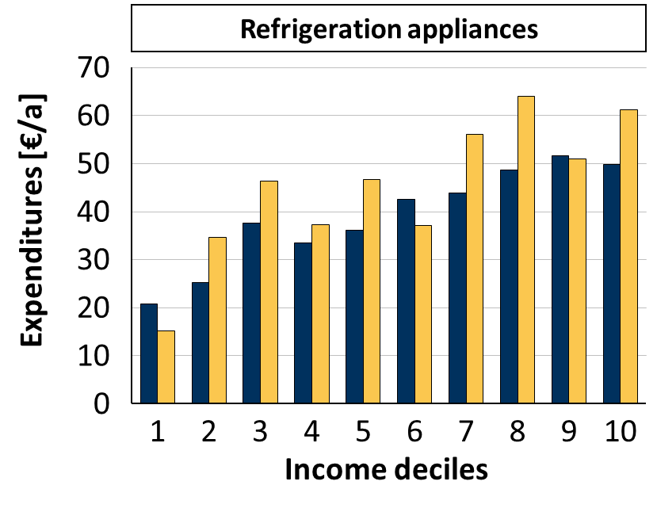 | 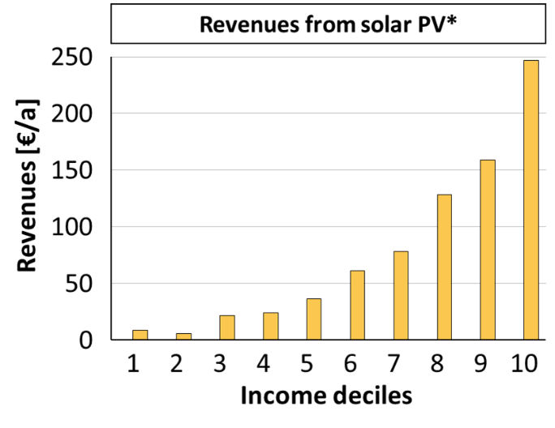
Supplementary Figure 2: Indicators for expenditures on energy efficiency measures and revenues from own generation. Expenditures and revenues are given in inflation-adjusted 2003 prices. Private households are grouped into income deciles according to the OECD equivalence scale. *Data for 2003 on revenues from solar PV is not available in the ICS data set.

Supplementary Equation 1: Average cost-expenditures function 2003.
$$c_{el}^{2003S1}\left(e_{el}\right)=\left\{\begin{aligned}-0.000547154e_{el}+0.35126465, &0≤e_{el}<254.45 \\ -0.000120115e_{el}+0.242604652, &254.45≤e_{el}<597.8 \\ -0.0000221478e_{el}+0.184039969, &597.8≤e_{el}<1,183.68 \\ -0.0000812312e_{el}+0.25397577, &1,183.68≤e_{el}<1,935.33 \\ 0.096766549, &e_{el}≥1,935.33\end{aligned}\right.$$

$$c_{el}^{2003S2}\left(e_{el}\right)=\left\{\begin{aligned}-0.000547154e_{el}+0.347974115, &0≤e_{el}<252.07 \\ -0.000120115e_{el}+0.240332009, &252.07≤e_{el}<592.2 \\ -0.0000221478e_{el}+0.182315941, &592.2≤e_{el}<1,172.59 \\ -0.0000812312e_{el}+0.251596606, &1,172.59≤e_{el}<1,917.2 \\ 0.095860071, &e_{el}≥1,917.2\end{aligned}\right.$$
Supplementary Equation 2: Average cost-expenditures function 2018.
$$c_{el}^{2018S1}\left(e_{el}\right)=\left\{\begin{aligned}-0.00040864e_{el}+0.569764429, &0≤e_{el}<581.35 \\ -0.00006218e_{el}+0.368347232, &581.35≤e_{el}<1,120.13 \\ -0.00001146e_{el}+0.311540600, &1,120.13≤e_{el}<2,795 \\ -0.00001062e_{el}+0.309177312, &2,795≤e_{el}<4,000.5 \\ 0.2667, &e_{el}≥4,000.5\end{aligned}\right.$$
$$c_{el}^{2018S2}\left(e_{el}\right)=\left\{\begin{aligned}-0.00040813e_{el}+0.572893645, &0≤e_{el}<584.85 \\ -0.00006332e_{el}+0.371230214, &584.85≤e_{el}<1,125 \\ -0.00001161e_{el}+0.313058036, &1,125≤e_{el}<2,805 \\ -0.00001943e_{el}+0.334998619, &2,805≤e_{el}<3,891 \\ 0.2594, &e_{el}≥3,891\end{aligned}\right.$$

