Supplemental Material

Table S1 Baseline characteristics of CHARLS participants (classified by SHR tertiles).

Characteristic | N | Overall  N = 4,279¹ | Q1  N = 1,501¹ | Q2  N = 1,328¹ | Q3  N = 1,450¹ | p-value²
Age | 4,279 | 59.53 ± 9.20 | 59.76 ± 8.98 | 59.21 ± 9.35 | 59.60 ± 9.29 | 0.11
Gender, n (%) | 4,279 |  |  |  |  | <0.001
Male |  | 1,497 (35) | 480 (32) | 438 (33) | 579 (40)
Female |  | 2,782 (65) | 1,021 (68) | 890 (67) | 871 (60)
Education level, n (%) | 4,279 |  |  |  |  | 0.5
Below high school |  | 3,804 (89) | 1,346 (90) | 1,174 (88) | 1,284 (89)
High school and above |  | 475 (11) | 155 (10) | 154 (12) | 166 (11)
Marital status, n (%) | 4,279 |  |  |  |  | 0.7
Married or living with partner |  | 3,707 (87) | 1,292 (86) | 1,156 (87) | 1,259 (87)
Widowed/divorced/separated/never married |  | 572 (13) | 209 (14) | 172 (13) | 191 (13)
Smoking status, n (%) | 4,279 |  |  |  |  | 0.008
Never smoker |  | 2,979 (70) | 1,068 (71) | 938 (71) | 973 (67)
Former smoker |  | 918 (21) | 315 (21) | 255 (19) | 348 (24)
Current smoker |  | 382 (8.9) | 118 (7.9) | 135 (10) | 129 (8.9)
Drinking status, n (%) | 4,279 |  |  |  |  | <0.001
Never |  | 2,892 (68) | 1,040 (69) | 919 (69) | 933 (64)
Former |  | 365 (8.5) | 141 (9.4) | 122 (9.2) | 102 (7.0)
Current |  | 1,022 (24) | 320 (21) | 287 (22) | 415 (29)
BMI (kg/m²) | 4,279 | 25.71 ± 3.69 | 25.95 ± 3.77 | 25.78 ± 3.67 | 25.39 ± 3.61 | <0.001
Waist Circumference (cm) | 4,279 | 90.98 ± 10.86 | 92.12 ± 9.76 | 90.99 ± 10.90 | 89.80 ± 11.76 | <0.001
SBP | 4,279 | 137.90 ± 20.44 | 138.58 ± 20.88 | 137.26 ± 20.29 | 137.77 ± 20.10 | 0.4
DBP | 4,279 | 79.65 ± 11.55 | 80.15 ± 11.57 | 79.62 ± 11.83 | 79.17 ± 11.23 | 0.065
Triglyceride (mg/dL) | 4,279 | 196.07 ± 146.73 | 169.93 ± 86.91 | 178.88 ± 97.36 | 238.88 ± 210.36 | <0.001
TC (mg/dL) | 4,279 | 200.23 ± 41.75 | 201.03 ± 38.99 | 199.31 ± 39.09 | 200.26 ± 46.61 | 0.2
HDL-C (mg/dL) | 4,279 | 42.15 ± 12.06 | 42.93 ± 10.91 | 43.01 ± 12.30 | 40.55 ± 12.79 | <0.001
LDL-C (mg/dL) | 4,279 | 117.51 ± 39.12 | 123.62 ± 35.51 | 119.57 ± 38.17 | 109.31 ± 42.07 | <0.001
Glucose, plasma (mg/dL) | 4,279 | 123.31 ± 47.37 | 105.83 ± 22.05 | 116.64 ± 30.65 | 147.51 ± 65.70 | <0.001
HbA1c (%) | 4,279 | 5.46 ± 1.01 | 5.69 ± 0.88 | 5.39 ± 0.98 | 5.29 ± 1.13 | <0.001
BUN (mg/dL) | 4,279 | 15.50 ± 4.49 | 15.34 ± 4.46 | 15.22 ± 4.46 | 15.93 ± 4.52 | <0.001
UA (mg/dL) | 4,279 | 4.63 ± 1.31 | 4.60 ± 1.26 | 4.57 ± 1.31 | 4.71 ± 1.36 | 0.028
Creatinine (mg/dL) | 4,279 | 0.78 ± 0.26 | 0.77 ± 0.20 | 0.78 ± 0.20 | 0.80 ± 0.36 | 0.044
Hemoglobin (g/dL) | 4,279 | 14.49 ± 2.19 | 14.66 ± 2.29 | 14.52 ± 2.13 | 14.28 ± 2.13 | <0.001
WBC (×10⁹/L) | 4,279 | 6.45 ± 1.87 | 6.56 ± 1.86 | 6.41 ± 1.83 | 6.38 ± 1.91 | 0.006
SHR | 4,279 | 1.13 ± 0.28 | 0.92 ± 0.09 | 1.08 ± 0.04 | 1.39 ± 0.32 | <0.001
¹For categorical variables, all values are expressed as numbers (n) and proportion (%), for continuous variables, all values are expressed as mean ± standard deviation; ² Categorical variables were analysed using the Rao-Scott Chi-Square Test; continuous variables were analysed using the Kruskal-Wallis test.
BMI: Body Mass Index; SBP: Systolic blood pressure; DBP: Diastolic blood pressure; TC: Total cholesterol; HDL-C: high density lipoprotein cholesterol; LDL-C: low density lipoprotein cholesterol; HbA1c: Hemoglobin A1c; BUN: Blood urea nitrogen; UA: Uric acid; WBC: White blood cell; SHR: stress hyperglycemia ratio

Table S2 Multivariate Cox regression model to assess the association between SHR and mortality risk (CHARLS).
Correlation with mortality risk | Quantiles of the SHR
Correlation with mortality risk | Q1 | Q2 | Q3 | P for trend
All-cause mortality
Number of deaths | 162 | 150 | 210
Model 1 HR (95% CI)  P-value | Reference | 1.05 (0.84, 1.31)  0.681 | 1.37 (1.12, 1.69)  0.002 | 0.002
Model 2 HR (95% CI)  P-value | Reference | 1.06 (0.85, 1.33)  0.592 | 1.36 (1.11, 1.67)  0.003 | 0.003
Model 3 HR (95% CI)  P-value | Reference | 1.05 (0.84, 1.31)  0.679 | 1.33 (1.08, 1.65)  0.008 | 0.011

Model 1: no covariates were adjusted; Model 2: adjusted for age, gender; Model 3: adjusted for age, gender, education level, marital status, smoking status, drinking status, BMI, TC, LDL-C, BUN, UA, creatinine, hemoglobin and WBC.
SHR: stress-induced hyperglycemia; CVD: cardiovascular diseases; HR: hazard ratio; 95% CI: 95% confidence interval

Table S3 Assess multicollinearity among predictor variables using variance inflation factor (VIF) analysis.
Feature | VIF
Age | 1.695
Gender | 1.784
Race | 1.051
BMI | 1.164
SBP | 1.311
DBP | 1.334
TC | 1.139
HDL-C | 1.285
BUN | 1.856
UA | 1.317
Creatinine | 1.563
Hemoglobin | 1.601
SHR | 1.036

BMI: Body Mass Index; SBP: Systolic blood pressure; DBP: Diastolic blood pressure; TC: Total cholesterol; HDL-C: high density lipoprotein cholesterol BUN: Blood urea nitrogen; UA: Uric acid; SHR: stress hyperglycemia ratio

Figure_S1
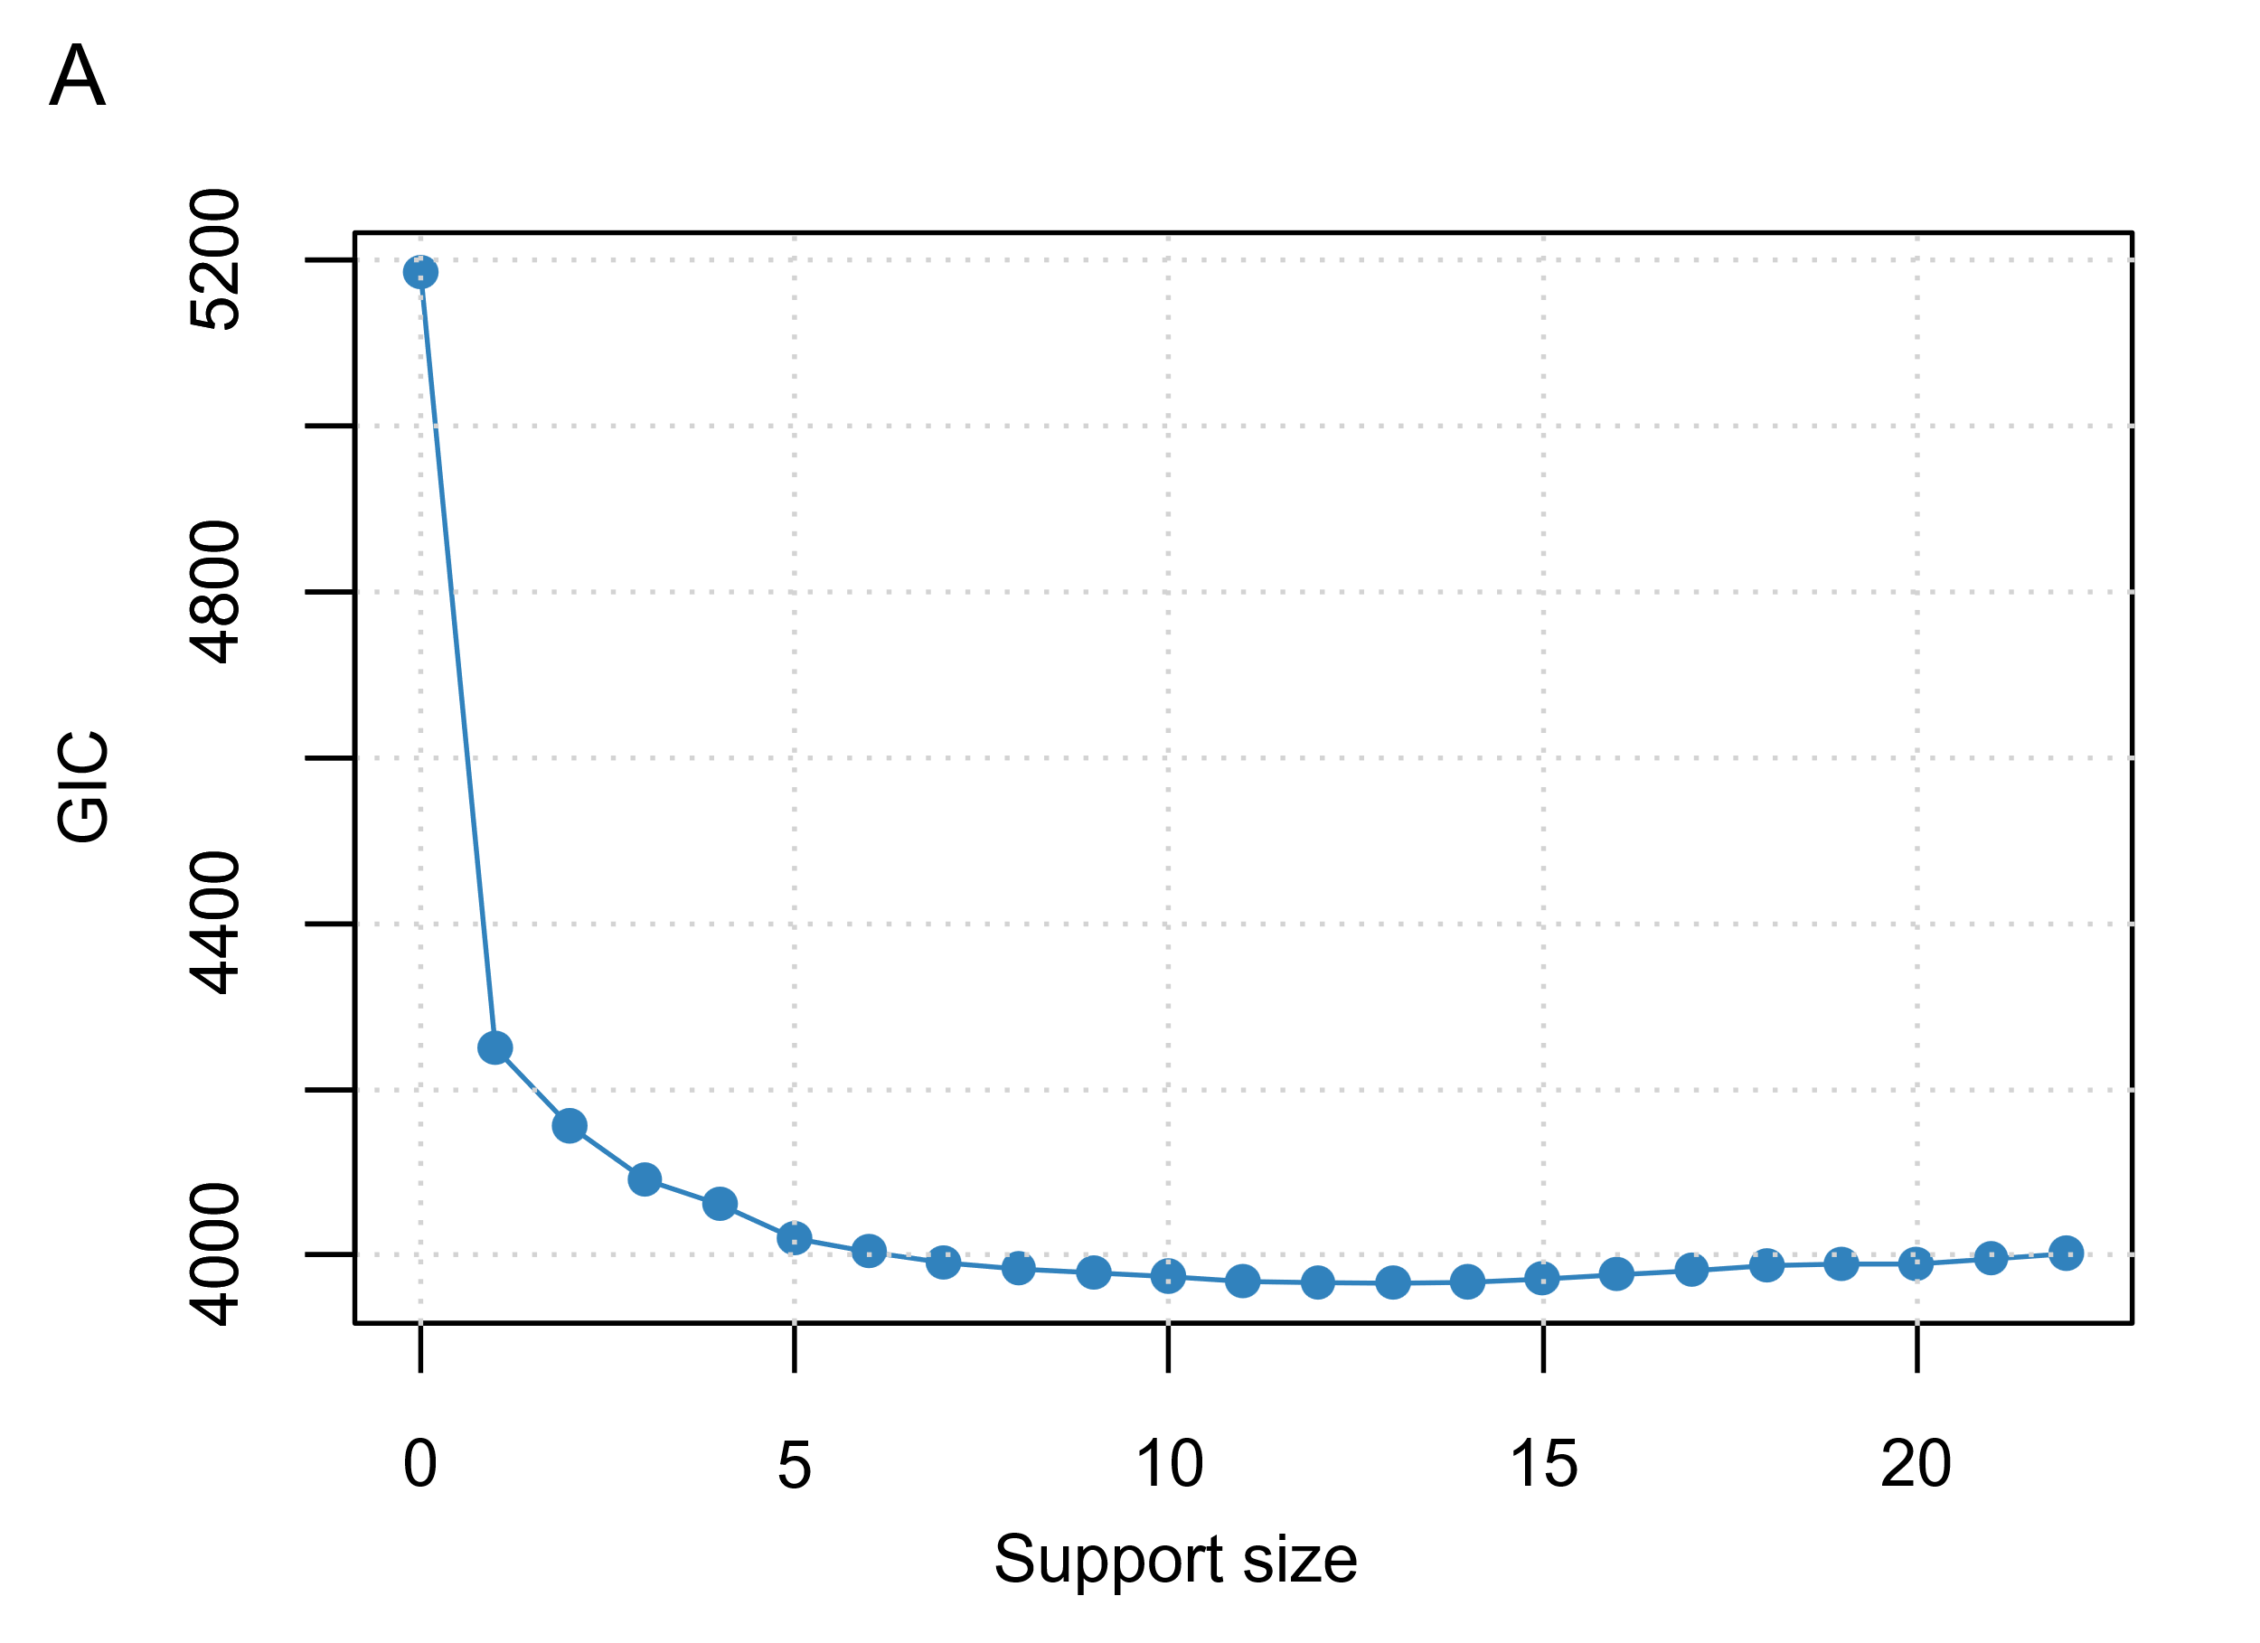
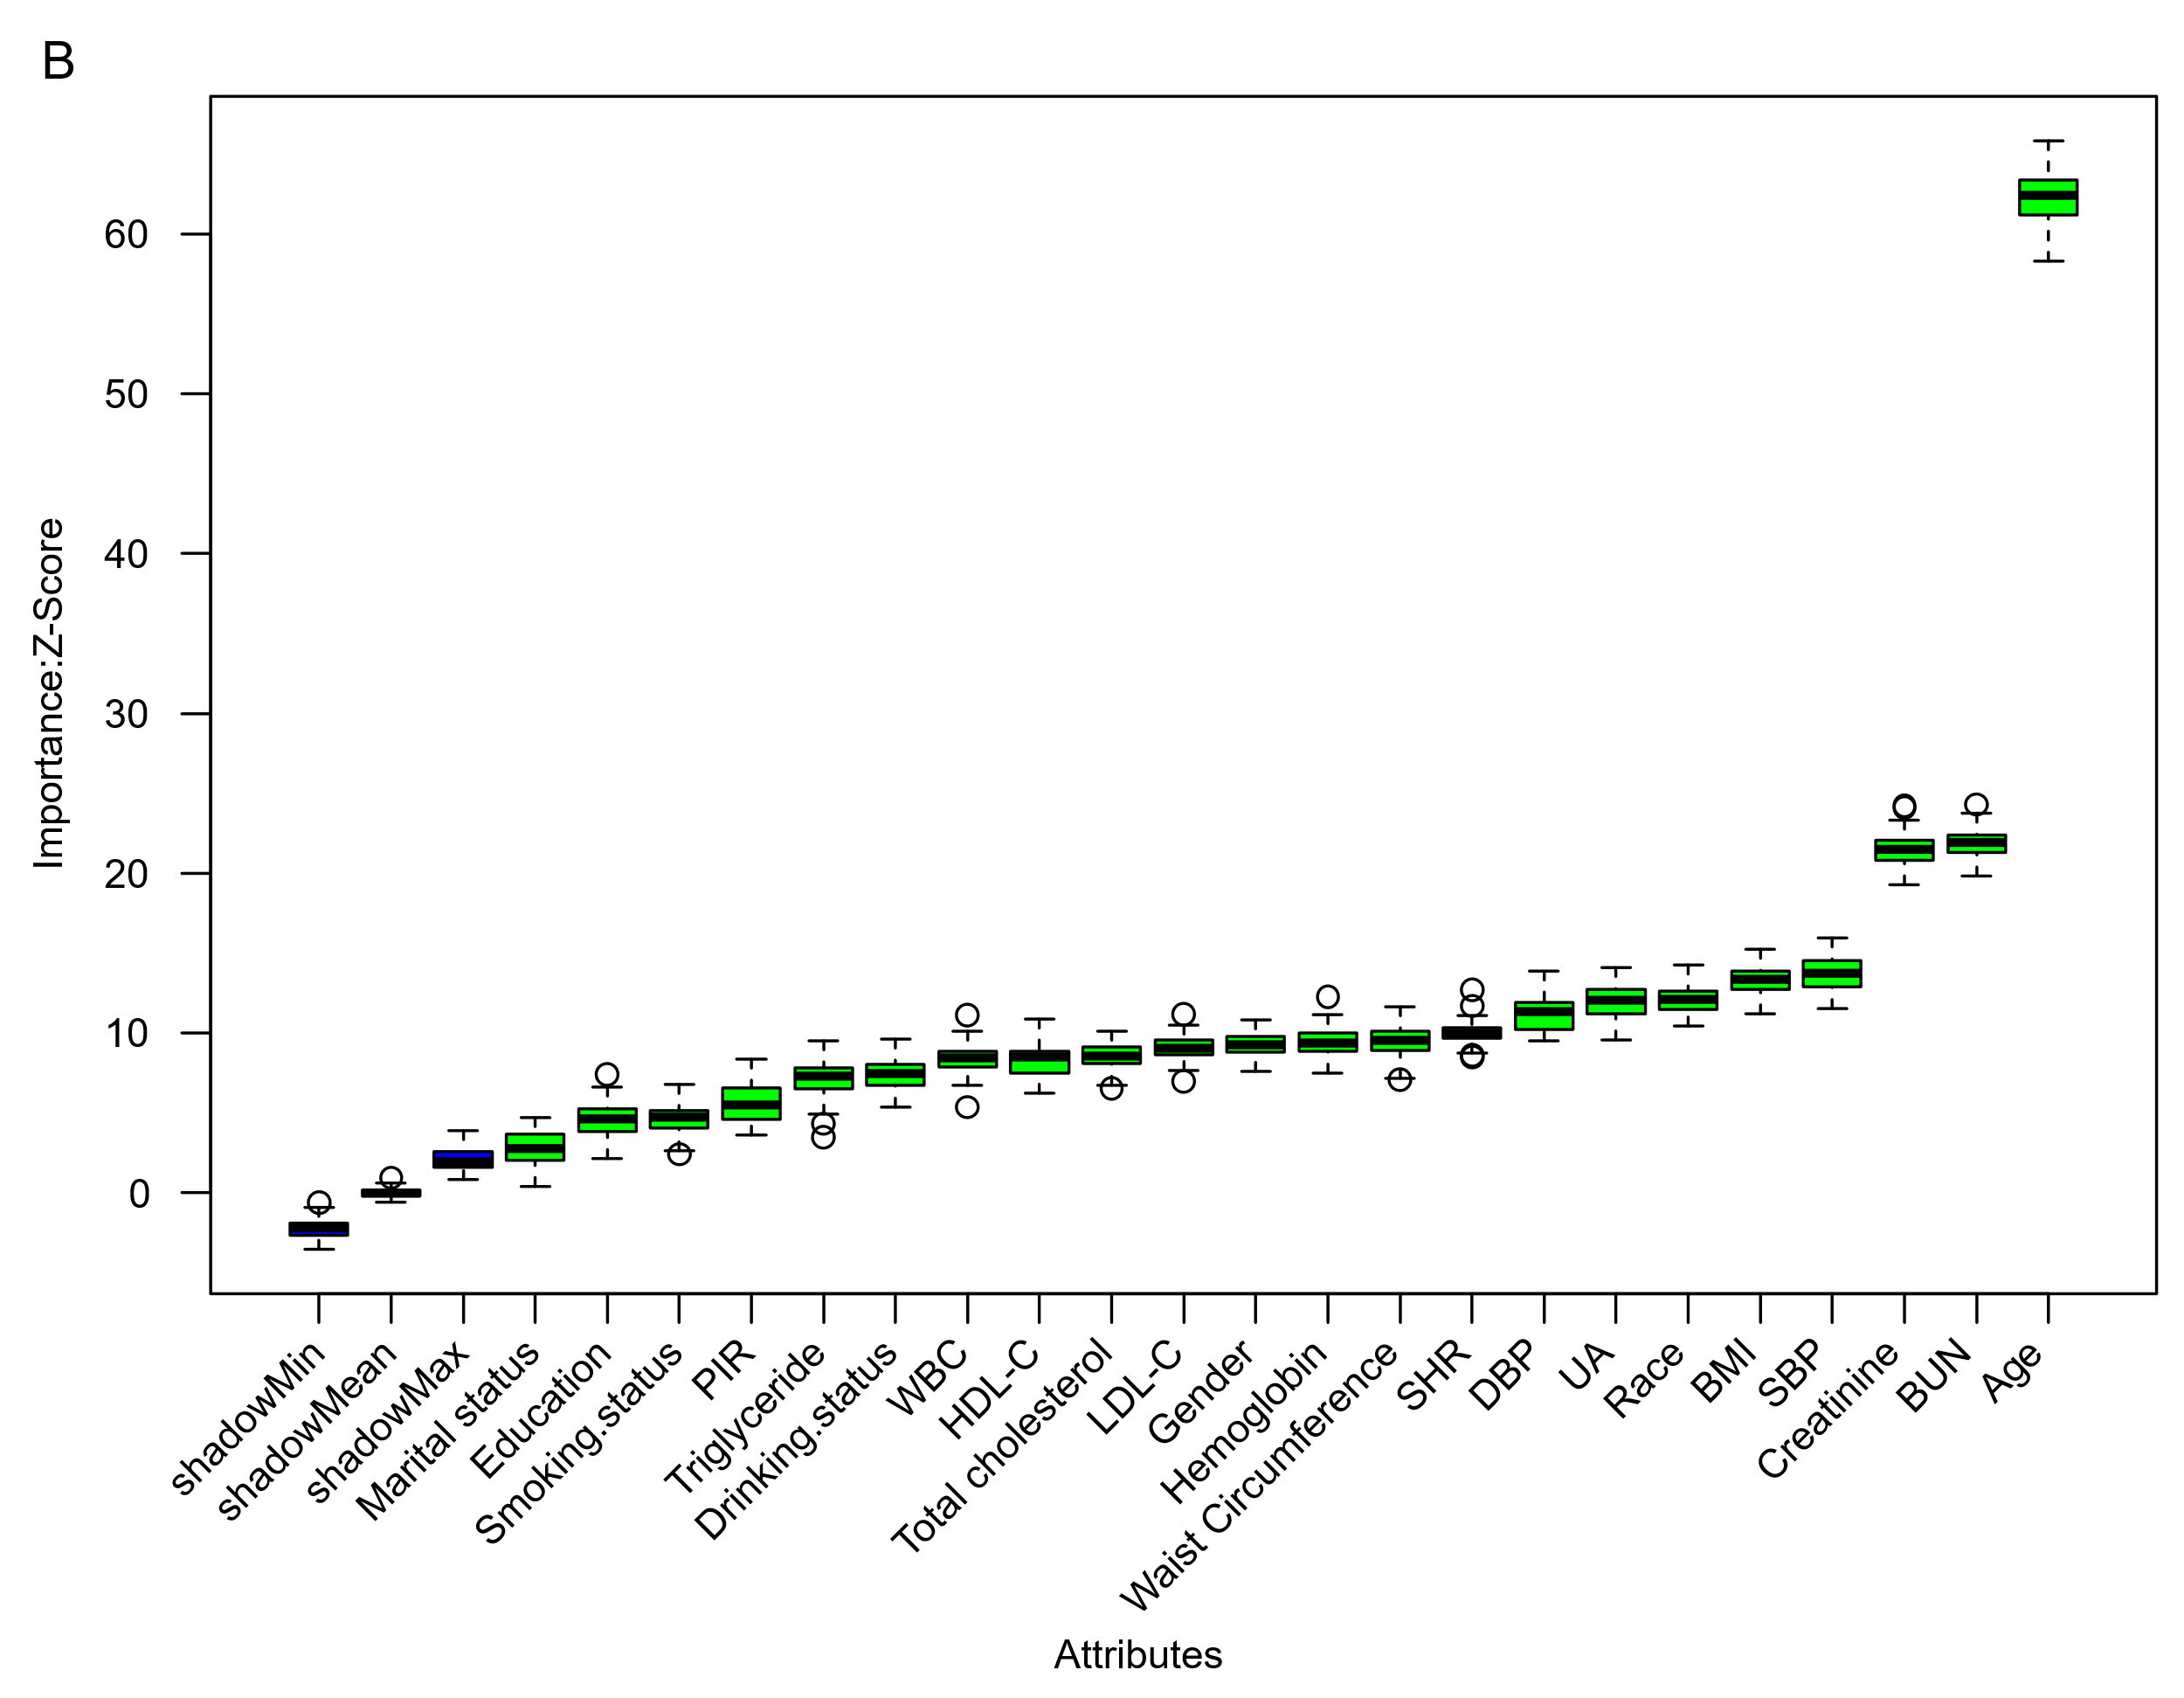
The ABESS algorithm (A) and Boruta algorithm (B) were employed during the variable selection phase. (A) Changes in the Generalised Information Criterion (GIC) when selecting features using the ABESS algorithm. (B) The Boruta algorithm is used to assess the significance of potential risk factors for mortality. The x-axis displays the variable names, and the y-axis represents the Z-values for each variable. Box plots illustrate the Z-values calculated during the modelling process, with green boxes indicating important variables and red boxes indicating unimportant variables.
PIR: Ratio of family income to poverty; WBC: White blood cell; HDL-C: high density lipoprotein cholesterol; LDL-C: low density lipoprotein cholesterol; SHR: stress hyperglycemia ratio; BMI: Body Mass Index; SBP: Systolic blood pressure; DBP: Diastolic blood pressure; BUN: Blood urea nitrogen; UA: Uric acid
Figure_S2
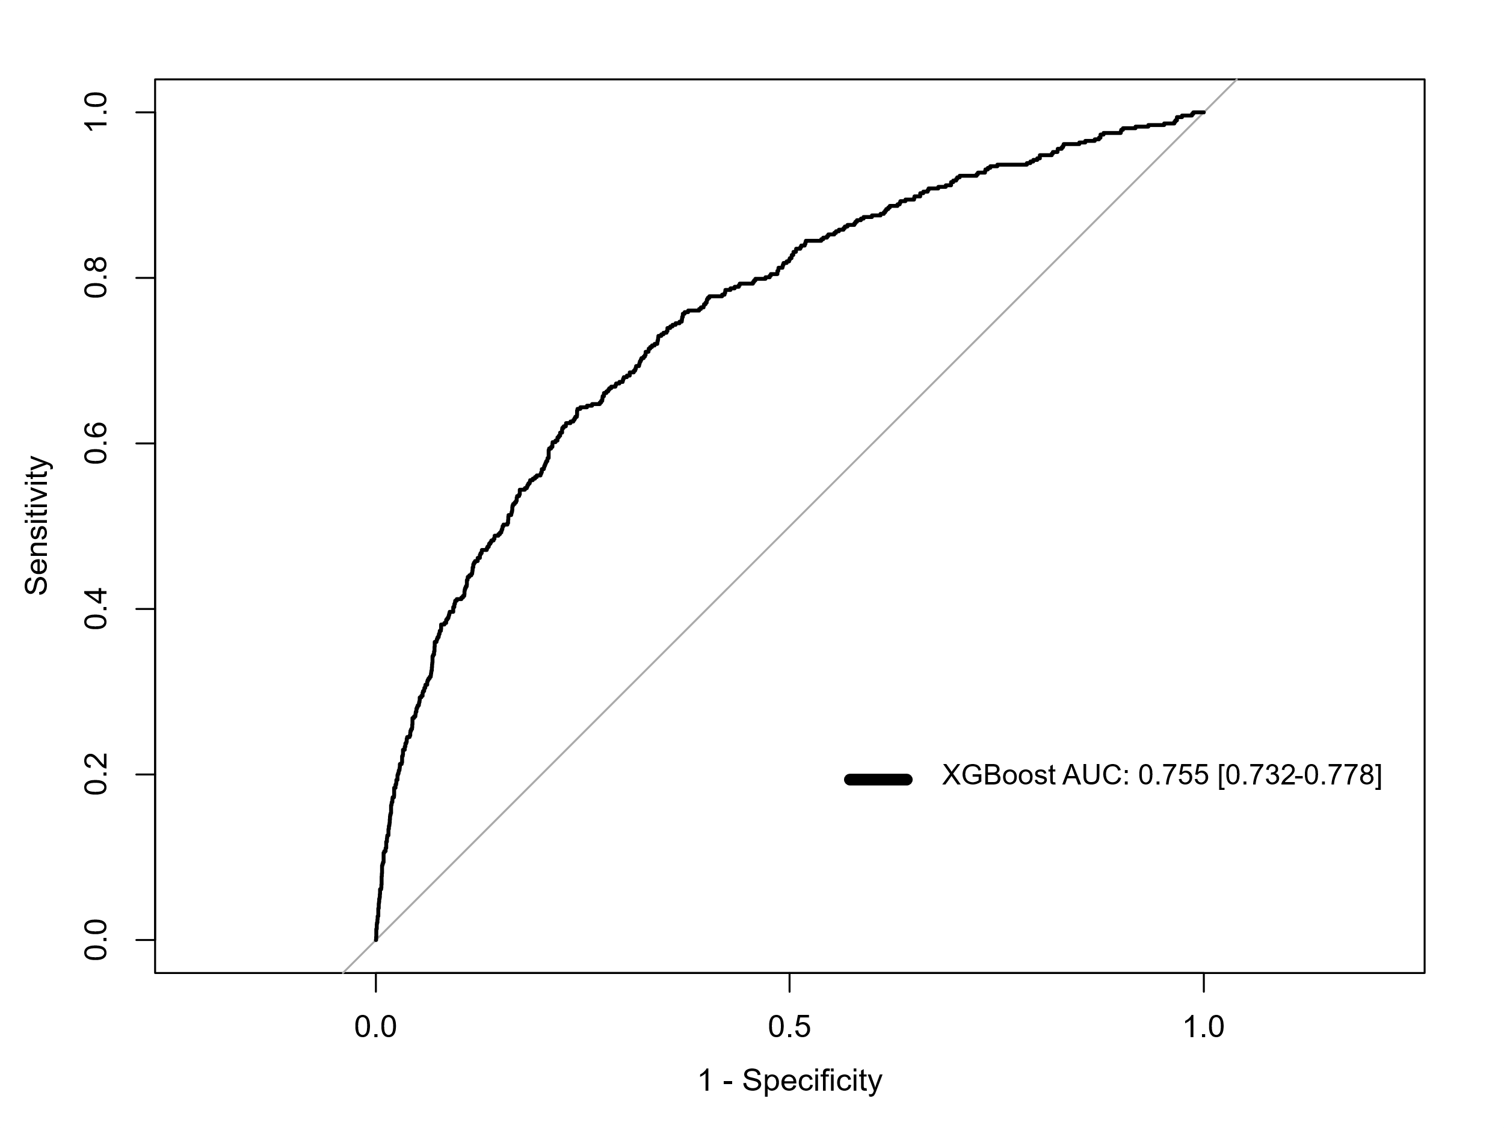
ROC curve of the XGBoost model on an external validation set.
ROC: receiver operating characteristic; AUC: area under the curve.

Figure_S3 A stratified analysis of the association between SHR and all-cause mortality (A) and CVD mortality (B) among CMS respondents in the NHANES database.
A
B
PIR: Ratio of family income to poverty; CVD: cardiovascular diseases; CMS: Cardiometabolic syndrome; HR: hazard ratio; 95% CI: 95% confidence interval.
Figure_S4 A stratified analysis of the association between SHR and all-cause mortality among CMS respondents in the CHARLS database.

Ratio of family income to poverty; CMS: Cardiometabolic syndrome; HR: hazard ratio; 95% CI: 95% confidence interval.

