Targeting MYC-inducing enhancer-associated noncoding (MYC-IEANC) RNAs inhibits the proliferation of HCC cells
Hae In Choi¹, Jin Choul Chai³, Young Seek Lee³, Kyoung Hwa Jung^{4*}, Young Gyu Chai^{1,2*}

¹ Department of Bionanotechnology, Hanyang University, Seoul, 04673, Republic of Korea.
² Department of Molecular & Life Science, Hanyang University, Ansan, 15588, Republic of Korea
³ College of Veterinary Medicine, Seoul National University, Seoul, 08826, Republic of Korea
⁴ Convergence Technology Campus of Korea Polytechnic II, Incheon, 21417, Republic of Korea.

Contact information
Young Gyu Chai (Ph.D.)
Department of Molecular & Life Science
Hanyang University
Ansan, Gyeonggi-do, 15588, Republic of Korea.
Tel: 82-31-400-5513, Fax: 82-31-436-8173
E-mail: ygchai@hanyang.ac.kr

Kyoung Hwa Jung (Ph.D.)
Department of Biopharmaceutical System
Gwangmyeong Convergence Technology Campus of Korea Polytechnic II
Gwangmyeong-si, Gyeonggi-do, 14222, Republic of Korea
Tel: 82-2-2139-4871, Fax: 82-2-2139-4810
E-mail: khjung2@gmail.com

Supplementary figures
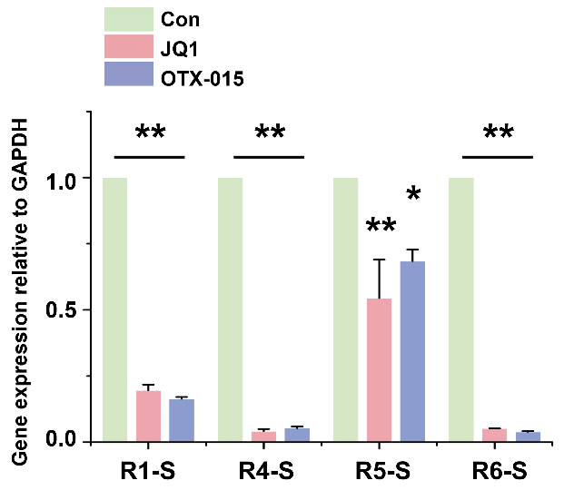
Figure S1

Figure S1. eRNA expression of MYC enhancer regions in HCC cells
qRT-PCR of eRNA transcription levels in BET inhibitor-treated HepG2 cells (5 µM, 24 h). The values are the mean ± SD from triplicate well measurements. *, p < 0.05 and **, p < 0.01.

Figure S2
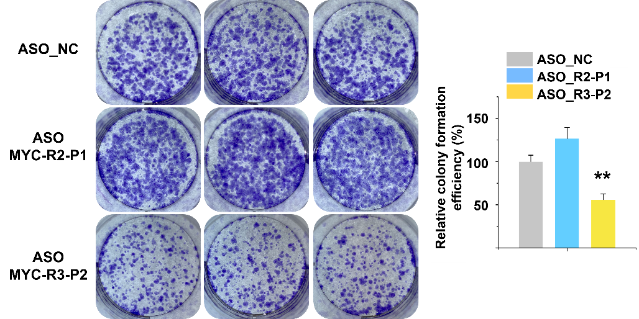
Figure S2. Effects of ASO treatment on HCC cells proliferation
Colony formation ability of ASO-treated HCC cells. Cells were grown for 10 days and stained with crystal violet. The relative colony formation efficiency was measured as a percentage of the area covered by the colonies. The data represent three biologically independent experiments. **, p < 0.01.

