Supplementary Information
North Atlantic Ocean circulation and deep water formation under warmer climate conditions in EC-Earth3-HR
René Navarro-Labastida; Rossby Centre, Swedish Meteorological and Hydrological Institute (SMHI), Norrköping, Sweden; https://orcid.org/0000-0002-3059-8192
Mehdi Pasha Karami; Rossby Centre, Swedish Meteorological and Hydrological Institute (SMHI), Norrköping, Sweden; https://orcid.org/0000-0003-0390-2889
Torben Koenigk; Swedish Meteorological and Hydrological Institute (SMHI); Norrköping, Sweden; Bolin Center for Climate Research, Stockholm, Sweden; https://orcid.org/0000-0003-2051-743X
Agatha M. de Boer; Department of Geological Sciences, Stockholm University, Stockholm, Sweden; Bolin Center for Climate Research, Stockholm, Sweden;
Marie Sicard;Department of Geological Sciences, Stockholm University, Stockholm, Sweden; Bolin Center for Climate Research, Stockholm, Sweden; School of Earth and Environment, University of Leeds, Leeds, UK
Correspondence to: renegabriel.navarrolabastida@smhi.se

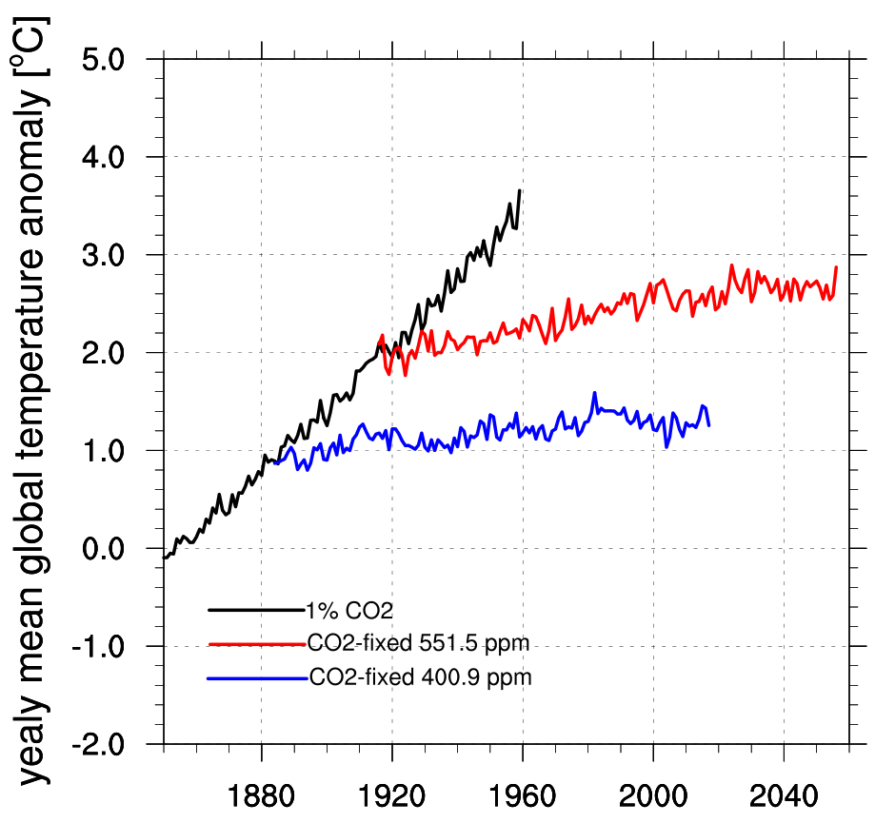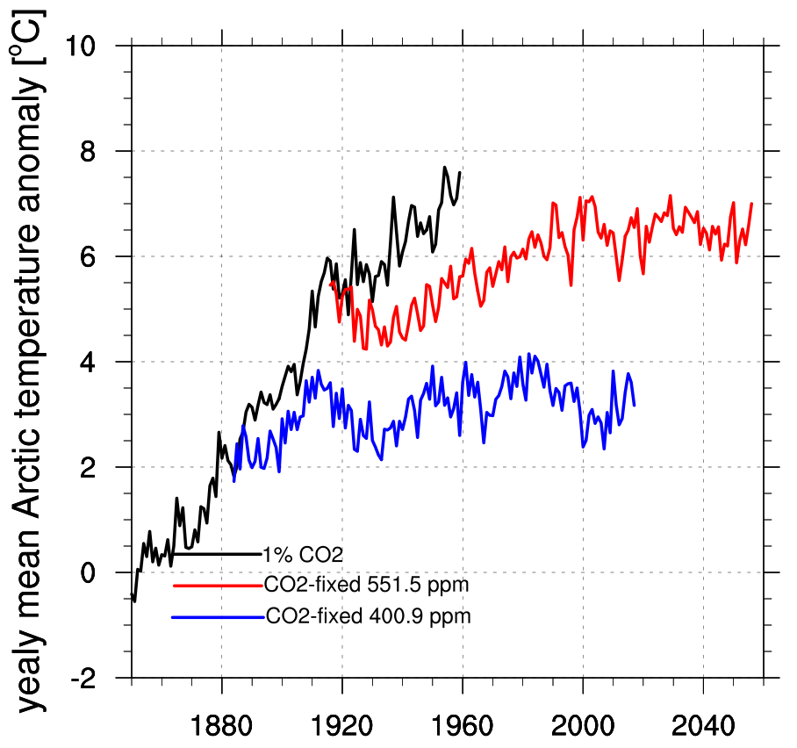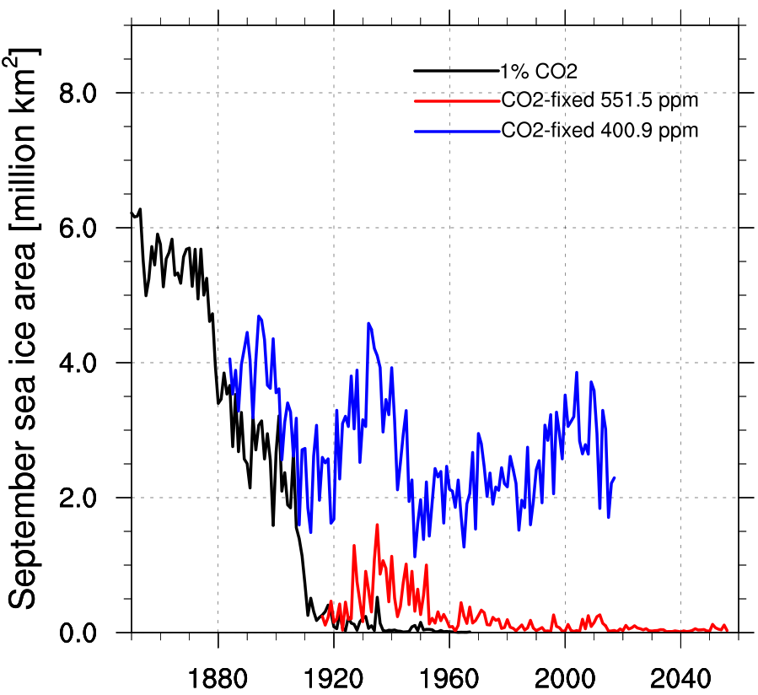
Fig. S1 Yearly mean global temperature anomaly, yearly mean Arctic temperature anomaly, and September sea ice area. Shown results are for the 1% CO2 experiment, the fixed CO2 at ~401, where Arctic warming of ~ 3.7°C is reached, as expected for the Last Interglacial, and the fixed CO2 at ~551 (from year 1917 of 1% CO2), where a global mean temperature of around 2°C is reached

