Country | Sea level rise across 22 years | Temperature rise across 22 years
India | 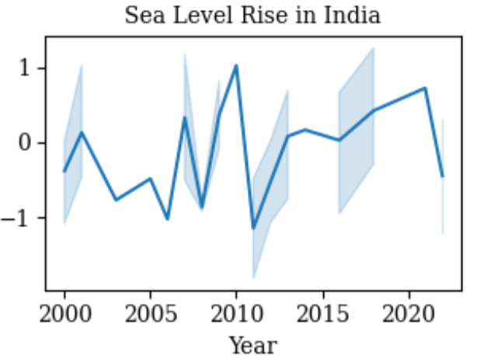 | 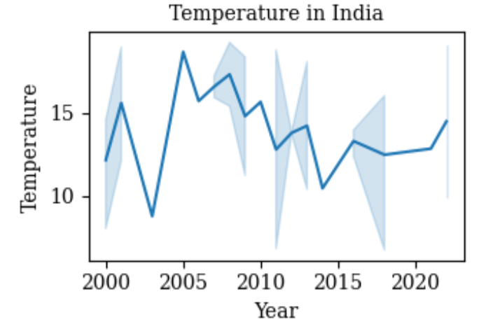
USA | 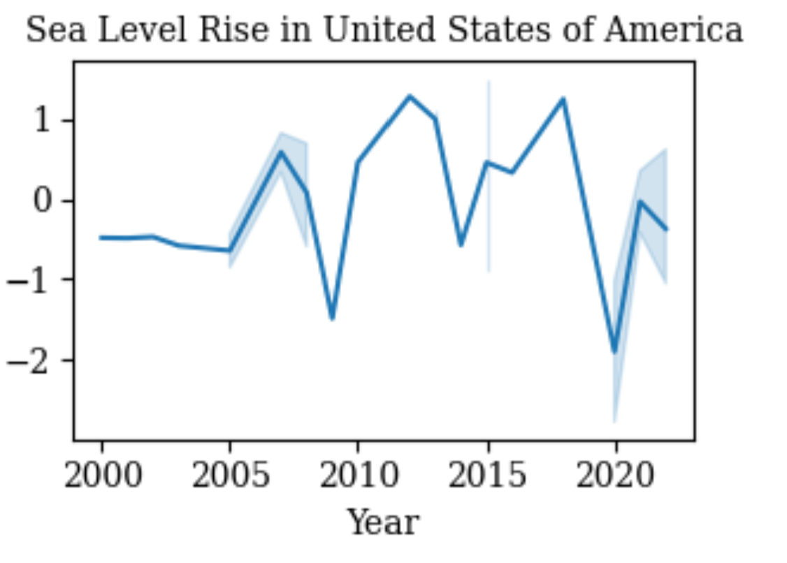 | 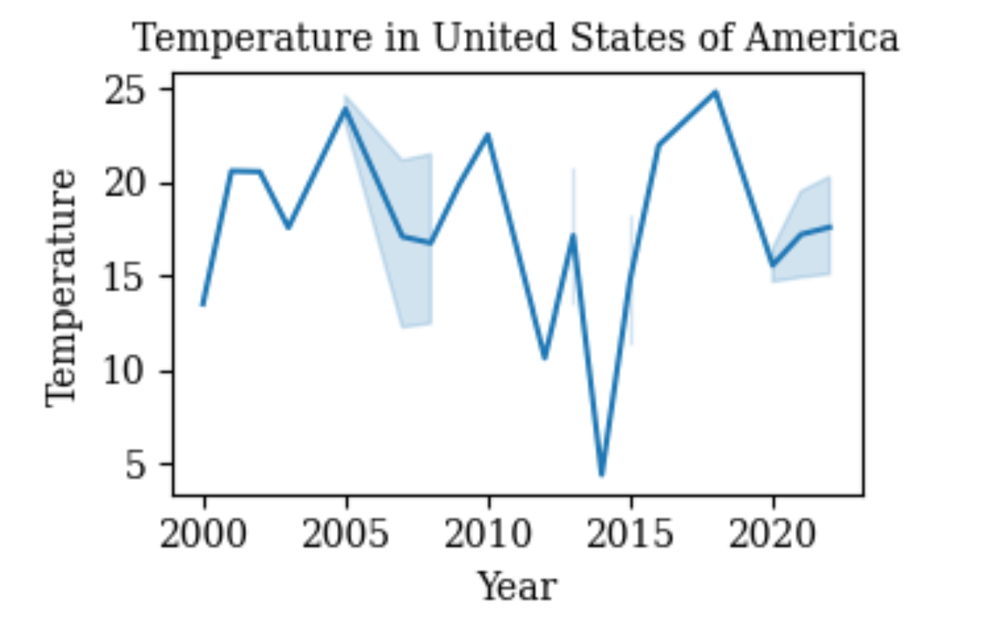
China | 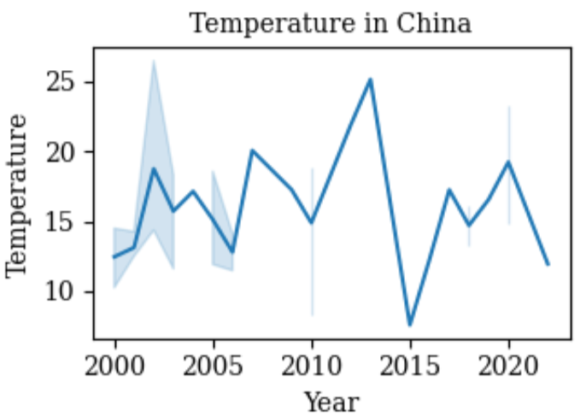 | 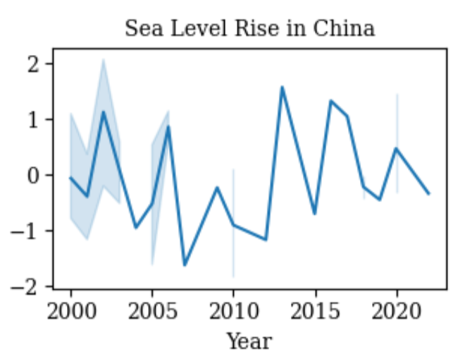
Russian Federation | 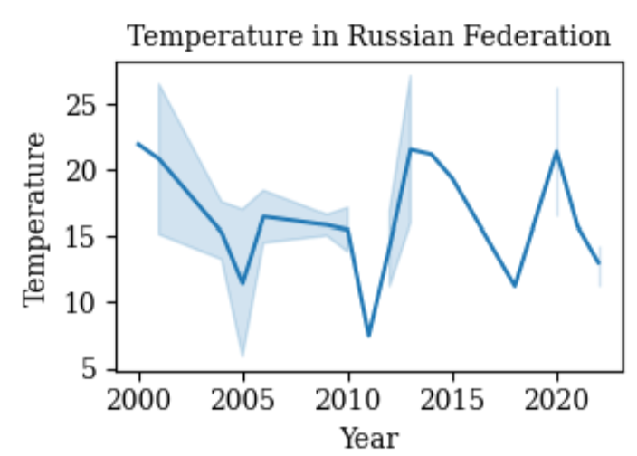 | 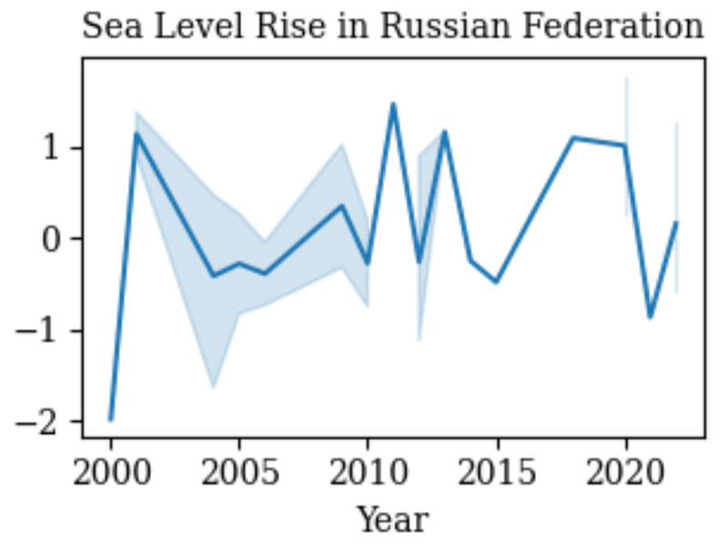
Japan | 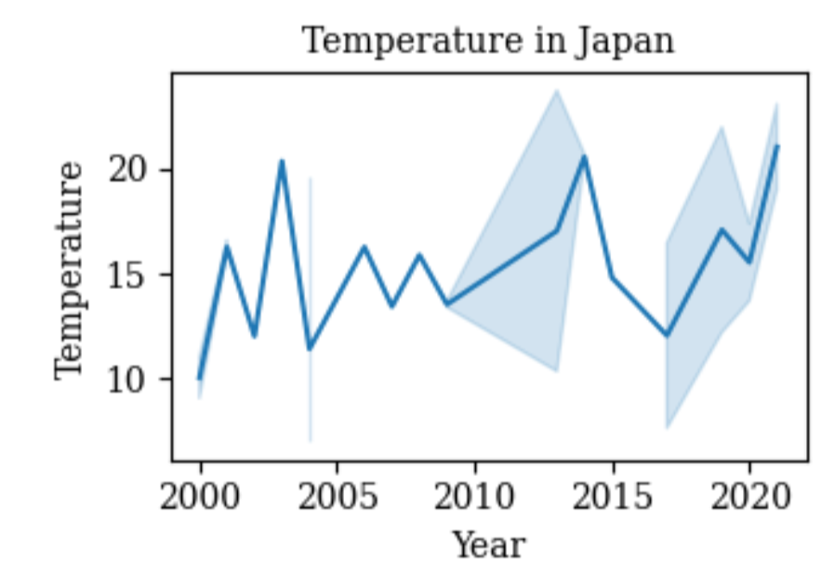 | 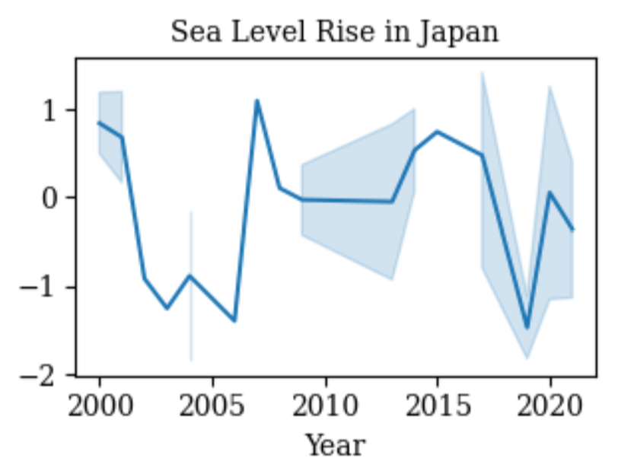

Table 3- Trends in temperature and sea-level rise across the five different countries tested in the exploratory data analysis.

Variable | Frequency curve
Temperature | 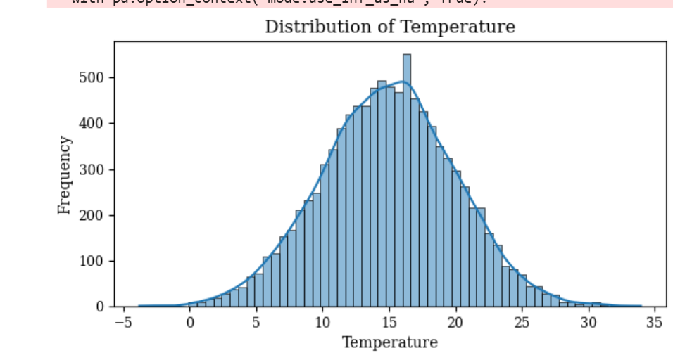
Sea Level Rise | 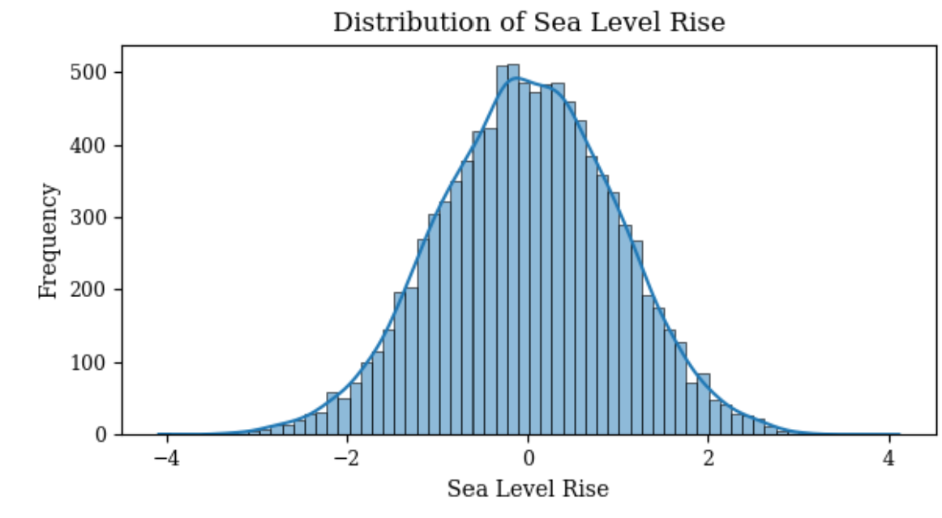
Wind Speed | 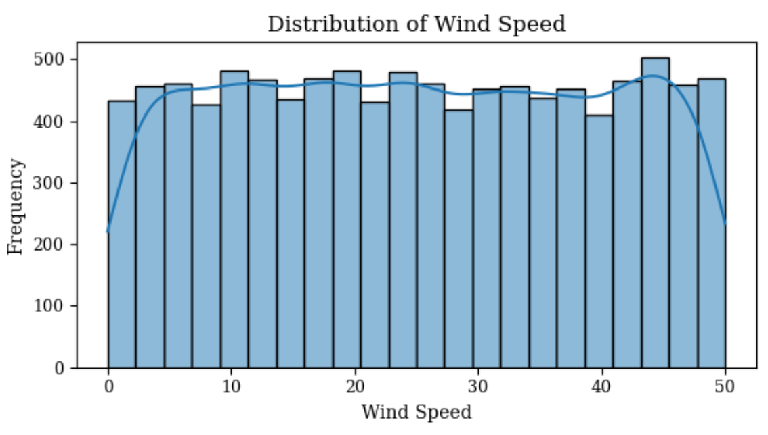
Humidity | 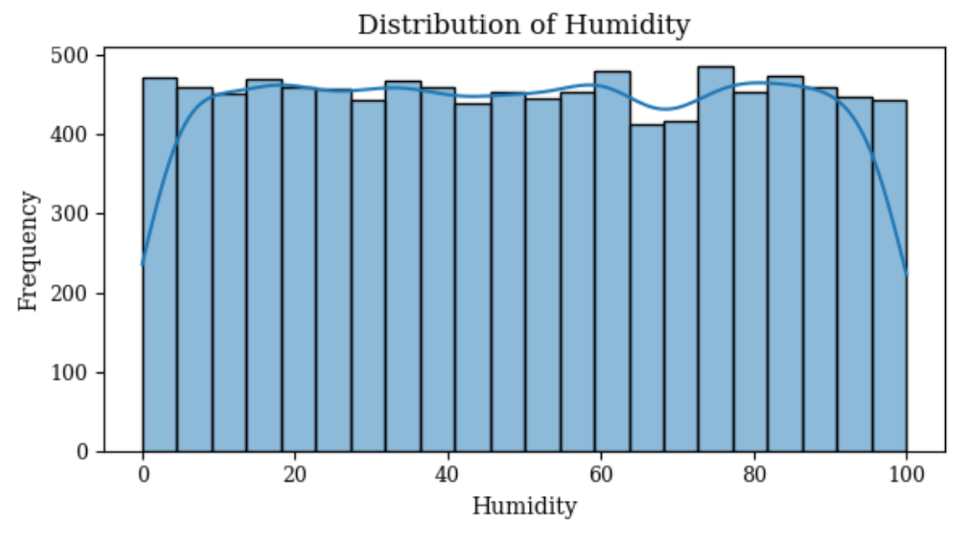
Precipitation | 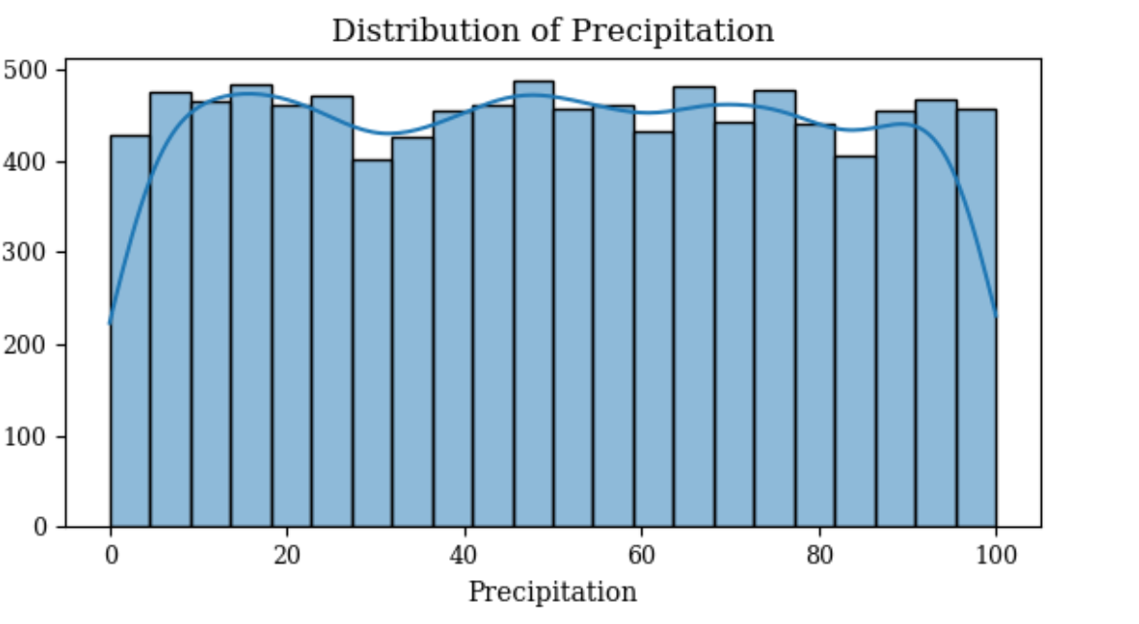
Co₂ emissions | 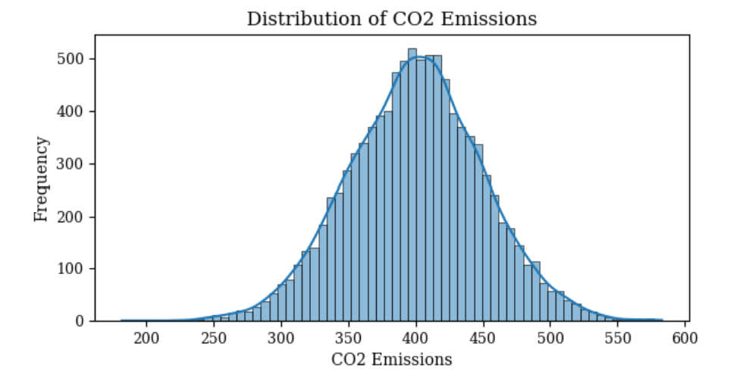

Table 4 displays the frequency curves of the variables used in testing: temperature, sea level rise, precipitation, humidity, wind speed, and Co₂ emissions.
Accuracy Test | Formula | Reference
RMSE | $$\begin{aligned}\sqrt{\frac{1}{n}\sum_{i=1}^{n}{(y_{i}-{\overset{^}{y}}_{i})^{2}}}\end{aligned}$$ | Hodson et al., (2022)
MAE | $$\left\{\frac{1}{n}\right\}\sum_{\left\{i=1\right\}}^{\left\{n\right\}}{\left|y_{i}-{y_{i}}^{^}\right|}$$ | Hodson et al., (2022)
MAPE | $$\frac{1}{N}\sum_{\left\{t=1\right\}}^{\left\{N\right\}}{\left|\frac{\left\{A_{t}-F_{t}\right\}}{\left\{A_{t}\right\}}\right|}$$ | Kim et al., (2016)
MSE | $$\left\{\frac{1}{m}\right\}\sum_{\left\{i=1\right\}}^{m}{{\left(X_{i}-Y_{i}\right)}^{2}}$$ | Chico et al., (2021)
MAPE | $$\frac{1}{m}\sum_{\left\{i=1\right\}}^{m}{\left|\frac{\left\{Y_{i}-X_{i}\right\}}{\left\{Y_{i}\right\}}\right|}$$ | Chico et al., (2021)
Table 6 - Displays the formulas of the various accuracy scores and the references

