Supplementary Materials(Figure S1-S6, Table S1)：

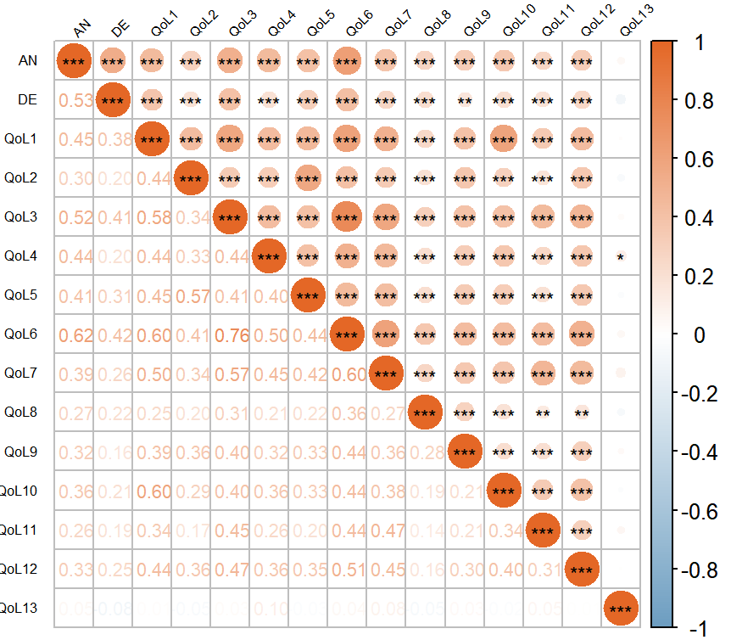
Figure S1: Zero-Order Correlation Matrix of Psychosomatic Symptoms
Note: AN = anxiety; DE = depression; QoL1 = neuro-muscular; QoL2 = voice; QoL3 = attention; QoL4 = sympathetic symptoms; QoL5 = throat/mouth problems; QoL6 = psychological distress; QoL7 = sensory symptoms; QoL8 = scar; QoL9 = feeling cold; QoL10 = tingling sensations; QoL11 = weight gain; QoL12 = headache; QoL13 = reduced sexual interest. * p < 0.05, ** p < 0.01, *** p < 0.001; red indicates positive correlations, blue denotes negative correlations.

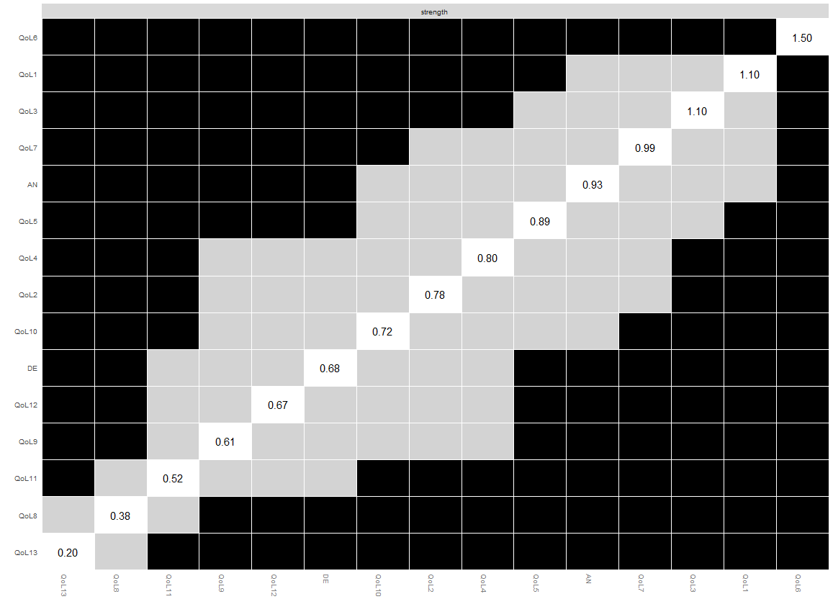
Figure S2: Differences in Strength Centrality
Nodes are displayed in row-column layout. Black boxes indicate statistically significant differences in edge weights (α = 0.05), while gray boxes denote non-significant differences.

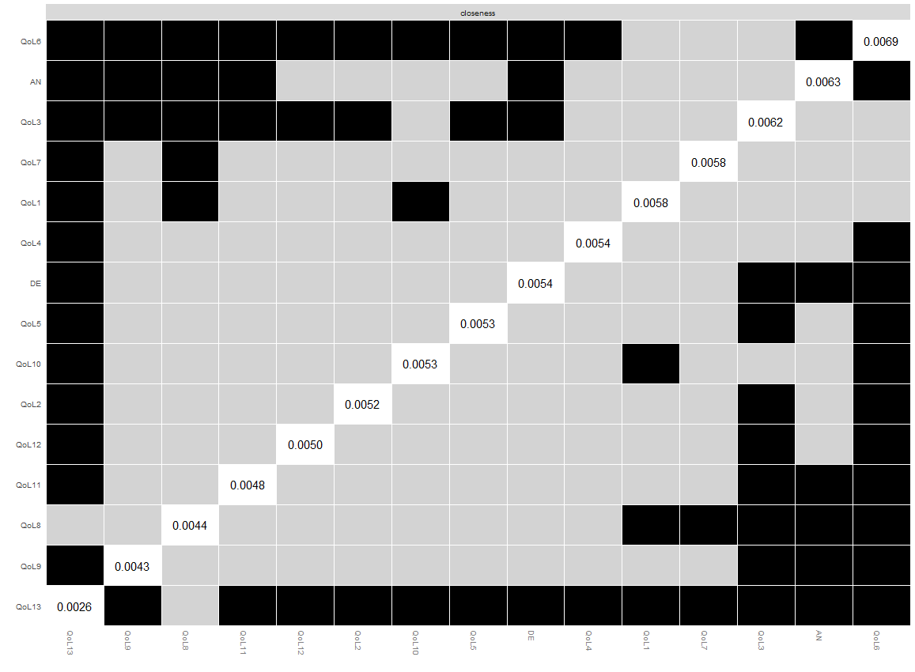
Figure S3: Differences in Closeness Centrality
Nodes are displayed in row-column layout. Black boxes indicate statistically significant differences in edge weights (α = 0.05), while gray boxes denote non-significant differences.

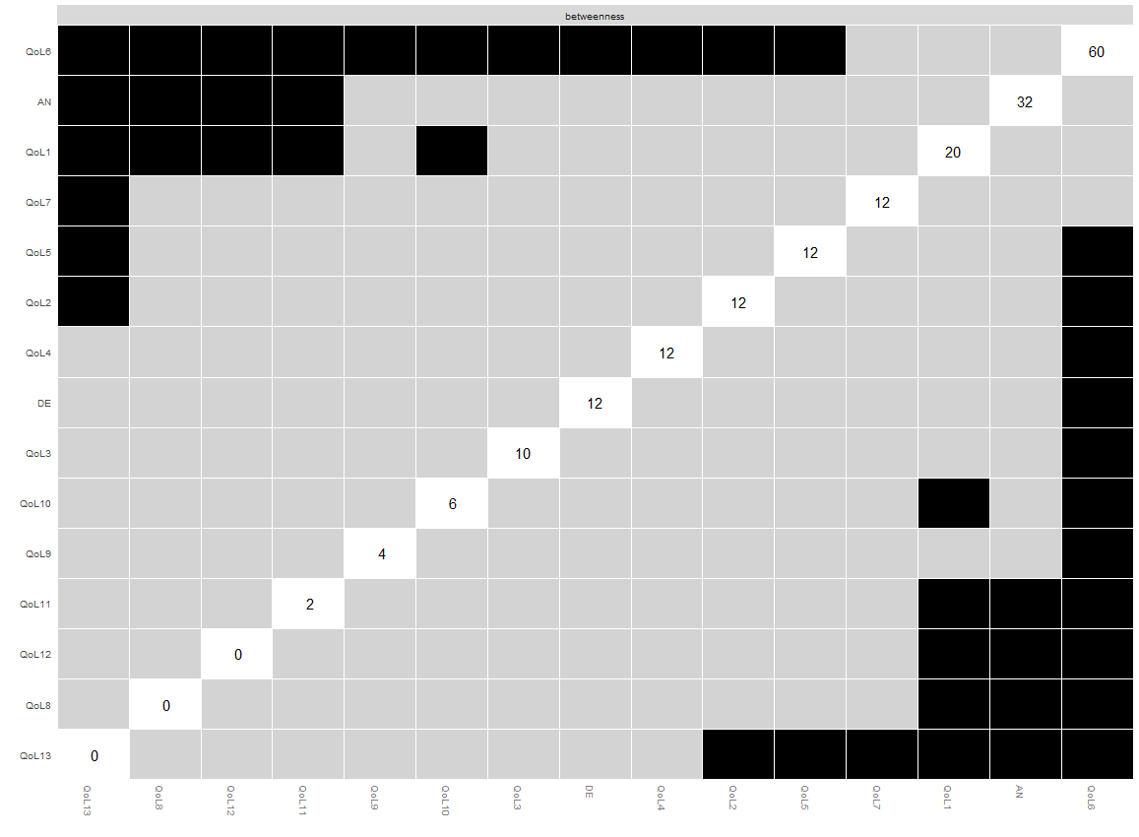
Figure S4: Differences in Betweenness Centrality
Nodes are displayed in row-column layout. Black boxes indicate statistically significant differences in edge weights (α = 0.05), while gray boxes denote non-significant differences.

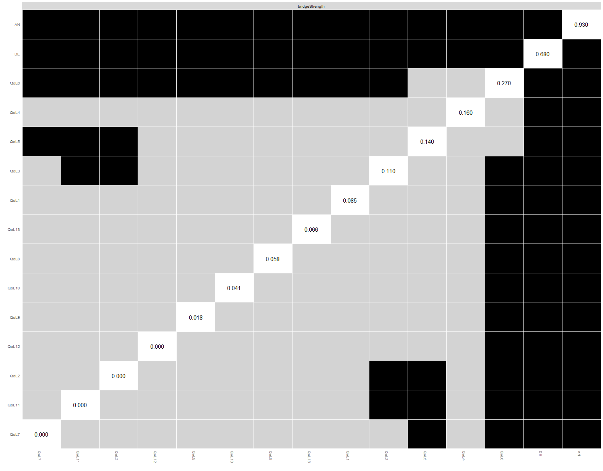
Figure S5: Differences in Bridge Strength Centrality
Nodes are displayed in row-column layout. Black boxes indicate statistically significant differences in edge weights (α = 0.05), while gray boxes denote non-significant differences.

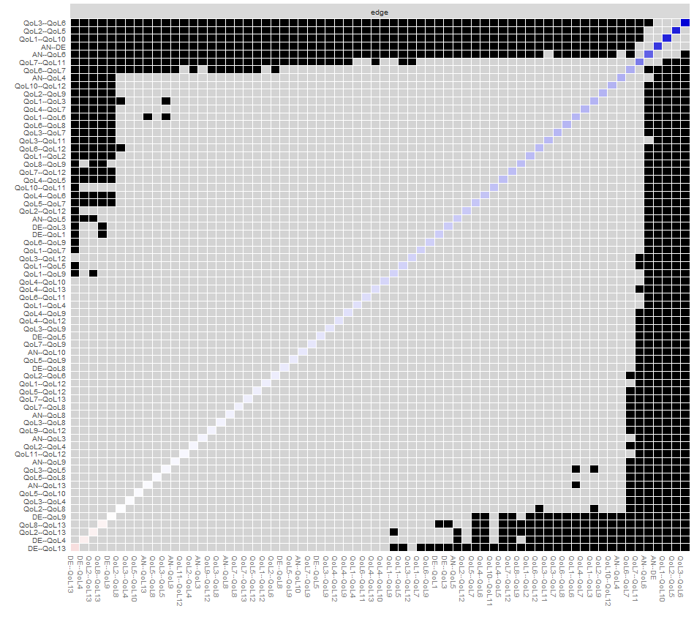
Figure S6: Differences in Edge Weights
Black boxes at row-column intersections indicate statistically significant differences in edge weights (p < 0.05), while gray boxes denote non-significant differences.

Table S1：Centrality Metrics for Psychosomatic Symptoms in postoperative DTC Patients
Variable | Strength (z-score) | Closeness(z-score) | Betweenness(z-score) | ExpectedInfluence(z-score)
AN | 0.45 | 1.07 | 1.23 | 0.50
DE | -0.36 | 0.17 | -0.06 | -0.71
QoL1 | 1.09 | 0.52 | 0.45 | 1.07
QoL2 | -0.03 | -0.09 | -0.06 | -0.06
QoL3 | 0.88 | 0.93 | -0.19 | 0.88
QoL4 | 0.04 | 0.19 | -0.06 | -0.02
QoL5 | 0.33 | 0.03 | -0.06 | 0.39
QoL6 | 2.15 | 1.64 | 3.02 | 2.01
QoL7 | 0.65 | 0.58 | -0.06 | 0.67
QoL8 | -1.31 | -0.85 | -0.83 | -1.18
QoL9 | -0.56 | -0.99 | -0.57 | -0.42
QoL10 | -0.21 | 0.02 | -0.45 | -0.09
QoL11 | -0.87 | -0.43 | -0.70 | -0.67
QoL12 | -0.39 | -0.20 | -0.83 | -0.24
QoL13 | -1.88 | -2.59 | -0.83 | -2.14
Note: AN = anxiety; DE = depression; QoL1 = neuro-muscular; QoL2 = voice; QoL3 = attention; QoL4 = sympathetic symptoms; QoL5 = throat/mouth problems; QoL6 = psychological distress; QoL7 = sensory symptoms; QoL8 = scar; QoL9 = feeling cold; QoL10 = tingling sensations; QoL11 = weight gain; QoL12 = headache; QoL13 = reduced sexual interest.

