Supplementary Figure 1. Regional expression pattern of AldoC compared to canonical astrocytic markers.
(A) Western blot analysis showing protein levels of AldoC, GFAP, and GLT-1 in the cortex, striatum, and hippocampus. β-tubulin was used as a loading control. (B) Quantification of protein expression levels normalized to β-tubulin (n = 4 per group). AldoC exhibited relatively uniform expression across regions, while GFAP and GLT-1 showed greater variability. Data are presented as mean ± SEM. (C) Representative low-magnification immunofluorescence image of a sagittal brain section stained with anti-AldoC antibody, showing broad expression throughout the brain. Insets (i–iii) correspond to magnified views of boxed regions in cortex, hippocampus, and cerebellum, respectively. Scale bars: main panel, 1000 μm; insets, 200 μm.

Supplementary Figure 2. Co-localization of GFP with AldoC and calbindin in the cerebellum of AldoC BAC-GFP transgenic mice.
(A) Low-magnification image showing GFP (green) and AldoC (red) expression in the cerebellum. (B) High-magnification images (boxed region in A) show strong colocalization of GFP and AldoC in cerebellar lobules, including Purkinje cell layers. Left to right: GFP channel, AldoC channel, merged image. Scale bars: A, 200 μm; B, 100 μm. (C) Low-magnification image showing GFP (green) and calbindin (red) expression in the cerebellum. (D) High-magnification images (boxed region in C) demonstrate colocalization of GFP and calbindin in Purkinje cells. Left to right: GFP channel, calbindin channel, merged image. Scale bars: C, 200 μm; D, 100 μm.

Supplementary Figure 3. Region-specific distribution and morphological diversity of GFP-positive astrocytes in AldoC BAC-GFP transgenic mice.
Representative fluorescence images showing GFP-expressing cells in various brain regions of AldoC BAC-GFP mice. Central sagittal brain overview highlights widespread GFP signal. Magnified views display region-specific astrocyte density and morphology in the cortex, corpus callosum, zona layer (zo) of the superior colliculus, olfactory bulb, hippocampal region, pons, and cerebellum. GFP-positive astrocytes exhibited radial morphologies in the cortex and olfactory bulb, while linear morphologies were more apparent in the cerebellum and pons. Astrocyte density was notably lower in white matter regions such as the corpus callosum. Scale bar: 50 μm.

Supplementary Figure 4. Co-localization of NG2 with astrocytic markers in the hippocampus.
(A) Representative immunofluorescence images showing co-staining of NG2 (green) and glutamine synthetase (GS, red) in the hippocampus. Merged image and enlarged view demonstrate partial overlap (arrowheads) between NG2-positive cells and GS. (B) Co-staining of NG2 (green) and GLT-1 (red) in the hippocampus. Merged image and enlarged region reveal co-localization (arrowheads), indicating potential expression of astrocytic markers in NG2-positive cells. Scale bars: 100 μm (left three panels), 50 μm (rightmost panels).

Supplementary Figure 5. Differential expression of astrocytic markers in the medial and lateral habenula.
(A–C) Representative immunofluorescence images showing DAPI (blue), GFP (green), and astrocytic markers (red) in the medial habenula (mHb) and lateral habenula (lHb) of AldoC BAC-GFP mice. (A) Co-localization of GFP with glutamine synthetase (GS). (B) Co-localization of GFP with S100β. (C) Co-localization of GFP with GLT-1. Right panels show merged images. Yellow dashed lines delineate the mHb and lHb regions. (D-F) Quantification graphs of marker expression normalized to the mHb signal. GS and GLT-1 expression were significantly higher in the lHb, while S100β was more enriched in the mHb.
Data are presented as mean ± SEM. Statistical significance was determined by unpaired t-test. P < 0.05; **P < 0.01; ***P < 0.001. Scale bars: 100 μm.

Supplementary fig. 1
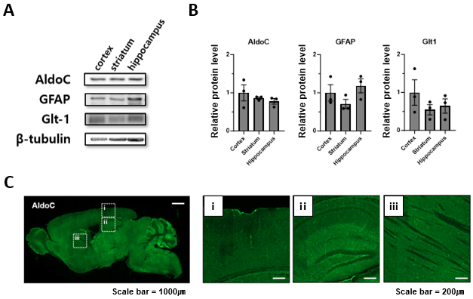

Supplementary fig. 2
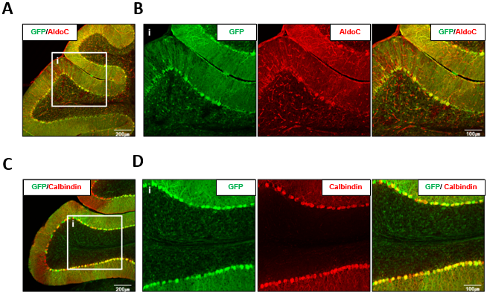

Supplementary fig. 3
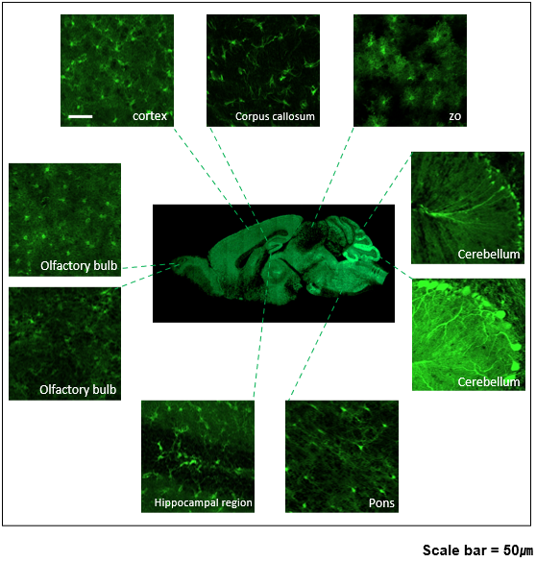

Supplementary fig. 4
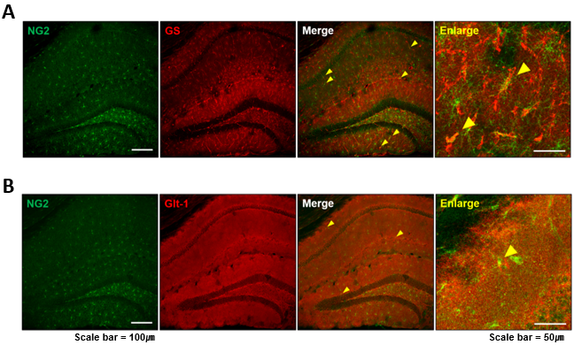

Supplementary fig. 5
