The Potential of Maillard Reaction Intermediates derived from Cysteine-Xylose Maillard Reaction System as Flavor Precursors: Starting from the Perspectives of Storage Stability, Antioxidant Characteristics and Flavor Formation Rules.
Di Kang§, Lin Jiang⊥, Songjin Zheng§, Haifeng Wang⊥, Teng Li⊥, Yuying Fu⊥, Yun Zhai⊥*
⊥ School of Food Science and Biotechnology, Zhejiang Gongshang University, Hangzhou, 310018, P. R. China.
§ China Tobacco Hebei Industrial Co., LTD, Shijiazhuang, 050051, P. R. China.
Author Information
* Corresponding Author: Yun Zhai, Ph.D., Associate Professor
Postal address: School of Food Science and Biotechnology, Zhejiang Gongshang University, Hangzhou, 310018, People’s Republic of China. E-mail: 18352538819@163.com.
Di Kang, Master.
Postal address: China Tobacco Hebei Industrial Co., LTD, Shijiazhuang, 050051, People’s Republic of China. E-mail: 1283201616@qq.com.
Lin Jiang, master.
Postal address: School of Food Science and Biotechnology, Zhejiang Gongshang University, Hangzhou, 310018, People’s Republic of China. E-mail: wangmumu542@163.com.
Songjin Zheng, Master.
Postal address: China Tobacco Hebei Industrial Co., LTD, Shijiazhuang, 050051, People’s Republic of China. E-mail: zsj211@126.com.
Haifeng Wang, Ph.D.
Postal address: School of Food Science and Biotechnology, Zhejiang Gongshang University, Hangzhou, 310018, People’s Republic of China. E-mail: whf4341514@163.com.
Teng Li, PhD, Associate Professor
Postal address: School of Food Science and Biotechnology, Zhejiang Gongshang University, Hangzhou, 310018, People’s Republic of China. E-mail: tli0718@mail.zjgsu.edu.cn.
Yuying Fu, Ph.D., Professor.
Postal address: School of Food Science and Biotechnology, Zhejiang Gongshang University, Hangzhou, 310018, People’s Republic of China. E-mail: webfu@126.com.

Supplementary data
Below are the supplementary data for the derivative fragmentation in the LC-MS/MS spectrum and ¹³C NMR data of TTCA; The water activity corresponding to each saturated salt solution at 25°C; Calibration curves of volatile compounds; Volatile flavor compounds (μg/L) identified in the TTCA model reactions under elevated temperatures of 100, 120 and 140 ℃ at an initial pH value of 7.0; Volatile flavor compounds (μg/L) identified in the TTCA model reactions under different pH values of 5.5, 7 and 8 at the temperature of 120 ℃; The high performance liquid chromatogram of TTCA/ARP compounds and the total ions chromatogram (a)/LC-MS/MS spectra (b) of purified TTCA; The release of Cys during the degradation of TTCA; The depletion of Cys compound at an initial pH of 7 under different temperatures (100, 120 and 140 ℃).

Table S1. Derivative fragmentation in the LC-MS/MS spectrum and ¹³C NMR data of TTCA
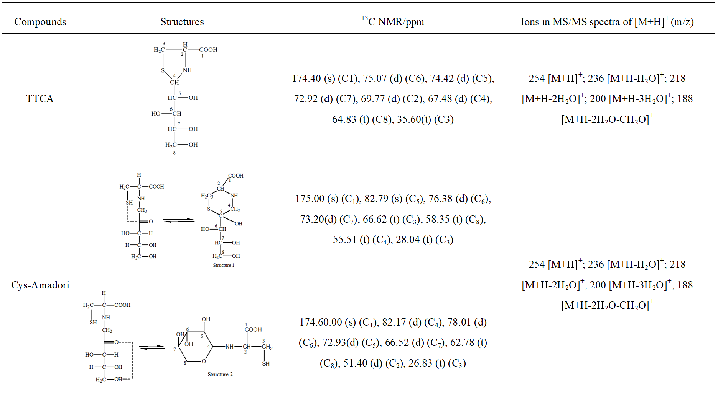

Table S2. Water activity corresponding to each saturated salt solution at 25°C.
saline | a_{w}
saline | 25°C
lithium chloride | 0.113 ± 0.003
potassium carbonate | 0.432 ± 0.004
dicalcium phosphate | 0.843 ± 0.003

Table S3. The calibration curves of volatile flavor compounds
Volatile flavor compounds | Calibration curves | R²
Thiophene | y = 0.0223 x + 0.0011 | 0.9991
2-Methylthiophene | y = 0.0472 x + 0.0009 | 0.9994
Thiazole | y = 0.0601 x ₋ 0.0012 | 0.9982
2-Methylthiazole | y = 0.0084 x ₋ 0.0521 | 0.9923
3-Mercapto-2-butanone | y = 0.1216 x ₋ 0.0007 | 0.9999
2,5-Dimethyl-thiazole | y = 0.0637 x + 0.0012 | 0.9979
2-Methyl-3-furanthiol | y = 0.0039 x + 0.0011 | 0.9989
2-Ethyl-thiazole | y = 0.0629x + 0.0041 | 0.9994
3-Mercapto-2-pentanone | y = 0.0379 x + 0.0131 | 0.9997
2,4,5-Trimethylthiazole | y = 0.0571 x ₋ 0.0007 | 0.9994
4,5-Dimethyl-thiazole | y = 0.0297 x ₋ 0.0042 | 0.9969
2-Furfurylthiol | y = 0.0287 x ₋ 0.0003 | 0.9992
5-Ethyl-2,4-dimethyl-thiazole | y = 0.0184 x + 0.0008 | 0.9981
2-Ethyl-4-methyl-thiazole | y = 0.0430 x + 0.0024 | 0.9923
3-Thiophenethiol | y = 0.0285 x + 0.0033 | 0.9954
2-Acetylthiazole | y = 0.0364 x ₋ 0.0014 | 0.9967
2-Thiophenecarboxaldehyde | y = 0.0446 x + 0.0009 | 0.9998
5-Methyl-2-thiophenecarboxaldehyde | y = 0.0296 x ₋ 0.0007 | 0.9999
2-Thiophenemethanethiol | y = 0.0517 x + 0.0012 | 0.9954
1-(3-Thienyl)-ethanone | y = 0.0728 x ₋ 0.00012 | 0.9981
2,5-Thiophenedicarboxaldehyde | y = 0.0423 x ₋ 0.0031 | 0.9997
Methylpyrazine | y = 0.0398 x + 0.0012 | 0.9949
Pyrazine | y = 0.0294 x + 0.0012 | 0.9989
3-Methyl-pyridine | y = 0.0563 x + 0.0032 | 0.9998
2,5-Dimethyl-pyrazine | y = 0.0319 x + 0.0013 | 0.9978
Furan | y = 0.0253 x ₋ 0.0012 | 0.9968
2-Methyl-furan | y = 0.0336 x + 0.0021 | 0.9997
Furfural | y = 0.0347 x ₋ 0.0012 | 0.9923
1-(2-Furanyl)-ethanone | y = 0.0629 x + 0.0024 | 0.9948
2(5H)-Furanone | y = 0.0598 x ₋ 0.0011 | 0.9993
4-Hydroxy-5-methyl-3(2H)-furanone | y = 0.0098 x + 0.0002 | 0.9971

Table S4. Volatile flavor compounds (μg/L) identified in the TTCA model reactions under elevated temperatures of 100, 120 and 140 ℃ at an initial pH value of 7.0.
Compounds | RIª | RI^{b} | Concentration (μg/L) |  |  | ID^{c}
Compounds | RIª | RI^{b} | 100℃ | 120℃ | 140℃ | ID^{c}
Sulfur-containing compounds
Thiophene | 1016 | 1022 | 0.000 | 0.000 | 0.118±0.072 | RI, MS
2-Methylthiophene | 1135 | 1095 | 0.000 | 0.000 | 0.892±0.115 | RI, MS
Thiazole | 1240 | 1262 | 0.896±0.053c | 1.796±0.12b | 2.038±0.139a | RI, MS
2-Methylthiazole | 1272 | 1278 | 0.142±0.008bc | 0.194±0.014b | 0.254±0.109a | RI, MS
3-Mercapto-2-butanone | 1273 | 1283 | 1.303±0.153bc | 1.798±0.127b | 2.398±0.141a | RI, MS
2,5-Dimethyl-thiazole | 1301 | 1326 | 0.079±0.013c | 2.203±0.142b | 2.553±0.096a | RI, MS
2-Methyl-3-furanthiol | 1302 | 1305 | 1.237±0.142bc | 1.388±0.256b | 5.907±0.085a | RI, MS
2-Ethyl-thiazole | 1319 | 1304 | 0.245±0.035b | 0.273±0.006ab | 0.289±0.025a | RI, MS
3-Mercapto-2-pentanone | 1352 | 1343 | 0.973±0.099c | 1.298±0.253b | 1.736±0.234a | RI, MS
2,4,5-Trimethylthiazole | 1373 | 1390 | 0.419±0.052c | 3.199±0.075b | 3.843±0.188a | RI, MS
2-Furfurylthiol | 1426 | 1402 | 3.734±0.085c | 4.107±0.137b | 11.439±0.265a | RI, MS
5-Ethyl-2,4-dimethyl-thiazole | 1437 | - | 0.000 | 0.587±0.078b | 0.889±0.085a | RI, MS
2-Ethyl-4-methyl-thiazole | 1449 | 1410 | 0.117±0.005c | 1.278±0.117b | 2.112±0.370a | RI, MS
3-Thiophenethiol | 1564 | 1530 | 0.000 | 0.178±0.027b | 0.268±0.062a | RI, MS
2-Acetylthiazole | 1646 | 1643 | 3.079±0.215c | 8.795±0.094b | 9.858±1.215a | RI, MS
2-Thiophenecarboxaldehyde | 1674 | 1679 | 0.09±0.013c | 2.196±0.25b | 2.28±0.144a | RI, MS
5-Methyl-2-thiophenecarboxaldehyde | 1701 | 1785 | 0.936±0.06c | 3.649±0.099b | 5.706±0.644a | RI, MS
2-Thiophenemethanethiol | 1702 | 1713 | 0.119±0.074c | 0.196±0.015b | 0.332±0.21a | RI, MS
2-Methyl-3-[(2-methyl-3-thienyl)dithio)furan | 1732 | - | 0.021±0.004c | 0.098±0.033b | 0.137±0.036a | RI, MS
1,2,3-Trithiolane | 1794 | - | 0.208±0.029c | 0.378±0.071b | 0.497±0.185a | RI, MS
3,3'-Dithiobisthiophene | 1845 | - | 0.000 | 0.000 | 0.000 | RI, MS
Thieno[3,2-b]thiophene | 1868 | 1843 | 0.000 | 1.302±0.079b | 3.369±0.454a | RI, MS
2,5-Thiophenedicarboxaldehyde | 1911 | - | 0.346±0.039c | 0.724±0.139b | 1.283±0.122a | RI, MS
2-Methylthieno[2,3-b] thiophene | 1947 | - | 0.000 | 0.19±0.03b | 2.123±0.221a | RI, MS
Bis(2-furfuryl)sulfide | 2419 | - | 0.034±0.007bc | 0.042±0.004b | 0.078±0.018a | RI, MS
Subtotal |  |  | 13.978±0.568c | 35.866±1.382b | 60.400±1.620a
Nitrogen-containing heterocycles
Methylpyrazine | 1214 | 1263 | 0.000 | 0.000 | 0.000 | RI, MS
Pyrazine | 1216 | 1209 | 0.000 | 0.000 | 0.000 | RI, MS
3-Methyl-pyridine | 1307 | 1346 | 0.000 | 0.000 | 0.000 | RI, MS
2,5-Dimethyl-pyrazine | 1320 | 1328 | 0.000 | 0.000 | 0.000 | RI, MS
Subtotal |  |  | 0.000 | 0.000 | 0.000
Oxygen-containing heterocycles
Furan | 797 | 798 | 0.000 | 0.138±0.017a | 1.108±0.092b | RI, MS
2-Methyl-furan | 851 | 829 | 0.000 | 0.019±0.007b | 0.133±0.088a | RI, MS
Furfural | 1457 | 1460 | 3.381±0.089c | 5.793±0.422b | 11.039±0.302a | RI, MS
1-(2-Furanyl)-ethanone | 1497 | 1501 | 0.000 | 0.136±0.017b | 0.379±0.087a | RI, MS
2(5H)-Furanone | 1748 | 1767 | 0.000 | 0.072±0.012b | 0.098±0.015a | RI, MS
Subtotal |  |  | 3.381±0.089c | 6.158±0.425b | 12.757±0.469a | RI, MS
Total |  |  | 17.359±0.527c | 42.024±1.737b | 73.157±1.557a | RI, MS
Notes: Results were presented as means ± standard deviation, data within a row with different letters are significantly different (p < 0.05) using Duncan’s multiple comparison test (n = 3).
a: Linear retention indices calculated using a series of n-alkanes on the DB-W AX column (30 m × 0.25 mm× 0.25 μm).
b: Linear retention indices searched from http:// www.flavornet.org and http://webbook.nist.gov/chemistry/.
c: ID: Identification methods.
d: “-”, not detected.

Table S5. Volatile flavor compounds (μg/L) identified in the TTCA model reactions under different pH values of 5.5, 7 and 8 at the temperature of 120 ℃.
Compounds | RIª | Ri^{b} | Concentration (μg/L) |  |  | ID^{c}
Compounds | RIª | Ri^{b} | pH 5.5 | pH 7 | pH8 | ID^{c}
Sulfur-containing compounds
Thiols/Sulfides
3-Mercapto-2-butanone | 1273 | 1283 | 1.796±0.152a | 1.303±0.006b | 0.973±0.077c | RI, MS
2-Methyl-3-furanthiol | 1302 | 1305 | 1.936±0.065a | 1.237±0.061b | 1.103±0.008c | RI, MS
3-Mercapto-2-pentanone | 1352 | 1343 | 1.793±0.036a | 0.973±0.025c | 1.332±0.176b | RI, MS
2-Furfurylthiol | 1426 | 1402 | 5.639±0.095a | 3.734±0.074b | 3.012±0.097c | RI, MS
3-Thiophenethiol | 1564 | 1530 | 0.000 | 0.000 | 0.079±0.004a | RI, MS
2-Methyl-3-[(2-methyl-3-thienyl)dithio)furan | 1732 | - | 0.179±0.014a | 0.021±0.004b | 0.000 | MS
2-Thiophenemethanethiol | 1947 | - | 0.211±0.007a | 0.119±0.016b | 0.034±0.004c | MS
Bis(2-furfuryl)sulfide | 2419 | - | 0.057±0.007a | 0.034±0.012b | 0.000 | MS
Subtotal |  |  | 11.611±0.123a | 7.421±0.146b | 6.533±0.143c
Thiophenes
Thiophene | 1016 | 1022 | 0.000 | 0.000 | 0.179±0.008a | RI, MS
2,3-Dihydro-5-methyl-thiophene | 1133 | 1156 | 0.000 | 0.000 | 0.000 | RI, MS
2-Methylthiophene | 1135 | 1095 | 0.028±0.004a | 0.000 | 0.000 | RI, MS
2,5-Dimethyl-thiophene | 1144 | 1190 | 0.000 | 0.000 | 0.193±0.014a | RI, MS
Dihydro-2-methyl-3(2H)-thiophenone | 1497 | 1506 | 0.000 | 0.000 | 0.079±0.007a | RI, MS
Dihydro-3-(2H)-thiophenone | 1542 | 1563 | 0.000 | 0.000 | 0.087±0.023a | RI, MS
2-Thiophenecarboxaldehyde | 1674 | 1679 | 0.221±0.005a | 0.09±0.007b | 0.012±0.004c | RI, MS
Thieno[3,2-b]thiophene | 1868 | 1843 | 0.000 | 0.000 | 0.196±0.011a | RI, MS
5-Methyl-2-thiophenecarboxaldehyde | 1701 | 1785 | 0.837±0.01b | 0.936±0.043a | 0.423±0.016c | RI, MS
2-Acetyl-3-methylthiophene | 1757 | - | 0.000 | 0.000 | 0.000 | MS
3,3'-Dithiobisthiophene | 1845 | - | 0.000 | 0.000 | 0.000 | MS
2,5-Thiophenedicarboxaldehyde | 1911 | - | 0.336±0.023a | 0.346±0.027a | 0.329±0.011a | MS
2-Methylthieno[2,3-b] thiophene | 1947 | - | 0.000 | 0.000 | 0.189±0.02a | RI,
2,3'-Bithiophene | 2194 | - | 0.000 | 0.000 | 0.023±0.007a | MS
Subtotal |  |  | 1.422±0.039b | 1.372±0.068b | 1.71±0.025a
Thiazoles
Thiazole | 1240 | 1262 | 0.334±0.012c | 0.896±0.012b | 2.137±0.054a | RI, MS
2-Methylthiazole | 1272 | 1278 | 0.023±0.004b | 0.142±0.007b | 1.779±0.113a | RI, MS
2,5-Dimethyl-thiazole | 1301 | 1326 | 0.000 | 0.079±0.015b | 0.127±0.008a | RI, MS
2,4,5-Trimethylthiazole | 1373 | 1390 | 0.112±0.067c | 0.419±0.074b | 1.192±0.021a | RI, MS
2-Ethyl-thiazole | 1319 | 1304 | 0.000 | 0.245±0.012b | 0.283±0.018a | RI, MS
2-Ethyl-4-methyl-thiazole | 1449 | 1410 | 0.000 | 0.117±0.01b | 0.217±0.007a | RI, MS
2-Acetylthiazole | 1646 | 1643 | 0.238±0.008c | 3.079±0.075b | 5.179±0.085a | RI, MS
Subtotal |  |  | 0.707±0.07c | 4.977±0.175b | 10.914±0.226a
Other sulfur-containing compounds
1,2,3-Trithiolane | 1794 | - | 1.128±0.01c | 0.208±0.009b | 0.000 | MS
Nitrogen-containing heterocycles
Pyrazine | 1210 | 1209 | 0.000 | 0.000 | 0.129±0.007a | RI, MS
Methylpyrazine | 1214 | 1263 | 0.000 | 0.000 | 0.271±0.016a | RI, MS
3-Methyl-pyridine | 1307 | 1346 | 0.000 | 0.000 | 0.037±0.013a | RI, MS
2,5-Dimethyl-pyrazine | 1320 | 1328 | 0.000 | 0.000 | 0.438±0.033a | RI, MS
Pyrrole | 1497 | 1507 | 0.000 | 0.000 | 0.021±0.002a | RI, MS
Subtotal |  |  | 0.000 | 0.000 | 0.896±0.032a
Oxygen-containing heterocycles
Furan | 797 | 798 | 0.796±0.115a | 0.000 | 0.000 | RI, MS
2-Melthy-furan | 851 | 829 | 0.273±0.045a | 0.000 | 0.000 | RI, MS
Furfural | 1457 | 1460 | 4.238±0.32a | 3.381±0.34b | 1.128±0.147c | RI, MS
Benzofuran | 1493 | - | 0.000 | 0.000 | 0.000 | MS
4-Hydroxy-5-methyl-3(2H)-furanone | 2108 | 2124 | 0.000 | 0.000 | 0.000 | RI, MS
Subtotal |  |  | 5.307±0.459a | 3.381±0.34b | 1.128±0.147c
Total content of sulfur-containing compounds |  |  | 14.868±0.096b | 13.978±0.081c | 19.157±0.353a
Total |  |  | 20.175±0.504a | 17.359±0.421b | 21.181±0.334a
Notes: Results were presented as means ± standard deviation, data within a row with different letters are significantly different (p < 0.05) using Duncan’s multiple comparison test (n = 3).
a: Linear retention indices calculated using a series of n-alkanes on the DB-W AX column (30 m × 0.25 mm× 0.25 μm).
b: Linear retention indices searched from http:// www.flavornet.org and http://webbook.nist.gov/chemistry/.
c: ID: Identification methods.
d: “-”, not detected.

Figure Captions
Figure S1. The high performance liquid chromatogram of TTCA/ARP compounds.
Figure S2. The total ions chromatogram (a)/LC-MS/MS spectra (b) of purified TTCA
Figure S3. The release of Cys during the degradation of TTCA.
Figure S4. Depletion of Cys compound at an initial pH of 7 under different temperatures (100, 120 and 140 ℃).

Fig. S1
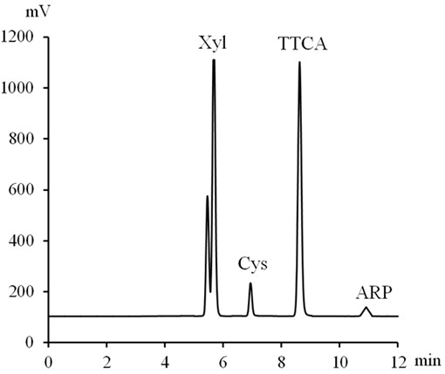

Fig. S2
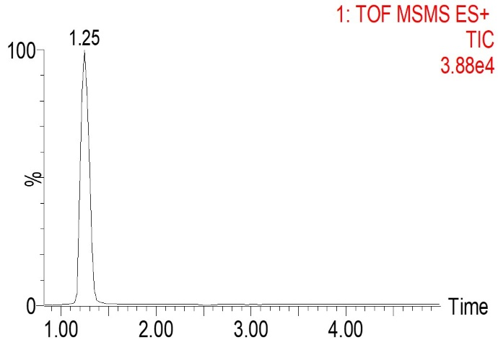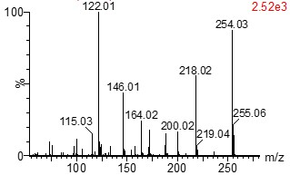
- (b)

Fig. S3
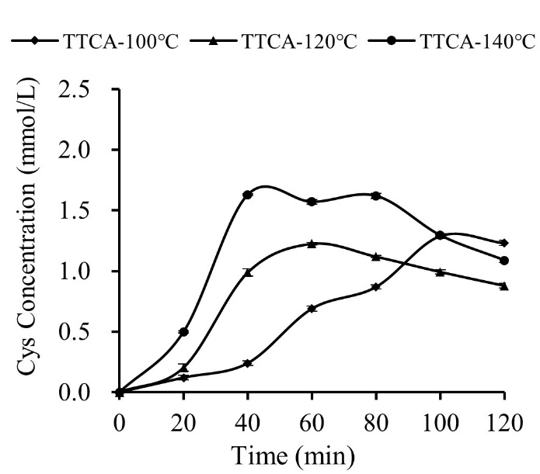

Fig. S4
