Appendices
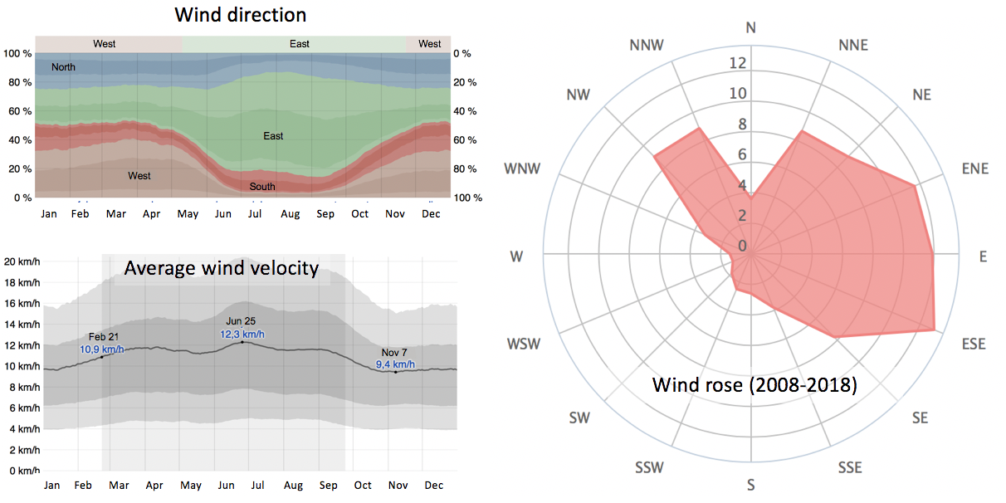Figure A1. Wheater conditions in the dry and semi-arid Torreón city: annual variation of the a) temperature, b) humid comfort level, c) daily rain probability, d) month average rain precipitation, and e) clouds category.
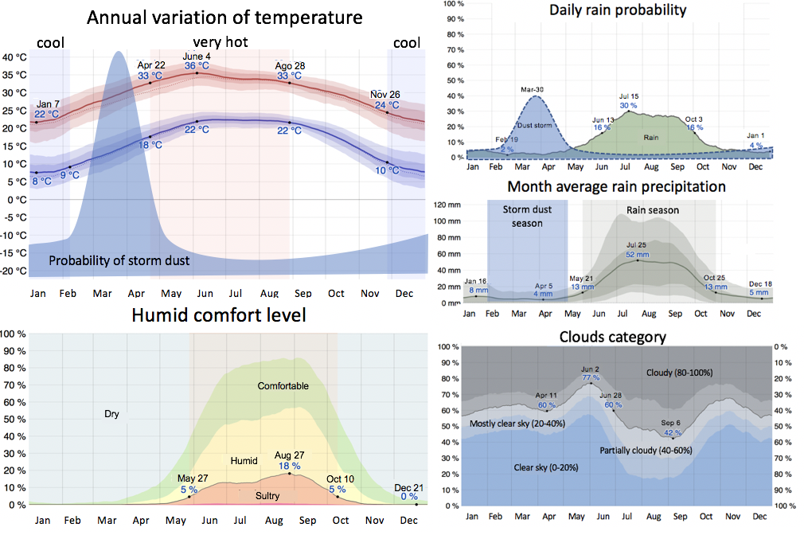
Figure A2. Wind conditions in Torreón city: a) direction, b) average velocity, and c) wind rose (2008–2018).
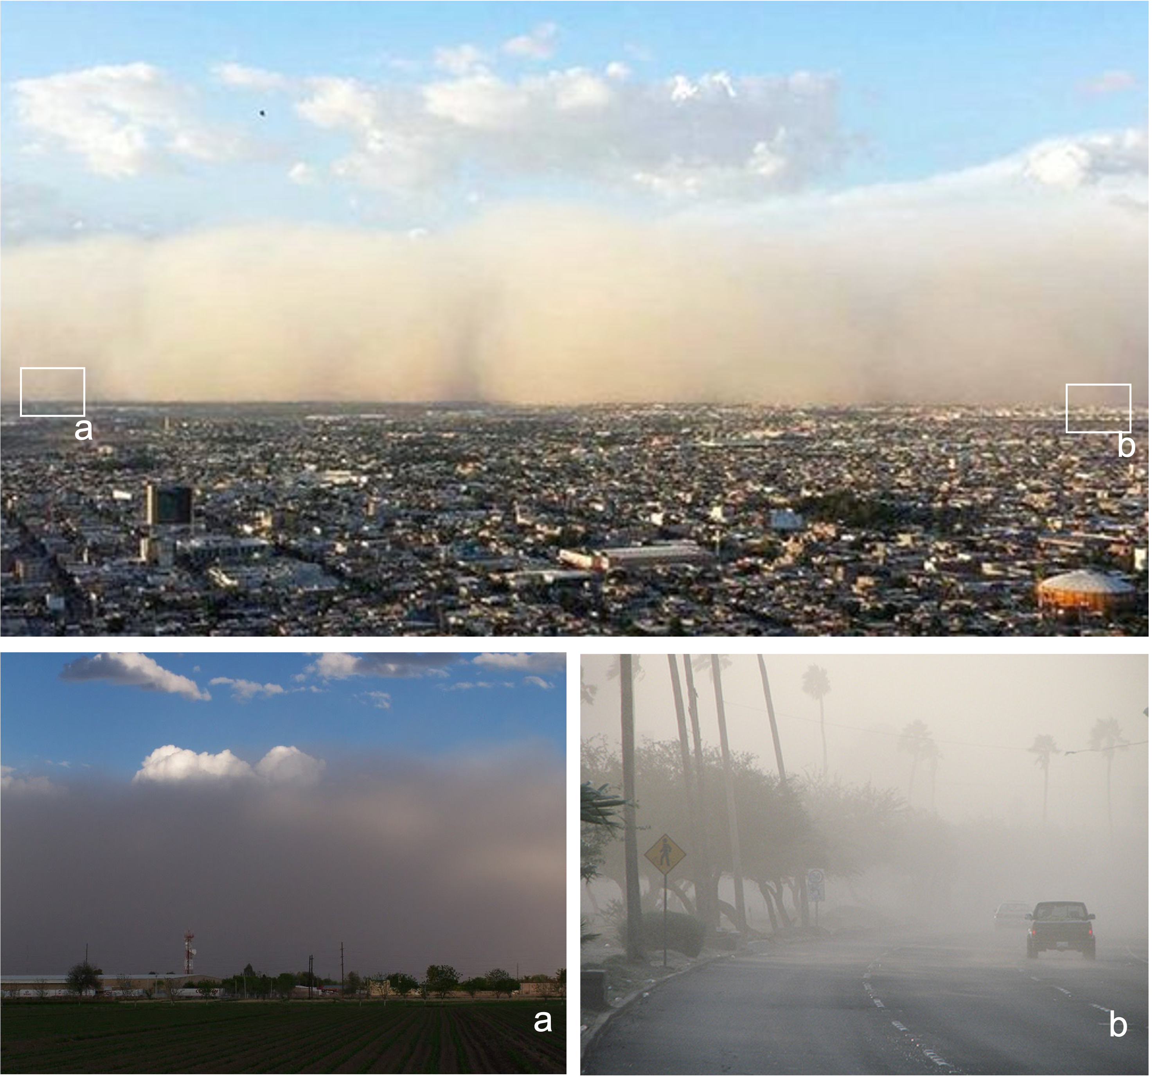Figure A3. Photographs of a dust storm (tolvanera) in Torreón, Mexico (2017).

