APPENDICES

APPENDIX 1 – MYMOP2 Primary Outcome Measure

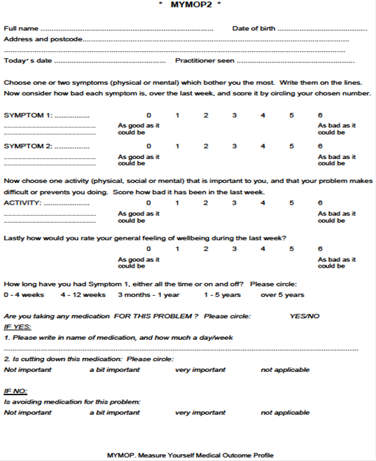

APPENDIX 2 – ACUFOCIN TRIAL DESIGN

