Table. Pulse rate variability (PRV) in beef calves cast under three analgesic protocols in tropical Colombia.
Treatment | Description | n | Median (Q1–Q3) in bpm
T1 | Spermatic cord block with lidocaine (10 mL, 2% per cord) + tolfenamic acid (4 mg/kg IM, preop) | 196 | 59 (49.75–71)
T2 | Low epidural anesthesia with lidocaine (4 mL, 2%) + tolfenamic acid (4 mg/kg IM, preop) | 196 | 60 (49–86)
T3 | Tolfenamic acid only (4 mg/kg IM, preop) | 196 | 61 (56–69)
bpm = Beats per minute.

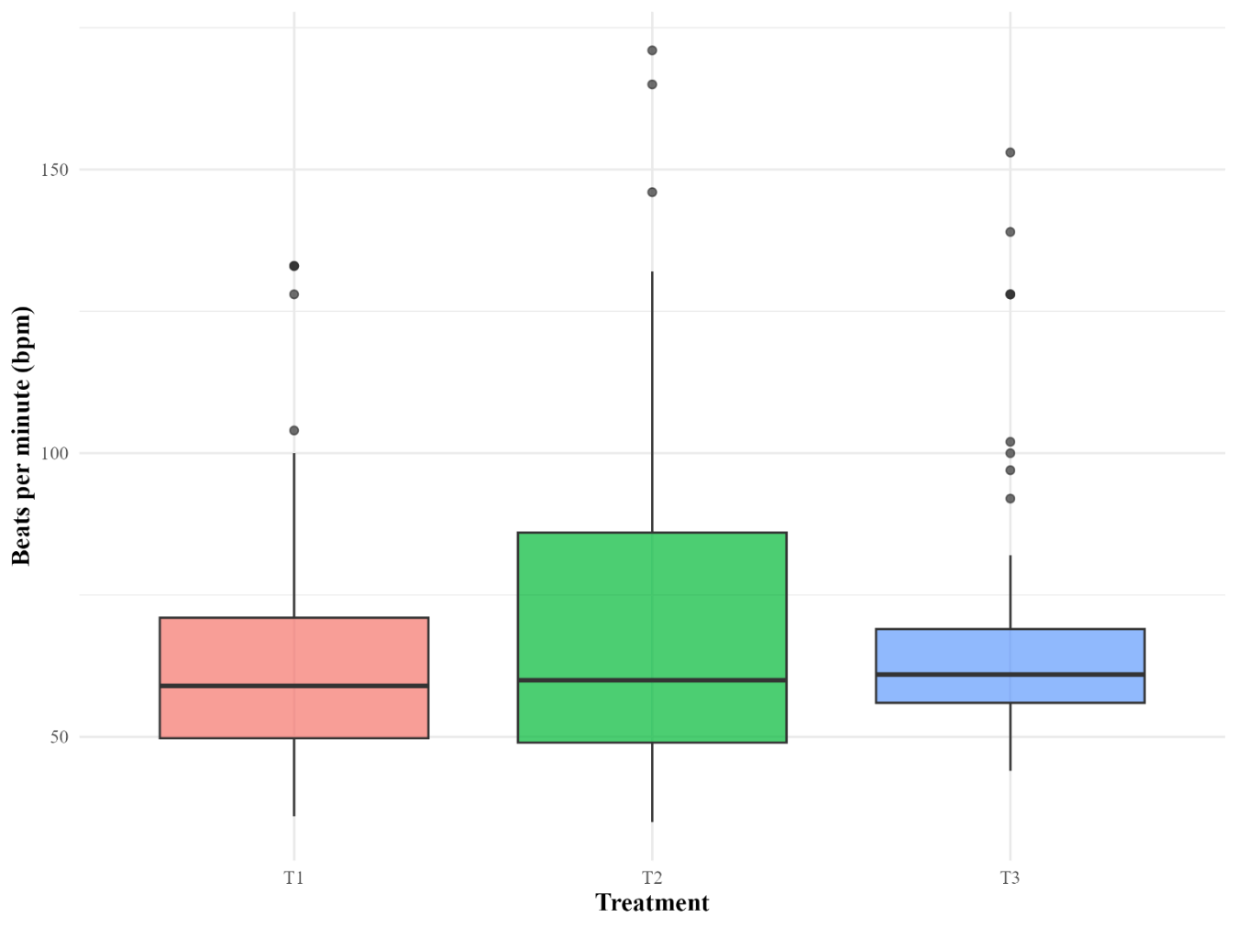 Figure. Distribution of pulse rate (in beats per minute—bpm) in beef calves cast under three analgesic protocols in tropical Colombia.
T1 = Spermatic cord block with lidocaine (10 mL, 2% per cord) + tolfenamic acid (4 mg/kg IM, preop); T2 = Low epidural anesthesia with lidocaine (4 mL, 2%) + tolfenamic acid (4 mg/kg IM, preop); T3 = Tolfenamic acid only (4 mg/kg IM, preop).

Table. Hematological parameters at baseline (0 h) and 24 h after castration in beef calves under three analgesic protocols in tropical Colombia.
Parameter | T1 (0 h) | T2 (0 h) | T3 (0 h) | T1 (24 h) | T2 (24 h) | T3 (24 h)
RBC (×10⁶/µL) | 8.7 | 8.6 | 8 | 8.2 | 7.8 | 7.7
Hb (g/dL) | 10 | 10.3 | 9.2 | 9.6 | 9.3 | 9
HCT (%) | 32.9 | 34.2 | 30.3 | 31.7 | 30.1 | 29.3
WBC (×10³/µL) | 13.1 | 15.6 | 12.5 | 15.5 | 15.2 | 15
Neutrophils (×10³/µL) | 4.1 | 5 | 3.8 | 5.9 | 6 | 5.1
Lymphocytes (×10³/µL) | 7.7 | 9.1 | 7.5 | 8.4 | 8 | 8.6
Platelets (×10³/µL) | 253.3 | 336 | 388 | 376.1 | 361.1 | 307
T1 = Spermatic cord block with lidocaine (10 mL, 2% per cord) + tolfenamic acid (4 mg/kg IM, preop); T2 = Low epidural anesthesia with lidocaine (4 mL, 2%) + tolfenamic acid (4 mg/kg IM, preop); T3 = Tolfenamic acid only (4 mg/kg IM, preop). The values are expressed as the means ± SDs or medians [IQRs] depending on the data distribution.

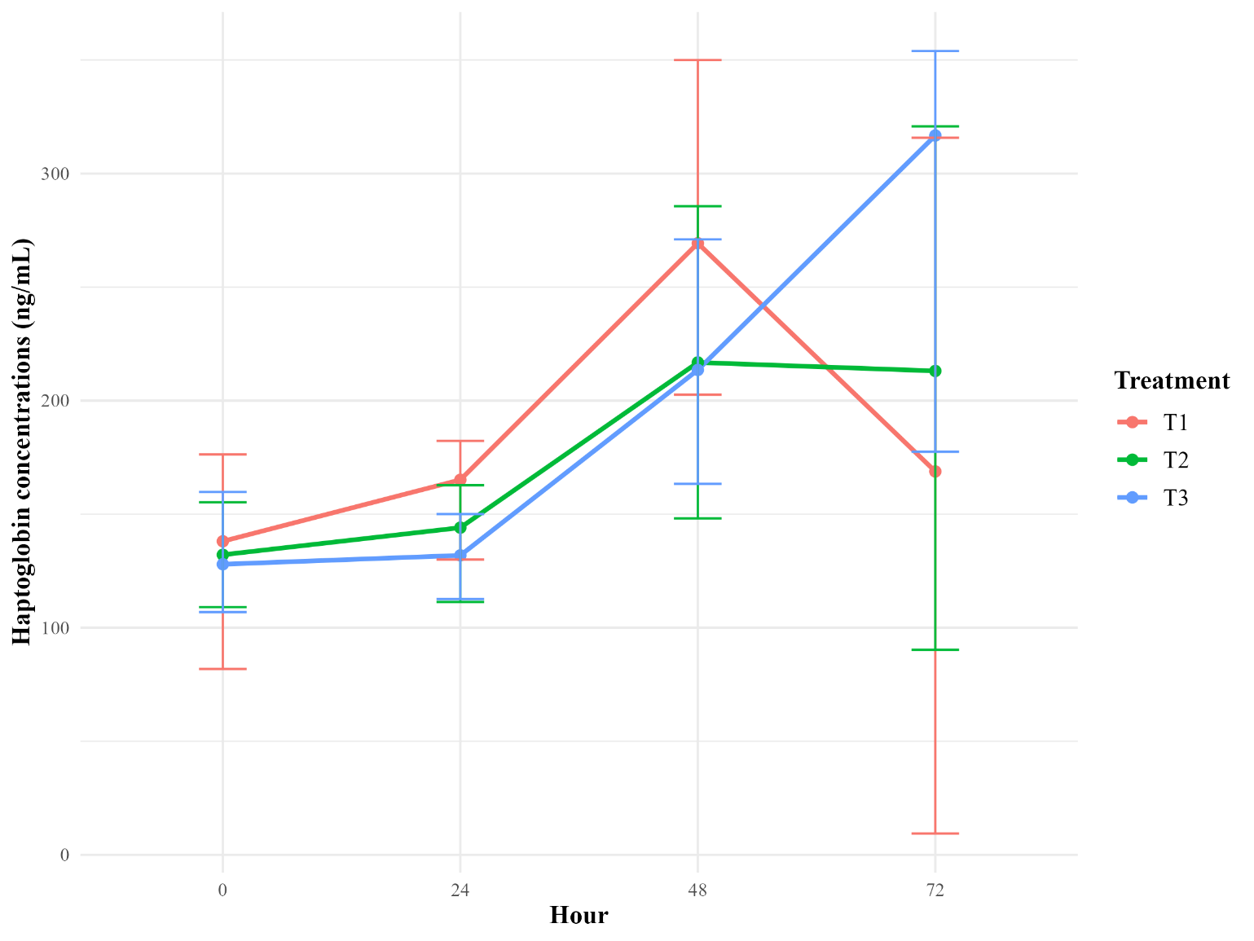
Figure. Median serum haptoglobin concentrations (ng/mL) in beef calves cast under three analgesic protocols in tropical Colombia at 0, 24, 48, and 72 h postcastration.
T1 = Spermatic cord block with lidocaine (10 mL, 2% per cord) + tolfenamic acid (4 mg/kg IM, preop); T2 = Low epidural anesthesia with lidocaine (4 mL, 2%) + tolfenamic acid (4 mg/kg IM, preop); T3 = Tolfenamic acid only (4 mg/kg IM, preop).

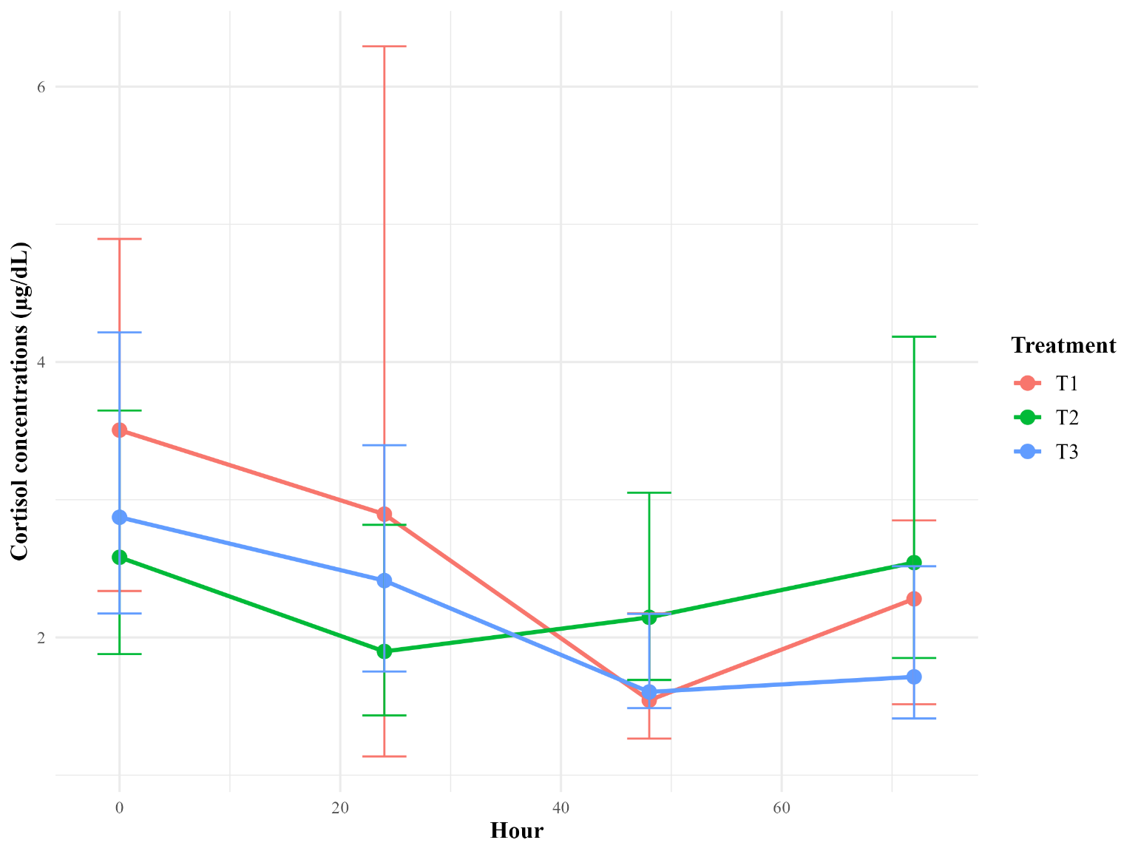
Figure. Distribution of serum cortisol concentrations (µg/dL) at different time points after castration (0, 24, 48, and 72 h) in beef calves under three analgesic protocols in tropical Colombia.
T1 = Spermatic cord block with lidocaine (10 mL, 2% per cord) + tolfenamic acid (4 mg/kg IM, preop); T2 = Low epidural anesthesia with lidocaine (4 mL, 2%) + tolfenamic acid (4 mg/kg IM, preop); T3 = Tolfenamic acid only (4 mg/kg IM, preop). The data are shown as boxplots indicating the median (horizontal line), interquartile range (box), and range (whiskers).

Table. Temporal evolution of scrotal surface temperature (°C) in beef calves castrated under three analgesic protocols in tropical Colombia.
Time (h) | n | Median | Q1 | Q3 | IQR
24 | 42 | 32.0 | 30.00 | 33.27 | 3.27
48 | 42 | 33.7 | 32.73 | 34.38 | 1.65
72 | 42 | 33.5 | 31.88 | 34.90 | 3.02
The values are expressed as medians, first quartiles (Q1), third quartiles (Q3), and interquartile ranges (IQRs).

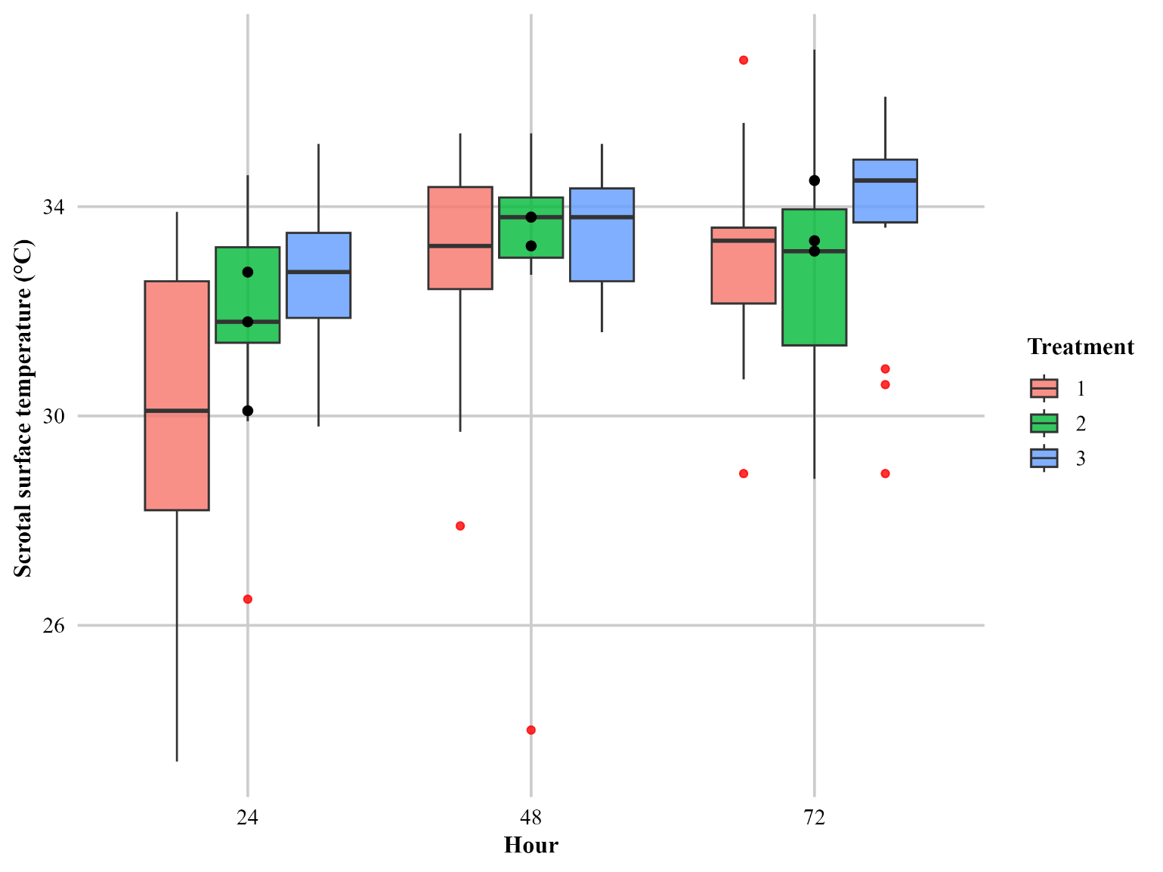

Figure. Temporal changes in measured by infrared thermography (IRT) in beef calves under three analgesic protocols in tropical Colombia at 24, 48, and 72 h postcastration.
T1 = Spermatic cord block with lidocaine (10 mL, 2% per cord) + tolfenamic acid (4 mg/kg IM, preop); T2 = Low epidural anesthesia with lidocaine (4 mL, 2%) + tolfenamic acid (4 mg/kg IM, preop); T3 = Tolfenamic acid only (4 mg/kg IM, preop).

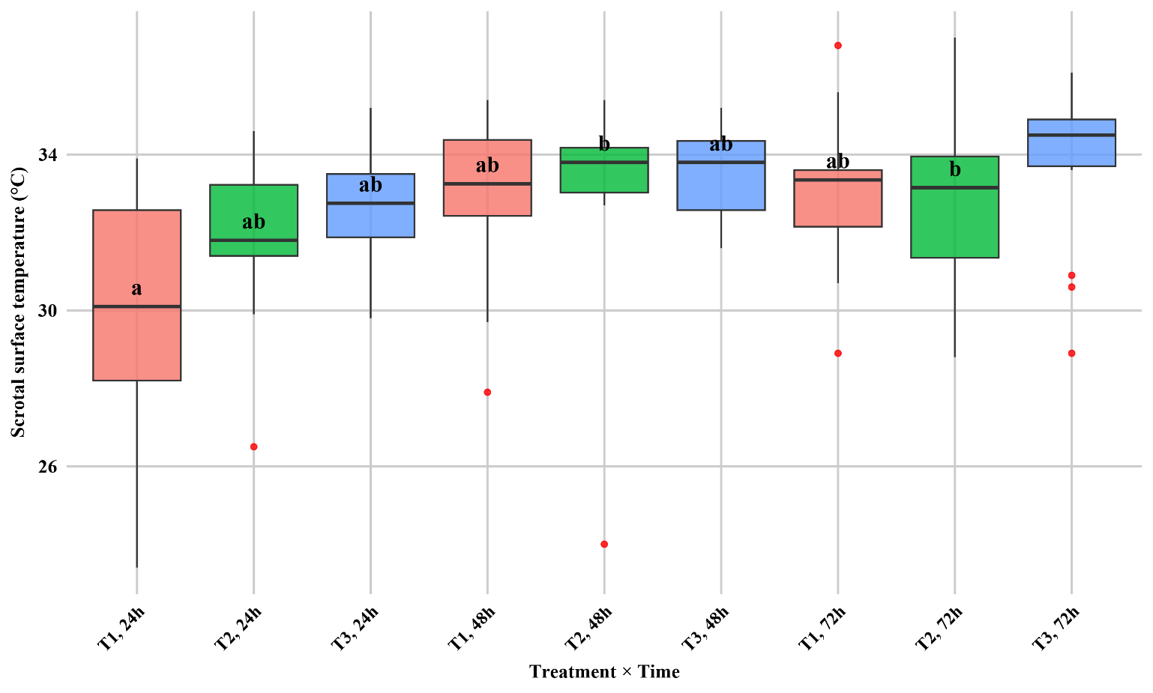
Figure. Interaction between treatment and time on scrotal surface temperature (°C) in beef calves cast under three analgesic protocols in tropical Colombia.
Boxplots represent medians, interquartile ranges, and outliers. Different letters indicate significant differences between groups (p < 0.05).

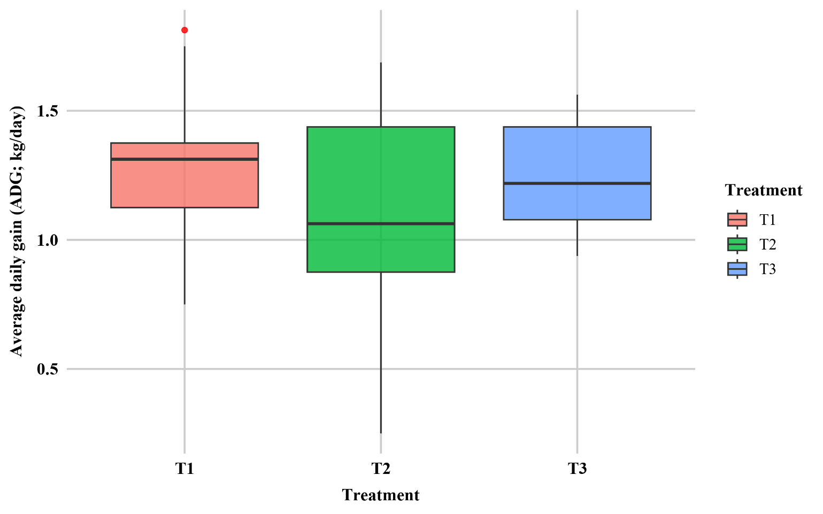
Figure. Distribution of average daily gain (ADG; kg/day) in beef calves cast under three analgesic protocols in tropical Colombia.
T1 = Spermatic cord block with lidocaine (10 mL, 2% per cord) + tolfenamic acid (4 mg/kg IM, preop); T2 = Low epidural anesthesia with lidocaine (4 mL, 2%) + tolfenamic acid (4 mg/kg IM, preop); T3 = Tolfenamic acid only (4 mg/kg IM, preop). Boxplots represent the median, interquartile range, and outliers.

Table. Summary statistics of average daily gain (kg/day) in beef calves cast under three analgesic protocols in tropical Colombia.
Treatment | Description | n | Mean (kg/day) | SD | Median | Min | Max
T1 | Spermatic cord block with lidocaine (10 mL, 2% per cord) + tolfenamic acid (4 mg/kg IM, preop) | 13 | 1.31 | 0.31 | 1.31 | 0.75 | 1.81
T2 | Low epidural anesthesia with lidocaine (4 mL, 2%) + tolfenamic acid (4 mg/kg IM, preop) | 13 | 1.11 | 0.40 | 1.06 | 0.25 | 1.69
T3 | Tolfenamic acid only (4 mg/kg IM, preop) | 14 | 1.25 | 0.20 | 1.22 | 0.94 | 1.56
The values are expressed as the means ± standard deviations (SDs), medians, minimums, and maximums.

