Supplementary Figures
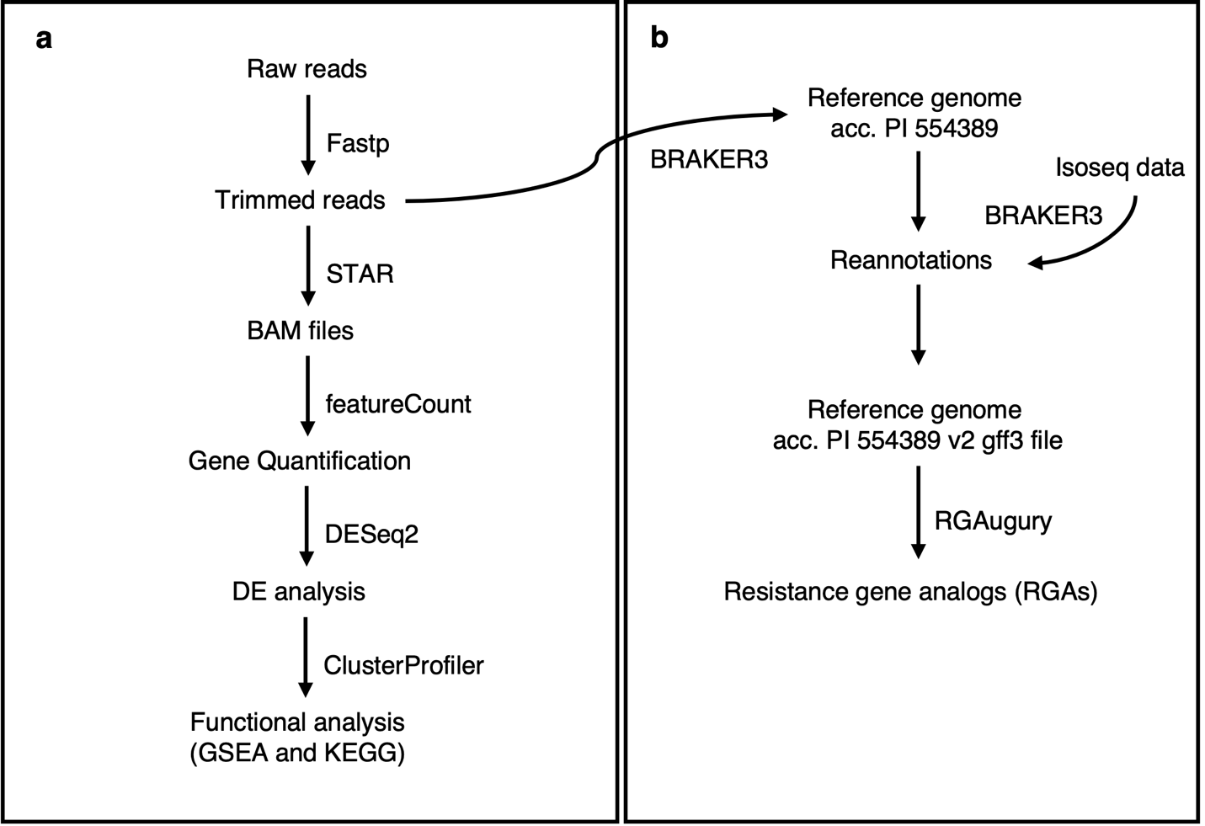
Figure S1: Data analysis workflow used for the RNAseq analysis (a), and reannotations and resistance gene analogs (RGAs) identification (b).

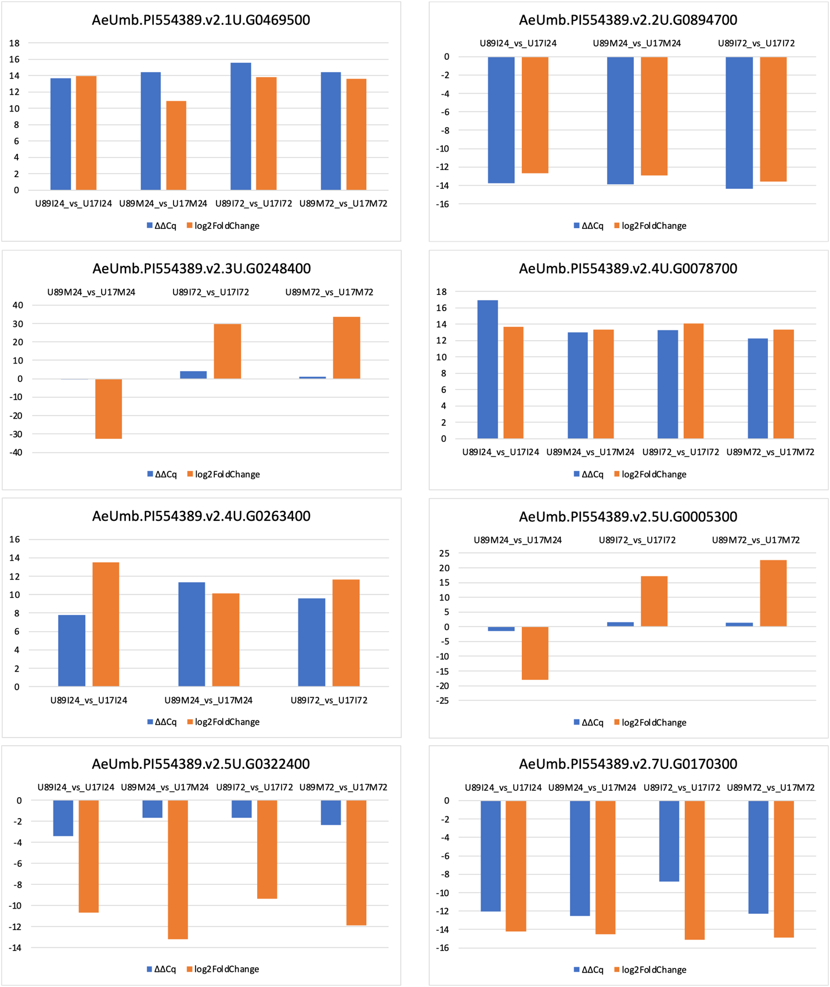
Figure S2: Bar plot showing the comparison of gene expression levels determined by qRT-PCR and RNA-seq for selected genes across four treatment conditions: U89I24_vs_U17I24, U89M24_vs_U17M24, U89I72_vs_U17I72, and U89M72_vs_U17M72.

