Tabel 1. Results of Condom Catheter Testing
Aspects of testing | Type of Condoms
Aspects of testing | Brand A | Brand B | Brand C | Brand D | Brand E
Specifications  Material  Length (mm)  Wide (mm)  Texture  Color | Natural latex  178  52  Nontextured  Noncolored | Natural latex  190  50  Nontextured  Noncolored | Natural latex  178  49  Nontextured  Noncolored | Natural latex  178  53  Ribbed  Colored | Natural latex  178  52  Dotted  Noncolored
Shape
(a) Tying at 3 cm from the tip (standard knot site)  500 mL  saline water | Rounded at the base | Rounded at the base | Rounded at the base | Rounded at the  base | Rounded at the base
 | 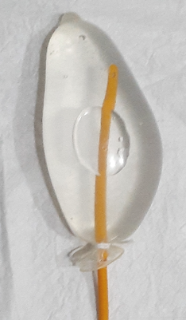 | 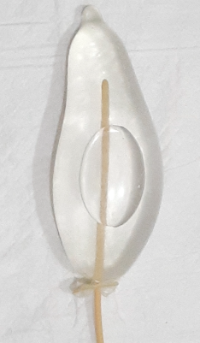 | 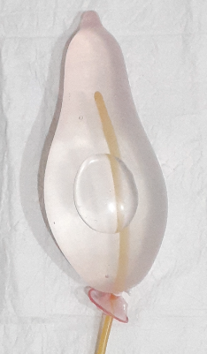 | 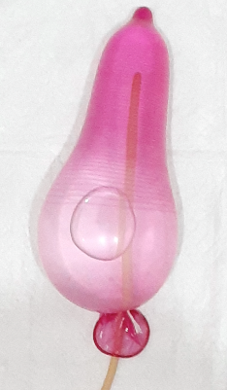 | 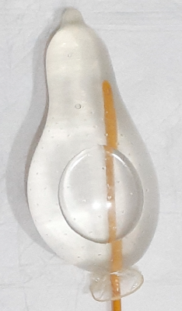
1000 mL  saline water | 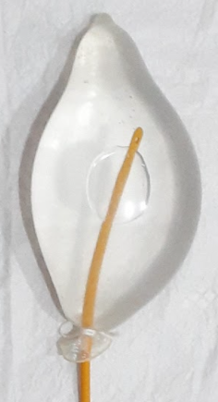 | 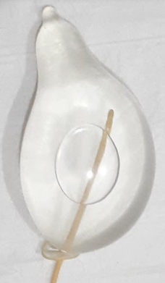 | 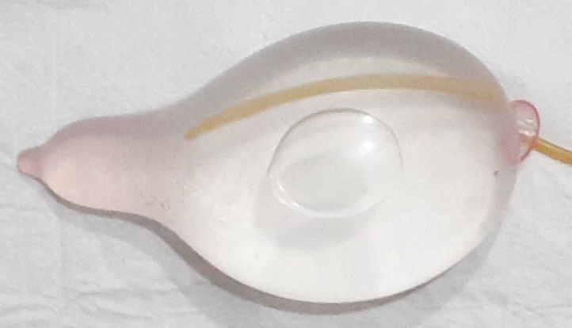 | 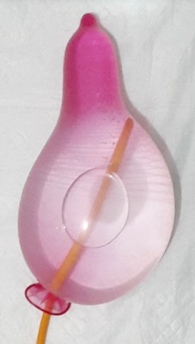 | 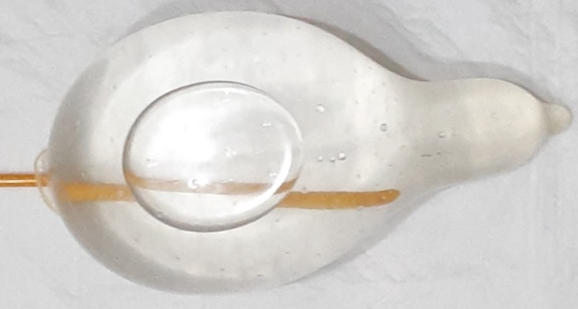
3000 mL  saline water | Elongated  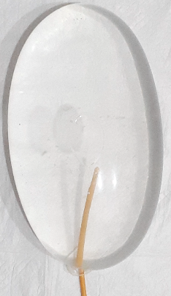 | Elongated  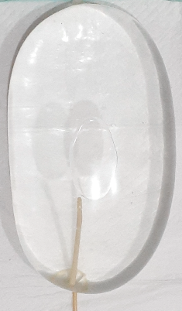 | Elongated  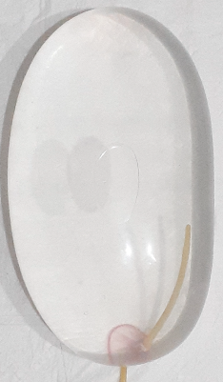 | Elongated  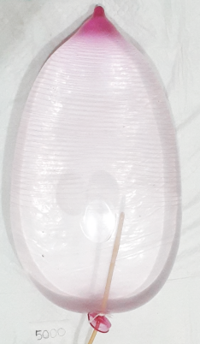 | Elongated  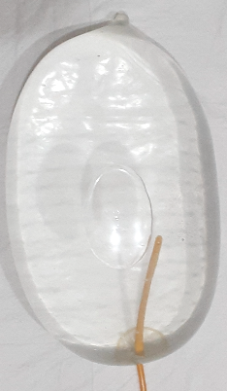
(b) Tying in the middle of the condom (proposed knot site)  500 mL  saline water | Rounded at almost all part | Rounded at almost all part | Rounded at almost all part | Rounded at almost all part | Rounded at almost all part
 | 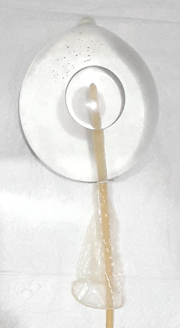 | 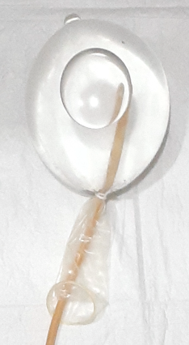 | 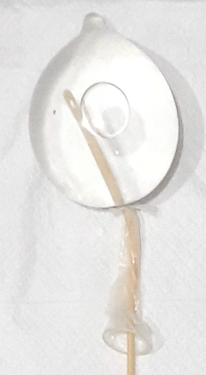 | 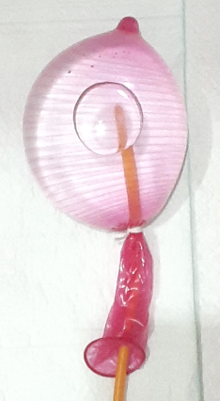 | 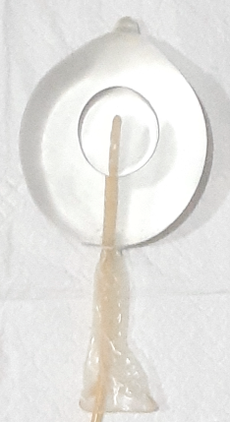
1000 mL  saline water | 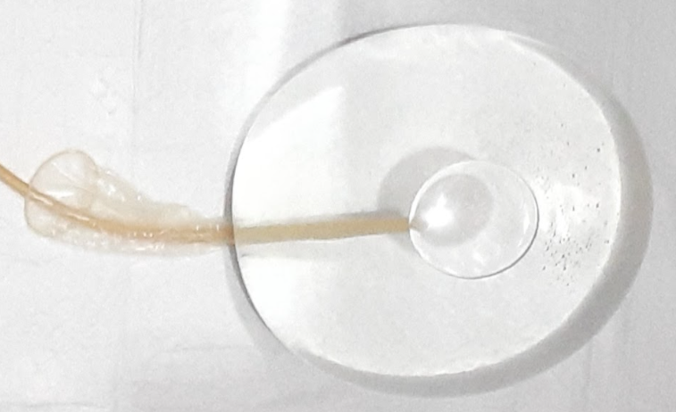 | 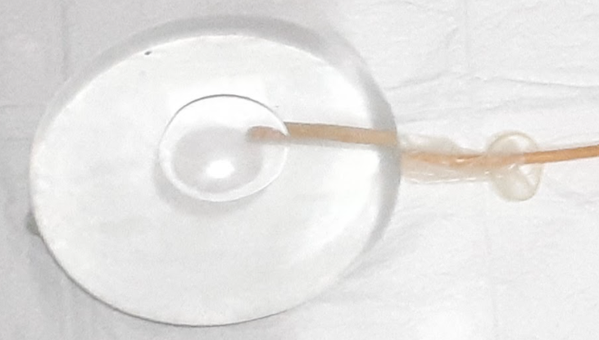 | 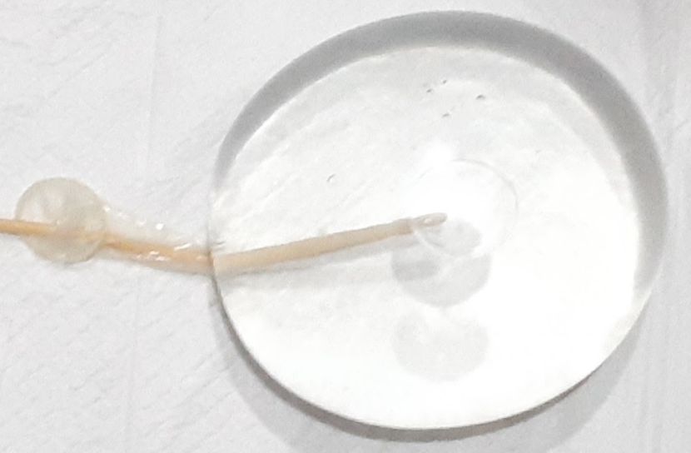 | 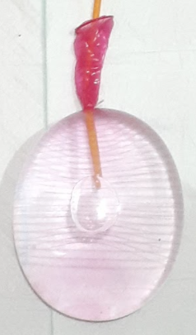 | 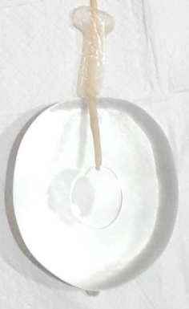
3000 mL  saline water | Widened  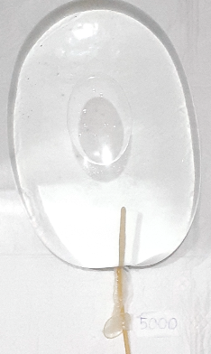 | Widened  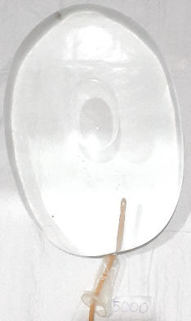 | Widened  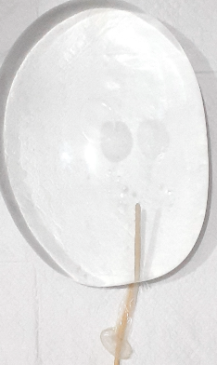 | Widened  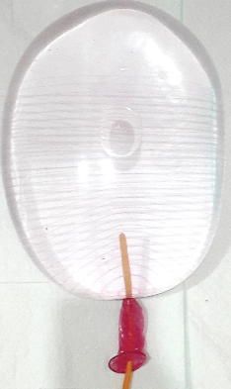 | Widened  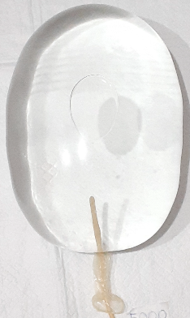
Maximum capacity  For both knot site type | Up to 5000 mL | Up to 5000 mL | Up to 5000 mL | Up to 5000 mL | Up to 5000 mL
Leakage  (In 2 × 24 h)  For all types of knot site and volume | None | None | None | None | None

Table 2. Flow Velocity based on Type of Catheter
Type number and diameter (mm) | Mean of flow velocity  (min) | P-value*  (95%CI) | P-value**  (95%CI)
14F (4.7) | 5.40 | 0.001 (3.60-4.07)
16F (5.3) | 4.36 | 0.001 (3.60-4.07)
18F (6.0) | 3.57 | 0.001 (3.60-4.07) | 0.111(3.31-3.52)
20F (6.7) | 3.56 | 0.001 (3.60-4.07) | 0.111(3.31-3.52)
22F (7.3) | 3.46 | 0.001 (3.60-4.07) | 0.111(3.31-3.52)
24F (8.0) | 3.20 | 0.001 (3.60-4.07) | 0.111(3.31-3.52)
No catheter | 3.30 | 0.001 (3.60-4.07) | 0.111(3.31-3.52)
*ANOVA test for all catheter types and no catheter
**ANOVA test for catheter nos 18F, 20F, 22F, and 2F4 and no catheter

