A | B
C | D
Supplementary Figure 1. Raw data of individual seismoacoustic recordings, minute-by-minute presentation. A. 5xFAD-Tg (males); B. Non-Tg (males); C. 5xFAD-Tg (females); D. Non-Tg (females).

A  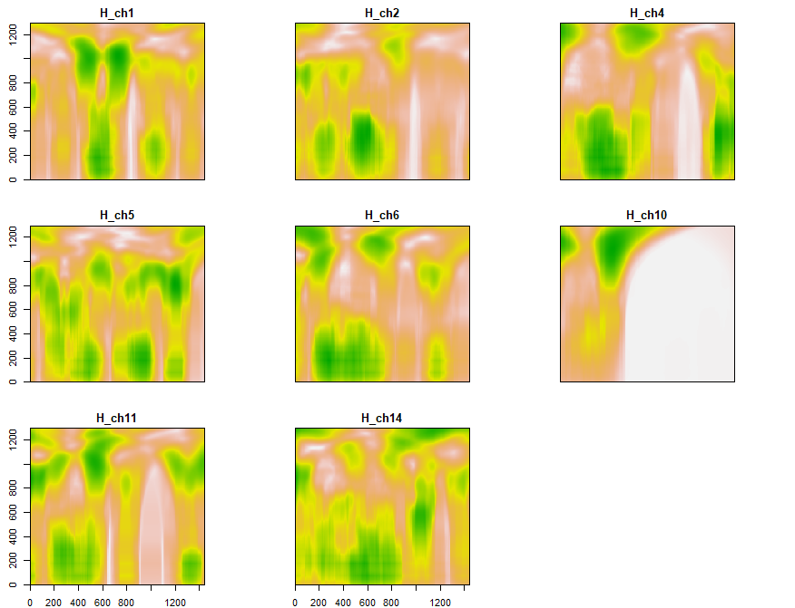 | B  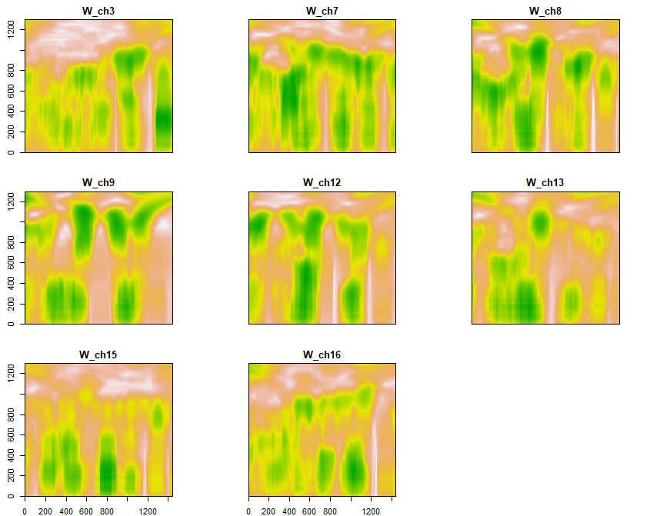
C  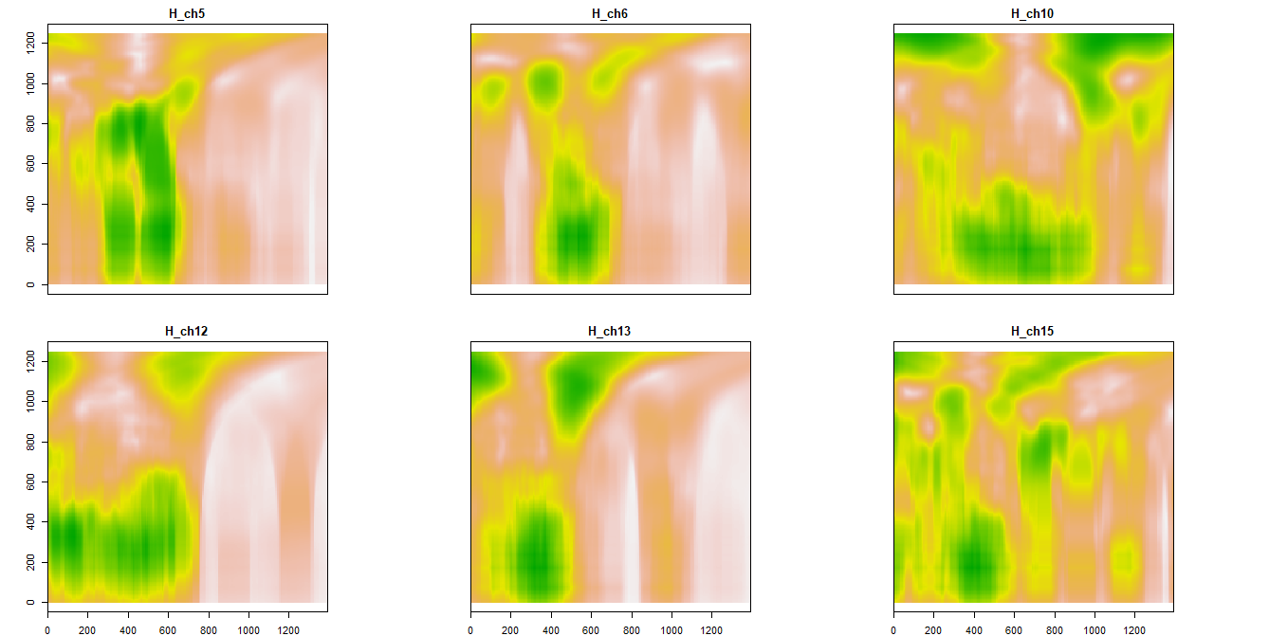 | D  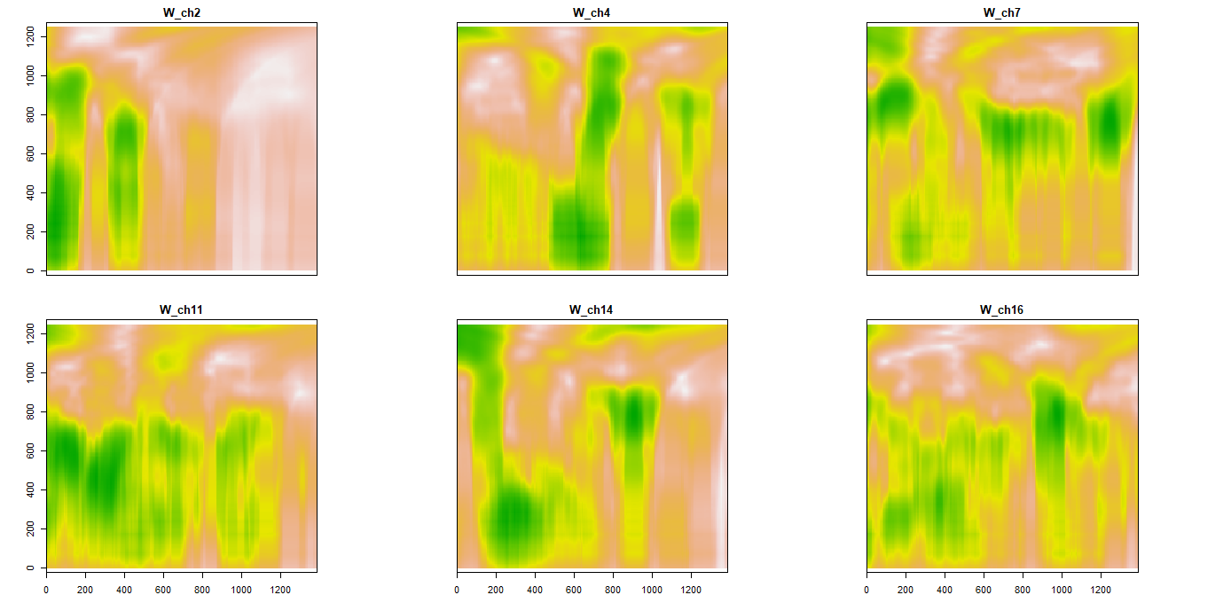
Supplementary Figure 2. Individual wavelet spectrograms by sex and genotype. A. 5xFAD-Tg (males); B. Non-Tg (males); C. 5xFAD-Tg (females); D. Non-Tg (females)

