High Performance Voltage Tailorable Room-temperature Ca-metal Batteries
Huawei Song, Jian Su, and Chengxin Wang*
State Key Laboratory of Optoelectronic Materials and Technologies, School of Materials Science and Engineering, Sun Yat-Sen (Zhongshan) University, Guangzhou 510275, People’s Republic of China
Email:wchengx@mail.sysu.edu.cn (Prof. Chengxin Wang)
Keywords: calcium metal, tailorable window voltage, anion-cation, relay insertion/extraction, rechargeable battery

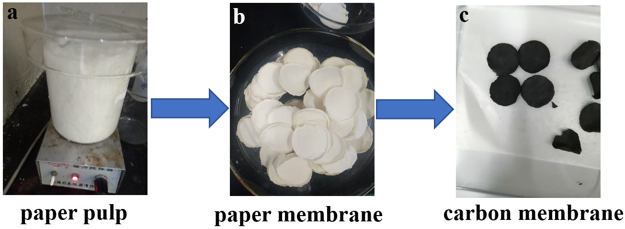
Figure S1. Illustration of the simplified process for recycling cellulose waste paper towards CWPDGC membranes.
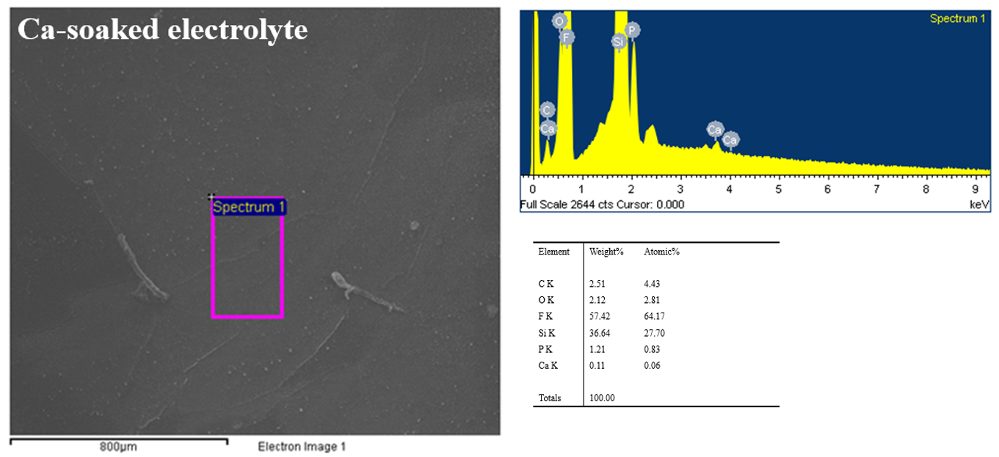
Figure S2. Element quantitative analysis of the Ca-soaked electrolyte, the content of Ca²⁺ roughly amounts to ~7.8% among all the cations (Li⁺ and Ca²⁺) (Si element comes from the Si substrate).

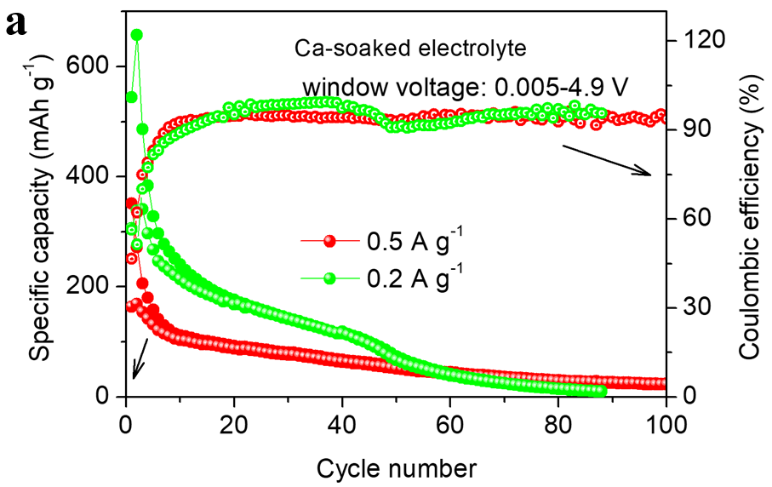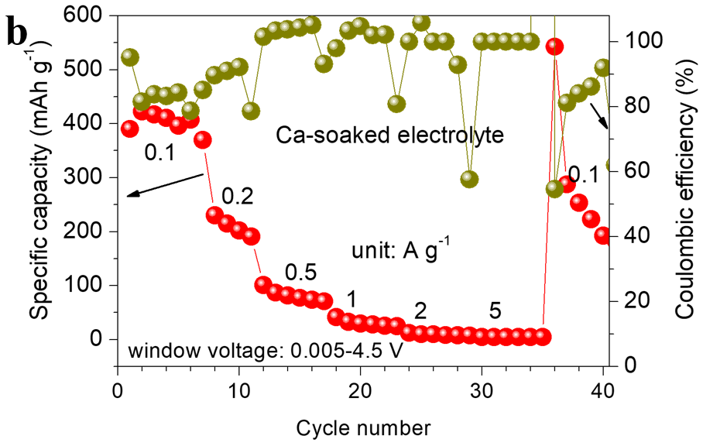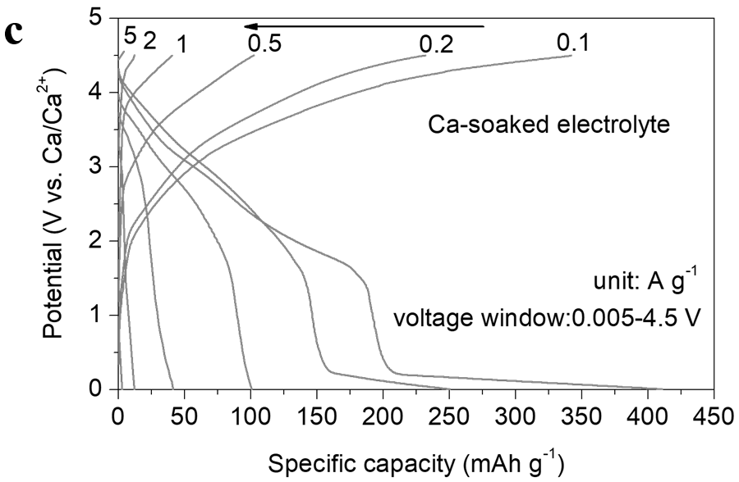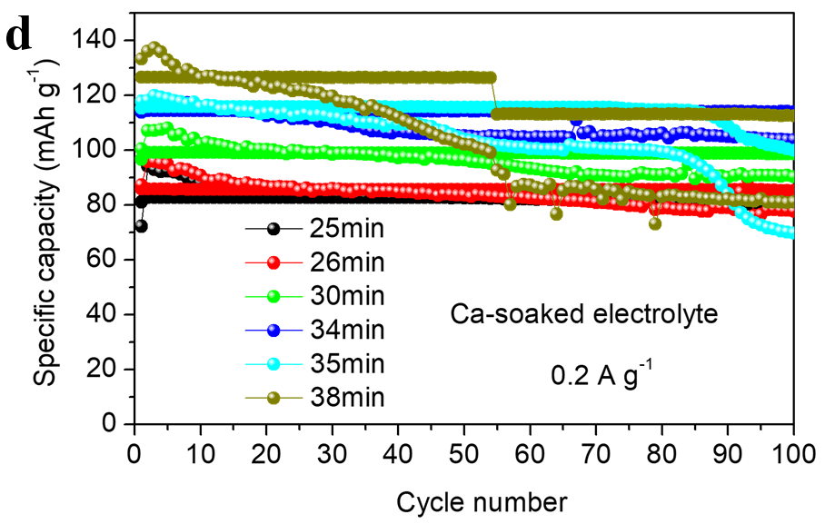
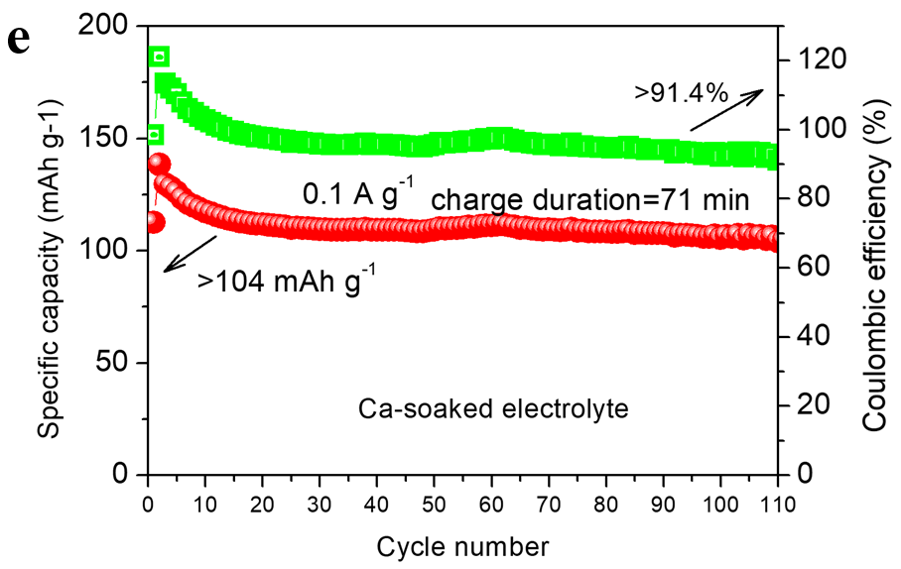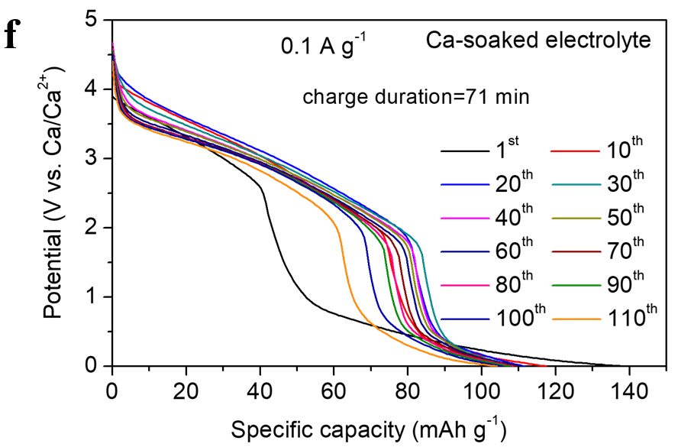
Figure S3. Ca-CWPDGC batteries at wide window voltages. a) cycling performance and b) rate performance at fixed window voltages, c) typical charge-discharge profiles at various rates, d) cycling performance for different charge durations at 200 mA g⁻¹, e) cycling performance for a charge duration of 71 min at 100 mA g⁻¹ and f) the corresponding discharge profiles at different cycles.

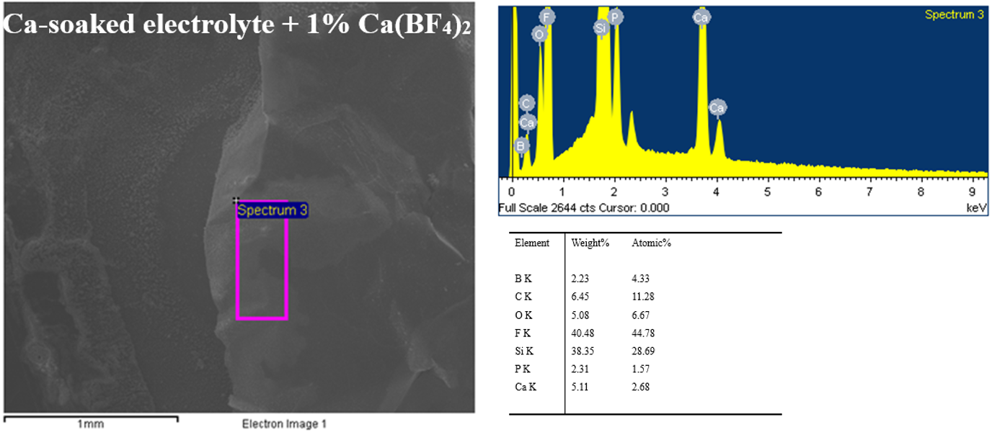
Figure S4. Element quantitative analysis of the Ca-soaked electrolyte with 1% Ca(BF₄)₂ additive, the content of Ca²⁺ roughly amounts to ~83.2% among all the cations (Li⁺ and Ca²⁺) (Si element comes from the Si substrate).

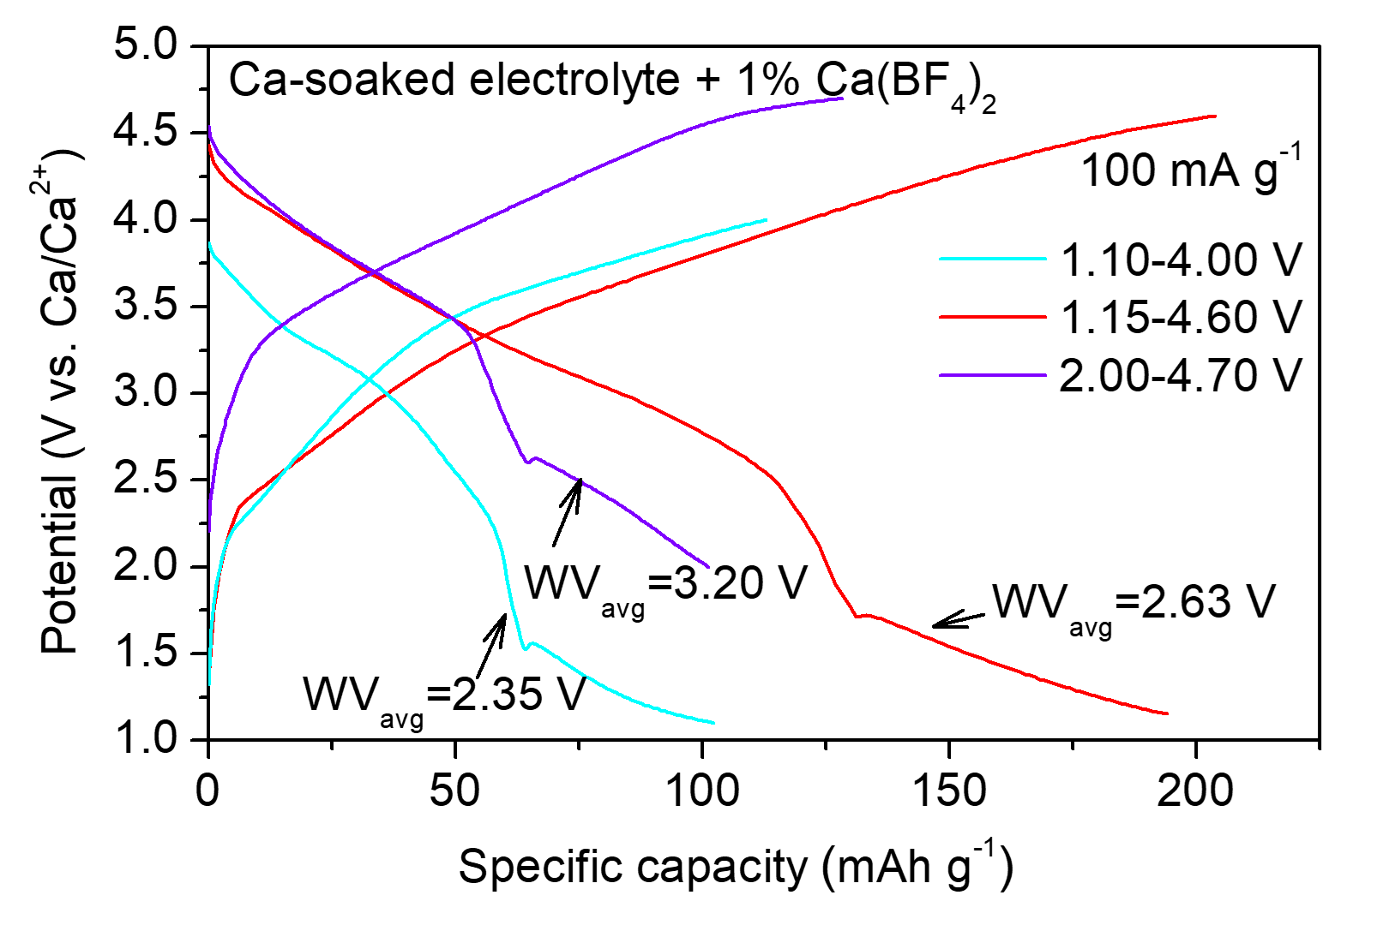
Figure S5. Typical charge-discharge profiles of Ca-CWPDGC batteries at tailored window voltages and the corresponding output average working window voltages (WV_{avg}).

