Figure S1. Geographical distribution of study participants (at the level of Statistical Areas 1 to preserve confidentiality)

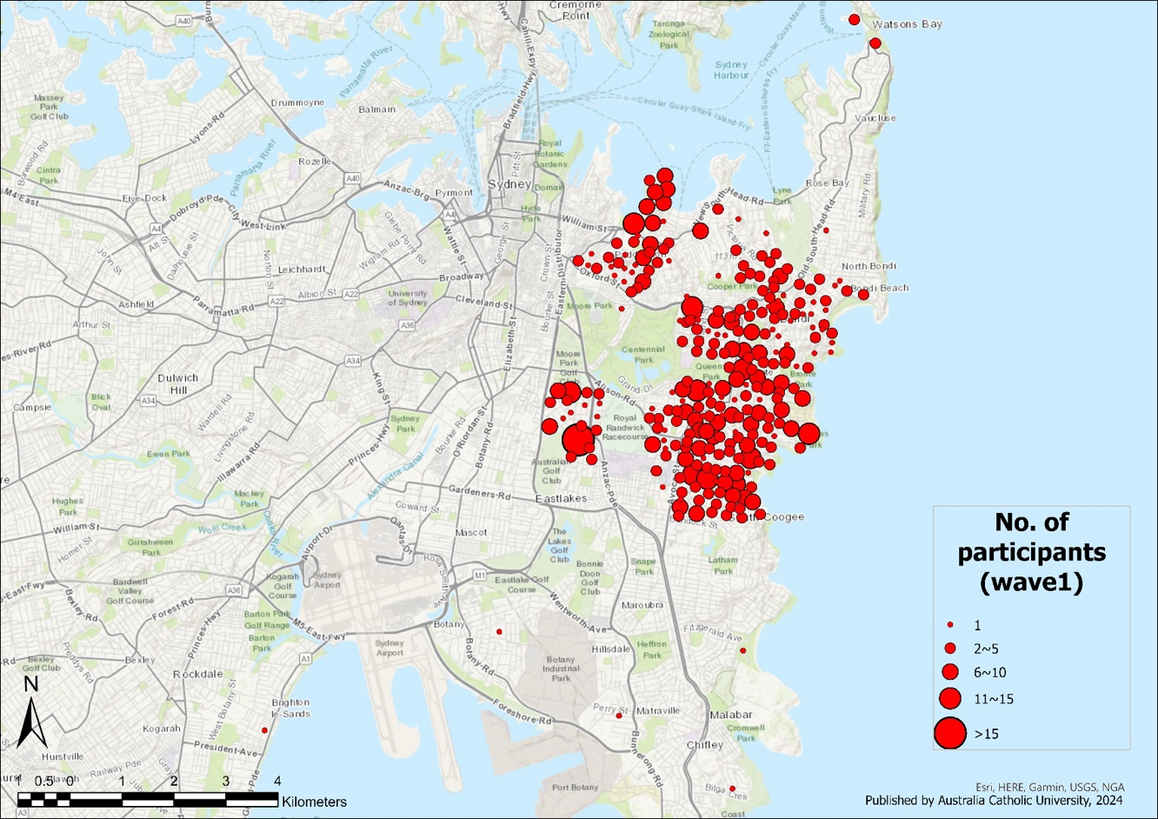

Figure S2. Flowchart of participants with hippocampal subfield data in the wave 1, 2 and 4 of the Sydney Memory and Ageing Study, assessed biennially.

Sydney MAS Study
Total Participants
N = 1037

Deceased: 34
Subfield data not available: 271
Deceased: 16
Subfield data not available: 181
Wave 4
Structural MRI
N=239
Wave 2
Structural MRI
N=347
Wave 1 (Baseline)
Structural MRI
N=514

Hippocampal subfield data not available: 523

Figure S3. High-level data processing steps used for analysis of association between hippocampal subfield volumes and street intersection density.

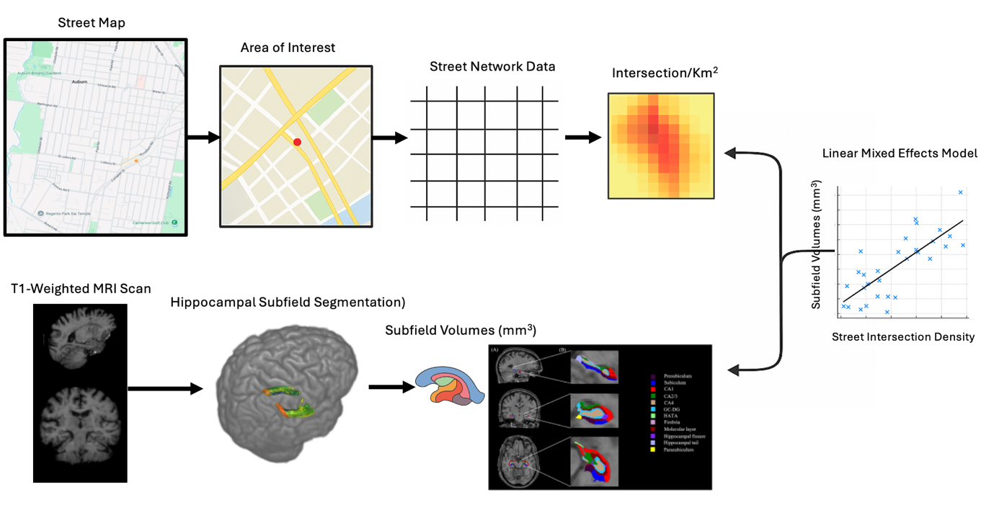

Figure S4. Directed acyclic graphs (DAGs) identified sets of variables to include in the statistical analyses to sufficiently control for potential confounders. The DAG below informed the model of the total effect of street intersection density in the residential buffer on hippocampal subfield volume. Variables with red circles denote the set of potential confounders. SES = socio-economic status; PM_{2.5}, particulate matter with a diameter of 2.5 μm or smaller; NO₂, nitrogen dioxide.

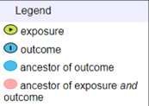
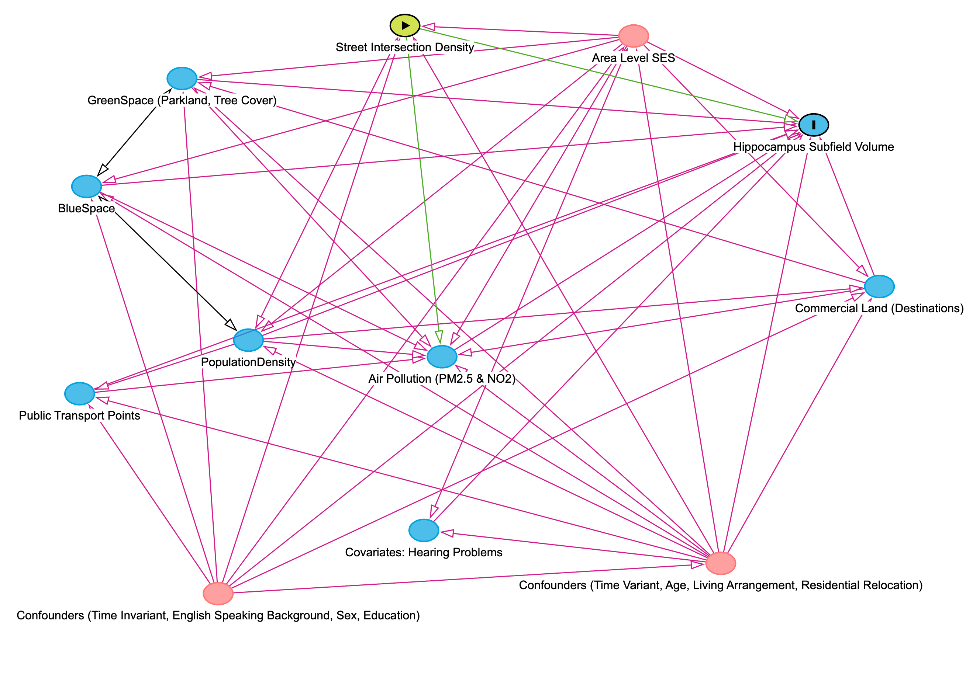

Figure S5. Trajectories depict model-predicted, population-level percent volume retention in hippocampal subfields that showed significant age-related change from 70 to 90 years. Predictions are based on a reference individual, with all continuous covariates set to sample means. Random intercepts and age slopes were included in the models but are not reflected in the fixed-effects predictions shown here.

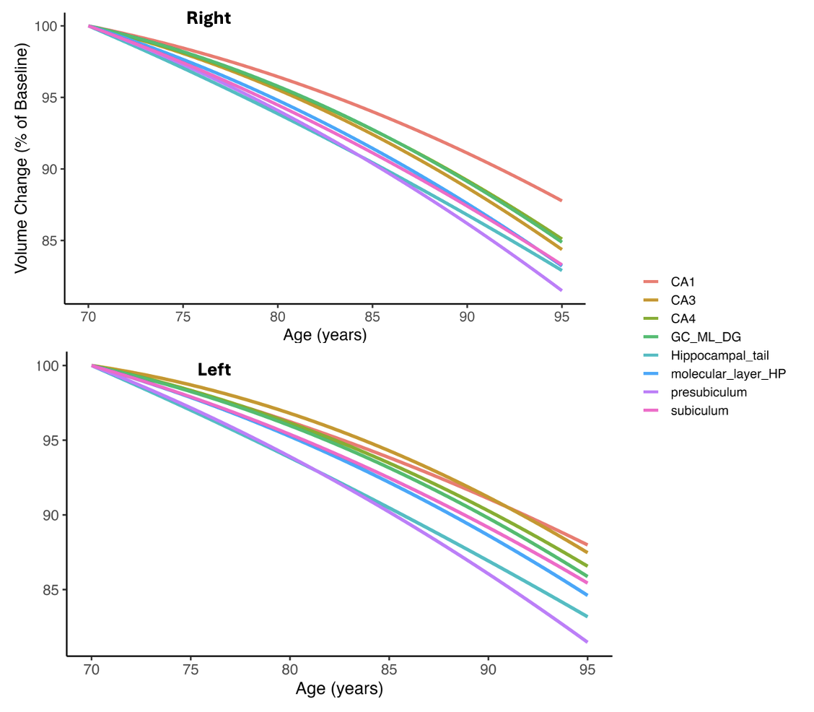

Table S1: Predictors of participants’ remaining in the study at Waves 2 and Wave 4

Variable | OR | 95% CI | P-Value
Retention at Wave 2
Age | 1.04 | (1, 1.08) | 0.041
Baseline Work (No. of Hours) | 0.97 | (0.94, 1) | 0.127
Mobile without mobility aids | 0.48 | (0.31, 0.75) | 0.001
Retention at Wave 4 | 4.74 | (0.6, 37.65) | 0.14
Age | 1.07 | (1.03, 1.12) | 0.001
Baseline Work (No. of Hours) | 0.97 | (0.95, 1) | 0.063
Mobile without mobility aids | 0.56 | (0.34, 0.89) | 0.017

Table S2: This table presents standardized beta estimates, 95% confidence intervals (CIs), t-statistics, and p-values for within-person change in street intersection density with within-person change in hippocampal subfield volume. Regions are listed separately for the right (R) and left (L.).
 | Within person change (Main Effect)
Regions | estimates (95% CI) | t-value | p-value
R.subiculum | 0.00102 (-0.502, 0.504) | 0.004 | 0.997
R.parasubiculum | -0.013 (-0.206, 0.18) | -0.135 | 0.893
R.presubiculum | -0.237 (-0.647, 0.172) | -1.137 | 0.256
R.hippocampal.fissure | -0.21 (-0.651, 0.231) | -0.935 | 0.35
R.CA1 | -0.151 (-0.834, 0.532) | -0.436 | 0.663
R.CA3 | 0.019 (-0.333, 0.372) | 0.108 | 0.914
R.CA4 | -0.014 (-0.377, 0.348) | -0.078 | 0.938
R.HATA | 0.04 (-0.081, 0.161) | 0.655 | 0.513
R.molecular_layer_HP | -0.142 (-0.754, 0.471) | -0.454 | 0.65
R.fimbria | 0.137 (-0.114, 0.388) | 1.071 | 0.285
R.Hippocampal_tail | -0.551 (-1.305, 0.202) | -1.437 | 0.151
R. GC-ML-DG | -0.00934 (-0.402, 0.384) | -0.047 | 0.963
L.subiculum | -0.188 (-0.634, 0.258) | -0.828 | 0.408
L.parasubiculum | -0.00115 (-0.177, 0.175) | -0.013 | 0.99
L.presubiculum | -0.313 (-0.717, 0.092) | -1.518 | 0.129
L.hippocampal.fissure | -0.331 (-0.739, 0.077) | -1.592 | 0.112
L.CA1 | -0.293 (-0.887, 0.3) | -0.97 | 0.332
L.CA3 | -0.099 (-0.395, 0.197) | -0.658 | 0.511
L.CA4 | -0.083 (-0.383, 0.217) | -0.54 | 0.589
L.HATA | -0.045 (-0.149, 0.058) | -0.856 | 0.392
L.molecular_layer_HP | -0.287 (-0.804, 0.229) | -1.093 | 0.275
L.fimbria | 0.11 (-0.125, 0.345) | 0.918 | 0.359
L.Hippocampal_tail | -0.477 (-1.122, 0.168) | -1.453 | 0.147
L. GC-ML-DG | -0.126 (-0.447, 0.195) | -0.772 | 0.441

Table S3: This table presents standardized beta estimates, 95% confidence intervals (CIs), t-statistics, and p-values for the within-person change in street intersection density with within-person changes in trajectory of hippocampal subfield volume (linear). Regions are listed separately for the right (R) and left (L.).

 | Age * Within Person Change (Interaction Effect)
Regions | estimates (95% CI) | t-value | p-value
R.subiculum | 0.0018 (-0.06, 0.064) | 0.057 | 0.955
R.parasubiculum | 0.00629 (-0.018, 0.031) | 0.508 | 0.611
R.presubiculum | 0.031 (-0.02, 0.083) | 1.201 | 0.23
R.hippocampal.fissure | 0.016 (-0.04, 0.072) | 0.57 | 0.569
R.CA1 | 0.035 (-0.05, 0.119) | 0.809 | 0.419
R.CA3 | -0.00084 (-0.045, 0.043) | -0.038 | 0.97
R.CA4 | 0.00083 (-0.045, 0.046) | 0.036 | 0.971
R.HATA | -0.00386 (-0.019, 0.011) | -0.495 | 0.621
R.molecular_layer_HP | 0.024 (-0.052, 0.1) | 0.626 | 0.532
R.fimbria | -0.019 (-0.051, 0.013) | -1.179 | 0.239
R.Hippocampal_tail | 0.076 (-0.018, 0.171) | 1.589 | 0.113
R. GC-ML-DG | 0.00158 (-0.047, 0.051) | 0.063 | 0.95
L.subiculum | 0.028 (-0.028, 0.083) | 0.985 | 0.325
L.parasubiculum | -0.00062 (-0.023, 0.022) | -0.055 | 0.956
L.presubiculum | 0.039 (-0.011, 0.09) | 1.524 | 0.128
L.hippocampal.fissure | 0.038 (-0.013, 0.09) | 1.455 | 0.146
L.CA1 | 0.018 (-0.056, 0.092) | 0.478 | 0.633
L.CA3 | 0.014 (-0.022, 0.051) | 0.775 | 0.439
L.CA4 | 0.00995 (-0.027, 0.047) | 0.524 | 0.6
L.HATA | 0.00681 (-0.0063, 0.02) | 1.02 | 0.308
L.molecular_layer_HP | 0.03 (-0.033, 0.093) | 0.929 | 0.353
L.fimbria | -0.015 (-0.045, 0.015) | -0.987 | 0.324
L.Hippocampal_tail | 0.042 (-0.039, 0.122) | 1.014 | 0.311
L. GC-ML-DG | 0.014 (-0.026, 0.053) | 0.692 | 0.489

Table S4:
This table presents standardized beta estimates, 95% confidence intervals (CIs), t-statistics, and p-values for the within-person change in street intersection density with within-person changes in trajectory of hippocampal subfield volume (quadratic). Regions are listed separately for the right (R) and left (L.).

 | Age (Quadratic) * Within Person Change (Interaction Effect)
Regions | estimates (95% CI) | t-value | p-value
R.subiculum | -0.00016 (-0.00205, 0.00174) | -0.164 | 0.87
R.parasubiculum | -0.00027 (-0.00102, 0.00048) | -0.696 | 0.487
R.presubiculum | -0.00118 (-0.00275, 4e-04) | -1.47 | 0.142
R.hippocampal.fissure | -0.00022 (-0.00195, 0.0015) | -0.255 | 0.799
R.CA1 | -0.0012 (-0.00377, 0.00137) | -0.919 | 0.358
R.CA3 | -4e-05 (-0.00139, 0.0013) | -0.063 | 0.95
R.CA4 | 4e-05 (-0.00136, 0.00144) | 0.062 | 0.95
R.HATA | 7e-05 (-0.00041, 0.00054) | 0.283 | 0.777
R.molecular_layer_HP | -0.00081 (-0.00311, 0.0015) | -0.69 | 0.491
R.fimbria | 0.00057 (-4e-04, 0.00155) | 1.152 | 0.25
R.Hippocampal_tail | -0.00206 (-0.00495, 0.00084) | -1.396 | 0.163
R. GC-ML-DG | 0 (-0.0015, 0.0015) | -0.002 | 0.998
L.subiculum | -0.00065 (-0.00234, 0.00104) | -0.751 | 0.453
L.parasubiculum | -1e-05 (-7e-04, 0.00068) | -0.027 | 0.978
L.presubiculum | -0.00115 (-0.0027, 4e-04) | -1.457 | 0.146
L.hippocampal.fissure | -0.00052 (-0.0021, 0.00107) | -0.638 | 0.524
L.CA1 | 0.00032 (-0.00193, 0.00257) | 0.278 | 0.781
L.CA3 | -0.00023 (-0.00135, 0.00088) | -0.409 | 0.682
L.CA4 | -5e-05 (-0.00119, 0.00109) | -0.088 | 0.93
L.HATA | -2e-04 (-0.00061, 2e-04) | -0.982 | 0.327
L.molecular_layer_HP | -0.00027 (-0.0022, 0.00166) | -0.275 | 0.784
L.fimbria | 0.00023 (-0.00069, 0.00115) | 0.49 | 0.624
L.Hippocampal_tail | -0.00038 (-0.00284, 0.00208) | -0.305 | 0.761
L. GC-ML-DG | -0.00016 (-0.00136, 0.00105) | -0.254 | 0.8

