Sleep Apnea Detection Using Wearable ECG and Deep Learning: Validation with Polysomnography
Sue Hyun Lee^{1*}, Minwoo Kim^{2*}, Sung Pil Cho², Yeewoong Kim², Min Kyung Chu³, Won-Joo Kim⁴, Kyoung Heo³, Kyung Min Kim³
¹ Department of Neurology, National Health Insurance Service Ilsan Hospital, Goyang-si, Korea
² MEZOO Co., Ltd., Wonju-si, Korea
³ Department of Neurology, Severance Hospital, Yonsei University College of Medicine, Seoul, Korea
⁴ Department of Neurology, Gangnam Severance Hospital, Yonsei University College of Medicine, Seoul, Korea
* These authors contributed equally to the work

Corresponding author: Kyung Min Kim, MD, PhD
Department of Neurology, Severance Hospital, Yonsei University College of Medicine, 50-1 Yonsei-ro, Seodaemun-gu, Seoul 03722, Republic of Korea
Telephone: +82-2-2228-1600, Fax: +82-2-393-0707, Email: penlighting11@yuhs.ac

Figure S1. Graphs of loss and accuracy change for train and validation per epoch. 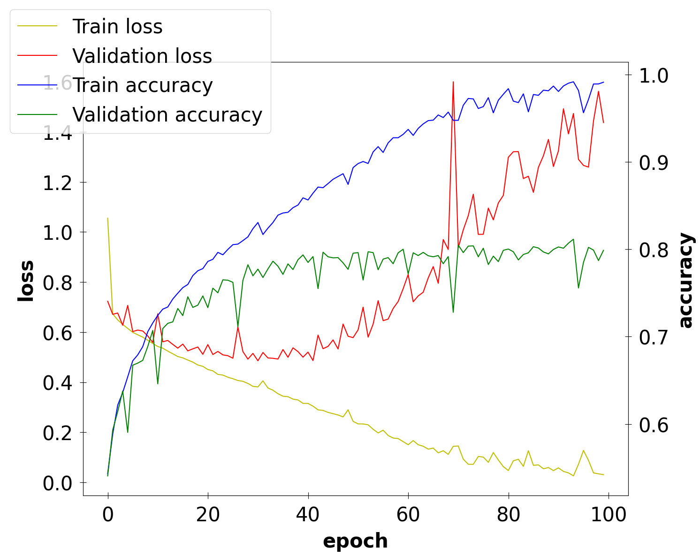

Table S1. Performance comparison of several optimizers and learning rate ratio in predicting normal and apnea/hypopnea
Optimizer | Epoch | Training loss | Training Accuracy | Validation Accuracy
SGD | 63 | 0.5291 | 0.7330 | 0.7092
RMSProp | 30 | 0.4556 | 0.7863 | 0.7602
Adagrad | 33 | 0.5994 | 0.6714 | 0.6534
Adadelta | 42 | 0.6439 | 0.6293 | 0.6345
Adam | 41 | 0.3598 | 0.8392 | 0.7837
Adamax | 68 | 0.3453 | 0.8438 | 0.8026
Nadam | 65 | 0.1326 | 0.9447 | 0.8072
Learning rate | Epoch | Training loss | Training Accuracy | Validation Accuracy
0.001 | 43 | 0.2746 | 0.8802 | 0.8017
0.005 | 1 | 0.6920 | 0.5242 | 0.5260
0.0001 | 54 | 0.4549 | 0.7893 | 0.7737
0.0005 | 34 | 0.3840 | 0.8257 | 0.7892
0.00001 | 43 | 0.5821 | 0.6900 | 0.6838
0.00005 | 33 | 0.5426 | 0.7218 | 0.7317
SGD: Stochastic Gradient Descent; RMSProp: Root Mean Square Propagation; Adagrad: Adaptive Gradient; Adadelta: Adaptive Delta; Adam: Adaptive Moment Estimation; Adamax: Adam + Max; Nadam: Nesterov-accelerated Adaptive Moment Estimation

Table S2. Performance comparison of EKG segment length
Segment length | Accuracy | Precision | Recall | F1-Score
5 minutes | 0.7650 | 0.8279 | 0.7622 | 0.7937
3 minutes | 0.8115 | 0.8193 | 0.8249 | 0.8221
1 minute | 0.7755 | 0.7179 | 0.7017 | 0.7097
30 seconds | 0.7752 | 0.6146 | 0.5491 | 0.5800

