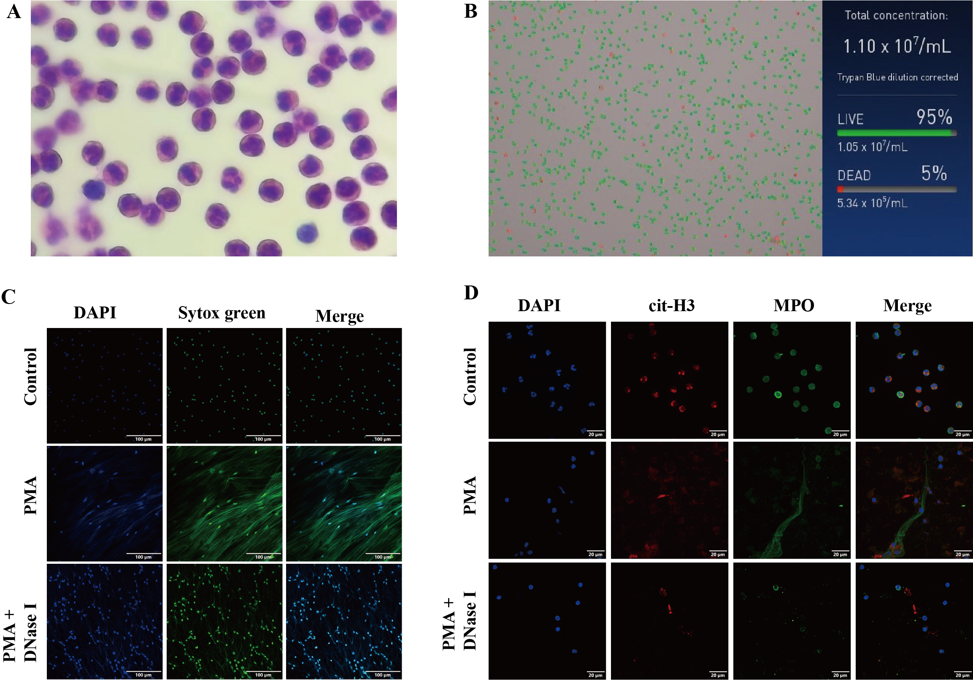
Supplementary Figure 1. Neutrophil isolation, NETs preparation and identification. (A) The characteristic multilobulated nuclear morphology of neutrophils was confirmed by Wright-Giemsa staining analysis. (B) The viability of neutrophil cells was assessed using Trypan blue staining analysis. (C) Extracellular DNA release from neutrophils was detected using Sytox Green fluorescence staining (green), while DAPI staining (blue) indicated nuclear localization. Scale bar = 100 μm. (D) NETs-specific markers, including citrullinated histone H3 (cit-H3, red) and myeloperoxidase (MPO, green), along with DAPI staining (blue) for nuclear localization, were identified using immunofluorescence confocal microscopy. Scale bar = 20 μm.
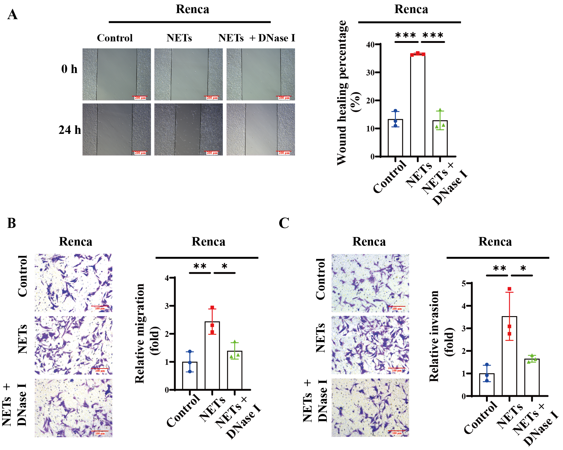
Supplementary Figure 2. NETs promoted the migration and invasion capabilities of Renca cells. The metastatic abilities of Renca cells following NETs treatment, with or without DNase I, were analyzed by wound-healing (A) and transwell assay (B-C). All experiments were independently repeated at least three times. Data are presented as mean ± SD from three independent experiments. Statistical analyses were performed using unpaired Student's t-tests.
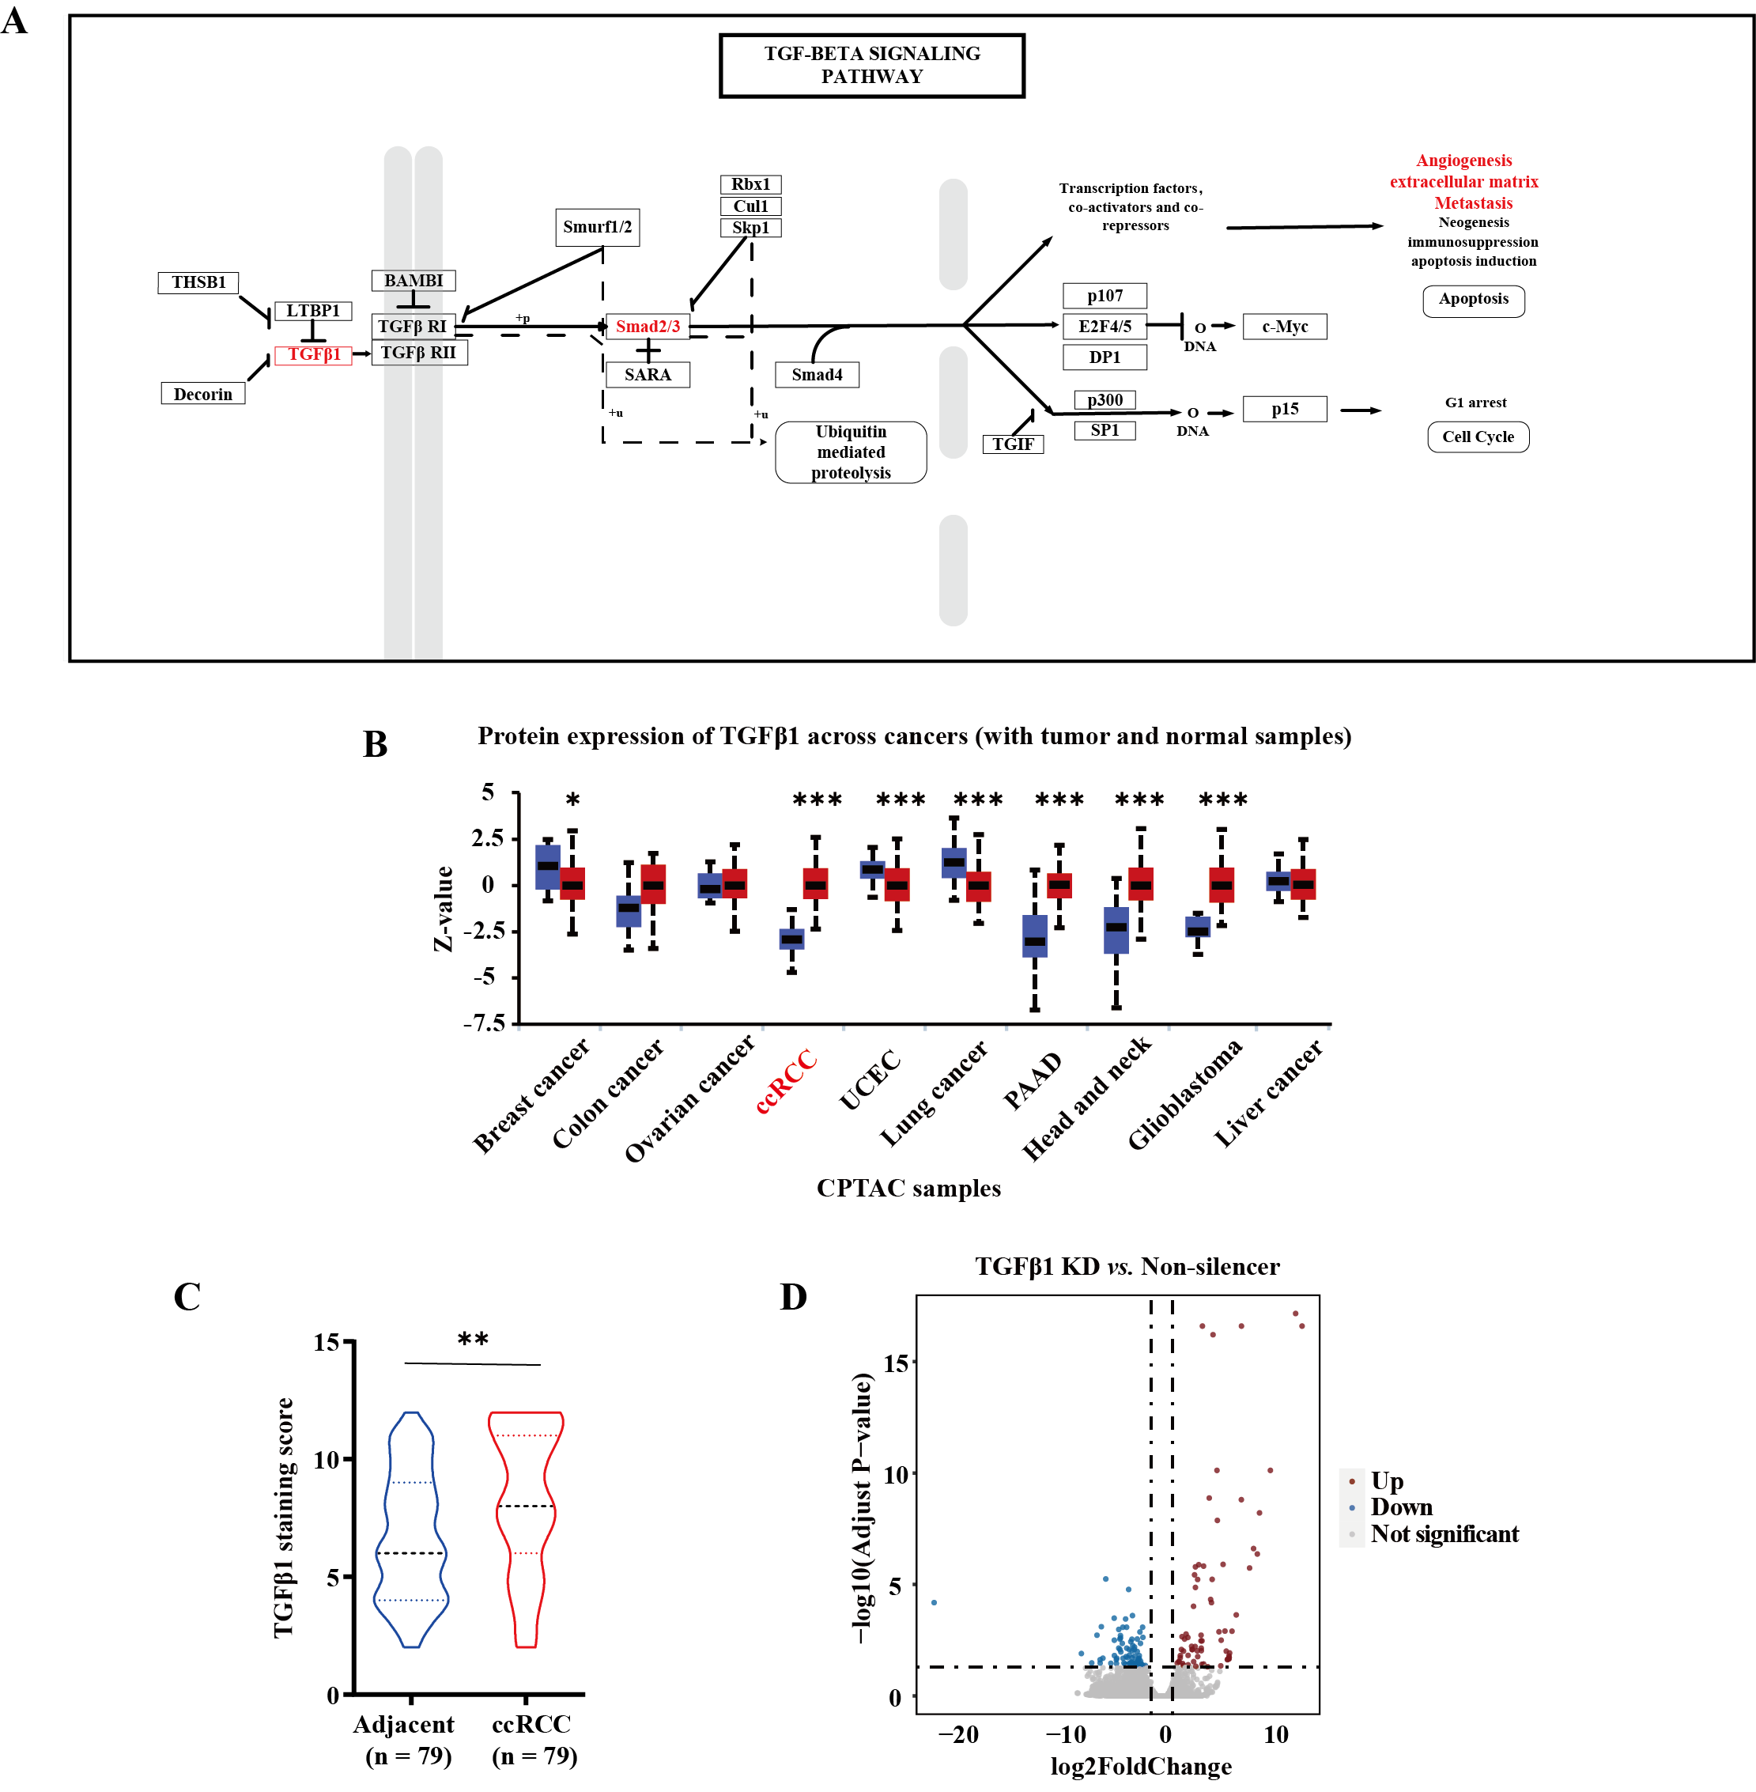
Supplementary Figure 3. (A) Schematic representation of the TGFβ1 signaling pathway. (B) The protein expression levels of TGFβ1 across different tumor types were analyzed using the UALCAN database. (C) The expression levels of TGFβ1 in ccRCC and adjacent normal tissues were analyzed using immunohistochemical staining (χ² test). (D) Volcano plot analysis of differentially expressed genes in RNA-seq assays.
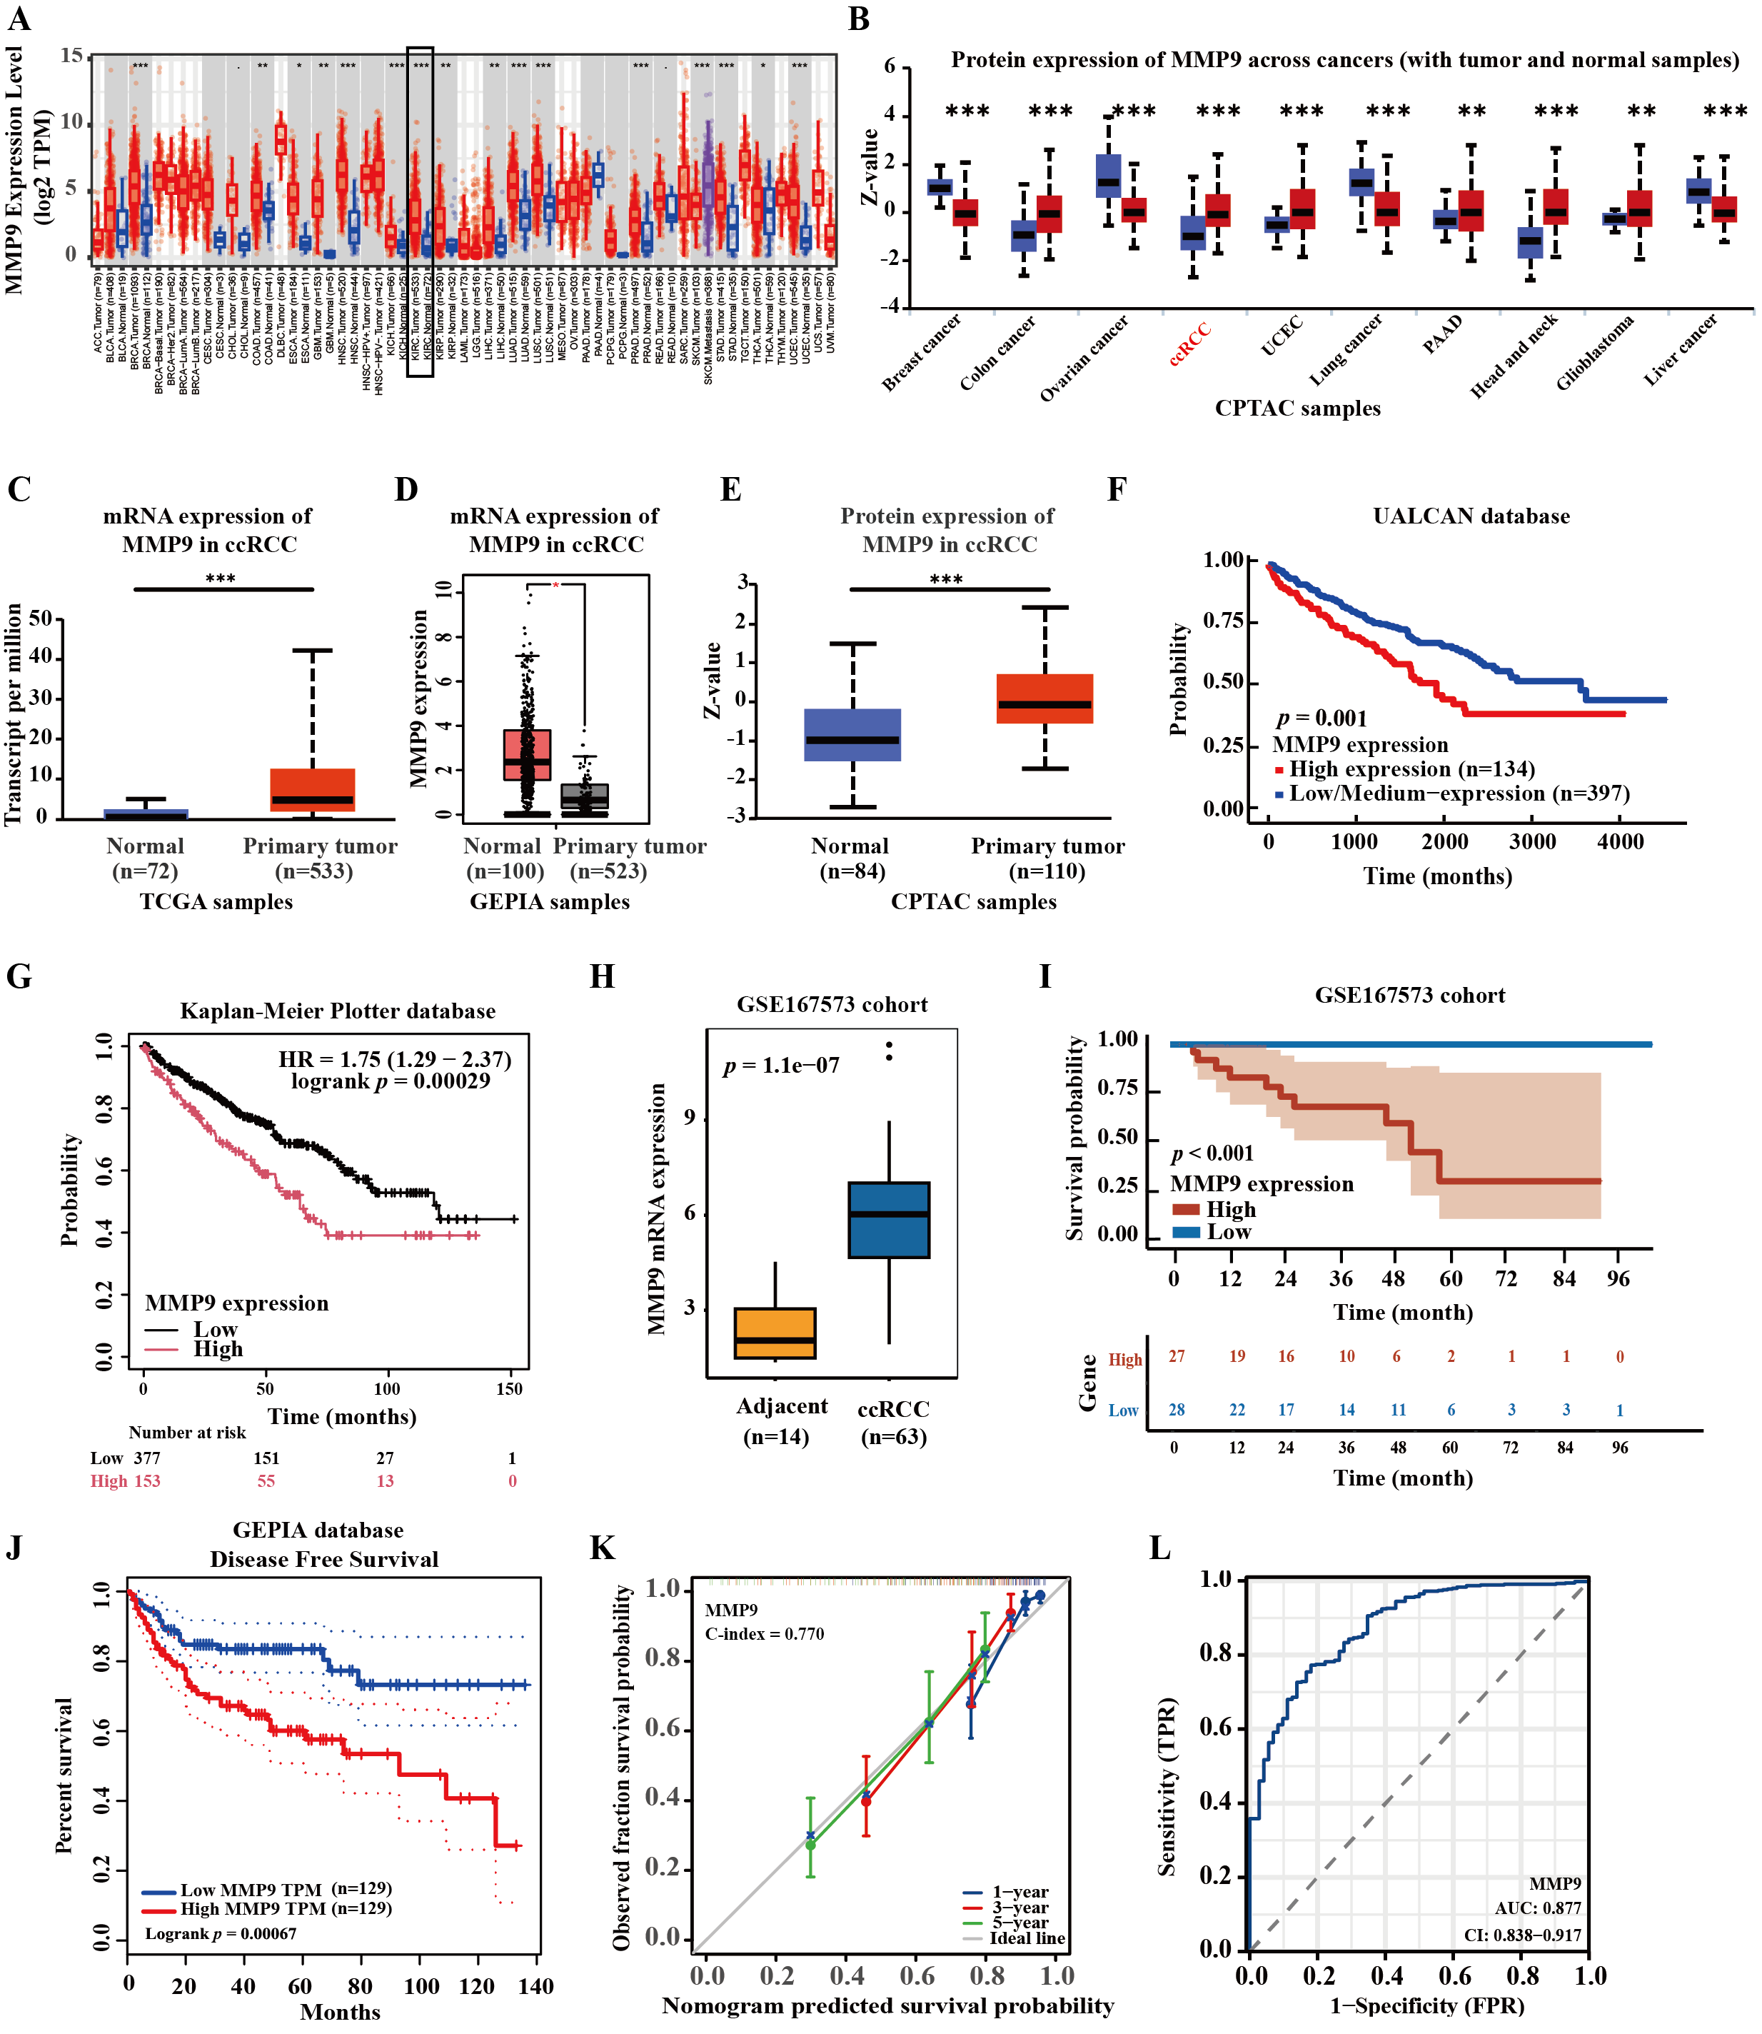
Supplementary Figure 4. MMP9 was highly expressed in ccRCC tissues and was associated with unfavorable clinical outcomes in patients with ccRCC. (A) The mRNA expression levels of MMP9 across different tumor types were analyzed using the TIMER2.0 database. (B-I) The expression of MMP9 in ccRCC tumor tissues and adjacent normal tissues, as well as its association with patient survival prognosis, was examined through data mining using the UALCAN (B-C, E-F), GEPIA (D), Kaplan-Meier Plotter (G), and GEO (GSE167573, H-I) databases. (J) The relationship between high and low expression levels of MMP9 and the disease-free survival prognosis in patients with ccRCC was analyzed through data mining based on the GEPIA database. (K-L) Calibration curve of the nomogram predicted survival probability (K), and ROC analysis of MMP9 in ccRCC (L) were conducted based on data mining from TCGA database.
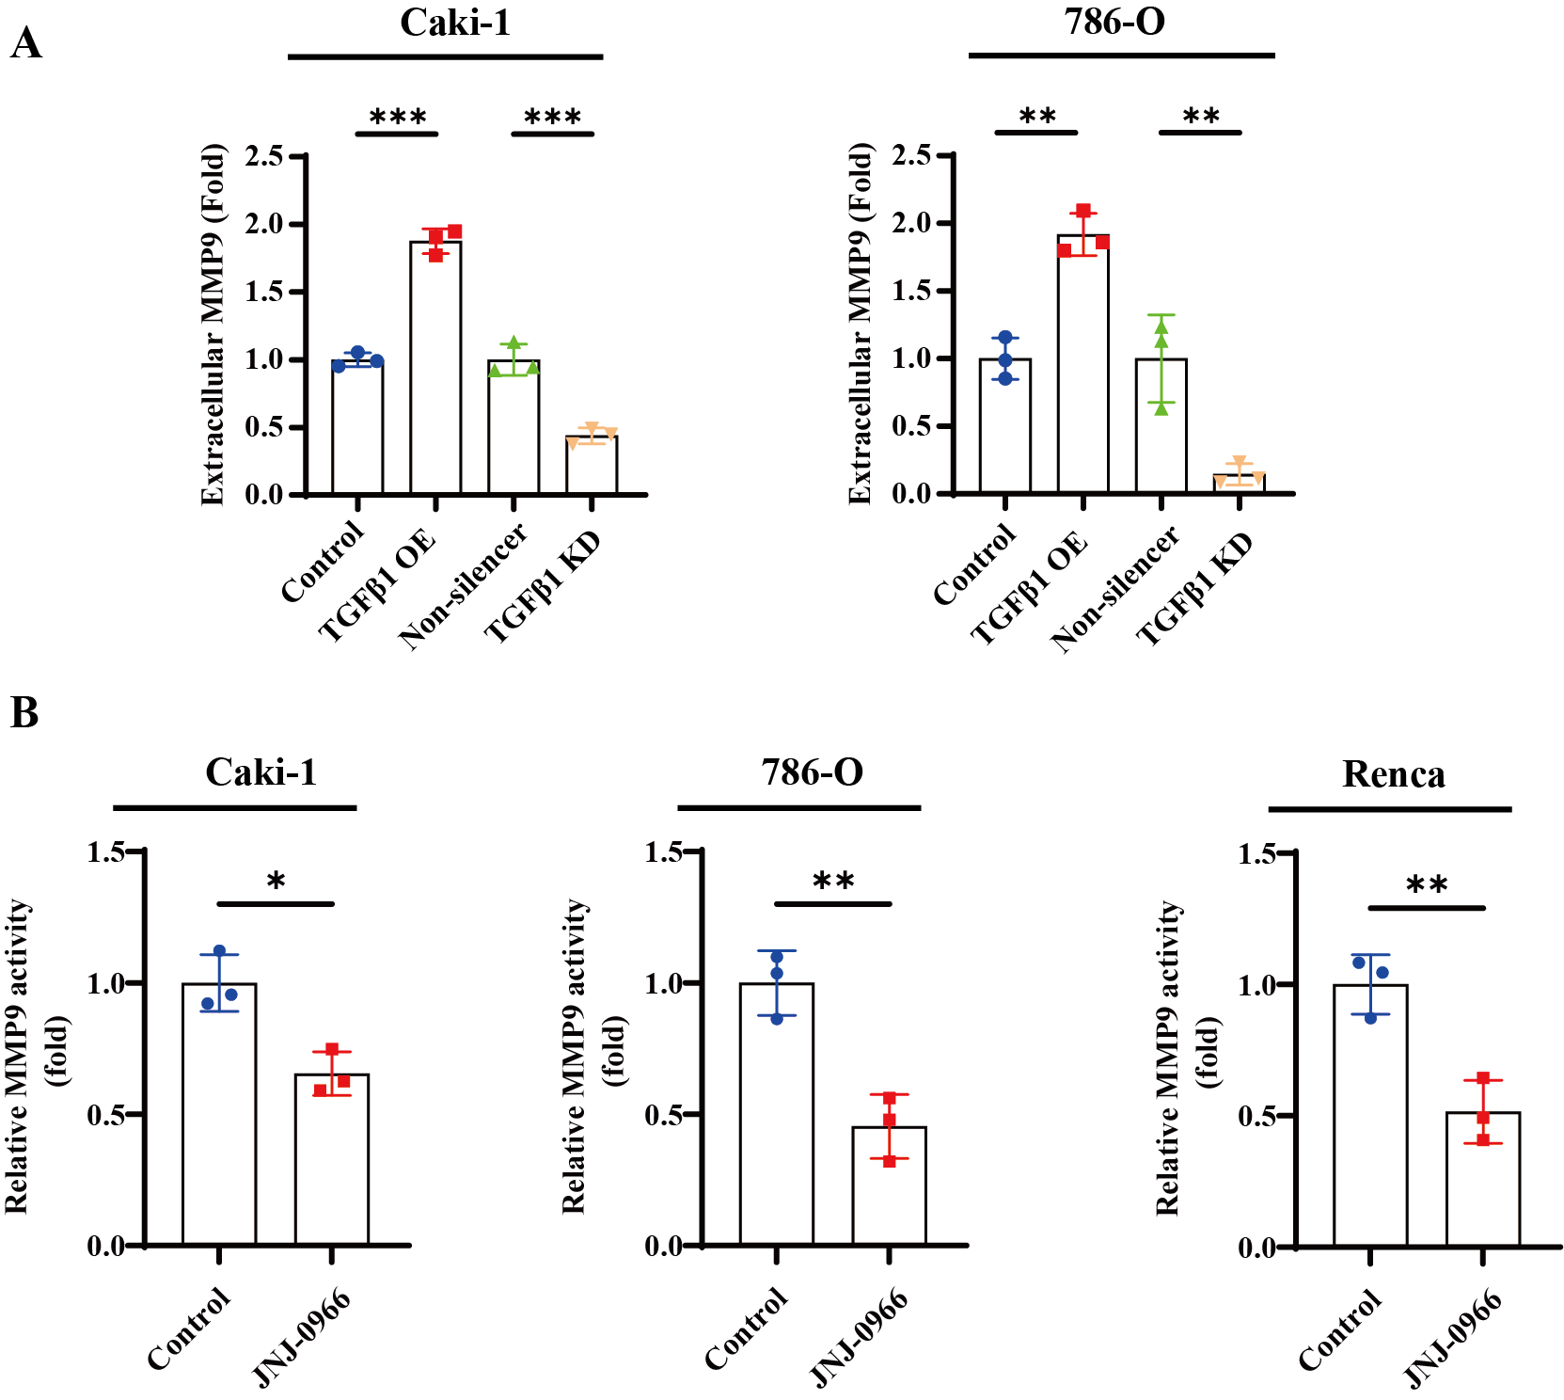
Supplementary Figure 5. Assessment of MMP9 concentration and functional activity. (A) MMP9 levels in the culture supernatants of TGFβ1 stably transfected ccRCC cell lines and their respective control cells were measured by ELISA. (B) The relative enzymatic activities of MMP9 in ccRCC cells following treatment with the MMP9 inhibitor (JNJ-0966), were evaluated using the MMP9 activity assay kit. All experiments were independently repeated at least three times. Data are presented as mean ± SD from three independent experiments. Statistical analyses were performed using unpaired Student's t-tests.

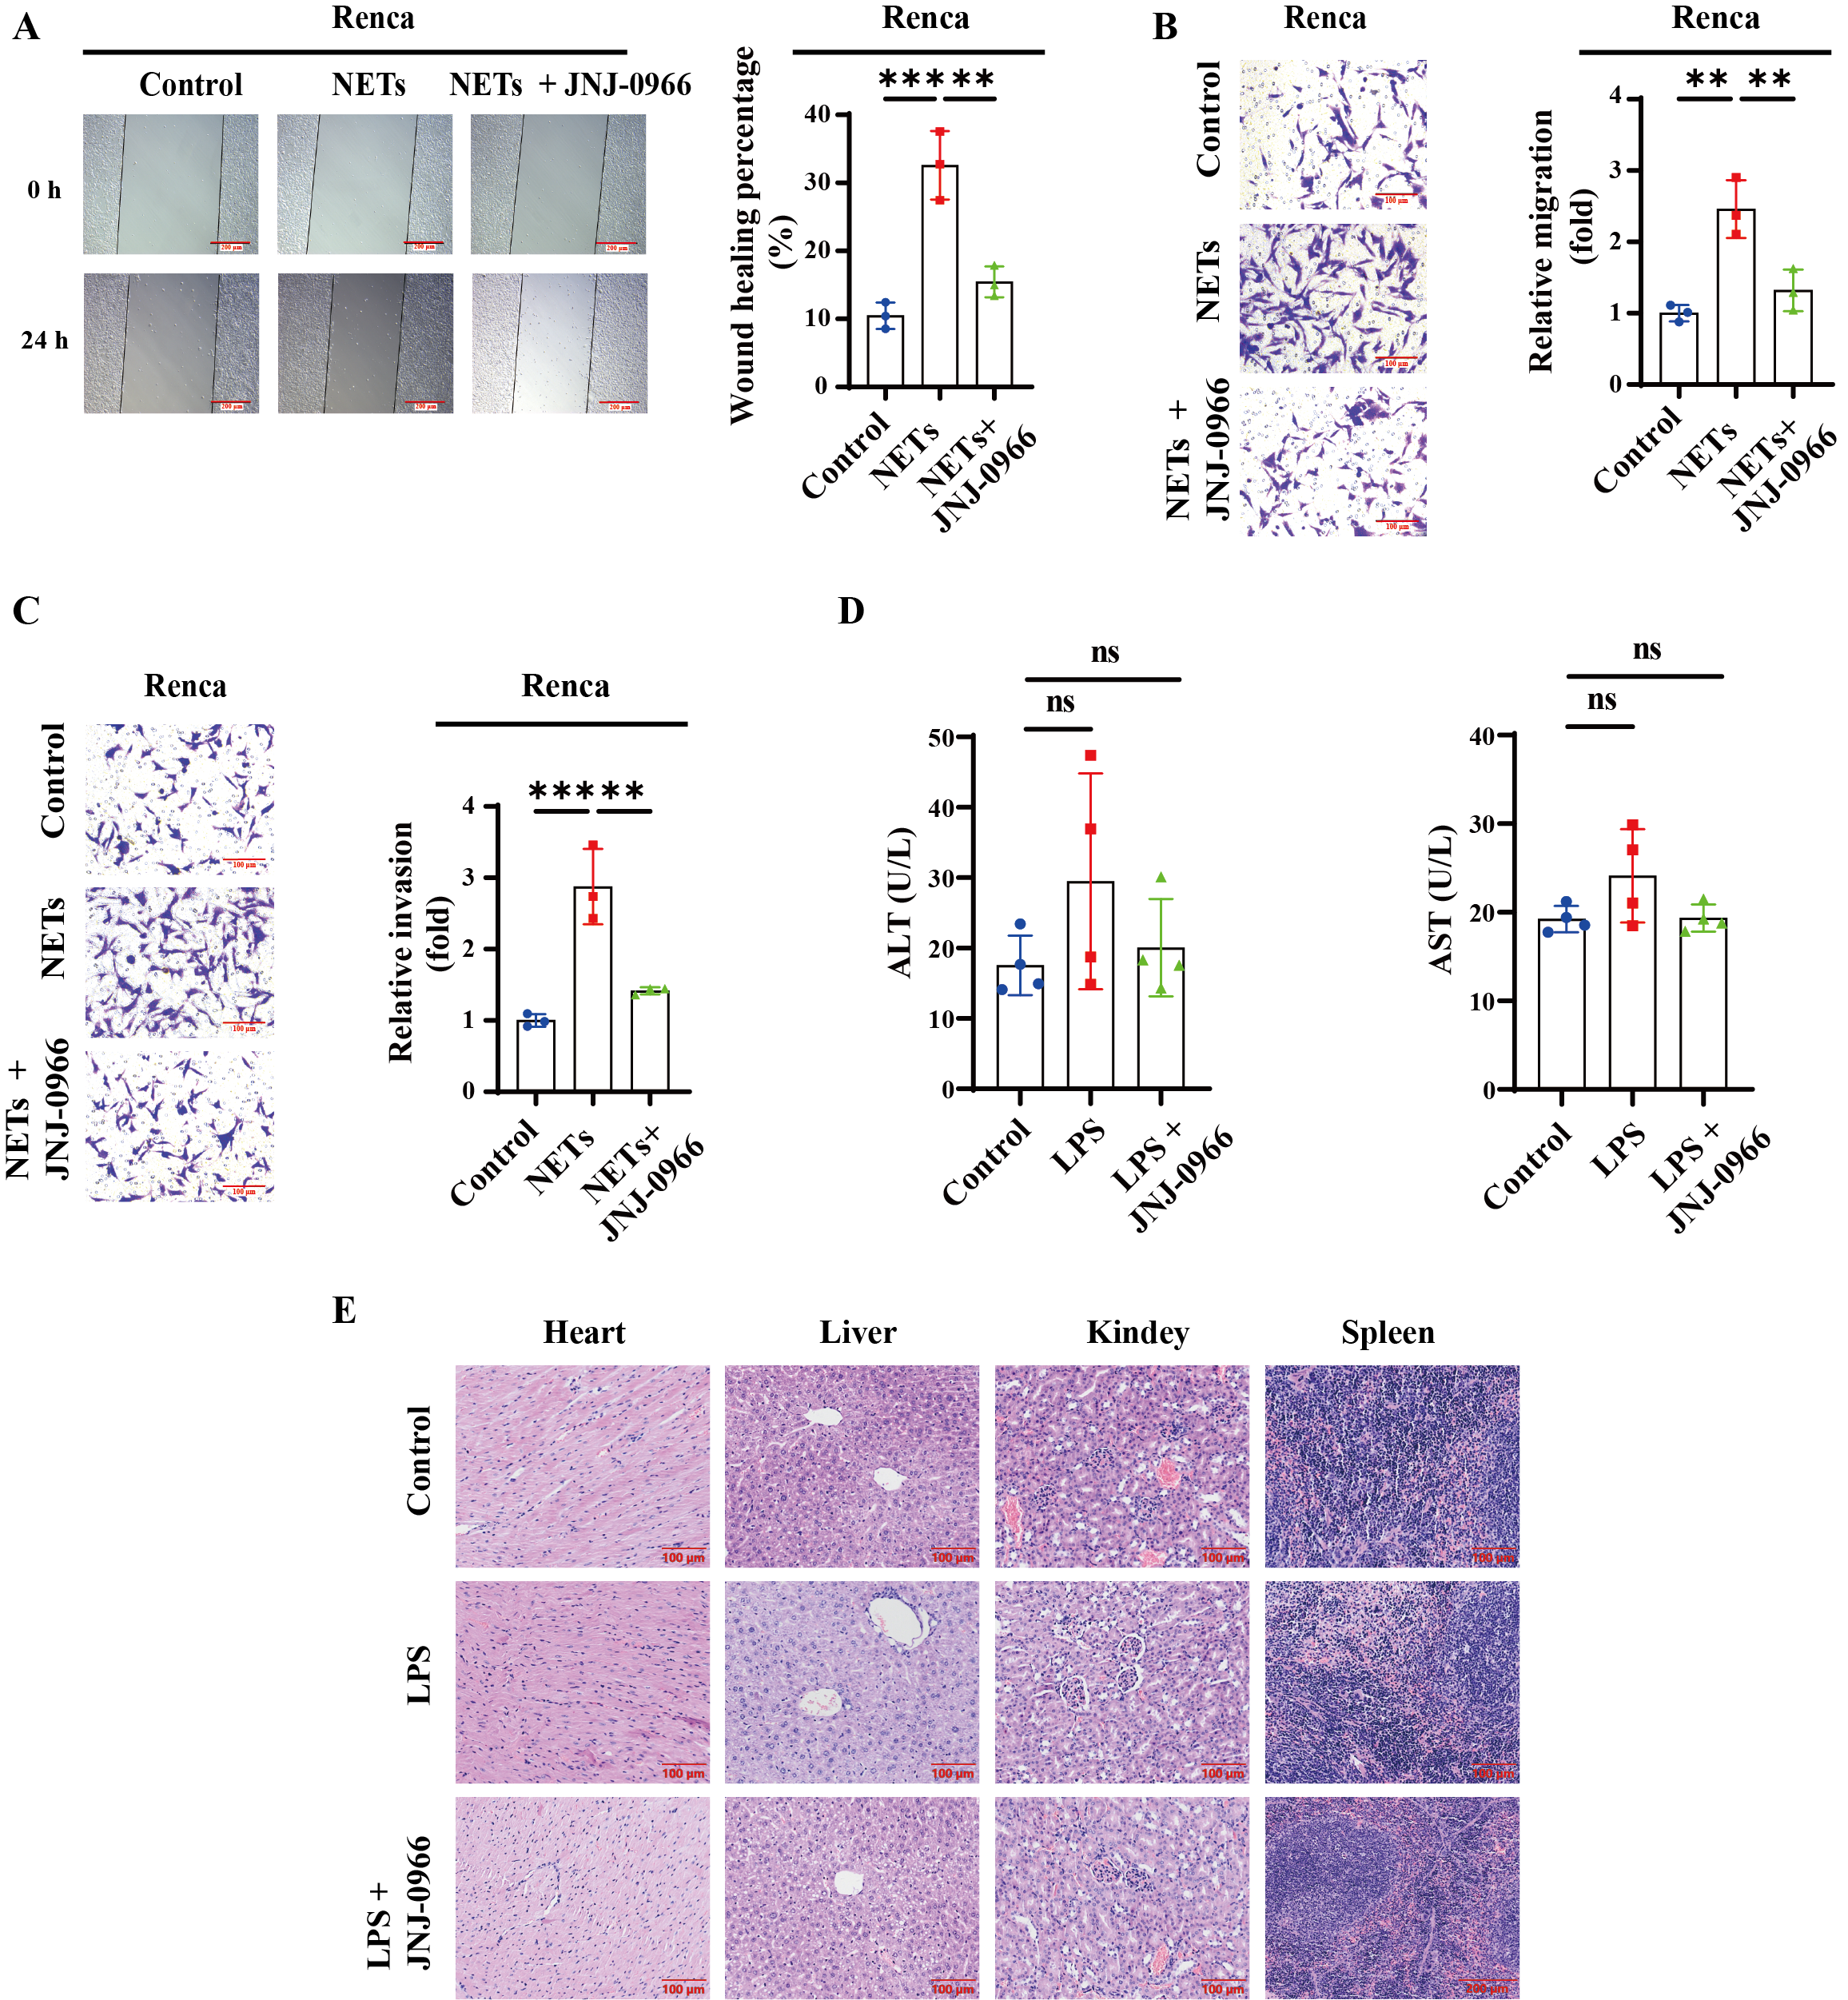
Supplementary Figure 6. MMP9 inhibitors suppressed NETs-mediated ccRCC metastasis. (A-C) The metastatic capacities of Renca cells following NETs treatment, with or without the MMP9 inhibitor (JNJ-0966), were analyzed using wound-healing (A) and transwell assays (B-C). (D) Plasma levels of ALT and AST in mice from different groups were quantified via colorimetric assays. (E) Organ damage to the heart, liver, kidney, and spleen in mice across experimental cohorts was assessed by H&E staining. All experiments were independently repeated at least three times. Data are presented as mean ± SD from three independent experiments. Statistical analyses were performed using unpaired Student's t-tests.

Supplementary Table. Correlation between TGFβ1 expression levels and clinicopathologic characteristics in ccRCC were analyzed based on data mining from TCGA database.
Characteristics | TGFβ1 Expression Levels |  | p Value
Characteristics | Low, n (%) | High, n (%) | p Value
Age |  |  | 0.699
<= 60 | 132 (24.4%) | 137 (25.3%)
> 60 | 138 (25.5%) | 134 (24.8%)
Gender |  |  | 0.398
Female | 98 (18.1%) | 89 (16.5%)
Male | 172 (31.8%) | 182 (33.6%)
Pathologic T stage |  |  | 0.017
T1&T2 | 188 (34.8%) | 162 (29.9%)
T3&T4 | 82 (15.2%) | 109 (20.1%)
Pathologic N stage |  |  | 0.287
N0 | 124 (48.1%) | 118 (45.7%)
N1 | 6 (2.3%) | 10 (3.9%)
Pathologic M stage |  |  | 0.049
M0 | 220 (43.3%) | 209 (41.1%)
M1 | 31 (6.1%) | 48 (9.4%)
Histologic grade |  |  | 0.156
G1&G2 | 132 (24.8%) | 118 (22.1%)
G3&G4 | 132 (24.8%) | 151 (28.3%)
MMP9 |  |  | < 0.001
Low | 166 (30.7%) | 104 (19.2%)
High | 104 (19.2%) | 167 (30.9%)
Significant p-value is in bold.

