Supplementary Tables

Table S1. Pig breed sample info, sampled between 16 to 20 November 2020 (No. = total number; farm names pseudonymized). Breed types: Commercials (Pietrain x Hampshires x Durocs, Large-Whites, Durocs; COMs), Hampshires (HMPs) and Large-Whites (L-Ws).
Farm | Slaughter location | Damline | Sireline | No. of pigs in batch | Breed type
W | Industry | Large White x Landrace | Pietrain x Hampshire x Duroc | 36 | COMs
W | Industry | Large White x Landrace | Pietrain x Hampshire x Duroc | 82 | COMs
W-F | Industry | Large White x Landrace | Large White | 23 | COMs
J-S | Industry | Large White x Landrace | Duroc | 89 | COMs
H | Industry | Large White x Landrace | Duroc | 98 | COMs
N-H | Industry | Large White x Landrace | Duroc | 17 | COMs
M-L | Industry | Large White x Landrace | Duroc | 1 | COMs
W-F | Industry | Large White x Landrace x Duroc | Hampshire | 122 | HMPs
W-F | Industry | Large White x Landrace x Duroc | Hampshire | 139 | HMPs
W-F | Industry | Large White x Landrace x Duroc | Hampshire | 80 | HMPs
W-F | Industry | Large White x Landrace x Duroc | Large White | 80 | L-Ws
W-F | Industry | Large White x Landrace x Duroc | Large White | 64 | L-Ws
W-F | Industry | Large White x Landrace x Duroc | Large White | 95 | L-Ws
W-F | Industry | Large White x Landrace x Duroc | Large White | 120 | L-Ws

Table S2. Breed subset (for reduced genetic variability within the commercial breed type) sample info (No. = total number; farm names pseudonymized). Breed types: Commercials (Pietrain x Hampshires x Durocs, Large-Whites, Durocs; COMs), Hampshires (HAMPs) and Large-Whites (L-Ws).
Farm | Slaughter location | Damline | Sireline | No. of pigs in batch | Breed type
J-S | Industry | Large White x Landrace | Duroc | 87 | COMs
H | Industry | Large White x Landrace | Duroc | 98 | COMs
N-H | Industry | Large White x Landrace | Duroc | 14 | COMs
M-L | Industry | Large White x Landrace | Duroc | 1 | COMs
W-F | Industry | Large White x Landrace x Duroc | Hampshire | 71 | HMPs
W-F | Industry | Large White x Landrace x Duroc | Hampshire | 82 | HMPs
W-F | Industry | Large White x Landrace x Duroc | Hampshire | 47 | HMPs
W-F | Industry | Large White x Landrace x Duroc | Large White | 44 | L-Ws
W-F | Industry | Large White x Landrace x Duroc | Large White | 36 | L-Ws
W-F | Industry | Large White x Landrace x Duroc | Large White | 53 | L-Ws
W-F | Industry | Large White x Landrace x Duroc | Large White | 67 | L-Ws

Table S3. Boar taint sample info (/ = information unknown; No. = total number; company names were pseudonymized).
Phase I | Date of sampling | Company | Slaughterhouse (location) | No. of boars in batch | No. of pigs in batch | Batch info
 | 25-04-2018 | T | Tielt | 45 | 165 | /
 | 31-05-2018 | M | Tielt | 121 | 252 | Porkers
 | 01-05-2018 | W-S | Tielt | 165 | 184 | Sow line Certus
 | 14-06-2018 | P | Tielt | 222 | 365 | Sow line Certus
 | 26-06-2018 | W-S | Tielt | 176 | 373 | Sow line Certus
 | 10-07-2018 | W-S | Tielt | 117 | 381 | Sow line Certus
 | 06-09-2018 | W-S | Tielt | 118 | 200 | Sow line Certus
 | 17-09-2018 | W-S | Tielt | 216 | 400 | Sow line Certus
 | 19-09-2018 | W | Tielt | 40 | 70 | Porkers
 | 26-09-2018 | / | Westerlo | 70 | 80 | Better Life label
 | 26-09-2018 | / | Westerlo | 515 | 515 | Better Life label
 | 03-10-2018 | W-S | Tielt | 237 | 306 | Sow line
 | 09-10-2018 | P | Tielt | 13 | 190 | Sow line Certus
Phase II
 | 21-11-2018 | / | Westerlo | 207 | / | Better Life label
 | 04-12-2018 | / | Westerlo | 347 | / | Better Life label

Table S4. Instrument settings for pig breed and boar taint classification using REIMS.
 | Pig breed | Boar taint
MS
Ionisation mode | Negative | Negative
Scan range | 50 – 1200 Da | 400 – 1200 Da
Scan rate | 0.5 s | 0.5 s
Cone voltage | 40 V | 40 V
Heater bias | 40 V | 30 V
Probe
Power | 40 V | 40 V
Number of burns per sample | 5 | 2
Duration of 1 burn | 3 s | 2 s
Time in between burns | 3 – 4 s | 2 – 3 s

Table S5. Hyperparameter optimisation parameters of SVM and RF algorithms. Other parameters used the default parameters (e.g. Gini importance as criteria in RF).
Classification goal | Algorithm | Parameter | Range tested
Breed | SVM | C | 0.001, 0.1, 10, 100, 1000000
 |  | Gamma | 0.1, 0.01
 |  | Kernel | 'linear', 'poly', 'RBF'
Breed | RF | N estimators | 10, 25, 50, 100, 250, 500
 |  | Min samples leaf | 1, 3
 |  | Max leaf nodes | 10, 20, 35, 50, None
 |  | Max depth | 15, 30, 75, 125, None
Boar taint | SVM | C | 0.001, 0.1, 10, 100, 1000000
 |  | Gamma | 0.1, 0.01
 |  | Kernel | 'linear', 'poly', 'RBF'
Boar taint | RF | N estimators | 10, 25, 50, 100, 250, 500
 |  | Min samples leaf | 1, 3
 |  | Max leaf nodes | 10, 20, 35, 50, None
 |  | Max depth | 15, 30, 75, 125, None

Table S6. Classification confusion matrix of OPLS-DA for the overall breed dataset (n=1046; COMs=346, HMPs=341, L-Ws=359).
True Class | Predicted class |  |  | Accuracy | Precision | Recall | Specificity | F1-Score
 | COMs | HMPs | L-Ws
COMs vs. HMPs
COMs | 310 | 32 | 0 | 0.9050 | 0.9064 | 0.9038 | 0.9062 | 0.9051
HMPs | 33 | 309 | 0 |  | 0.9035 | 0.9038 | 0.9038 | 0.9048
HMPs vs. L-Ws
HMPs | 0 | 293 | 31 | 0.9152 | 0.9043 | 0.9156 | 0.9148 | 0.9099
L-Ws | 0 | 27 | 333 |  | 0.9250 | 0.9148 | 0.9156 | 0.9199
COMs vs. L-Ws
COMs | 306 | 0 | 29 | 0.9269 | 0.9134 | 0.9358 | 0.9188 | 0.9245
L-Ws | 21 | 0 | 328 |  | 0.9398 | 0.9188 | 0.9358 | 0.9292

Table S7. Classification confusion matrix of OPLS-DA for the breed subset (n=600; Durocs=200, HMPs=200, L-Ws=200).
True Class | Predicted class |  |  | Accuracy | Precision | Recall | Specificity | F1-Score
 | COMs | HMPs | L-Ws
COMs vs. HMPs
COMs | 193 | 8 | 0 | 0.9450 | 0.9602 | 0.9324 | 0.9585 | 0.9461
HMPs | 14 | 185 | 0 |  | 0.9296 | 0.9585 | 0.9324 | 0.9439
HMPs vs. L-Ws
HMPs | 0 | 151 | 29 | 0.8575 | 0.8389 | 0.8436 | 0.8688 | 0.8412
L-Ws | 0 | 28 | 192 |  | 0.8727 | 0.8688 | 0.8436 | 0.8707
COMs vs. L-Ws
COMs | 170 | 0 | 19 | 0.9175 | 0.8995 | 0.9239 | 0.9120 | 0.9115
L-Ws | 14 | 0 | 197 |  | 0.9336 | 0.9120 | 0.9239 | 0.9227

Table S8. Classification confusion matrix of SVM for the overall breed dataset (n=1046; COMs=346, HMPs=341, L-Ws=359).
True Class | Predicted class |  |  | Accuracy | Precision | Recall | Specificity | F1-Score
 | COMs | HMPs | L-Ws
COMs vs. HMPs
COMs | 318 | 24 | 0 | 0.9313 | 0.9326 | 0.9298 | 0.9328 | 0.9312
HMPs | 23 | 319 | 0 |  | 0.9300 | 0.9328 | 0.9298 | 0.9314
HMPs vs. L-Ws
HMPs | 0 | 287 | 40 | 0.8953 | 0.8969 | 0.8777 | 0.9108 | 0.8872
L-Ws | 0 | 33 | 337 |  | 0.8939 | 0.9108 | 0.8777 | 0.9023
COMs vs. L-Ws
COMs | 314 | 0 | 27 | 0.9458 | 0.9662 | 0.9208 | 0.9694 | 0.9429
L-Ws | 11 | 0 | 349 |  | 0.9282 | 0.9694 | 0.9208 | 0.9484

Table S9. Classification confusion matrix of SVM for the breed subset (n=600; Durocs=200, HMPs=200, L-Ws=200).
True Class | Predicted class |  |  | Accuracy | Precision | Recall | Specificity | F1-Score
 | COMs | HMPs | L-Ws
COMs vs. HMPs
COMs | 193 | 8 | 0 | 0.9408 | 0.9234 | 0.9602 | 0.9196 | 0.9415
HMPs | 16 | 183 | 0 |  | 0.9581 | 0.9196 | 0.9602 | 0.9385
HMPs vs. L-Ws
HMPs | 0 | 190 | 25 | 0.9045 | 0.9360 | 0.8837 | 0.9297 | 0.9091
L-Ws | 0 | 13 | 172 |  | 0.8731 | 0.9297 | 0.8837 | 0.9005
COMs vs. L-Ws
COMs | 200 | 0 | 8 | 0.9624 | 0.9662 | 0.9639 | 0.9635 | 0.9639
L-Ws | 7 | 0 | 185 |  | 0.9585 | 0.9635 | 0.9639 | 0.9610

Table S10. Model hyperparameters of SVM models for pairwise comparisons among the three breed categories in the overall dataset and (reduced genetic variability) breed subset; and boar taint datasets, as calculated on the training sets.
Model | Kernel | C | Gamma (γ)
All
COMs vs. HMPs | Linear | 0.1 | 0.1
HMPs vs. L-Ws | Linear | 0.001 | 0.01
COMs vs. L-Ws | Linear | 100 | 0.1
Subset
COMs vs. HMPs | Linear | 0.001 | 0.1
HMPs vs. L-Ws | Linear | 0.1 | 0.1
COMs vs. L-Ws | Linear | 0.1 | 0.1
Phase I boar taint
Overall | Polynomial | 100 | 0.1
Balanced | Polynomial | 1000000 | 0.1
Phase II boar taint
Overall | Polynomial | 1000000 | 0.01
Balanced | Linear | 100 | 0.1

Table S11. Model parameters of RF models for pairwise comparisons among the three breed categories in the overall dataset and (reduced genetic variability) breed subset; and boar taint datasets, as calculated on the training sets.
Model | n trees | Min samples leaf | Max leaf nodes | Max depth
Overall breed
COMs vs. HMPs | 500 | 3 | 35 | 75
HMPs vs. L-Ws | 50 | 1 | None | None
COMs vs. L-Ws | 500 | 3 | None | 125
Breed subset
COMs vs. HMPs | 500 | 1 | None | 30
HMPs vs. L-Ws | 50 | 3 | None | 15
COMs vs. L-Ws | 100 | 3 | 3 | None
Phase I boar taint
Overall | 100 | 3 | 10 | 15
Balanced | 50 | 3 | 10 | 30
Phase II boar taint
Overall | 100 | 3 | 20 | 75
Balanced | 100 | 3 | 20 | None

Table S12. Classification confusion matrix of RF for the overall breed dataset (n=1046; COMs=346, HMPs=341, L-Ws=359).
True Class | Predicted class |  |  | Accuracy | Precision | Recall | Specificity | F1-Score
 | COMs | HMPs | L-Ws
COMs vs. HMPs
COMs | 262 | 80 | 0 | 0.7909 | 0.8062 | 0.7661 | 0.8158 | 0.7856
HMPs | 63 | 279 | 0 |  | 0.7772 | 0.8158 | 0.7661 | 0.7960
HMPs vs. L-Ws
HMPs | 0 | 231 | 96 | 0.7202 | 0.7000 | 0.7064 | 0.7324 | 0.7032
L-Ws | 0 | 99 | 271 |  | 0.7384 | 0.7324 | 0.7064 | 0.7354
COMs vs. L-Ws
COMs | 262 | 0 | 79 | 0.7946 | 0.8012 | 0.7683 | 0.8194 | 0.7844
L-Ws | 65 | 0 | 295 |  | 0.7888 | 0.8194 | 0.7683 | 0.8038

Table S13. Classification confusion matrix of RF for the breed subset (n=600; Durocs=200, HMPs=200, L-Ws=200).
True Class | Predicted class |  |  | Accuracy | Precision | Recall | Specificity | F1-Score
 | COMs | HMPs | L-Ws
COMs vs. HMPs
COMs | 177 | 24 | 0 | 0.8701 | 0.8634 | 0.8806 | 0.8593 | 0.8719
HMPs | 28 | 171 | 0 |  | 0.8769 | 0.8593 | 0.8806 | 0.8680
HMPs vs. L-Ws
HMPs | 0 | 141 | 74 | 0.7125 | 0.7747 | 0.6558 | 0.7784 | 0.7103
L-Ws | 0 | 41 | 144 |  | 0.6606 | 0.7784 | 0.6558 | 0.7146
COMs vs. L-Ws
COMs | 172 | 0 | 36 | 0.8375 | 0.8557 | 0.8269 | 0.8490 | 0.8411
L-Ws | 29 | 0 | 163 |  | 0.8191 | 0.8490 | 0.8269 | 0.8338

Table S14. Classification confusion matrices of OPLS-DA boar taint models (test set results).
True Class | Predicted class |  | Accuracy | Precision | Recall | Specificity | F1-Score
 | Tainted | Untainted
Phase I overall
Tainted | 9 | 15 | 0.9418 | 0.3750 | 0.9000 | 0.9434 | 0.5294
Untainted | 1 | 250 |  | 0.9960 | 0.9434 | 0.9000 | 0.9690
Phase I balanced
Tainted | 24 | 2 | 0.9592 | 0.9231 | 1.0000 | 0.9200 | 0.9600
Untainted | 0 | 23 |  | 1.0000 | 0.9200 | 1.0000 | 0.9583
Phase II overall
Tainted | 6 | 11 | 0.7170 | 0.3529 | 0.6000 | 0.7442 | 0.4444
Untainted | 4 | 32 |  | 0.8889 | 0.7442 | 0.6000 | 0.8101
Phase II balanced
Tainted | 8 | 8 | 0.6061 | 0.5000 | 0.6154 | 0.6000 | 0.5517
Untainted | 5 | 12 |  | 0.7059 | 0.6000 | 0.6154 | 0.6486

Table S15. Classification confusion matrices of SVM boar taint models (test set results).
True Class | Predicted class |  | Accuracy | Precision | Recall | Specificity | F1-Score
 | Tainted | Untainted
Phase I overall
Tainted | 8 | 16 | 0.9345 | 0.3333 | 0.8000 | 0.9396 | 0.4706
Untainted | 2 | 249 |  | 0.9920 | 0.9396 | 0.8000 | 0.9651
Phase I balanced
Tainted | 24 | 2 | 0.9388 | 0.9231 | 0.9600 | 0.9167 | 0.9412
Untainted | 1 | 22 |  | 0.9565 | 0.9167 | 0.9600 | 0.9362
Phase II overall
Tainted | 4 | 13 | 0.7358 | 0.2353 | 0.8000 | 0.7292 | 0.3636
Untainted | 1 | 35 |  | 0.9722 | 0.7292 | 0.8000 | 0.8333
Phase II balanced
Tainted | 11 | 5 | 0.6970 | 0.6875 | 0.6875 | 0.7059 | 0.6875
Untainted | 5 | 12 |  | 0.7059 | 0.7059 | 0.6875 | 0.7059

Table S16. Classification confusion matrices of RF boar taint models (test set results).
True Class | Predicted class |  | Accuracy | Precision | Recall | Specificity | F1-Score
 | Tainted | Untainted
Phase I overall
Tainted | 10 | 14 | 0.9455 | 0.4167 | 0.9091 | 0.9470 | 0.5714
Untainted | 1 | 250 |  | 0.9960 | 0.9470 | 0.9091 | 0.9709
Phase I balanced
Tainted | 25 | 1 | 0.9592 | 0.9615 | 0.9615 | 0.9565 | 0.9615
Untainted | 1 | 22 |  | 0.9565 | 0.9565 | 0.9615 | 0.9565
Phase II overall
Tainted | 1 | 16 | 0.6981 | 0.0588 | 1.0000 | 0.6923 | 0.1111
Untainted | 0 | 36 |  | 1.0000 | 0.6923 | 1.0000 | 0.8182
Phase II balanced
Tainted | 9 | 7 | 0.6970 | 0.5625 | 0.7500 | 0.6667 | 0.6429
Untainted | 3 | 14 |  | 0.8235 | 0.6667 | 0.7500 | 0.7368

Supplementary Figures

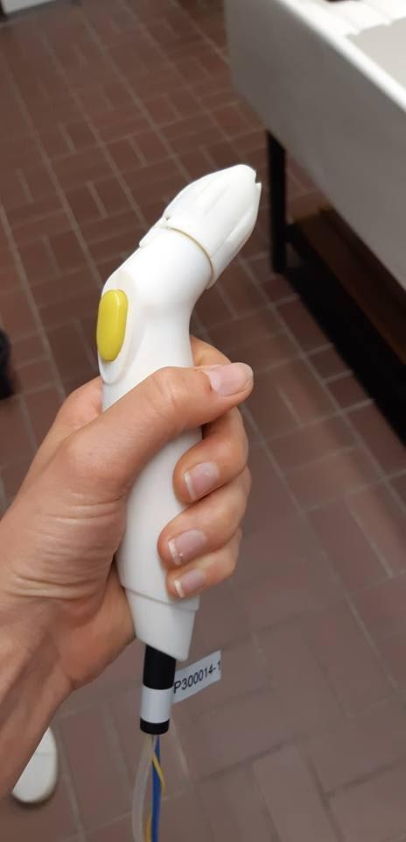
Figure S1: Picture of the hand-held, 3D-printed ‘fat probe’ designed for at-line application. The fat probe is a bi-polar probe, with the addition of a spacer and sheath to avoid short-circuit. Optimisation included the development of a more ergonomic and user-friendly design, strengthening of probe arms to reduce twisting / movement during sampling and a more durable connection of wires and tubing to the hand piece.

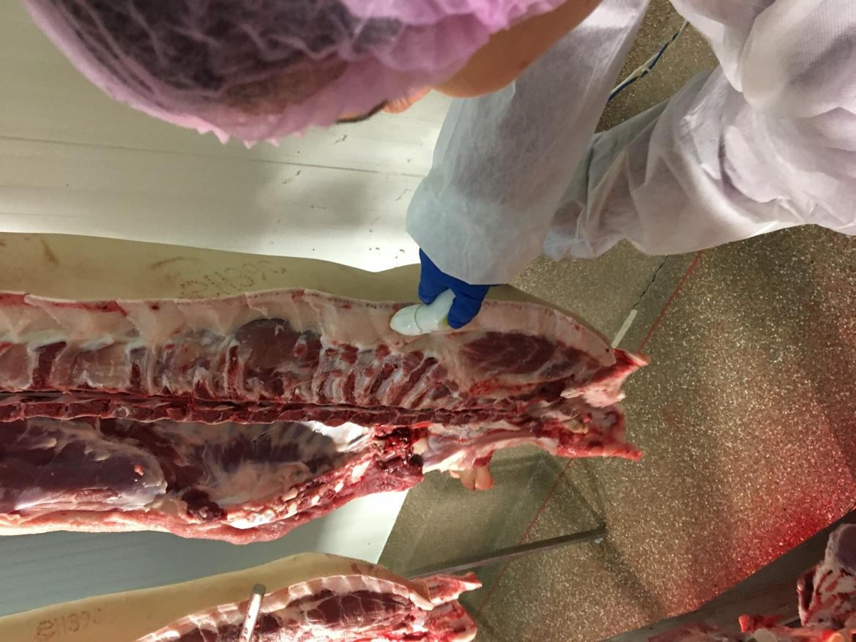
Figure S2: Picture of the application of the fat probe.

