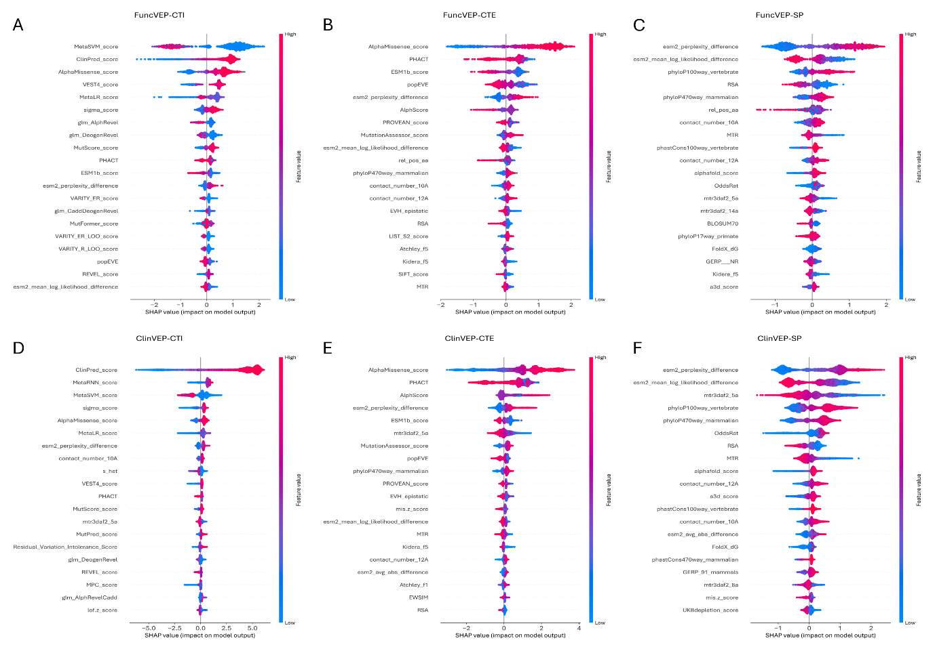
Extended Data Fig. 1. SHAP summary plots of feature impact on model output. SHAP values quantify the contribution of each feature to individual predictions. For each model, the top 20 features ranked by overall impact are shown on the y‑axis, and the x‑axis represents the magnitude and direction of impact. Each point corresponds to one variant, with feature values encoded by color (red = high feature value, blue = low feature value). Points to the right indicate contributions toward predicting a variant as damaging; points to the left indicate contributions toward predicting a variant as neutral. For example, high values of protein language model–derived features (e.g., ESM2 perplexity difference) tend to shift predictions toward damaging. (A) FuncVEP‑CTI, (B) FuncVEP‑CTE, (C) FuncVEP‑SP, (D) ClinVEP‑CTI, (E) ClinVEP‑CTE, and (F) ClinVEP‑SP.
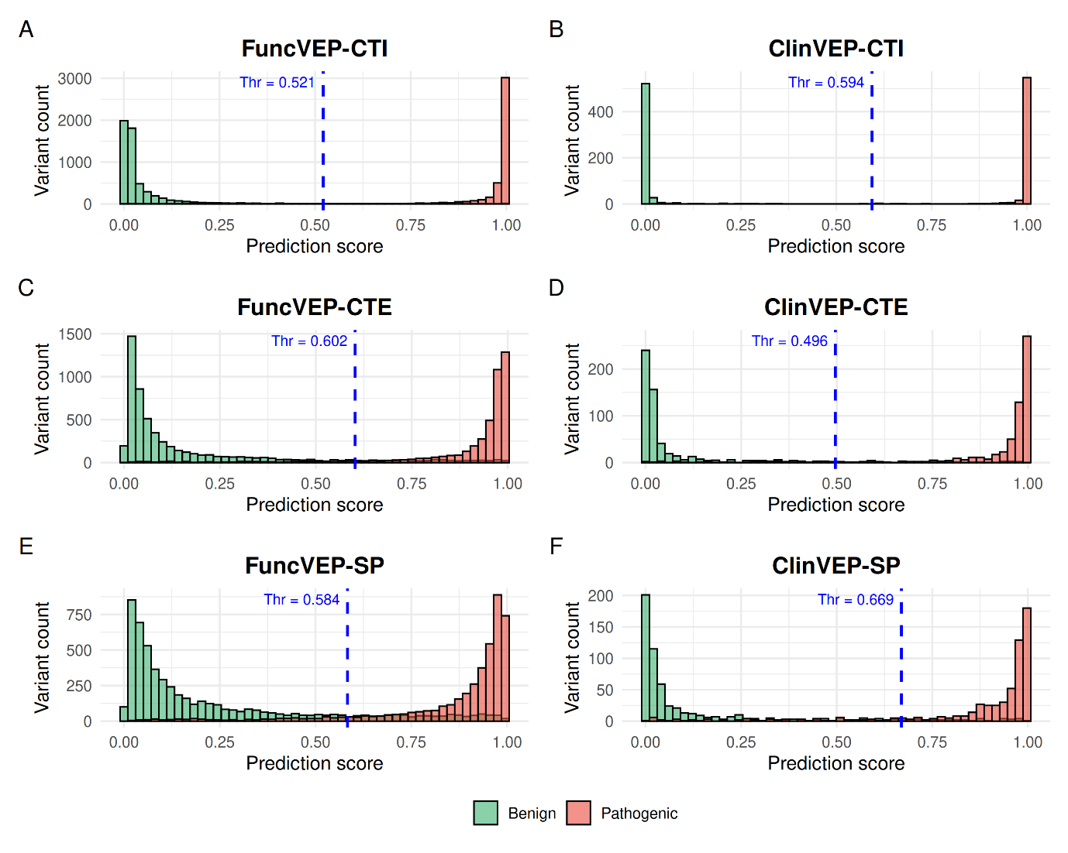
Extended Data Fig. 2. Distribution of model scores and decision thresholds on the clinical dataset. Histograms display the distribution of pathogenic (red) and benign (green) variants from the clinical dataset across the output scores of each model, illustrating the degree of separation between the two classes. The x-axis shows the model output score, and the y-axis indicates the number of variants in each score bin. Blue dashed lines represent the optimized binary decision thresholds used for classification, with the corresponding threshold values labeled above each line. (A) FuncVEP-CTI, (B) ClinVEP-CTI, (C) FuncVEP-CTE, (D) ClinVEP-CTE, (E) FuncVEP-SP, and (F) ClinVEP-SP.
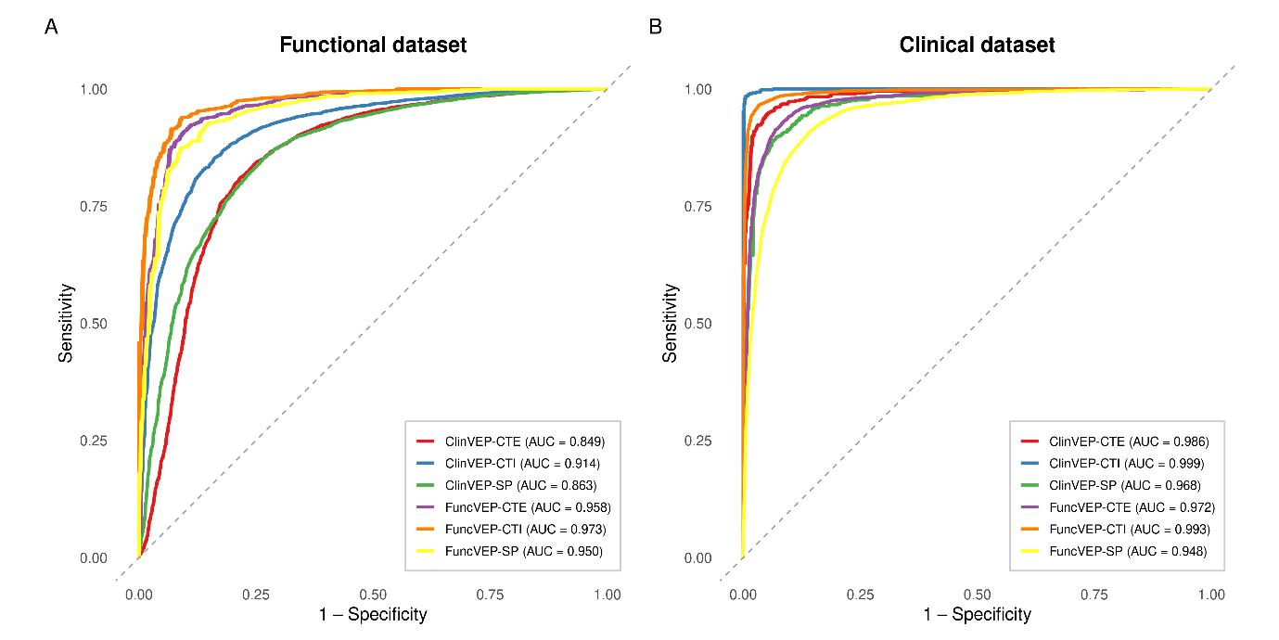
Extended Data Fig. 3. Receiver operating characteristic (ROC) curves for the six models evaluated on the functional and clinical datasets. ROC curves for all six models are shown on a single plot. (A) Performance on the functional dataset. (B) Performance on the clinical dataset.
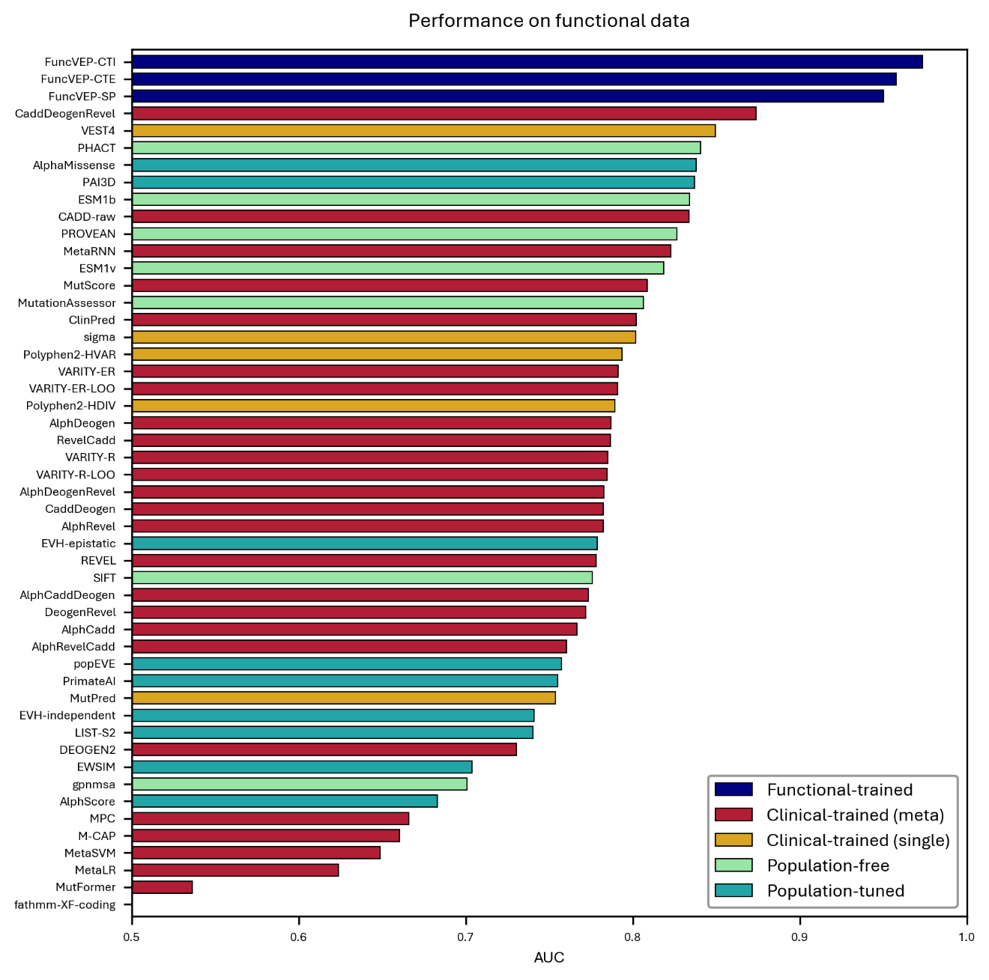
Extended Data Fig. 4. Performance of 50 VEPs on the functional dataset. Bar plot showing the AUC of each variant effect predictor on the functional dataset. The x‑axis represents AUC values, and the y‑axis lists the individual tools.

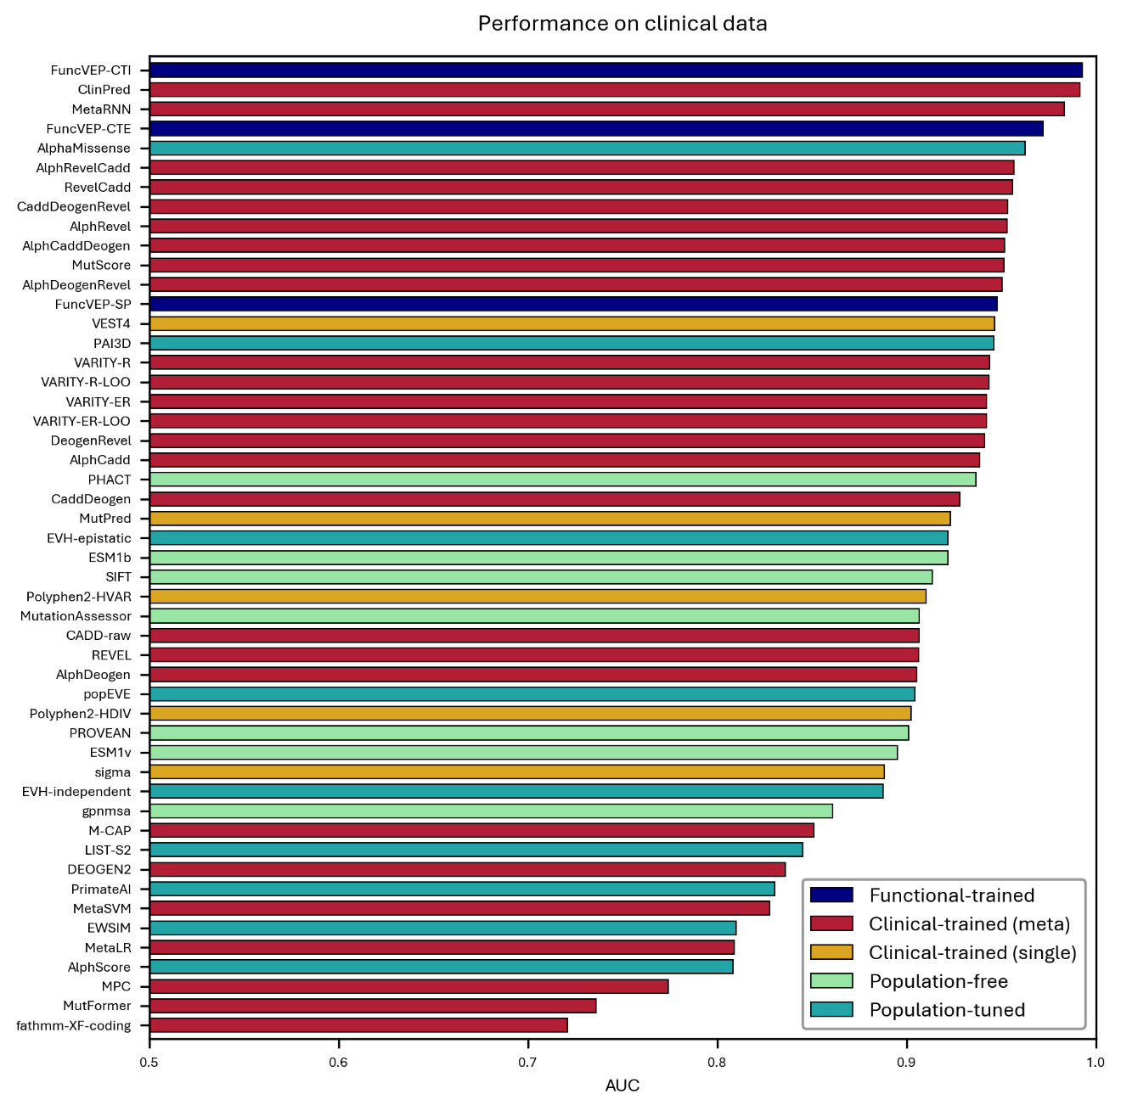
Extended Data Fig. 5. Performance of 50 VEPs on the clinical dataset. Bar plot showing the AUC of each variant effect predictor on the clinical dataset. Bars are color-coded by tool category. The x-axis represents AUC values, and the y-axis lists individual predictors.
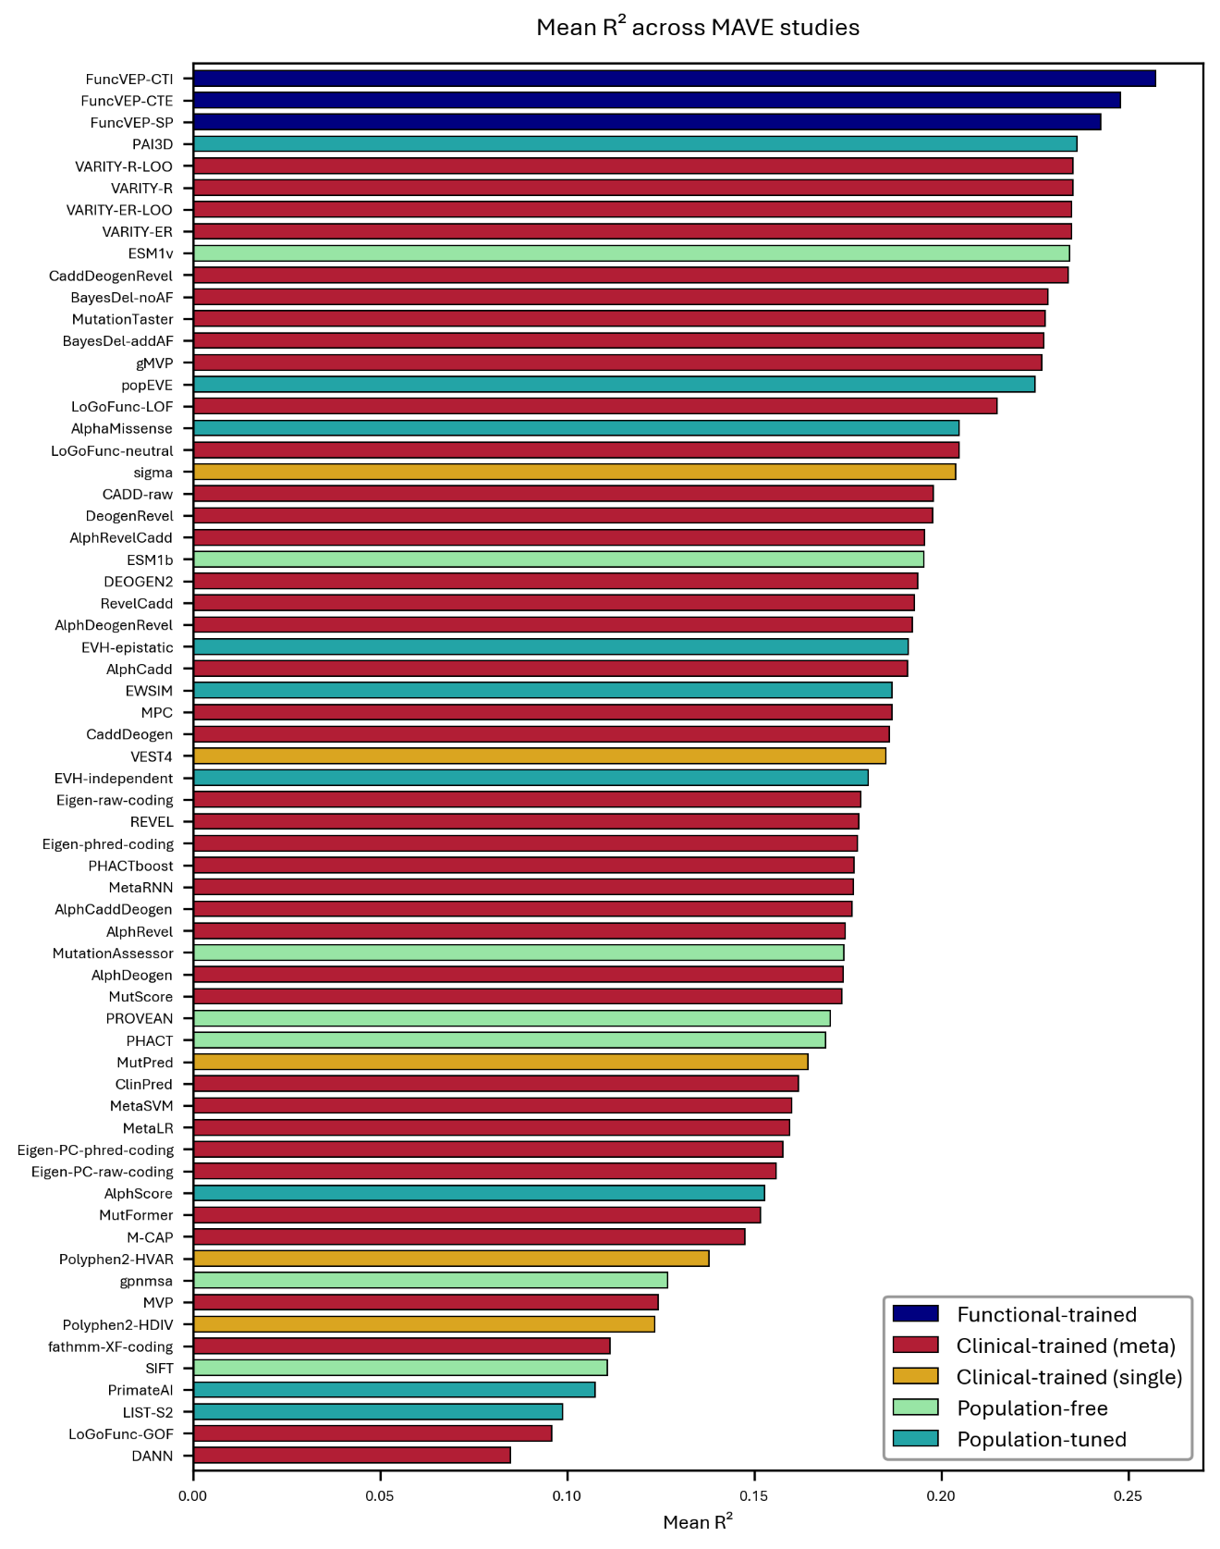
Extended Data Fig. 6. Correlation (GAM R²) of 50 VEPs with calibrated MAVE datasets. Bar plot showing the average R² value of each variant effect predictor across MAVE studies, calculated using a generalized additive model (GAM).
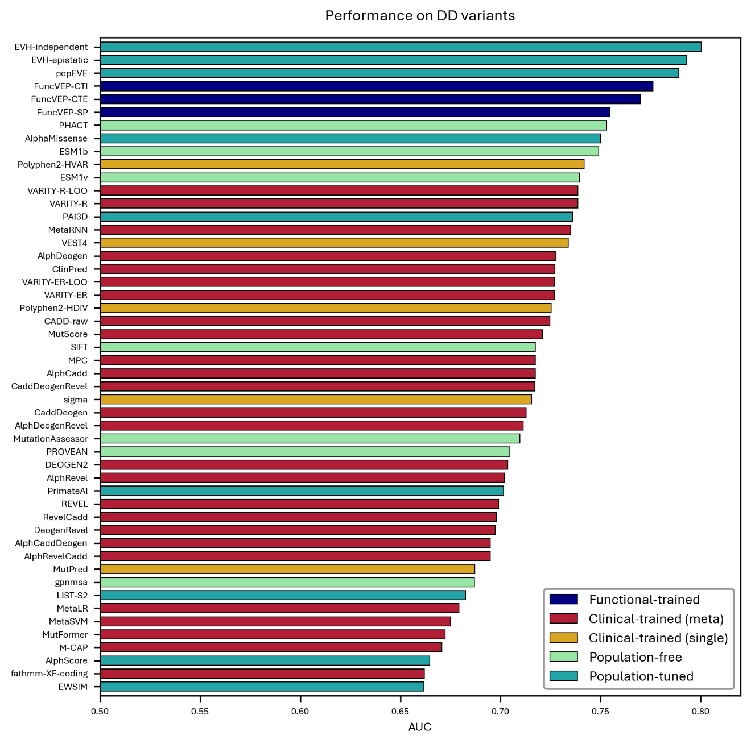
Extended Data Fig. 7. Performance of 50 VEPs on de novo missense variants from developmental disorder (DD) cohorts. Bar plot showing the AUC of each variant effect predictor on the developmental disorders de novo dataset. The x-axis represents AUC values, and the y-axis lists individual predictors.
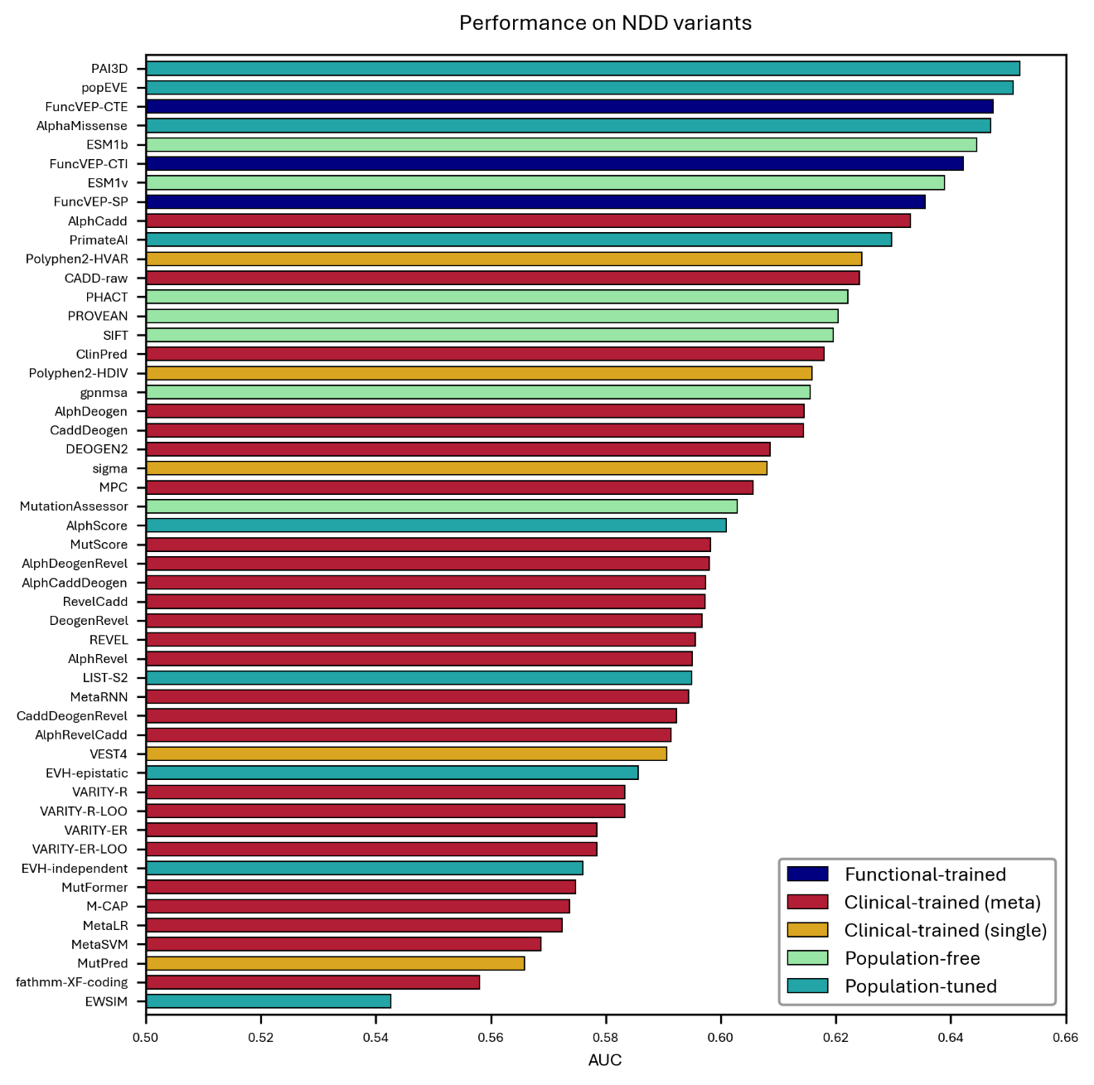
Extended Data Fig. 8. Performance of 50 VEPs on de novo missense variants from neurodevelopmental disorder (NDD) cohorts. Bar plot showing the AUC of each variant effect predictor on the neurodevelopmental disorders de novo dataset. The x-axis represents AUC values, and the y-axis lists individual predictors.

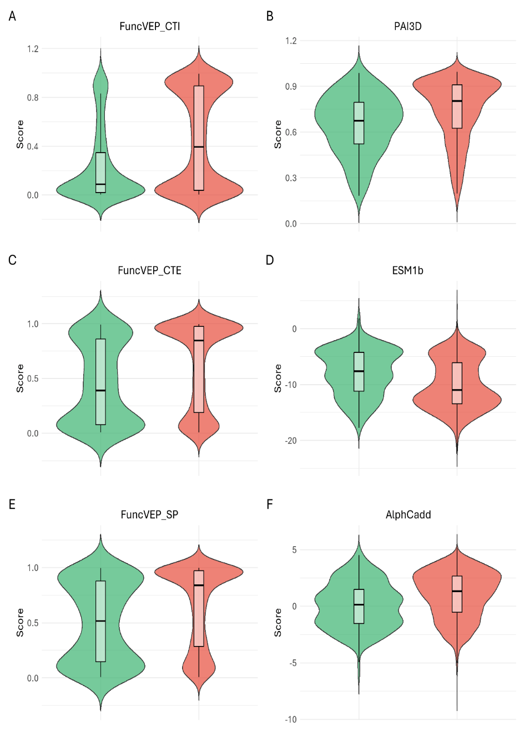
Extended Data Fig. 9. Distribution of model scores on the neurodevelopmental disorders de novo dataset. Violin plots display the distribution of pathogenic (red) and benign (green) variants from the NDD de novo variants across the scores of the best performing predictor from each category and all FuncVEP models. For each class, the violin’s width is proportional to density, while the overlaid white boxplot indicates the median and inter-quartile range. The x-axis shows the variant class and the y-axis shows the raw model score. Panels correspond to individual models: (A) FuncVEP-CTI, (B) PAI3D, (C) FuncVEP-CTE, (D) ESM-1b, (E) FuncVEP-SP, and (F) AlphCadd.
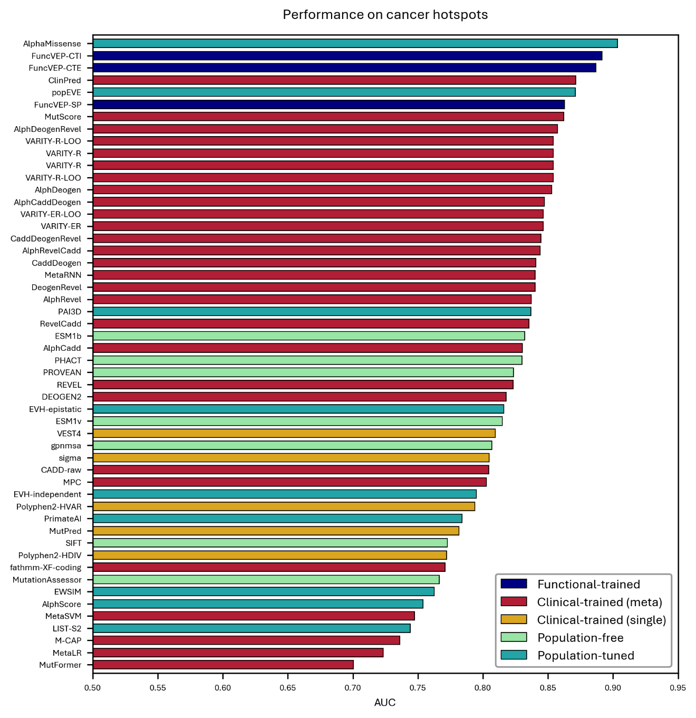
Extended Data Fig. 10. Performance of 50 VEPs on somatic missense variants in cancer hotspots. Bar plot showing the AUC of each variant effect predictor on the cancer hotspot dataset. The x-axis represents AUC values, and the y-axis lists individual predictors.

