Intrinsically Stretchable Large-Area Pixelated Electrochromic Displays via Direct Photopatterning

Kang Sik Kim^{a†}, Soo Yeon Eom^{b†}, Seong Hwan Yang^{a†}, Jeong-Wan Jo^{c}, Fayong Sun^{b}, Beomjin Jeong^{b,d}, Myung-Jae-Lee^{e}, Jong-Woong Kim^{f,g}, Yong-Hoon Kim^{h}, Jong S. Park^{b,d,i*}, and Sung Kyu Park^{a*}

ª Department of Intelligent Semiconductor Engineering, Chung-Ang University, Seoul 06974, Korea
^{b} School of Chemical Engineering, Department of Organic Material Science and Engineering, Pusan National University, Pusan 46241, Korea
^{c} Electrical Engineering Division, Department of Engineering, University of Cambridge, 9 JJ Thomson Avenue, Cambridge CB3 0FA, UK
^{d} Department of Organic Material Science and Engineering, Pusan National University, Busan 46241, Korea
^{e} Convergence Research Institute, Daegu Gyeongbuk Institute of Science and Technology (DGIST), Daegu 42988, Korea
^{f} Department of Semiconductor Convergence Engineering, Sungkyunkwan University, Suwon 16419, Republic of Korea
^{g} School of Mechanical Engineering, Sungkyunkwan University, Suwon 16419, Republic of Korea
^{h} Department of Semiconductor Convergence Engineering, Sungkyunkwan University, Suwon 16419, Korea.
^{i} Research Institute for Convergence of Biomedical Science and Technology, Pusan National University

*Corresponding Authors.
Email addresses: skpark@cau.ac.kr (S. K. Park) and jongpark@pusan.ac.kr (J. S. Park)

Supplementary Notes 1.
Synthesis of 2-Bromoethyl acrylate
In detail, the selection of ionic liquid was not based on chemical compatibility, as no significant interactions were observed between the acrylate viologens and either of the ionic liquids. Instead, the selection was guided by evaluating critical electrochemical parameters, including optical contrast, response speed, and long-term electrochemical stability.
2-Bromoethyl acrylate was synthesized according to the previously reported procedure in the references with Tairan Cheng groups¹. Add Imidazole (1.13 g, 16.5 mmol) and melt under N₂ conditions. After completely dissolving, add PPh₃ (2.61 g, 10 mmol) under vacuum. While stirring, add 20 mL anhydrous dichloromethane to an ice bath. Add Bromine (0.6 mL, 9.5 mmol) and 2-hydroxyethyl acrylate (0.6 mL, 5 mmol) dropwise. After stirring for 45 minutes at 0℃, stir for 1 hour at room temperature. Immediately after the reaction is over, aqueous NaHCO₃ solution is added. Then, extract the organic phase obtained with DCM. After drying by adding MgSO₄, separate the mixture by column chromatography with petroleum ether and ethyl acetate (30:1). The separated material is evaporated to obtain a liquid product.

Supplementary Notes 2.
Synthesis of 4,4'-(1,4-phenylene)bis(1-(2-(acryloyloxy)ethyl)pyridin-1-ium)
1,4-Di(4-pyridyl)benzene was synthesized by the known Suzuki reaction. 1,4-Diiodobenzene (2 g, 6 mmol), 4-pyridienboronic acid (2 g, 16.2 mmol), potassium carbonate (3.32 g, 24 mmol), and tetrakis(triphenylphosphine)-palladium(0) (0.54 g, 0.48 mmol) were stirred in 80 mL 1,4-dioxane : deionized water (4:1) at 90℃ in a nitrogen atmosphere for 70 hours. After cooling, the obtained organic phase is washed with water and brine, and then extracted with DCM. After drying by adding MgSO₄, separate the mixture by column chromatography with DCM and MeOH (97:3). The separated material is evaporated to obtain a pure DPBV as yellow colored solids (0.77 g, 55.2%).
DPBV(0.77 g, 3.3 mmol) and 2-bromoethyl acrylate(1.93 g, 8.3 mmol) were stirred in 20 mL acetonitrile at 80℃ in a nitrogen atmosphere for 96 hours. After cooling, the resulting yellow solids were filtered and washed with acetonitrile. The solids were collected and dried at room temperature. For counter anion exchange, convert [PB-AEPV][Br]₂ to ammonium hexafluorophosphate (NH₄PF₆) in methanol at room temperature to yield [PB-AEPV][PF₆]₂. Acrylate viologen and NH₄PF₆ were dissolved in a 1:3 M solution and stirred in 10 mL of methanol at room temperature for 24 hours. After completion of the reaction, the product was filtered to obtain a white solid and dried at room temperature under vacuum. (0.5 g, 48%) ¹H NMR (DMSO-d₆, 25 °C, 500 MHz): δ = 9.22 (6.8 Hz, 4H, d, Ar H), 8.70 (6.8Hz, 4H, d, Ar H), 8.36 (4H, d, Ar H), 6.32-6.36 (1.1 Hz, 1.1 Hz, 2H, dd, -CH₂), 6.12-6.17 (10.5 Hz, 10.5 Hz, 2H, dd, CH), 5.99-6.01 (1.1 Hz, 1.1 Hz,2H, dd, - CH₂), 4.96-4.98 (4H, t, -CH₂), 4.68 (4.6 Hz, 4H, d, -CH₂).

Supplementary Notes 3.
Synthesis of 4-(2,4,5–tri(pyridine–4-yl)phenyl)-bis(1-(2-(acryloyloxy)ethyl)pyridine
4-(2,4,5-tri(pyridine-4-yl)phenyl)pyridine was synthesized according to the previously reported procedure in the references². 1,2,4,5-Tetrabromobenzene (1.87 g, 4.74 mmol), 4-pyridienboronic acid (3.7 g, 30.1 mmol), potassium carbonate (11 g, 79.5 mmol), and tetrakis(triphenylphosphine)-palladium(0) (1 g, 0.865 mmol) were stirred in 160 mL 1,4-dioxane : DI water (3:1) at 100℃ in a nitrogen atmosphere for 36 hours. After cooling, the obtained organic phase is washed with water and brine, and then extracted with DCM. After drying by adding MgSO₄, it is recrystallized with acetonitrile to remove by-products to obtain pure TPyPhV. The obtained material was washed several times with acetonitrile to obtain a pure white solid. (1.7 g, 90.6%) .
TPyPhV (0.2 g, 0.52 mmol), 2-bromoethyl acrylate(0.35 g, 2.6 mmol), and hydroquinone (0.012 g 0.1 mmol) were stirred in 10 mL DMF at 120℃ in a nitrogen atmosphere for 24 hours. After cooling, add water to the reactants. Washing with ethyl ether then extracted the organic phase with DI water. (3 times) NH₄PF₆ is added to the obtained organic phase to immediately proceed with anion exchange. When NH₄PF₆ is added in a ratio of 1:5 M and an excess of DI water is added and sonicated, a bright red solid is formed. The obtained [TPyPhAEPV][PF₆]₂ was filtered, washed several times with water, and dried at room temperature under vacuum. (0.29 g, 55.8%) ¹H NMR (DMSO-d₆, 25 °C, 500 MHz): δ = 9.11-9.12 (6.3 Hz, 8H, d, Ar H), 8.17-8.18 (5.4 Hz, 10 H, d, Ar H), 6.31-6.35 (17.3 Hz, 4H, d, -CH₂), 6.11-6.16 (10.5 Hz, 10.5 Hz, 4H, dd, -CH), 6.0-6.02 (10.5 Hz, 4H, d, -CH₂), 4.98 (8H, s, -CH₂), 4.64 (8H, s, -CH₂).

Supplementary Notes 4.
Synthesis of 1,1'-bis(2-(acryloyloxy)ethyl)-[4,4'-bipyridine]-1,1'-diium
4,4-Bipyridine (2 g, 4.6 mmol) and 2-bromoethyl acrylate (2.05 g, 11.5 mmol) were stirred in 80 mL acetonitrile at 80℃ in a nitrogen atmosphere for 96 hours. After cooling, confirming the formation of a yellow precipitate, it was filtered and washed several times with acetonitrile. It is immediately dissolved in methanol in a state where the moisture is not completely removed, and NH₄PF₆ is added to perform an anion exchange reaction. For counter anion exchange, convert [B-AEBPV][Br]₂ to ammonium hexafluorophosphate (NH₄PF₆) in methanol at room temperature to yield [B-AEBPV][PF₆]₂. Acrylate viologen and NH₄PF₆ were dissolved in a 1:3 M solution and stirred in 10 mL of methanol at room temperature for 24 hours. After completion of the reaction, the product was filtered to obtain a white solid and dried at room temperature under vacuum. (0.43 g, 14.6%) . 1H NMR (DMSO-d₆, 25 °C, 500 MHz): δ = 9.17-9.21 (5.6 Hz, 5.6 Hz, 4H, dd, Ar H), 8.86 (4H, t, Ar H), 8.59-8.64 (5.6 Hz, 5.6 Hz, 4H, dd, - CH₂), 7.98-8.02 (5.1 Hz, 5.1 Hz, 4H, dd, - CH₂), 4.91-4.92 (2H, t, - CH₂), 4.80-4.82 (2H, t, -CH), 4.60-4.61 (2H, t, -CH₂).

Supplementary Notes 5.
Device fabrication
All experiments conducted on ITO glass were conducted in an active range of 2 × 2.5 cm². In order to maintain the SPEC gel at 60 μm, 60 μm Surlyn was used to maintain a constant thickness. The prepared SPEC gel was homogeneous and formed an orange-colored solution due to ferrocene. In addition, the experiment conducted on ITO glass was made of a simple structure containing electrolyte in a SPEC gel as a single-layer structure.
SPEC-R shows a red coloration. SPEC-R contains [PB-AEPV][PF₆]₂ 200 mg, polyurethane acrylate 1,000 mg, [Li][TFSI] 400 mg, [BMIM][TFSI] 2,000 mg, ferrocene 30 mg, MA-POSS 50 mg, TPO 36 mg, and co-solvent propylene carbonate 500 mg, acetone 500 mg.
SPEC-G shows a green coloration. SPEC-G contains [TPyPhAEPV][PF₆]₂ 200 mg, polyurethane acrylate 1,000 mg, [BMIM][TFSI] 1,000 mg, ferrocene 20 mg, TPO 2 mg, and co-solvent dimethyl sulfoxide 1,500 mg, acetone 500 mg.
SPEC-B shows a blue coloration. SPEC-B contains [B-AEBPV][PF₆]₂ 200 mg, polyurethane acrylate 1,000 mg, [Li][TFSI] 400 mg, [EMIM][TFSI] 2,000 mg, ferrocene 30 mg, MA-POSS 50 mg, TPO 36 mg, and co-solvent propylene carbonate 500 mg, acetone 500 mg.

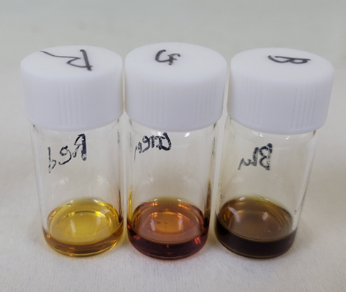
Supplementary Fig. 1. Red, green, and blue-colour stretchable and photopatternable electrochromic (SPEC) gel solutions.

In detail, the selection of the ionic liquid was not based on chemical compatibility, as no significant interactions were observed between the acrylate viologens and either of the ionic liquids. Instead, the selection was guided by evaluating critical electrochemical parameters, including optical contrast, response speed, and long-term electrochemical stability.

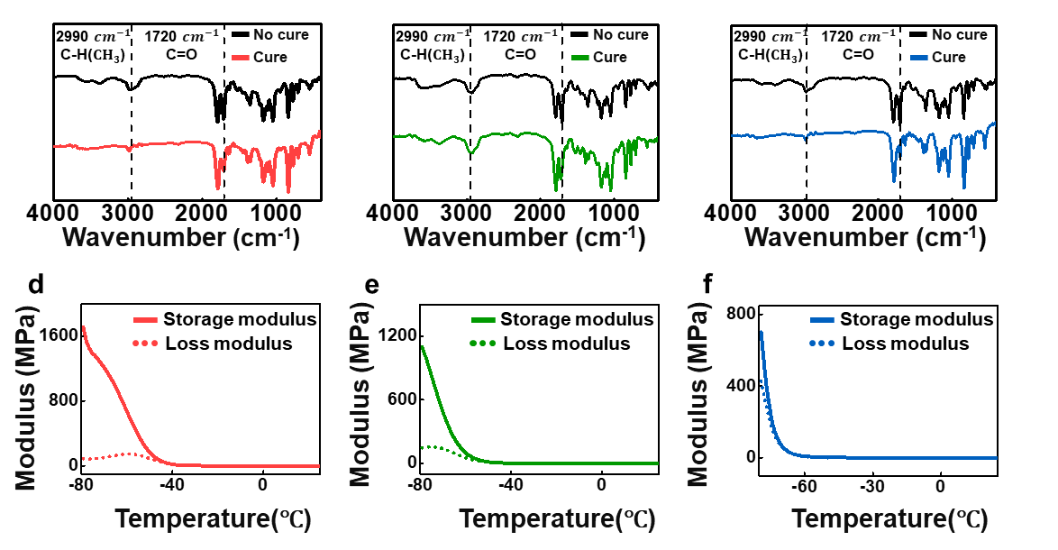
Supplementary Fig. 2. a-c) FTIR spectra before and after curing of the SPEC gel (a) SPEC-R, (b) SPEC-G, and (c) SPEC-B. d-f) DMA measurements conducted to characterize the elastic properties of the ion gel, storage modulus, and loss modulus curves for (d) SPEC-R, (e) SPEC-G, and (f) SPEC-B.

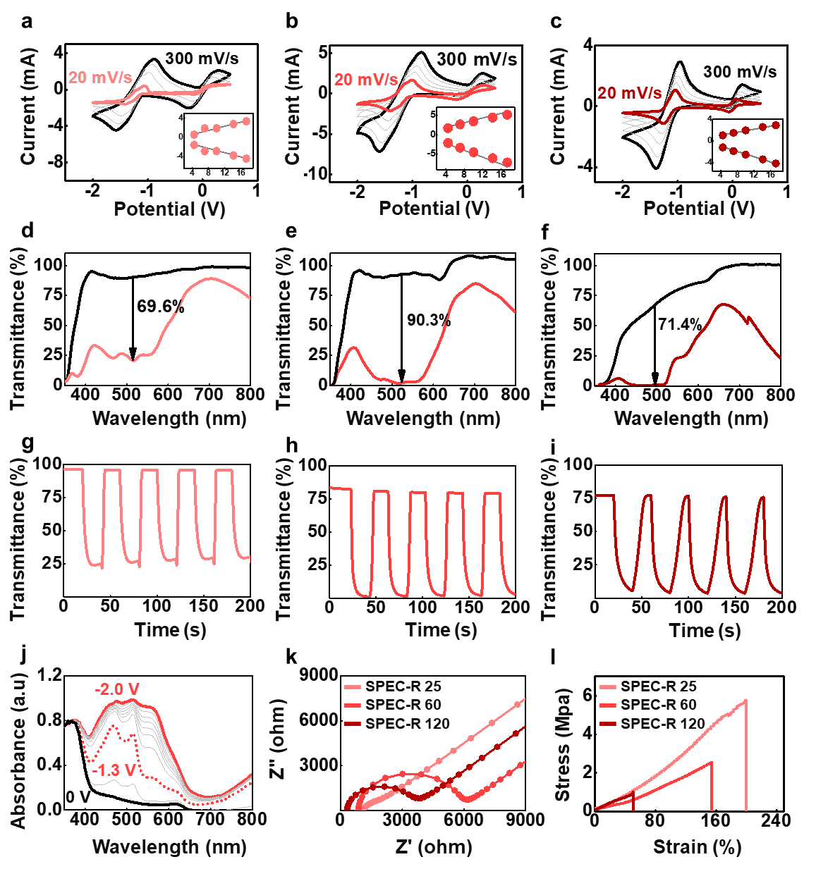
Supplementary Fig. 3. a-c) Electrochromic properties according to the thickness of SPEC-R. CV curves of stretchable ECDs with different scan rates. (a) SPEC-R 25 (SPEC gel thickness 25 μm), (b) SPEC-R 60 (SPEC gel thickness 60 μm), and (c) SPEC-R 120 (SPEC gel thickness 120 μm). d-f ) The corresponding transmittance change curves with -2 V (coloration) and removed voltage state (bleaching) for (d) SPEC-R 25, (e) SPEC-R 60, and (f) SPEC-R 120. g-i) Kinetic stability of the electrochromic device according to the thickness of SPEC-R during constant potential stepping between -2 V (coloration) and short-circuit (bleaching) for (g) SPEC-R 25, (h) SPEC-R 60, and (i) SPEC-R 120. (j) The corresponding absorbance change curves with different applied potentials for SPEC-R 60. (k) Nyquist plot, (l) Strain-Stress curves for different thicknesses of SPEC-R.

The thickness of SPEC gels was varied as 25, 60, and 120 μm (Supplementary Fig. 3-5). The electrochemical analyses show that there were no notable differences in the thickness. Thus, the optimal thickness was determined through the transmittance switching performance of the ECDs. For clarity, the SPEC gels are denoted by both their color (R, G, B) and thickness; for example, SPEC-R 25 refers to the SPEC-R with a thickness of 25 μm, while SPEC-G 60 and SPEC-B 120 represent the SPEC-G and SPEC-B with thicknesses of 60 and 120 μm, respectively. A large transmittance variation was observed with a thickness of 60 μm, with SPEC-R, SPEC-G, and SPEC-B exhibiting ΔT values of 90.3%, 69.0%, and 83.5%, respectively. When a thickness was 25 μm for the SPEC-R, the transmittance was high in the neutral state, with a T_{max} of 90.2%; however, the colored state did not produce a dark color during coloration. Also, with a thickness of 120 μm, the neutral transmittance was low, with a T_{max} of 72.2% , resulting in insufficient transparency in the neutral state. Specifically, even with 20 s of -2 V applied, complete discoloration did not occur for SPEC-G with 120 μm and SPEC-B with 120 μm, leading to poor color saturation. The fastest switching time was observed for the 25 μm-thick SPEC gels, indicating rapid color changes due to minimal transmittance difference between bleaching and coloring states. This trend is related to ionic conductivity, which is reduced at higher thickness for all SPEC gels. Greater thickness slowed ion diffusion and transport, reducing ion conductivity and extending bleaching and colouring times. Based on these results, a thickness of 60 μm was selected for subsequent experiments.

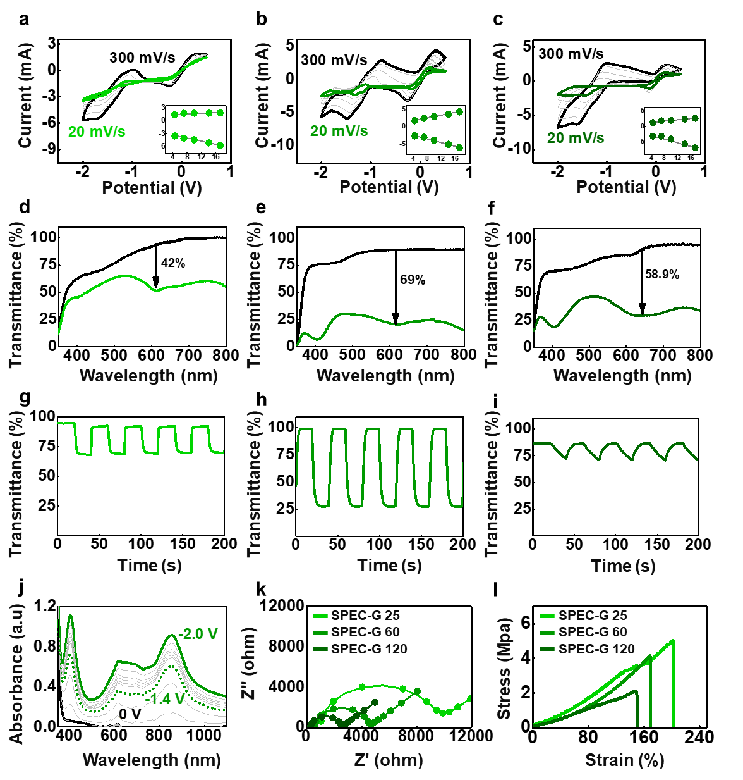

Supplementary Fig. 4. a-c Electrochromic properties according to the thickness of SPEC-G. CV curves of stretchable ECDs with different scan rates. (a) SPEC-G 25 (SPEC gel thickness 25 μm), (b) SPEC-G 60 (SPEC gel thickness 60 μm), and (c) SPEC-G 120 (SPEC gel thickness 120 μm). d-f) The corresponding transmittance change curves with -2 V (coloration) and removed voltage state (bleaching) for (d) SPEC-G 25, (e) SPEC-G 60, and (f) SPEC-G 120. g-i) Kinetic stability of the electrochromic device according to the thickness of SPEC-G during constant potential stepping between -2 V (coloration) and short-circuit (bleaching) for (g) SPEC-G 25, (h) SPEC-G 60, and (i) SPEC-G 120. (j) The corresponding absorbance change curves with different applied potentials for SPEC-G 60. (k) Nyquist plot, (l) Strain-Stress curves for different thicknesses of SPEC-G.

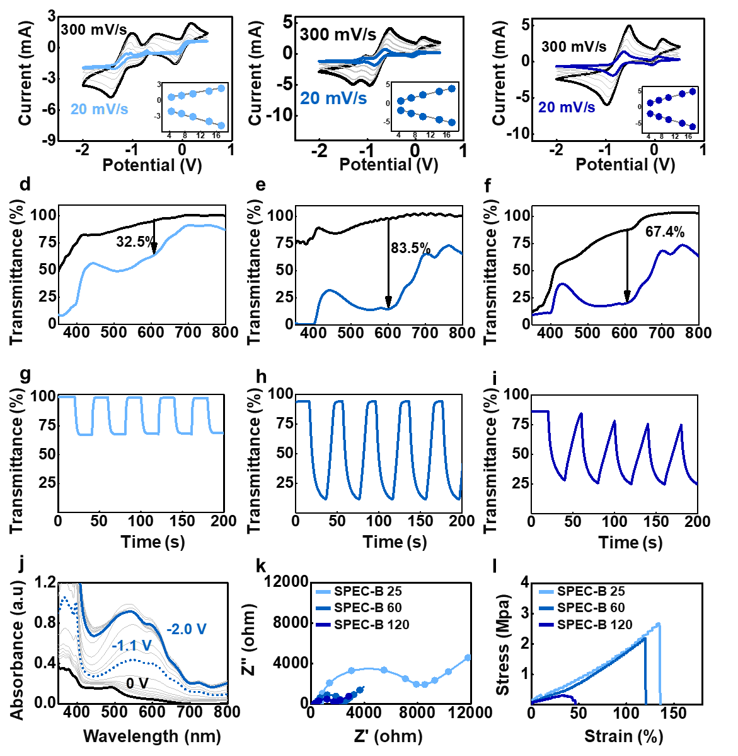
Supplementary Fig. 5. a-c) Electrochromic properties according to the thickness of SPEC-B. CV curves of stretchable ECDs with different scan rates. (a) SPEC-B 25 (SPEC gel thickness 25 μm), (b) SPEC-B 60 (SPEC gel thickness 60 μm), and (c) SPEC-B 120 (SPEC gel thickness 120 μm). d-f) The corresponding transmittance change curves with -2 V (coloration) and removed voltage state (bleaching) for (d) SPEC-B 25, (e) SPEC-B 60, and (f) SPEC-B 120. g-i) Kinetic stability of the electrochromic device according to the thickness of SPEC-B during constant potential stepping between -2 V (coloration) and short-circuit (bleaching) for (g) SPEC-B 25, (h) SPEC-B 60, and (i) SPEC-B 120. (j) The corresponding absorbance change curves with different applied potentials for SPEC-B 60. (k) Nyquist plot. (l) Strain-Stress curves for different thicknesses of SPEC-B.

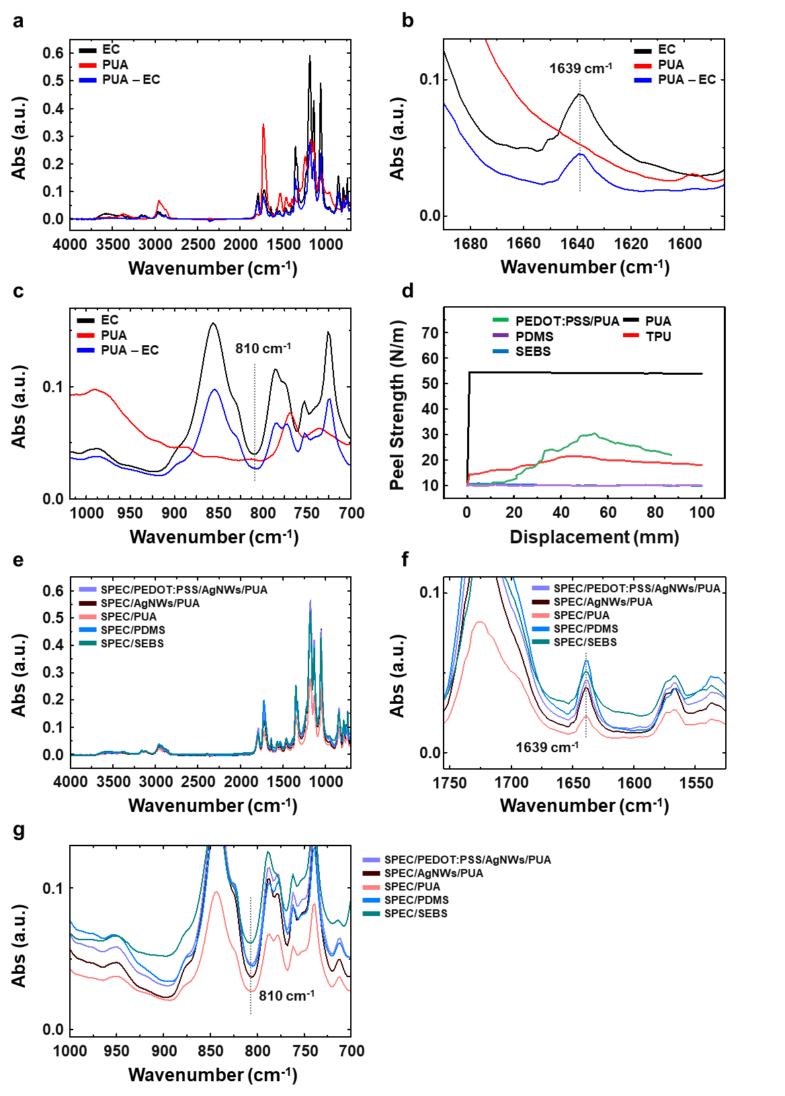
Supplementary Fig. 6. The FTIR spectra of SPEC, PUA, and SPEC/PUA after photo-curing: (a) 4000-700 cm⁻¹, (b) 1690-1580 cm⁻¹, and (c) 975-720 cm⁻¹. (d) Peel strength of TPU/SPEC, PUA/SPEC, SEBS/SPEC, PEDOT:PSS/SPEC, and PDMS/SPEC. The FTIR spectra of PEDOT:PSS/AgNWs/PUA, AgNWs/PUA, PUA, PDMS, and SEBS with SPEC after photo-curing : (e) 4000-700 cm⁻¹, (f) 1755-1525 cm⁻¹, and (g) 1000-700 cm⁻¹.

FTIR measured the changes in bonding states induced by photo-polymerization (Supplementary Fig. 6a-c). Similar results were observed for all three gels. A decrease in intensity at 1639 cm⁻¹ after curing indicated a reduction in the carboxyl group (C=O) bond peak, suggesting that the acrylate groups undergo crosslinking during photo-polymerization. Changes in the methyl group (CH₃) bond at 2990 cm⁻¹ were also noted. Crosslinking during curing causes fragmentation of CH₃ groups, resulting in a decrease in tensity. These changes indicate that acrylate groups participate in photo-polymerization, facilitating crosslinking and forming stable films for free-standing applications. Peel tests were performed to evaluate the adhesive strength of SPEC on various substrates consisting of PEDOT:PSS/PUA, PUA, Polydimethylsiloxane (PDMS), thermoplastic polyurethane (TPU), polystyrene-block-poly(ethylene-ran-butylene)-block-polystyrene (SEBS) (Supplementary Fig. 6d). PDMS and SEBS-based substrates exhibited no measurable peel force at 0 mm displacement. In contrast, TPU substrates showed an initial peel force of 5 N/m at 0 mm, increasing to 10 N/m at 40 mm. PEDOT:PSS on PUA substrates showed a peel strength of 20 N/m sustained up to 60 mm displacement before decreasing. Significantly, the PUA substrate exhibited a consistent peel force of 45 N/m from 0 mm displacement onward. These results suggest that SPEC exhibits stable adhesive strength with PUA substrates, whereas poor adhesion is observed with PDMS, SEBS, and TPU.

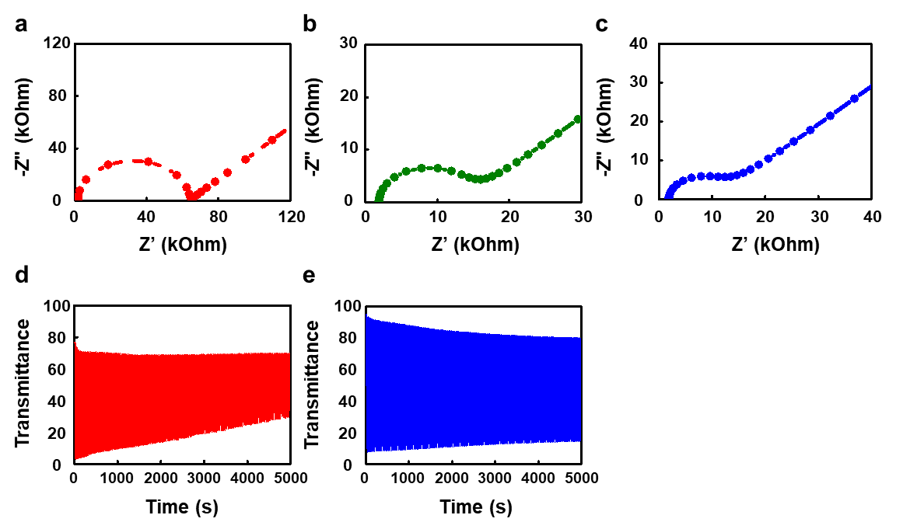
Supplementary Fig. 7. EIS plot of (a) SPEC-R, (b) SPEC-G, and (c) SPEC-B, and kinetic stability of (d) SPEC-R and (e) SPEC-B. All analyses were conducted without the addition of ionic liquid.

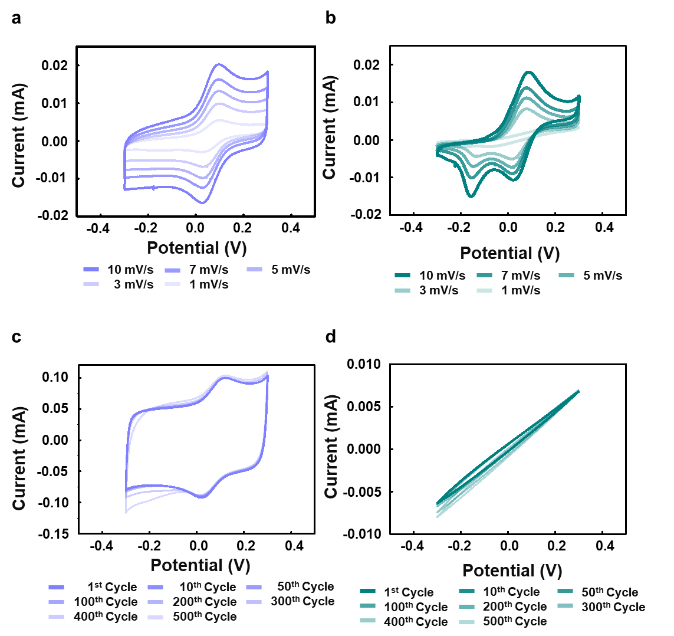
Supplementary Fig. 8. CV curves of AgNWs/PUA electrode with PEDOT:PSS (a, c) and without PEDOT:PSS (b, d), measured at different scan rates and over multiple cycles.

Cyclic voltammetry (CV) measurements confirmed the enhanced durability of the PEDOT:PSS/AgNWs electrode compared to the pristine AgNW electrode (Supplementary Fig. 8). While the pristine AgNW electrode exhibited significant degradation during cycling, with the disappearance of redox peaks, the PEDOT:PSS/AgNWs electrode retained unchanged redox activity, supporting stable operation of the electrochromic device. The integration of PEDOT:PSS with AgNWs enhances network connectivity and mechanical compliance, preserving sufficient conductivity and enabling stable biasing of the EC layer at elevated strains.
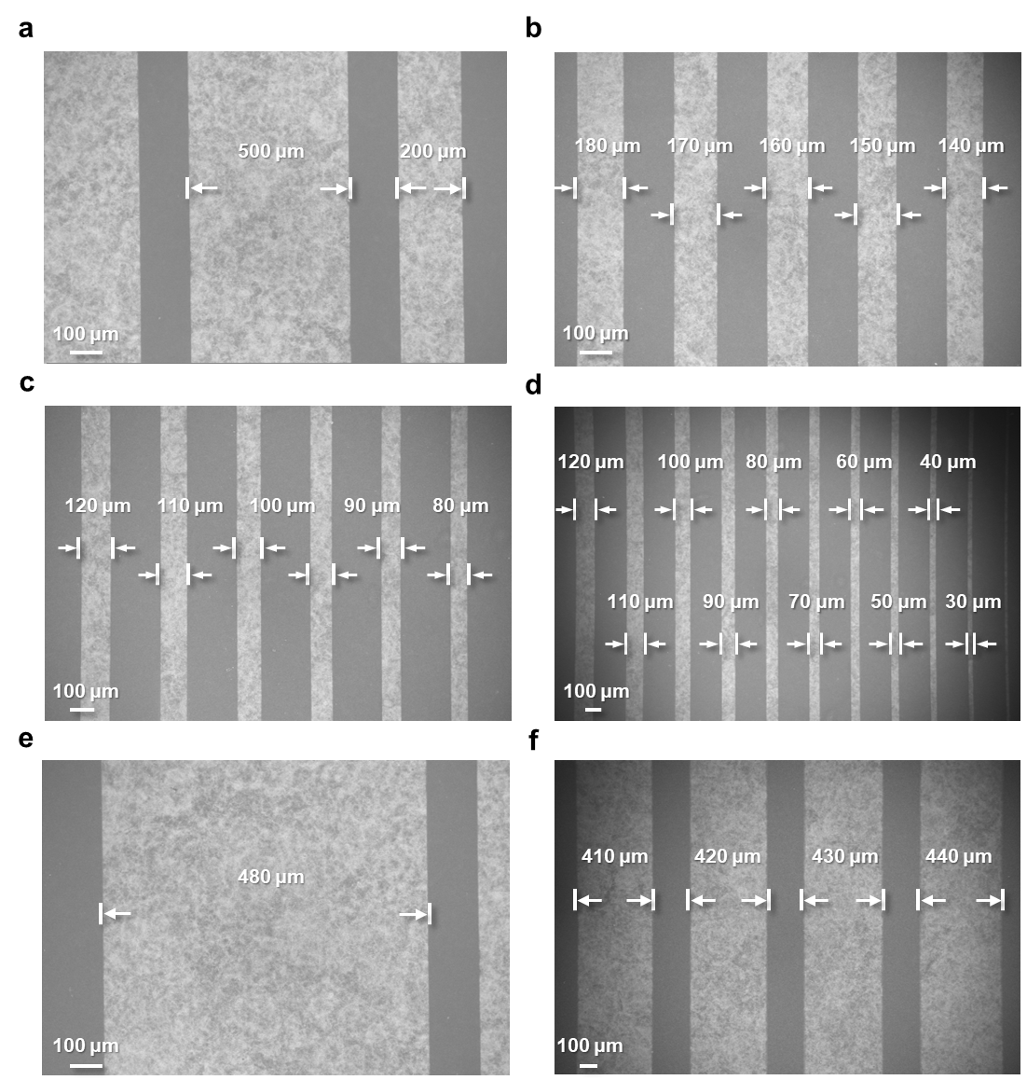

Supplementary Fig. 9. SEM images of AgNWs patterns line widths of (a) with a line width 200 µm and 500 µm, (b) 140 to 180 µm, (c) 80 to 120 µm, (d) 30 to 120 µm, (e) 480 µm, and (f) 410 to 440 µm.

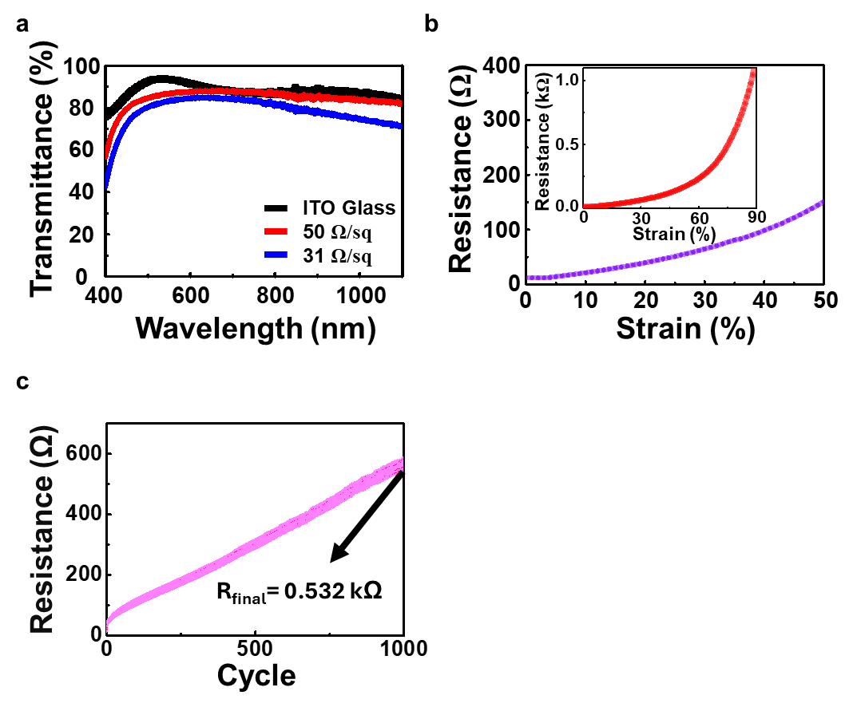
Supplementary Fig. 10. (a) Transmittance curves of ITO glass and PEDOT:PSS/AgNWs/PUA electrodes with specified sheet resistance. (b) Resistance-strain characteristic of PEDOT:PSS/AgNWs/PUA electrode up to 50% strain. Inset: Resistance-strain curve up to 90% strain. (c) The resistance change of the PEDOT:PSS/AgNWs/PUA electrode during 1000 cycles of 30% strain.

The resulting PEDOT-rich linear chain structures substantially enhance mechanical stretchability³, allowing for deformation up to 60% without severe crack generation (Supplementary Fig. 10). The 150 μm-thick PEDOT:PSS/AgNWs/PUA electrode exhibited over 80% of transmittance in the visible ranges (450–800 nm), comparable to that of ITO-coated glass (Supplementary Fig. 10a). Additionally, the electrode demonstrated a sheet resistance of less than 30 Ω/. Mechanical evaluations, including both static and cyclic stretching tests, showed that the composite electrode maintained excellent electrical conductivity (R/R₀ < 14.12) under strains of up to 50% (Supplementary Fig. 10b), and exhibited no visible defects even after 1,000 stretching cycles (Supplementary Fig. 9c).

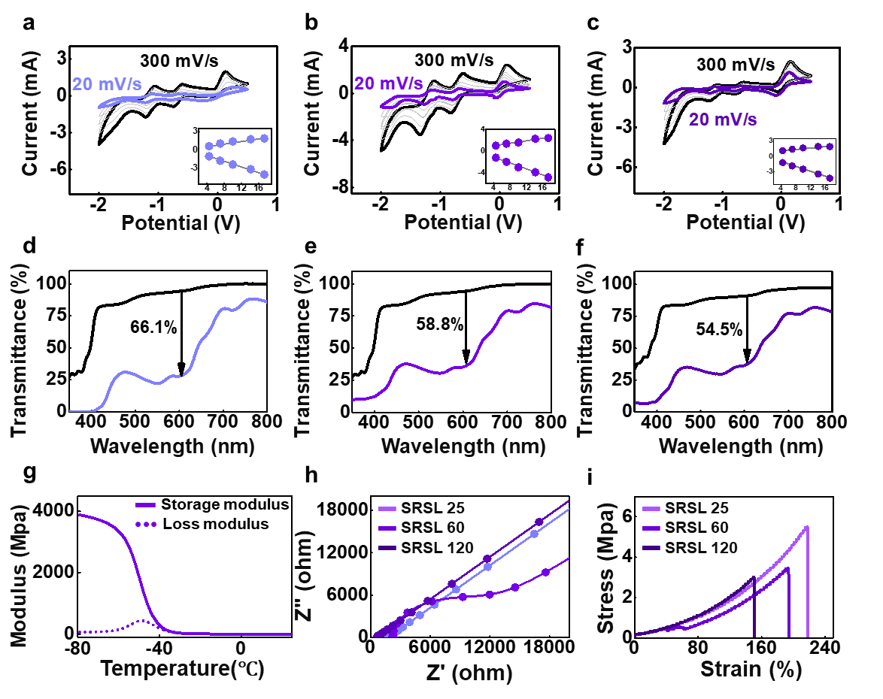
Supplementary Fig. 11. a-c) Electrochromic properties according to the thickness of SRSL. The device was fixed with a SPEC gel to adjust the thickness of the SPEC gel to 60 μm. CV curves of stretchable EC devices with different scan rates. (a) SRSL 25 (SRSL thickness 25 μm), (b) SRSL 60 (SRSL thickness 60 μm), and (c) SRSL 120 (SRSL thickness 120 μm). d-f) The corresponding transmittance change curves with -2 V (coloration) and removed voltage state (bleaching) for (d) SRSL 25, (e) SRSL 60, and (f) SRSL 120. (g) DMA measurements conducted to characterize the elastic properties of the SRSL, storage modulus, and loss modulus curves. (h) Nyquist plot, (i) Strain-Stress curves for different thicknesses of SRSL.

The measurements were conducted with different thicknesses of SRSL (Supplementary Fig. 11). In the following analyses, the SRSL are identified by their thickness (25, 60, and 120 μm), denoted as SRSL-25, SRSL-60, and SRSL-120, respectively. The impact of SRSL thickness on cyclic voltammetry (CV) results was more significant. As the SRSL thickness increased, the area of the current-voltage response decreased, indicating reduced activity and slower reaction rates, which was also confirmed through Nyquist plots (Supplementary Fig. 11h). The dynamic mechanical analysis (DMA) confirmed the elasticity of the SRSL, maintaining a higher storage modulus than loss modulus, which allows for stable shape restoration after deformation (Supplementary Fig. 11g). The universal testing machine (UTM) measurements revealed that all three colors of SPEC gel at 60 μm showed stable elongation rates of over 120%, which confirms the mechanical capability of elongated devices (Supplementary Fig. 11i). Combining with electrochemical results, it is evident that the SPEC gel films efficiently store and disperse energy, maintaining their shape stably despite external deformation (Supplementary Fig. 2d-f). Therefore, with high elasticity and strength, stable ECDs can be formed on stretchable electrodes.

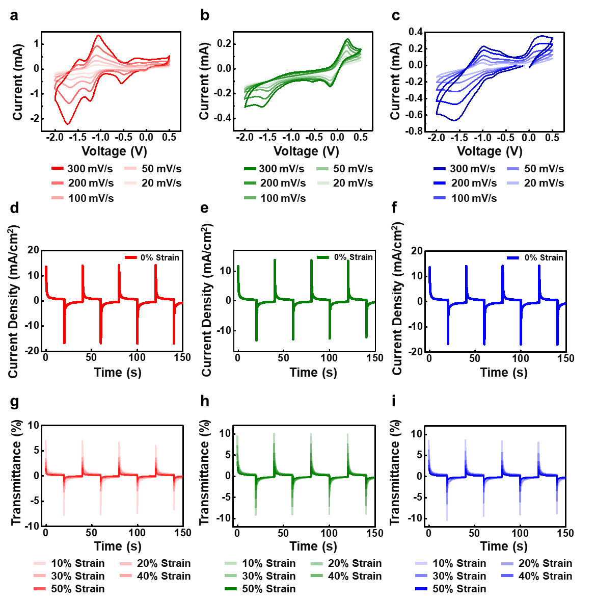
Supplementary Fig. 12. CV curves of (a) SPEC-R, (b) SPEC-G, (c) SPEC-B with different scan rates. Current density curves of (d) SPEC-R, (e) SPEC-G, (f) SPEC-B under 0% strain and (g) SPEC-R, (h) SPEC-G, (i) SPEC-B under 10~50% strain.

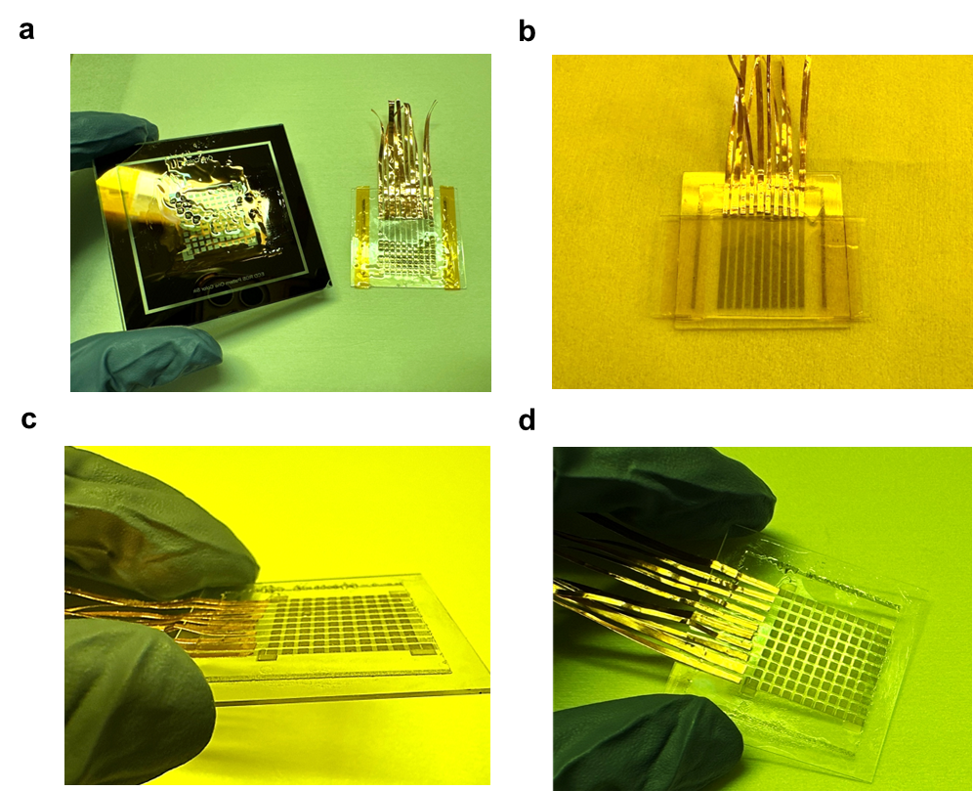
Supplementary Fig. 13. Photographs of EC pixels after UV irradiation (a) w/o and (b) w/ PDMS-coated substrate. The photographs of successfully photopatterned EC pixels on PEDOT:PSS/AgNW/PUA eletrode: side view (c) and top view (d).

Because the as-spun SPEC films are in a liquid state before the UV-curing process, the photomask should not directly contact the as-spun SPEC films. Otherwise, a portion of cured SPEC gels can be transferred to the photomask (Supplementary Fig. 13a). Additionally, the liquid properties of the SPEC solution hinder the formation of a gel with uniform height. To overcome this, we utilized PDMS. A PI tape (thickness = 60 μm) was formed on the stretchable electrode, where the pattern would be created. After applying the SPEC solution, a PDMS-coated substrate was placed on top, followed by positioning a photomask for UV curing (Supplementary Fig. 13b). Following the developing process, EC pixels were successfully photo-patterned on the stretchable electrode.

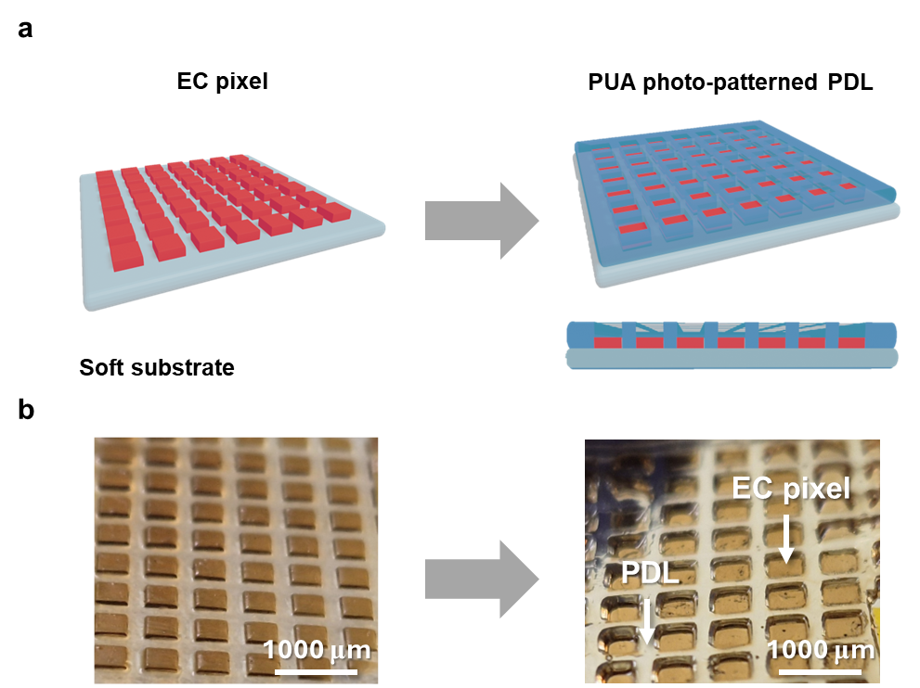
Supplementary Fig. 14. (a) Schematic of PDL with EC pixels. (b) Photographs of PDL with EC pixels.

Following UV irradiation, well-defined EC pixels were formed without delamination, attributed to strong interfacial acrylate bonding (Supplementary Fig. 6). To prevent ion migration-induced crosstalk between adjacent pixels, two key architectural components were incorporated: a SRSL and a PDL (Supplementary Fig. 14). The fabrication began with patterning the PDL on the device backplane by coating a PDL solution, followed by back-side UV curing. Because the stretchable electrode is UV-transparent and the SPEC pixels are UV-blocking, the SPEC pixels acted as self-aligned photomasks during UV exposure. This enabled polymerization to occur only in the areas surrounding the pixels, allowing for precise PDL formation without requiring additional alignment steps (Supplementary Fig. 14b). After forming the PDL, the SRSL solution was coated over the pre-patterned PDL and pixelated SPEC layers. Upon curing, the SRSL layer filled the interstitial regions, making conformal contact with the substrate and completing the encapsulation structure. An optimal SRSL thickness of 60 μm was determined to ensure both high electrochemical performance and robust mechanical stability during device operation (Supplementary Fig. 3-5, 11). The resulting SRSL layer adhered well to the underlying PUA-based substrate, providing the necessary flexibility and stretchability for integration into mechanically deformable electrochromic displays.

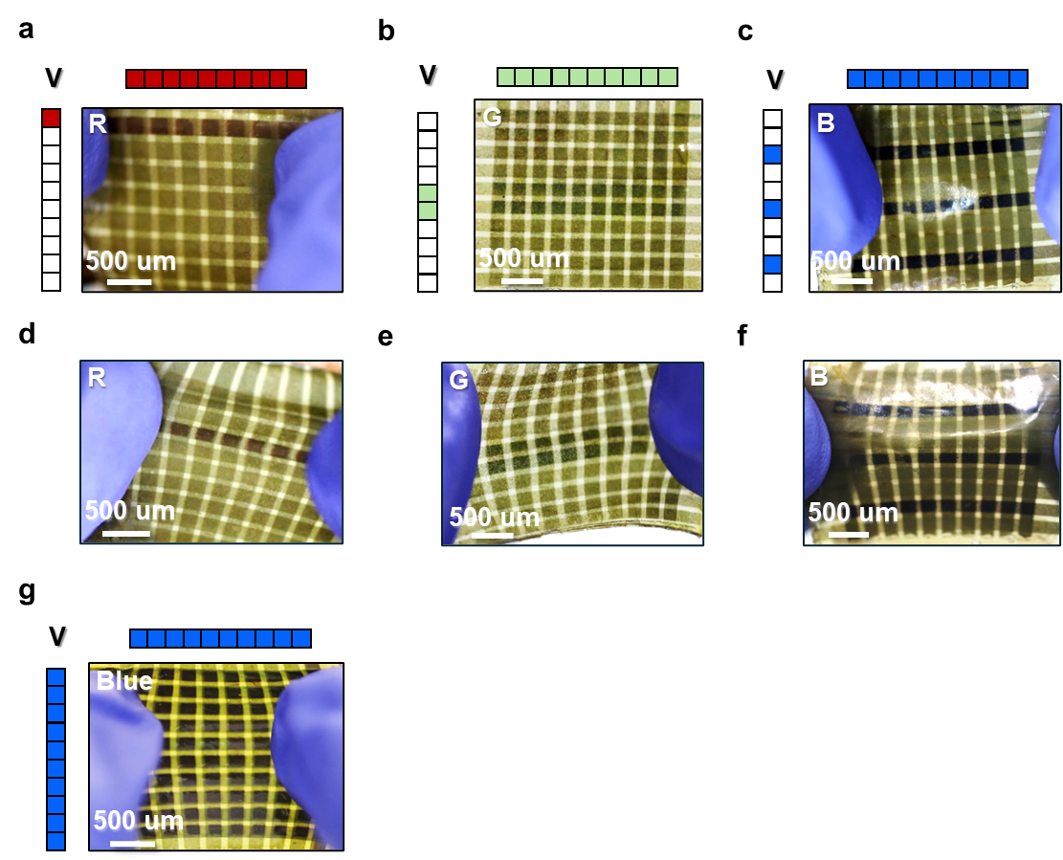
Supplementary Fig. 15. Photographs of stretchable sub-pixelated passive matrix ECD arrays based on SPEC-R (left), SPEC-G (middle), and SPEC-B (right) under 0% strain (a-c), under 30% strain (d-f), and under 30% strain for blue sub-pixels (g).
Supplementary Table 1.
H-NMR spectrum of 2-Bromoethyl acrylate

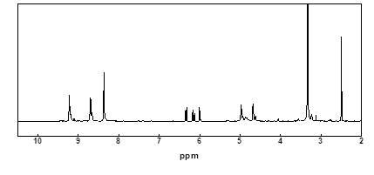

Supplementary Table 2.
H-NMR spectrum of 4,4'-(1,4-phenylene)bis(1-(2-(acryloyloxy)ethyl)pyridin-1-ium)
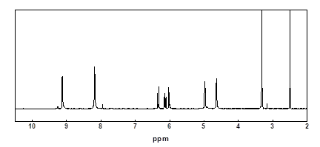

Supplementary Table 3.
H-NMR spectrum of 4-(2,4,5–tri(pyridine–4-yl)phenyl)-bis(1-(2-(acryloyloxy)ethyl)pyridine
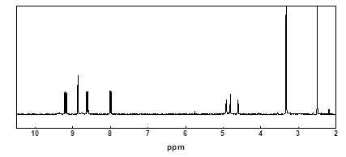

Supplementary Table 4. T_{max}, T_{min}, ΔT, t_{c}, t_{b}, ΔT/ΔT₅, ion conductivity, strain of SPEC-R with thicknesses of 25, 60, and 120 μm.
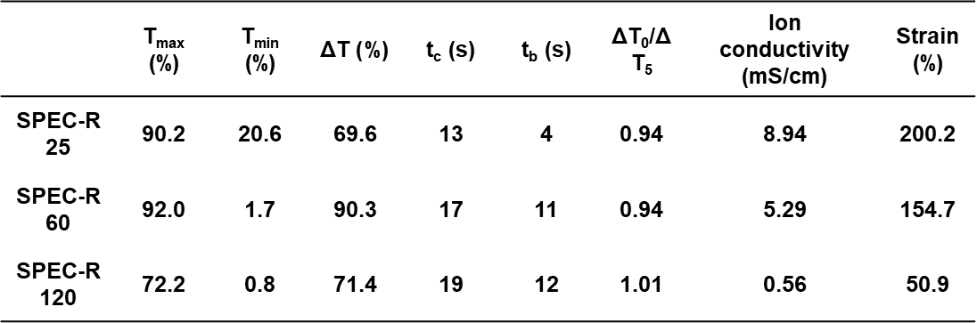

Supplementary Table 5. T_{max}, T_{min}, ΔT, t_{c}, t_{b}, ΔT/ΔT₅, ion conductivity, strain of SPEC-G with thicknesses of 25, 60, and 120 μm.
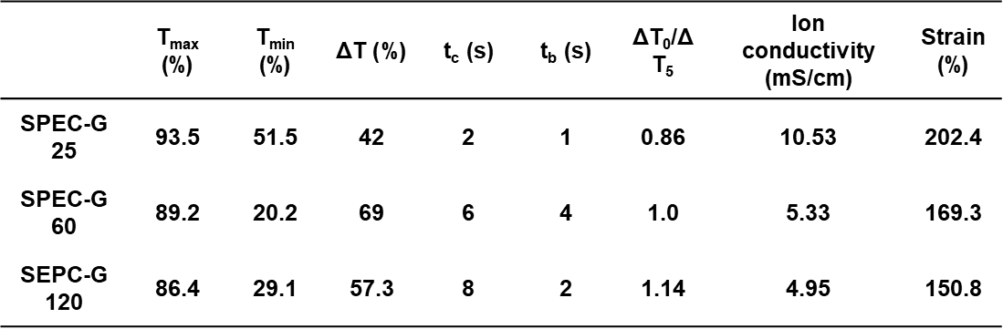

Supplementary Table 6. T_{max}, T_{min}, ΔT, t_{c}, t_{b}, ΔT/ΔT₅, ion conductivity, strain of SPEC-B with thicknesses of 25, 60, and 120 μm.
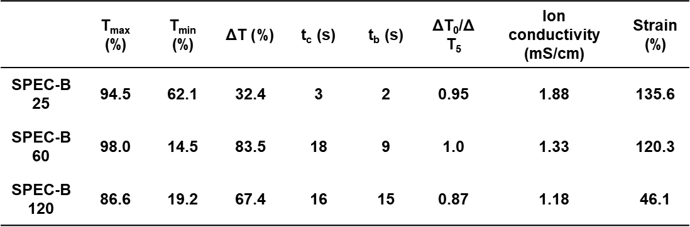
Supplementary Table 7. T_{max}, T_{min}, ΔT, ion conductivity, strain of SRSL with thicknesses of 25, 60, and 120 μm.
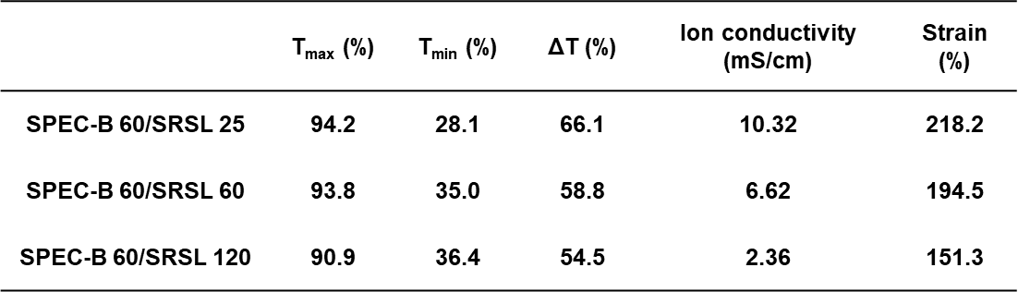

References
- Tairan Cheng, Boxiang Liu, Rui Wu and Shifa Zhu. Cu-catalyzed carboboration of acetylene with Michael acceptors. Chem. Sci., 13, 7604 (2022)
- B Ji, W Wang, D Deng, Y Zhang, L Cao, L Zhou, C Ruan & T Li. Structural competition between π⋯π interactions and halogen bonds: a crystallographic study. CrystEngComm, 15, 769-774 (2013)
- Lee, J. H. et al. Highly stretchable transparent bar coated Ag NW/PEDOT:PSS hybrid electrode for wearable and stretchable devices. RSC Adv 12, 3055–3061 (2022).

