Supporting Information: A Fresh Look at the Photophysics of Benzophenone

Carolina Francener, Hector Miranda-Salinas, Larissa Gomes Franca and Andrew Monkman

C. Francener, H. Miranda-Salinas, L.G. Franca, A. Monkman
Organic Electroactive Materials Research Group, Physics Department, Durham University DH1 3LE, United Kingdom
E-mail:

L.G. Franca
Department of Materials Science and Metallurgy, University of Cambridge, CB3 0FS, United Kingdom.

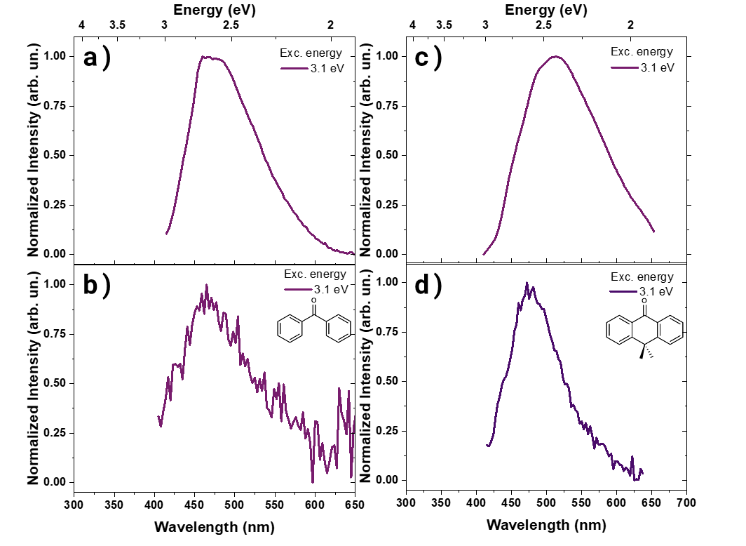
Supplementary Figure 1. Emission from aggregate state in BP and DMA films. Normalized PL of BP (a,b) and DMA (c,d) at room temperature (top) and 80 K (bottom) in a host-guest film with Zeonex as polymeric matrix (1% wt/wt) under 3.1 eV excitation energy (λ_{exc} = 400 nm).

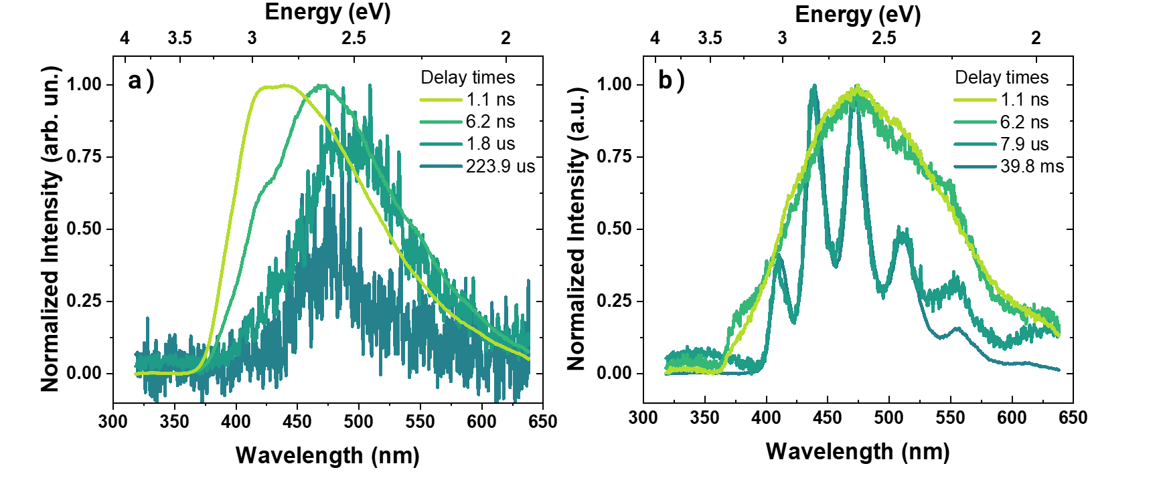Supplementary Figure 2. Time-resolved spectroscopy of DMA. Normalized time-resolved emission spectra of DMA at room temperature (a) and 80 K (b). $λ_{exc}=355 nm$ ; 3.5 eV.

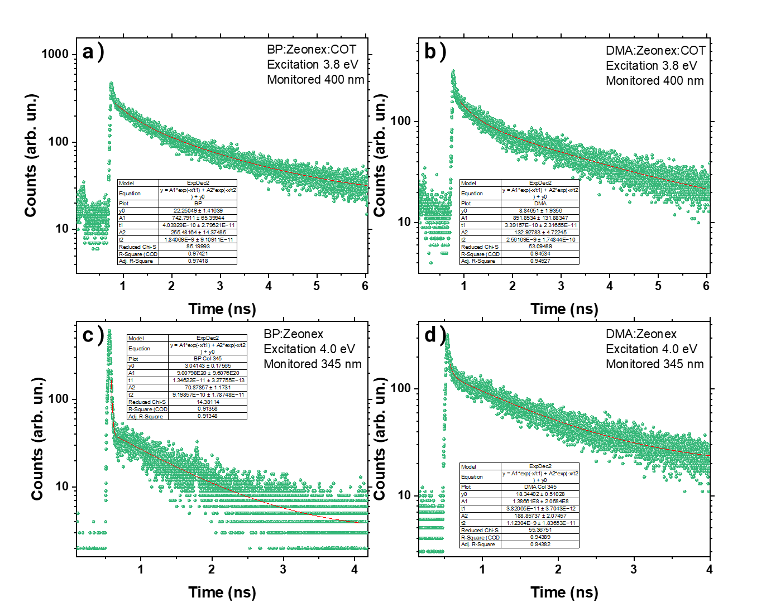
Supplementary Figure 3. Picosecond time-correlated single photon counting decay of BP and DMA for acquiring S₁ and S₂ lifetimes. Decays of BP (a) and DMA (b) with a 6 ns window in zeonex film (1% wt/wt) doped with COT (10% wt/wt). Emission of monitored at 400 nm. $λ_{exc}=323 nm$ ; 3.8 eV. Decays of BP (c) and DMA (d) with a 4 ns window in zeonex film (1% wt/wt) doped with COT (10% wt/wt). Emission monitored at 345 nm. $λ_{exc}=309 nm$ ; 4.0 eV. Inset contains the fitting parameters for all decay curves.

 | BP |  | DMA
 | S₁ | S₂ | S₁ | S₂
A₁ | 742 | 9E20 | 851 | 1E8
t₁ | 403 ps | ---ª | 339 ps | 38 ps
A₂ | 255 | 70 | 133 | 188
t₂ | 1.8 ns | 0.9 ns | 2.5 ns | 1.2 ns
Supplementary Table 1. Data from bi-exponential fitting of decay curves obtained with ps-TCSPC. Data from the fitting of Supplementary Fig. 3. ªBP S₂ t₁ decay time is faster than IRF.
Supplementary Figure 4. Overlap of cyclooctatetraene (COT) absorption and S₂ emission of BP and DMA. Absorption of 200 µM COT in toluene (dashed) and emission of DMA and BP in Zeonex film (1% wt) under 310 nm excitation (solid). ). $λ_{exc}=355 nm$ ; 3.05 eV.

Supplementary Figure 5. Quenching of delayed fluoresced by cyclooctatetraene. Decay curves of BP in carbon tetrachloride (CCl₄) 20µM solution in the presence and absence of a triplet state quencher (COT). Mono-exponential fitting of the ns-range emission provides a lifetime of 2.8 ns and 1.8 ns for the solution with and without COT, respectively. $λ_{exc}=355 nm$ ; 3.5 eV.
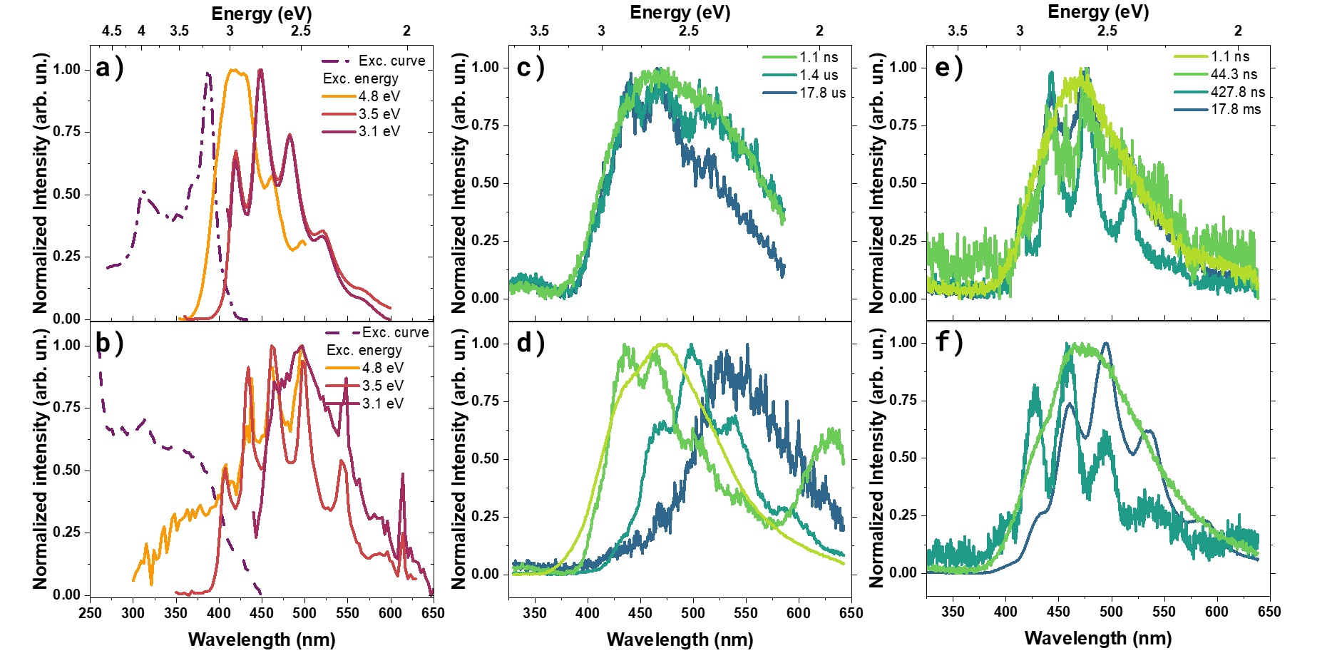
Supplementary Figure 6. Steady-state and time-resolved spectroscopy of BP and DMA in crystalline state. Normalized PL of crystal of BP (a) and DMA (b). Emission was monitored at 447 nm and 462 nm for acquisition of excitation profile for BP and DMA, respectively. Normalized time-resolved emission spectra of BP and DMA crystals at room temperature (c,d) and 80 K (e,f). $λ_{exc}=355 nm$ ; 3.5 eV.

Supplementary Figure 7. Dual-phosphorescence emission from crystal of DMA. PL (black line), emission delayed by 107.1 ns (green) and emission delayed by 14.1 µs (blue) of crystal of DMA. $λ_{exc}=355 nm$ ; 3.5 eV.

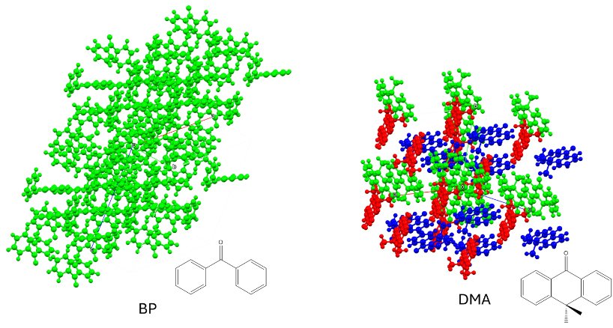
Supplementary Figure 8. Crystalline molecular arrangement of BP and DMA. Crystal structure of BP¹ and DMA². BP molecules have unidirectional arrangement whereas DMA crystalline structure has 3 different arrangements, explaining the observation of dual-phosphorescnece as it is coming from two of these separate arrangements.

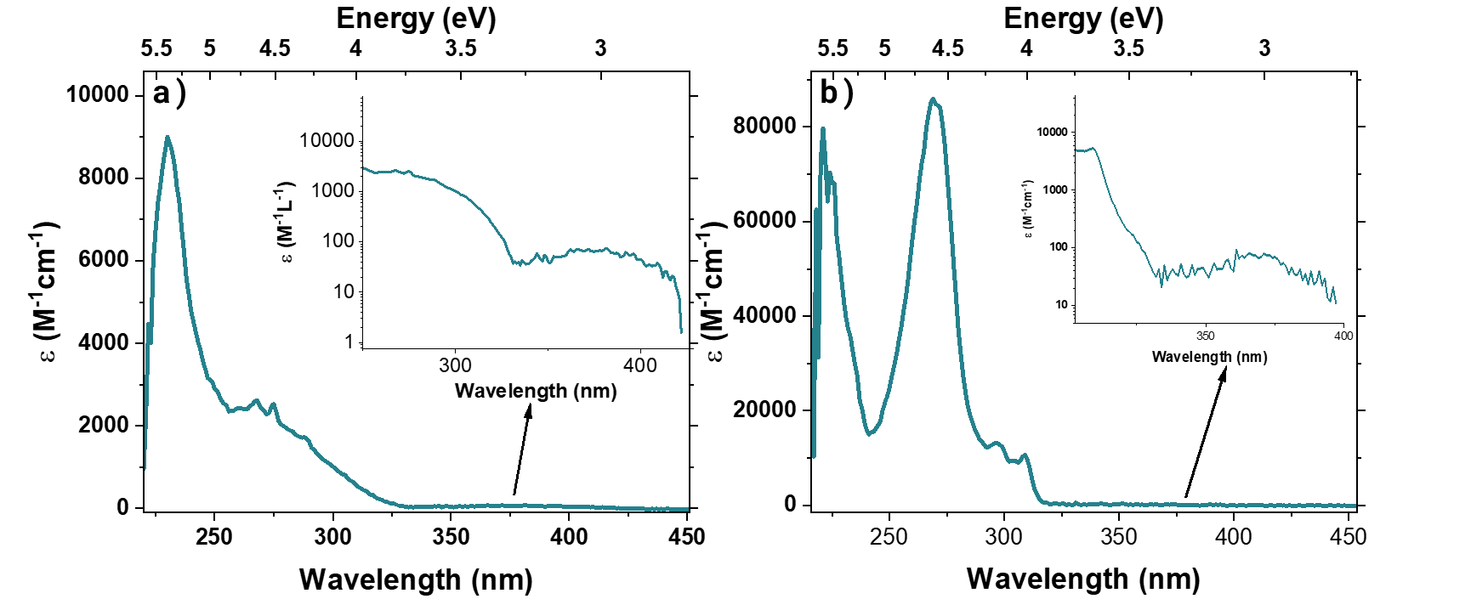
Supplementary Figure 9. Absorption of BP and DMA in methylcyclohexane. Absorption of BP (a) and DMA (b) in 10 µM methylcyclohexane (MCH) solution. Inset zooms into S₀→T₁ absorption band.
Supplementary Figure 10. Absorption of BP in MCH with variation of concentration. Absorption of BP in MCH at concentrations between 10 µM and 100µM.

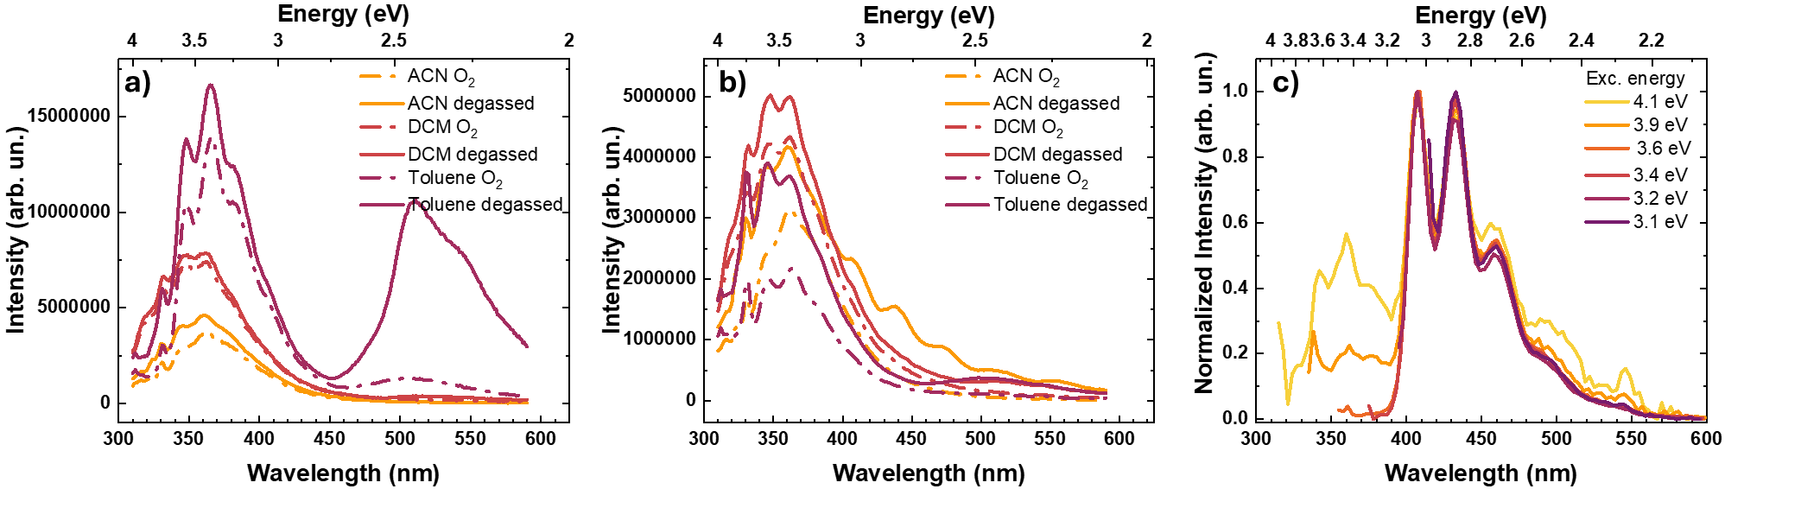
Supplementary Figure 11. Influence of solvent polarity and H-abstraction processes in the emission of BP and DMA. Emission of BP (a) and DMA (b) in 20 µM solutions of acetonitrile (ACN), dichloromethane (DCM) and toluene $λ_{exc}=355 nm$ ; 3.5 eV. The degassing process was carried out by freeze-pump-thaw. A band, at 520 nm peak, appears in BP dissolved in toluene solution after the degassing process. Weak phosphorescence is present for DMA in degassed acetonitrile solution. PL of BP in 20 µM carbon tetrachloride (CCl₄) air saturated solution under varied excitation energies (c).

Supplementary Figure 12. Excitation profile of DMA. Excitation curve of DMA doped in a guest-host film with zeonex (1% wt/wt) at 80 K. Emission was monitored at 440 nm.

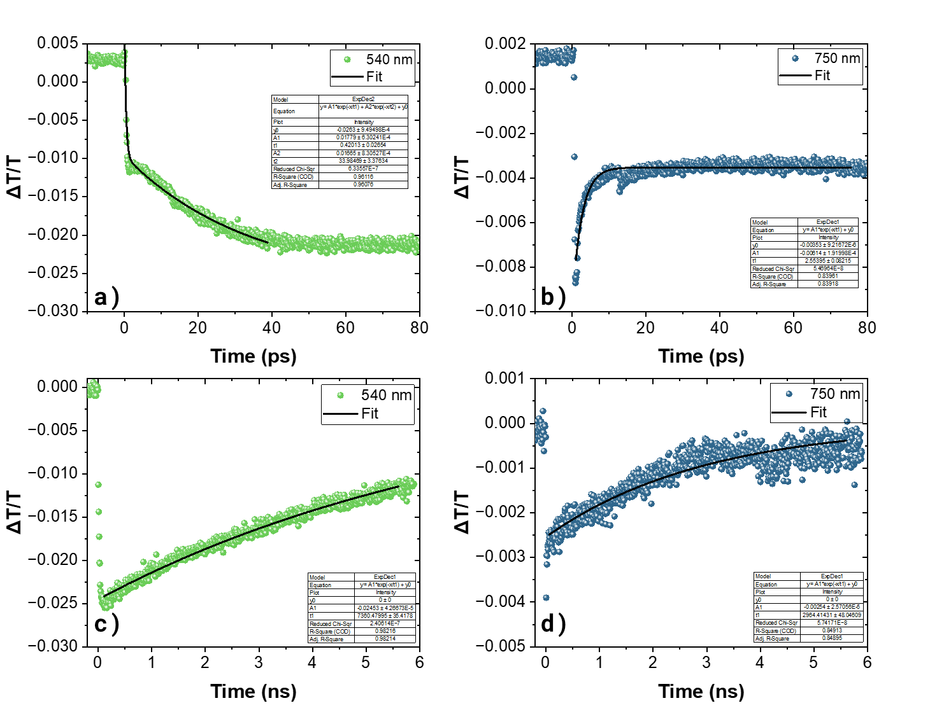
Supplementary Figure 13. Triplet population build-up of BP. Transient absorption decays of BP for the 540 and 750 nm bands in the ps time window a) and b), and in the ns time window c) and d), respectively, inset contains the fitting parameters for all decay curves. [c] = 1 × 10⁻⁴ M, λ_{ex} = 343 nm ; 3.6 eV.

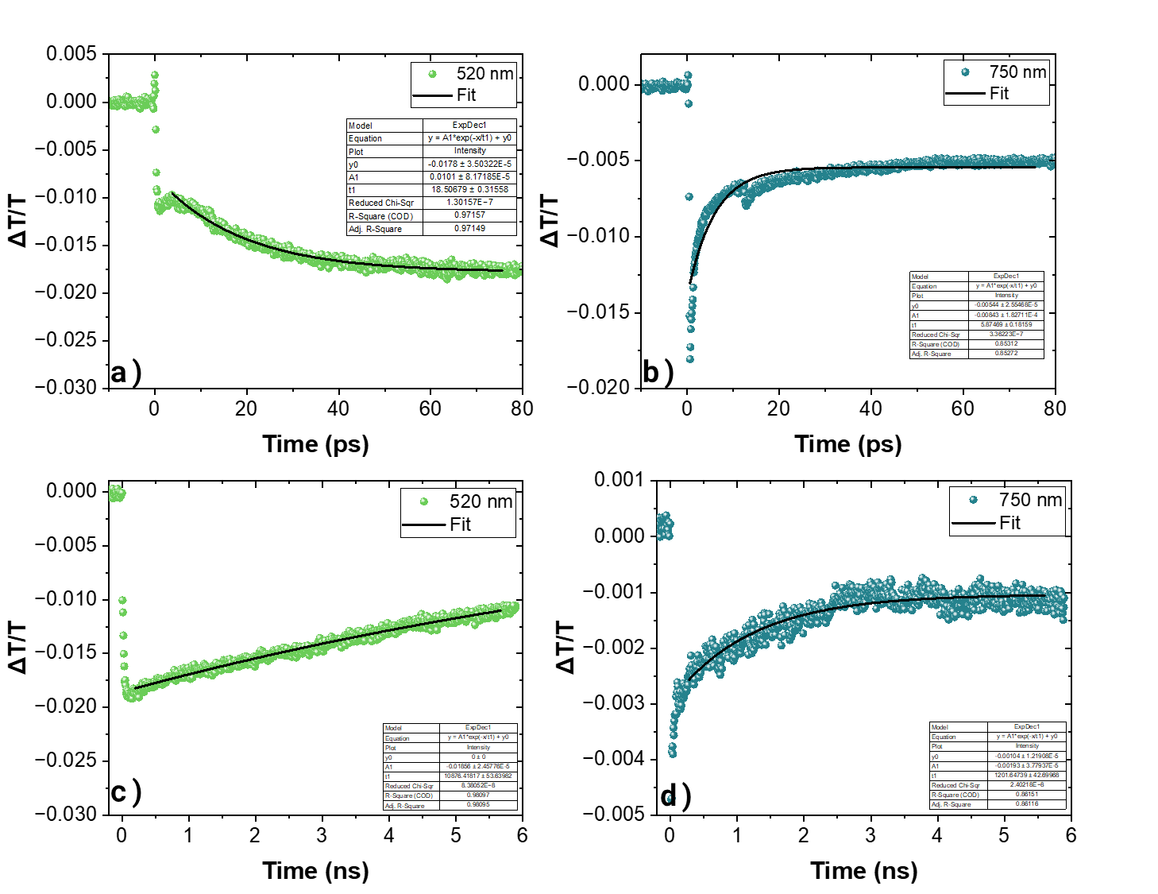
Supplementary Figure 14. Triplet population build-up of DMA. Transient absorption decays of DMA for the 540 and 750 nm bands in the ps time window a) and b), and in the ns time window c) and d), respectively, inset contains the fitting parameters for all decay curves. [c] = 1 × 10⁻⁴ M, λ_{ex} = 343 nm ; 3.6 eV.

References
1. Reilly, A. M. et al. Predicting anisotropic displacement parameters using molecular dynamics: density functional theory plus dispersion modelling of thermal motion in benzophenone. J Appl Crystallogr 46, 656–662 (2013).
2. Fun, H.-K., Hemamalini, M., Siddaraju, B. P., Yathirajan, H. S. & Siddegowda, M. S. 10,10-Dimethylanthrone. Acta Crystallogr Sect E Struct Rep Online 66, o808–o809 (2010).

