A human iPSC-based neural spheroid platform for modeling glioblastoma infiltration using high-content imaging

Victoria S K Tsang^{1,2}*, Federica Riccio¹, Hannah Nudds³, Jason Coombes¹, Heiko Wurdak⁴, Harry J C J Bulstrode^{5,6}, Ivo Lieberam^{1,7} and Davide Danovi^{1,5,8,9}
¹Centre for Gene Therapy and Regenerative Medicine, King’s College London, London, United Kingdom
²Translational Medicine and Therapeutics, Queen Mary University of London, London, United Kingdom
³Department of Clinical and Movement Neurosciences, University College London, London, United Kingdom
⁴School of Medicine, University of Leeds, Leeds, United Kingdom
⁵Wellcome MRC Cambridge Stem Cell Institute, University of Cambridge, Cambridge, United Kingdom
⁶Department of Neurosurgery, Addenbrooke's Hospital, Cambridge, United Kingdom
⁷Centre for Developmental Neurobiology and MRC Centre for Neurodevelopmental Disorders, King’s College London, London, United Kingdom
⁸Department of Basic and Clinical Neuroscience, King’s College London, London, United Kingdom
⁹Migration Biotherapeutics, Cardiff, United Kingdom

*lead contact (v.tsang@qmul.ac.uk).

Supplementary figures

Figure S1.
- Normal distribution curves for NS17, GBM20, and GBM1 infiltration calculated from the means and standard deviation at Days 4 and 5 (Z-factor = 0.218240948 and 0.574686702, respectively).
- Quantification of NS17 infiltration of the neural spheroid at Day 3, normalized to Day 0. Error bars represent mean ± SD. number of independent experiments (n) = 3.
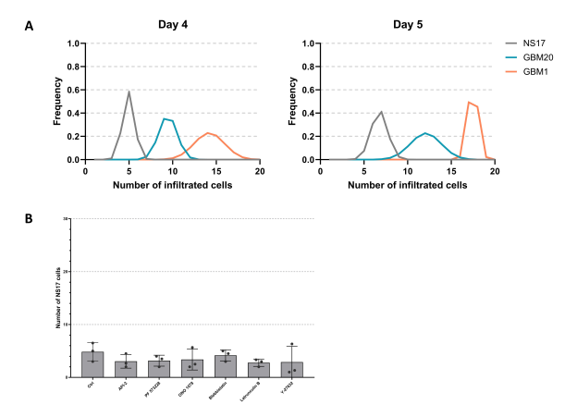
Supplementary videos. Neural spheroids co-cultured with NS17, GBM20, and GBM1 cells imaged for 24h

