Supplementary materials for “Course of long COVID symptoms over time in the ComPaRe long COVID prospective e-cohort”

Supplementary material 1: Study flow chart. *The high number of patients without a confirmed infection is due to the limited availability of testing during the first wave of COVID-19 in March 2020, in France

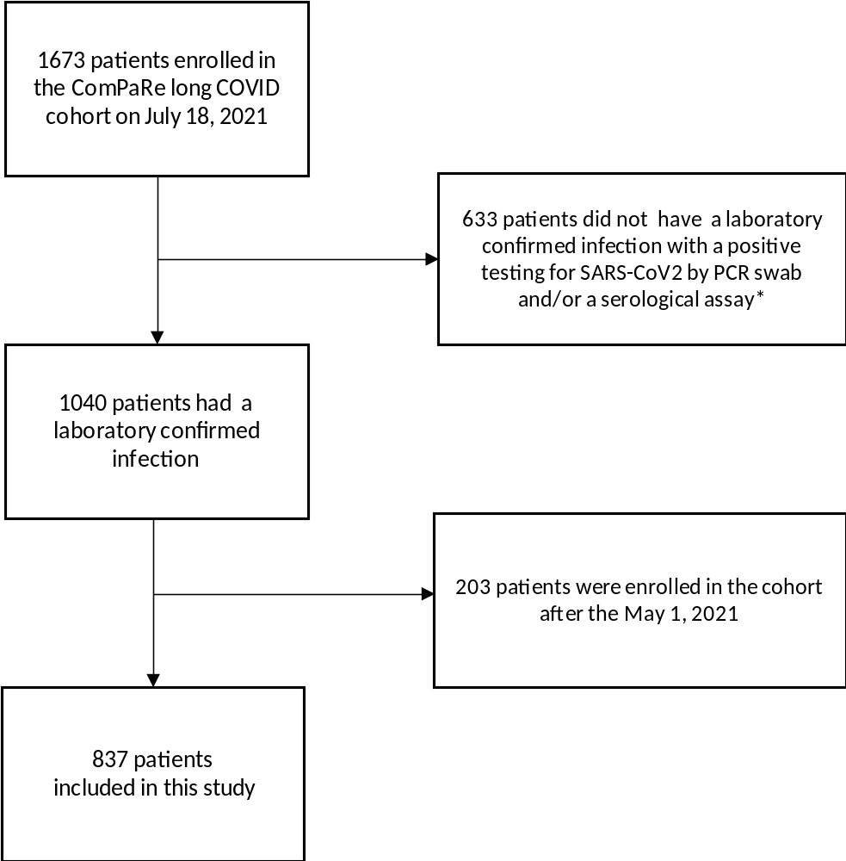

Supplementary material 2: Patients’ characteristics (n=838)
Characteristic | Total  (n=838)
Age, median (Q1−Q3) – year | 46 (37−53)
Male sex – number (%) | 166 (19.8)
Educational level – number (%)  Middle school or equivalent  High school or equivalent  2 years post-secondary education  ≥ 3 years post-secondary education  Other | 60 (7.2)  90 (10.7)  187 (22.3)  484 (57.8)  16 (1.9)
At least one comorbidity – number (%) | 321 (38.3)
Comorbidities – number (%)  High blood pressure  Diabetes  Stroke or cardiac ischemic disease  Chronic kidney disease  Chronic lung disease (e.g., asthma/COPD)  Thyroid disorder  Cancer  Depression/Anxiety | 36 (4.3)  18 (2.1)  5 (0.6)  4 (0.5)  59 (7.0)  19 (2.3)  15 (1.8)  33 (3.9)
Time since symptom onset, median (Q1−Q3) - days | 279 (215 - 435)
Hospitalized for covid-19 – number (%) | 113 (13.5)
Hospitalized in ICU for covid-19 – number (%) | 24 (2.9)
Duration of hospitalization, median (Q1-Q3) | 5 (1−12)

Supplementary material 3: Follow-up of patients included in the study. *As data collection is in progress, these figures may improve with time.
 | Number of patients enrolled in the cohort | Number (%) of patients  actually followed-up
At least 2 months since enrollment (enrolled before May 2021) | 837 | 704 (84%)
At least 4 months since enrollment (enrolled before March 2021) | 724 | 602 (83%)
At least 6 months since enrollment (enrolled before January 2021) | 454 | 297 (65%)*

Supplementary material 4: Estimated prevalence of each of the 53 symptoms assessed by the Long COVID ST at 30 and 180 days after disease onset (n=838). Prevalence is estimated by a multistate model where patients could be either “experiencing" or “not experiencing" the symptom under consideration. On the assumption that a patient’s state at an arbitrary time was the same as the state at their previous observation time and that patient’s states before the first observation and after the last observation are unknown, we estimated the prevalence of the given symptom day by day from disease onset. Colors indicate symptoms with a prevalence decreasing over time (green), symptoms with no change in prevalence over time (yellow), and symptoms with an increasing prevalence over time (red).
Symptom | Estimated prevalence at 30 days | Estimated prevalence at 180 days | Difference
Change/Loss of taste | 62.5 | 27.7 | -34.8
Diarrhea | 43.8 | 19.3 | -24.5
Change/Loss of smell | 62.5 | 38.9 | -23.6
Congested/Runny nose | 50 | 26.7 | -23.3
Cough | 43.8 | 20.7 | -23.1
Dizziness/malaise | 62.5 | 39.6 | -22.9
Difficulty sleeping | 75 | 53.3 | -21.7
Loss of appetite | 31.2 | 9.8 | -21.4
Sore tongue/mouth, dysphagia | 37.5 | 16.8 | -20.7
Costal pain | 43.8 | 24.2 | -19.6
Fever and chills | 50 | 31.6 | -18.4
Sharp sudden pain, chest burns | 37.5 | 20 | -17.5
Weight loss | 25 | 8.8 | -16.2
Abdominal pain | 50 | 34 | -16
Chest pressure | 43.8 | 28.1 | -15.7
Body aches | 50 | 35.8 | -14.2
Paraesthesia | 43.8 | 29.8 | -14
Hot flushes | 37.5 | 23.9 | -13.6
Headache | 68.8 | 56.1 | -12.7
Clogged ears | 18.8 | 10.2 | -8.6
Tinnitus | 37.5 | 29.8 | -7.7
Swollen lymph nodes | 12.5 | 6.7 | -5.8
Skin rash | 25 | 19.3 | -5.7
Nausea/Vomiting | 25 | 19.6 | -5.4
Dyspnea | 43.8 | 40 | -3.8
Tachycardia/palpitations/arrhythmia | 37.5 | 34 | -3.5
Dry skin/peeling | 25 | 22.8 | -2.2
Circulatory problems (including bulging veins) | 12.5 | 10.5 | -2
Sweating | 18.8 | 17.5 | -1.3
Heavy legs/swelling of the legs | 18.8 | 18.2 | -0.6
Tremor | 12.5 | 11.9 | -0.6
Changing mood/impact on morale | 43.8 | 43.9 | 0.1
Blurry vision | 31.2 | 31.6 | 0.4
Muscle aches | 43.8 | 44.2 | 0.4
Ear pain | 12.5 | 14 | 1.5
Hypoesthesia | 0 | 2.5 | 2.5
Balance disorder | 18.8 | 21.8 | 3
Discoloration/swelling of hands and feet | 6.2 | 10.2 | 4
Phono/photophobia | 6.2 | 10.5 | 4.3
Fatigue | 75 | 80 | 5
Dry eyes | 25 | 30.2 | 5.2
Bone and joint pain | 31.2 | 36.5 | 5.3
Sleeping more | 18.8 | 24.2 | 5.4
Brain fog/Difficulty concentrating | 56.2 | 61.8 | 5.6
High or low blood pressure | 6.2 | 13 | 6.8
Spontaneous bruises | 0 | 8.1 | 8.1
Heat/Cold intolerance | 6.2 | 14.7 | 8.5
Urinary symptoms | 0 | 9.8 | 9.8
Neck, back, and low back pain | 31.2 | 41.4 | 10.2
Gynecological problems | 0 | 11.9 | 11.9
Memory problems | 25 | 44.9 | 19.9
Hair loss | 0 | 25.6 | 25.6
Word-finding problems | 12.5 | 46.3 | 33.8

Supplementary material 5: Estimated prevalence of symptoms between patients aged ≤ 40 years old and >40 years old. For each of the 53 symptom of the long COVID ST, the day-by-day prevalence in patients aged 40 years old and younger, and those older than 40 years old was calculated. We present below the 6 symptoms for which the sum of absolute differences is > 2100 (on average 10% difference in prevalence between the two subgroups from 30 to 240 days).
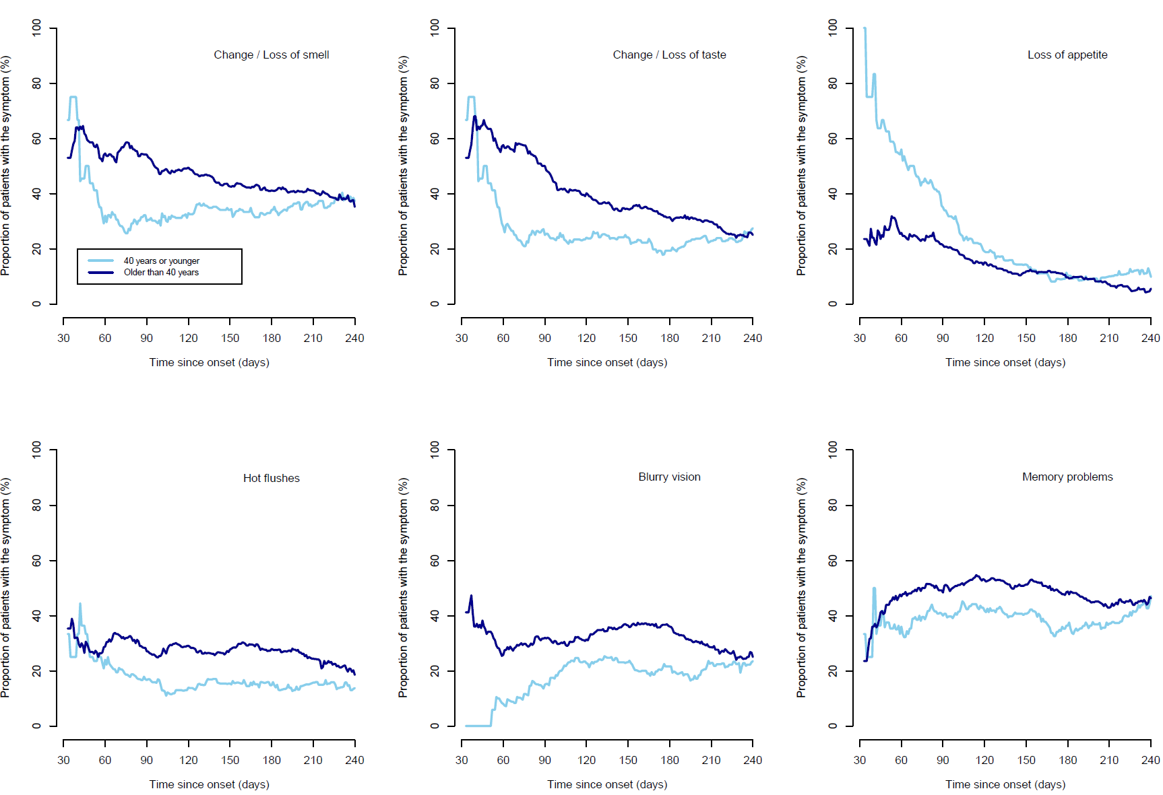

Supplementary material 6: Longitudinal course of the frequency of symptoms for patients with long COVID. Data come from the answer to the question: “how often symptoms occurred during the last 30 days” using four response options: “permanent symptoms”, “daily relapses”, “weekly relapses”, and “less than weekly relapses.”

