Supplementary Materials for
In Situ Atomic-Scale Observation of Dislocation Climb and Grain Boundary Transformation in Nanostructured Metal
Shufen Chu¹, Pan Liu^{1,2}*, Yin Zhang³, Xiaodong Wang¹, Shuangxi Song¹, Ting Zhu³*, Ze Zhang⁴, Xiaodong Han⁵, Baode Sun¹, Mingwei Chen^{2,6}*
*Corresponding authors: panliu@sjtu.edu.cn (PL); ting.zhu@me.gatech.edu (TZ); mwchen@jhu.edu (MC)

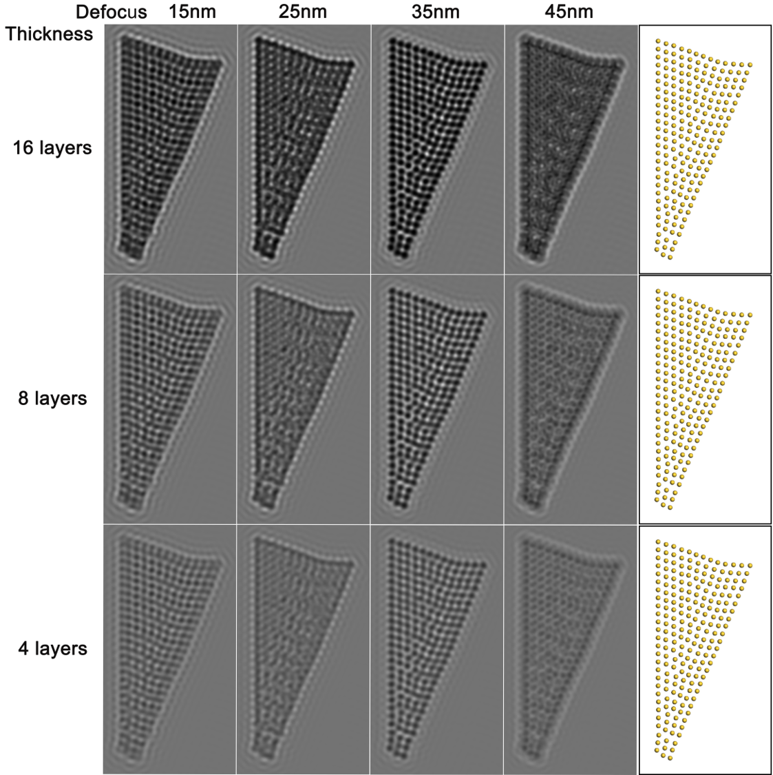
Supplementary Figure 1. Simulated HRTEM images from the reconstructed atomic model of the HAGB. Parameters used include the acceleration voltage of 200 kV, spherical aberration coefficient of 0.5 mm, defocus spread of 5 nm and beam convergence of 0.03/Angstrom. The simulated images with defocus values of 15 nm, 25 nm, 35 nm, and 45 nm and thicknesses of 16, 8, and 4 layers of ($\text{1}\overline{\text{1}}\text{0}$) plane are shown in the first four columns, respectively. The actual Au atom position is given in the last column for comparison. The simulated images vary dramatically with different defocus values. When the defocus value is 35 nm, the simulated images are in good agreement with our experimental results. Hence, as compared with the actual Au atom positions, it is acceptable that the dark spots represent Au atomic columns while the white spots represent the channels between atomic columns. In addition, with a fixed defocus value of 35 nm, the contrast of dark spots (corresponding to atomic columns) becomes brighter continuously as the sample thickness decreases, showing that a semi-quantitative analysis of HRTEM images should be reasonable.

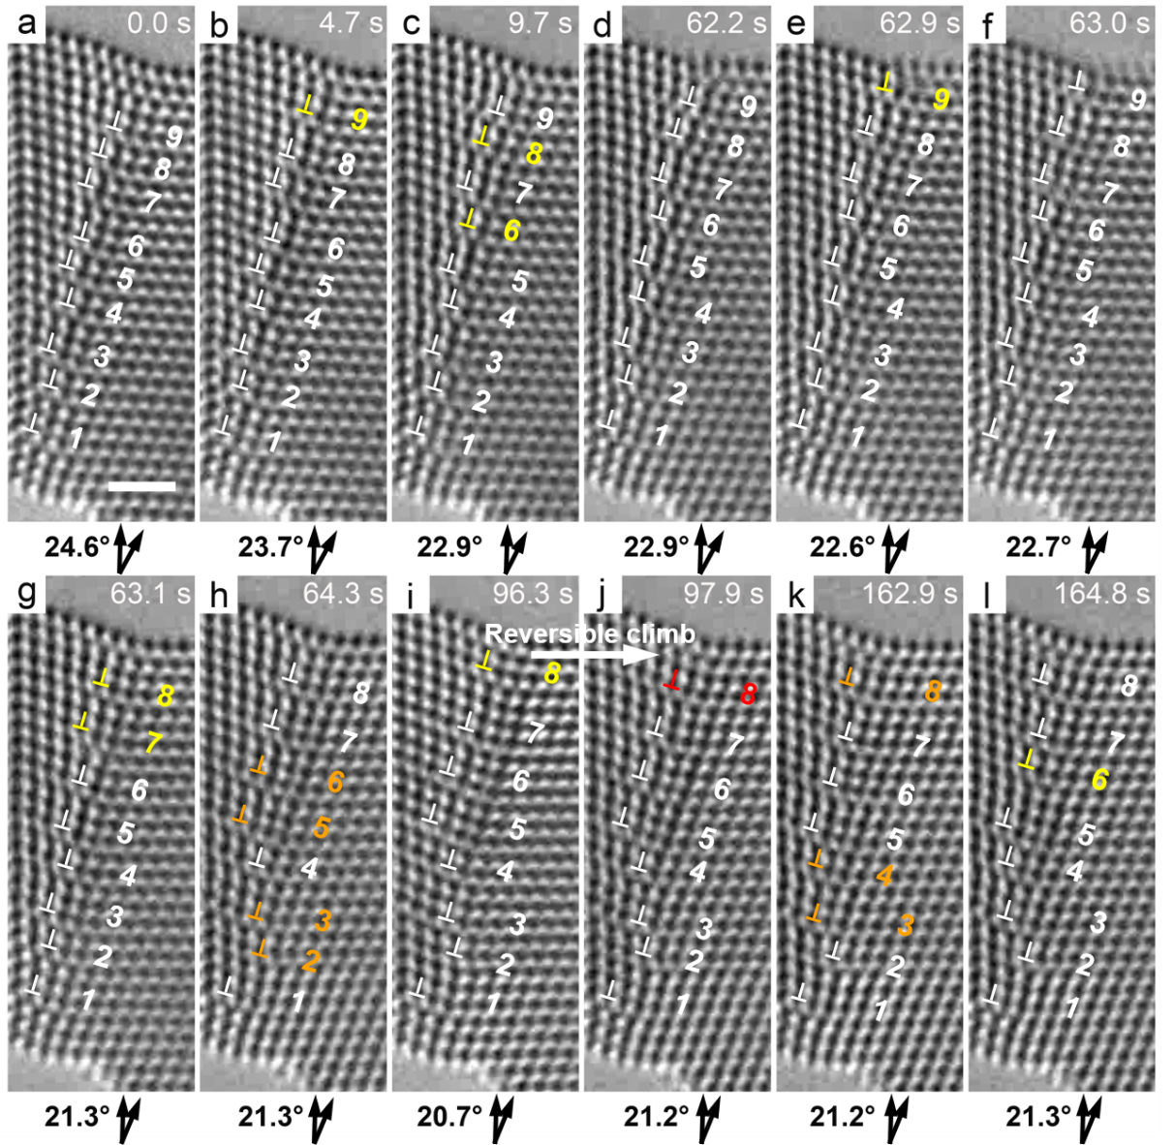
Supplementary Figure 2. In situ HRTEM images showing more detailed dislocation processes of GB dislocation climb and glide. Each event of positive and negative climb in the present frame relative to the previous frame is marked by yellow and red symbols ⊥, respectively, while dislocations staying still are marked by white symbols ⊥. Each event of dislocation glide is marked by orange symbols ⊥. Reversible climb occurs in (i) and (j), likely due to local stress fluctuation. Scale bar: 1 nm.

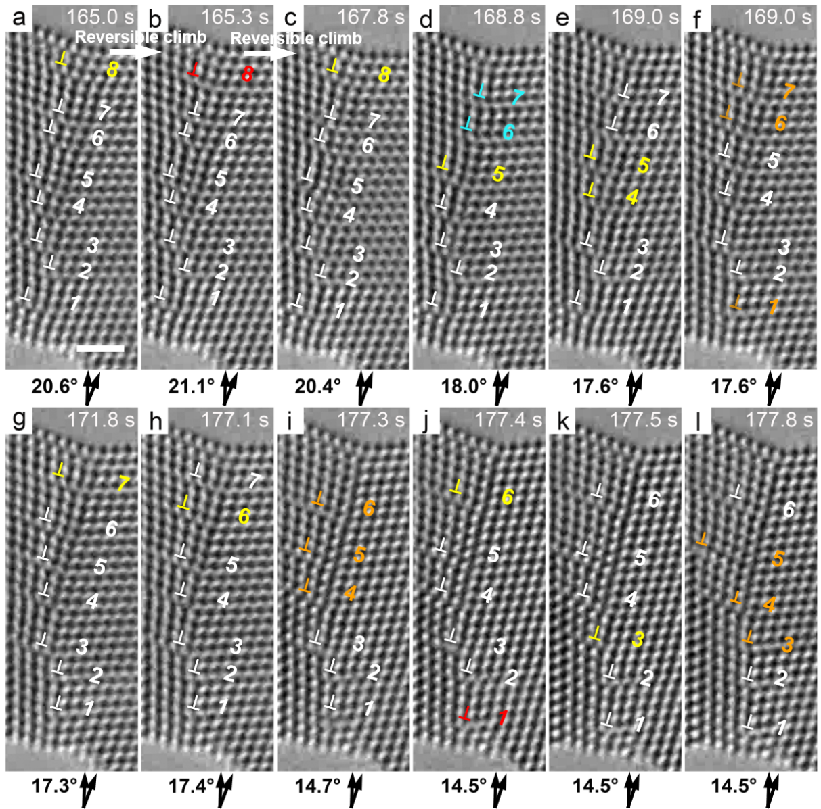
Supplementary Figure 3. In situ HRTEM images showing more detailed dislocation processes of GB dislocation climb and glide. The convention of symbols are the same as Supplementary Figure 3. Reversible climb of GB dislocations occurs in (a-c). Coupled dislocation climb and sliding are marked by cyan symbols ⊥. Scale bar: 1 nm.

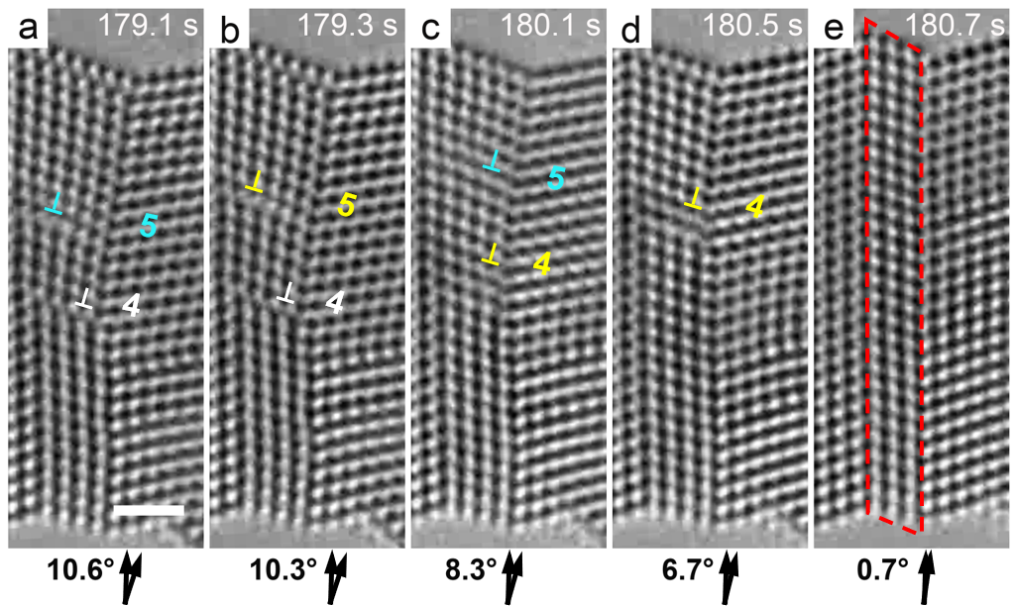
Supplementary Figure 4. In situ HRTEM images showing more detailed dislocation processes of GB dislocation climb and glide. The HAGB was eventually transformed into a Σ3 coherent TB in (e). The thickness of the twin lamella is decreased from 5 atomic layers of {111} in (d) to 4 layers in (e), and this can be ascribed to TB migration under local shear stress. Scale bar: 1 nm.

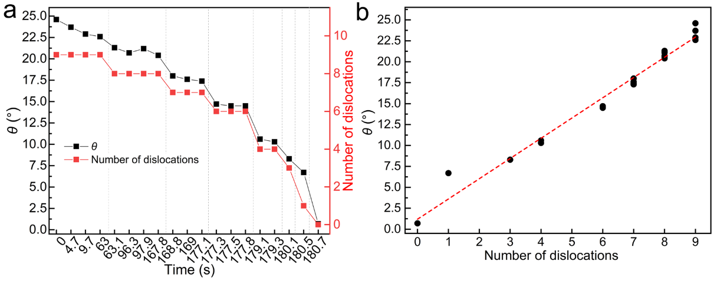
Supplementary Figure 5. (a) Misorientation angle θ and the number of GB dislocations are plotted against time. (b) A linear fitting curve (red dashed line) matches the trend of data points between θ and the number of dislocations. The resulting linear relationship between θ and the number of dislocations is consistent with the Frank-Bilby equation, $\text{θ }\text{= 2arc}\text{sin}{\frac{\text{b}}{\text{2}\text{d}}}$ (where b is the Burgers vector length and d is the average spacing between GB dislocations).

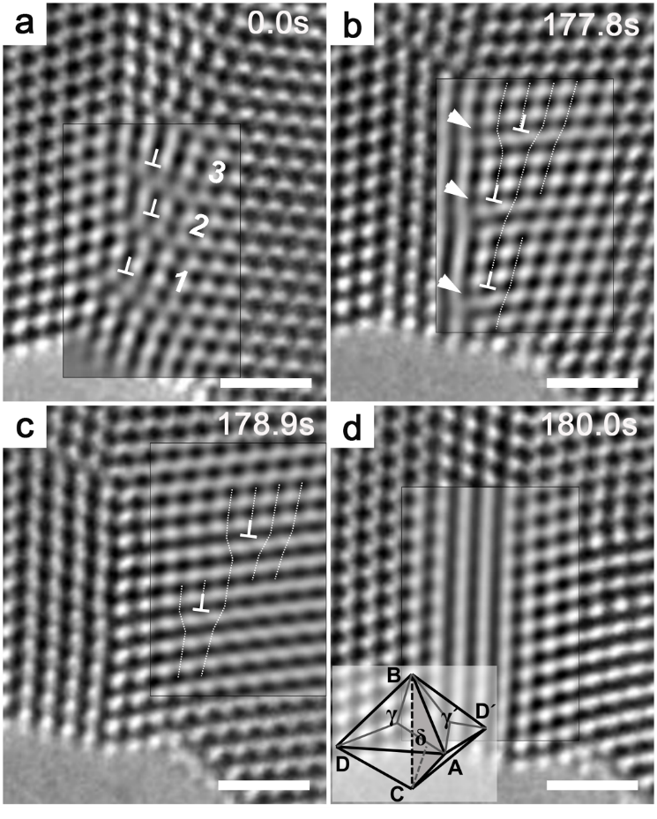
Supplementary Figure 6. Interaction between dislocations “1” - “3” and the TB. Dislocations “1” - “3” pass through the TB to enter the right grain, resulting in migration of the TB to the right. Three steps are produced in (b) and marked by white arrows; they are the projection of 1/6[$\overline{\text{1}}\text{2}\overline{\text{1}}$] partial dislocations. The reaction between each dislocation and the TB follows 1/2[011] → 1/2[$\overline{\text{1}}\text{0}\overline{\text{1}}$] + 1/6[$\overline{\text{1}}\text{2}\overline{\text{1}}$] (DA→A´D´+ Cδ) ^{1,2}. As a result of this reaction, each full dislocations (A´D´) glides into the right grain, while each twin partial (Cδ) glides along the TB and vanishes in (c), resulting in migration of the TB to the right. A perfect twin lamella forms in (d). To display the defects more clearly, the boxed regions were filtered by the inverse Fast Fourier Transform method. Scale bar: 1 nm.
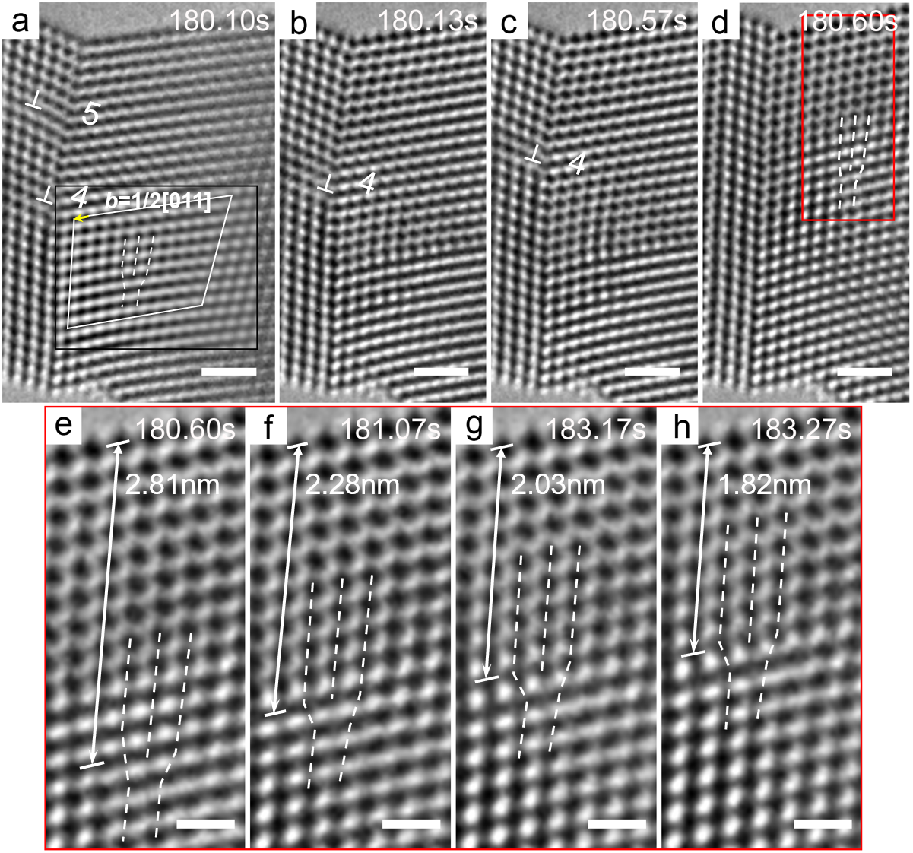
Supplementary Figure 7. A short time series of HRTEM images right before and after dislocations “5” and “4” disappear. Because of fast dislocation activities involved, the detailed processes of their disappearance were not captured. However, it can be deduced from the movements of surrounding dislocations that dislocations “5” and “4” annihilate from the top surface of the ligament by climb, since no new dislocation is found at the TB or in the right grain. In (a), a Burgers circuit encloses a full dislocation in the right grain; this dislocation results from slip transmission of a dislocation (in the middle grain) across the TB and it further climbs upward in the right grain as indicated by the red box in (d). (e)-(h) Zoom-in images corresponding to the red-boxed region in (d) showing the occurrence of dislocation climb in the lattice of the right grain. The distance between the dislocation core and the top surface is indicated by a double-headed arrow, and this distance is decreased from (e) to (h), indicative of dislocation climb in the lattice. Scale bar: 1 nm in (a)-(d), and 0.5 nm in (e)-(h).

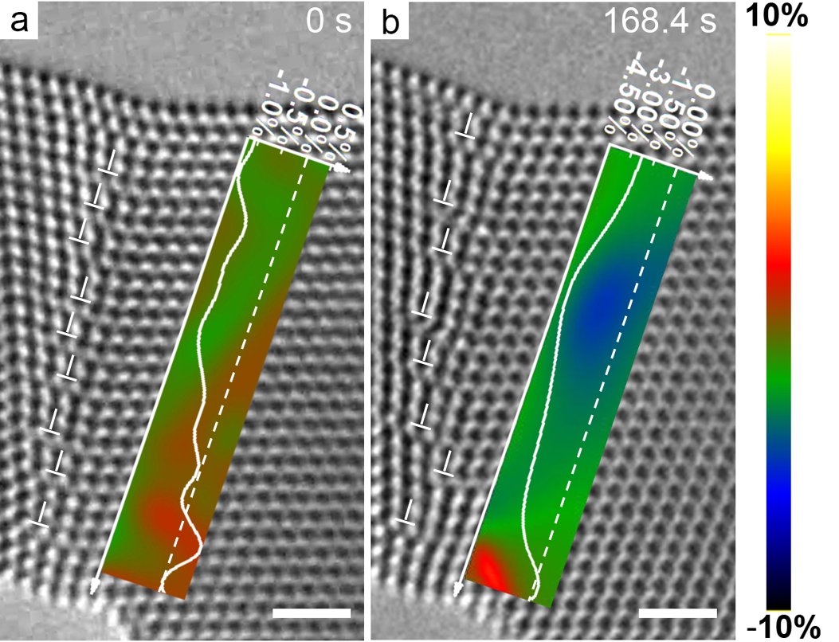
Supplementary Figure 8. Distribution of normal lattice strain on the GB plane, as estimated by the GPA method, at t = 0 s (a) and t = 168.4 s (b). The strain color map spans a range from -10% (black) to 10% (white). The strain distribution indicates the compressive and tensile lattice strain on the upper and lower part of the GB plane, respectively. Scale bar: 1 nm.
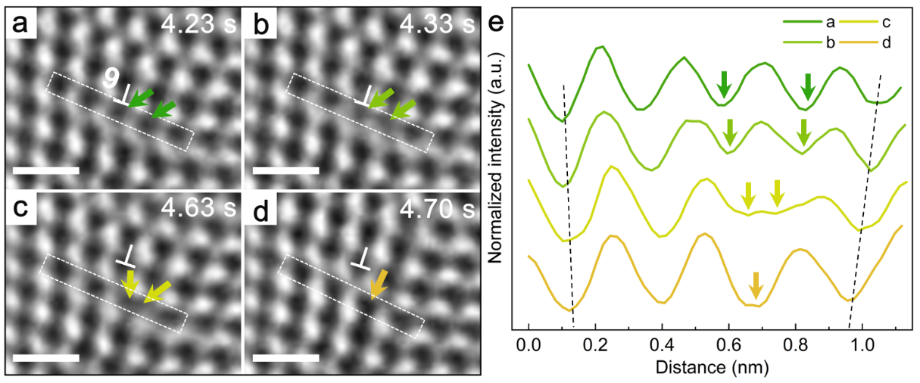
Supplementary Figure 9. Additional example of two atomic columns involved during the reconstruction of the core of a positively-climbing GB dislocation. The contrast intensity profiles in (e) are extracted along the dotted rectangles in (a)-(d). Scale bar: 0.5 nm.

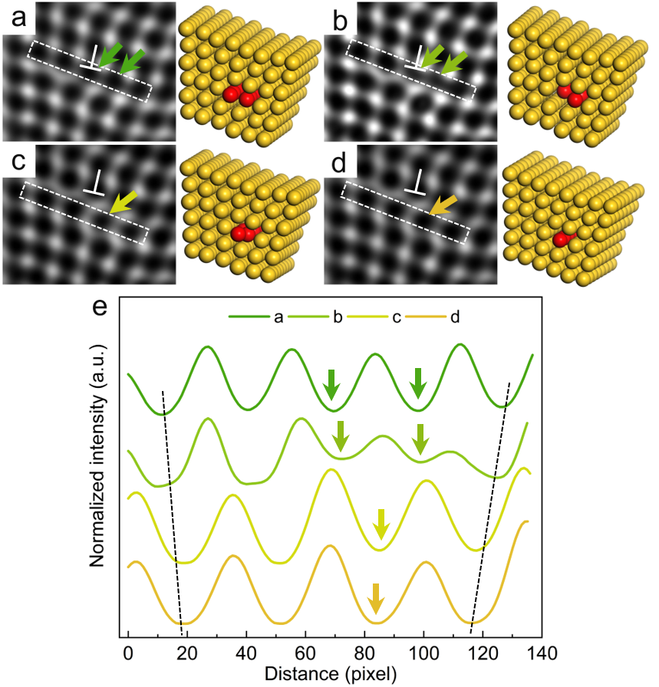
Supplementary Figure 10. (a)-(d) Simulated HRTEM images (left) and corresponding atomic configurations (right) during climb of a GB dislocation. In the simulation, the defocus value is set as 35 nm and the sample has 8 layers of ($\text{1}\overline{\text{1}}\text{0}$) plane along the $[\text{1}\overline{\text{1}}\text{0}\text{]}$ direction. Dark spots in the simulated HRTEM images represent atomic columns. Red atomic columns are used to represent the dislocation core in the reconstructed atomic configuration (right) in (a). A half amount of atoms are being removed from the two red columns in the dislocation core in (b), followed by the merging process in (c). Two red columns merge into one column in (d), indicating the completion of dislocation climb by one atomic layer. The normalized contrast intensities along the dotted rectangles are plotted in (e), showing the same dislocation climb process as the experimental results.
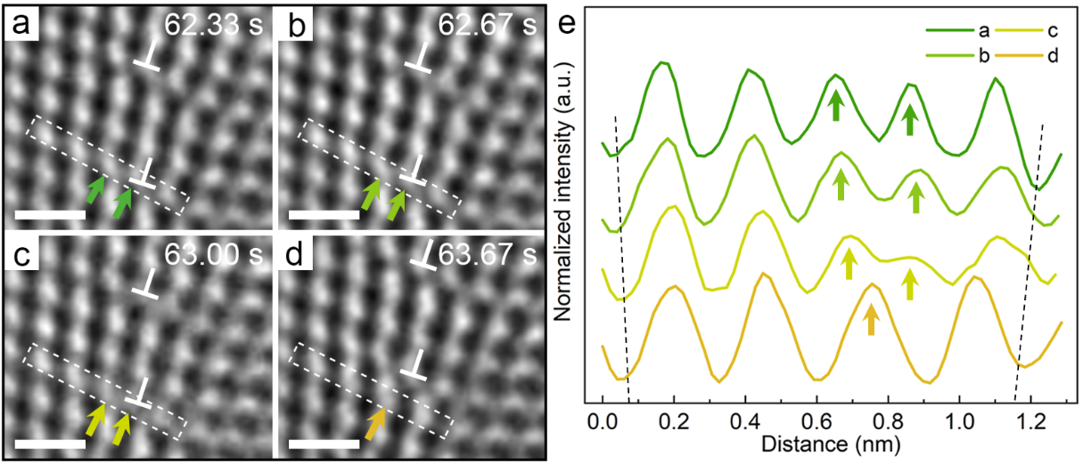
Supplementary Figure 11. An alternative analysis of dislocation climb by taking the bright spots in HRTEM images as atomic columns. Peaks pointed by arrows in the line profile a to c indicate the gradually decrease of contrast intensity. The decreased distance between the two peaks indicates the merging process of the two atomic columns at the dislocation core. The appearance of a single peak (atomic column) with the concomitant of disappearance of the two previous peaks (atomic columns) in the line profile d indicates the completion of dislocation climb by one atomic layer. Scale bar: 0.5nm.

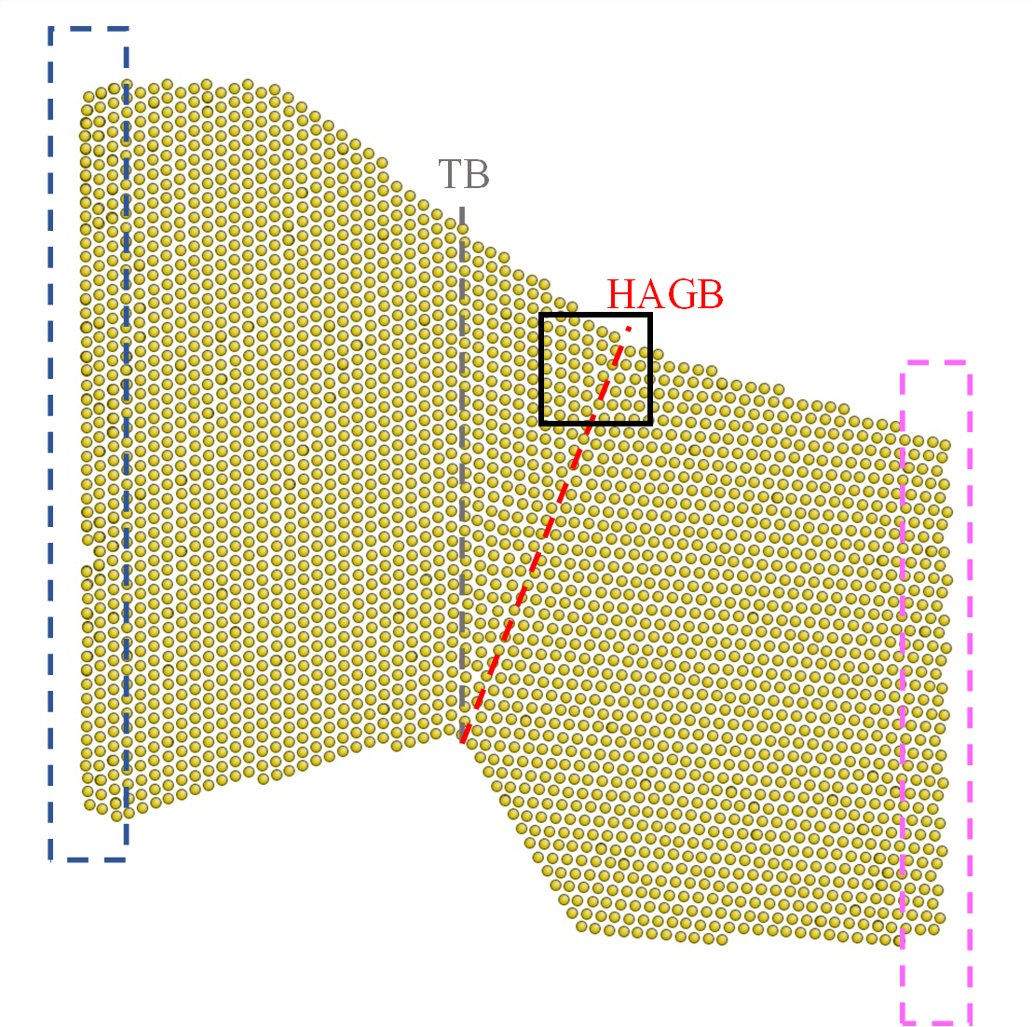
Supplementary Figure 12. GCMC simulation setup showing the atomic configuration of the Au ligament reconstructed from the HRTEM image in Fig. 1a. The twin boundary (TB) and high-angle grain boundary (HAGB) are marked. During GCMC simulation, atoms on the left side (blue box) of the reconstructed Au ligament were fixed and atoms on the right side (pink box) were subjected to an applied bending load.

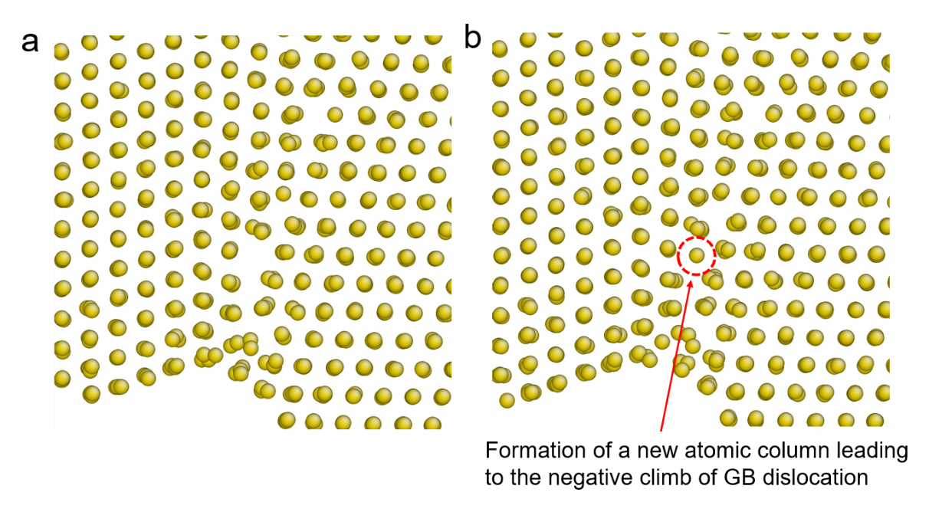
Supplementary Figure 13. GCMC simulation result of negative climb of a GB dislocation, showing the atomic structure (a) before and (b) after climb.

Supplementary Table 1. Maximum climb velocity of dislocations “1”- “9”.
Dislocation number | 1 | 2 | 3 | 4 | 5 | 6 | 7 | 8 | 9
Maximum velocity (nm/s) | $$\text{-1.40×}{\text{10}}^{\text{-3}}$$ | 0 | $$\text{1.40×}{\text{10}}^{\text{-3}}$$ | $$\text{17}\text{.}\text{2}$$ | $$\text{15}\text{.}\text{6}$$ | $$\text{7.09×}{\text{10}}^{\text{-1}}$$ | $$\text{1.28×}{\text{10}}^{\text{-1}}$$ | $$\text{2}\text{.}\text{48}$$ | $$\text{3.23×}{\text{10}}^{\text{-1}}$$

Supplementary Discussion
Effect of electron beam irradiation on structure and temperature.
The maximum increase of temperature under electron irradiation was estimated by Fisher’s model ³: $\text{ΔT }\text{= }\frac{\text{I}}{\text{πκe}}\text{(}\frac{\text{ΔE}}{\text{d}}\text{)ln}\frac{{\text{b}}_{\text{s}}}{{\text{r}}_{\text{0}}}$, where I is the total beam current, $κ$ is the thermal conductivity, e is the electron charge, b_{s} is the sample radius, r₀ is the effective beam radius, and $\text{Δ}\text{E}$ is the total energy loss per electron in a sample with a thickness of d. The total beam current I is I = Jπr₀², where J is the current intensity. Because energy loss in the sample was small compared to the initial energy (200 keV), the term $\text{Δ}\text{E}$/d was equal to the stopping power of electrons, dE/dx, which was calculated from the Bethe-Bloch equation ⁴:
$$\text{-}\frac{\text{dE}}{\text{dx}}\text{ =} \frac{\text{2}\text{πZρ}{\left(\frac{{\text{e}}^{\text{2}}}{\text{4}\text{π}{\text{ε}}_{\text{0}}}\right)}^{\text{2}}}{\text{m}υ^{\text{2}}}\text{\{ln}\left[\frac{\text{E}{\left(\text{E}\text{+}\text{m}{\text{c}}^{\text{2}}\right)}^{\text{2}}{\text{β}}^{\text{2}}}{\text{2}{\text{I}}_{\text{e}}^{\text{2}}\text{m}{\text{c}}^{\text{2}}}\right]\text{+}\left(\text{1-}{\text{β}}^{\text{2}}\right)\text{-}\left(\text{1-}\sqrt{\text{1-}{\text{β}}^{\text{2}}}\text{+}{\text{β}}^{\text{2}}\right)\text{ln2+}\frac{\text{1}}{\text{8}}{\left(\text{1-}\sqrt{\text{1-}{\text{β}}^{\text{2}}}\right)}^{\text{2}}\text{\}}$$
where Z is the atomic number of the target element, $\text{ρ}$is the atomic density, ε₀ is the
dielectric constant, m is the electron rest mass, υ is the electron velocity, E is the electron energy, c is the speed of light, I_{e} is the average excitation energy of electrons in the target, and β = υ/c. In the present study, the acceleration voltage is 200 kV, such that β = 0.6946 and υ = 2.0837×10⁸ m/s.
For Au, Z = 79, ρ = 4.79×10²⁹ m⁻³ (the mass density is 19320 kg/m³), I_{e} = 10Z = 790, κ = 301 W/mK, m = 9.1×10⁻³¹ kg, e = 1.6×10⁻¹⁹ C, c = 3×10⁸ m/s, ε₀ = 8.85×10⁻¹² F/m. By using these two equations, the maximum temperature increase was estimated to be 3.8 K in the Au region in our experiments with I = 2.5 nA, b_{s} = 1.5 mm and r₀ = 100 nm. Hence, the effect of electron beam irradiation only leads to a few degrees above room temperature, which has negligible contributions to the dislocation climb behavior.

Supplementary Movies 1-5
Movie 1: In situ bending deformation of an Au ligament, recorded at a rate of 30 frames per second and played at 5× speed.

Movie 2: Fast dislocation climb in the final stage of deformation, recorded at a rate of 30 frames per second and played at 0.2× speed.

Movie 3-5: Positive and negative dislocation climb as well as the evolution of dislocation cores, recorded at a rate of 30 frames per second and played at 0.125× speed (Movie 3, Movie 5) or 0.2× speed (Movie 4).

Supplementary References
1. Jin, Z. H., et al. Interactions between non-screw lattice dislocations and coherent twin boundaries in face-centered cubic metals. Acta Mater. 56, 1126-1135 (2008).
2. Wang, Y. & Sui, M. Atomic-scale in situ observation of lattice dislocations passing through twin boundaries. Appl. Phys. Lett. 94, 021909 (2009).
3. Fisher, S. B. On the temperature rise in electron irradiated foils. Radiat. EIT. 5, 239-243 (1970).
4. Jenc̆ic̆, I., Bench, M. W., Robertson, I. M. & Kirk, M. A. Electron‐beam‐induced crystallization of isolated amorphous regions in Si, Ge, GaP, and GaAs. J. Appl. Phys. 78, 974-982 (1995).

