Supplementary Information
Supplementary Table 1. Panel of 40 heat-stress genes
Supplementary Table 2. Cluster_top20genespercluster_logFC_colorectum_HV_cohort
Supplementary Table 3. CellChat defnet data from healthy colonic epithelial cells
Supplementary Table 4. CellChat defnet data from healthy rectal epithelial cells
Supplementary Table 5. Gene panel for Xenium in situ
Supplementary Table 6. Cluster_top20genespercluster_logFC_rectum_HV_IBS_cohort
Supplementary Table 7. Cluster_top20genespercluster_logFC_colon_HV_CD_cohort
Supplementary Table 8. Differential abundance analysis (miloR) in CD

Corresponding author
Prof. Alexandre Denadai-Souza
Address: Herestraat 49, O&N1, Box 703, 3000 Leuven, Belgium
Tel: +32 16 32 14 23
Correspondence: alexandre.denadai-souza@kuleuven.be

Extended Data Fig. 1. Overview of the human cohort and omics workflow
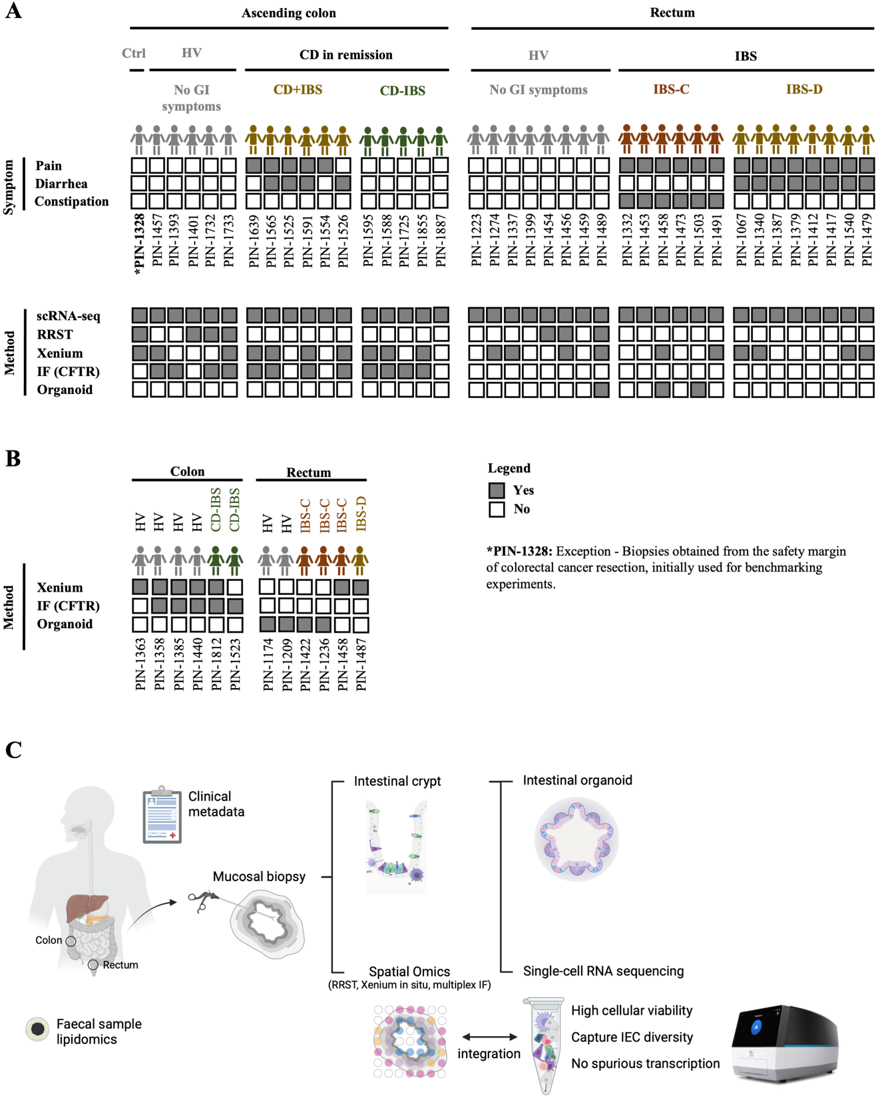
a, Primary human cohort showing gastrointestinal symptom status and experimental approaches applied to each subject’s samples. b, Extended human cohort used for validation experiments. c, Multi-omics workflow applied in this study. Created in BioRender. (2025) https://BioRender.com/di5leki.
Extended Data Table 1. Demographic and clinical characteristics of the human cohort used for single-cell RNA sequencing of colonic epithelial cells

 | HV | CD+IBS | CD-IBS
N | 6 | 6 | 5
Female, N (%) | 3 (50) | 3 (50) | 0 (0)
Age, median (IQR) | 50 (47-54) | 41 (38-46) | 34 (23-44)
SES-CD, median (IQR) | 0 (0-0) | 3 (0-3.25) | 3 (0-3)
Cal, median (IQR) | 53 (32-164) | 94 (32-175) | 30 (14-186)
CRP, median (IQR) | 6 (2-23) | 14 (8-50) | 8 (3-23)
VAS, median (IQR) | 0 (0-0) | 4.3 (2.25-7.25) | 0 (0-0)
Diarrhea, N (%) | 0 (0) | 4 (67) | 0 (0)

HV: healthy volunteers, CD+IBS: Crohn’s disease patients in remission with irritable bowel syndrome (IBS)- like symptoms. CD-IBS: Crohn’s disease patients in remission without IBS-like symptoms, SES-CD: simple endoscopic score for Crohn’s disease, Cal: calprotectin (µg/g), CRP: C reactive protein (mg/L), VAS: visual analog score.

Extended Data Table 2. Demographic and clinical characteristics of the human cohort used for single-cell RNA sequencing of rectal epithelial cells
 | HV | IBS-C | IBS-D
N | 8 | 6 | 8
Female, N (%) | 7 (88) | 5 (83) | 7 (88)
Age, median (IQR) | 28 (26-36) | 42 (33-55) | 28 (26-36)
VAS, median (IQR) | 0 (0-0) | 6 (5.75-7.25) | 5.5 (3.25-6.75)

HV: healthy volunteers, IBS: irritable bowel syndrome, -C: predominance of constipation, -D: predominance of diarrhea, IBS-SSS: IBS-Symptom Severity Score, IQR: interquartile range, VAS: visual analog scale.

Extended Data Fig. 2. Relative expression of heat-stress genes
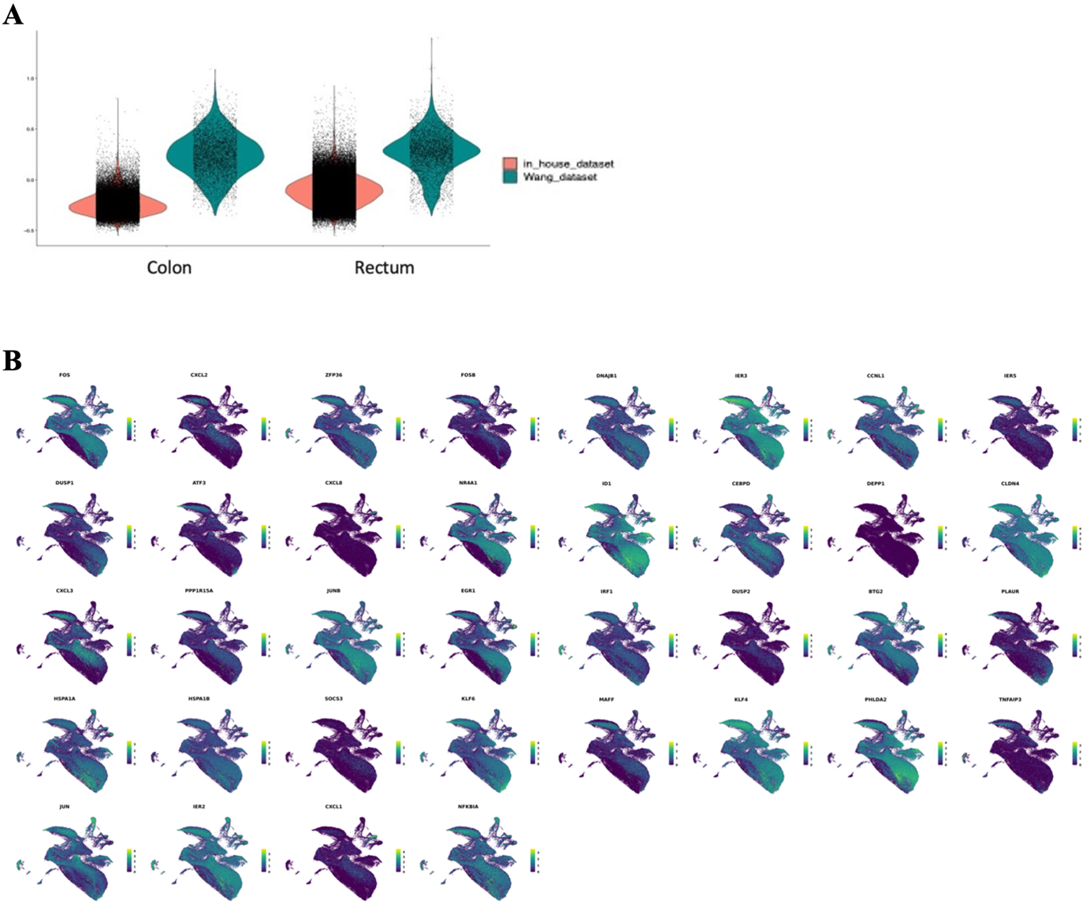
a, Violin plot comparing mean expression of a 38-gene heat-stress panel between our dataset and a previously published study using 3- vs. 35-minute enzymatic digestion at 37 °C, respectively. b, Feature plot showing spatial enrichment of individual heat-stress genes in the healthy human colorectum.

Extended Data Fig. 3. Transcription factors differentially active within the human health colorectum
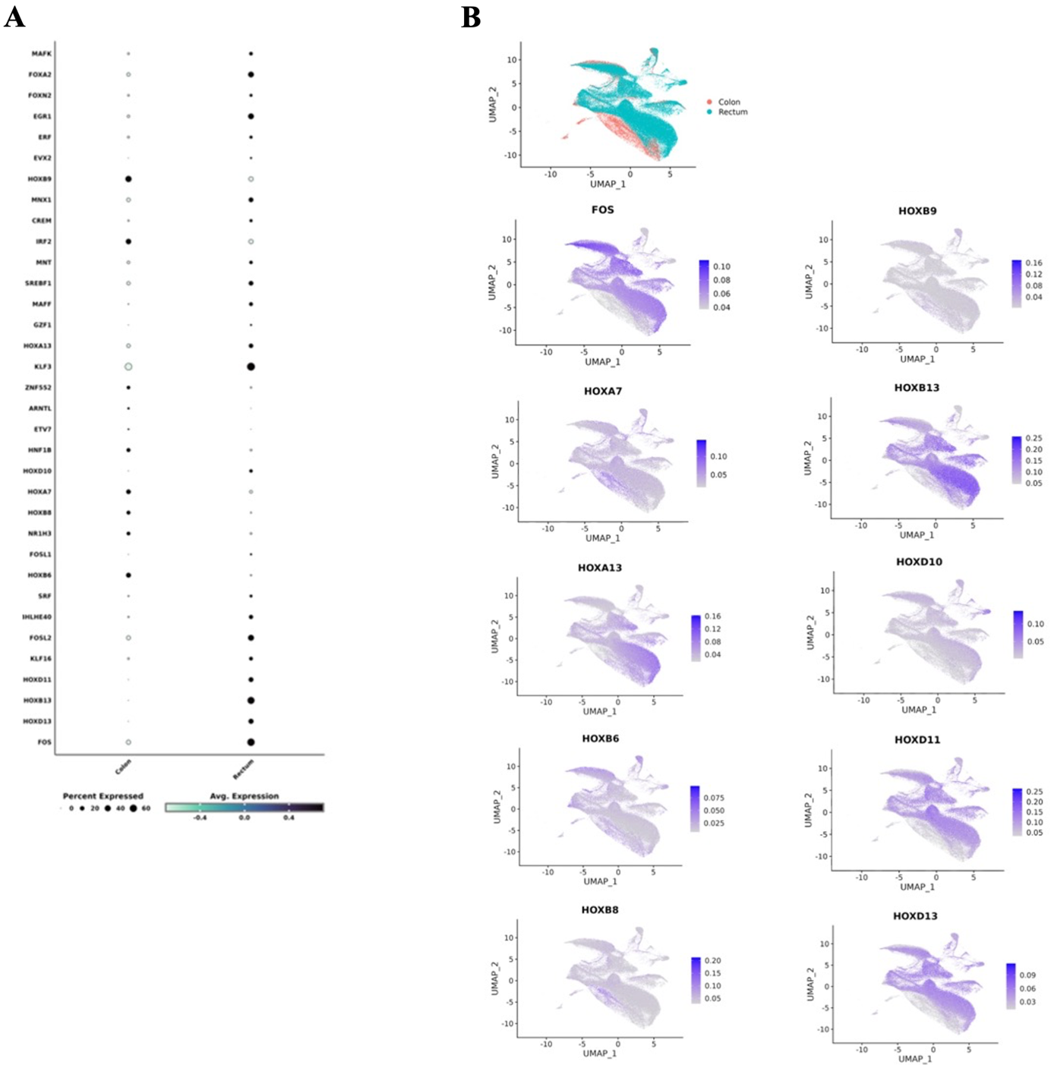
a, Dot plot showing the proportion of cell types and states enriched for transcription factors in the healthy colorectum. b, Feature plot highlighting enrichment of individual transcription factors from the FOS and HOX gene families in the healthy colorectum.

Extended Data Fig. 4. Stemness potential index inferred by CytoTRACE 2
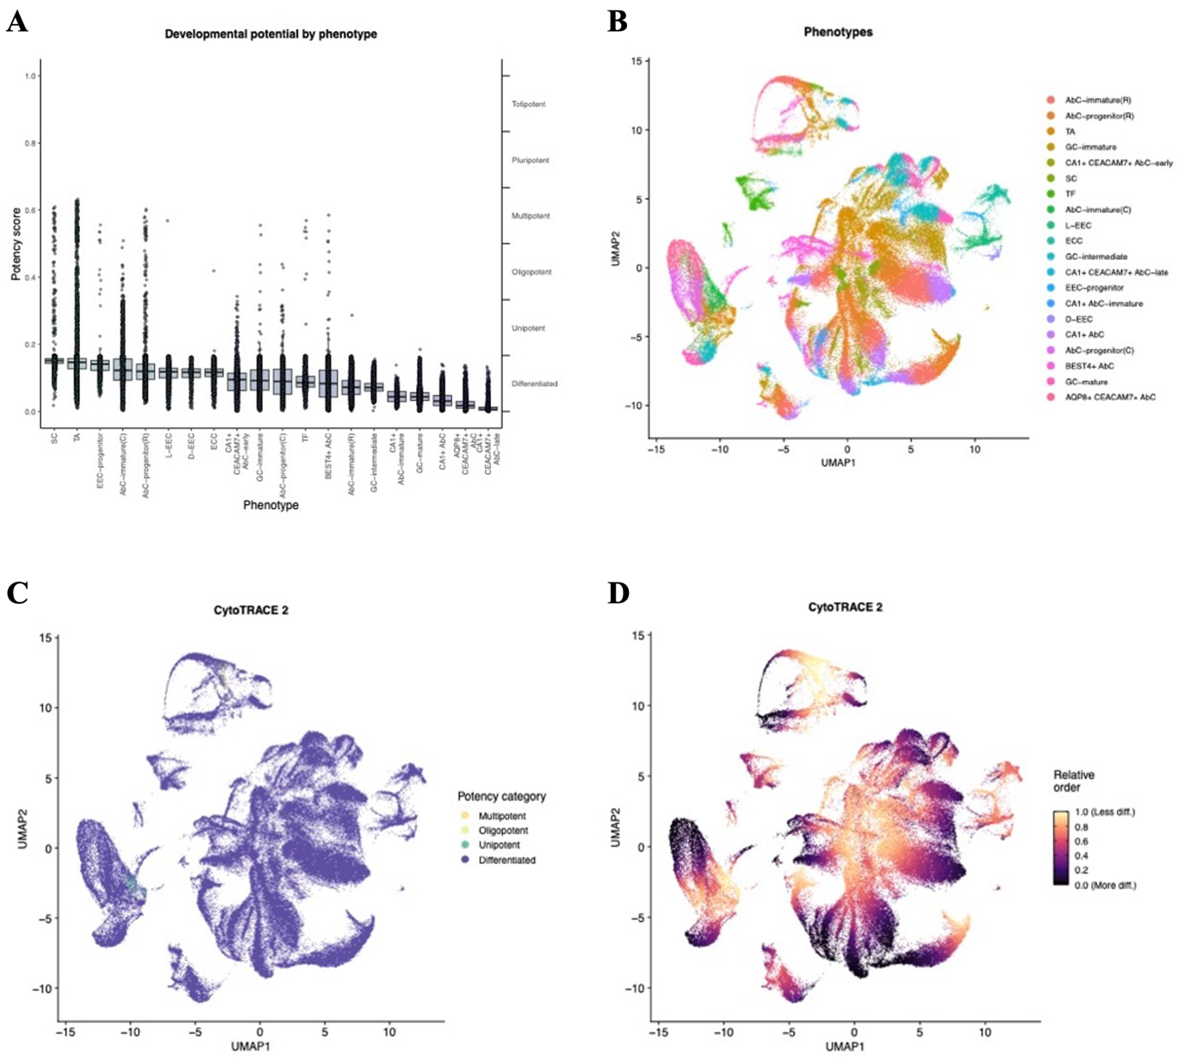
a, Box plot showing hierarchical ordering of stemness potential index across cell types and states, as inferred by CytoTRACE2. b, UMAP representation of phenotype clustering by cell type and state. c, Feature plot indicating potency categories from multipotent to differentiated. d, Feature plot illustrating relative ordering from less differentiated to differentiated cell states.
Extended Data Fig. 5. Spot-level deconvolution of epithelial cell populations in the healthy human rectum
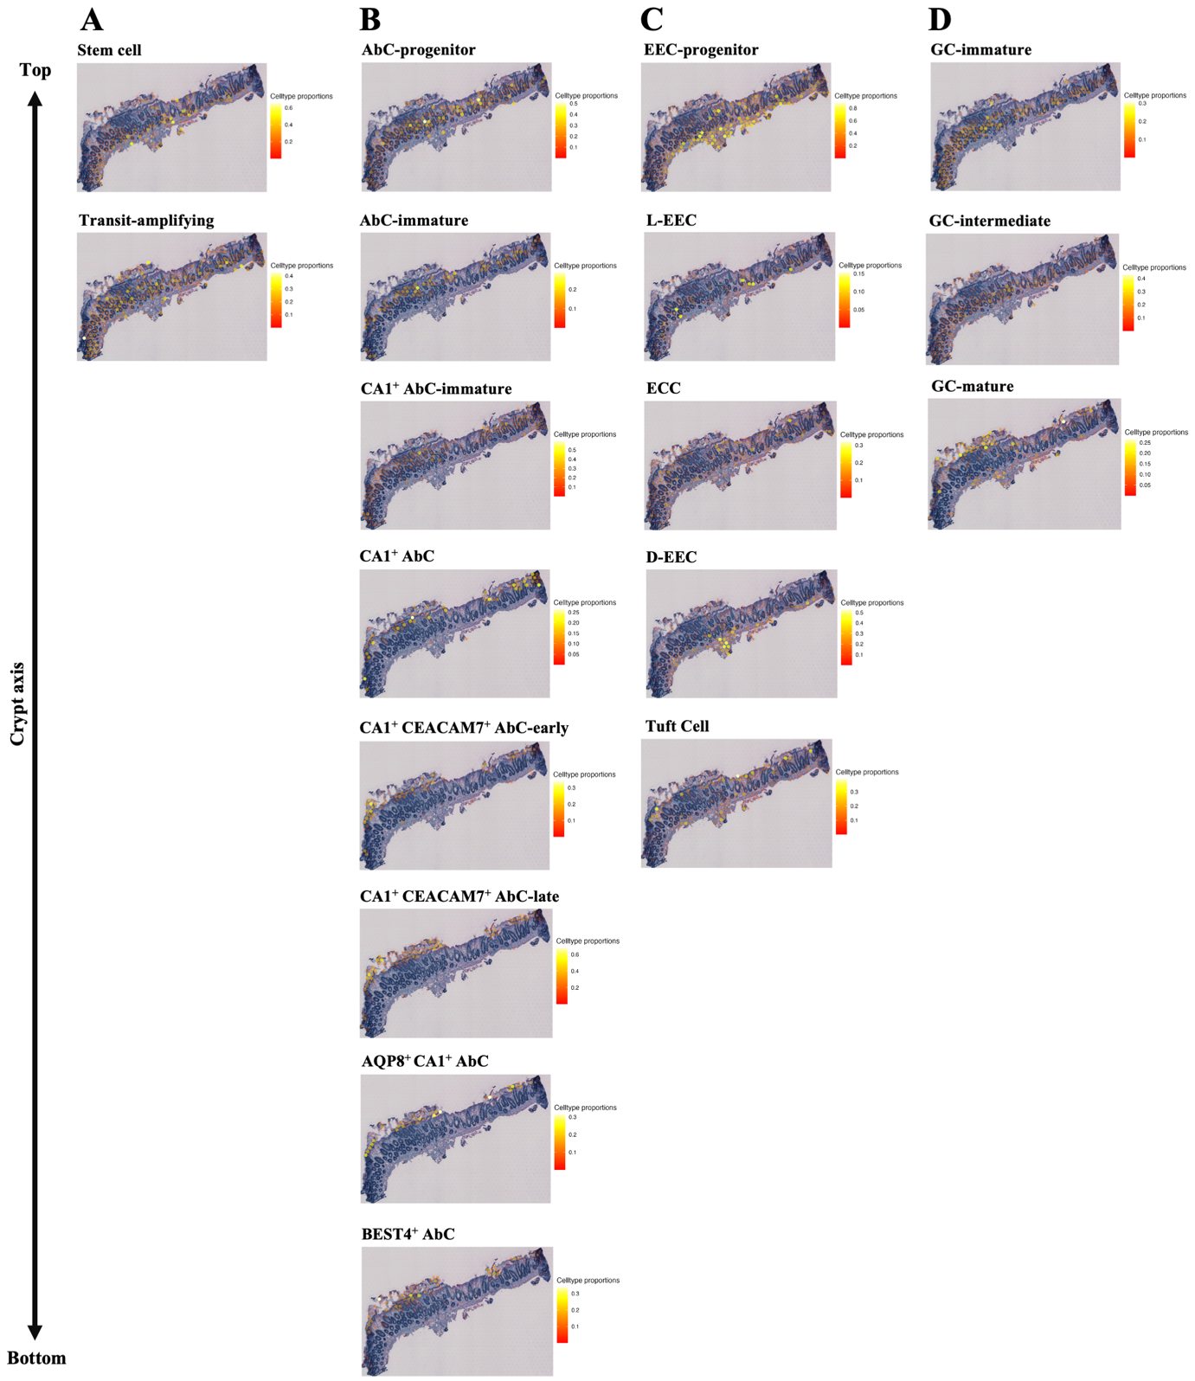
a, Stem and transit-amplifying cells. b, AbC types and states. c, Chemosensory cells. d, Goblet cells.

Extended Data Fig. 6. Colorectal expression of intestinal barrier genes
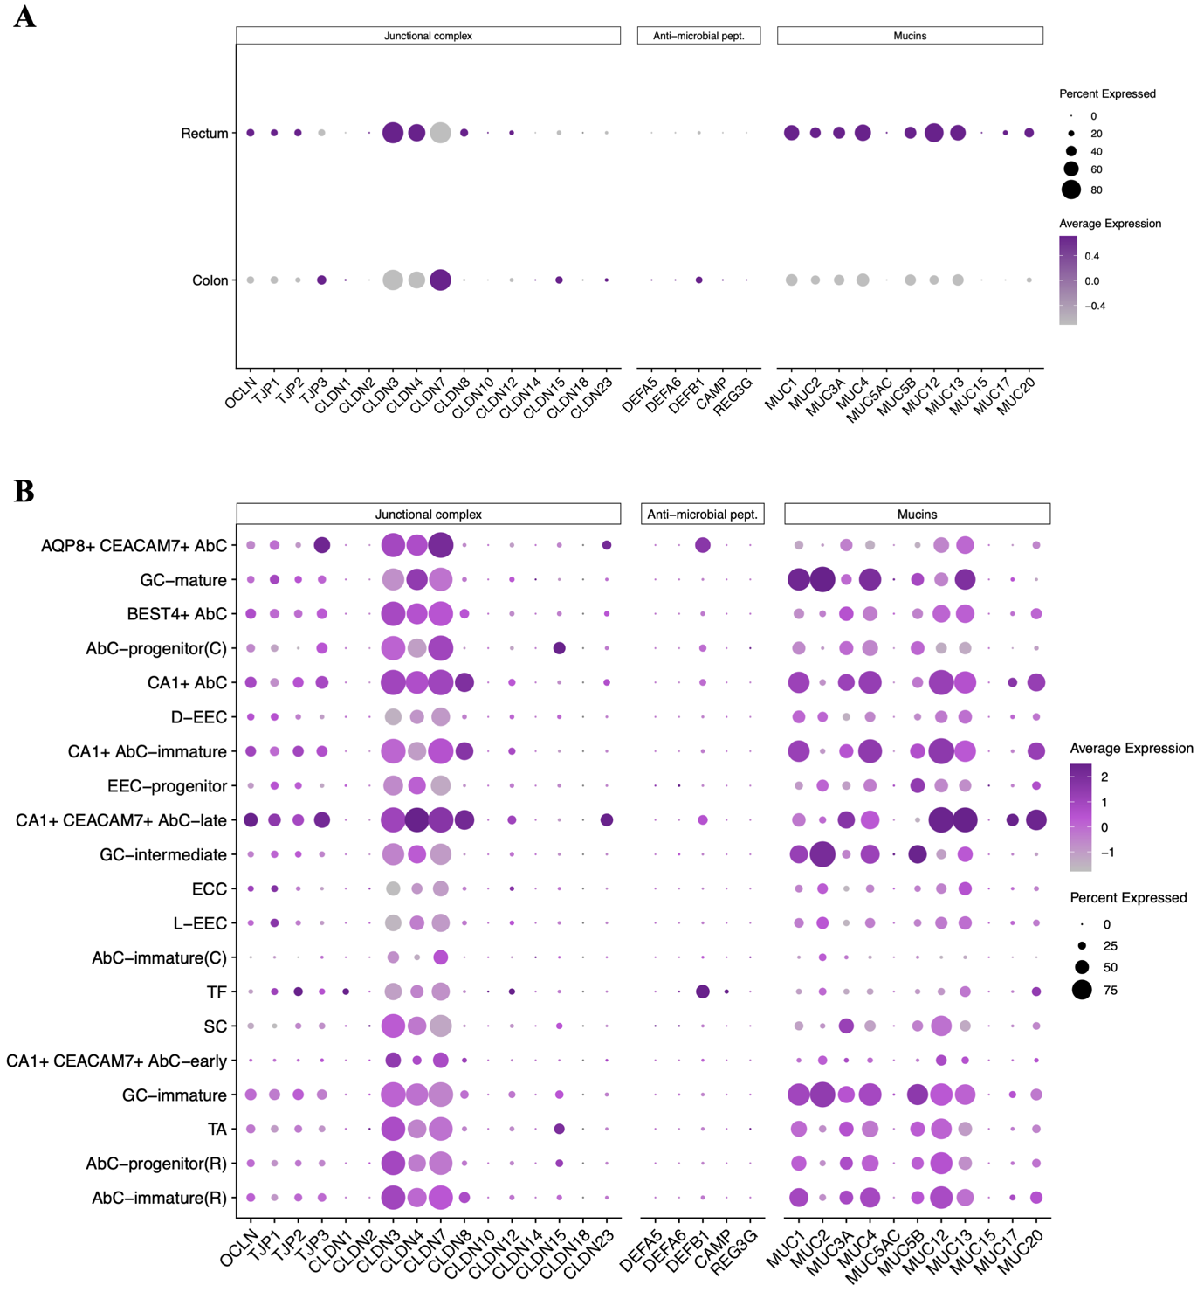
a, Dot plot showing the global proportion of cells and average expression levels of intestinal barrier genes between colon and rectum. b, Dot plot showing the proportion of cell types and states enriched for intestinal barrier genes.

Extended Data Fig. 7. Colorectal expression of gut-liver axis genes
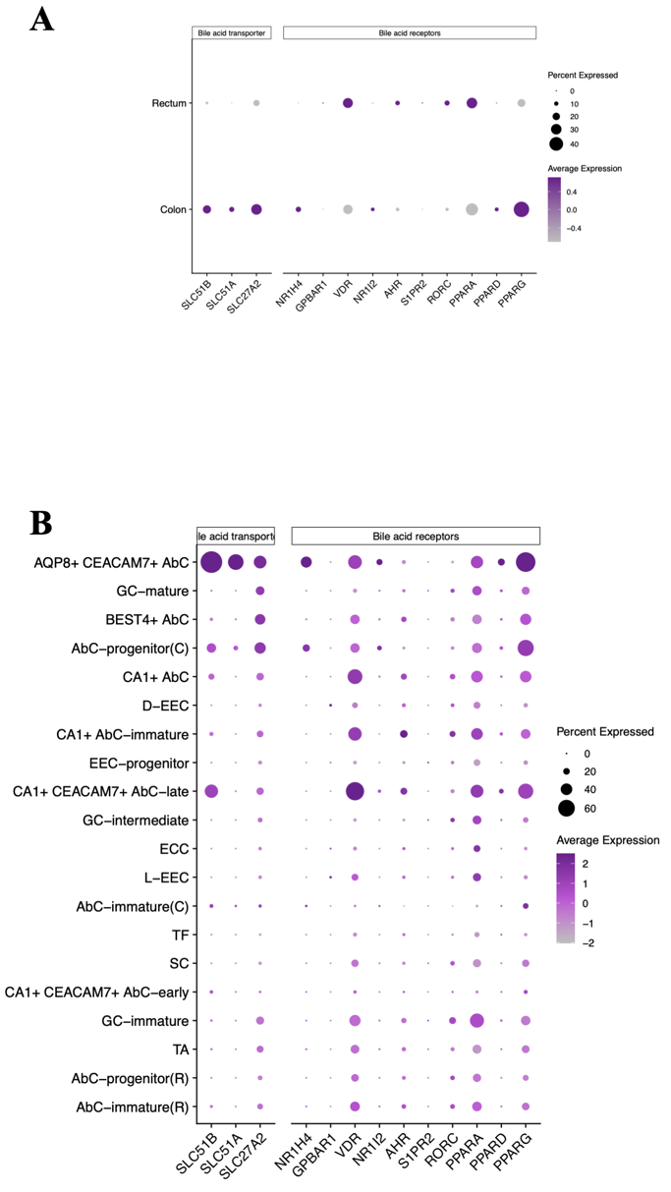
a, Dot plot showing the global proportion of cells and average expression levels of gut-liver axis genes between colon and rectum. b, Dot plot showing the proportion of cell types and states enriched for gut-liver axis genes.

Extended Data Fig. 8. Colorectal expression of nutrient transporters
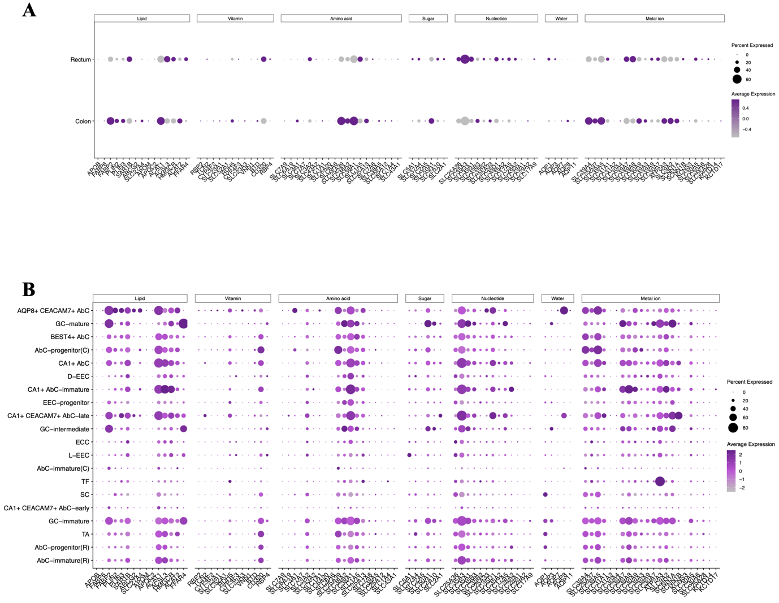
a, Dot plot showing the global proportion of cells and average expression levels of genes encoding nutrient transporters between the colon and rectum. b, Dot plot showing the proportion of cell types and states enriched for genes encoding nutrient transporters.
Extended Data Fig. 9. Colorectal expression of inorganic and organic solute carriers
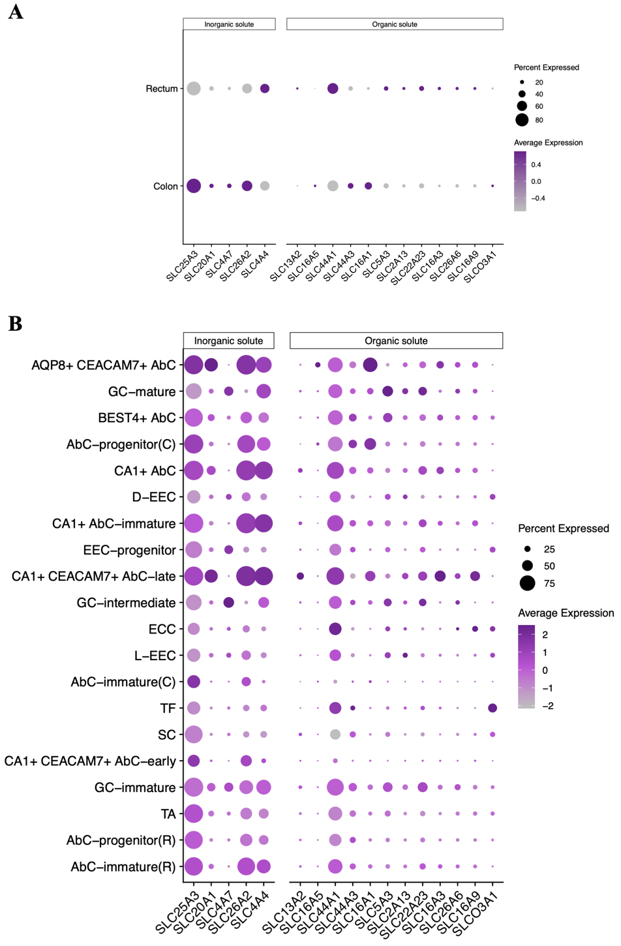
a, Dot plot showing the global proportion of cells and average expression levels of genes encoding inorganic and organic solute carriers between the colon and rectum. b, Dot plot showing the proportion of cell types and states enriched for genes encoding inorganic and organic solute carriers.

Extended Data Fig. 10. Colorectal expression of ion transporters
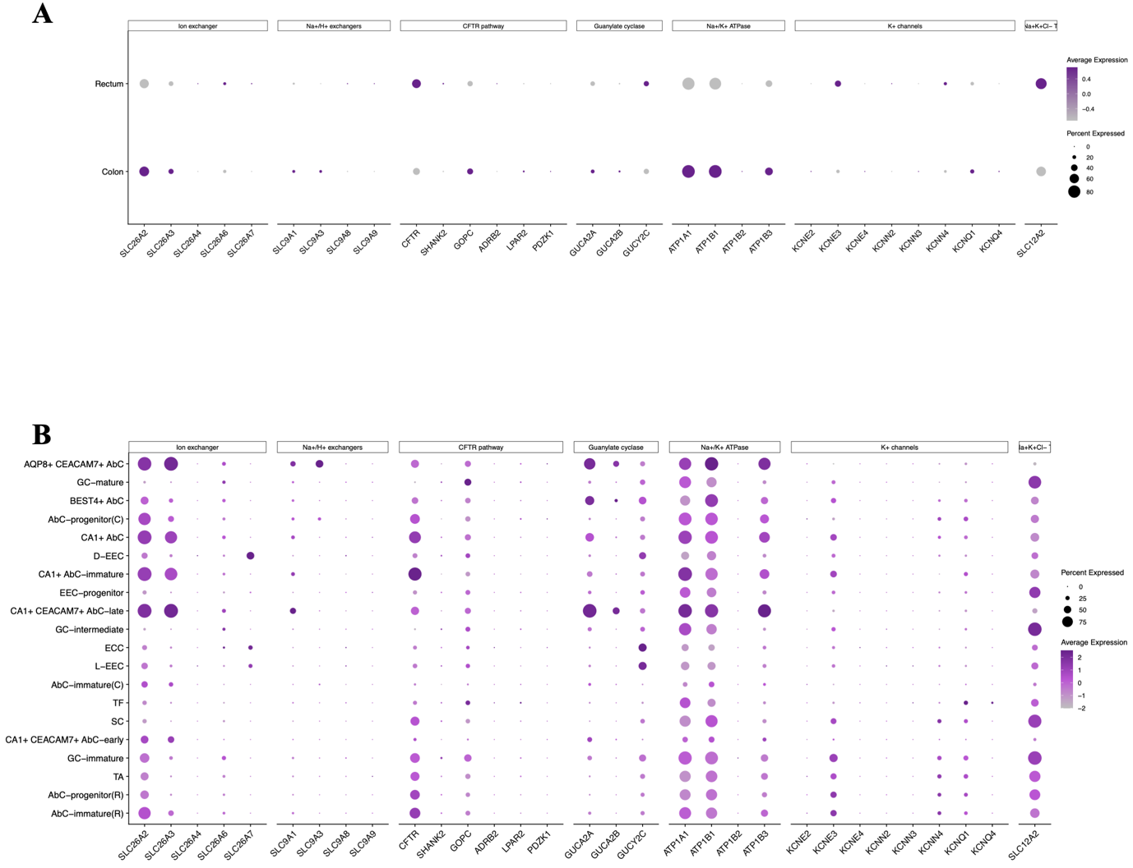
a, Dot plot showing the global proportion of cells and average expression levels of genes encoding ion transporters between the colon and rectum. b, Dot plot showing the proportion of cell types and states enriched for genes encoding ion transporters.

Extended Data Fig. 11. Overview of cell-cell interactions in the healthy colorectal epithelium
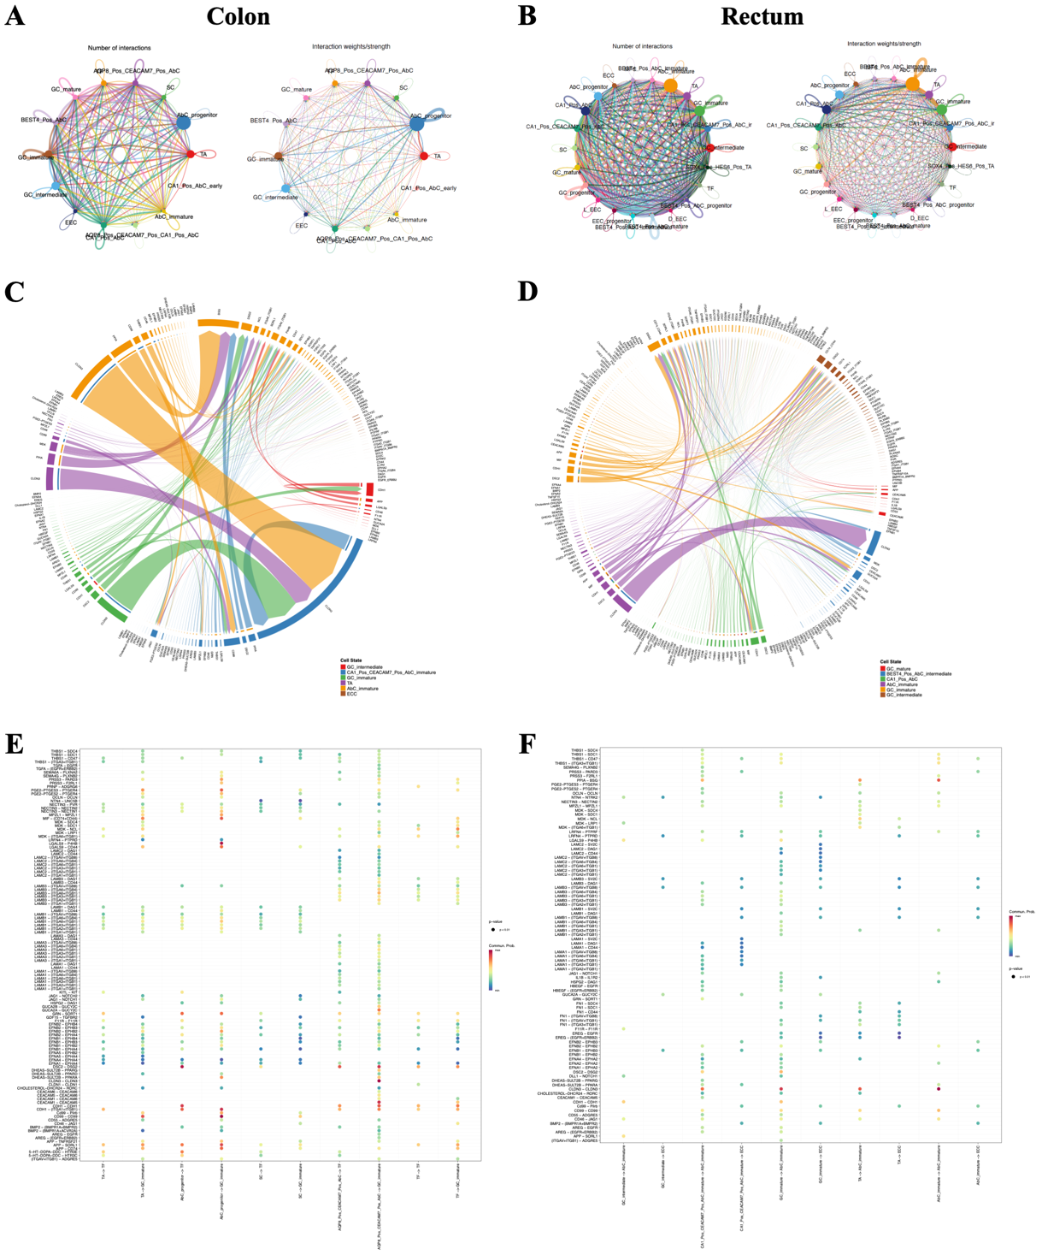
a,b, Circle plots illustrating the number and strength of interactions between cell types and states in the ascending colon and rectum, respectively. c,d, Chord diagrams showing ligand–receptor pairs between cell states in the ascending colon and rectum, respectively. e,f, Bubble plots indicating communication probabilities of ligand–receptor pairs between cell states in the ascending colon and rectum, respectively.
Extended Data Fig. 12. Xenium in situ integration of rectal tissue samples
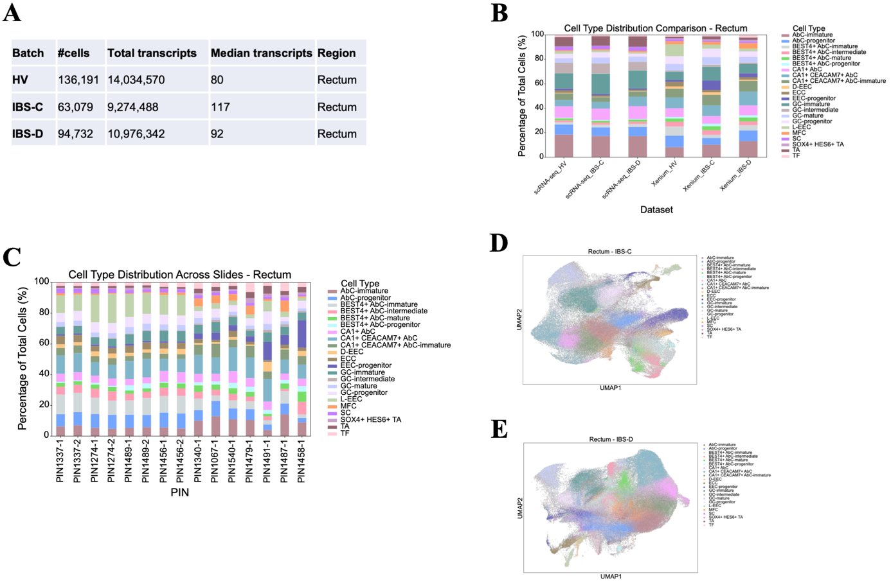
a, Table summarizing the number of cells captured, total transcripts, and median transcript counts per cell. b, Bar plot comparing percentage distribution of rectal epithelial cell types captured by scRNA-seq and Xenium in situ assays across sample groups. c, Bar plot displaying percentage distribution of cell types per tissue section labeled by anonymized patient ID (PIN) and section number (-1 or -2). d, UMAP plot showing integrated rectal cells from IBS-constipation (IBS-C) patients profiled by the Xenium assay. e, UMAP plot showing integrated rectal cells from IBS-diarrhea (IBS-D) patients profiled by the Xenium assay.

Extended Data Fig. 13. Expression of barrier and transporter genes in IBS
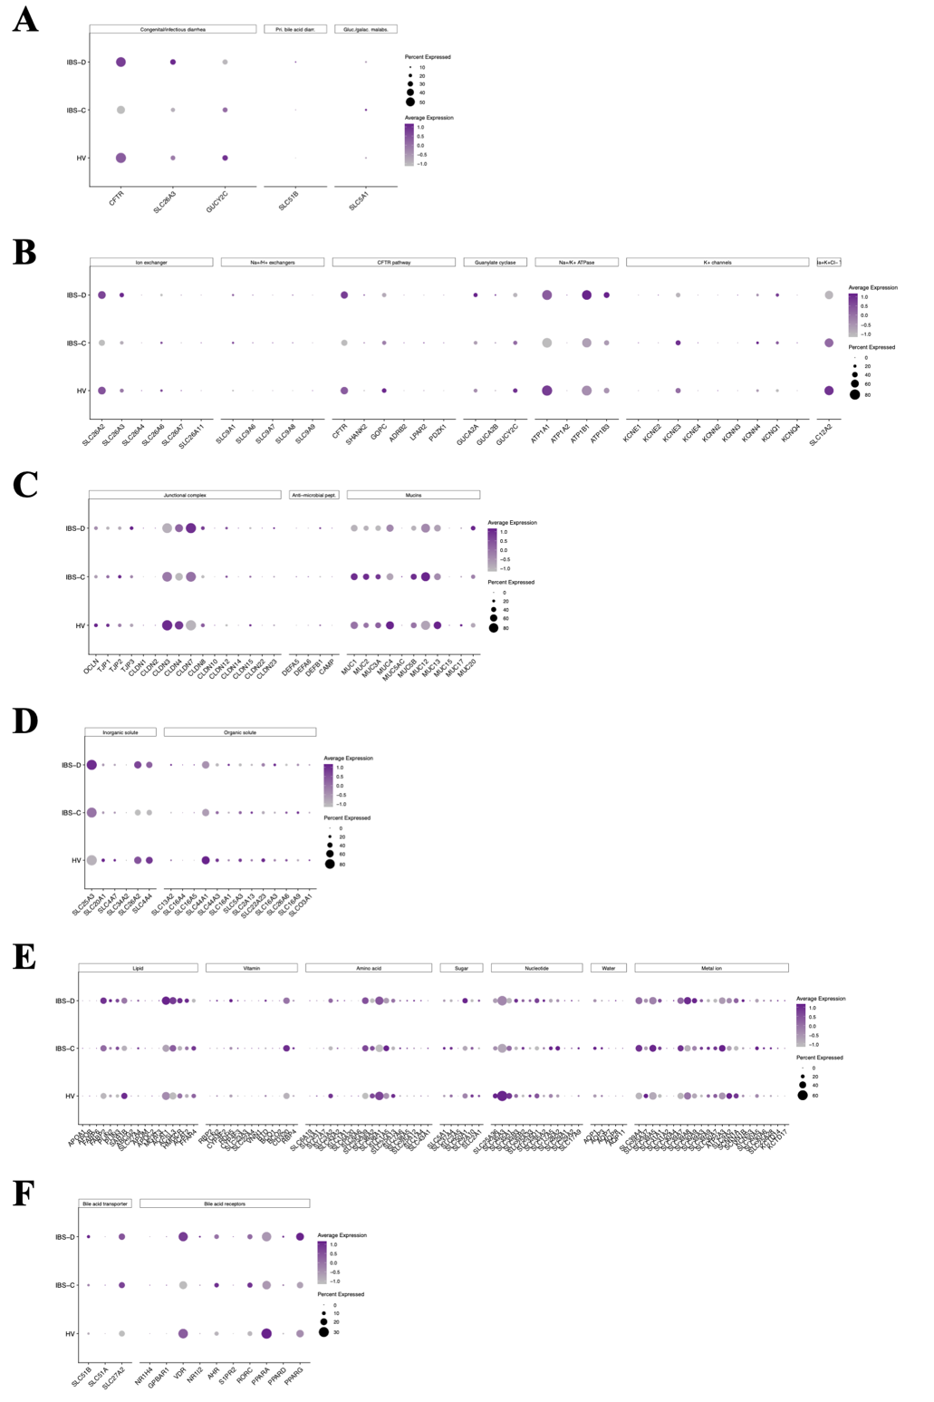
a–f, Dot plots showing the proportion of cells and average expression levels of genes associated with infectious or congenital diarrhea (a), ion transporters (b), intestinal barrier function (c), inorganic and organic solute carriers (d), nutrient transporters (e), and bile acid receptors and transporters (f) in HV and IBS patients.

Extended Data Fig. 14. Aberrant cell type frequency in CD
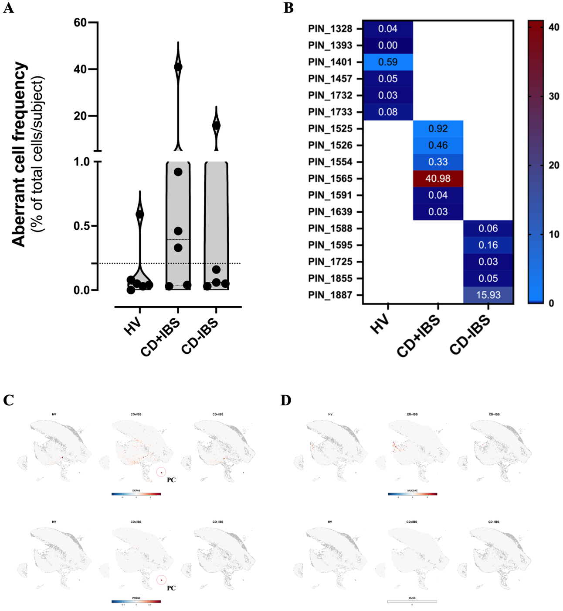
a, Violin plot showing combined frequency of SymAC-1 and -2 populations expressed as a percentage of total cells per subject. The dashed line indicates the 75th percentile threshold. b, Heatmap displaying per-subject combined frequencies of SymAC-1 and -2 in HV and CD groups. c, feature plots highlighting expression of canonical Paneth cell (red dashed circle) marker genes. d, feature plots indicating lack of metaplastic INFLARE marker expression in SymACs.

Extended Data Fig. 15. Xenium in situ integration of colonic tissue samples
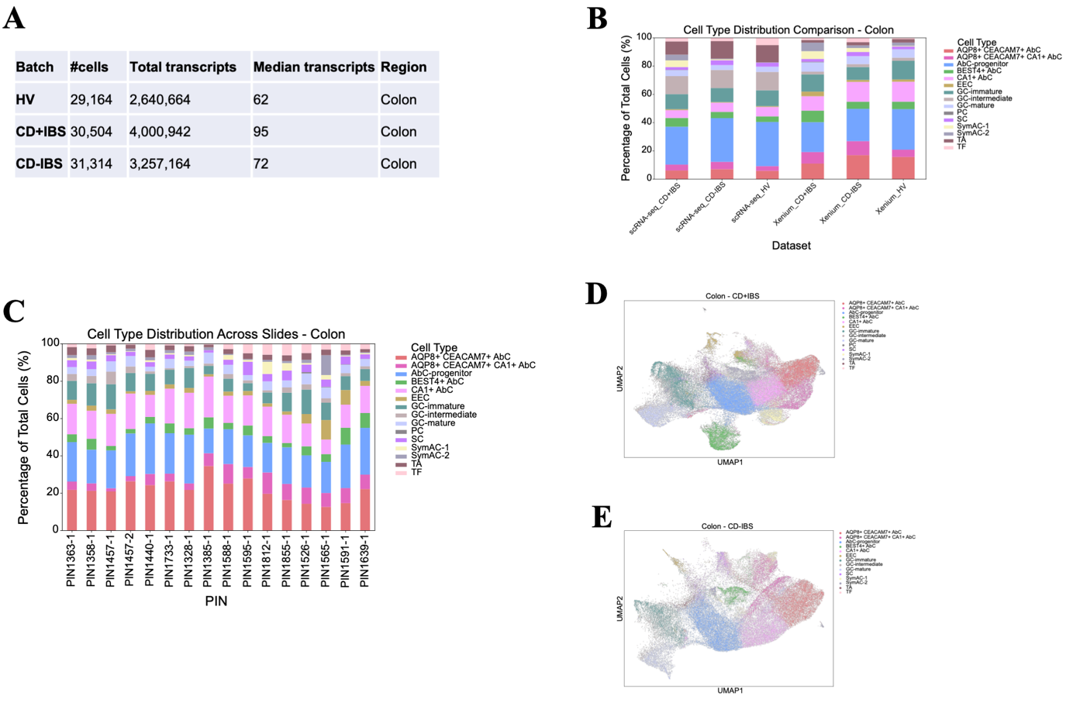
a, Table summarizing the number of cells captured, total and median transcript counts. b, Bar plot comparing the percentage distribution of colonic epithelial cell types captured by scRNA-seq and Xenium in situ. c, Bar plot showing the percentage distribution of cell types per tissue section labeled by anonymized patient ID (PIN) and section number (-1 or -2). d, UMAP plot showing integrated colonic cells from CD+IBS patients profiled by the Xenium assay. e, UMAP plot showing integrated colonic cells from CD-IBS patients profiled by the Xenium assay.

Extended Data Fig. 16. Expression of genes associated with diarrhea in CD
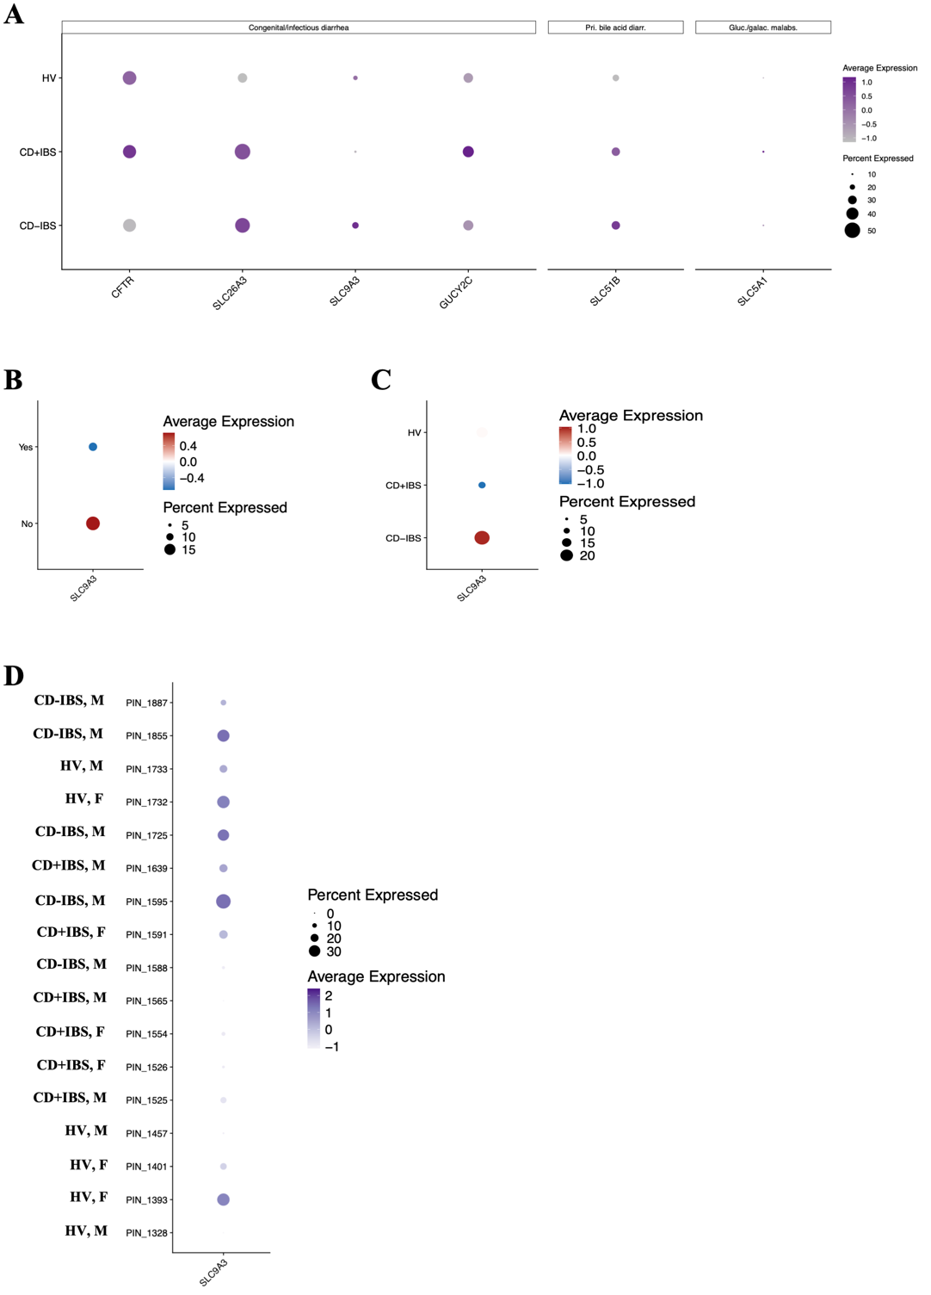
a, Dot plot showing the proportion of cells and average expression of genes associated with infectious or congenital diarrhea. b, Dot plot highlighting the proportion of cell types and states expressing SLC9A3, a key sodium transporter negatively associated with diarrhea. c, Dot plot showing SLC9A3 expression by cell types and states in HV and CD patients with or without IBS-like symptoms. d, Dot plot showing per-subject proportion and average expression levels of SLC9A3.
Extended Data Fig. 17. Expression of barrier and transporter genes in CD
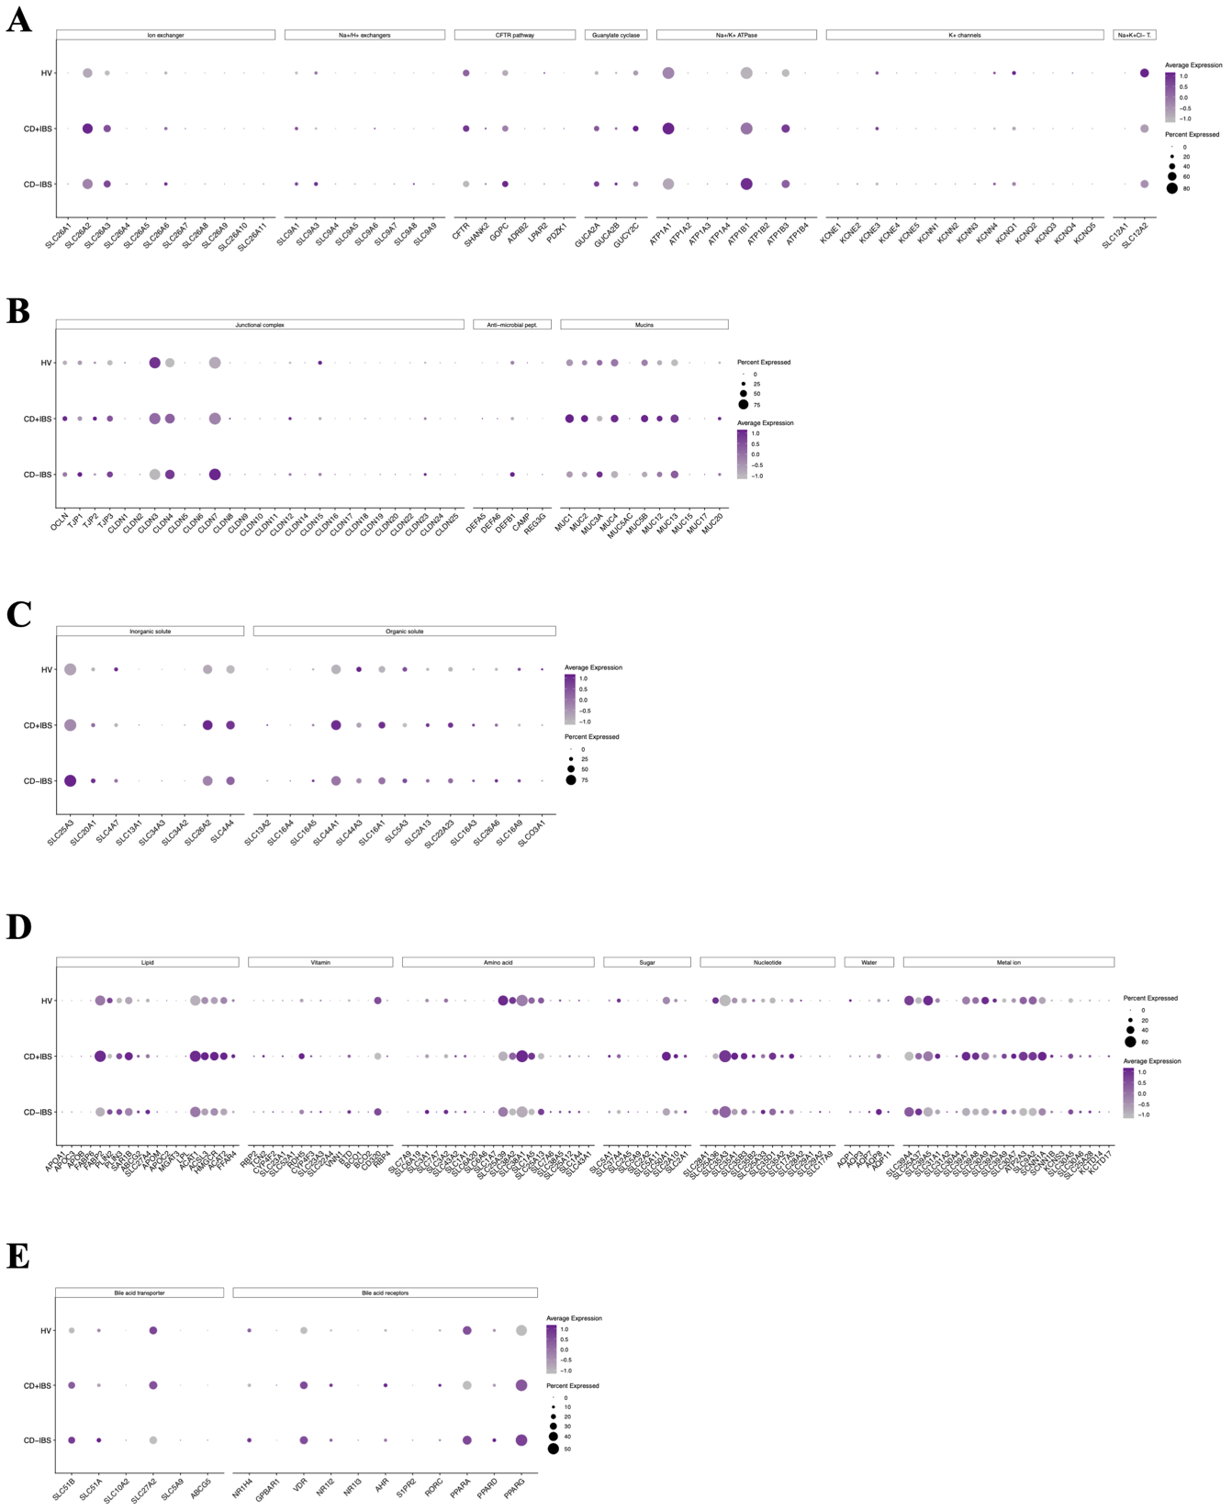
a–e, Dot plots showing the proportion of cells and average expression levels of genes encoding ion transporters (a), intestinal barrier components (b), inorganic and organic solute carriers (c), nutrient transporters (d), and bile acid receptors and transporters (e) in HV and CD groups.
Extended Data Table 3. Demographic and clinical characteristics of the human cohort used for short chain fatty acid quantification
 | HV | IBS
N | 18 | 43
Female, N (%) | 15 (75) | 32 (78)
Age, mean ± SD | 31.9 ± 12.1 | 30.1 ± 7.6
Mild IBS, N (%)  75<IBS-SSS<149 |  | 7 (17)
IBS-moderate, N (%)  150<IBS-SSS<299 |  | 16 (39)
IBS-severe, N (%)  IBS-SSS>300 |  | 18 (44)

HV: healthy volunteers, IBS: irritable bowel syndrome, SD: standard deviation

Extended Data Fig. 18. Expression of EEC mediators and fecal SCFA in GI disorders
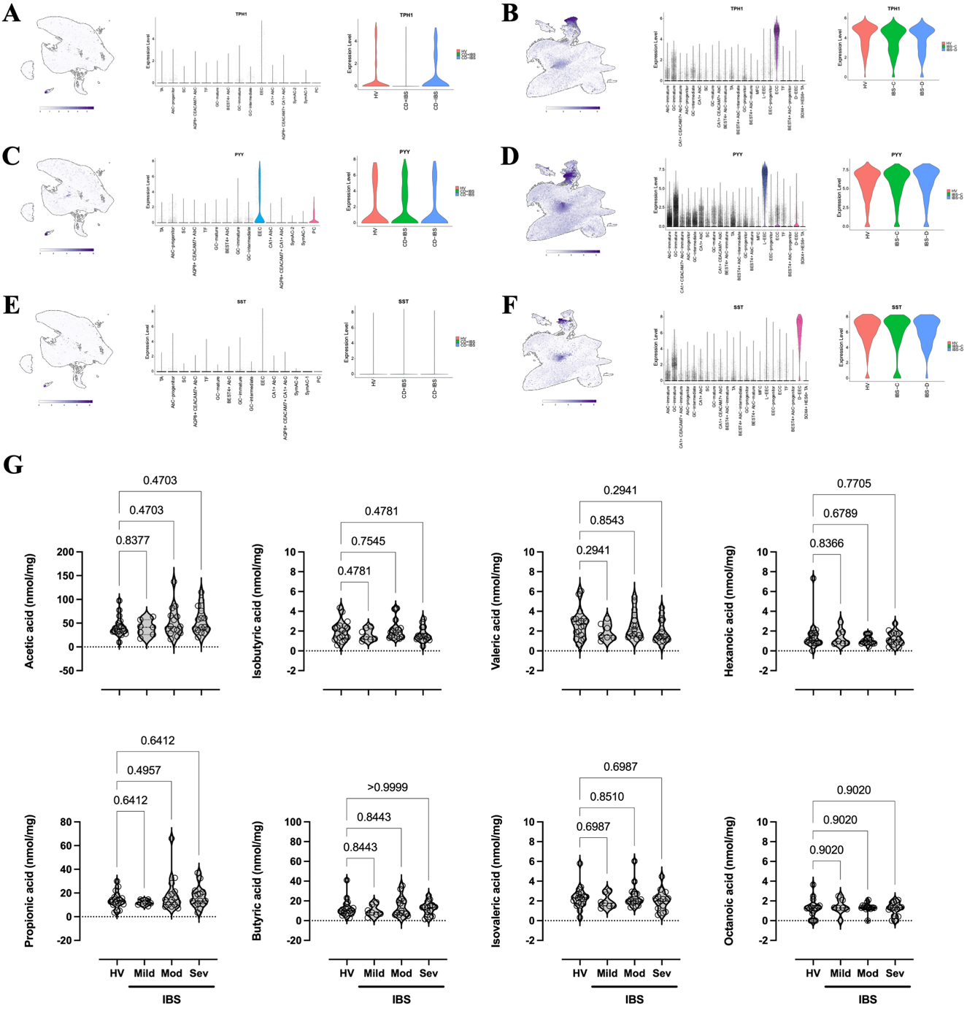
a–f, Feature plots and middle violin plots showing TPH1 (a, b), PYY (c, d), and SST (e, f) expression in colonic (a, c, e) and rectal (b, d, f) epithelial cells from HV, CD, and IBS patients. Right violin plots display relative expression within enteroendocrine cells (EECs) comparing HV versus CD+IBS, CD-IBS, or IBS groups. g, Violin plots showing fecal short-chain fatty acid concentrations (nmol/mg) in HV and IBS patients stratified by disease severity (mild, moderate, severe). Data analyzed by ordinary one-way ANOVA with two-stage step-up method of Benjamini, Krieger, and Yekutieli correcting for false discovery rate.

